Supplementary data
Quercetin attenuates the production of pro-inflammatory cytokines in H292 human lung epithelial cells infected with Pseudomonas aeruginosa, by modulating ExoS production

Hye In Ahn¹, Ji-Won Park¹, Hyun-Jae Jang¹, Ok-kyoung Kwon¹, Jung Hee Kim¹, Sei-Ryang Oh¹, Sang-Bae Han², and Kyung-Seop Ahn^{1*}

¹ Natural Medicine Research Center, Korea Research Institute of Bioscience and Biotechnology, 30 Yeongudanji-ro, Ochang-eup, Cheongwon-gu, Cheongju-si, Chungbuk 28116, Republic of Korea
² College of Pharmacy, Chungbuk National University, 52 Naesudong-ro, Heungdeok-gu, Cheongju-si, Chungbuk 28160, Republic of Korea

* Corresponding Authors: Kyung-Seop Ahn, ksahn@kribb.re.kr

Table of Contents
Fig S1.1. UPLC-QTOF-MS data of quercetin 2
Fig S1.2. ¹H NMR (400 MHz, DMSO-d₆) spectrum of quercetin 3
Fig S1.3. ¹³C NMR (100 MHz, DMSO-d₆) spectrum of quercetin 4

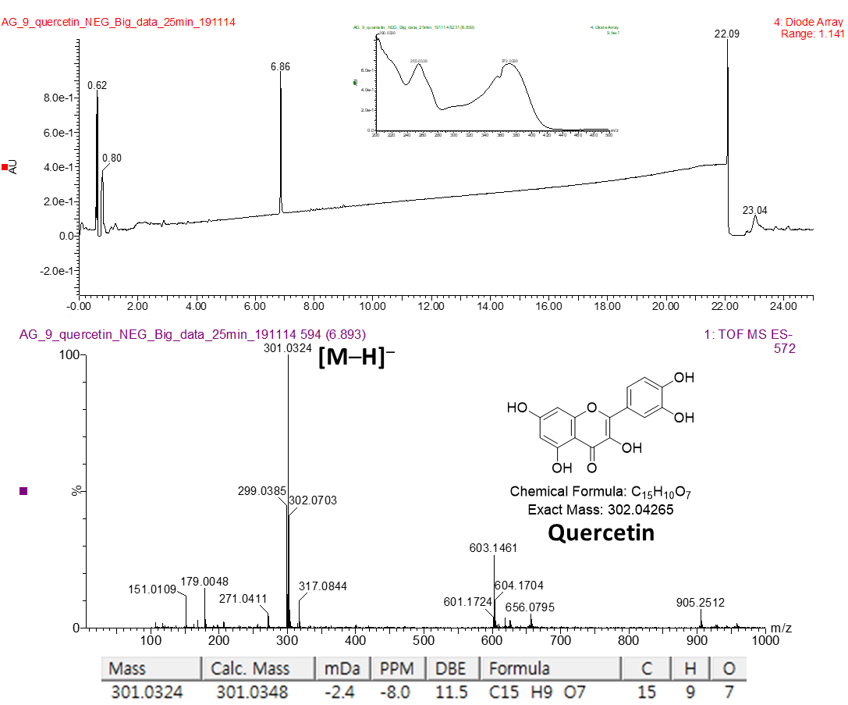
Figure S1.1. UPLC-QTOF-MS data of quercetin
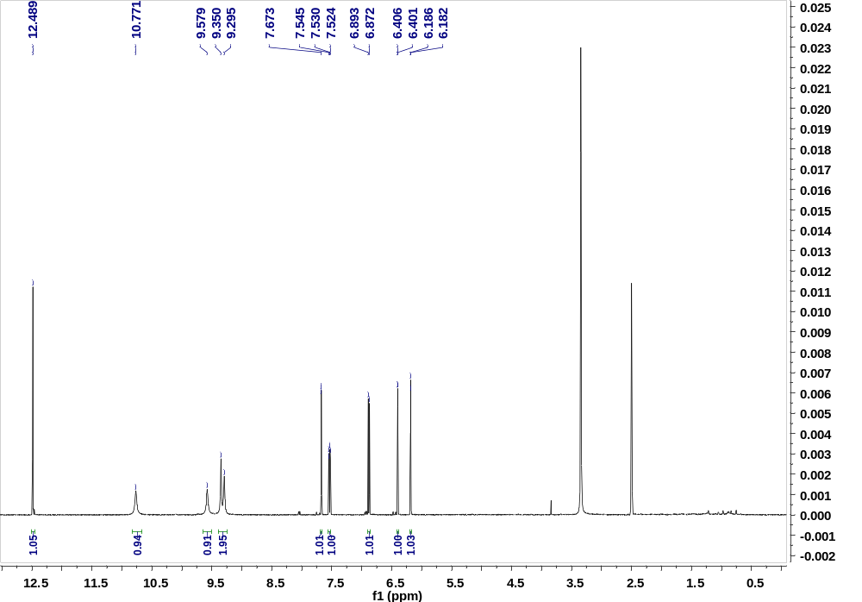
Figure S1.2. ¹H NMR (400 MHz, DMSO-d₆) spectrum of quercetin.
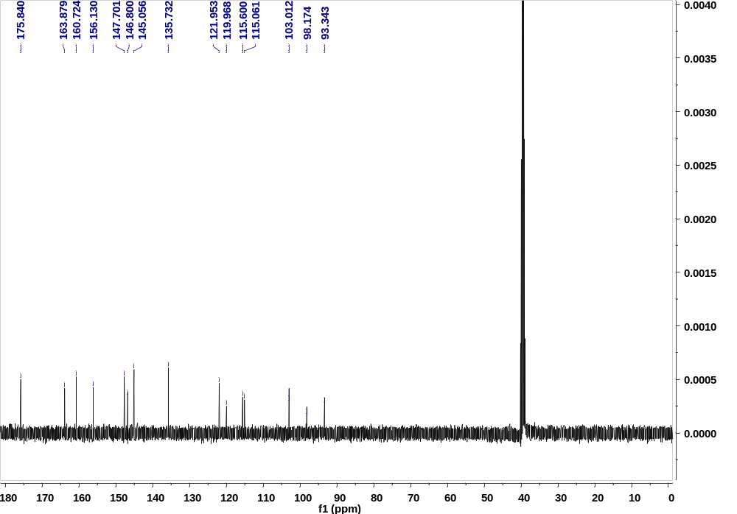
Figure S1.3. ¹³C NMR (100 MHz, DMSO-d₆) spectrum of quercetin.
Quercetin
Yellow amorphous powder; ESI-MS m/z 301 [M–H]– ; ¹H NMR (400 MHz, DMSO-d₆) δ_{H}: 12.49 (1H, s, OH-5), 7.68 (1H, d, J = 2.0 Hz, H-2′), 7.54 (1H, d, J = 8.4, 2.0 Hz, H-6′), 6.88 (1H, d, J = 8.4 Hz, H-5′), 6.40 (1H, d, J = 2.0 Hz, H-8) 6.18 (1H, d, J = 2.0 Hz, H-6); ¹³C-NMR (100 MHz, DMSO-d₆) δ_{C}: 175.8 (C-4), 163.9 (C-7), 160.7 (C-5), 156.1 (C-9), 147.7 (C-2), 146.8 (C-4′), 145.1 (C-3′), 135.7 (C-3), 122.0 (C-1′), 120.0 (C-6′), 115.6 (C-5′), 115.1 (C-2′), 103.0 (C-10), 98.2 (C-6), 93.3 (C-8).

References
Xu, J., Li, X., Zhang, P., Li, Z. L., Wang, Y., 2005. Antiinflammatory constituents from the roots of Smilax bockii warb. Arch Pharm Res 28, 395–399.

