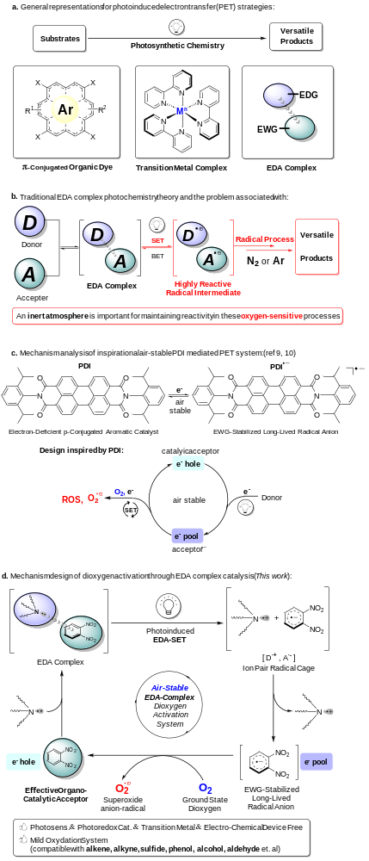
Scheme 1. EDA complex photochemistry and dioxygen activation. (a) Overview of photochemistry. (b) Traditional EDA complex photochemistry theory and the problem associated with. (c) Research inspiration. (d) Mechanism design.

Table 1. Screening of reaction conditions. ª
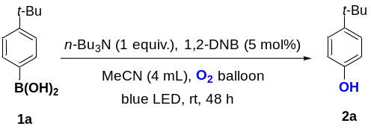
entry | changed conditions | isolated yield
1 | none | 99%
2 | Toluene as solvent | Trace
3 | DMSO as solvent | ND
4 | MeOH as solvent | Trace
5 | THF as solvent | Trace
6 | DCM as solvent | Trace
7 | DMF as solvent | 17%
8 | EtOAc as solvent | Trace
9 | 0.5 eq amine Donor | 56%
10 | 1.5 eq amine Donor | 98%
11 | 2.0 eq amine Donor | 97%
12 | Tri-n-octylamine as Donor | 29%
13 | DABCO as Donor | Trace
14 | Et₃N as Donor | 28%
15 | DIPEA as Donor | Trace
16 | NPh₃ as Donor | Trace
17 | 1,3-DNB as Accepter | 34%
18 | 1,4-DNB as Accepter | 17%
19 | No Light | ND
20 | No Donor | ND
21 | No Accepter | ND
22 | Under Ar | ND
23 | 600 uL H₂O as additive | Trace
ª Reaction conditions: 1a (0.5 mmol), amine donor (0.5 mmol), 1,2-DNB accepter (0.025 mmol, 5 mol%) in solvent (4.0 mL) under blue LED irradiation and oxygen atmosphere (1 atm).
Table 2. Substrate scope ª
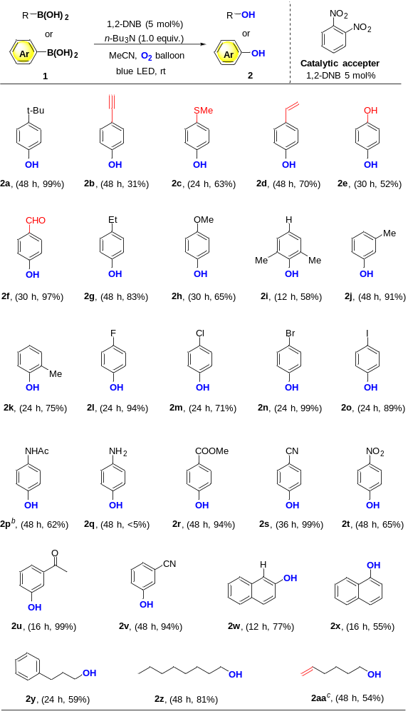
ª Reactions were conducted on 0.5 mmol scale using 1.0 equiv. amine, 5 mol% 1,2-DNB at 0.125 M. Isolated yields after chromatographic puriﬁcation. [b] 4-acetylaminophenylboronic acid pinacol ester was used as starting compound. ^{c} H-NMR Yield in CD₃CN due to its low boiling point.

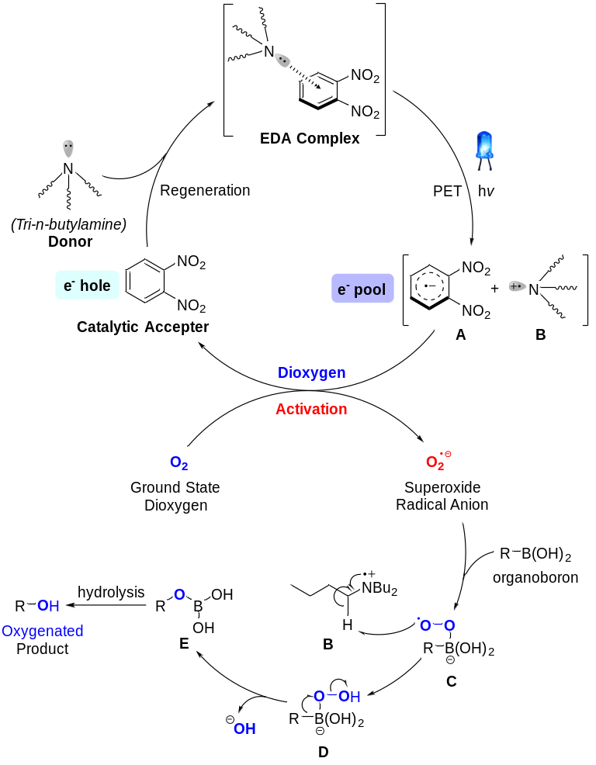
Scheme 2. Proposed EDA catalytic aerobic oxygenation mechanism.

