Supplementary Appendix

Table of Contents
Dose modifications and toxicity prevention 3
Description of the guidelines for intensity-modulated radiation therapy in this trial 4
Definitions of the endpoints 7
Per-protocol analysis 8
Supplemental Table S1: Patient baseline characteristics of per-protocol population. 9
Supplemental Table S2. Survival analysis in per-protocol population. 10
Supplemental Table S3: Characteristics of the patients at baseline between QUINTUPLED and historical cohorts. 11
Supplemental Table S4. Compliance to induction chemotherapy. 12
Supplemental Table S5. Compliance to camrelizumab and apatinib. 13
Supplemental Table S6. Compliance to concurrent cisplatin chemotherapy and radiotherapy. 14
Supplemental Table S7. Plasma EBV DNA clearance information. 15
Supplemental Table S8. Treatment-related adverse events, according to treatment phase and grade. 16
Supplemental Table S9. Immune-related adverse events, according to treatment phase and grade. 18
Supplemental Figure S1. Response to induction therapy. 19
Supplemental Figure S2. Representative MRI comparison of pre- and after induction phase. 20
Supplemental Figure S3. Pathology of nasopharyngeal and lymph node tissues. 21
Supplemental Figure S4. Trajectories of plasma EBV DNA levels. 22
Supplemental Figure S5. Immune-related toxic epidermal necrolysis-like skin reaction. 23

Dose modifications and toxicity prevention
Patients were examined and graded for subjective or objective evidence of toxic effects of treatment according to the National Cancer Institute Common Terminology Criteria for Adverse Events (CTCAE; version 5) every week when the induction and concurrent chemotherapy and radiotherapy was administered and before each camrelizumab dose. Radiotherapy dose modifications were not allowed.
Chemotherapy dose adjustments were allowed in cases of hematological or non-hematological toxicity. In the case of hematological toxicity, during the induction and concurrent phase, chemotherapy was withheld until the nadir values were 1500 cells per μL or higher for neutrophils and 100 000 cells per μL or higher for platelets. In the case of renal or liver toxicity, chemotherapy was withheld until adequate renal function and liver function were regained.
Dose reductions of camrelizumab were not allowed. Dose interruptions and dose reductions (maximum of two reductions) of apatinib were permitted for toxicities that were not relieved by supportive care. The first dose reduction was to 250 mg once per day with 5 days on and 2 days off, and additional reduction was to 250 mg once per day every other day. If the apatinib dose was reduced, it could not be increased later. At the middle of study, the initial dose of apatinib was adjusted with 250 mg once per day with 5 days on and 2 days off.
To prevent chemotherapy-induced nausea and vomiting, we recommended 5-HT3-receptor antagonist (ondansetrone 8 mg or granisetron 3 mg, intravenously) and NK-1-receptor antagonist (aprepitant 125 mg po on day 1 and 80 mg on days 2 and 3); metoclopramide (10 mg intramuscularly) could also be used if symptoms persist despite the triplet combination. To prevent cisplatin-induced nephrotoxicity, we administered a 3-day hydration protocol on days 0–2 and used diuretics (mannitol 50 g intravenously and furosemide 20 mg intravenously) on the day of cisplatin administration. Severe malnutrition or continuous weight loss during treatment was an indication for parenteral or nasogastric nutritional supplementation. All of the supportive care could be delivered in both inpatient and outpatient settings at the physician’s discretion. Polyethylene glycol-conjugated recombinant human granulocyte stimulating factor is an alternative agent for the prevention of serious neutropenia. For grade 4 neutropenia, prophylactic antibiotics were administered.

Description of the guidelines for intensity-modulated radiation therapy in this trial
In general, all patients were immobilized in the supine position and using a thermoplastic mask that covered the head, neck, and shoulder. Both non-enhanced CT (for dose calculation) and contrast-enhanced CT (for target delineation) images were obtained from the vertex to 2 cm below the sternoclavicular joint, with 3-mm slices.
Target volumes were defined in accordance with the International Commission on Radiation Units and Measurements (ICRU) reports 50 and 62. Gross tumor volume (GTV) included the primary tumor and enlarged lymph nodes. High-risk clinical target volume was defined as the nasopharyngeal GTV plus a 5-10 mm margin (2-3 mm posteriorly if adjacent to the brainstem or spinal cord) to encompass the high-risk sites of microscopic extension and the whole nasopharynx. Low-risk clinical target volume was defined as the high-risk clinical target volume plus a 5-10 mm margin (2-3 mm posteriorly if adjacent to the brainstem or spinal cord) to encompass the low-risk sites of microscopic extension, including the skull base, clivus, sphenoid sinus, parapharyngeal space, pterygoid fossa, retropharyngeal nodal regions, and elective neck area from level IB to level V. For the planning target volumes of GTVnx, GTVnd, CTV_{high-risk}, and CTV_{low-risk}, total radiation doses of 68–72 Gy, 64–68 Gy, 60-64 Gy, and 54-58 Gy, respectively, were administered in 30-33 fractions, delivered daily at five fractions per week, starting on the first day of the first concurrent chemoradiotherapy cycle.
The normal tissue dose constraints are listed in Table SS1. All plans were generated by a team of dosimetrists using a wholefield (including neck radiation) simultaneous integrated boost technique. In general, when critical normal tissues (e.g., brain stem and spinal cord) were adjacent to the high-dose target volumes, the target volume coverage could be compromised to keep these critical normal tissues within the dose constraints. When other normal tissues of lower priority were adjacent to the high-dose target volumes, the dose to these tissues was kept as low as possible without compromising the target coverage. The trade-off between covering the target volume and protecting normal tissue in each case was discussed and decided upon by the research team at each institution. Radiation was delivered once daily at five fractions per week. It was recommended that patients commence chemoradiotherapy within 21-28 days from the first day of the last cycle of induction chemotherapy.
Supplemental Table SS1. Normal tissue dose constraint structure.
Structure | Dose constraints
Critical organ at risk
Brain stem | Dmax ≤ 54 Gy
PRV-Brain stem | D1 ≤ 60 Gy
Spinal cord Dmax* | Dmax* ≤ 45 Gy
PRV-Spinal cord | D1†≤ 50 Gy
Optic nerve | Dmax ≤ 54 Gy
PRV-Optic nerve | D1 ≤ 60 Gy
Optic chiasm | Dmax ≤ 54 Gy
PRV-Optic chiasm | D1 ≤ 60 Gy
Temporal lobe | Dmax ≤ 60 Gy
PRV-Temporal lobe | D1 ≤ 65 Gy
Intermediate-risk organ at risk
Pituitary | Dmax < 60 Gy
Mandibular | Dmax < 70 Gy
Temporomandibular Joint | Dmax < 70 Gy
Lens | Dmean‡ < 8 Gy
Eyes | Dmean < 35 Gy
Low-risk organ at risk
Parotid | Dmean < 26 Gy
Parotid | V30¶ < 50%
Cochlea | Dmean < 50 Gy
Tongue | Dmean < 45 Gy
Larynx | Dmean < 45 Gy
PRV = planning organ at risk volume.
* Maximum point dose to the target volume.
† Dose received by 1% of the target volume.
‡ Mean dose to the target volume.
¶ At least 50% of the gland will receive <30 Gy (should be achieved in at least one gland)

Plasma Epstein-Barr virus (EBV) DNA extraction and real-time quantitative polymerase chain reaction analysis.
Peripheral blood (3 ml) was obtained in an EDTA tube and centrifuged at 1600 x g for 15 min for isolation of plasma and peripheral blood mononuclear cells. Then Viral DNA was extracted using the QIAamp Blood Kit (Qiagen, Hilden, Germany) and stored at -80°C until further processing. A total of 500 μl plasma samples were used for DNA extraction per column and a final elution volume of 50 μl was used to elute the DNA from the extraction column. A real-time quantitative polymerase chain reaction (PCR) system was developed for plasma EBV DNA detection toward the BamHI-W region of the EBV genome. The sequences consisted of the amplification primers W-44F (5’-AGT CTC TGC CTC AGG GCA-3’) and W-119R (5’-ACA GAG GGC CTG TCC ACCG-3’) and the dual-labeled fluorescent probe W-67T (5’-[FAM] CAC TGT CTG TAA AGT CCA GCC TCC[TAMRA]-3’). Quantification testing of plasma Epstein-Barr virus (EBV) DNA level were based on a lower limit of detection cutoff value of 1000 copies/mL.

Definitions of the endpoints
Distant metastasis-free survival was calculated from the date of treatment initiation to the date of documented distant metastasis; overall survival was calculated from the date of treatment initiation to death; failure-free survival was calculated from the date of treatment initiation to the date of documented distant metastasis, locoregional recurrence, or death from any cause, whichever occurred first; locoregional recurrence-free survival was calculated from the date of treatment initiation to the date of documented locoregional recurrence. Patients with a distant metastasis failure as a first event were censored for locoregional recurrence and vice versa. If both distant metastasis and locoregional recurrences occurred at the same time, patients were considered as having an event for both distant metastasis-free survival and locoregional recurrence-free survival. Patients who were lost to follow-up, or are still alive without distant metastasis or locoregional recurrence were censored at the date of last follow-up. Treatment responses were categorized as complete response, partial response, stable disease and progressive disease based on the Response Evaluation Criteria in Solid Tumors (version 1.1).¹

References:
1. Eisenhauer EA, Therasse P, Bogaerts J, et al. New response evaluation criteria in solid tumours: revised RECIST guideline (version 1.1). Eur J Cancer 2009; 45: 228-47.

Per-protocol analysis
The per-protocol population comprised of cases that completed radical radiotherapy and at least one dose of induction therapy. Supplemental Table S1 lists baseline characteristics of per-protocol population. The efficacy in per-protocol population is summarized in the Supplemental Table S2.

Supplemental Table S1: Patient baseline characteristics of per-protocol population.
Characteristic | No. (%) of patients (N=47)
Age, year
Median (interquartile range) | 45 (37-51)
Range | 20-65
Sex
Male | 35 (74.5)
Female | 12 (25.5)
ECOG perform status*
0 | 37 (78.7)
1 | 10 (21.3)
Tumor category†
T1 | 3 (6.4)
T2 | 7 (14.9)
T3 | 26 (55.3)
T4 | 11 (23.4)
Histology classification
Non-keratinising differentiated | 1 (2.1)
Non-keratinising undifferentiated | 46 (97.9)
Plasma EBV DNA level, median (interquartile range), copies/mL‡ | 4710 (1680-17200)
* Eastern Cooperative Oncology Group (ECOG) performance-status scores range from 0 to 5, with higher scores indicating greater disability.
† Tumor category refer to the T stage according to the TNM staging system (American Joint Committee on Cancer, 8th edition).
‡ Shown are the data of pretreatment plasma Epstein-Barr virus (EBV) DNA level which were based on a detectable cutoff value of 1000 copies/mL.

Supplemental Table S2. Survival analysis in per-protocol population.
 | Evaluable patients (n=47)
Distant metastasis-free survival
Distant failures | 1 (2.1%)
Proportion of patients without distant failures at 2 year (95% CI) | 97.9% (85.7-99.7)
Locoregional failure-free survival
Locoregional failures | 1 (2.1%)
Proportion of patients without distant failures at 2 year (95% CI) | 97.8% (86.3-99.7)
Overall survival
Death | 1 (2.1%)
Proportion of patients alive at 2 year (95% CI) | 97.9% (85.7-99.7)
Failure-free survival
Failures | 2 (4.3%)
Proportion of failure-free patients at 2 year (95% CI) | 95.7% (84.4-98.9)
IC = induction chemotherapy.

Supplemental Table S3: Characteristics of the patients at baseline between QUINTUPLED and historical cohorts.
 | Patients, No. (%)
Characteristic | QUINTUPLED cohort  (N=49) | Historical cohort*  (N=111) | P value
Age, year |  |  | 0.64
Median (interquartile range) | 46 (37-52) | 46 (38-51)
Range | 20-65 | 18-65
Sex |  |  | 0.60
Male | 37 (75.5) | 88 (79.3)
Female | 12 (24.5) | 23 (20.7)
ECOG perform status† |  |  | 0.10
0 | 39 (79.6) | 99 (89.2)
1 | 10 (20.4) | 12 (10.8)
Tumor category‡ |  |  | 0.39
T1 | 3 (6.1) | 5 (4.5)
T2 | 7 (14.3) | 7 (6.3)
T3 | 26 (53.1) | 66 (59.5)
T4 | 13 (26.5) | 33 (29.7)
Histology classification |  |  | 1.00
Non-keratinising differentiated | 1 (2.0) | 2 (1.8)
Non-keratinising undifferentiated | 48 (98.0) | 109 (98.2)
Plasma EBV DNA level, median (interquartile range), copies/mL§ | 4710 (1670-17900) | 3670 (1150-27400)¶ | 0.057
* Li WZ, Lv X, Hu D, et al. Effect of induction chemotherapy with paclitaxel, cisplatin, and capecitabine vs cisplatin and fluorouracil on failure-free survival for patients with stage IVA to IVB nasopharyngeal carcinoma: a multicenter phase 3 randomized clinical trial. JAMA oncology 2022;8:706-14.
† Eastern Cooperative Oncology Group (ECOG) performance-status scores range from 0 to 5, with higher scores indicating greater disability.
‡ Tumor category refer to the T stage according to the TNM staging system (American Joint Committee on Cancer, 8th edition).
§ Shown are the data of pretreatment plasma Epstein-Barr virus (EBV) DNA level which were based on a lower limit of detection cutoff value of 1000 copies/mL.
¶ Two patients’ pretreatment plasma EBV DNA level were unmeasured in historical cohort.

Supplemental Table S4. Compliance to induction chemotherapy.
Variable | No. (%) of patients
No. patients evaluated | 49
Patients completing at least two cycle IC, no. (%) | 49 (100%)
Patients completing three cycle IC, no. (%) | 49 (100%)
Patients with dose reductions | 5 (10.2)
Dose reductions of NAB-paclitaxel | 1 (2%)
Dose reductions of cisplatin | 3 (6%)
Dose reductions of capecitabine | 4 (8%)
Reason for dose modification, no. (%)
Hand-foot syndrome | 2 (4.1)
Gastrointestinal | 2 (4.1)
Thrombocytopenia | 1 (2.0)
Patients with at least one cycle delay > 3 days, no. (%) | 16 (33%)
Patients with at least one cycle delay > 7 days, no. (%) | 8 (16%)
Reason for delay, no. (%)
Treatment-related adverse event | 5 (10%)
Other* | 11 (22%)
Median (IQR) duration of IC (days) | 44 (42-49)
Median (IQR) interval between last day of IC and first day of RT (days) | 19 (16-23)
Median (IQR) interval between first day of IC to first day of RT (days) | 68 (64-72)
IC = induction chemotherapy; IQR = interquartile range; RT = radiotherapy.
* Other reasons for treatment delays included logistics, personal reasons, or other non-treatment relative factors, i.e., COVID-19 epidemic prevention travel policy.

Supplemental Table S5. Compliance to camrelizumab and apatinib.
Variable | No. (%) of patients
No. patients evaluated | 49
Patients receiving camrelizumab, no. (%) | 49 (100)
Median (interquartile range) cycles of camrelizumab | 12 (9-16)
Patients with dose interruptions | 22 (44.9)
Reason for dose interruptions, no. (%)
Disease recurrence | 2 (4.1)
Reactive capillary endothelial proliferation | 3 (6.1)
Abnormal inflammatory cytokines | 3 (6.1)
Plasma cortisol abnormalities | 3 (6.1)
Hypothyroidism | 2 (4.1)
Rash/epidermal necrolysis-like skin reaction | 2 (4.1)
Thrombocytopenia | 1 (2.0)
Anemia | 1 (2.0)
Other reasons* | 5 (10.2)
Patients receiving apatinib, no. (%) | 49 (100)
Median interquartile range) dose of apatinib (mg) | 7500 (5000-10125†)
Patients receiving at least 3750 mg (one cycle dose) | 44 (89.8)
Patients receiving at least 7500 mg (two cycle doses) | 34 (69.4)
Patients receiving at least 10000 mg (three cycle doses) † | 21 (42.9)
Patients with dose interruptions of apatinib | 26 (53.1)
Reason for dose interruptions, no. (%)
Rash | 10 (20.6)
Hand-foot syndrome | 2 (4.1)
Nasal bleeding | 2 (4.1)
Dermatitis | 2 (4.1)
Pruritus | 2 (4.1)
Fatigue | 1 (2.0)
Diarrhea | 1 (2.0)
Vomit | 1 (2.0)
Increased blood pressure | 1 (2.0)
Thrombocytopenia | 1 (2.0)
Other reasons* | 3 (6.1)
Patients with dose reduction of apatinib | 3 (6.1)
Reason for dose reduction, no. (%)
Rash | 2 (4.1)
Hand-foot syndrome | 1 (2.0)
* Other reasons for treatment delays included logistics, personal reasons, or other non-treatment relative factors, i.e., COVID-19 epidemic prevention travel policy.
† At the beginning of the study, the initial dose of apatinib was 250 mg daily from day 1 to day 56; from patient #26, with the protocol modification, the initial dose of apatinib adjusted with 250 mg once per day with 5 days on and 2 days off in second (final) version protocol for total 8 weeks (It was recommended that patients stopped apatinib at least 7 days before starting IMRT).

Supplemental Table S6. Compliance to concurrent cisplatin chemotherapy and radiotherapy.
Variable | No. (%) of patients
No. patients evaluated | 49
Patients receiving RT, no. (%) | 48
Patients completing RT, no. (%) | 47 (98%)*
Median (IQR) dose of RT (Gy) | 6930 (6900-6990)
Median (IQR) fraction | 30 (30-32)
Median (IQR) dose per fraction (Gy) | 2.30 (2.16-2.33)
Median (IQR) duration of RT (days) | 44 (42-46)
Patients starting concurrent cisplatin, no. (%) | 48
Patients completing at least one cycles CC, no. (%) | 48 (100%)
Patients completing two cycles CC, no. (%) | 41 (85%)
Reason for discontinuation, no. (%)
Refused | 4 (8.3)
Non-hematological | 3 (6.3)
Patients with dose reductions of concurrent cisplatin, no. (%) | 2 (4%)
Reason for dose reductions, no. (%)
Both hematological and non-hematological | 1 (2.1)
Non-hematological | 1 (2.1)
CC = concurrent chemotherapy; IQR = interquartile range; RT = radiotherapy.
* One patient whose radiotherapy was interrupted prematurely after receiving 9 fractions because of personal reason.

Supplemental Table S7. Plasma EBV DNA clearance information.*
 | No. (%) of patients
No. patients evaluated | 49 (100%)
Patients who had positive plasma EBV DNA level at baseline | 48 (98%)
Persistently detectable | 2 (4%)
Change to undetectable | 46 (96%)
Median (IQR) clearance time, days | 36 (27-56)
Range, days | 7-106
Undetectable during induction therapy phase | 41 (85%)
After 1st cycle of induction therapy | 15 (31%)
After 2nd cycle of induction therapy | 17 (35%)
After 3rd cycle of induction therapy | 9 (19%)
Undetectable during radiotherapy phase | 5 (10%)
IQR = interquartile range.
* Quantification testing of plasma Epstein-Barr virus (EBV) DNA level were based on a lower limit of detection cutoff value of 1000 copies/mL. Here the undetectable level meaning whose EBV DNA level is reported with 0 copies/mL.

Supplemental Table S8. Treatment-related adverse events, according to treatment phase and grade.
Event | Cumulative treatment-related adverse events  (n=49) |  |  | Induction phase  (n=49) |  |  | Concurrent phase  (n=48)
 | Grade 1 or 2 | Grade 3 or 4 |  | Grade 1 or 2 | Grade 3 or 4 |  | Grade 1 or 2 | Grade 3 or 4
Any treatment-related adverse event* | 17 (34.7) | 32 (65.3) |  | 26 (53.1) | 23 (46.9) |  | 27 (56.2) | 21 (43.8)
Leukopenia | 31 (63.3) | 7 (14.3) |  | 15 (30.6) | 3 (6.1) |  | 23 (47.9) | 2 (4.2)
Neutropenia | 36 (73.5) | 8 (16.3) |  | 25 (51.0) | 7 (14.3) |  | 34 (70.8) | 1 (2.1)
Anemia | 41 (83.7) | 7 (14.3) |  | 43 (87.8) | 0 |  | 42 (87.5) | 4 (8.3)
Thrombocytopenia | 16 (32.7) | 5 (10.2) |  | 10 (20.4) | 1 (2.0) |  | 13 (27.1) | 2 (4.2)
Hypokalemia | 23 (46.9) | 4 (8.2) |  | 20 (40.8) | 2 (4.1) |  | 15 (31.3) | 1 (2.1)
Hyponatremia | 23 (46.9) | 2 (4.1) |  | 20 (40.8) | 1 (2.0) |  | 10 (20.8) | 1 (2.1)
Hypomagnesemia | 31 (63.3) | 0 |  | 14 (28.6) | 0 |  | 27 (56.3) | 0
hypermagnesemia | 15 (30.6) | 0 |  | 15 (30.6) | 0 |  | 0 | 0
Hypocalcemia | 30 (61.3) | 0 |  | 29 (59.2) | 0 |  | 9 (18.8) | 0
hypercalcinemia | 10 (20.4) | 0 |  | 1 (2.0) | 0 |  | 4 (8.3) | 0
Hypoalbuminemia | 27 (55.1) | 0 |  | 24 (49.0) | 0 |  | 18 (37.5) | 0
Alanine aminotransferase increased | 28 (57.1) | 0 |  | 25 (51.0) | 0 |  | 5 (10.4) | 0
Aspartate aminotransferase increased | 36 (73.5) | 1 (2.0) |  | 34 (69.4) | 0 |  | 8 (16.7) | 0
Lactate dehydrogenase increased | 40 (81.6) | 0 |  | 40 (81.6) | 0 |  | 9 (18.8) | 0
Blood creatinine increased | 9 (18.4) | 0 |  | 5 (10.2) | 0 |  | 7 (14.6) | 0
Hyperuricaemia | 28 (57.1) | 0 |  | 22 (44.9) | 0 |  | 17 (35.4) | 0
Hypercholesterolemia | 32 (65.3) | 1 (2.0) |  | 22 (44.9) | 1 (2.0) |  | 16 (33.3) | 0
Rash | 22 (44.9) | 5 (10.2) |  | 21 (42.9) | 5 (10.2) |  | 4 (8.3) | 0
Reactive capillary endothelial proliferation | 42 (85.7) | 0 |  | 25 (51.0) | 0 |  | 34 (70.8) | 0
Fatigue | 39 (79.6) | 2 (4.1) |  | 37 (75.5) | 2 (4.1) |  | 38 (79.2) | 0
Decreased appetite | 43 (87.8) | 0 |  | 43 (87.8) | 0 |  | 42 (87.5) | 0
Dry mouth | 40 (83.7) | 7 (14.3) |  | 0 | 0 |  | 35 (72.9) | 5 (10.4)
Mucositis | 32 (65.3) | 14 (28.6) |  | 5 (10.2) | 0 |  | 31 (64.6) | 14 (29.2)
Dermatitis | 32 (65.3) | 3 (6.1) |  | 0 | 0 |  | 32 (66.7) | 3 (6.3)
Weight loss | 31 (63.3) | 1 (2.0) |  | 6 (12.2) | 0 |  | 27 (56.3) | 1 (2.1)
hypogeusia | 41 (83.7) | - |  | 5 (10.2) | - |  | 39 (81.3) | -
Nausea | 41 (83.7) | 7 (14.3) |  | 41 (83.7) | 5 (10.2) |  | 45 (93.8) | 2 (4.2)
Vomit | 32 (65.3) | 6 (12.2) |  | 26 (53.1) | 3 (6.1) |  | 34 (70.8) | 3 (6.3)
Hypertension | 4 (8.2) | 1 (2.0) |  | 4 (8.2) | 1 (2.0) |  | 0 | 0
Diarrhea | 6 (12.2) | 2 (4.1) |  | 4 (8.2) | 2 (4.1) |  | 3 (6.3) | 0
Constipation | 21 (42.9) | 0 |  | 14 (28.6) | 0 |  | 18 (37.5) | 0
Dizziness | 11 (22.4) | 0 |  | 9 (18.4) | 0 |  | 4 (8.3) | 0
Pruritus | 22 (44.9) | 3 (6.1) |  | 21 (42.9) | 3 (6.1) |  | 8 (16.7) | 0
Hiccup | 11 (22.4) | 0 |  | 8 (16.3) | 0 |  | 6 (12.5) | 0
Hoarseness | 18 (36.7) | 0 |  | 8 (16.3) | 0 |  | 9 (18.8) | 0
Fever | 7 (14.3) | 0 |  | 3 (6.1) | 0 |  | 2 (4.2) | 0
Peripheral neuropathy | 40 (81.6) | 1 (2.0) |  | 39 (79.6) | 1 (2.0) |  | 22 (45.8) | 0
Allergic reaction | 3 (6.1) | 0 |  | 3 (6.1) | 0 |  | 0 | 0
Any late adverse events† | 39 (79.6) | 8 (16.3) |  | - | - |  | - | -
Hearing impairment | 20 (40.8) | 5 (10.2) |  | - | - |  | - | -
Dry mouth | 40 (81.6) | 4 (8.2) |  | - | - |  | - | -
Trismus | 4 (8.2) | 0 |  | - | - |  | - | -
Temporal lobe injury | 6 (12.2) | 0 |  | - | - |  | - | -
Eye damage | 3 (6.1) | 0 |  | - | - |  | - | -
Peripheral neuropathy | 4 (8.2) | 0 |  | - | - |  | - | -
* Listed are all the treatment-related adverse events that occurred during the treatment period. The severity of treatment-related adverse events was graded according to the Common Terminology Criteria for Adverse Events, version 5.0, of the National Cancer Institute. Data are for grade 1-2 treatment-related adverse events occurred in at least 5% of the patients and all grade 3 and grade 4 adverse events. Patients may have had more than one event. No grade 5 treatment-related adverse events occurred.
† Late adverse events that occurred 12 weeks after the end of radiation therapy. Shown are late adverse events of interest that occurred in at least 5% of the patients and all grade 3 or 4 late adverse events. The severity of late adverse events was graded according to the Radiation Therapy Oncology Group and European Organization for Research and Treatment of Cancer late radiation morbidity scoring scheme.

Supplemental Table S9. Immune-related adverse events, according to treatment phase and grade.*
Event | Cumulative immune-related adverse events  (n=49) |  |  | Induction phase  (n=49) |  |  | Concurrent phase  (n=48) |  |  | Maintain phase  (n=48)
 | Grade 1 or 2 | Grade 3 or 4 |  | Grade 1 or 2 | Grade 3 or 4 |  | Grade 1 or 2 | Grade 3 or 4 |  | Grade 1 or 2 | Grade 3 or 4
Any immune-related adverse events† | 43 (87.8) | 5 (10.2) |  | 29 (59.2) | 5 (10.2) |  | 39 (81.3) | 0 |  | 43 (87.8) | 0
Reactive capillary endothelial proliferation‡ | 42 (85.7) | 0 |  | 25 (51.0) | 0 |  | 34 (70.8) | 0 |  | 40 (81.6) | 0
Hypothyroidism | 15 (30.6) | 0 |  | 7 (14.3) | 0 |  | 3 (6.3) | 0 |  | 14 (28.6) | 0
Rash | 5 (10.2) | 3 (6.1) |  | 4 (8.2) | 3 (6.1) |  | 1 (2.1) | 0 |  | 0 | 0
Anti-thyroid antibody positive | 13 (26.5) | 0 |  | 8 (16.3) | 0 |  | 7 (14.3) | 0 |  | 12 (24.5) | 0
Thyroglobulin decreased | 15 (30.6) | 0 |  | 11 (22.5) | 0 |  | 9 (18.4) | 0 |  | 10 (20.4) | 0
Diarrhea | 0 | 1 (2.0) |  | 0 | 1 (2.0) |  | 0 | 0 |  | 0 | 0
Brain natriuretic peptide increased | 3 (6.1) | 0 |  | 2 (4.1) | 0 |  | 2 (4.1) | 0 |  | 0 | 0
Lipase increased | 5 (10.2) | 0 |  | 3 (6.1) | 0 |  | 0 | 0 |  | 2 (4.1) | 0
Inflammatory cytokine increased | 0 | 1 (2.0) |  | 0 | 1 (2.0) |  | 0 | 0 |  | 0 | 0
* Due to one patient declined concurrent chemoradiotherapy after induction phase, there were 48 patients for safety analysis in concurrent and maintain phase.
† Immune-related adverse events that occurred during the treatment period or within 30 days after the treatment period. The severity of immune--related adverse events was graded according to the Common Terminology Criteria for Adverse Events, version 5.0, of the National Cancer Institute. Shown are adverse events of interest that occurred in at least 3 patients or grade 3 or grade 4 adverse events. Patients may have had more than one event. No grade 5 immune-related adverse events occurred.
‡ Two cases have the reactive capillary endothelial proliferation at nasal, and nasopharynx mucosa, respectively.

Supplemental Figure S1. Response to induction therapy. One week after completing induction therapy, the responses to induction therapy are assessed by imaging by independent image committee and is classified according to the Response Evaluation Criteria in Solid Tumors (RECIST) criteria, version 1.1. All patients achieved objective response (complete and partial response) after completing induction therapy.

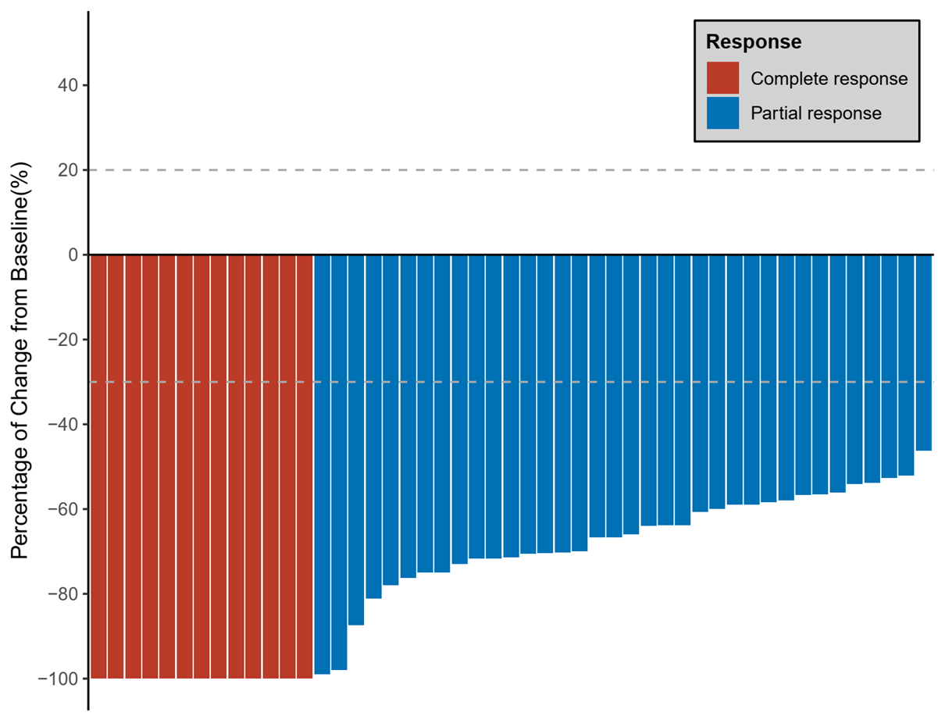

Supplemental Figure S2. Representative MRI comparison of pre- and after induction phase. Panel A (Right cavernous sinus invasion), B (Right oropharyngeal invasion), C (Right cavernous sinus, clivus, petrous apex, and area II-IV lymph node invasion) and D (Left cavernous sinus, retropharyngeal and area II-V lymph nodes invasion) denote nasopharyngeal and neck MRI before treatment. Panel E, F, G, and H denote complete response to induction therapy in the corresponding aforementioned sites, respectively.
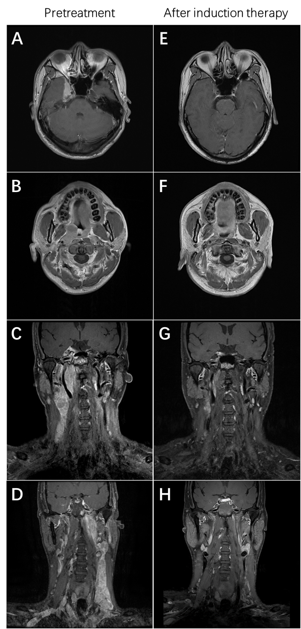
Supplemental Figure S3. Pathology of nasopharyngeal and lymph node tissues. Panel A and E denote hematoxylin-eosin staining of nasopharyngeal tissue and lymph node tissue before treatment. Panel B and F denote immunohistochemistry staining of cell keratins (CK, positive) in nasopharyngeal tissue and lymph node tissue before treatment, respectively. Panel C and G denote situ hybridization of Epstein-Barr encoding region (EBER, positive) in nasopharyngeal tissue and lymph node tissue before treatment, respectively. Panel D and H denote hematoxylin-eosin staining of nasopharyngeal tissue and lymph node tissue after induction therapy showing pathological complete response, respectively.

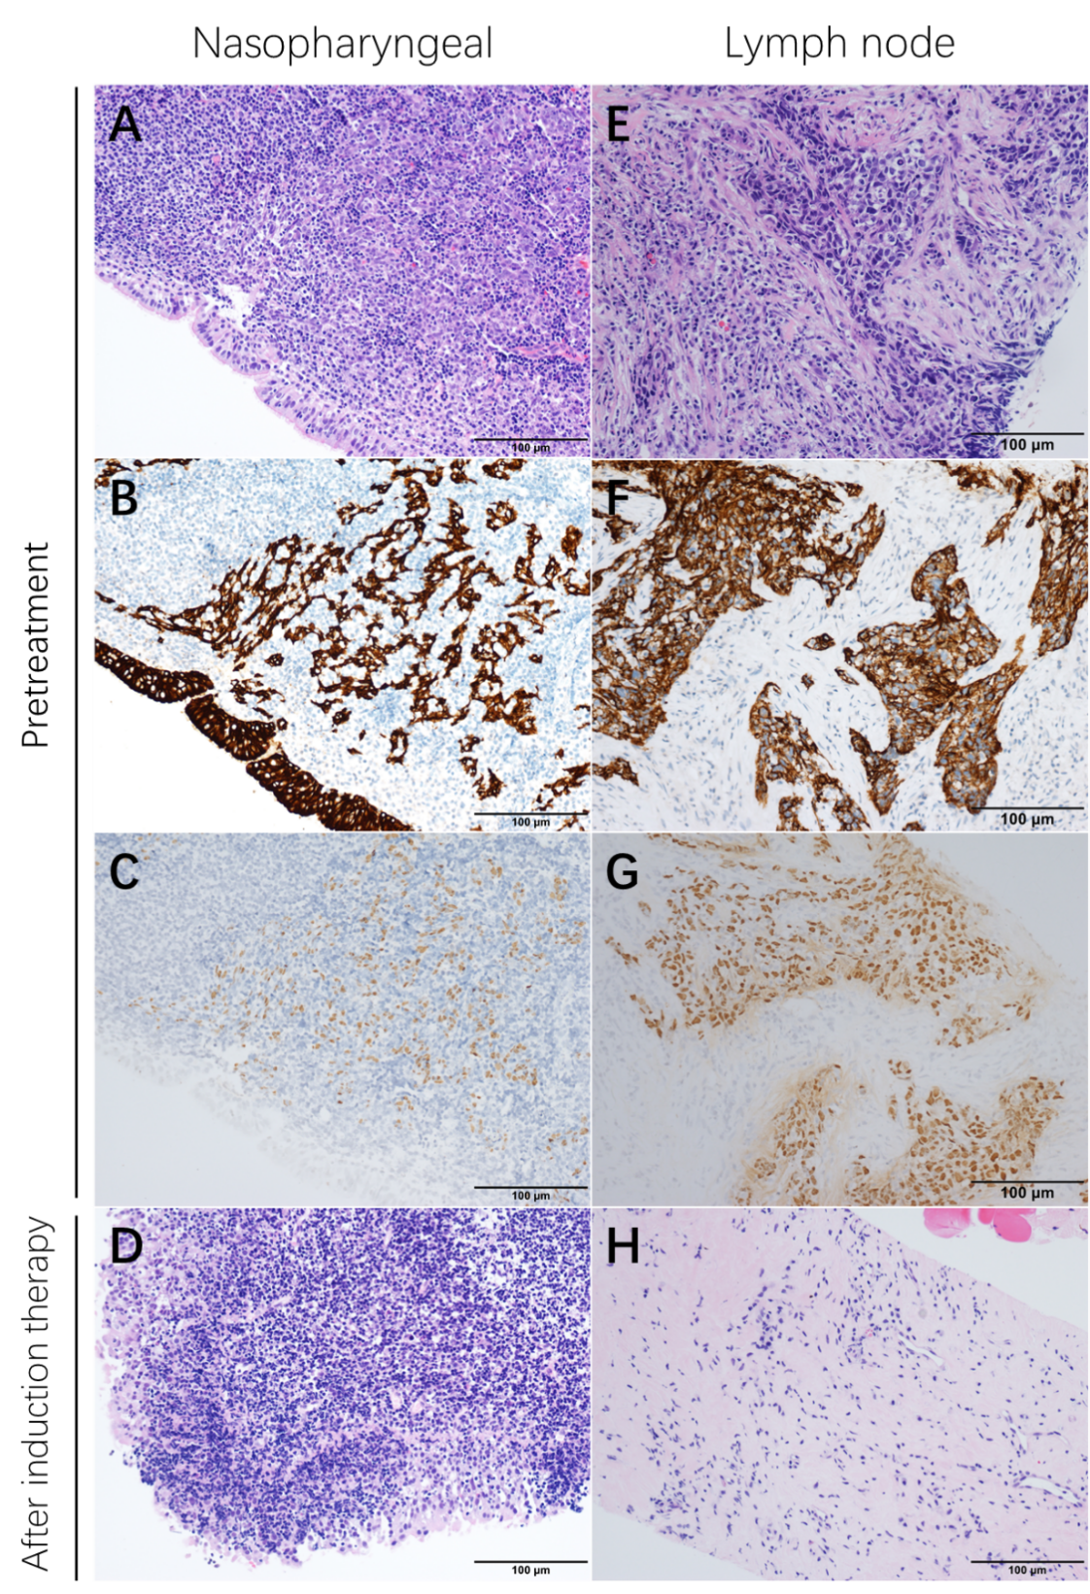
Supplemental Figure S4. Trajectories of plasma EBV DNA levels. The longitudinal monitoring trajectories of the change in plasma Epstein-Barr virus (EBV) DNA concentrations in the intention-to-treat population. Red and orange dotted line denote two patients had persistently detectable plasma EBV DNA, including one achieving regional partial response and another dead from subsequent liver and bone metastases, respectively.

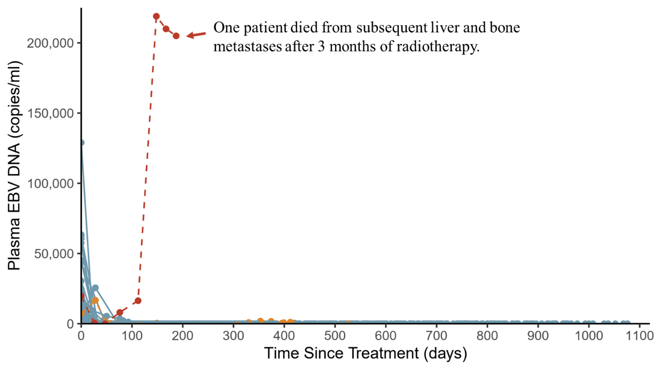

Supplemental Figure S5. Immune-related toxic epidermal necrolysis-like skin reaction. One 38-year-old male patient presented with rashes 2 weeks later after receiving the first dose induction therapy (Panel A), and gradually developed toxic epidermal necrolysis (TEN)-like skin reaction with erythematous macules and pigmentation within 1 week (Panel B). This patient was hospitalized and received methylprednisolone 1 mg/kg/day and intravenous immune globulin for 7 days (Panel C and D). The skin rashes subsided after 10 days of hospitalization (Panel E). Panel F denote this patient 3 months after the end dose of camrelizumab. Panel G and H denote the histology of skin revealing intraepidermal edema and basal liquefaction with lymphocytic infiltration in epithelium and superficial dermis, respectively.*Authors have obtained consent from the patient to publication of the images.

