Supplementary Materials
Automated Detection of Nine Infantile Fundus Diseases and Conditions in Retinal Images Using a Deep Learning System

Supplementary Tables
Supplementary Table 1. Brief descriptions of features in retinal images of diseases and conditions
ID | Diseases/conditions | Brief descriptions of retinal images
0 | Normal | The optic disc was red with clear borders, a C/D ratio of approximately 0.2, a normal foveal reflex in the macular region, a flat retina, and normal retinal vascular morphology.
1 | Coats | Visible distortion of retinal vessels, irregular cystic dilatation or beading, retinal punctate or patchy hemorrhages, and massive yellow-white fatty exudates in the deep and subretinal layers.
2 | Coloboma | Defects are visible in the retina, with clear boundaries and different shapes and sizes. Retinal blood vessels can be seen crawling in the defect area, and white sclera is exposed.
3 | RB | Clear borders, single or multiple lesions, white or yellow nodular bulges, uneven surface, and different sizes.
4 | RP | Mid-peripheral RPE atrophy with bone-spicule perivascular pigmentation, arteriorlar attenuation and waxy disc pallor.
5 | CRF | Raised retinal folds that start from the optic disc and often extend to the surrounding retina.
6 | ROP
6.1 | Mild ROP | ROP stage 1 and stage 2, the demarcation line is relatively flat and white, lies within the plane of the retina; the ridge may vary in height and its color may appear to range from white to pink.
6.2 | Moderate ROP | ROP stage 3, extraretinal neovascularization extends from the ridge to the vitreous and is continuous with the posterior ridge, or proliferates.
6.3 | Severe ROP | ROP stage 4 and stage 5, retinal detachment, include partial retinal detachment and total retinal detachment

Abbreviations: RB Retinoblastoma, RP retinitis pigmentosa, CRF congenital retinal fold, ROP retinopathy of prematurity.

Supplementary Table 2. Distribution of the amount of data for each class of pictures in the nine diseases and conditions.
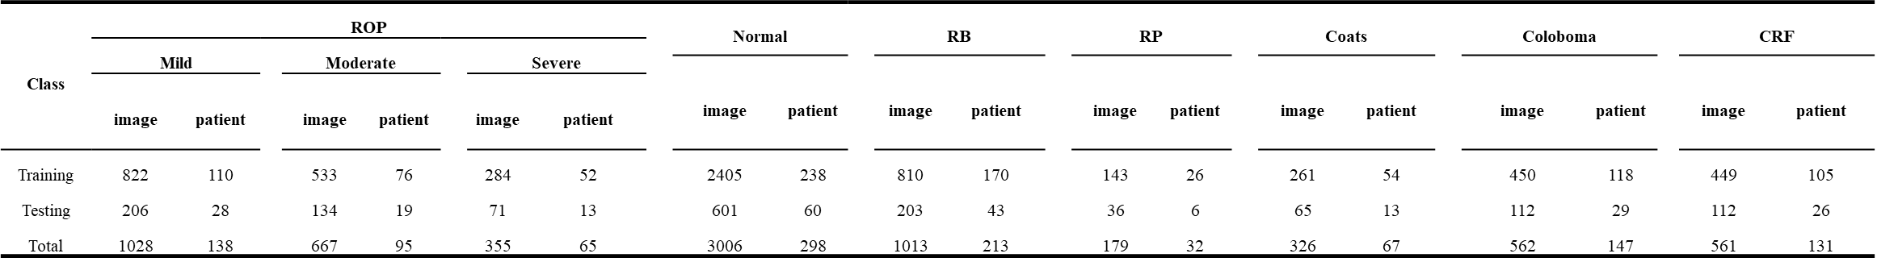
Abbreviations: ROP, retinopathy of prematurity; RB Retinoblastoma; RP, retinitis pigmentosa; CRF, congenital retinal folds.

Supplementary Table 3. The experiments of ROP staging are reported.
Methods | Accuracy | Precision | Recall | F1 | Kappa
ResNet-18 | 91.82(0.49) | 93.01(0.26) | 92.83(0.98) | 92.89(0.52) | 86.64(1.41)
ResNet-34 | 92.41(0.02) | 93.19(0.19) | 93.47(0.02) | 93.21(0.05) | 87.61(0.19)
ResNet-50 | 93.14(0.13) | 94.23(0.14) | 94.05(0.07) | 94.13(0.09) | 88.78(0.32)

Supplementary Figures
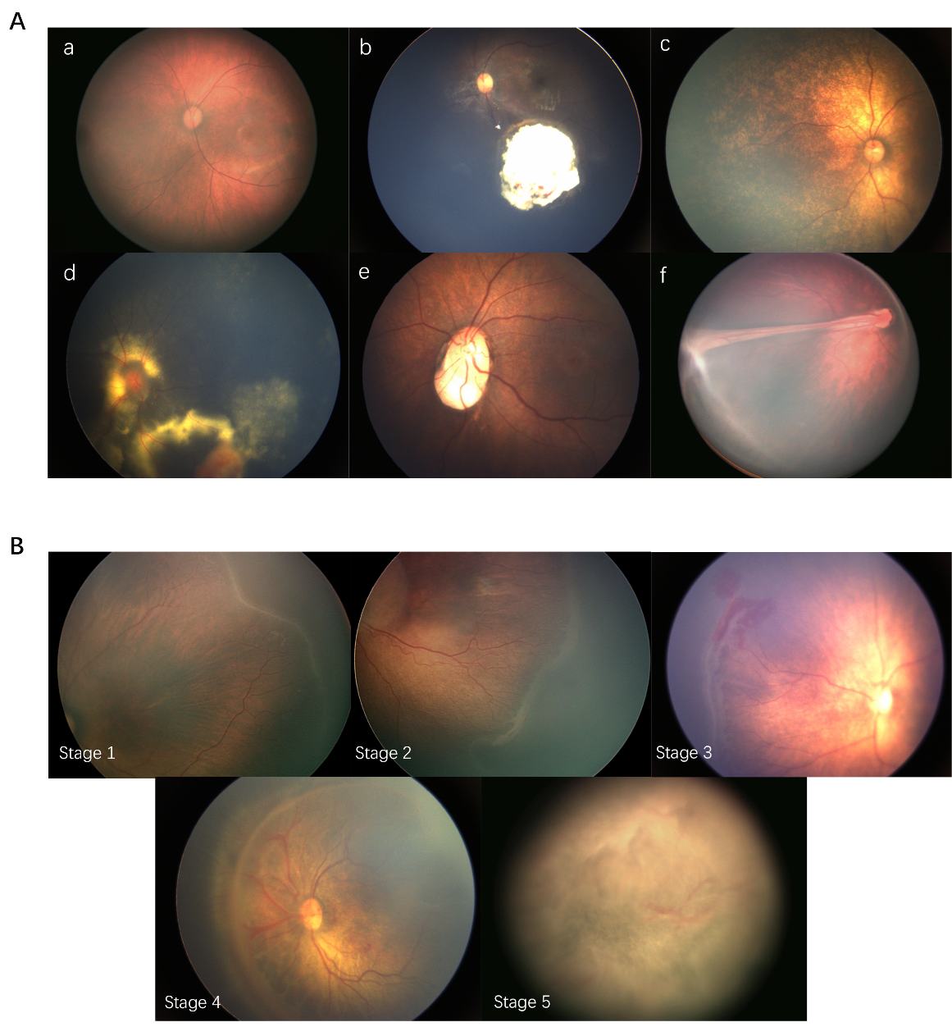
Supplementary Figure 1. Typical retinal images for each disease during examination. A, Typical retinal images for six main class except ROP. (a) Normal fundus image; (b) RB image; (c) RP image; (d) Coats image; (e) Congenital choroidal defect image; (f) Retinal fold stretch image. B, Standard ROP stage 1-5 retinal images in our examinations. Stage 1 with demarcation line; Stage 2 with the ridge; Stage 3 with extraretinal neovascular proliferation; Stage 4 with partial retinal detachment; Stage 5 with total retinal detachment.
Supplementary Figure 2. Sample selection of four hospital datasets. Images were collected from Shenzhen Eye Hospital (main datasets), Jieyang Woman Infant Health Care Hospital, Guilin Material and Child Health Hospital, and Guangdong Women's and Children's Hospital.

