Trust but verify: How to assess the reliability of paleomagnetic directions by using the R package PmagDirs
Edoardo Dallanave¹
¹Faculty of Geosciences, University of Bremen, Bremen, Germany (edoardo@uni-bremen.de)

Workflow example
Get started: download RStudio and the PmagDirs package from GitHub
RStudio Desktop requires the installation of R. Updated links to both are found at the URL:
https://posit.co/download/rstudio-desktop/
PmagDirs(0.1.0) is currently stored in GitHub. To pull it from the repository through the RStudio console, one easy way is to use the install_github command of the devtools package. To do so, type these commands in the RStudio console pressing return after each command.

> install.packages("devtools“)
> library(devtools)
> install_github(“edoardo-paleomag/PmagDirs”)
> library(PmagDirs)
> ?plot_Di

The last one should open a help page in the Help window of RStudio (Figure S1)
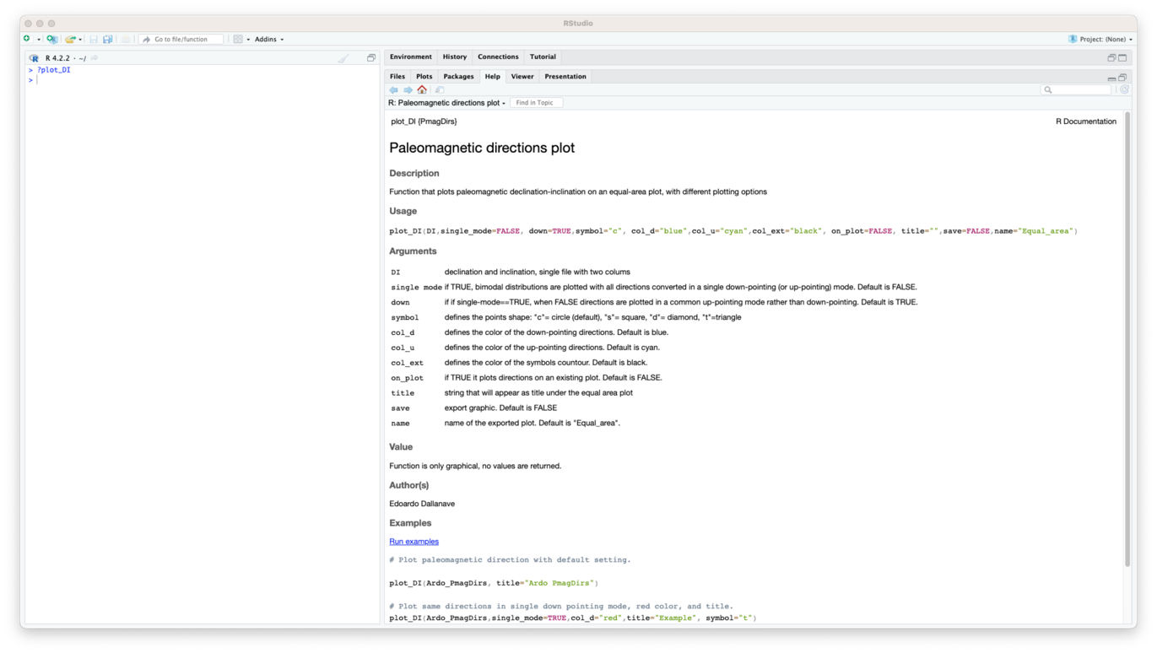
Figure S1. Help window of RStudio. All the functionalities of a specific script (in this case PmagDirs::plot_DI) are described.

By clicking on Run examples at the bottom of the help page, two equal area diagrams are displayed, both generated with the example datasets available within the package. The example data consist of paleomagnetic directions from the Italian Southern Alps¹ (a dataset of paleomagnetic directions from Northern New Caledonia² is also available). Information about the example dataset can be obtained as done for the single scripts, by typing:
> ?Ardo_PmagDirs

Setting the working directory and importing files
By using the Files window of RStudio, follow the path to the working directory of choice. Once in the directory, all files in the directory are listed. In order to have all automatically generated files and figures in this directory, it has to be set as working directory by selecting the option under the More menu (Figure S2).
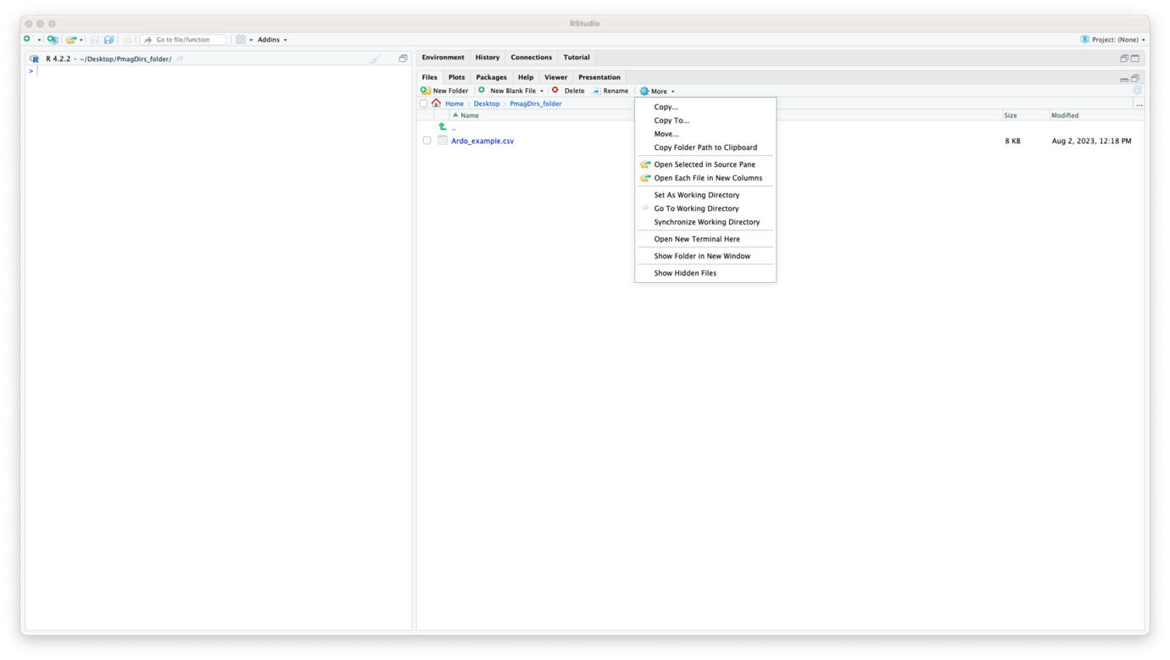
Figure S2. Set the working directory.

In the example of Figure S2, the directory contains a set of paleomagnetic directions (the same of Ardo_PmagDirs) that we wish to import in the RStudio Environment. An easy way to do so is to have them in comma separated value (.csv) format. The file can be imported (assigning a name, ardo in the example case) either from the command line by typing:

> ardo <– read.csv(“Ardo_example.csv”)

or by clicking on the file within the RStudio File window and following the instructions.

Plotting, filtering, and calculating average directions
Once the dataset is imported, we wish to visualize the data. This is done by typing:

> plot_DI(ardo)

This command will generate an equal area plot. All plotting options can be explored by typing ”?plot_DI”.
Fisher³ standard mean and confidence can be calculated and plotted on the same diagram (plotting on pre-existing diagram is default, see instructions by typing “?fisher_plot”) and result exported as ardo_ALL.csv file by typing the command:

> fisher_plot(ardo, export = T, name = "ardo_ALL")

This will generate the results shown in Figure S3 (files are saved in the working directory).
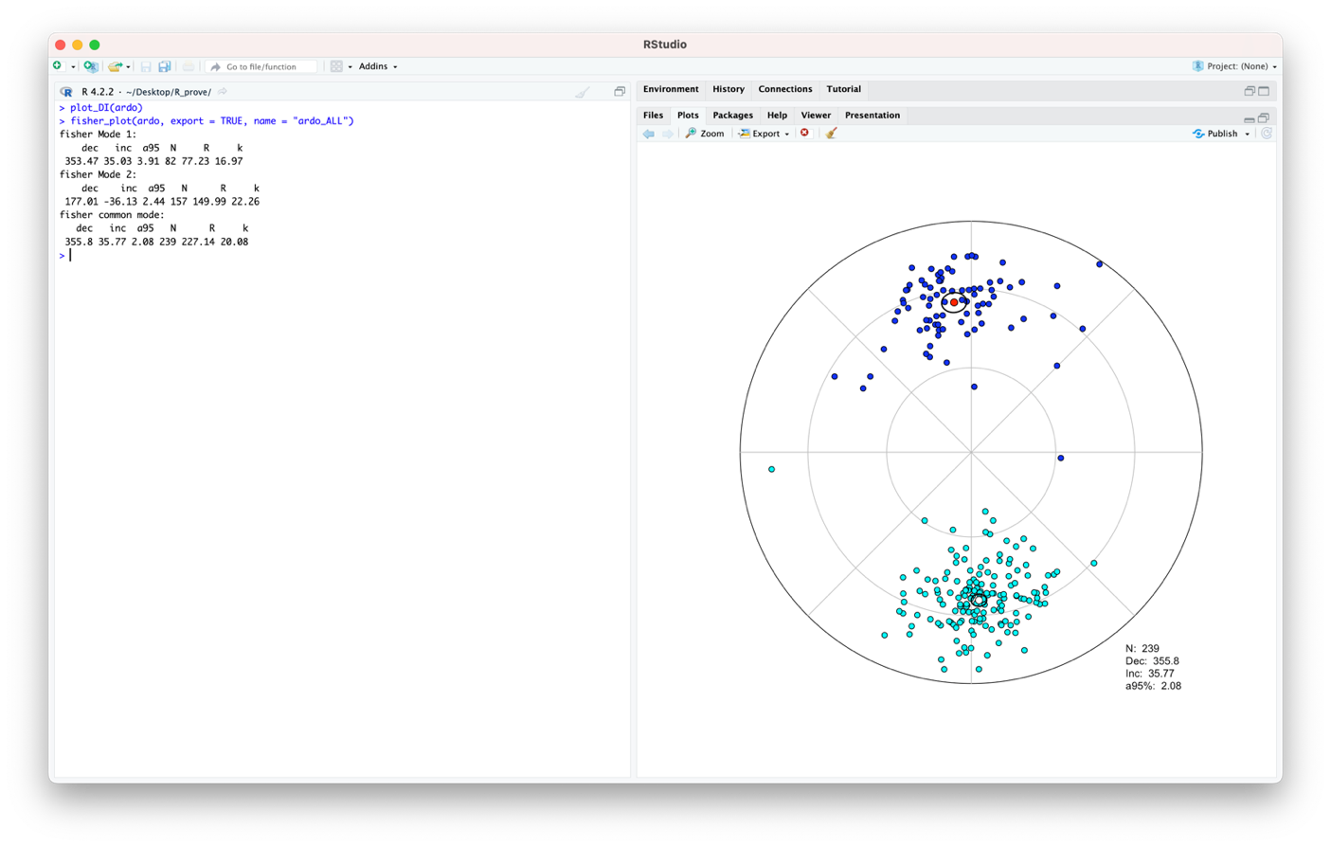
Figure S3. Direction data plotting and Fisher³ statistic calculation.

Some of the directions shown in Figure S3 are departing significantly from the two modes cluster. PmagDirs can apply a cut-off to exclude the potential outliers by using the PmagDirs::cut_DI function. Specifically, we wish to apply the cut-off proposed by Vandamme⁴ and store the filtered dataset in a new ardoVD file by typing the command:

> ardoVD <- cut_DI(ardo, lat = 46.04, long = 12.14)

where lat and long are latitude and longitude (respectively) of the Ardo section site¹ . Note that PmagDirs::cut_DI performs the Vandamme cut-off by default, and in order to apply a cut-off based on a fixed virtual geomagnetic pole (VGP) distance from the average paleomagnetic pole, the command “VD=F” (where F means FALSE) must be typed. The number of reiterations performed to filter the data is shown in the console. When applying this function, the new (ardoVD in the example case) file is not automatically exported in the working folder, unless specified in the cut_DI command line. This is done typing export = T (equivalent of export=TRUE). Text results that are present within the RStudio environment can be exported any time by using the command write.csv (type “?write.csv” for details).
The result of the cut-off can be evaluated visually by plotting both the original and the filtered dataset on the same equal area diagram. Different symbols and/or colors can be specified. For example, we can execute sequentially these commands:

> plot_DI(ardo, title = "Ardo cut-off")
> plot_DI(ardoVD, symbol = "s",col_d = "red",col_u = "pink",on_plot = T)

The firs command produced the equal area with the whole dataset, while the second command plots the filtered data on top of the first equal area (for this reason the title of the diagram, if required, must be typed within the first command). The second command will plot directions as squares, red when down-pointing and pink when up-pointing. Analogously to the plot generated in Figure S3, standard fisher statistic can be calculated, plotted, and exported into the working directory (Figure S4).

> fisher_plot(ardoVD,save = T,name = "Ardo_VD")

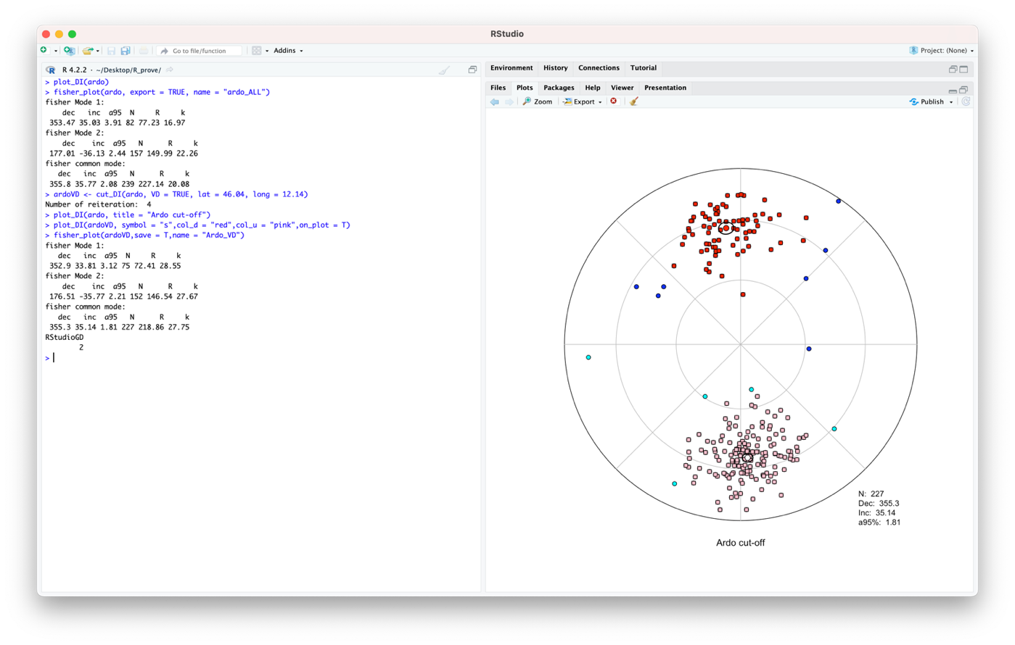
Figure S4. Results of the Vandamme (1994) cut-off application and calculation of the Fisher (1953) statistic of the filtered dataset.

We can now test the filtered dataset for antipodality. This can be performed by the function PmagDirs::revtest by typing:

> revtest(ardoVD,export = T, name = "Ardo_VD_revtest")

This will also automatically export the results and the figure in the working directory. When running the code, some packages will be automatically attached (potential conflicts warnings are deliberately left for users to check), then the calculation will be performed. The progressive number of bootstrapped datasets are also listed to monitor the process through (Figure S5).
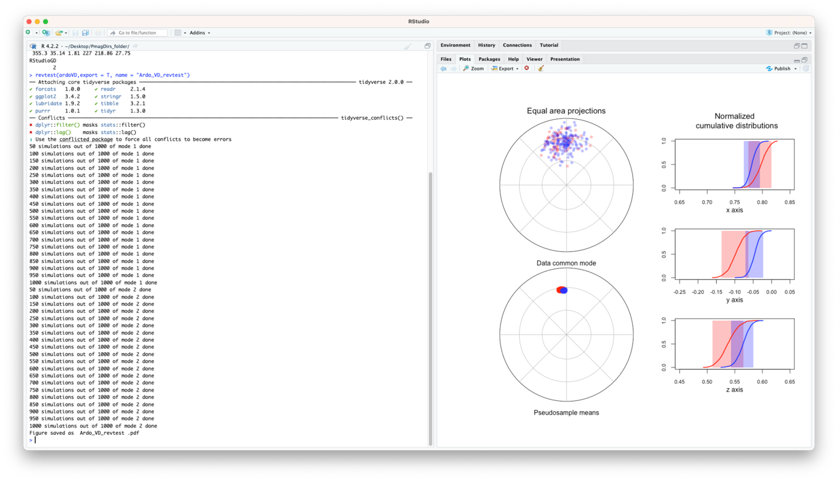
Figure S5. Results of the bootstrap-based reversal test (Tauxe et al., 1991). Overlapping cumulative distribution bands along the three axes indicate a positive reversal test.

Once the antipodality has been attested, the reliability of the distribution shape, in terms of measured elongation-inclination pair versus the expected one, can be attested with the PmagDirs::EI_boot function. The bootstrapping process is relatively fast, so a number of simulations higher than the 1000 set by default can be selected (e.g., nb=2000):

> EI_boot(ardoVD,nb = 2000)

This gives the results of Figure S6.
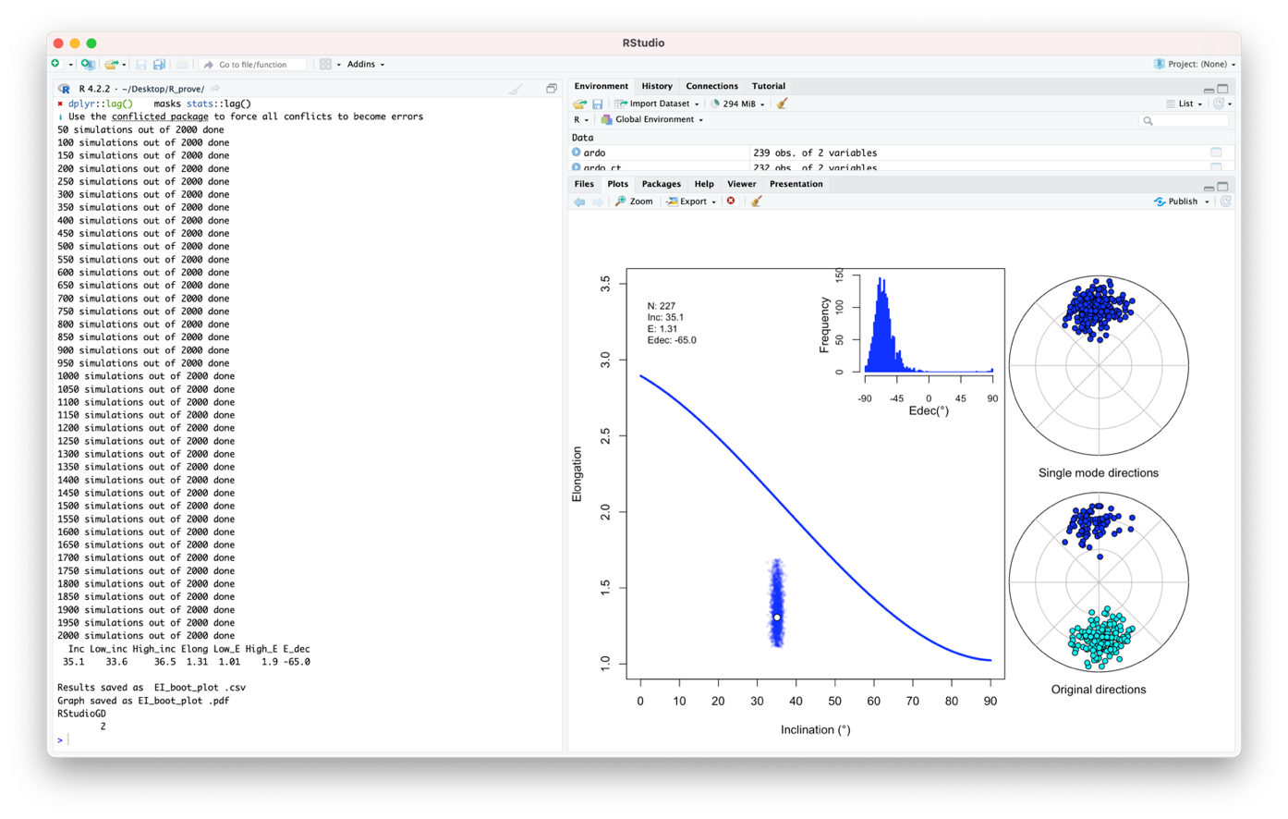
Figure S6. Elongation-inclination pair of the ardoVD dataset compared with the values expected by the TK03.GAD paleosecular variation model⁵ (blue thick line). The cloud of blue points within the main diagram (Elongation-Inclination) envelops the 95% confidence area, while the declination of elongation of the 2000 bootstrapped pseudosamples is shown as frequency function. Depending on the proportions of the different windows, equal areas and main diagram may overlap. Nonetheless, the exported figure proportions are optimized to avoid this problem.

Numerical data and confidence bounds are saved as .csv files, but from visual inspection of Figure S6 it results that the elongation of the distribution is significantly (and statistically) lower than the value expected from the TK03.GAD paleosecular variation model. Furthermore, the elongation declination (Edec) departs significantly from the expected 0°. These data indicate “flattened” paleomagnetic directions, very likely the results of sedimentary compaction associated with hematite as magnetic remanence carrier¹. The shallow bias inclination can be corrected by using the method proposed by Tauxe and Kent⁵, which has been successfully applied to many sedimentary paleomagnetic records (see references in main text). In synthesis, all directions are gradually flattened applying gradually decreasing values of flattening factor (f) within the formula tan (I_{o}) = f · tan (I_{o}), where I_{o} and I_{o} are respectively the observed and the original unflattened inclination. This can be performed by using the PmagDirs::ffind_boot function:

> ardo_unfl <– ffind_boot(ardoVD,name = "Ard_VD_unflattened", return=T)

that gives the results plotted in Figure S7.

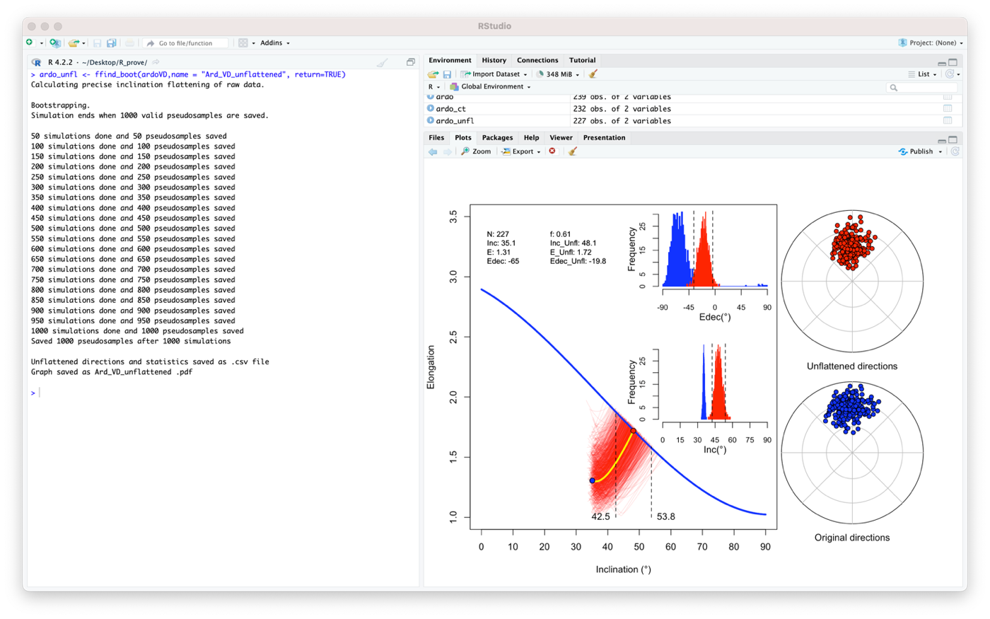
Figure S7. Results of the elongation-inclination-based test⁵ for inclination flattening correction on the ardoVD dataset. Main result (yellow line ending and red dot on the crossing point with the expected elongation curve) are shown together with the same process applied on 1000 bootstrapped pseudosamples (red lines) and the derived 95% confidence boundaries. The two histograms show the inclination and elongation of declination of the bootstrapped datasets as occurring frequency. The original and unflattened datasets are shown in the equal area diagrams to the right.

The command “return=T” allows to save the unflattened directions file directly in the RStudio environment, but the same file is also exported in the working directory, together with the figure and the detailed statistic results (unless specified otherwise when calling the function).

> plot_DI(ardo_unfl, symbol = "t", col_d = "brown",col_u = "yellow", title = "Ardo filtered and unflattened")
> fisher_plot(ardo_unfl, col_d = "dark green", col_u = “light green”, col_l = "red”, save = T, name = "Ardo_Unfl_fisher")

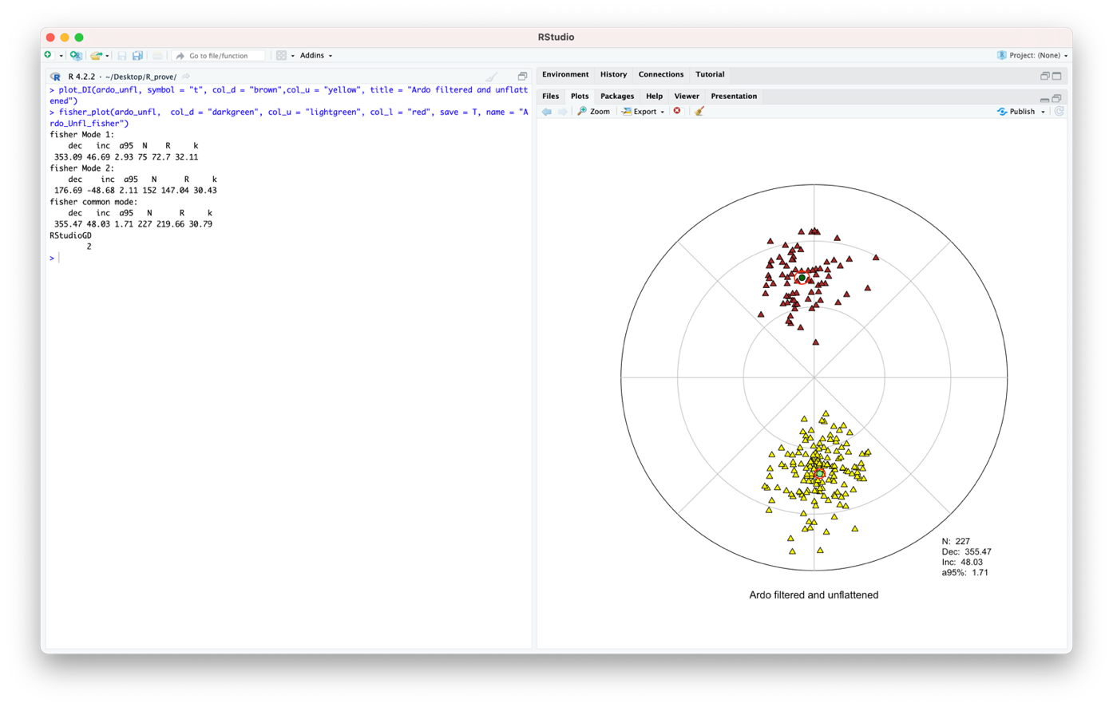
Figure S8. Application of Fisher³ statistic on the filtered and unflattened Ardo_PmagDirs set of paleomagnetic directions, followed by the calculation of the virtual geomagnetic poles (VGPs) position and average paleomagnetic pole.

If the results are satisfactory, the list of VGPs and the average paleomagnetic pole can be calculated. An example is:

> ardo_vgp <- VGP_DI(ardo_unfl, lat = 46.04,long = 12.14,type = "VGPsN",name = "Ardo_VGPs")

The function PmagDirs::VGP_DI automatically exports four csv text files within the working directory, which are called and described as follows:
- name_average_pole.csv: paleomagnetic pole with associated Fisher³ statistical parameters.
- name_bimodal.csv: virtual geomagnetic poles as resulted from calculation.
- name_rotated.csv: virtual geomagnetic poles rotated with the average pole coinciding with the spin axis (option for magnetic polarity reversals plotting).
- name_single_mode.csv: virtual geomagnetic poles in a single (northern hemisphere) mode.
The result file returned into the RStudio environment is defined by the command “type”, and in the current example is the single mode (VGPsN, which is also the default mode if type is not specified in the command line). The VGPs can be plotted onto a spherical orthographic (i.e., view from infinite point) projection by using the function PmagDirs::plot_VGP.

> plot_VGP(VGP = ardo_vgp, grid = 20, auto_cent = T, coast = T,A95 = T, name = "ardo_VGP")

The command “grid” allows to define the angular distance between the parallels and meridians. The longitude and latitude of the projection center can be defined within the command or set to automatically coincide with the paleomagnetic pole buy setting the auto centering command TRUE (auto_cent= T). The present-day coastlines can be added to the projection for clarity (coast= T), as well as the paleomagnetic pole calculation (A95= T) (Figure S9).

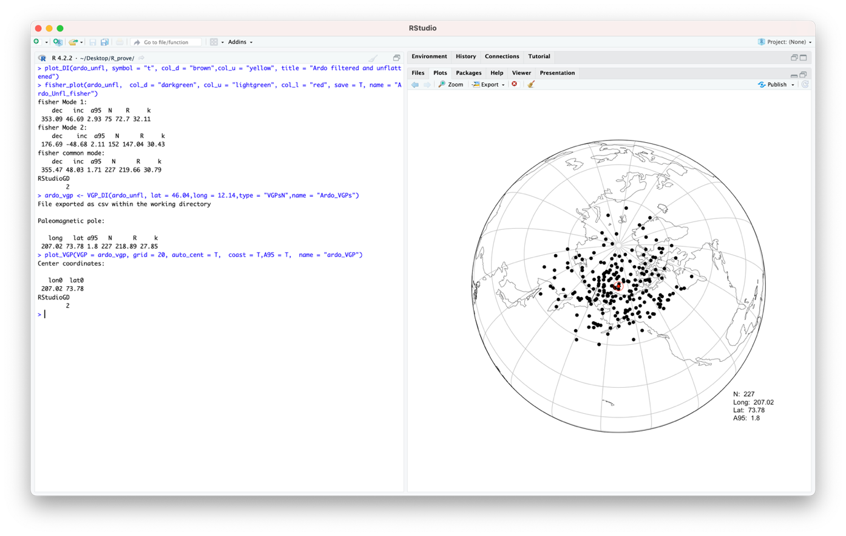
Figure S9. Spherical orthogonal projection of the virtual geomagnetic poles (VGPs) and their average direction as calculated by the function PmagDirs::VGP_DI and plotted with PmagDirs::plot_VGP.

The paleomagnetic pole can be plotted separately for comparison with the global synthetic apparent polar wander path (GAPWP⁶). The 95% confidence angle can be determined in two different ways: either by using standard Fisher³ or by calculating the average pole of a number (default is 1000) of bootstrapped pseudosamples⁷. In this case the angular distance of the bootstrapped poles with respect the real paleomagnetic pole is also plotted as a function of frequency. The command:

> VGP_boot(VGP = ardo_vgp,nb = 2000,auto_cent = T,grid = 20,coast = T,name = "VGP_boot")

returns the plot shown in Figure S10. By executing the command, once the bootstrapped process is concluded, both the PmagDirs::VGP_boot and the PmagDirs::VGP_A95 functions give the possibility to compare the result with the GAPWP⁶. This is executed by direct interaction within the console, as shown in Figure S10. In this specific case, the VGP data from the Ardo_PmagDirs record (filtered for outliers and corrected for inclination flattening) are compared with the 20 Ma to 100 Ma GAPWP plotted in South African coordinates. The paleomagnetic pole (Paleocene) is virtually coinciding with the GAPWP between 50 and 60 Ma, as expected (Figure S10). In the same Figure (S10) the paleomagnetic pole of the original (no cut-off and no inclination flattening correction) Ardo_PmagDirs set is calculated and compared with the data as determined through all steps described above.

> ardo_vgp_flawed <- VGP_DI(DI = ardo, lat = 46.04, long = 12.14, export = F)
> VGP_boot(VGP = ardo_vgp_unflawed, nb = 2000, lat = 73.78, long = 207.02, auto_cent = F, on_plot= T, color = "yellow")

The paleomagnetic pole is significantly departed from the reference GAPWP, despite the presence of reversals and positive antipodality test. This highlights the importance of an accurate evaluation of the paleomagnetic directions reliability.

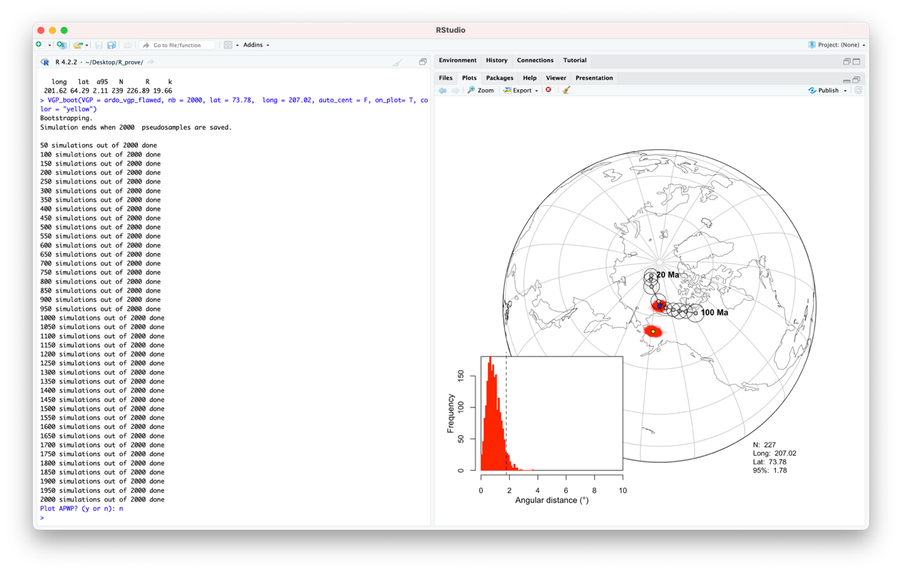
Figure S10. Paleomagnetic calculated from the Ardo_PmagDirs dataset after filtering the data for outliers and correcting for paleomagnetic inclination shallowing (blue dot) and by using the original data without any treatment (yellow dot), shown with the bootstrapped confidence angles. The histogram shows the confidence angle calculation of the unflawed (blue) pole, specified numerically in the bottom-right hand of the panel. Data are shown with the reference global synthetic apparent polar wander path (GAPWP) between 20 Ma and 100 Ma in South African coordinates⁶.

References
1. Dallanave, E., Agnini, C., Muttoni, G. & Rio, D. Paleocene magneto-biostratigraphy and climate-controlled rock magnetism from the Belluno Basin, Tethys Ocean, Italy. Palaeogeogr. Palaeoclimatol. Palaeoecol. 337–338, 130–142 (2012).
2. Dallanave, E. et al. Eocene (46-44 Ma) onset of Australia-Pacific plate motion in the southwest Pacific inferred from stratigraphy in New Caledonia and New Zealand. Geochem. Geophys. Geosystems 21, (2020).
3. Fisher, R. Dispersion on a sphere. Proc. R. Soc. Lond. A217, 295–305 (1953).
4. Vandamme, D. A new method to determine paleosecular variation. Phys. Earth Planet. Inter. 85, 131–142 (1994).
5. Tauxe, L. & Kent, D. V. A simplified statistical model for the geomagnetic field and the detection of shallow bias in paleomagnetic inclinations: Was the ancient magnetic field dipolar? in Timescales of the Paleomagnetic Field, Geophys. Monogr. (eds. Channell, J. E. T., Kent, D. V., Lowrie, W. & Meert, J. G.) vol. 145 101–115 (American Geophysical Union, 2004).
6. Torsvik, T. H. et al. Phanerozoic polar wander, palaeogeography and dynamics. Earth-Sci. Rev. 114, 325–368 (2012).
7. Tauxe, L., Kylstra, N. & Constable, C. Bootstrap statistics for paleomagnetic data. J. Geophys. Res. 96, 11723–117490 (1991).

