Two microbes assisting Miscanthus floridulus in remediating multi-metal(loid)s contaminated soil
Yunhua Xiao¹ , Jingjing Ma¹, Rui Chen¹, Sha Xiang¹, Bo Yang¹, Liang Chen¹, Jun Fang¹, Shuming Liu^{2,3*}
¹College of Bioscience and Biotechnology, Hunan Agricultural University, Changsha 410128, China
²School of Resources and Environment, Yili Normal University, Yining 835000, China
³Key Laboratory of Pollutant Chemistry and Environmental Treatment, Yili Normal University, Yining 835000, China.
*Corresponding Author: Shuming Liu (shumingl11@163.com)

Table S1 Speciation distributions of different metal(loid)s under the different treatments. (Unit: mg·kg⁻¹)
Metals | Acid-soluble fraction |  |  |  | Reducible fraction |  |  |  | Oxidizable fraction |  |  |  | Residual fraction
Metals | CK | MR | TS | MT | CK | MR | TS | MT | CK | MR | TS | MT | CK | MR | TS | MT
As | 0.73a | 0.56b | 0.44bc | 0.36c | 1.38a | 1.20ab | 0.98b | 0.67c | 1.80a | 0.75c | 1.41b | 1.49b | 26.06a | 21.41b | 22.28b | 23.28ab
Cd | 0.80a | 0.71ab | 0.61b | 0.67b | 1.99a | 1.81a | 2.08a | 1.78a | 0.85a | 0.61b | 0.70ab | 0.73ab | 1.43a | 1.17b | 1.22b | 1.49a
Cu | 0.32a | 0.28ab | 0.26b | 0.34a | 14.02a | 13.20a | 13.91a | 13.07a | 3.21a | 2.92a | 2.88a | 3.10a | 61.06a | 63.02a | 69.09a | 63.43a
Pb | 64.89a | 55.56b | 63.56ab | 57.99ab | 2338.84a | 2239.22a | 2068.53a | 2186.54a | 248.32a | 215.97b | 191.4c | 216.42b | 264.38a | 257.91a | 244.03a | 264.24a
Zn | 25.42a | 23.38ab | 21.57b | 20.23b | 63.57a | 59.30ab | 53.01b | 53.65b | 76.97a | 68.73b | 73.81ab | 61.25c | 797.1a | 667.21ab | 703.17ab | 608.72b

Table S2 Dissimilarities tests in bacterial communities' structure among different groups
Treatments |  | CK |  | MR |  | TS
Treatments |  | Delta/R²/R | p | Delta/R²/R | p | Delta/R²/R | p
MR | MRPP | 0.286 | 0.003
MR | ANOSIM | 0.569 | 0.003
MR | ADONIS | 0.216 | 0.001
TS | MRPP | 0.271 | 0.004 | 0.302 | 0.005
TS | ANOSIM | 0.963 | 0.001 | 0.669 | 0.003
TS | ADONIS | 0.387 | 0.001 | 0.243 | 0.004
MT | MRPP | 0.287 | 0.004 | 0.318 | 0.017 | 0.303 | 0.005
MT | ANOSIM | 0.843 | 0.002 | 0.520 | 0.014 | 0.633 | 0.002
MT | ADONIS | 0.378 | 0.001 | 0.227 | 0.008 | 0.230 | 0.001

Table S3 The relative abundances at family in the four groups
Family | CK | MR | TS | MT
0319_6A21 | 2.465a | 1.888b | 2.021b | 1.710b
Bacillaceae | 0.094a | 0.029b | 0.092a | 0.078a
Bdellovibrionaceae | 0.004b | 0.004b | 0.045a | 0.022b
Bradyrhizobiaceae | 1.226a | 1.079a | 0.779b | 0.846b
Chthoniobacteraceae | 0.327a | 0.242ab | 0.131c | 0.207b
Comamonadaceae | 1.453b | 1.668b | 2.960a | 1.847b
Cytophagaceae | 0.100b | 0.252a | 0.421a | 0.296a
EB1017 | 1.087a | 0.840ab | 0.665b | 0.700b
Ellin517 | 0.015c | 0.067ab | 0.110a | 0.034b
Enterobacteriaceae | 0.968c | 3.957b | 12.281a | 16.881a
Erythrobacteraceae | 0.029b | 0.142a | 0.045ab | 0.022b
Gaiellaceae | 6.424a | 5.203ab | 3.883c | 4.476bc
Haliangiaceae | 0.264ab | 0.199b | 0.403a | 0.238ab
Hyphomicrobiaceae | 5.745a | 4.780a | 3.437b | 3.620b
Koribacteraceae | 0.472a | 0.348b | 0.294b | 0.309b
Kouleothrixaceae | 0.432a | 0.262b | 0.166b | 0.256b
Methylophilaceae | 0.386ab | 0.255b | 0.939a | 0.165b
Micromonosporaceae | 6.202a | 5.239ab | 4.490b | 4.337b
Mycobacteriaceae | 0.436a | 0.331b | 0.217c | 0.213c
Nocardioidaceae | 5.567a | 4.919ab | 4.137b | 4.128b
OPB35 | 0.007b | 0.012b | 0.053a | 0.005b
Polyangiaceae | 0.037a | 0.004b | 0.046a | 0.041a
PRR_10 | 0.087a | 0.022b | 0.005b | 0.065a
Pseudomonadaceae | 0.126b | 0.229a | 1.413a | 1.004a
Rhizobiaceae | 0.201b | 0.506a | 0.340a | 0.428a
Rhodobacteraceae | 0.011b | 0.134a | 0.009b | 0.035a
Rhodocyclaceae | 0.000c | 0.019b | 0.026b | 0.103a
Rikenellaceae | 0.007bc | 0.059a | 0.010b | 0.000c
Ruminococcaceae | 0.021ab | 0.076a | 0.023b | 0.014b
Solibacteraceae | 0.404a | 0.318b | 0.335b | 0.235c
Streptomycetaceae | 0.680a | 0.557ab | 0.439b | 0.674a
Syntrophobacteraceae | 2.169a | 1.846b | 1.647bc | 1.483c

Table S4 The relative abundances at genus in the four groups
Genus | CK | MR | TS | MT
Actinophytocola | 0.207a | 0.053a | 0.048a | 0.000b
Alcaligenes | 0.010bc | 0.025ab | 0.000c | 0.023a
Anaeromyxobacter | 0.031a | 0.026a | 0.021a | 0.000b
Arenimonas | 0.009b | 0.039a | 0.024ab | 0.029a
Bacillus | 0.086a | 0.029b | 0.082a | 0.073a
Bdellovibrio | 0.004b | 0.004b | 0.045a | 0.022b
Bradyrhizobium | 1.048a | 0.854b | 0.690b | 0.718b
Candidatus_Solibacter | 0.379a | 0.290b | 0.317ab | 0.224c
Cupriavidus | 0.185b | 0.104c | 0.359a | 0.156bc
DA101 | 0.319a | 0.237ab | 0.128c | 0.207b
Devosia | 0.065b | 0.245a | 0.107ab | 0.149a
Dokdonella | 0.007ab | 0.186a | 0.001b | 0.033a
Enterobacter | 0.239b | 0.281b | 5.063a | 1.633a
Janthinobacterium | 0.024b | 0.023b | 0.114a | 0.037ab
Limnobacter | 0.091b | 0.084b | 0.797a | 0.163b
Massilia | 1.001a | 0.662b | 0.662b | 0.449c
Methylibium | 0.177b | 0.157b | 0.307a | 0.113b
Microbacterium | 0.093a | 0.109a | 0.058b | 0.089a
Microlunatus | 0.134a | 0.132a | 0.057b | 0.073ab
Mycobacterium | 0.436a | 0.331b | 0.217c | 0.213c
Nitrospira | 0.383a | 0.339ab | 0.292b | 0.277b
Nocardioides | 0.541a | 0.510a | 0.355b | 0.396ab
Parasegitibacter | 0.011b | 0.302a | 0.054a | 0.089a
Pedomicrobium | 0.792a | 0.638ab | 0.535b | 0.505b
Pilimelia | 0.833a | 0.443b | 0.451b | 0.387b
Pseudomonas | 0.126b | 0.229a | 1.410a | 1.004a
Ramlibacter | 0.584b | 0.723ab | 0.869a | 0.650b
Rhodobacter | 0.011b | 0.100a | 0.009b | 0.014b
Rhodoplanes | 3.788a | 2.949b | 2.118c | 2.216c
Rubrivivax | 0.045a | 0.062a | 0.009b | 0.048a
Serratia | 0.593c | 3.231b | 6.193ab | 14.364a
Sphingomonas | 0.135b | 0.281a | 0.387a | 0.218ab
Thauera | 0.000c | 0.019b | 0.021b | 0.103a
Variovorax | 0.016b | 0.017b | 0.107a | 0.047ab

Table S5 Major topological properties of empirical MENs microbial communities in the four groups
Network Indexes | CK | MR | TS | MT
Total nodes | 475 | 392 | 365 | 340
Total links | 846 | 765 | 556 | 653
Positive links (Proportion) | 444 (52.48%) | 418 (54.64%) | 379 (68.15%) | 411 (62.95%)
Negative links (Proportion) | 402 (47.52%) | 347 (45.36%) | 177 (31.85%) | 242 (37.05%)
R square of power-law | 0.764 | 0.799 | 0.722 | 0.788
Module | 36 | 46 | 42 | 38
Modularity | 0.834 | 0.753 | 0.888 | 0.753
Average degree (avgK) | 3.562 | 3.903 | 3.047 | 3.841
Average clustering coefficient (avgCC) | 0.338 | 0.36 | 0.298 | 0.276
Average path distance (GD) | 9.682 | 8.727 | 13.21 | 7.441
Geodesic efficiency (E) | 0.136 | 0.166 | 0.122 | 0.187
Harmonic geodesic distance (HD) | 7.34 | 6.028 | 8.204 | 5.36
Maximal degree | 15 | 18 | 10 | 13
Nodes with max degree | OTU_258 | OTU_223 | OTU_14 | OTU_4; OTU_118
Nodes with max betweenness | OTU_99 | OTU_61 | OTU_383 | OTU_420
Nodes with max stress centrality | OTU_9 | OTU_61 | OTU_383 | OTU_420
Centralization of stress centrality (CS) | 0.87 | 3.434 | 9.835 | 2.933
Maximal eigenvector centrality | 0.351 | 0.274 | 0.373 | 0.315
Nodes with max eigenvector centrality | OTU_258 | OTU_11 | OTU_14 | OTU_4
Centralization of eigenvector centrality (CE) | 0.341 | 0.258 | 0.362 | 0.298
Density (D) | 0.008 | 0.01 | 0.008 | 0.011
Connectedness (Con) | 0.738 | 0.595 | 0.537 | 0.617

Table S6 The relative abundance of key functional enzyme in different microbial communities.
Predictive functional enzyme | CK | MR | MT | TS
Glutathione peroxidase | 9.1981E-04 b | 9.8753E-04 ab | 1.0346E-03 a | 1.0567E-03 a
Superoxide dismutase | 1.7733E-03 b | 1.8073E-03 ab | 1.8664E-03 ab | 1.8711E-03 a
Superoxide reductase | 5.4450E-06 a | 7.6667E-06 a | 7.4217E-06 a | 1.0033E-05 a
Chlorophyll synthase | 1.6033E-05 a | 1.5732E-05 ab | 1.1517E-05 ab | 9.5917E-06 b
Glutathione synthase | 4.2750E-04 b | 4.9341E-04 ab | 5.6143E-04 a | 5.4305E-04 a
Table S7 The relative abundance of key functional genes about metal(loid)s transport in different microbial communities.
Genes for proteins/enzyzmes | Functional | CK | MR | MT | TS
ABC.ZM.A | Zn/Mn transport | 1.1066E-04 c | 1.1752E-04 bc | 1.6271E-04 a | 1.4399E-04 ab
corA | Mg transporter | 8.2259E-04 a | 7.9849E-04 a | 7.2943E-04 b | 7.2552E-04 b
corC | Mg/Co transporter | 1.2502E-04 c | 1.5118E-04 bc | 2.0285E-04 a | 1.8876E-04 ab
zntB | Zn transporter | 3.6886E-04 b | 3.8410E-04 b | 4.1701E-04 a | 4.1669E-04 a
zipB | Zn/Cd transporter | 5.6950E-05 a | 8.4891E-05 ab | 1.3937E-04 b | 1.3105E-04 a
ycnJ | Cu transport protein | 6.9217E-05 a | 6.5633E-05 b | 4.7383E-05 b | 6.8617E-05 b
mtsB | Fe/Zn/Mn/Cu transport | 1.3195E-04 a | 1.0785E-04 a | 8.6927E-05 a | 8.9305E-05 a

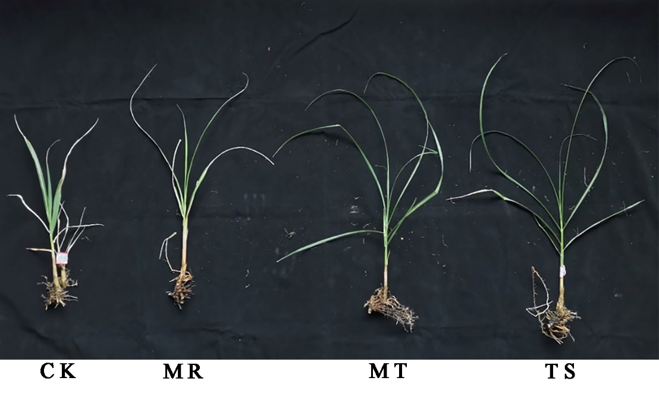
Figure S1 The harvested M. floridulus (Lab.) after nine weeks

Figure S2 Speciation distributions of different metal(loid)s under the different treatments. (a) As; (b) Cd; (c) Cu; (d) Pb; (e) Zn

Figure S3 Spearman correlations of phyla, soil and plant parameters

Figure S4 Spearman correlations of genera, soil and plant parameters
Figure S5 Spearman correlations of typical OTUs, soil and plant parameters

Figure S6 Spearman correlations of the key microbial genera, the plant growth and metal uptake of M. floridulus (Lab.)

Figure S7 Spearman correlations of the key microbial OTUs, the plant growth and metal uptake of M. floridulus (Lab.)

