Supplementary Material 4
Funnel plots.

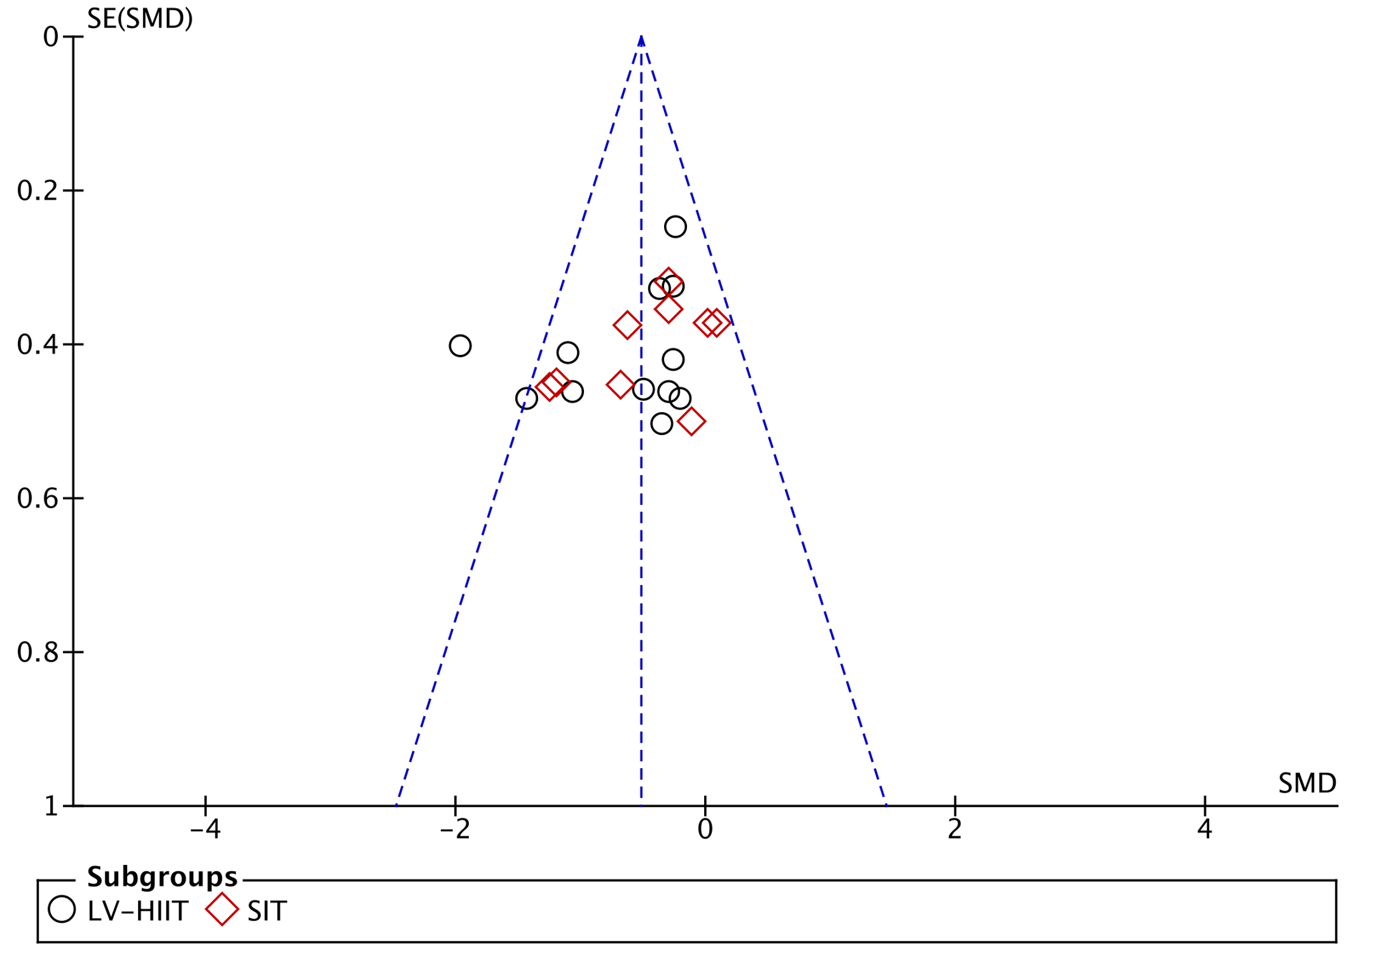
(Low-volume interval training versus CON for a whole-body fat mass)

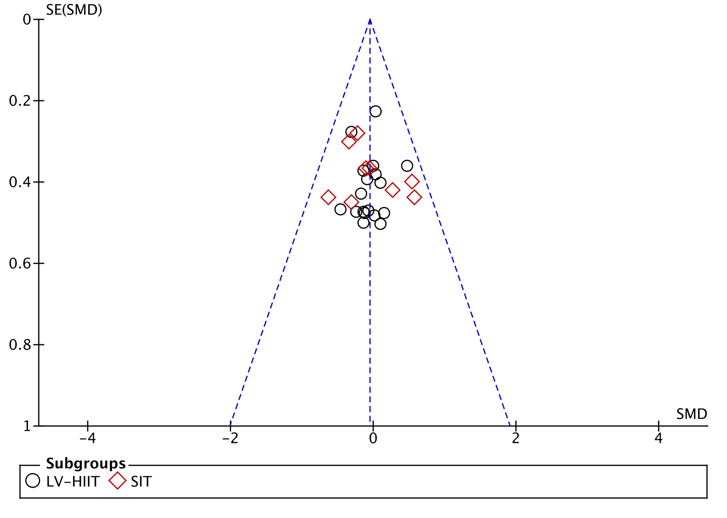
(Low-volume interval training versus MICT for a whole-body fat mass)

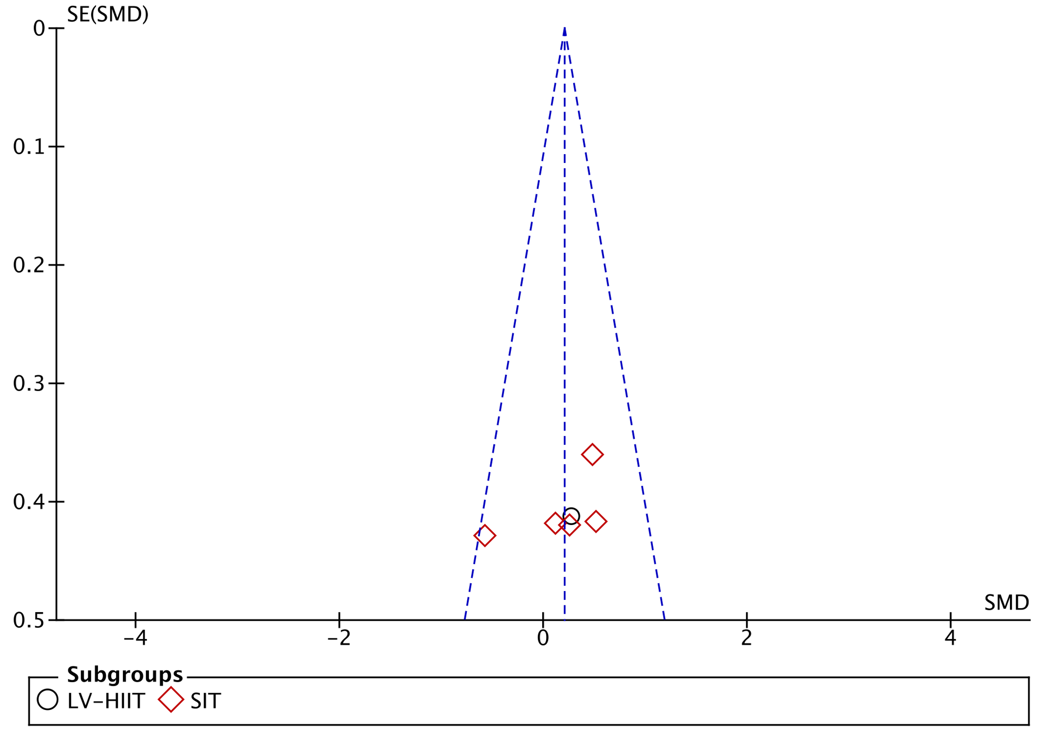
(Low-volume interval training versus HV-HIIT for a whole-body fat)

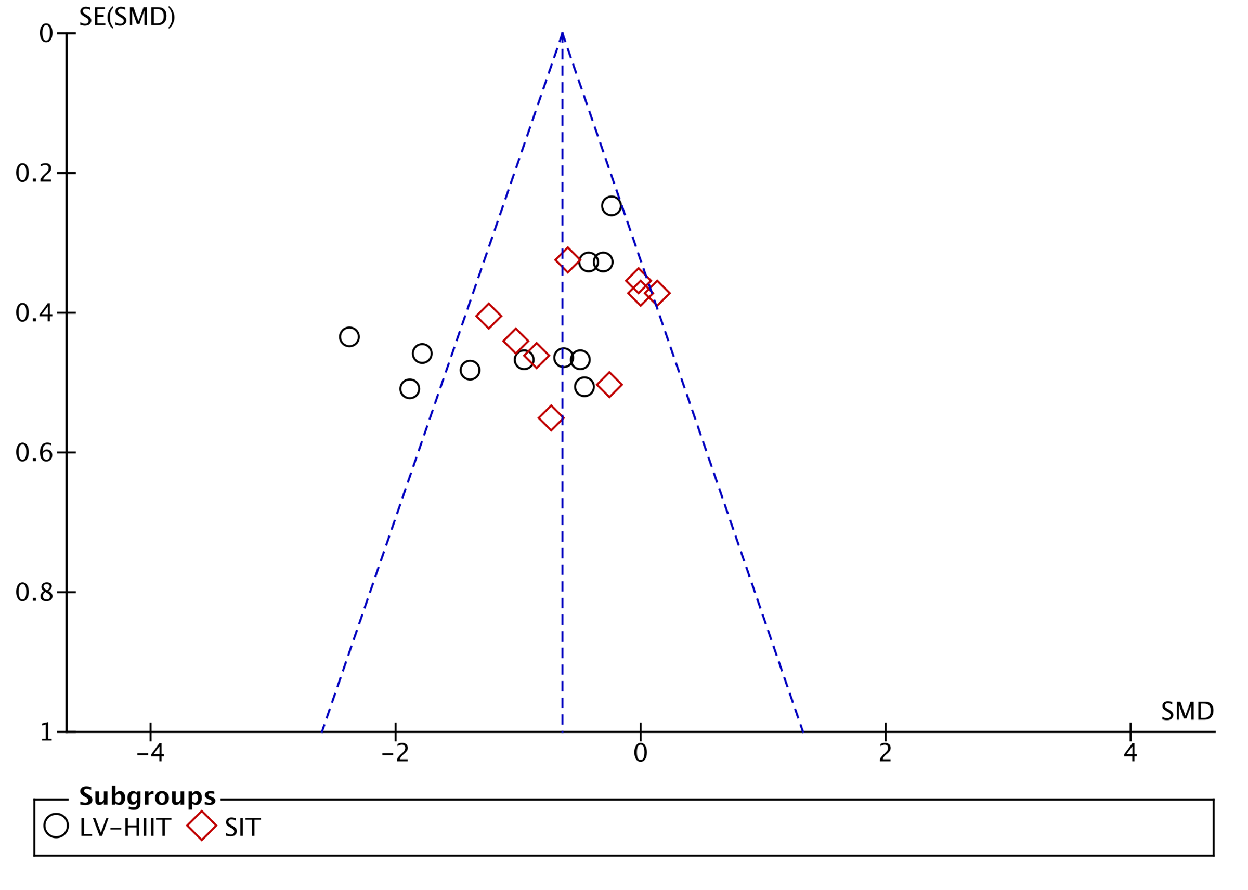
(Low-volume interval training versus CON for a body fat percentage)

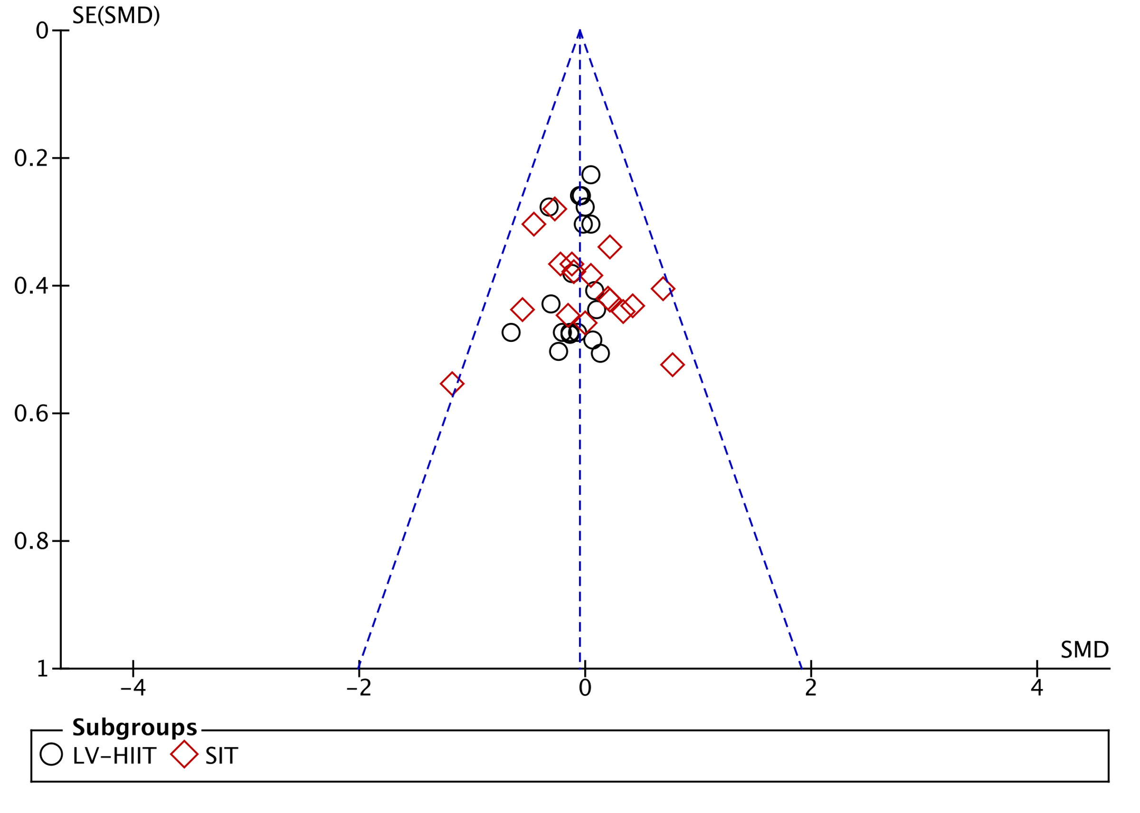
(Low-volume interval training versus MICT for a body fat percentage)

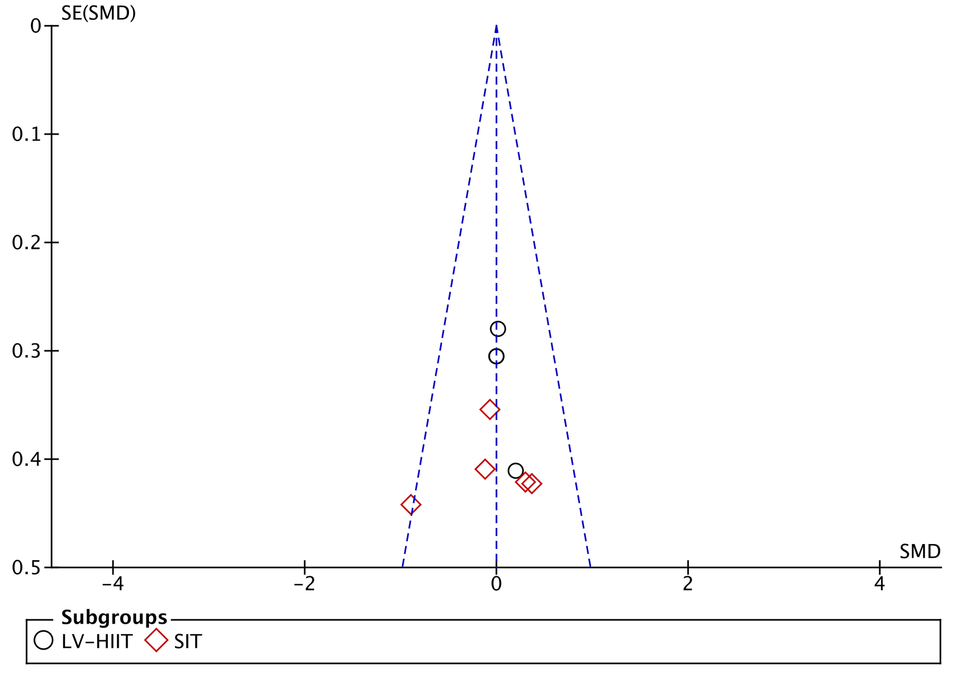
(Low-volume interval training versus HV-HIIT for a body fat percentage)

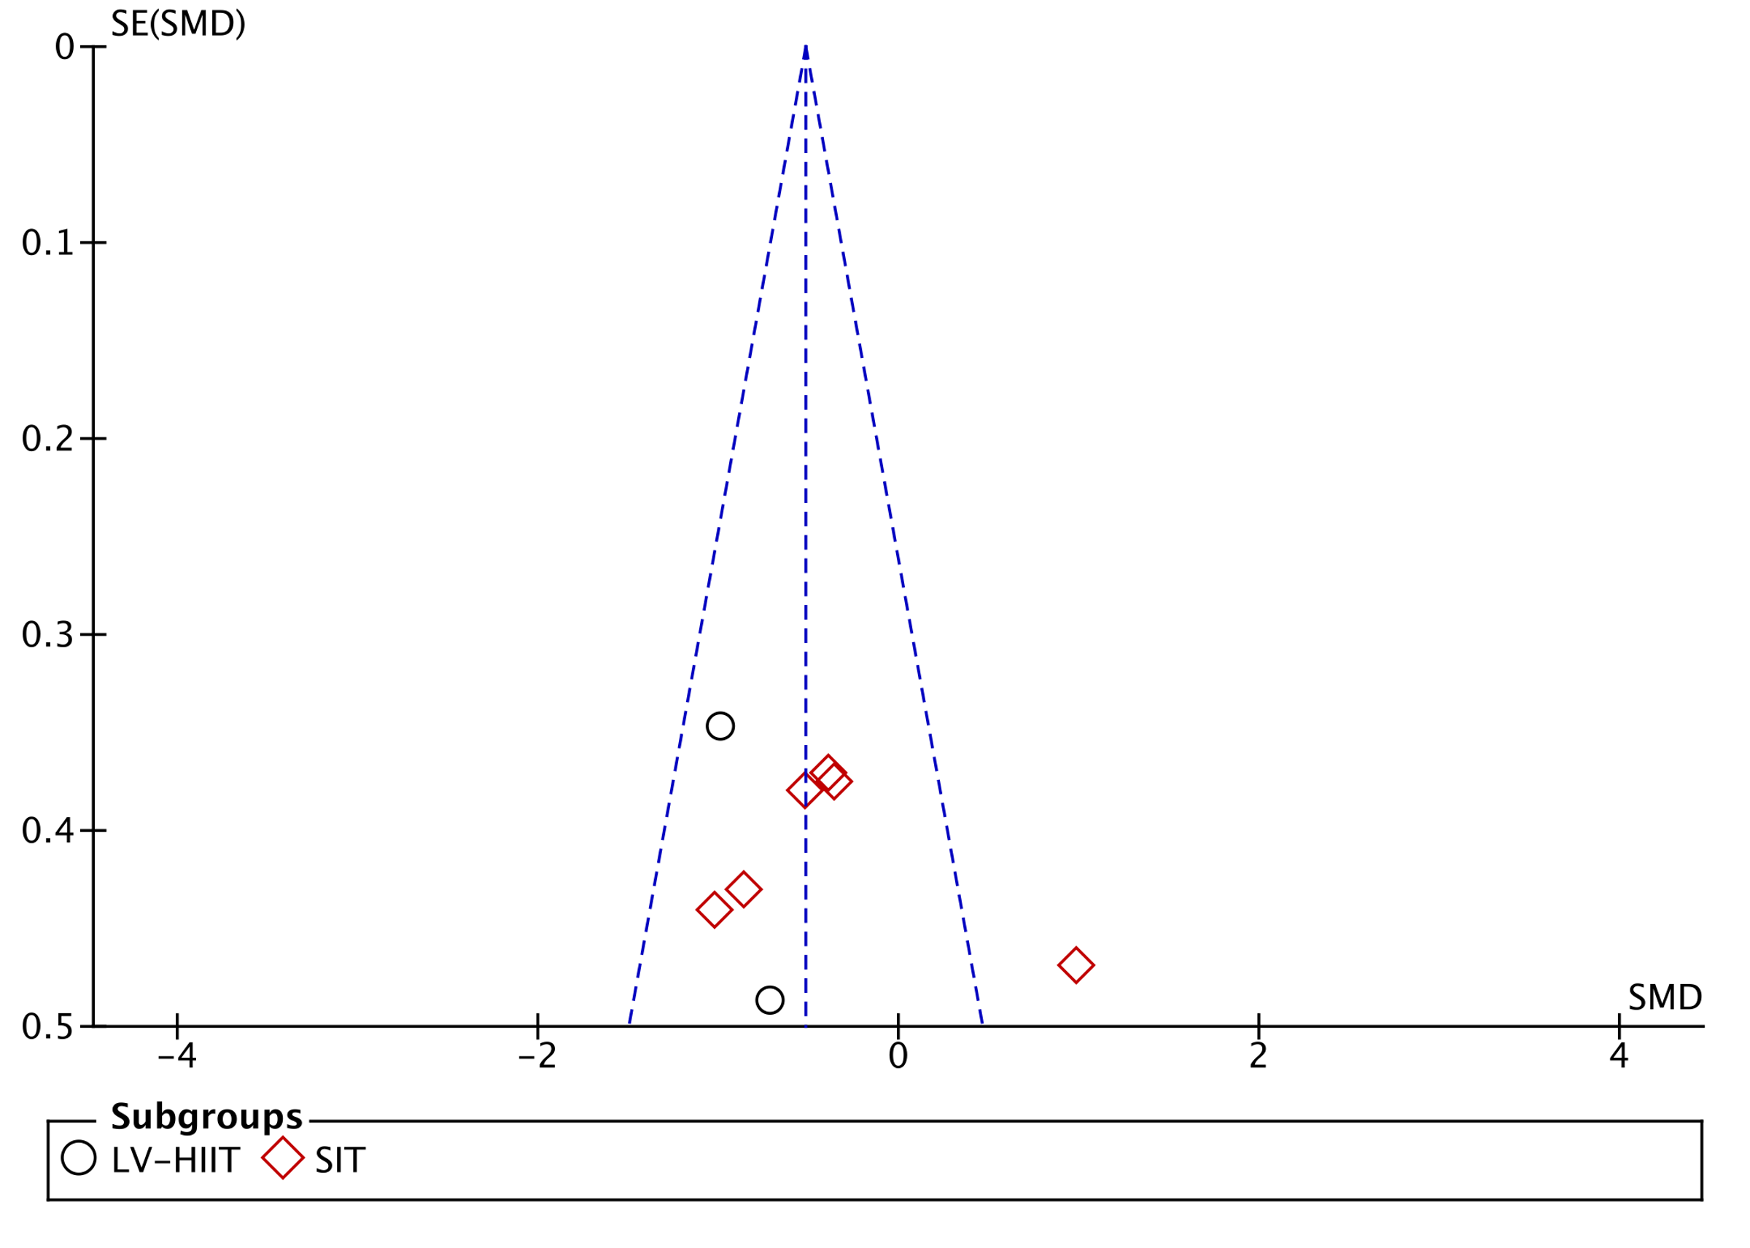
(Low-volume interval training versus CON for abdominal fat)

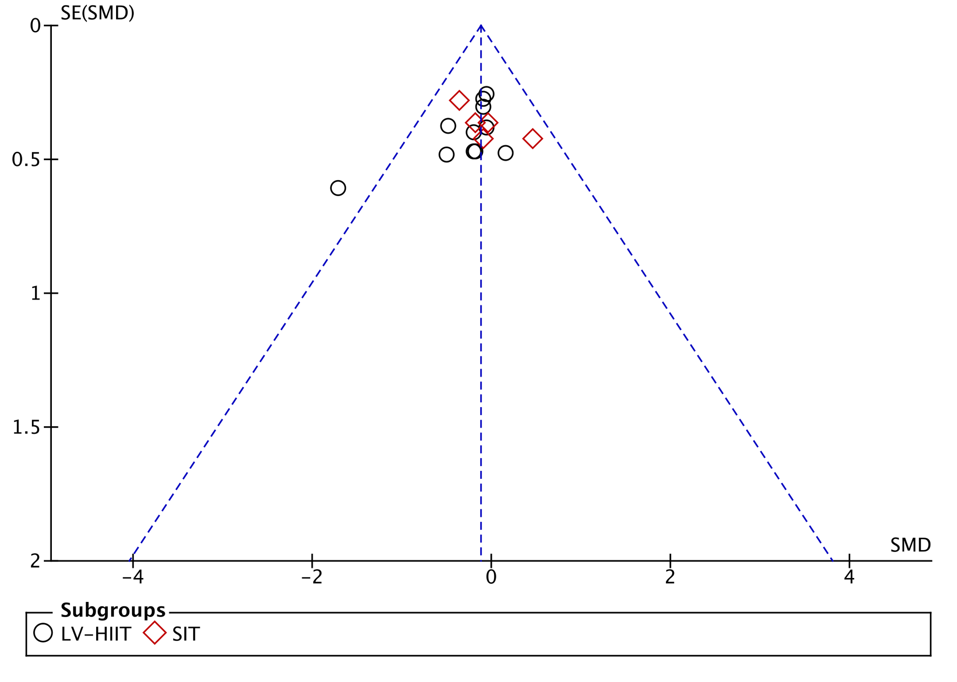
(Low-volume interval training versus MICT for abdominal fat)

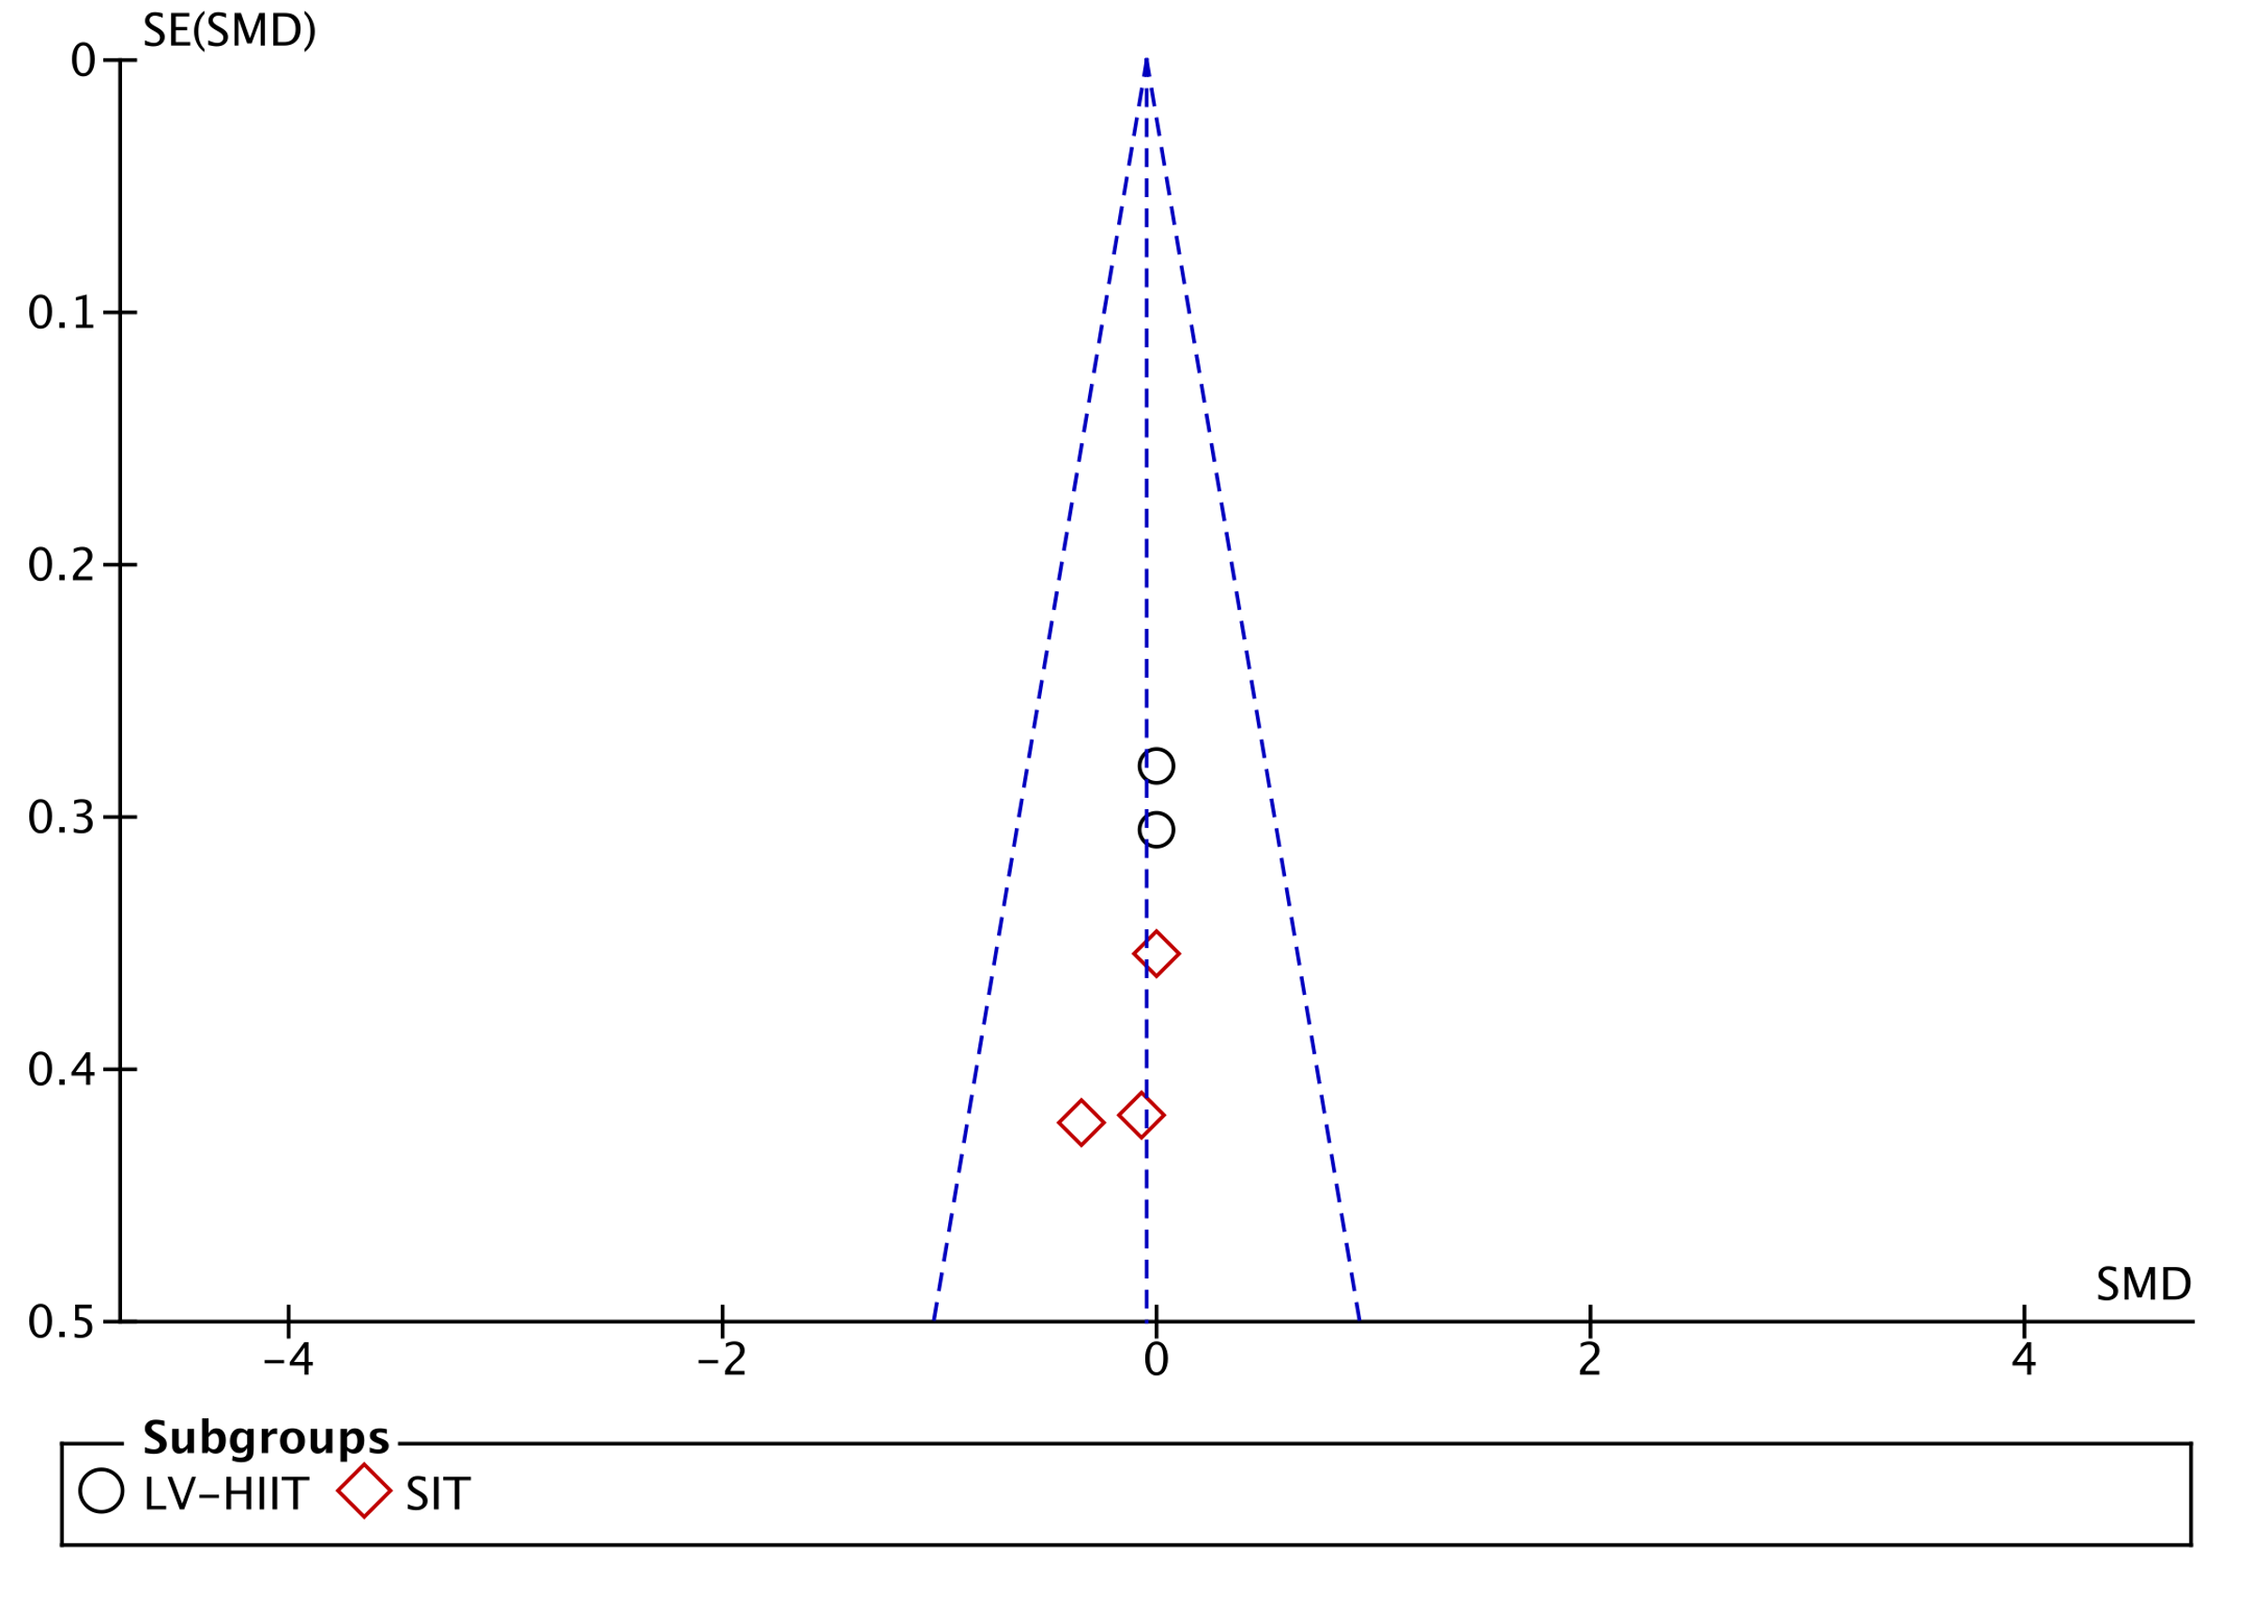
(Low-volume interval training versus HV-HIIT for abdominal fat)

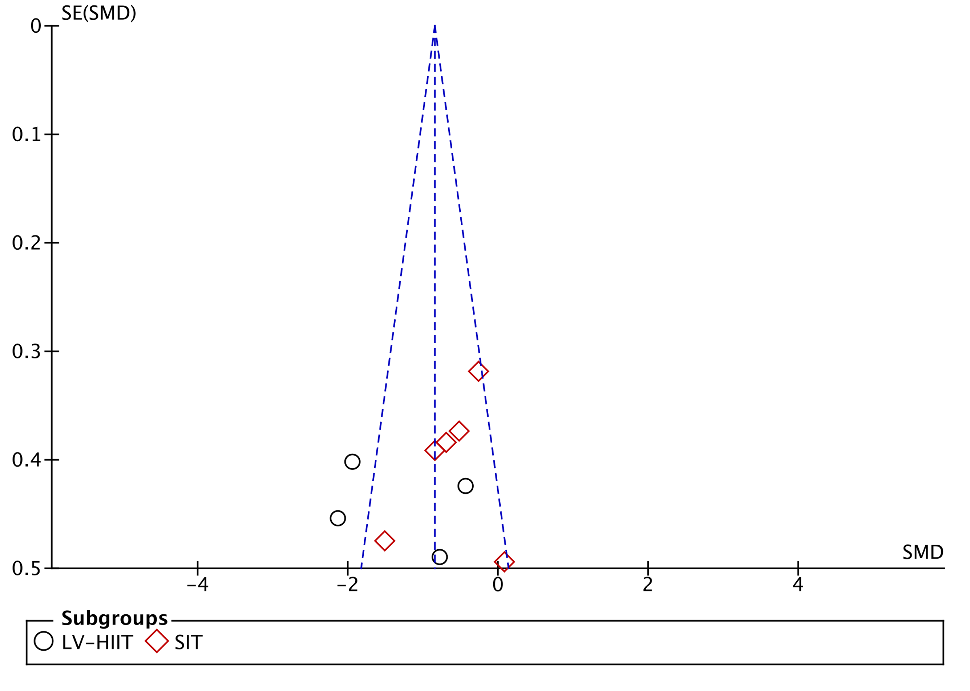
(Low-volume interval training versus CON for visceral fat)

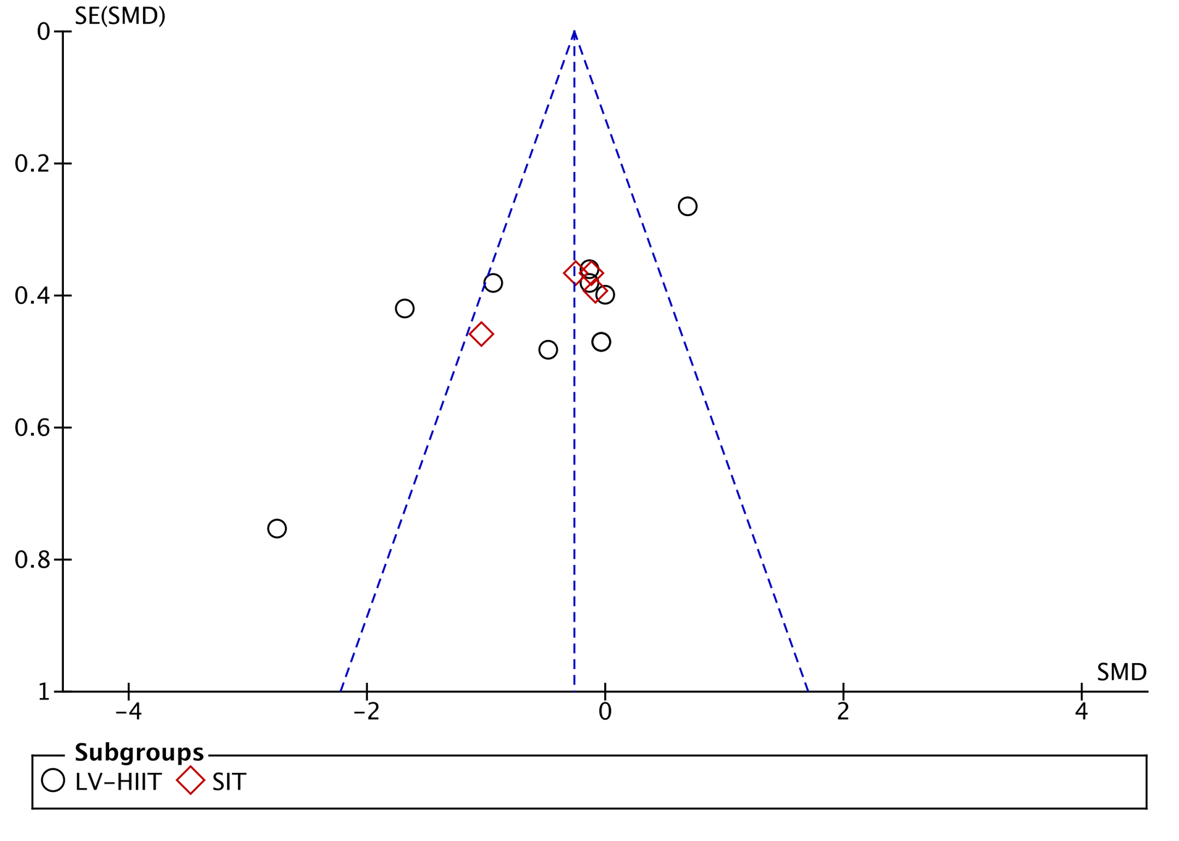
(Low-volume interval training versus MICT for visceral fat)

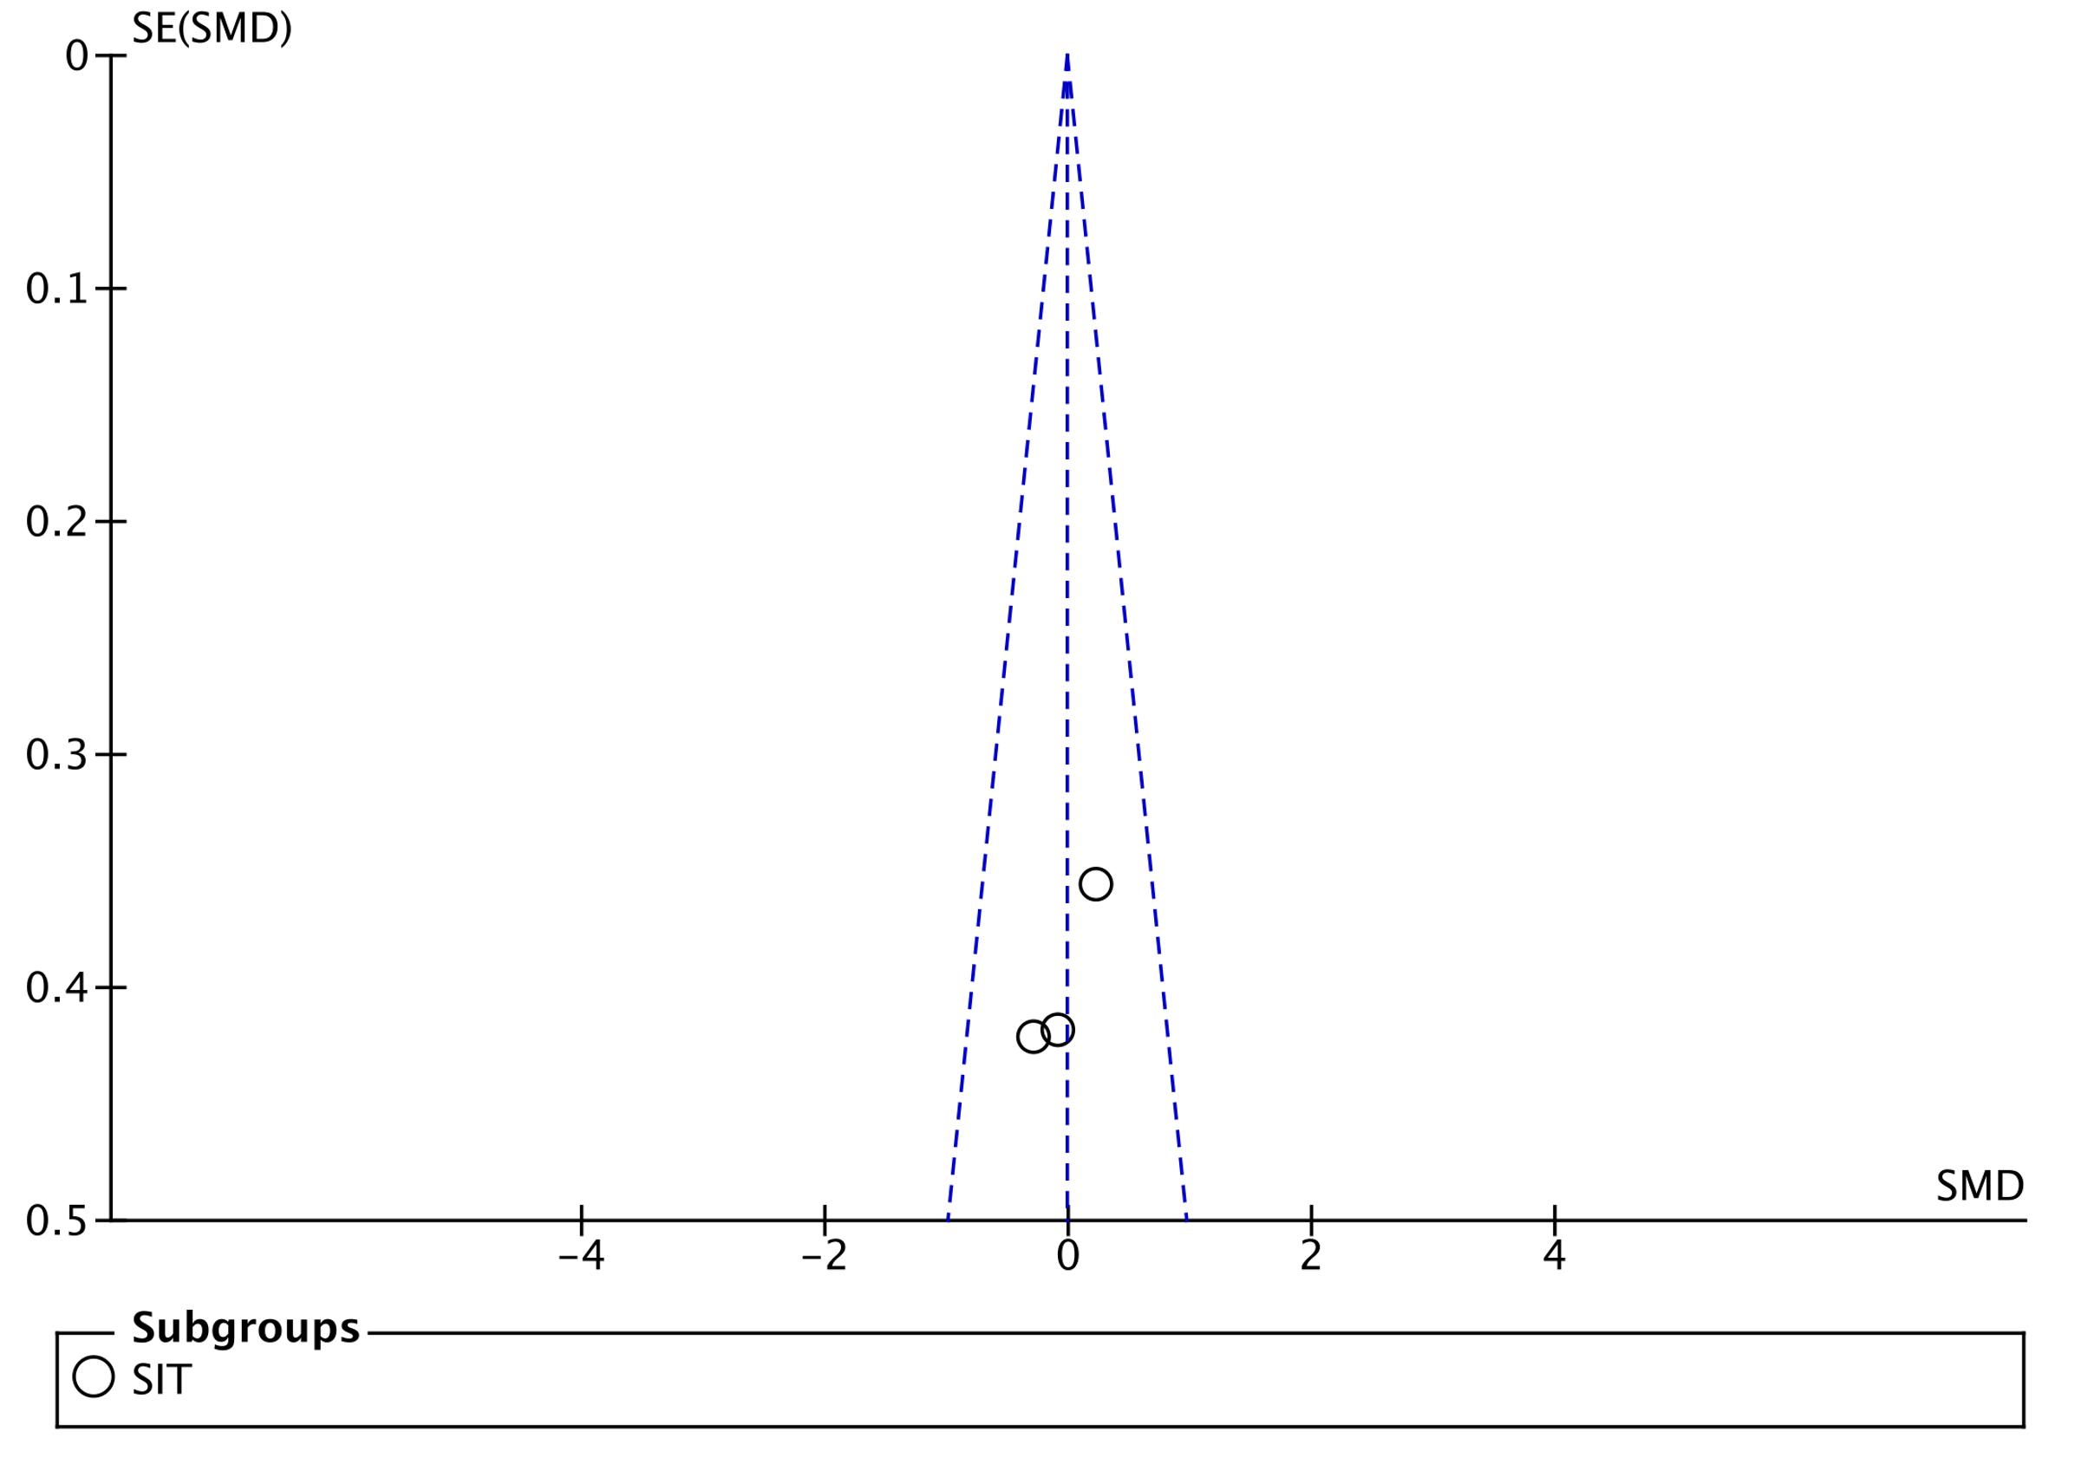
(Low-volume interval training versus HV-HIIT for visceral fat)

