Supplementary Material
Supplementary Table S1. Results of the MR study testing causal association between inflammatory cytokines and stroke and its subtypes.
Supplementary Table S2. The Association Between Inflammatory Cytokines and Stroke. Sheet1: Characteristics of the genetic instrument variables for the cytokines in the Mendelian randomization study at level P < 5 × 10^{–6}. Sheet 2: MR analysis of 41 cytokines and Stroke risk. Sheet 3: Heterogeneity analysis of 41 cytokines and Stroke risk. Sheet 4: MR Egger intercept analysis of the association between 41 cytokines and Stroke risk.
Supplementary Table S3. The Association Between Inflammatory Cytokines and IS. Sheet1: Characteristics of the genetic instrument variables for the cytokines in the Mendelian randomization study at level P < 5 × 10^{–6}. Sheet 2: MR analysis of 41 cytokines and IS risk. Sheet 3: Heterogeneity analysis of 41 cytokines and IS risk. Sheet 4: MR Egger intercept analysis of the association between 41 cytokines and IS risk.
Supplementary Table S4. The Association Between Inflammatory Cytokines and LAS. Sheet1: Characteristics of the genetic instrument variables for the cytokines in the Mendelian randomization study at level P < 5 × 10^{–6}. Sheet 2: MR analysis of 41 cytokines and LAS risk. Sheet 3: Heterogeneity analysis of 41 cytokines and LAS risk. Sheet 4: MR Egger intercept analysis of the association between 41 cytokines and LAS risk.
Supplementary Table S5. The Association Between Inflammatory Cytokines and SVS. Sheet1: Characteristics of the genetic instrument variables for the cytokines in the Mendelian randomization study at level P < 5 × 10^{–6}. Sheet 2: MR analysis of 41 cytokines and SVS risk. Sheet 3: Heterogeneity analysis of 41 cytokines and SVS risk. Sheet 4: MR Egger intercept analysis of the association between 41 cytokines and SVS risk.
Supplementary Table S6. The Association Between Inflammatory Cytokines and LIS. Sheet1: Characteristics of the genetic instrument variables for the cytokines in the Mendelian randomization study at level P < 5 × 10^{–6}. Sheet 2: MR analysis of 41 cytokines and LIS risk. Sheet 3: Heterogeneity analysis of 41 cytokines and LIS risk. Sheet 4: MR Egger intercept analysis of the association between 41 cytokines and LIS risk.
Supplementary Table S7. The Association Between Inflammatory Cytokines and CES. Sheet1: Characteristics of the genetic instrument variables for the cytokines in the Mendelian randomization study at level P < 5 × 10^{–6}. Sheet 2: MR analysis of 41 cytokines and CES risk. Sheet 3: Heterogeneity analysis of 41 cytokines and CES risk. Sheet 4: MR Egger intercept analysis of the association between 41 cytokines and CES risk.
Supplementary Table S8. The Association Between Inflammatory Cytokines and ICH. Sheet1: Characteristics of the genetic instrument variables for the cytokines in the Mendelian randomization study at level P < 5 × 10^{–6}. Sheet 2: MR analysis of 41 cytokines and ICH risk. Sheet 3: Heterogeneity analysis of 41 cytokines and ICH risk. Sheet 4: MR Egger intercept analysis of the association between 41 cytokines and ICH risk.
Supplementary Table S9. The Association Between Inflammatory Cytokines and LICH. Sheet1: Characteristics of the genetic instrument variables for the cytokines in the Mendelian randomization study at level P < 5 × 10^{–6}. Sheet 2: MR analysis of 41 cytokines and LICH risk. Sheet 3: Heterogeneity analysis of 41 cytokines and LICH risk. Sheet 4: MR Egger intercept analysis of the association between 41 cytokines and LICH risk.
Supplementary Table S10. The Association Between Inflammatory Cytokines and NLICH. Sheet1: Characteristics of the genetic instrument variables for the cytokines in the Mendelian randomization study at level P < 5 × 10^{–6}. Sheet 2: MR analysis of 41 cytokines and NLICH risk. Sheet 3: Heterogeneity analysis of 41 cytokines and NLICH risk. Sheet 4: MR Egger intercept analysis of the association between 41 cytokines and NLICH risk.

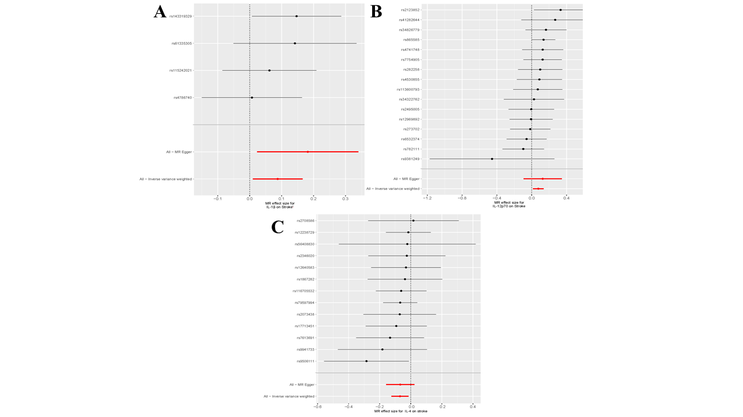
Supplementary Figure 1. (A)Forest plots for the exposure of IL-1β (B) Forest plots for the exposure of IL-12p70 (C) Forest plots for the exposure of IL-4
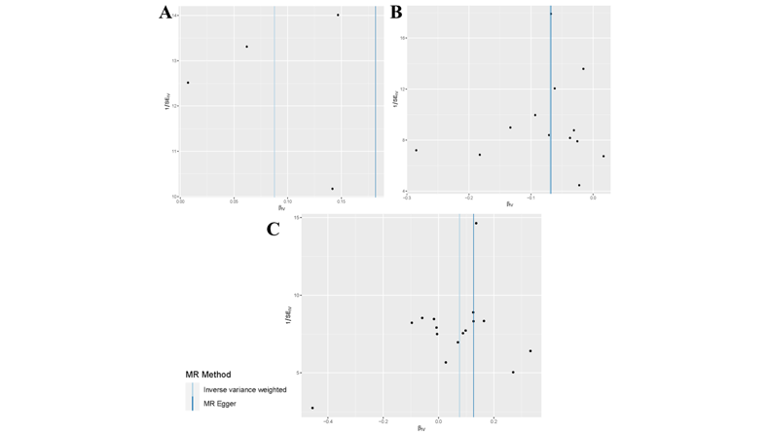
Supplementary Figure 2. (A) Funnel plots for the exposure of IL-1β (B) Funnel plots for the exposure of IL-4 (C) Funnel plots for the exposure of IL-12p70
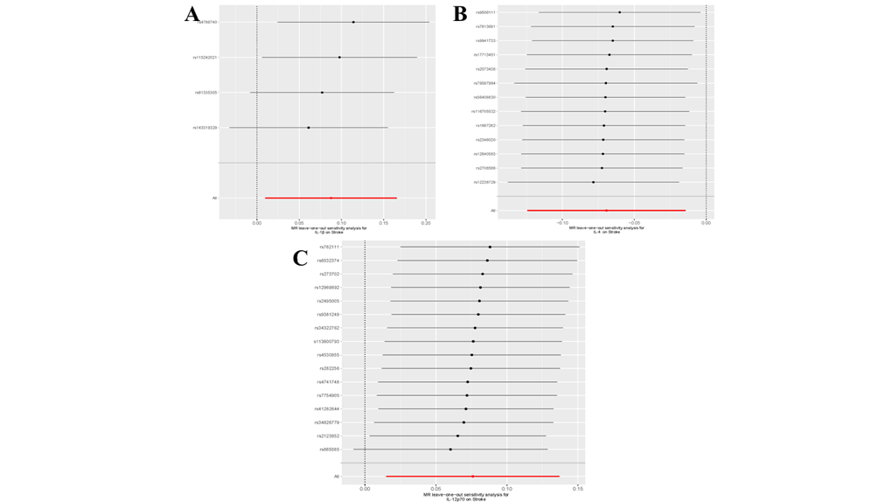
Supplementary Figure 3. (A) Leave-one-out plots for the exposure of IL-1β (B) Leave-one-out plots for the exposure of IL-4 (C) Leave-one-out plots for the exposure of IL-12p70
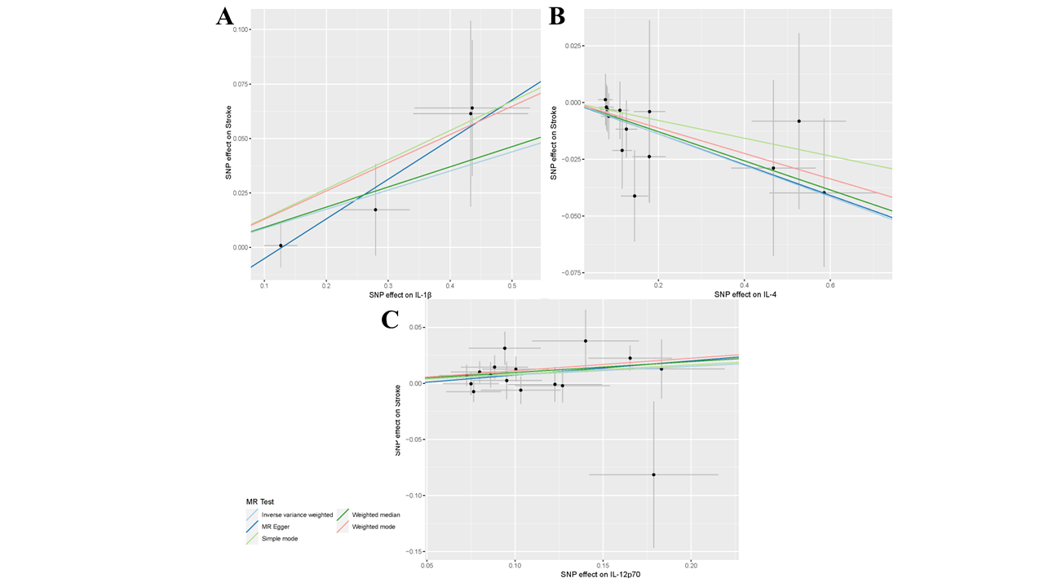
Supplementary Figure 4. (A) Scatter plots for the exposure of IL-1β (B) Scatter plots for the exposure of IL-4 (C) Scatter plots for the exposure of IL-12p70
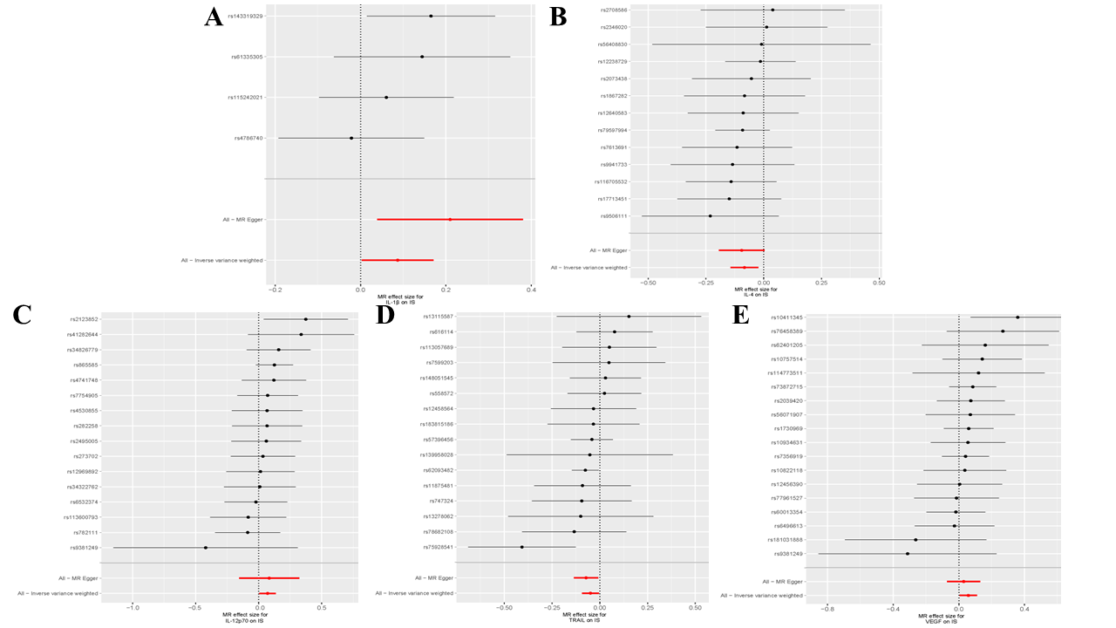
Supplementary Figure 5. (A)Forest plots for the exposure of IL-1β (B) Forest plots for the exposure of IL-4 (C) Forest plots for the exposure of IL-12p70(D) Forest plots for the exposure of TRAIL(E) Forest plots for the exposure of VEGF
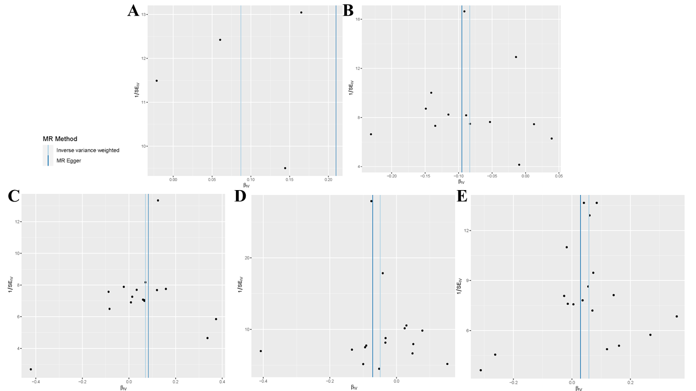
Supplementary Figure 6. (A) Funnel plots for the exposure of IL-1β (B) Funnel plots for the exposure of IL-4 (C) Funnel plots for the exposure of IL-12p70(D) Funnel plots for the exposure of TRAIL(E) Funnel plots for the exposure of VEGF
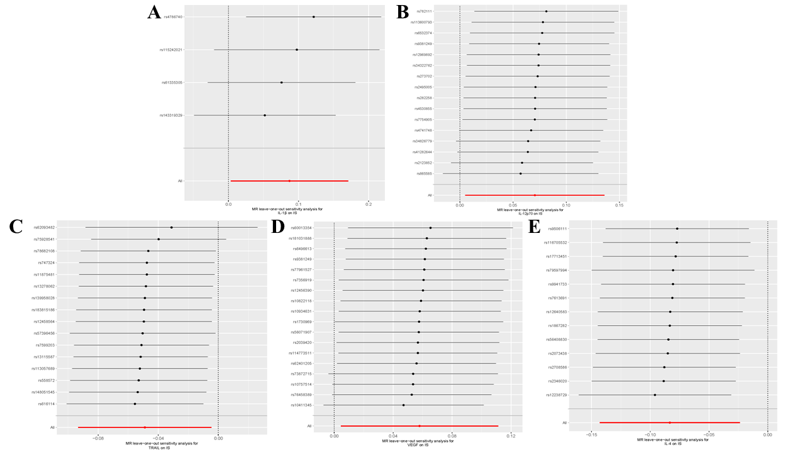
Supplementary Figure 7. (A) Leave-one-out plots for the exposure of IL-1β (B) Leave-one-out plots for the exposure of 12p70 (C) Leave-one-out plots for the exposure of TRAIL(D) Leave-one-out plots for the exposure of VEGF(E) Leave-one-out plots for the exposure of IL-4
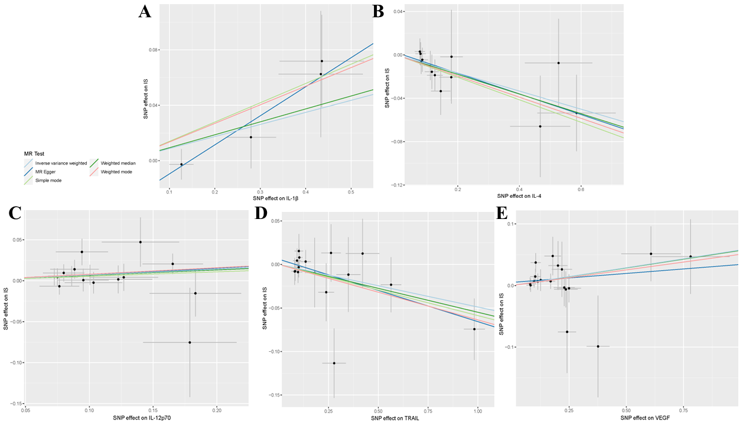
Supplementary Figure 13. (A) Scatter plots for the exposure of IL-1β (B) Scatter plots for the exposure of IL-4 (C) Scatter plots for the exposure of IL-12p70(D) Scatter plots for the exposure of TRAIL(E) Scatter plots for the exposure of VEGF
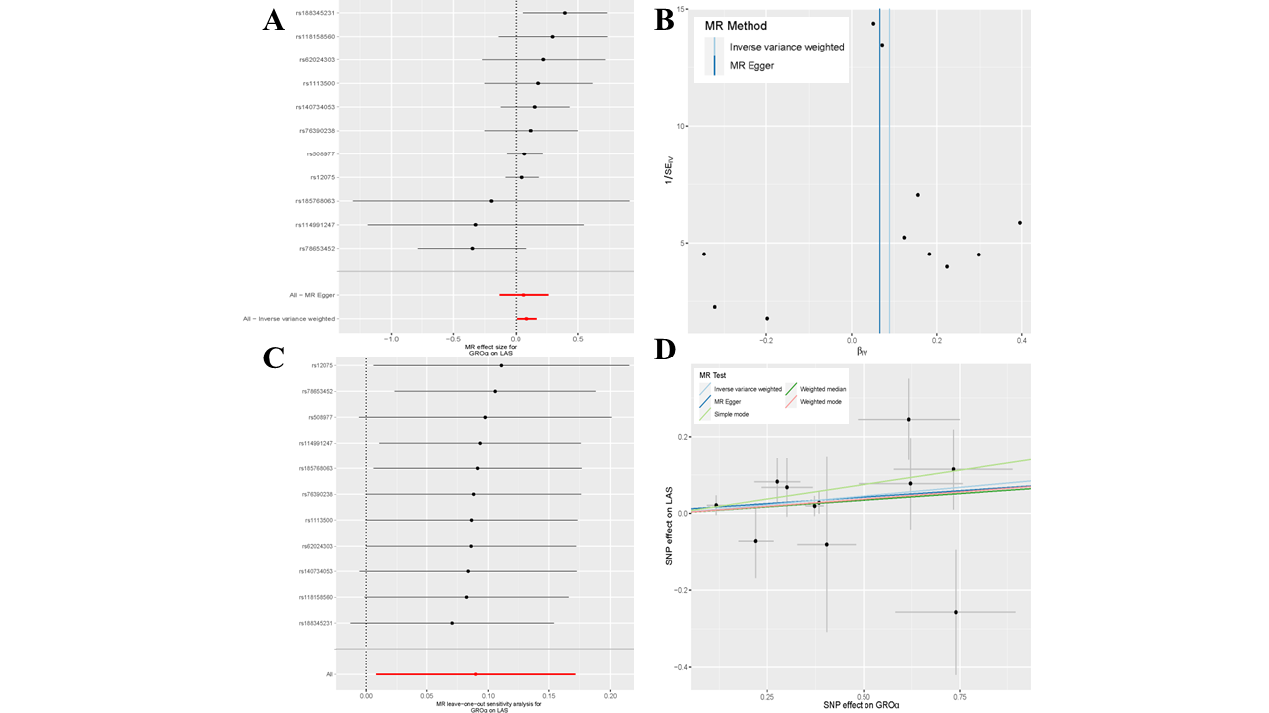
Supplementary Figure 9. (A) Forest plots for the exposure of GROα (B) Funnel plots for the exposure of GROα (C) Leave-one-out plots for the exposure of GROα (D)Scatter plots for the exposure of GROα
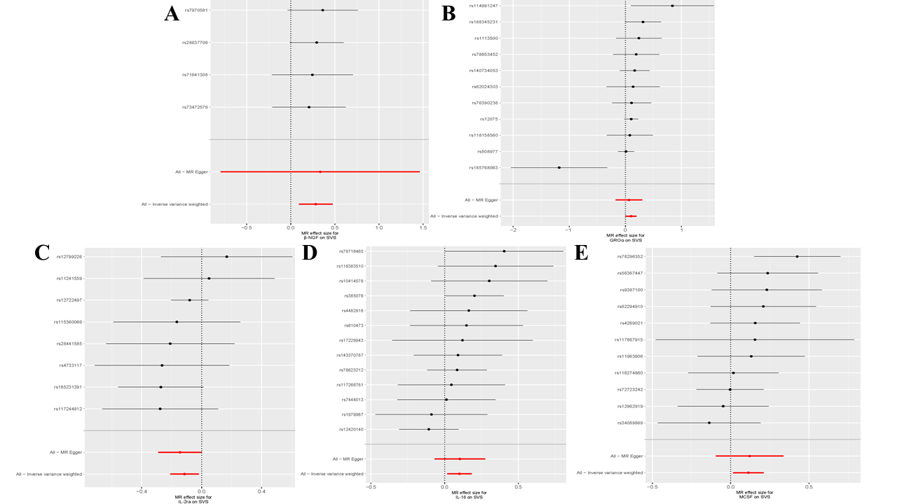
Supplementary Figure 10. (A)Forest plots for the exposure of β-NGF (B) Forest plots for the exposure of GROα (C) Forest plots for the exposure of IL-2RA(D) Forest plots for the exposure of IL-18(E) Forest plots for the exposure of MCSF
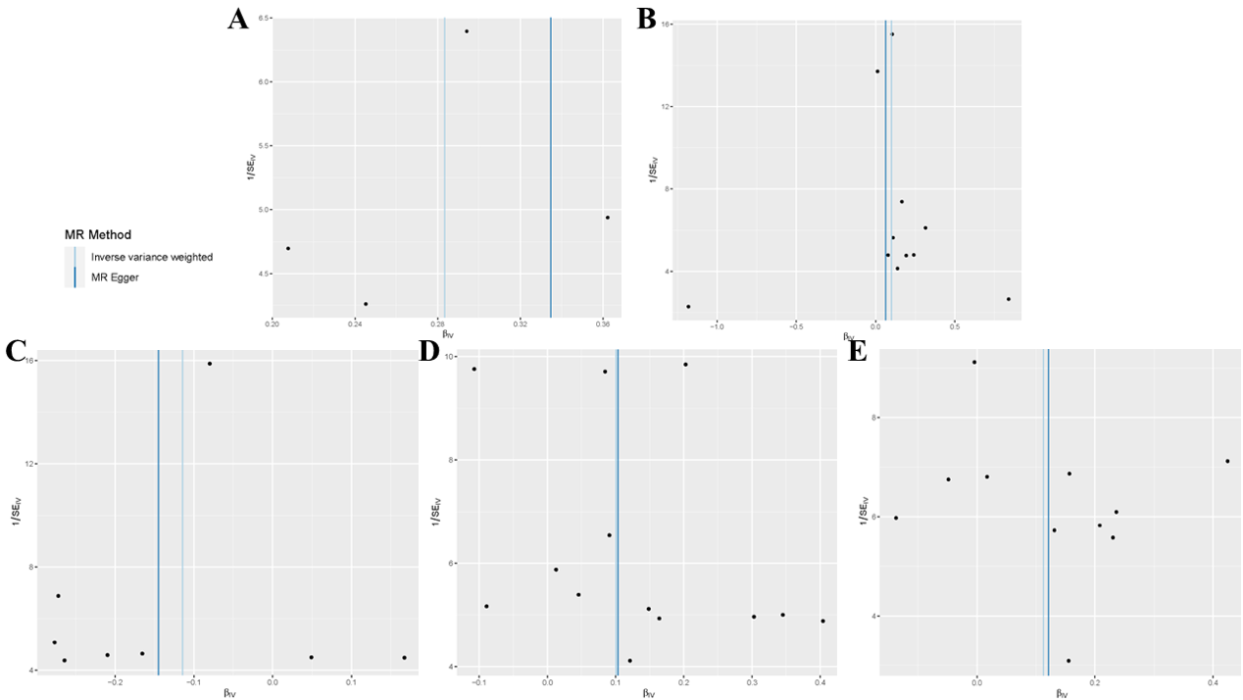
Supplementary Figure 11. (A) Funnel plots for the exposure of β-NGF (B) Funnel plots for the exposure of GROα (C) Funnel plots for the exposure of IL-2RA(D) Funnel plots for the exposure of IL-18(E) Funnel plots for the exposure of MCSF
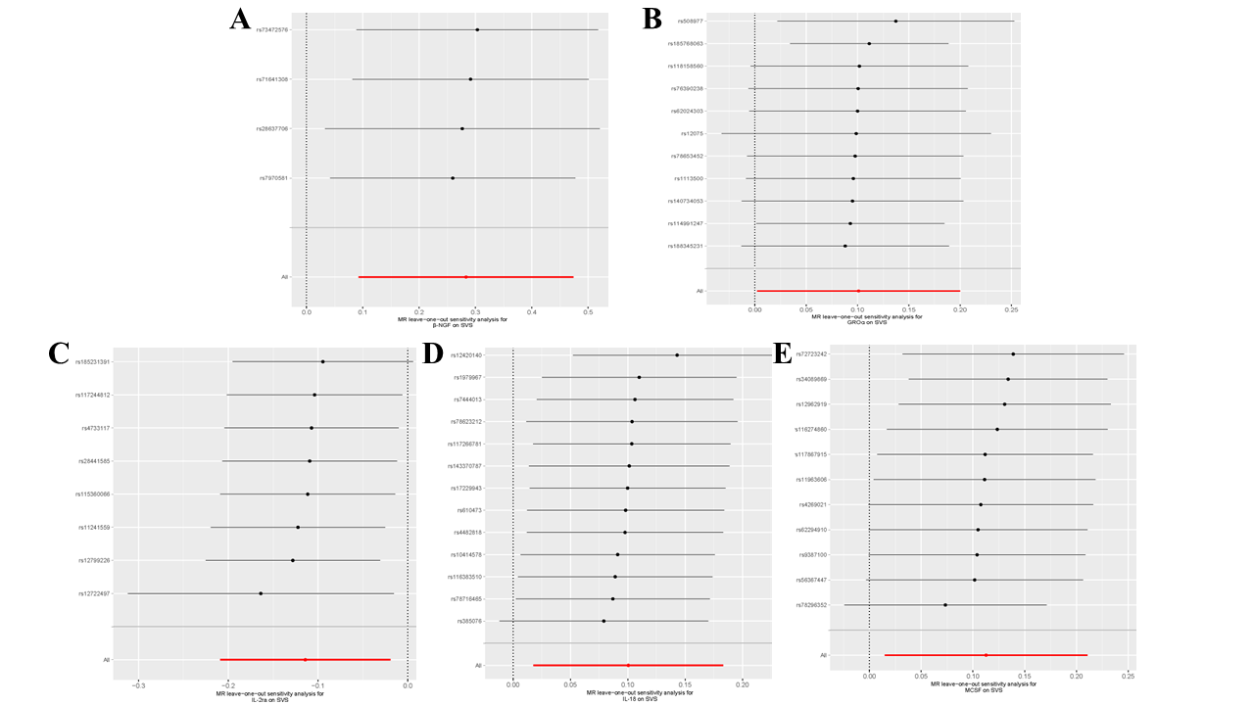
Supplementary Figure 12. (A) Leave-one-out plots for the exposure of β-NGF (B) Leave-one-out plots for the exposure of GROα (C) Leave-one-out plots for the exposure of IL-2RA(D) Leave-one-out plots for the exposure of IL-18(E) Leave-one-out plots for the exposure of MCSF
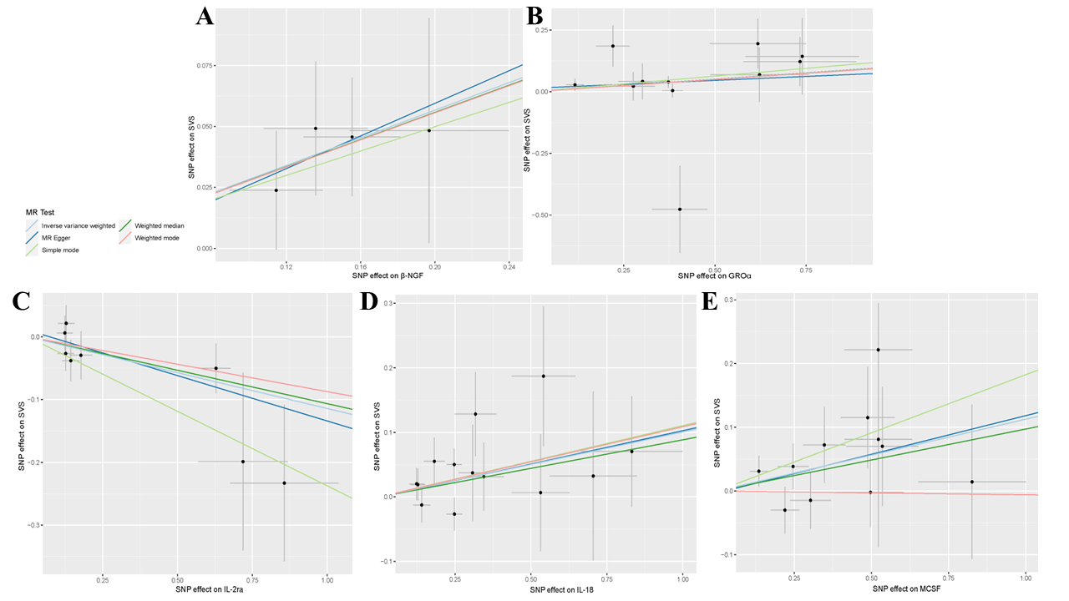
Supplementary Figure 13. (A) Scatter plots for the exposure of β-NGF (B) Scatter plots for the exposure of GROα (C) Scatter plots for the exposure of IL-2RA(D) Scatter plots for the exposure of IL-18(E) Scatter plots for the exposure of MCSF
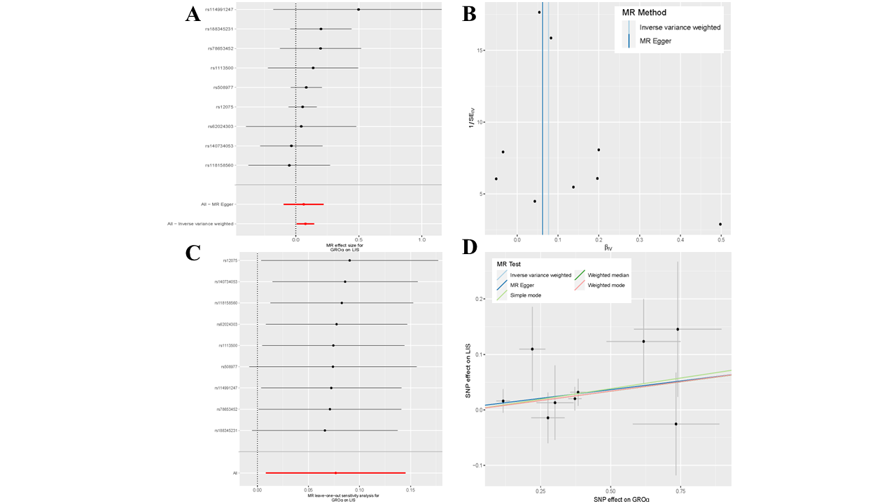 Supplementary Figure 14. (A) Forest plots for the exposure of GROα (B) Funnel plots for the exposure of GROα (C) Leave-one-out plots for the exposure of GROα (D)Scatter plots for the exposure of GROα
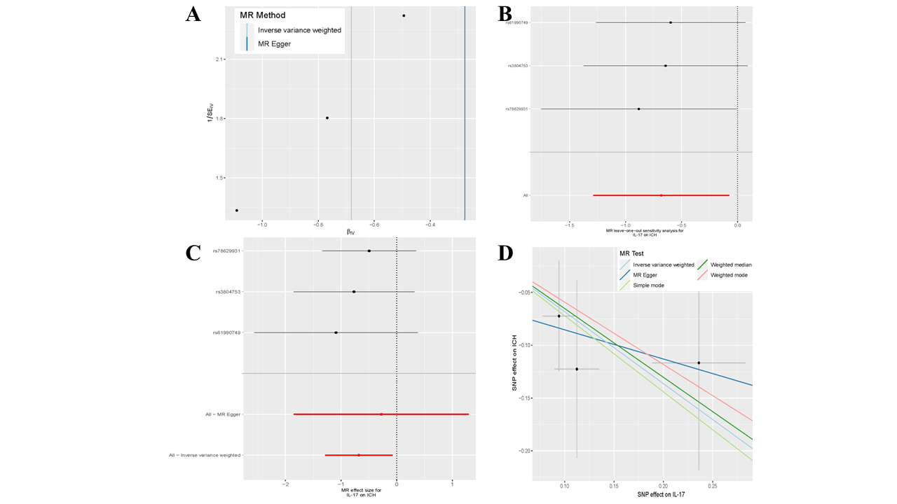
Supplementary Figure 15. (A) Funnel plots for the exposure of IL-17(B) Leave-one-out plots for the exposure of IL-17(C) Forest plots for the exposure of IL-17(D)Scatter plots for the exposure of IL-17
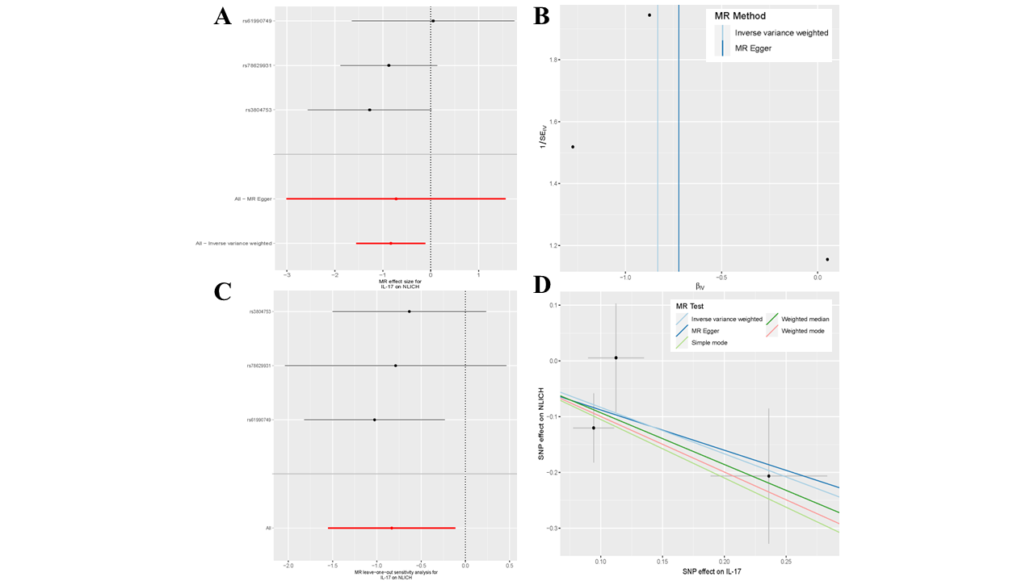
Supplementary Figure 16. (A) Forest plots for the exposure of IL-17 (B) Funnel plots for the exposure of IL-17 (C) Leave-one-out plots for the exposure of IL-17 (D)Scatter plots for the exposure of IL-17

