Attachment A:

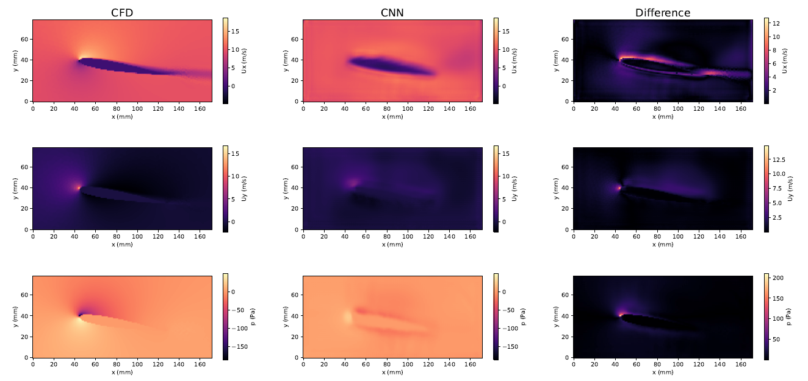
Fig. A1: Comparison for the NACA0012 airfoil. The fig. shows the comparison of the CFD simulation results (left column) and the predicted outcome of the CNN (middle column) for the flow velocity fields in the x-direction (Ux, top row), the y-direction (Uy, middle row), and the pressure field (p, bottom row). The right column shows the MAE between the CFD simulation and the CNN prediction. The CNN predictions were attained by a model trained with 763 samples. Taken from [16].

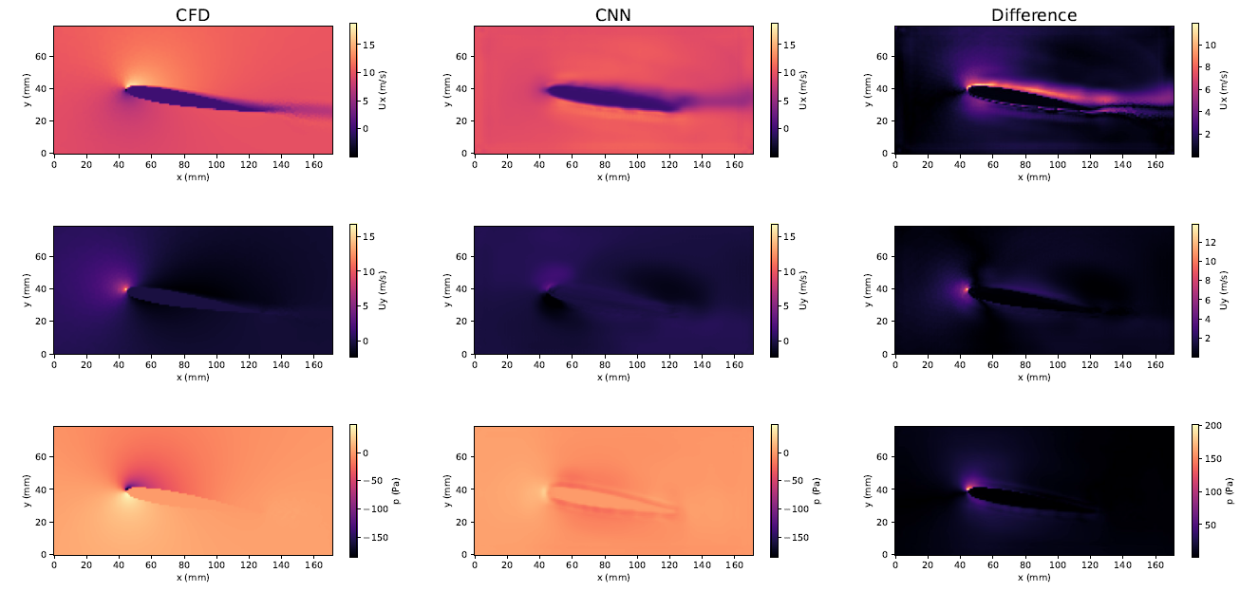
Fig. A2: Comparison for the NACA0012 airfoil. The fig. shows the comparison of the CFD simulation results (left column) and the predicted outcome of the CNN (middle column) for the flow velocity fields in the x-direction (Ux, top row), the y-direction (Uy, middle row), and the pressure field (p, bottom row). The right column shows the MAE between the CFD simulation and the CNN prediction. The CNN predictions were attained by a model trained with 2585 samples. Taken from [16]

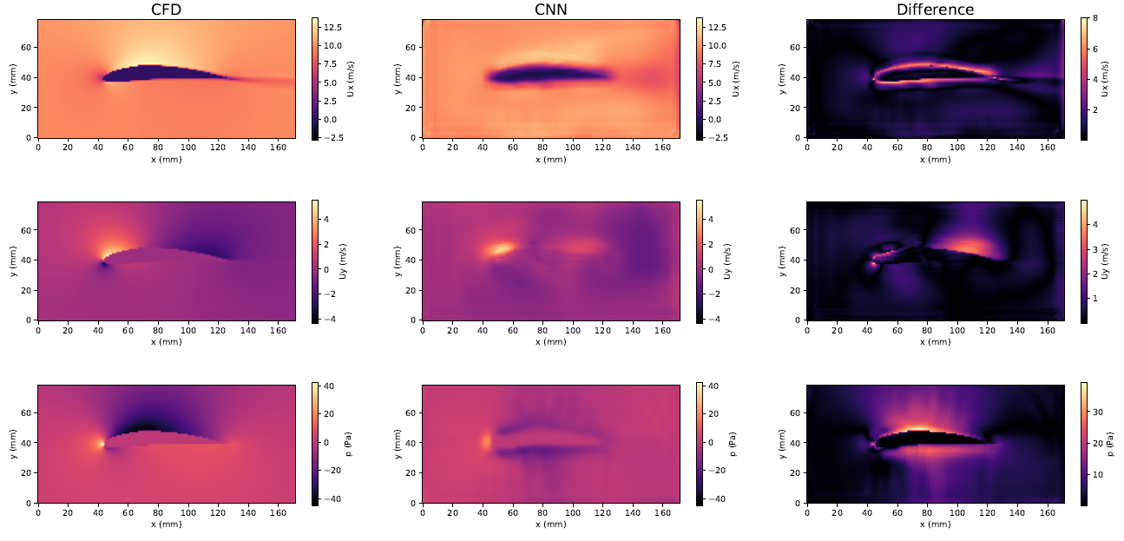
Fig. A3: Comparison for the NACA6412 airfoil. The fig. shows the comparison of the CFD simulation results (left column) and the predicted outcome of the CNN (middle column) for the flow velocity fields in the x-direction (Ux, top row), y-direction (Uy, middle row), and the pressure field (p, bottom row). The right column shows the MAE between the CFD simulation and the CNN prediction. The CNN predictions were attained by a model trained with 763 samples. Taken from [16]

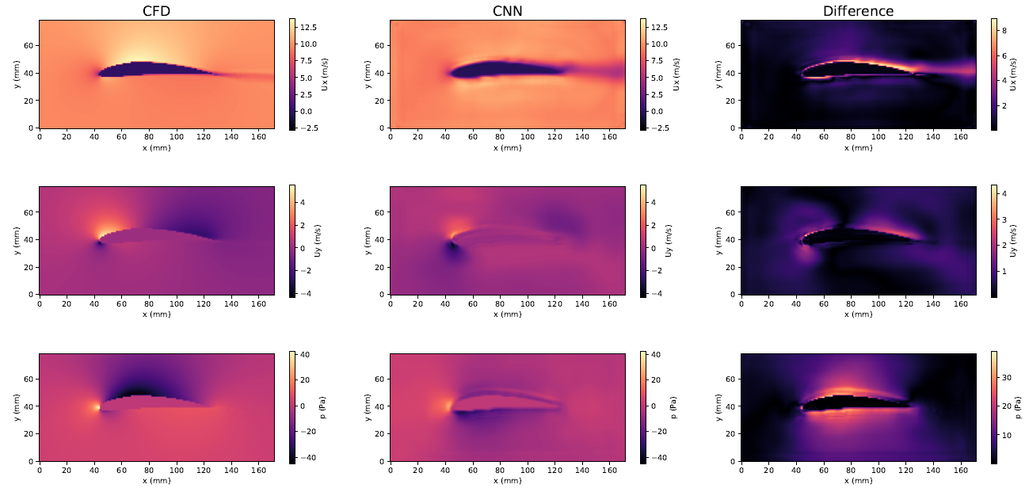
Fig. A4: Comparison for the NACA6412 airfoil. The fig. shows the comparison of the CFD simulation results (left column) and the predicted outcome of the CNN (middle column) for the flow velocity fields in the x-direction (Ux, top row), y-direction (Uy, middle row), and pressure field (p, bottom row). The right column shows the MAE between the CFD simulation and the CNN prediction. The CNN predictions were attained by a model trained with 2585 samples. Taken from [16]

Appendix B: Results of the Mesh Convergence Study
Tab. B1 Results of the grid convergence test for a C-mesh-shaped flow domain around the NACA0012 airfoil. The C_{L} was observed as a measure for the convergence test. It is abstracted that the C_{L} does not change for a number of cells above 45800. Taken from [16]
Number of Cells | Lift coefficient (C_{L})
24010 | 1.004
30400 | 1.013
45800 | 1.012
54960 | 1.012
64120 | 1.012

