Supporting Information
3D amplified single-cell RNA and protein imaging identifies oncogenic transcript subtypes in B cell acute lymphoblastic leukemia
Suyeon Shin^{1*}, Yoon-Jin Kim^{1*}, Hyo Geun Yun¹, Haerim Chung², Hyunsoo Cho^{2**}, and Sungyoung Choi^{1,3,4**}
ªDepartment of Electronic Engineering, Hanyang University, Seoul 04763, Republic of Korea
^{b}Division of Hematology, Department of Internal Medicine, Yonsei University College of Medicine, Seoul 03722, Republic of Korea
^{c}Department of Biomedical Engineering, Hanyang University
⁴Department of Healthcare Digital Engineering, Hanyang University

Contents:
1. Supplementary Figures.......................................................................... 2
2. Supplementary Tables…...........................................................................25
2. Supplementary Videos…...........................................................................30

1. Supplementary Figures
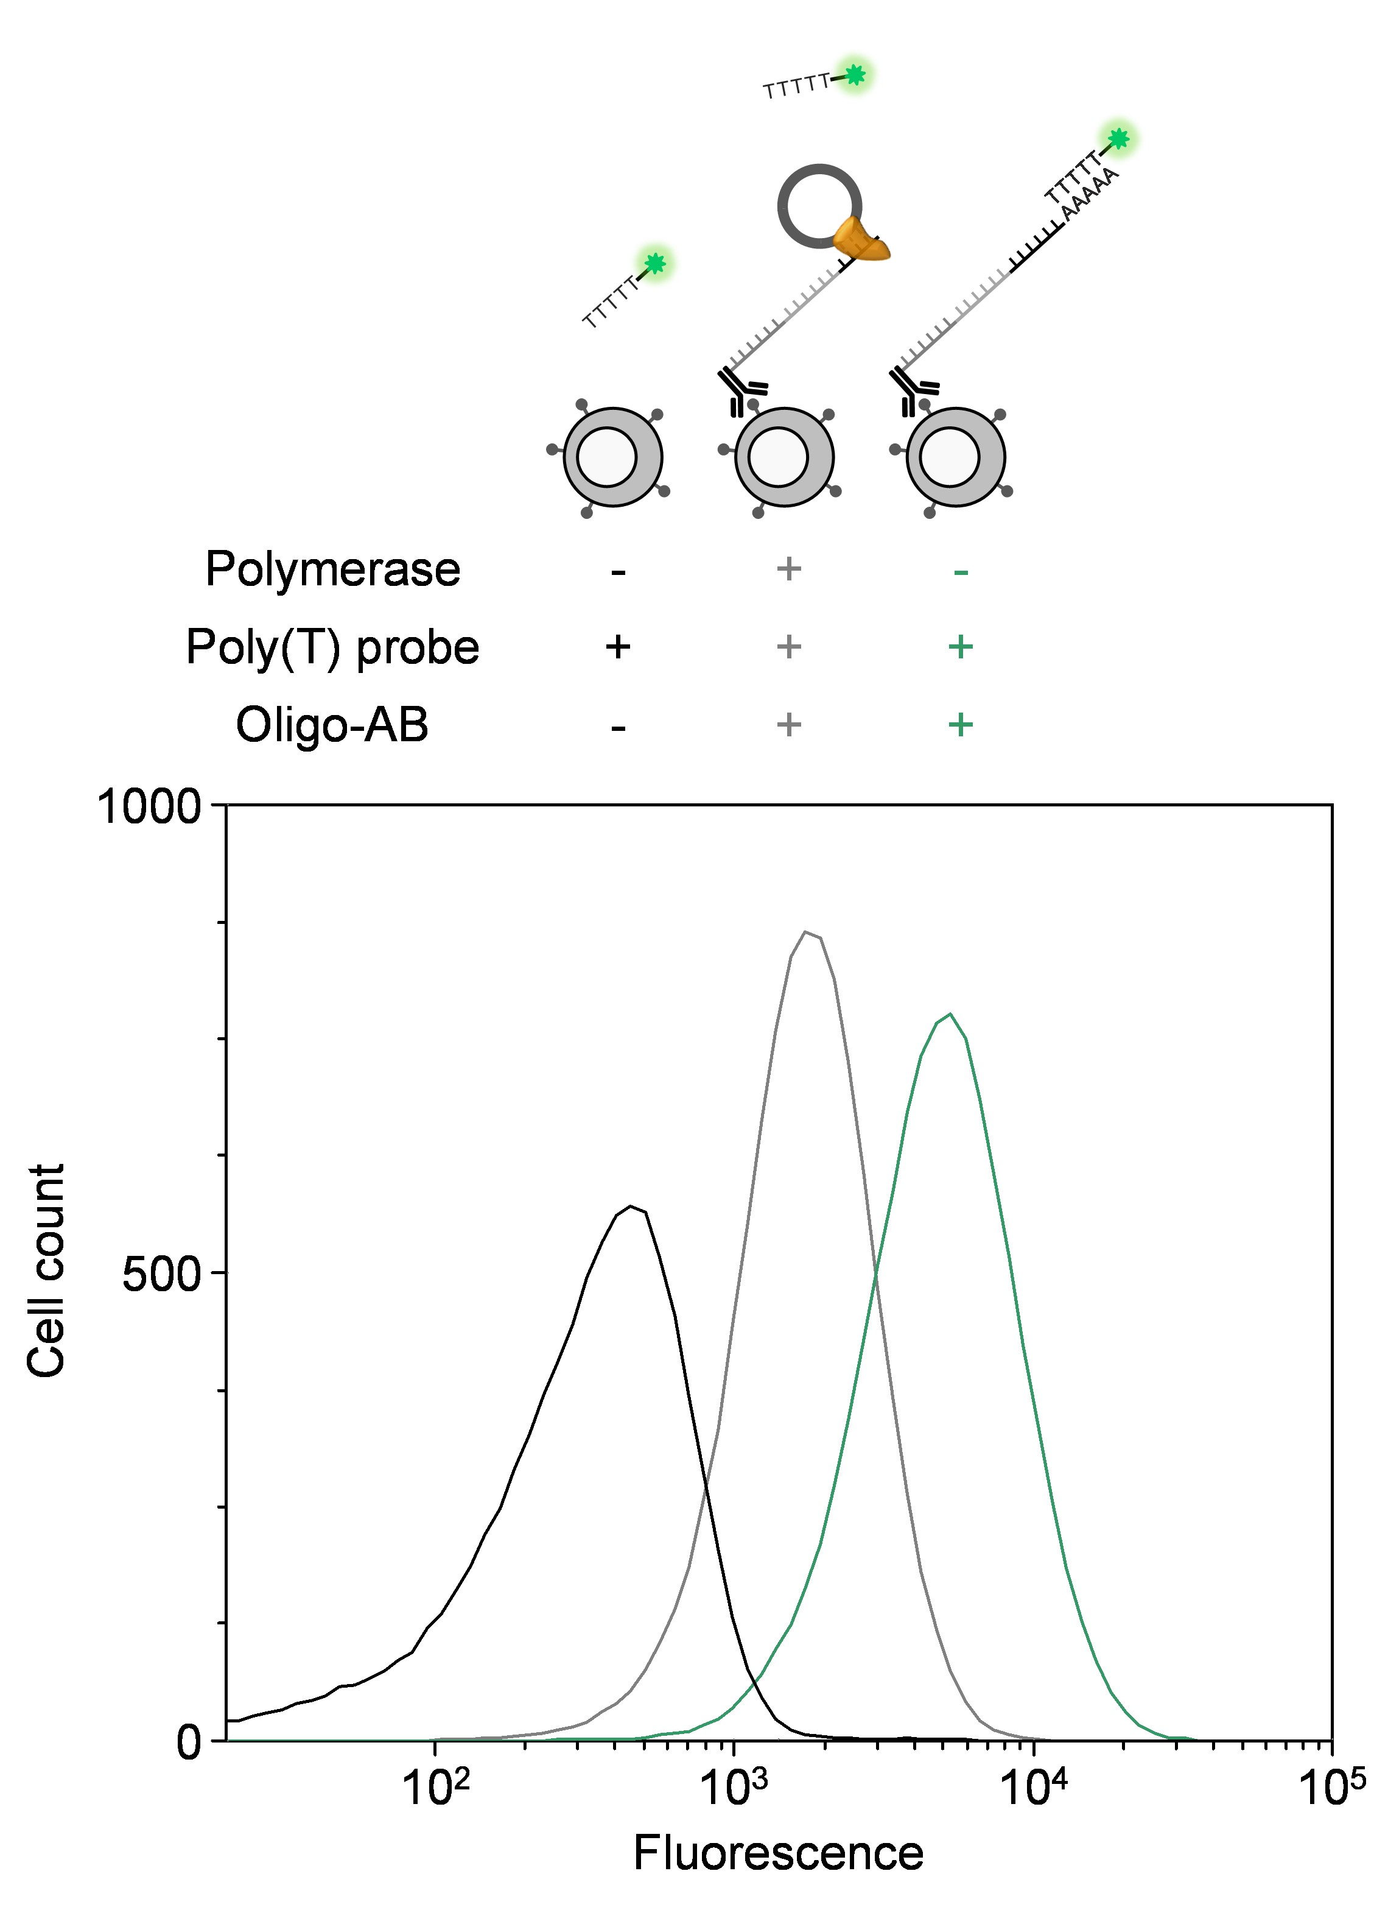

Fig. S1. Validation of the 3'-to-5' exonuclease activity of phi29 polymerase through flow cytometry. The fluorescence intensity difference was observed between cells incubated with the polymerase and cells without it, following fluorescent poly(T) probe labeling.

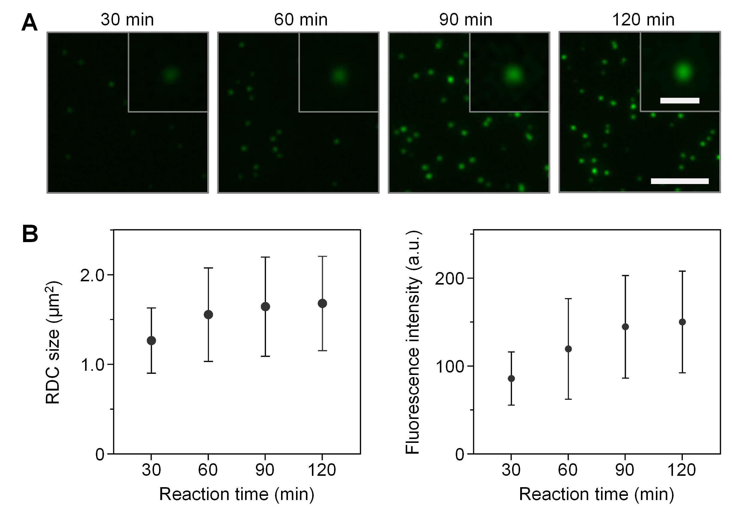

Fig. S2. Changes in RDC size and fluorescence intensity as a function of reaction time. (A) RDCs were generated from anti-CD3 antibodies physisorbed on glass surface at varying reaction times (Scale bar, 5 μm). Each inset provides a magnified view of a single RDC. (Scale bar, 1 μm). (B) Changes in RDC size and fluorescence intensity over time. RDC size is measured as the full area at half maximum, while fluorescence intensity is determined based on the maximum intensity (n ≥ 1000).

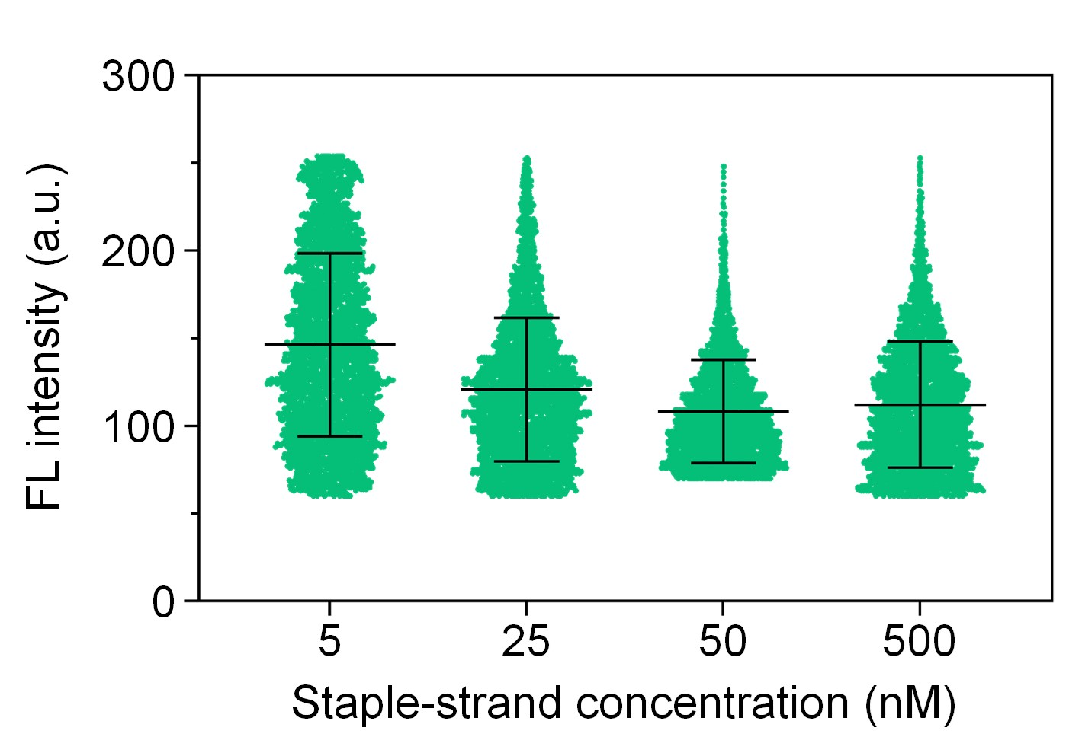

Fig. S3. Variation in fluorescence intensity as a function of staple-strand concentration (n = 5000). The presented data is a subset of the results presented in Figure 2F.

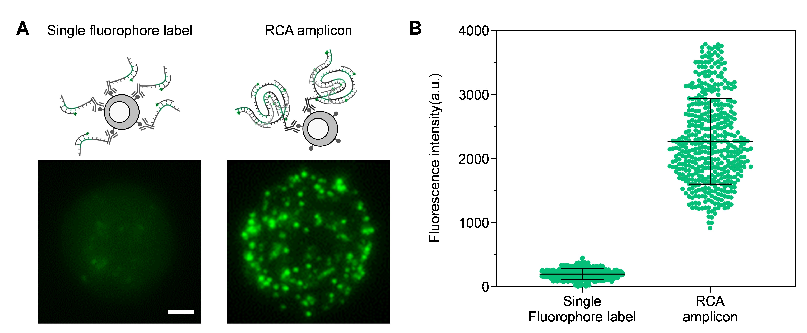

Fig. S4. Fluorescence signal enhancement by RCA. (A) Schematic illustrating a cell labelled with a single DNA probe-bound antibodies compared to a cell labelled with multiple DNA probe-bound RDCs, along with the resulting fluorescence single-cell images. Scale bar = 1 μm. (B) Significant enhancement in fluorescence intensity, on average 11.6-fold, achieved through RCA, enabling sensitive detection of individual RDCs on single cells (n = 450).

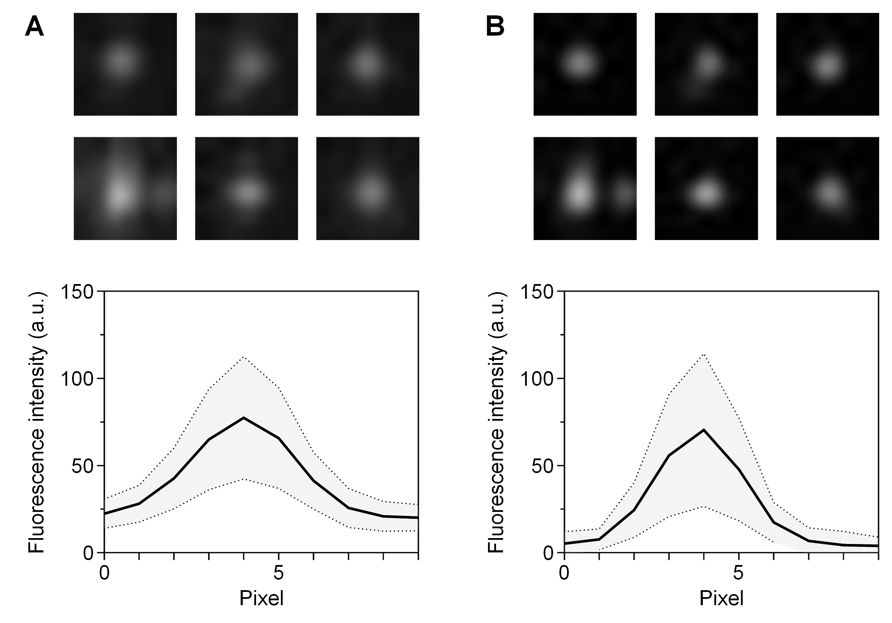
Fig. S5. Comparison of SNR before and after deconvolution for RDCs generated on the cell surface. (A and B) Representative fluorescence images and line scans (A) before deconvolution and (B) after deconvolution. The SNR, calculated as the ratio of the maximum fluorescence intensity of a single RDC to the background fluorescence level, was significantly enhanced from 3.64 to 15.19 through deconvolution (n = 500).

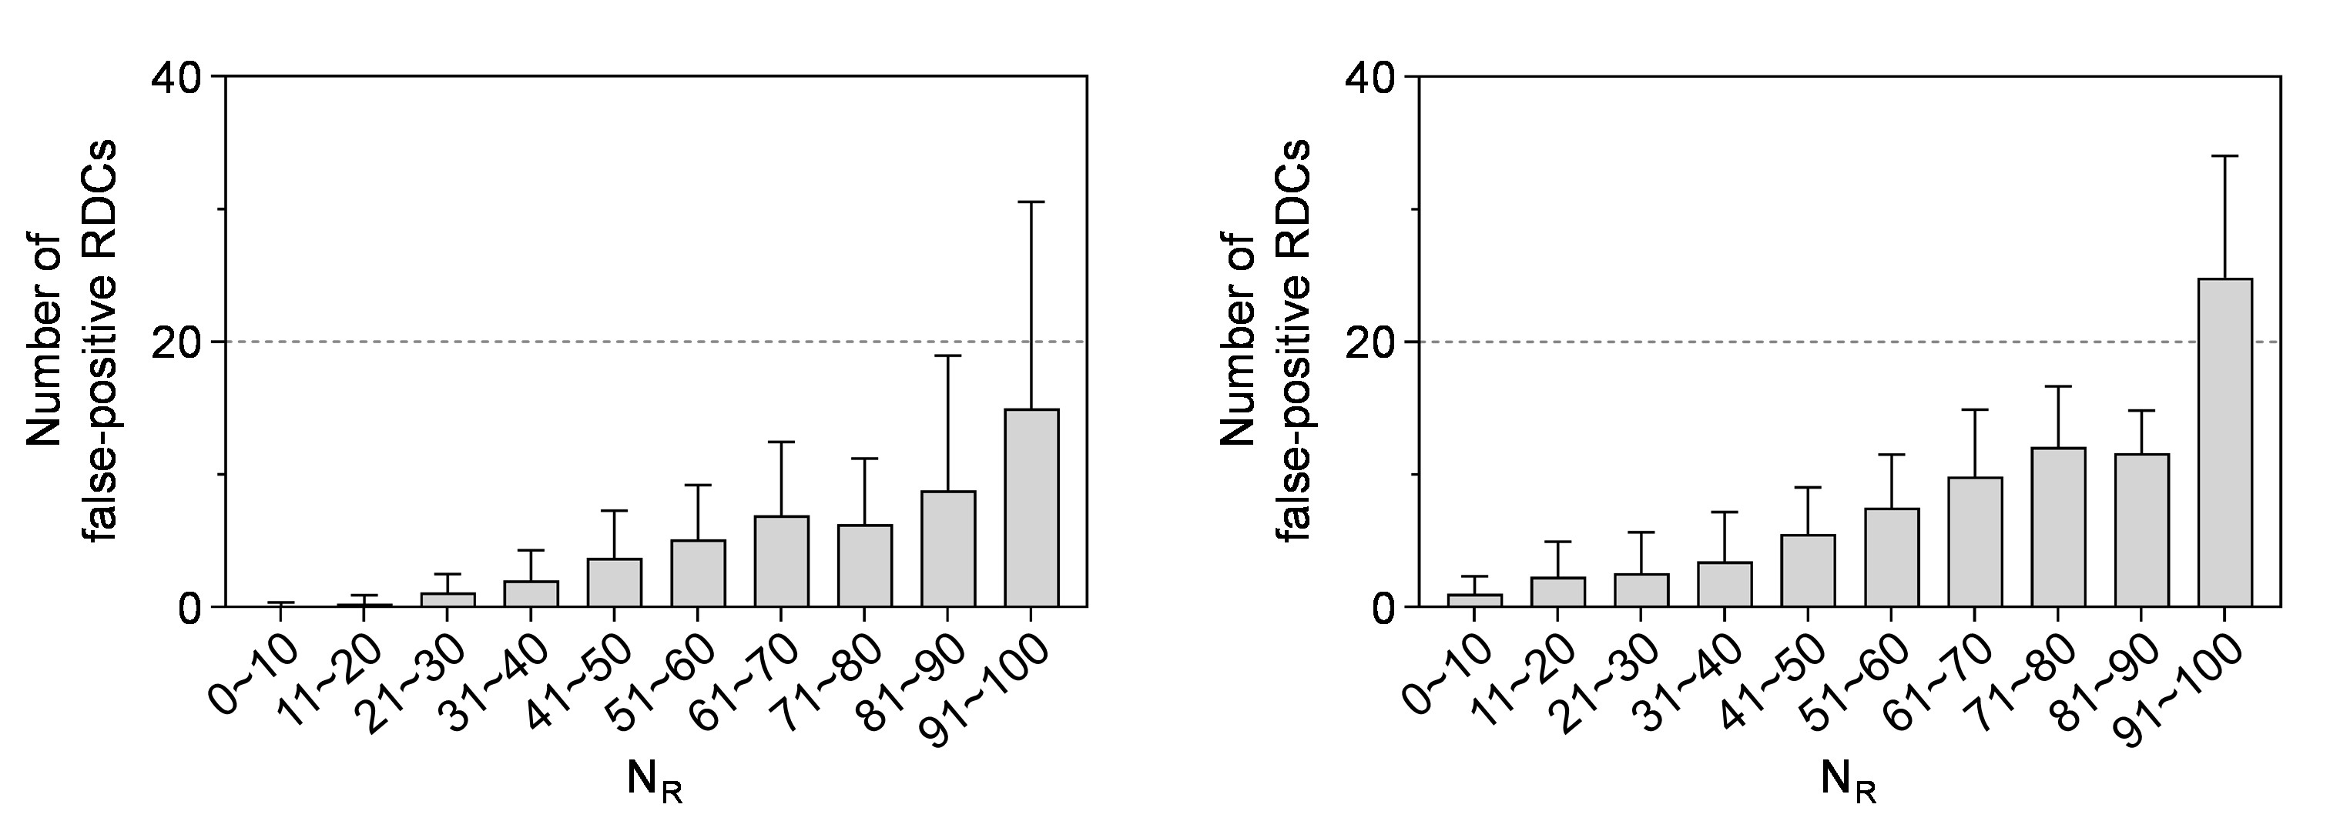
Fig. S6. Characterization of false RDCs exhibiting non-elliptical 3D morphology. The number of false RDCs shows an increasing trend as N_{R} rises. The data represents two RDC-type combinations generated on single cells: (Left) i:j:l:m = 1:0:0:0 and 0:1:0:0, and (Right) 1:0:0:0 and 1:2:0:0.

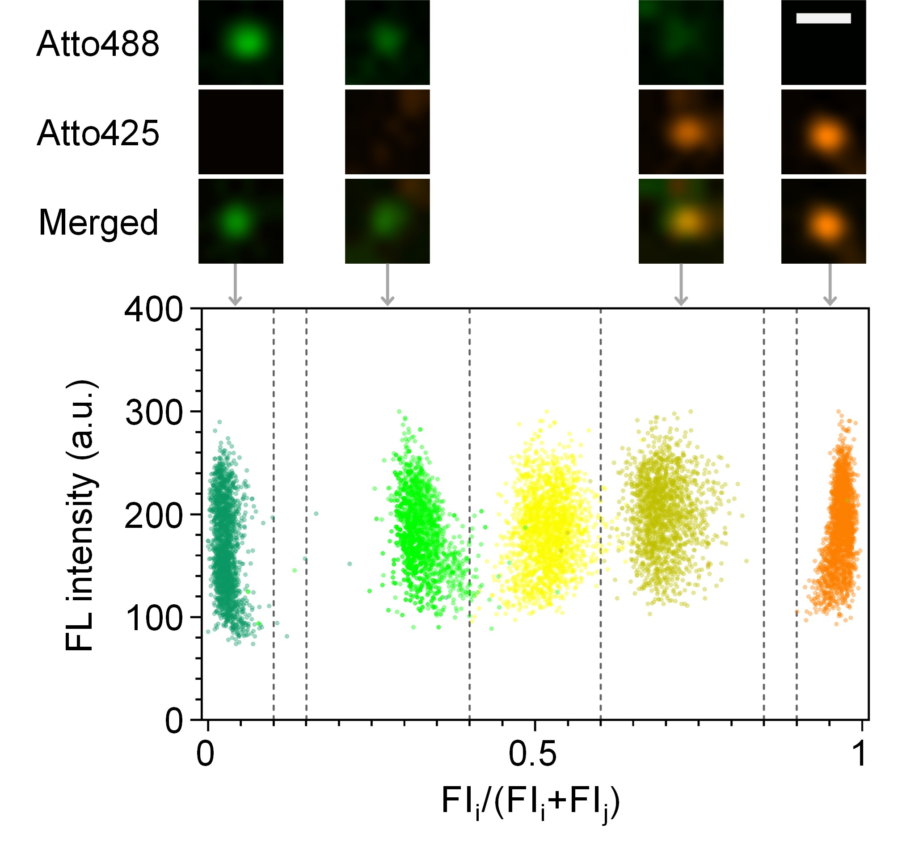
Fig. S7. Generation of protein RDCs with distinct fluorophore combinations on a glass surface. Each RDC exhibits distinct spectral characteristics, enabling clear separation among different ratio regimes (n ≥ 1654). Scale bar = 0.5 μm.

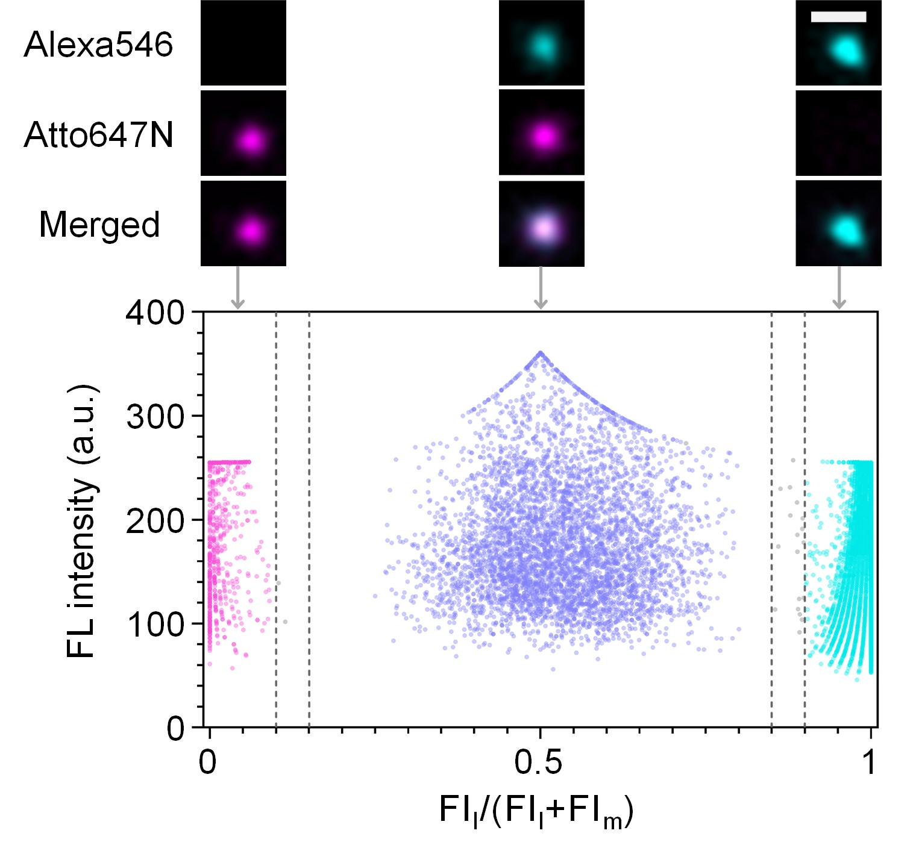
Fig. S8. Generation of mRNA RDCs with distinct fluorophore combinations in single cells. The mRNA RDCs with ratios of i:j:l:m = 0:0:1:0, 0:0:1:1, and 0:0:0:1 exhibited minimal fluorescence ratio overlap (n ≥ 820). Scale bar = 0.5 μm.

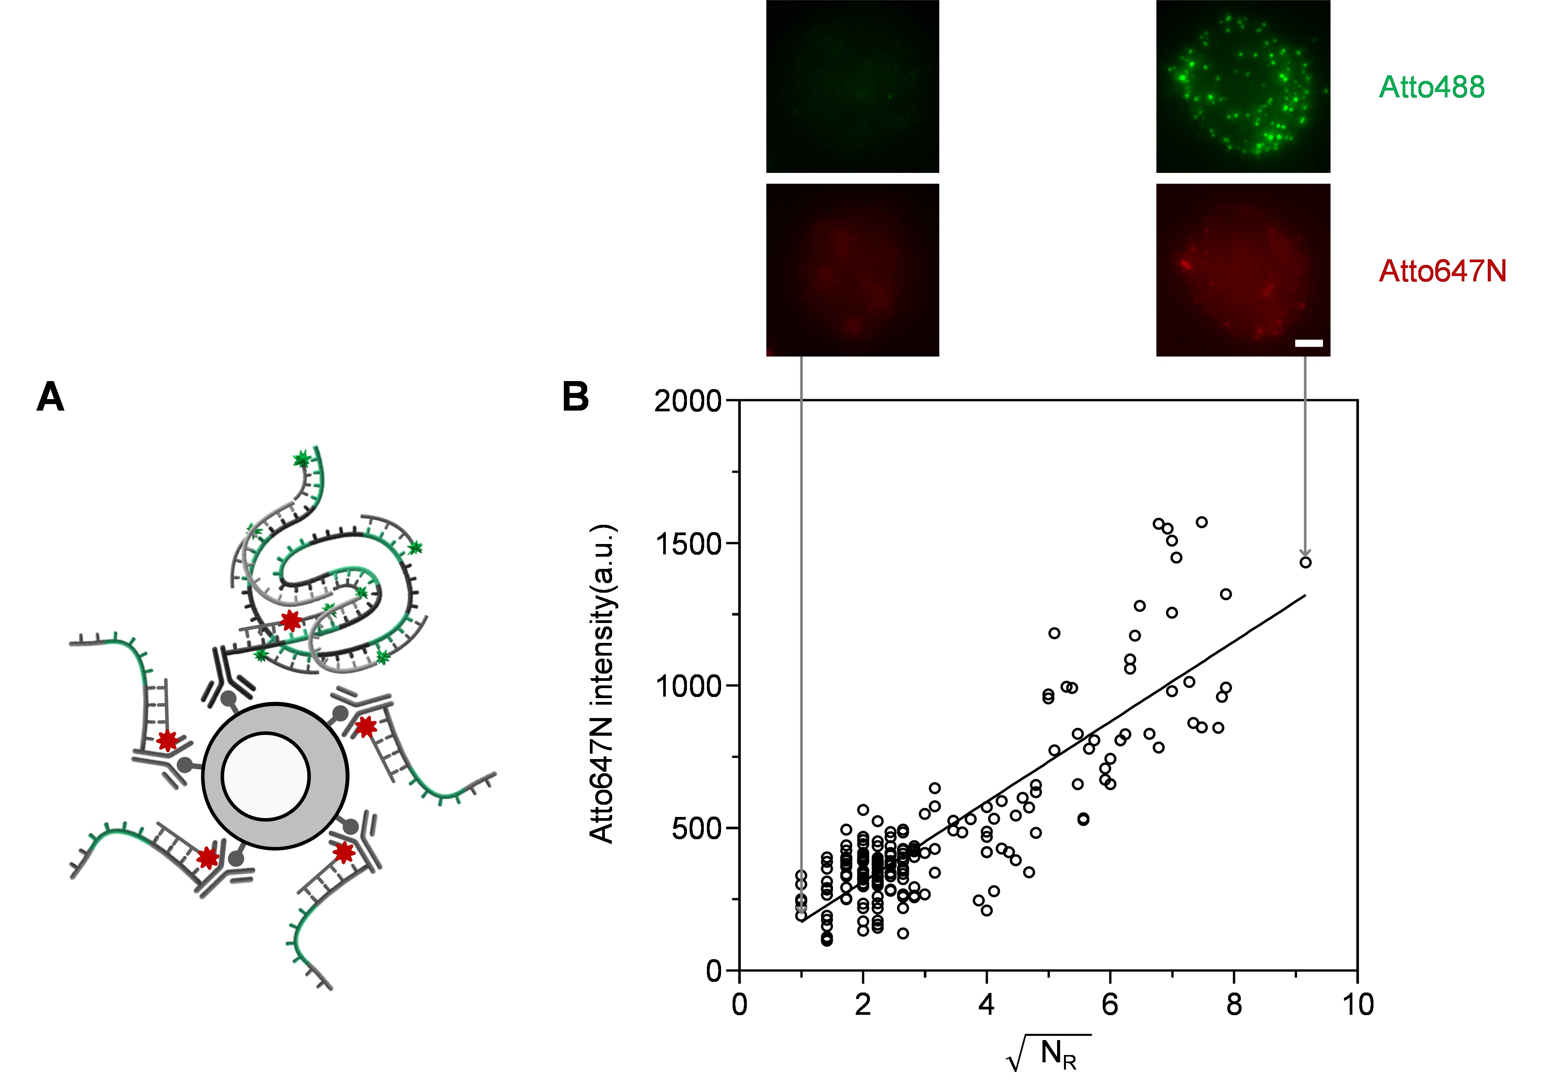
Fig. S9. Correlation between the number of RDCs and antigen expression level. (A) Schematic showing the labeling strategy of RCPs and oligo-ABs with distinct fluorophores. (B) Linear correlation between the square root of N_{R} and fluorescence intensity, with a squared Pearson correlation coefficient of R² = 0.7231 (n = 200). Scale bar = 1 μm.

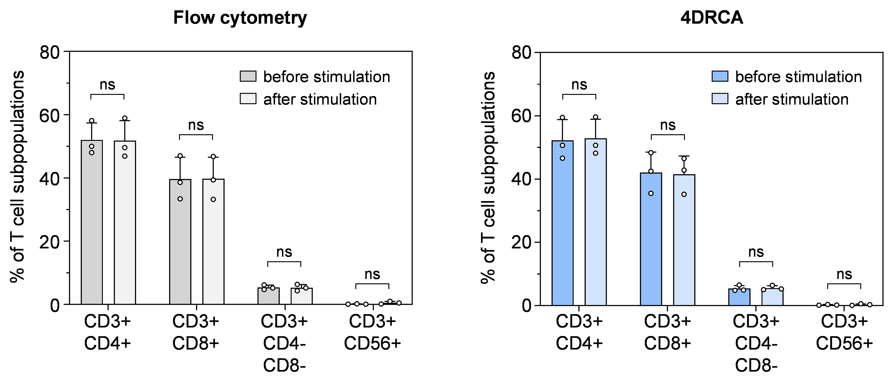
Fig. S10. Comparative analysis of T cell subpopulations before and after activation using flow cytometry and 4DRCA. The frequencies of the T cell subpopulations remained consistent after activation, as validated by both methods (n = 3 donors).

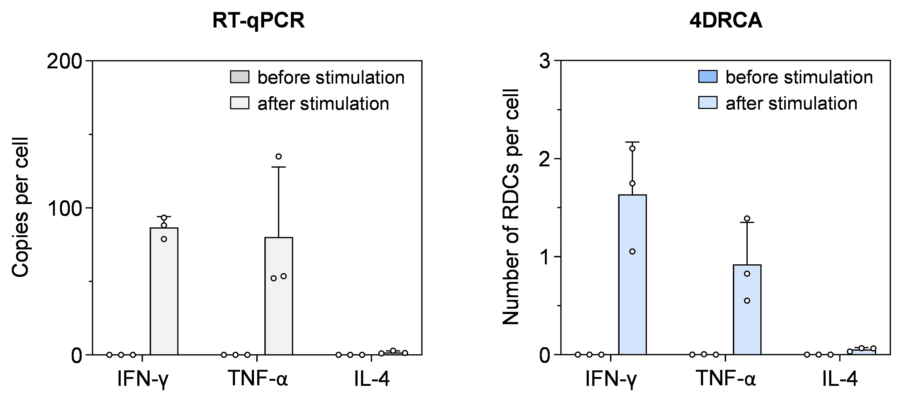
Fig. S11. Comparative analysis of mRNA expression levels before and after T cell activation using RT-qPCR and 4DRCA. Both 4DRCA and RT-qPCR revealed an increase in mRNA target levels after T cell activation (n = 3).

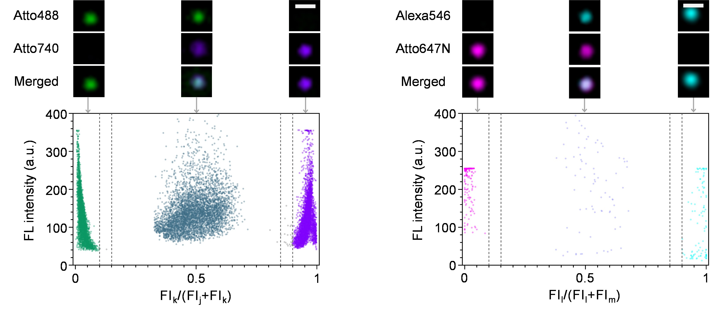
Fig. S12. Decoding of RDCs generated in leukemic cell lines. (Left) Protein RDCs were generated in Daudi cells with the ratios of i:j:k:l:m = 0:1:0:0:0, 0:1:1:0:0, and 0:0:1:0:0, representing CD10, CD19, and SLC, respectively (n ≥ 5000). (Right) Transcript RDCs were generated in KCL-22, SUP-B15, and K562 cells with ratios of i:j:k:l:m = 0:0:0:1:0, 0:0:0:1:1, and 0:0:0:0:1, representing e13a2, e1a2, and e14a2, respectively (n ≥ 80). The scatter plots illustrate the fluorescence intensities of the RDCs. Scale bars = 0.5 μm.

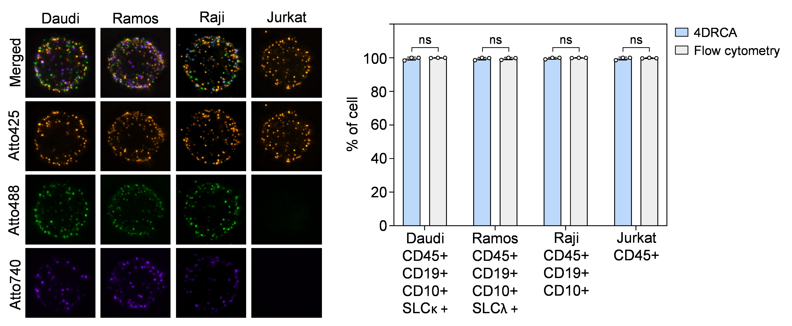
Fig. S13. Comparison of immunophenotyping results obtained with 4DRCA and conventional flow cytometry. (Left) Representative maximum intensity projection of fluorescence images of cell lines encoded with different RDCs. (Right) There was no significant difference in the frequency of each cell type expressing characteristic CD antigens between the two methods (P ≥ 0.4343) (n = 3).

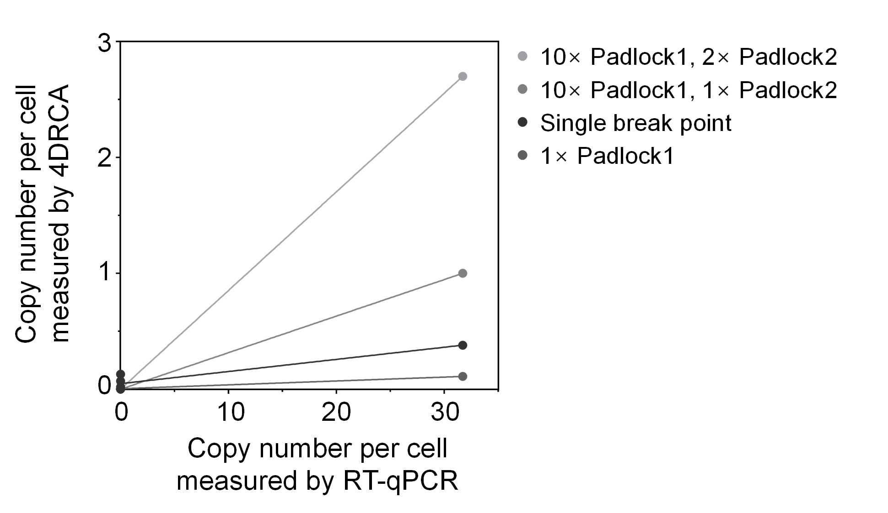
Fig. S14. Comparison of single- and dual-ligation padlock assays and the effect of the ratio between the padlock1 and padlock2 on RDC generation. The dual-ligation assay significantly increased the number of generated RDCs, overcoming the issue of breakpoint variability. By increasing the concentration of padlock1, the problem of hybridization instability between padlock1 and variable breakpoints was effectively resolved (n ≥ 500).

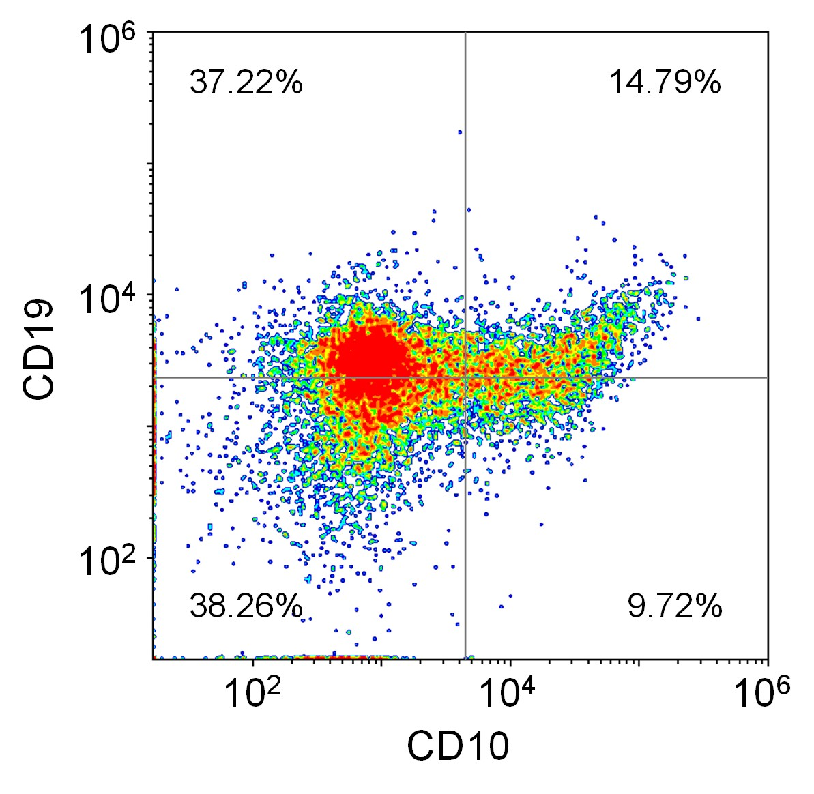
Fig. S15. Representative flow cytometry analysis of PBMCs from patient #. 1 representing their CD10+ and CD19+ antigen expression. Gating regions were defined based on IgG controls.

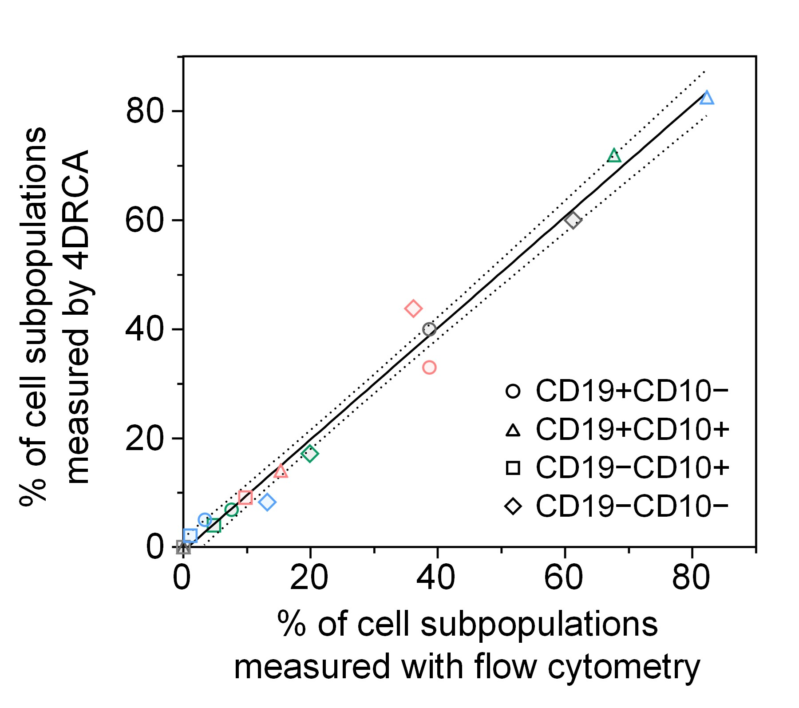
Fig. S16. Comparison of immunophenotyping results for B-ALL patients obtained using 4DRCA and conventional flow cytometry, showing R² = 0.9846 (n = 4). The solid line indicates a linear fit, and dotted lines denote the 95% confidence interval. Colored symbols indicate different donors: gray for donor #.1, red for donor #.2, blue for donor #.3 and green for donor #.4.

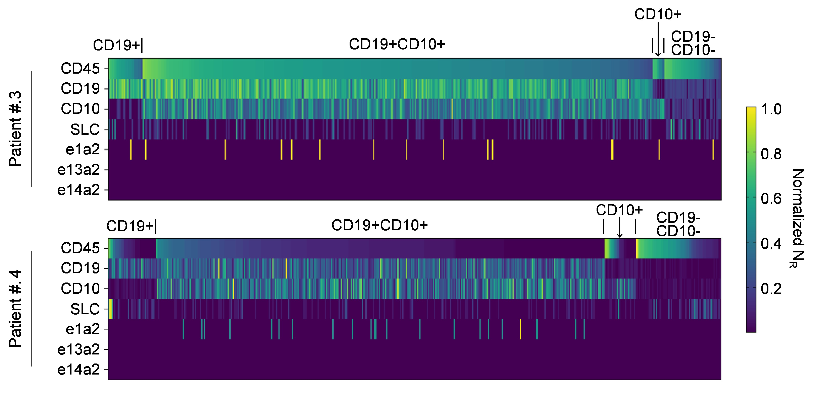
Fig. S17. Heat maps of single-cell profiling data for B-ALL patient #. 3 and #. 4.

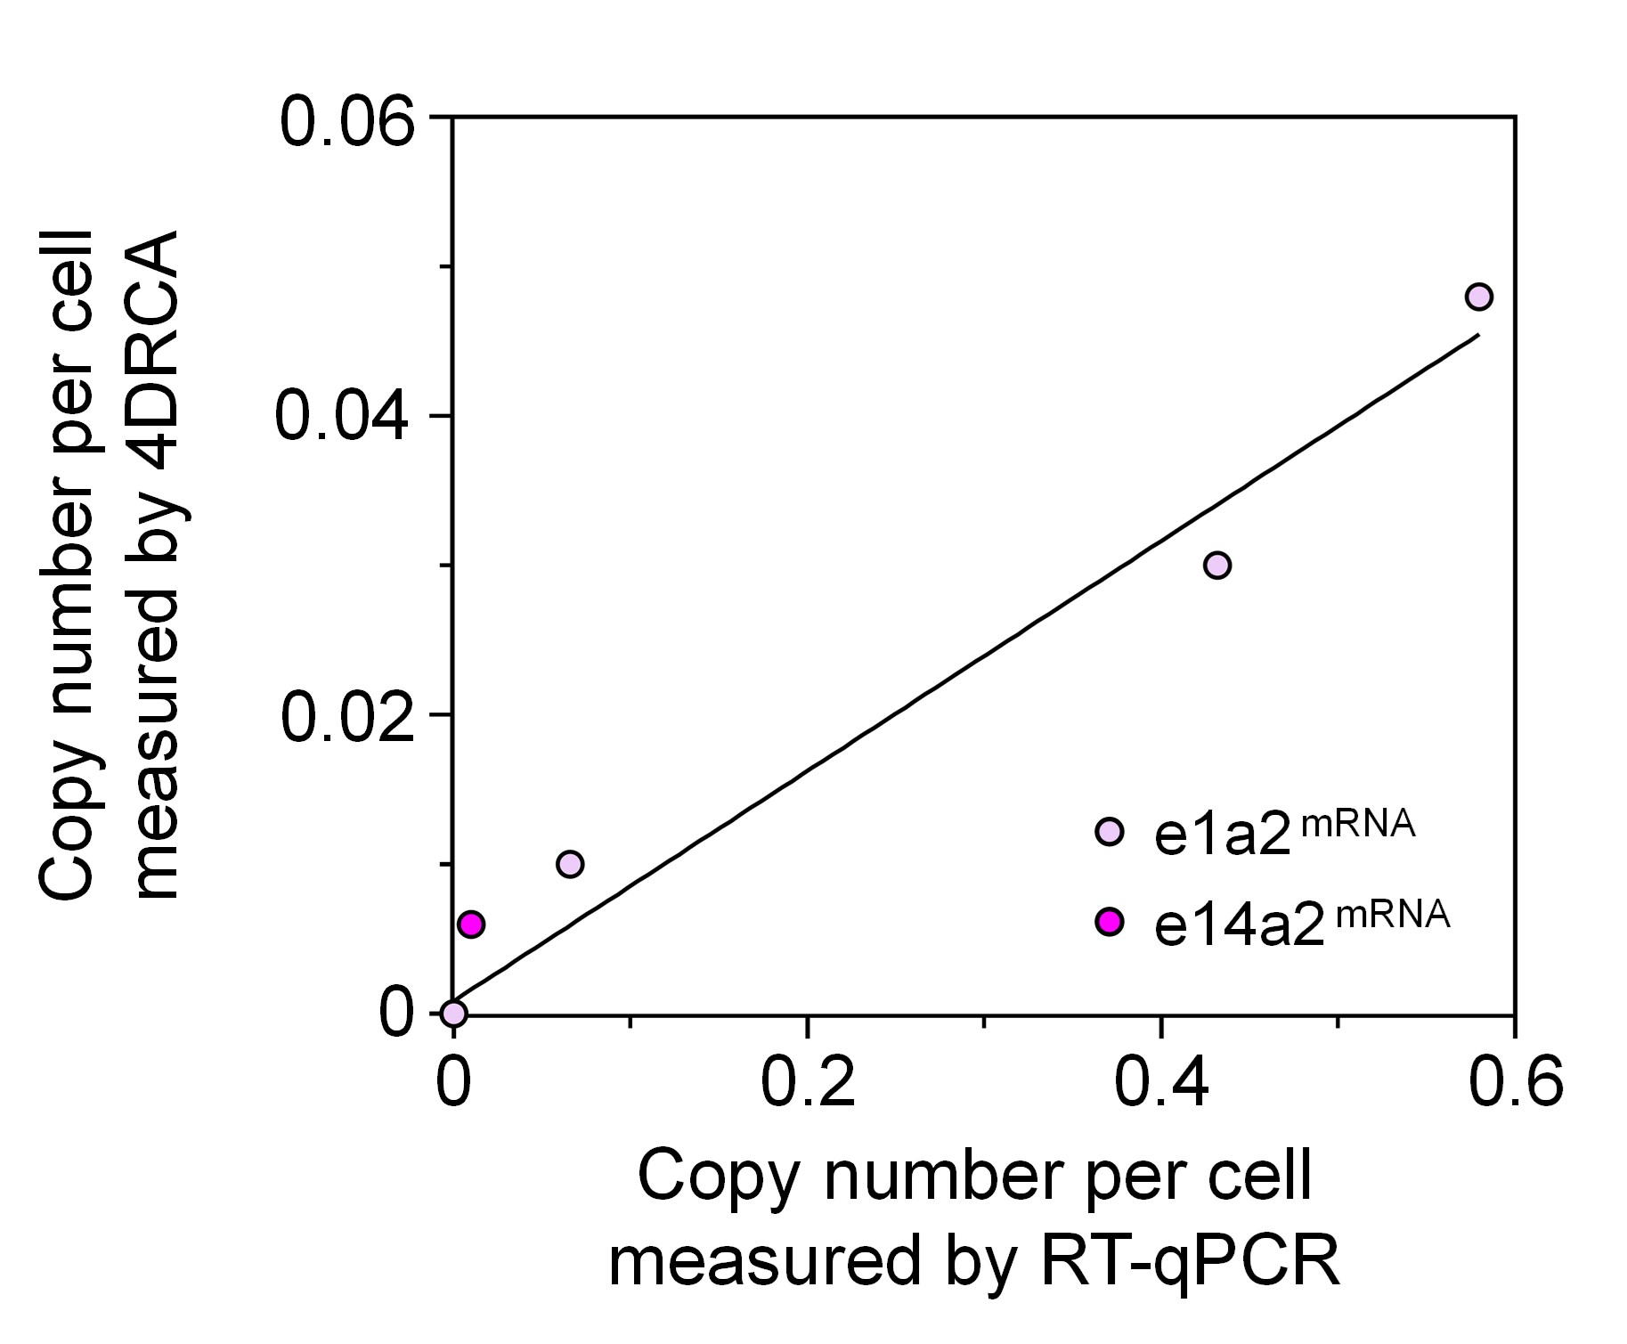
Fig. S18. Comparative analysis of BCR-ABL mRNA quantification results using 4DRCA and conventional RT-qPCR in B-ALL patients, showing a high degree of concordance with R² = 0.9445 (n = 4).

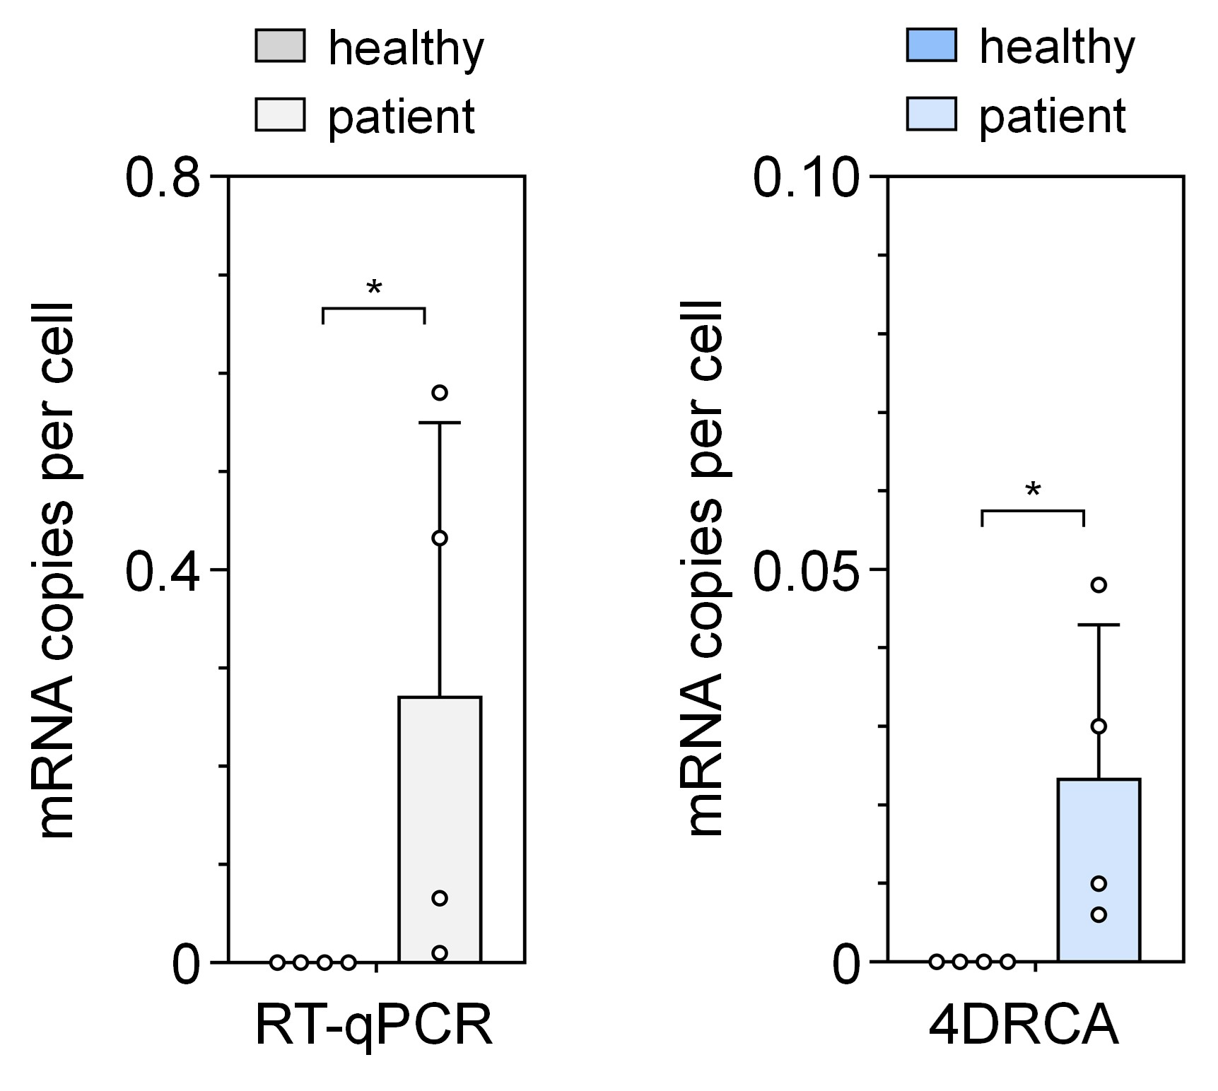
Fig. S19. Comparative analysis of BCR-ABL mRNA marker expression between B-ALL patients (n = 4) and healthy controls (n = 4). Significance levels based on Mann-Whitney test are indicated; *P < 0.05.

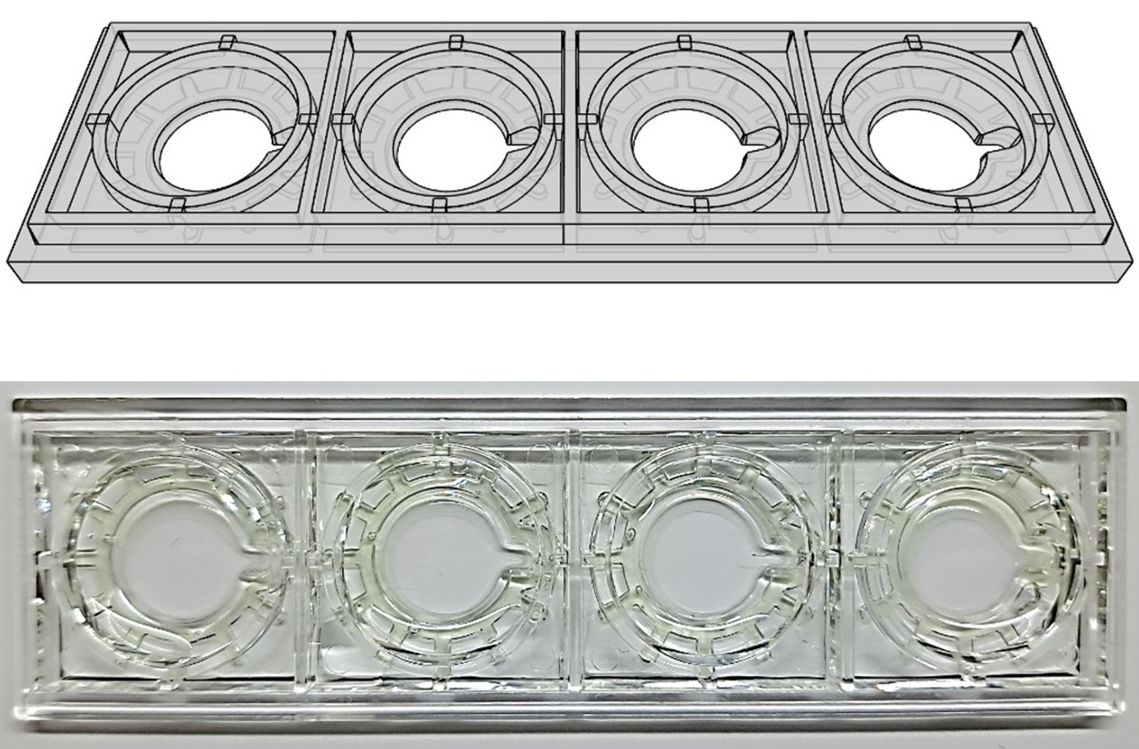

Fig. S20. 3D rendering and photograph of the multi-well chip.

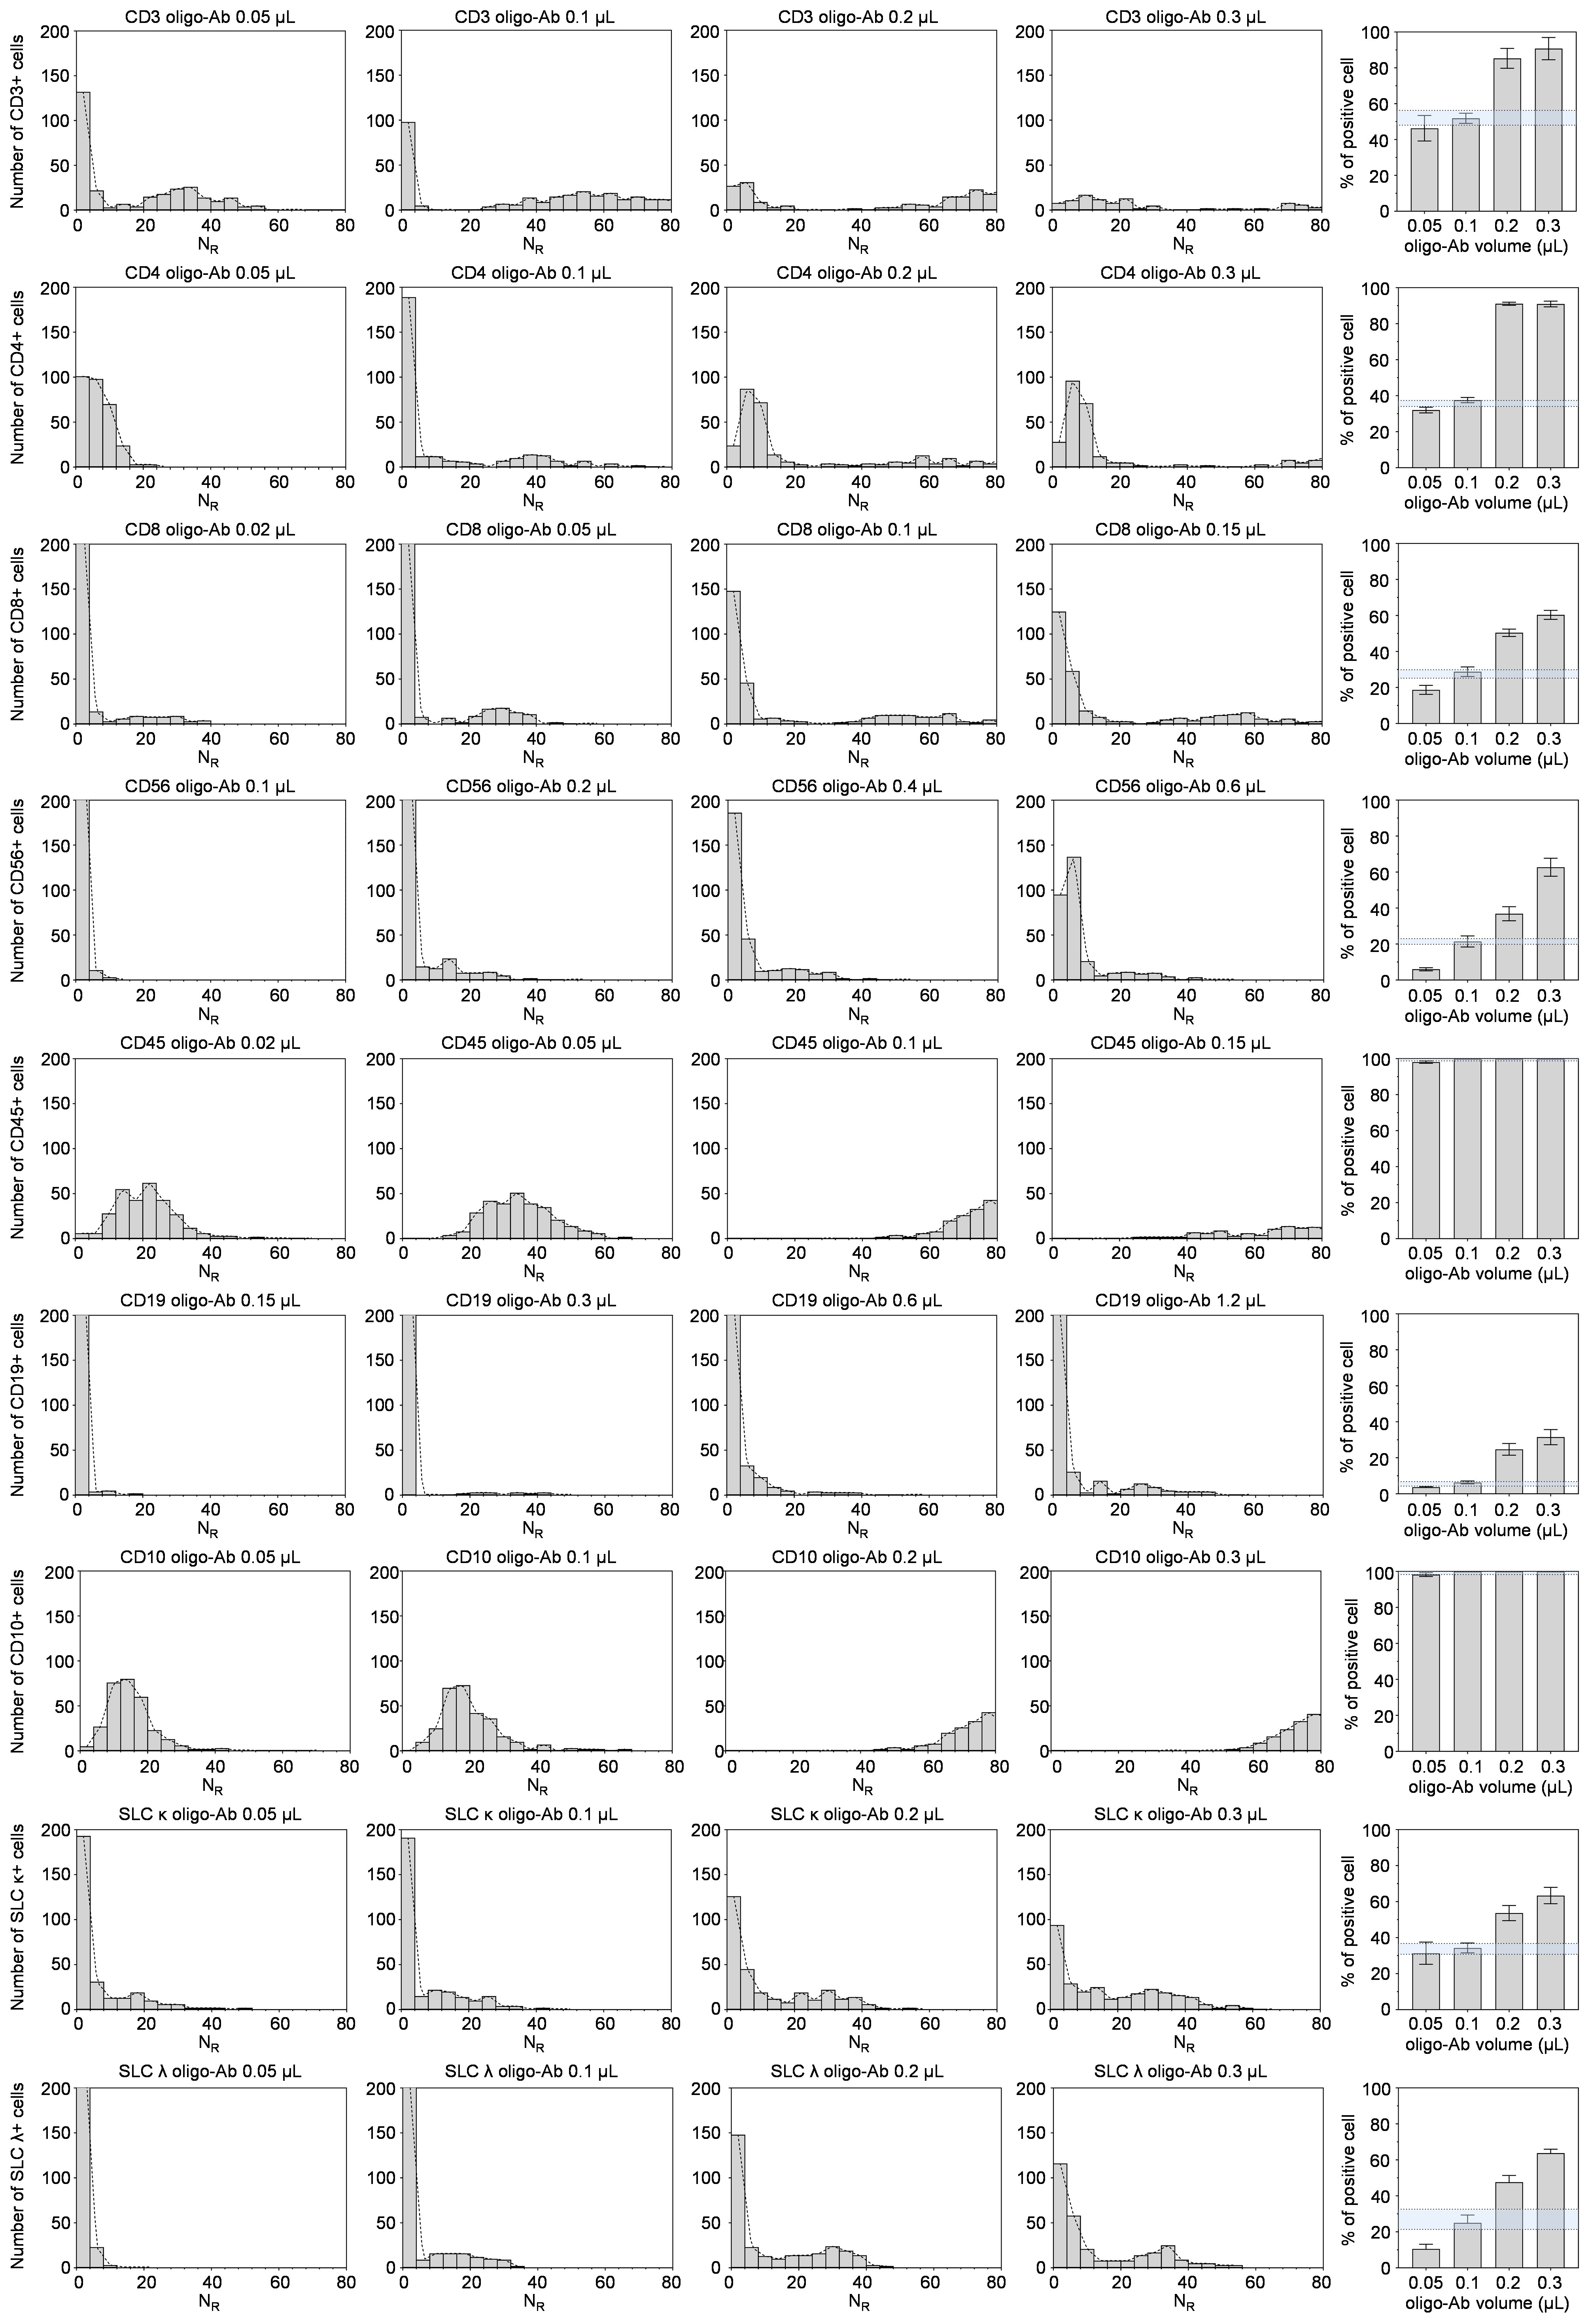
Fig. S21. Optimizing antibody usage. The concentrations of the oligo-ABs, which were not provided by the manufacturer, were individually calibrated to determine the optimal volume per test. RCA was conducted at various volumes for each oligo-AB, and the frequency of positive cells was analyzed using a positivity threshold of 4 RDCs. This frequency was compared to the positivity frequency obtained from flow cytometry analysis, and the antibody volume was optimized to achieve a match between the two values. These optimization tests were repeated for each new lot of antibodies to identify the optimal volume.

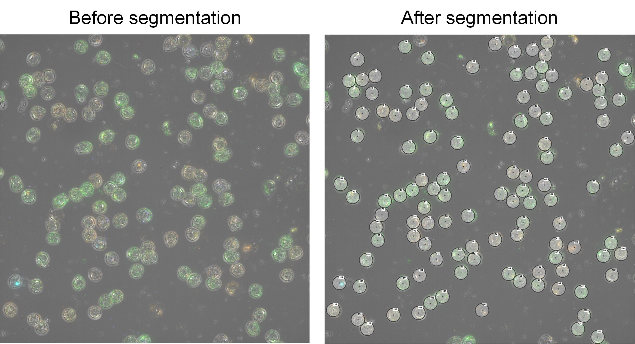
Fig. S22. Representative result of single-cell segmentation, showing cells circled along their outlines and numbered in sequential order.

2. Supplementary Tables

Table S1.
Oligonucleotide sequences used in this study.
Type | Sub-type | Sequence(5’→3’)
DNA probe | Atto 425 | Atto 425-TAGCCGTGACTATCGACT
DNA probe | Atto 488 | Atto 488-CCCTAACCCTAACCCTAA
DNA probe | Alexa 546 | Alexa 546-TATACAACATACTACCTC
DNA probe | Atto 647N | Atto 647N-TCAGAACTCACCTGTTAG
DNA probe | Atto 740 | Atto 740-CGTCTATTTAGTGGAGCC
Padlock probe | CD3 | [Phosphate]CACCGACGTCTTTGGCCTGGTGCAATAGTTTTTAGCCGTGACTATCGACTCAGGGCAATCAACCTA
Padlock probe | CD4 | [Phosphate]CTCGATCATATAGCCGTGACTATCGACTTTTTCCCTAACCCTAACCCTAATTTTCCCTAACCCTAACCCTAACAGGGCAGACGTTGGA
Padlock probe | CD8 | [Phosphate]ATATAAGCCATTTGGCCTGGTGCAATAGTTTTCCCTAACCCTAACCCTAACAGGGCAGACCCGACT
Padlock probe | C56 | [Phosphate]CCGATTATTATAGCCGTGACTATCGACTTTTTTAGCCGTGACTATCGACTTTTTCCCTAACCCTAACCCTAACAGGGCCCAACGCCTT
Padlock probe | CD45 | [Phosphate]GCAGATAACATAGCCGTGACTATCGACTTTTTTAGCCGTGACTATCGACTCAGGGCGACTACATTC
Padlock probe | CD19 | [Phosphate]TATTACCGGCCCCTAACCCTAACCCTAATTTTCGTCTATTTAGTGGAGCCCAGGGCCCACGAAGAT
Padlock probe | CD10 | [Phosphate]CTAAATCTCCTTTGGCCTGGTGCAATAGTTTTCCCTAACCCTAACCCTAACAGGGCCATAAATCCG
Padlock probe | SLC κ | [Phosphate]GCCTTAAAGCCGTCTATTTAGTGGAGCCTTTTCGTCTATTTAGTGGAGCCCAGGGCGCTAGGACCG
Padlock probe | SLC λ | [Phosphate]ACTGGCTGCGTCTATTTAGTGGAGCCTTTTCGTCTATTTAGTGGAGCCCAGGGCGTGACTT
Padlock probe | TNF-α | [Phosphate]TCTGGGGGCCGATCACTATACAACATACTACCTCCTCAATTCTGCTACTGTACTTCAGAACTCACCTGTTAGCTGGGGAACTCTTCCC
Padlock probe | IFN-γ | [Phosphate]TACCGAATAATTAGTCTATACAACATACTACCTCCTCAATTCTGCTACTGTACTTATACAACATACTACCTCGGACATTCAAGTCAGT
Padlock probe | IL4 | [Phosphate]GATCAGCTGCTTGTGCTCAGAACTCACCTGTTAGCTCAATTCTGCTACTGTACTTCAGAACTCACCTGTTAGGCCGTTTCAGGAATCG
Padlock probe | e14a2 | [Phosphate]TTGAACTCTGCTTAAATCTCAGAACTCACCTGTTAGCTCAATTCTGCTACTGTACTTTTGGCCTGGTGCAATAGGGACCCGGAGCTTTTCAC
Padlock probe | e14a2  PP1 | [Phosphate] TGAAGGGCTTTGAACTCTGC
Padlock probe | e14a2  PP2 | [Phosphate]TTAAATCCAGTCAGAACTCACCTGTTAGCTCAATTCTGCTACTGTACTTTTGGCCTGGTGCAATAGTACTGGCCGC
Padlock probe | e13a2 | [Phosphate]CTTCCTTATTGATGGTCATCAGAACTCACCTGTTAGCTCAATTCTGCTACTGTACTTATACAACATACTACCTCCTGGCCGCTGAAGGGCTT
Padlock probe | e13a2  PP1 | [Phosphate]TGAAGGGCTTCTTCCTTATT
Padlock probe | e13a2  PP2 | [Phosphate]GATGGTCAGCTATACAACATACTACCTCCTCAATTCTGCTACTGTACTTTTGGCCTGGTGCAATAGTACTGGCCGC
Padlock probe | e1a2 | [Phosphate]CTGCGTCTCCATGGAAGGTATACAACATACTACCTCCTCAATTCTGCTACTGTACTTTTGGCCTGGTGCAATAGGGACCCGGAGCTTTTCAC
Padlock probe | e1a2  PP1 | [Phosphate] TGAAGGGCTTCTGCGTCTCC
Padlock probe | e1a2  PP2 | [Phosphate]ATGGAAGGCGTCAGAACTCACCTGTTAGCTCAATTCTGCTACTGTACTTATACAACATACTACCTCTACTGGCCGC
Primer for PCR | TNF-α F | CTCTTCTGCCTGCTGCACTTTG
Primer for PCR | TNF-α R | ATGGGCTACAGGCTTGTCACTC
Primer for PCR | IFN-γ F | AGCTCTGCATCGTTTTGGGTT
Primer for PCR | IFN-γ R | GTTCCATTATCCGCTACATCTGAA
Primer for PCR | IL4 F | AGCAGCTGATCCGATTCCTGA
Primer for PCR | IL4 R | TCCAACGTACTCTGGTTGGCTTC
Primer for PCR | e14a2 F | TCCACTCAGCCACTGGATTTAA
Primer for PCR | e14a2 R | TGGGTCCAGCGAGAAGGTT
Primer for PCR | e13a2 F | GCATTCCGCTGACCATCAAT
Primer for PCR | e13a2 R | TGGGTCCAGCGAGAAGGTT
Primer for PCR | e1a2 F | CGCAAGACCGGGCAGAT
Primer for PCR | e1a2 R | TGGGTCCAGCGAGAAGGTT
Primer for RCA | Common primer for mRNA | AGTACAGTAGCAGAATTGAG
Staple strand | CD3 | CAACCTACACCGACAAAAACAACCTACACC[2'-MOE(G)][2'-MOE(A)][2'-MOE 5-Methyl(C)]
Staple strand | CD4 | CGTTGGACTCGATCAAAAACGTTGGACTCG[2'-MOE(A)][2'-MOE(U)][2'-MOE 5-Methyl(C)]
Staple strand | CD8 | CCCGACTATATAAGAAAAACCCGACTATAT[2'-MOE(A)][2'-MOE(A)][2'-MOE(G)]
Staple strand | CD56 | ACGCCTTCCGATTAAAAAAACGCCTTCCGA[2'-MOE(U)][2'-MOE(U)][2'-MOE(A)]
Staple strand | CD45 | TACATTCGCAGATAAAAAATACATTCGCAG[2'-O-Methyl(A)][2'-O-Methyl(U)][2'-MOE(A)]
Staple strand | CD19 | CGAAGATTATTACCAAAAACGAAGATTATT[2'-MOE(A)][2'-MOE 5-Methyl(C)][2'-MOE 5-Methyl(C)]
Staple strand | CD10 | AAATCCGCTAAATCAAAAAAAATCCGCTAA[2'-MOE(A)][2'-MOE(U)][2'-MOE 5-Methyl(C)]
Staple strand | SLC κ | AGGACCGGCCTTAAAAAAAAGGACCGGCCT[2'-MOE(U)][2'-MOE(A)][2'-MOE(A)]
Staple strand | SLC λ | GTGACTTACTGGCTAAAAAGTGACTTACTG[2'-MOE(G)][2'-MOE 5-Methyl(C)][2'-MOE(U)]

Table S2.
List of antibodies used in this study.
Application | Target | Clone | Vendor | Catalog No.
Flow cytometry | CD3 (PE-Cy™7) | SK7 | BD Biosciences | 557851
Flow cytometry | CD4 (APC) | RPA-T4 | BD Biosciences | 555349
Flow cytometry | CD8 (FITC) | RPA-T8 | BD Biosciences | 555366
Flow cytometry | CD56 (FITC) | B159 | BD Biosciences | 562794
Flow cytometry | CD56 (APC) | NCAM16.2 | BD Biosciences | 341027
Flow cytometry | CD45 (FITC) | HI30 | BD Biosciences | 555482
Flow cytometry | CD45 (APC) | HI30 | BD Biosciences | 555485
Flow cytometry | CD19 (PE-Cy™7) | HIB19 | BD Biosciences | 560728
Flow cytometry | CD10(FITC) | HI10a | BD Biosciences | 340925
Flow cytometry | λ Light Chain (FITC) | 1-155-2 | BD Biosciences | 346600
Flow cytometry | κ Light Chain (APC) | G20-193 | BD Biosciences | 561323
RCA | Ab-Oligo Mouse Anti-Human CD3 | SK7 | BD Biosciences | 940000
RCA | Ab-Oligo Mouse Anti-Human CD4 | RPA-T4 | BD Biosciences | 940304
RCA | Ab-Oligo Mouse Anti-Human CD8 | RPA-T8 | BD Biosciences | 940003
RCA | Ab-Oligo Mouse Anti-Human CD56 | NCAM1 | BD Biosciences | 940007
RCA | Ab-Oligo Mouse Anti-Human CD45 | HI30 | BD Biosciences | 940002
RCA | Ab-Oligo Mouse Anti-Human CD19 | SJ25C1 | BD Biosciences | 940004
RCA | Ab-Oligo Mouse Anti-Human CD10 | HI10a | BD Biosciences | 940045
RCA | λ Light Chain | MHL-38 | BioLegend | 316629
RCA | κ Light Chain | MHK-49 | BioLegend | 316535

3. Supplementary Videos
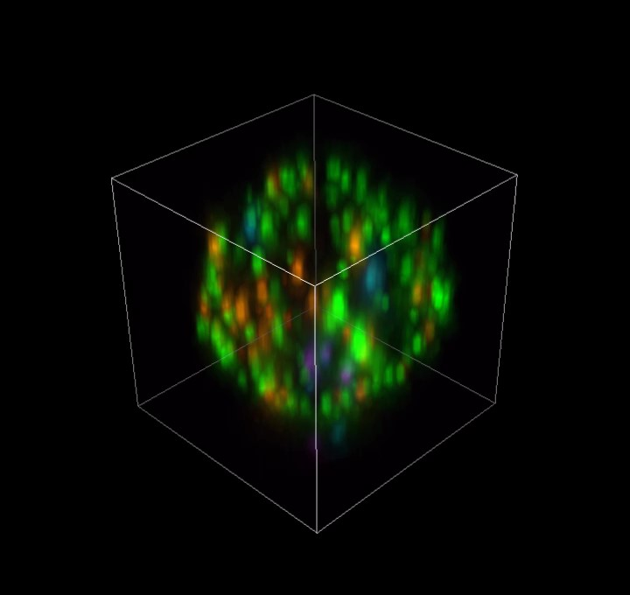
Movie S1. 3D rendering image of RDCs on a single T cell shown in Fig. 1B before 3D deconvolution.

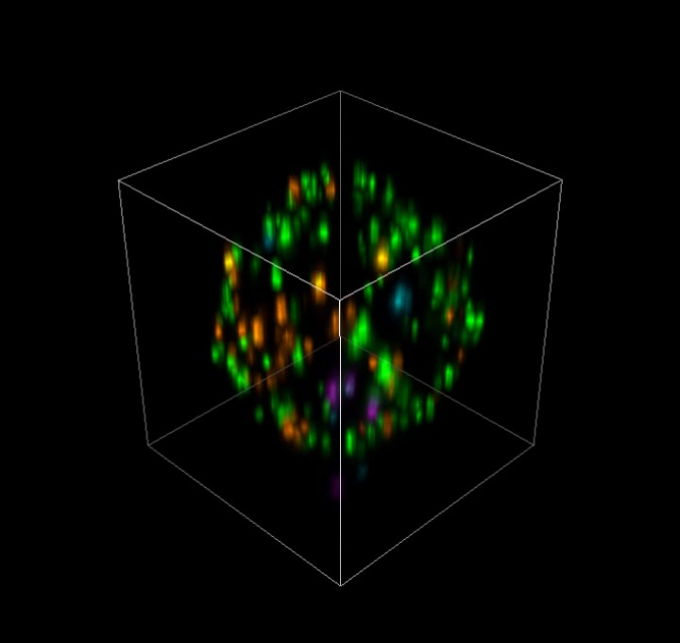
Movie S2. 3D rendering image of RDCs on a single T cell shown in Fig. 1B after 3D deconvolution.

