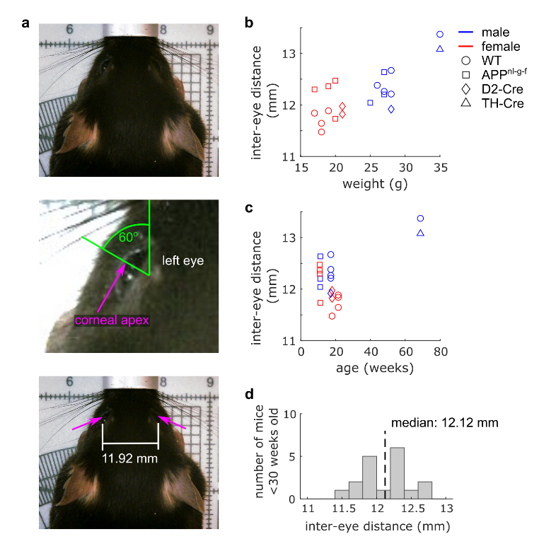

Supplementary Figure 1: Mouse inter-eye distance.
a, Views of an anesthetized mouse from above for measuring distance between corneal apexes. b, Scatterplot of eye distance measurement as a function of mouse weight, with markers colored by mouse sex (blue: male, red: female) and marker types identifying the mouse genotype. c, Scatterplot of the data in (b) plotted alternatively as a function of mouse age. d, Histogram of inter-eye distances of all mice younger than 30 weeks (n = 18 mice, 11-22 weeks), with the median inter-eye distance plotted as a dotted black line.

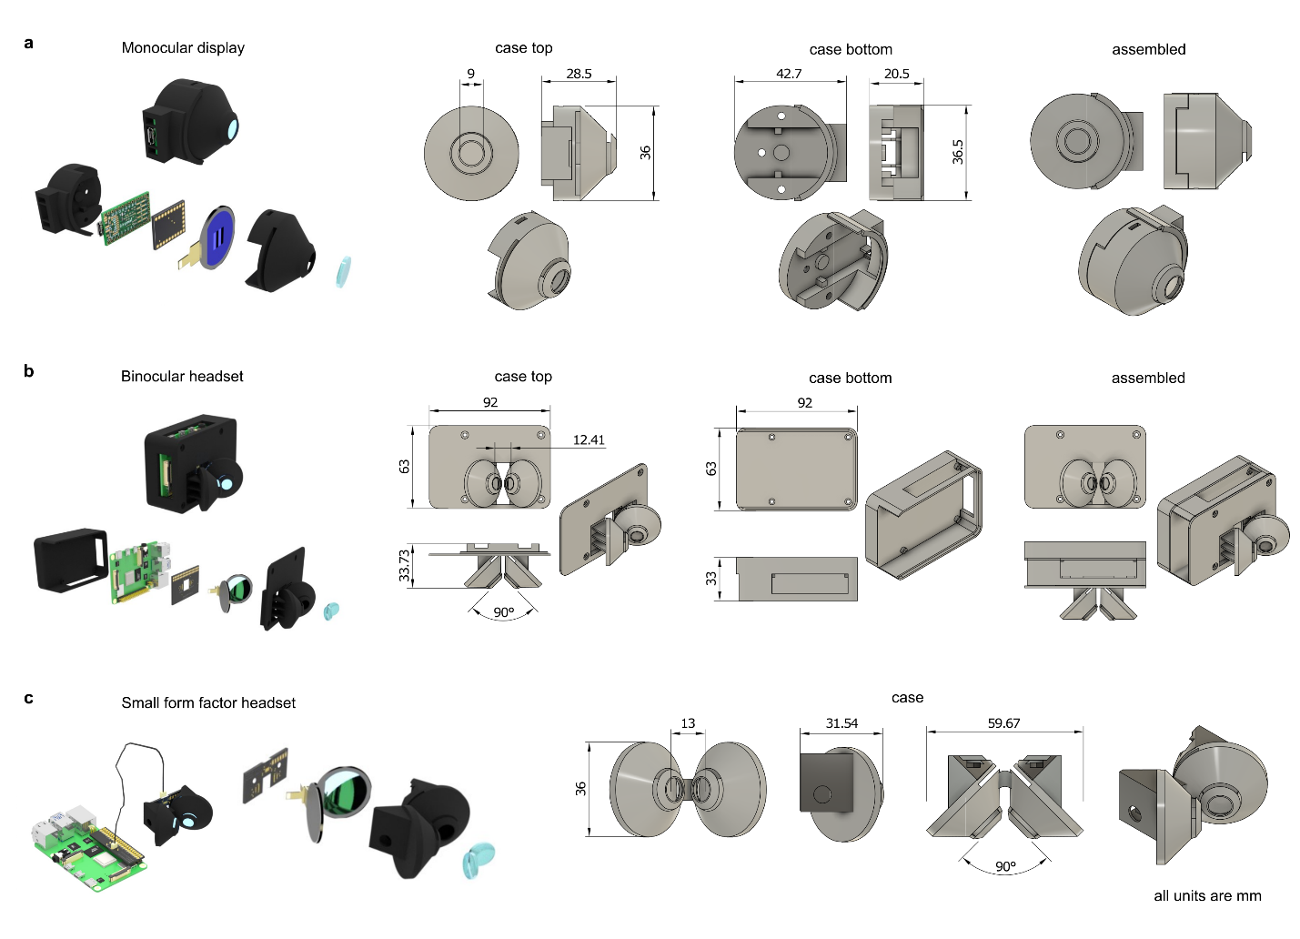

Supplementary Figure 2: Designs of monocular and binocular display enclosures.
a, (left) 3D renders of assembled and exploded views of the monocular display. (right) CAD designs and overall dimensions (in mm) of the top and bottom halves of the display case as well as the fully assembled case. b, (left) 3D renders and (right) CAD designs of the binocular headset. c, (left) 3D renders and (right) CAD designs of the smaller form factor binocular headset, connecting to a raspberry Pi with a SPI cable. All units are in mm.

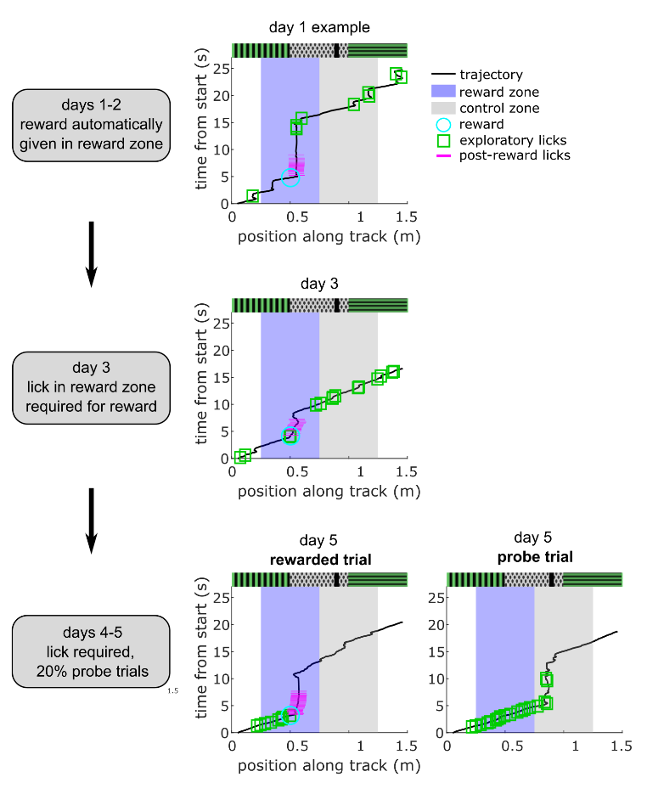

Supplementary Figure 3: Rewarded linear track protocol and example trajectories.
(left) Description of the 5-day training protocol for virtual linear track spatial-learning. (right) Example mouse trajectories during training days 1, 3, and 5, with detected licks and delivered liquid reward overlayed on the trajectory. Two example trajectories are shown for day 5, including one rewarded trial and one probe trial.

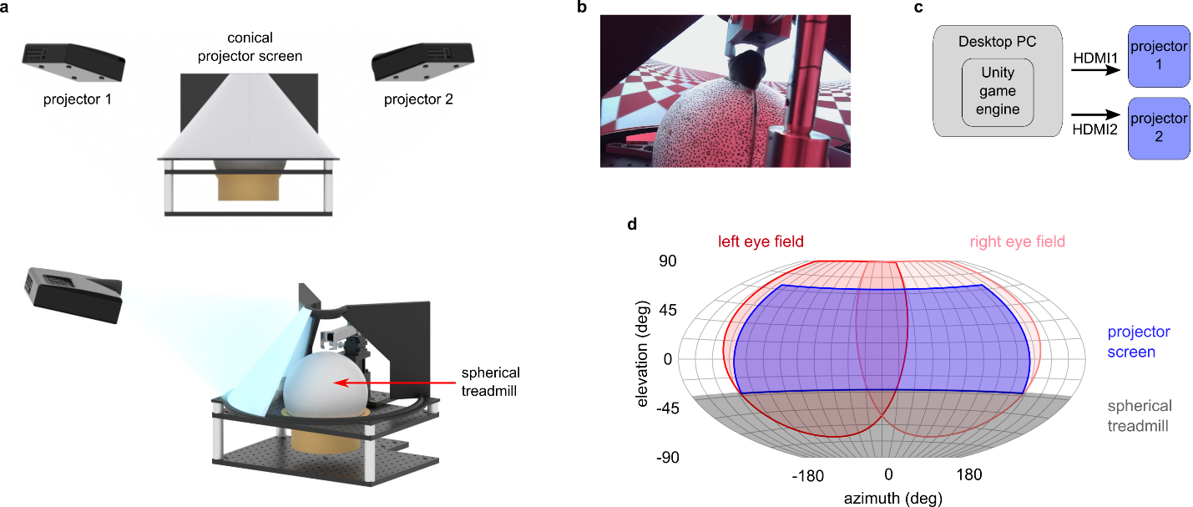

Supplementary Figure 4: Projector-based VR system for looming reaction comparison.
a, 3D renders of the custom projector-based VR system composed of two HD projectors, a high FOV conical screen, and spherical treadmill. b, Image of a head-fixed mouse running on the spherical treadmill inside the projector-based VR system. c, Communication diagram of the Desktop PC and Unity game engine system for rendering 3D environments onto the dual-projector display. d, Winkel-Tripel projection of the mouse’s estimated visual field (red shaded regions) overlayed with the estimated visual field coverage of the projector screen and spherical treadmill.

Supplementary Video 1 (attached)
Head-fixed mouse using VR headset while walking on a spherical treadmill.

Supplementary Video 2 (attached)
Example head-fixed startle responses from looming visual stimuli in VR headset.

