Appendix Figure 1. Choices and results for both organized breast cancer screening and opportunistic case detection 30
Appendix Figure 2. The incidence of breast cancer in the eight settings 31
Appendix Table 1. Variation range and distributions assumed for transition probabilities for breast cancer 31
Appendix Table 2. Variation range and distributions assumed for treatment costs 33
Appendix Table 3. Variation range and distributions assumed for screening costs 37
Appendix Table 4. Variation range and distributions assumed for utilities for different stages of breast cancer 42
Appendix Table 5. Variation range and distributions assumed for screening sensitivities and specificities 42
Appendix Figure 3. Natural mortality for different ages in China 43
Appendix Formula. The calculation formula of eight settings per capita GDP 44
Appendix Table 6. Parameters for the calculation of eight settings per capita GDP 44
Appendix Figure 4. Breast cancer screening management system 45
Appendix Table 7. Consolidated Health Economic Evaluation Reporting Standards (CHEERS) checklist 45

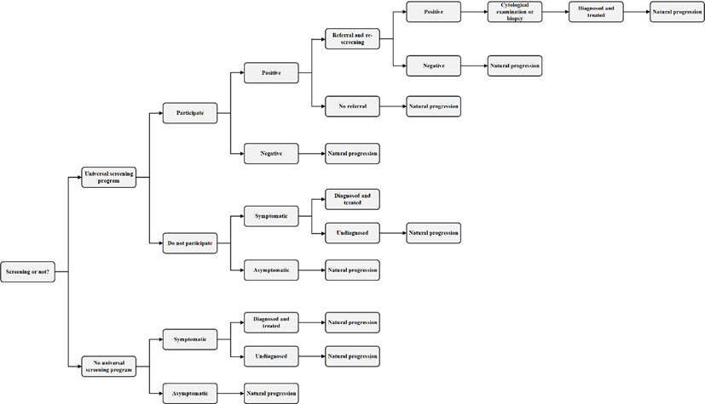

Appendix Figure 1. Choices and results for both organized breast cancer screening and opportunistic case detection

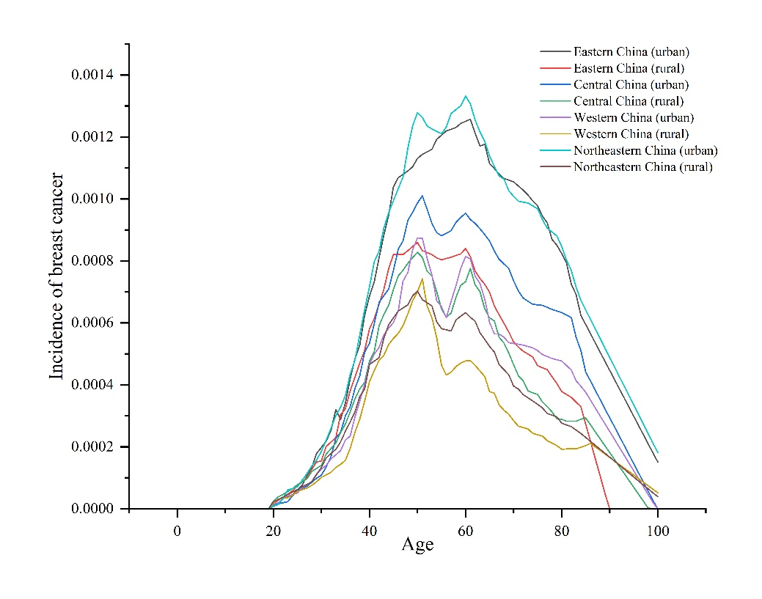

Appendix Figure 2. The incidence of breast cancer in the eight settings
*The incidence of breast cancer in the eight settings was collected from the China Cancer Registry Annual Report.¹ However, this report did not include data on the incidence in northeastern China. Published literature indicated that the incidence in northeastern China closely resembled that of the entire country, so we used the national incidence as a substitute.

Appendix Table 1. Variation range and distributions assumed for transition probabilities for breast cancer
 | Base-case values | Source | Ranges for sensitivity analysis (±5%) | Probability distribution for sensitivity analysis
Ratio of DCIS incidence to invasive breast cancer incidence | 12.00% | Sun, L et al. (2018)² | 11.40%-12.60% | Beta (1055.88,7743.12)
RR of invasive cancer from DCIS | 202.00% | Sun, L et al. (2018)² | 192.00%-212.00% | Uniform (1.92,2.12)
From Stage I to Stage II | 6.00% | Sun, L et al. (2018)² | 5.70%-6.30% | Beta (1127.94,17671.06)
From Stage II to Stage III | 11.00% | Sun, L et al. (2018)² | 10.45%-11.55% | Beta (1067.89,8460.20)
From Stage III to Stage IV | 15.00% | Sun, L et al. (2018)² | 14.25%-15.75% | Beta (1019.85,5779.15)
From Stage I to Breast cancer death | 9.00% | Malek, Pascha VA et al. (2021)³ | 8.55%-9.45% | Beta (1091.91,11040.42)
From Stage II to Breast cancer death | 5.00% | Malek, Pascha VA et al. (2021)³ | 4.75%-5.25% | Beta (1139.95,21659.05)
From Stage III to Breast cancer death | 9.00% | Malek, Pascha VA et al. (2021)³ | 8.55%-9.45% | Beta (1091.91,11040.42)
From Stage IV to Breast cancer death | 86.00% | Malek, Pascha VA et al. (2021)³ | 81.70%-90.30% | Beta (167.14,27.21)
From Remission stage I to Local recurrence stage I | 1.00% | Nguyen, C P et al. (2018)⁴ | 0.95%-1.05% | Beta (1187.99,117611.01)
From Remission stage I to Distant recurrence stage I | 0.00% | Nguyen, C P et al. (2018)⁴ | 0.0015%-0.0017% | Beta (1199.98,74997599.02)
From Local recurrence stage I to Distant recurrence stage I | 6.20% | Nguyen, C P et al. (2018)⁴ | 5.89%-6.51% | Beta (1125.54,17028.30)
From Local recurrence stage I to Breast cancer death | 1.30% | Nguyen, C P et al. (2018)⁴ | 1.24%-1.37% | Beta (1184.39,89922.31)
From Distant recurrence stage I to Breast cancer death | 38.60% | Nguyen, C P et al. (2018)⁴ | 52.73%-58.28% | Beta (736.41,1171.39)
From Remission stage II/III to Local recurrence stage II/III | 1.80% | Nguyen, C P et al. (2018)⁴ | 1.71%-1.89% | Beta (1178.38,64287.28)
From Remission stage II/III to Distant recurrence stage II/III | 2.40% | Nguyen, C P et al. (2018)⁴ | 2.28%-2.52% | Beta (1171.18,47627.82)
From Local recurrence stage II/III to Distant recurrence stage II/III | 16.50% | Nguyen, C P et al. (2018)⁴ | 15.68%-17.33% | Beta (1001.84,5069.89)
From Local recurrence stage II/III to Breast cancer death | 1.30% | Nguyen, C P et al. (2018)⁴ | 1.24%-1.37% | Beta (1184.39,89922.31)

Appendix Table 2. Variation range and distributions assumed for treatment costs
 |  |  | Western China settings
 |  |  | Base-case values | Source | Ranges for sensitivity analysis (±10%) | Probability distribution for sensitivity analysis
Treatment cost, US$/person
DCIS |  |  | 5558.36 | Li, H et al. (2013)⁵ | 5002.52-6114.19 | Gamma (300.00,18.53)
BC stage I |  |  | 8221.16 | Liao, X Z et al. (2018)⁶ | 7399.04-9043.27 | Gamma (300.00,27.40)
BC stage II |  |  | 8318 | Liao, X Z et al. (2018)⁶ | 7486.20-9149.80 | Gamma (300.00,27.73)
BC stage III |  |  | 10487.17 | Liao, X Z et al. (2018)⁶ | 9438.45-11535.89 | Gamma (300.00,34.96)
BC stage IV |  |  | 15784.22 | Liao, X Z et al. (2018)⁶ | 14205.80-17362.64 | Gamma (300.00,52.61)
Direct cost, US$/person |  |  |  | Liao, X Z et al. (2018)⁶
BC stage I |  |  | 7310.88 | Liao, X Z et al. (2018)⁶ | 6579.79-8041.97 | None defined
BC stage II |  |  | 7407.72 | Liao, X Z et al. (2018)⁶ | 6666.95-8148.49 | None defined
BC stage III |  |  | 9325.11 | Liao, X Z et al. (2018)⁶ | 8392.60-10257.62 | None defined
BC stage IV |  |  | 14167.02 | Liao, X Z et al. (2018)⁶ | 12750.32-15583.72 | None defined
Indirect cost, US$/person |  |  |  | Liao, X Z et al. (2018)⁶
BC stage I |  |  | 910.28 | Liao, X Z et al. (2018)⁶ | 819.25-1001.31 | None defined
BC stage II |  |  | 910.28 | Liao, X Z et al. (2018)⁶ | 819.25-1001.31 | None defined
BC stage III |  |  | 1162.06 | Liao, X Z et al. (2018)⁶ | 1045.85-1278.26 | None defined
BC stage IV |  |  | 1617.2 | Liao, X Z et al. (2018)⁶ | 1455.48-1778.92 | None defined
 |  |  | Central China settings
Treatment cost, US$/person
DCIS |  |  | 4533.94 | Li, H et al. (2013)⁵ | 4080.54-4987.33 | Gamma (300.00,15.11)
BC stage I |  |  | 6705.98 | Liao, X Z et al. (2018)⁶ | 6035.38-7376.58 | Gamma (300.00,22.35)
BC stage II |  |  | 6784.97 | Liao, X Z et al. (2018)⁶ | 6106.47-7463.47 | Gamma (300.00,22.62)
BC stage III |  |  | 8554.36 | Liao, X Z et al. (2018)⁶ | 7698.92-9409.80 | Gamma (300.00,28.51)
BC stage IV |  |  | 12875.15 | Liao, X Z et al. (2018)⁶ | 11587.63-14162.66 | Gamma (300.00,42.92)
Direct cost, US$/person |  |  |  | Liao, X Z et al. (2018)⁶
BC stage I |  |  | 5963.47 | Liao, X Z et al. (2018)⁶ | 5367.12-6559.81 | None defined
BC stage II |  |  | 6042.46 | Liao, X Z et al. (2018)⁶ | 5438.21-6646.70 | None defined
BC stage III |  |  | 7606.47 | Liao, X Z et al. (2018)⁶ | 6845.83-8367.12 | None defined
BC stage IV |  |  | 11556.01 | Liao, X Z et al. (2018)⁶ | 10400.40-12711.61 | None defined
Indirect cost, US$/person |  |  |  | Liao, X Z et al. (2018)⁶
BC stage I |  |  | 742.51 | Liao, X Z et al. (2018)⁶ | 668.26-816.76 | None defined
BC stage II |  |  | 742.51 | Liao, X Z et al. (2018)⁶ | 668.26-816.76 | None defined
BC stage III |  |  | 947.89 | Liao, X Z et al. (2018)⁶ | 853.10-1042.68 | None defined
BC stage IV |  |  | 1319.14 | Liao, X Z et al. (2018)⁶ | 1187.23-1451.06 | None defined
BC stage II |  |  | 918.46 | Liao, X Z et al. (2018)⁶ | 826.62-1010.31 | None defined
BC stage III |  |  | 1172.51 | Liao, X Z et al. (2018)⁶ | 1055.25-1289.76 | None defined
BC stage IV |  |  | 1631.74 | Liao, X Z et al. (2018)⁶ | 1468.56-1794.91 | None defined
Indirect cost, US$/person |  |  |  | Liao, X Z et al. (2018)⁶
BC stage I |  |  | 328.21 | Liao, X Z et al. (2018)⁶ | 295.39-361.03 | None defined
 |  |  | Eastern China settings
Treatment cost, US$/person
DCIS |  |  | 5608.33 | Li, H et al. (2013)⁵ | 5047.50-6169.16 | Gamma (300.00,18.69)
BC stage I |  |  | 8295.07 | Liao, X Z et al. (2018)⁶ | 7465.56-9124.58 | Gamma (300.00,27.65)
BC stage II |  |  | 8392.78 | Liao, X Z et al. (2018)⁶ | 7553.50-9232.06 | Gamma (300.00,27.98)
BC stage III |  |  | 10581.45 | Liao, X Z et al. (2018)⁶ | 9523.31-11639.60 | Gamma (300.00,35.27)
BC stage IV |  |  | 15926.12 | Liao, X Z et al. (2018)⁶ | 14333.51-17518.74 | Gamma (300.00,53.09)
Direct cost, US$/person |  |  |  | Liao, X Z et al. (2018)⁶
BC stage I |  |  | 7376.61 | Liao, X Z et al. (2018)⁶ | 6638.95-8114.27 | None defined
BC stage II |  |  | 7474.32 | Liao, X Z et al. (2018)⁶ | 6726.88-8221.75 | None defined
BC stage III |  |  | 9408.95 | Liao, X Z et al. (2018)⁶ | 8468.05-10349.84 | None defined
BC stage IV |  |  | 14294.39 | Liao, X Z et al. (2018)⁶ | 12864.95-15723.83 | None defined
Indirect cost, US$/person |  |  |  | Liao, X Z et al. (2018)⁶
BC stage I |  |  | 918.46 | Liao, X Z et al. (2018)⁶ | 826.62-1010.31 | None defined
BC stage II |  |  | 918.46 | Liao, X Z et al. (2018)⁶ | 826.62-1010.31 | None defined
BC stage III |  |  | 1172.51 | Liao, X Z et al. (2018)⁶ | 1055.25-1289.76 | None defined
BC stage IV |  |  | 1631.74 | Liao, X Z et al. (2018)⁶ | 1468.56-1794.91 | None defined
 |  |  | Northeastern China settings
Treatment cost, US$/person
DCIS |  |  | 2004.12 | Li, H et al. (2013)⁵ | 1803.71-2204.54 | Gamma (300.00,6.68)
BC stage I |  |  | 2964.23 | Liao, X Z et al. (2018)⁶ | 2667.80-3260.65 | Gamma (300.00,9.88)
BC stage II |  |  | 2999.14 | Liao, X Z et al. (2018)⁶ | 2699.23-3299.06 | Gamma (300.00,10.00)
BC stage III |  |  | 3781.26 | Liao, X Z et al. (2018)⁶ | 3403.13-4159.39 | Gamma (300.00,12.60)
BC stage IV |  |  | 5691.17 | Liao, X Z et al. (2018)⁶ | 5122.05-6260.28 | Gamma (300.00,18.97)
Direct cost, US$/person |  |  |  | Liao, X Z et al. (2018)⁶
BC stage I |  |  | 2636.02 | Liao, X Z et al. (2018)⁶ | 2372.41-2899.62 | None defined
BC stage II |  |  | 2670.93 | Liao, X Z et al. (2018)⁶ | 2403.84-2938.02 | None defined
BC stage III |  |  | 3362.27 | Liao, X Z et al. (2018)⁶ | 3026.04-3698.50 | None defined
BC stage IV |  |  | 5108.07 | Liao, X Z et al. (2018)⁶ | 4597.26-5618.88 | None defined
Indirect cost, US$/person |  |  |  | Liao, X Z et al. (2018)⁶
BC stage I |  |  | 328.21 | Liao, X Z et al. (2018)⁶ | 295.39-361.03 | None defined
BC stage II |  |  | 328.21 | Liao, X Z et al. (2018)⁶ | 295.39-361.03 | None defined
BC stage III |  |  | 418.99 | Liao, X Z et al. (2018)⁶ | 377.09-460.89 | None defined
BC stage IV |  |  | 583.1 | Liao, X Z et al. (2018)⁶ | 524.79-641.41 | None defined

Appendix Table 3. Variation range and distributions assumed for screening costs
 |  |  | Western China settings
 |  |  | Rural settings |  |  |  | Urban settings
 |  |  | Base-case values | Source | Ranges for sensitivity analysis (±10%) | Probability distribution for sensitivity analysis | Base-case values | Source | Ranges for sensitivity analysis (±10%) | Probability distribution for sensitivity analysis
Screening, US$
BSE |  |  | 0.26 | Calculation | 0.24-0.25 | Gamma (300.00,0.00) | 0.61 | Calculation | 0.55-0.67 | Gamma (300.00,0.00)
CBE |  |  | 1.65 | Calculation | 1.48-1.81 | Gamma (300.00,0.01) | 3.82 | Calculation | 3.44-4.20 | Gamma (300.00,0.01)
Mammography |  |  | 10.02 | Provincial medical service price* | 9.02-11.02 | Gamma (300.00,0.03) | 12.25 | Provincial medical service price* | 11.02-13.47 | Gamma (300.00,0.04)
Magnetic resonance imaging |  |  | 51.74 | Provincial medical service price* | 46.57-56.92 | Gamma (300.00,0.17) | 62.29 | Provincial medical service price* | 56.06-68/52 | Gamma (300.00,0.21)
Near-infrared optical mammography |  |  | 5.86 | Provincial medical service price* | 5.27-6.45 | Gamma (300.00,0.02) | 7.21 | Provincial medical service price* | 6.49-7.93 | Gamma (300.00,0.02)
Digital breast tomosynthesis Mammography |  |  | 10.18 | Provincial medical service price* | 9.16-11.20 | Gamma (300.00,0.03) | 14.36 | Provincial medical service price* | 12.92-15.79 | Gamma (300.00,0.05)
B-Mode |  |  | 2.78 | Provincial medical service price* | 2.51-3.06 | Gamma (300.00,0.01) | 3.44 | Provincial medical service price* | 3.10-3.79 | Gamma (300.00,0.01)
Color Doppler |  |  | 8.87 | Provincial medical service price* | 7.98-9.76 | Gamma (300.00,0.03) | 11.3 | Provincial medical service price* | 10.17-12.43 | Gamma (300.00,0.04)
Cytological examination |  |  | 6.07 | Provincial medical service price* | 5.46-6.67 | Gamma (300.00,0.02) | 7.06 | Provincial medical service price* | 6.36-7.77 | Gamma (300.00,0.02)
Biopsy |  |  | 10.14 | Provincial medical service price* | 9.13-11.16 | Gamma (300.00,0.03) | 11.98 | Provincial medical service price* | 10.79-13.18 | Gamma (300.00,0.04)
Color Doppler |  |  | 8.79 | Provincial medical service price* | 7.91-9.67 | Gamma (300.00,0.03) | 8.79 | Provincial medical service price* | 7.91-9.67 | Gamma (300.00,0.03)
Cytological examination |  |  | 8.07 | Provincial medical service price* | 7.26-8.88 | Gamma (300.00,0.03) | 8.5 | Provincial medical service price* | 7.65-9.35 | Gamma (300.00,0.03)
Biopsy |  |  | 17.76 | Provincial medical service price* | 15.98-19.53 | Gamma (300.00,0.06) | 18.69 | Provincial medical service price* | 16.82-20.56 | Gamma (300.00,0.06)
 |  |  | Central China settings
 |  |  | Rural settings |  |  |  | Urban settings
Screening, US$
BSE |  |  | 0.37 | Calculation | 0.33-0.41 | Gamma (300.00,0.00) | 0.57 | Calculation | 0.51-0.62 | Gamma (300.00,0.00)
CBE |  |  | 2.3 | Calculation | 2.07-2.53 | Gamma (300.00,0.01) | 3.54 | Calculation | 3.19-3.90 | Gamma (300.00,0.01)
Mammography |  |  | 7.33 | Provincial medical service price* | 6.59-8.06 | Gamma (300.00,0.02) | 7.33 | Provincial medical service price* | 6.59-9.06 | Gamma (300.00,0.02)
Magnetic resonance imaging |  |  | 62.63 | Provincial medical service price* | 56.37-68.89 | Gamma (300.00,0.21) | 62.63 | Provincial medical service price* | 56.37-68.89 | Gamma (300.00,0.21)
Near-infrared optical mammography |  |  | 2.93 | Provincial medical service price* | 2.64-3.22 | Gamma (300.00,0.01) | 2.93 | Provincial medical service price* | 2.64-3.22 | Gamma (300.00,0.01)
Digital breast tomosynthesis Mammography |  |  | 14.65 | Provincial medical service price* | 13.19-16.12 | Gamma (300.00,0.05) | 14.65 | Provincial medical service price* | 13.19-16.12 | Gamma (300.00,0.05)
B-Mode |  |  | 2.93 | Provincial medical service price* | 2.64-3.22 | Gamma (300.00,0.01) | 2.93 | Provincial medical service price* | 2.64-3.22 | Gamma (300.00,0.01)
Color Doppler |  |  | 8.79 | Provincial medical service price* | 7.91-9.67 | Gamma (300.00,0.03) | 8.79 | Provincial medical service price* | 7.91-9.67 | Gamma (300.00,0.03)
Cytological examination |  |  | 8.07 | Provincial medical service price* | 7.26-8.88 | Gamma (300.00,0.03) | 8.5 | Provincial medical service price* | 7.65-9.35 | Gamma (300.00,0.03)
Biopsy |  |  | 17.76 | Provincial medical service price* | 15.98-19.53 | Gamma (300.00,0.06) | 18.69 | Provincial medical service price* | 16.82-20.56 | Gamma (300.00,0.06)
 |  |  | Eastern China settings
 |  |  | Rural settings |  |  |  | Urban settings
Screening, US$
BSE |  |  | 0.7 | Calculation | 0.63-0.76 | Gamma (300.00,0.00) | 0.75 | Calculation | 0.68-0.83 | Gamma (300.00,0.00)
CBE |  |  | 4.35 | Calculation | 3.91-4.78 | Gamma (300.00,0.01) | 4.71 | Calculation | 4.24-5.18 | Gamma (300.00,0.02)
Mammography |  |  | 15.18 | Provincial medical service price* | 13.66-16.70 | Gamma (300.00,0.05) | 19.72 | Provincial medical service price* | 17.75-21.69 | Gamma (300.00,0.07)
Magnetic resonance imaging |  |  | 69.4 | Provincial medical service price* | 62.46-76.34 | Gamma (300.00,0.23) | 71.42 | Provincial medical service price* | 64.28-78.56 | Gamma (300.00,0.24)
Near-infrared optical mammography |  |  | 9.54 | Provincial medical service price* | 8.59-10.50 | Gamma (300.00,0.03) | 10.06 | Provincial medical service price* | 9.05-11.06 | Gamma (300.00,0.03)
Digital breast tomosynthesis Mammography |  |  | 47.85 | Provincial medical service price* | 43.07-52.64 | Gamma (300.00,0.16) | 49.68 | Provincial medical service price* | 44.71-54.65 | Gamma (300.00,0.17)
B-Mode |  |  | 4.5 | Provincial medical service price* | 4.05-4.96 | Gamma (300.00,0.02) | 4.76 | Provincial medical service price* | 4.29-5.24 | Gamma (300.00,0.02)
Color Doppler |  |  | 13.19 | Provincial medical service price* | 11.87-14.50 | Gamma (300.00,0.04) | 14.1 | Provincial medical service price* | 12.69-15.51 | Gamma (300.00,0.05)
Cytological examination |  |  | 8.82 | Provincial medical service price* | 7.93-9.70 | Gamma (300.00,0.03) | 10.65 | Provincial medical service price* | 9.59-11.72 | Gamma (300.00,0.04)
Biopsy |  |  | 9.43 | Provincial medical service price* | 8.49-10.38 | Gamma (300.00,0.03) | 10.7 | Provincial medical service price* | 9.63-11.77 | Gamma (300.00,0.04)
 |  |  | Northeastern China settings
 |  |  | Rural settings |  |  |  | Urban settings
Screening, US$
BSE |  |  | 0.35 | Calculation | 0.32-0.39 | Gamma (300.00,0.00) | 0.42 | Calculation | 0.37-0.46 | Gamma (300.00,0.00)
CBE |  |  | 2.2 | Calculation | 1.39-2.42 | Gamma (300.00,0.01) | 2.59 | Calculation | 2.34-2.85 | Gamma (300.00,0.01)
Mammography |  |  | 11.72 | Provincial medical service price* | 10.55-12.89 | Gamma (300.00,0.04) | 11.72 | Provincial medical service price* | 10.55-12.89 | Gamma (300.00,0.04)
Magnetic resonance imaging |  |  | 58.6 | Provincial medical service price* | 52.74-64.46 | Gamma (300.00,0.20) | 58.6 | Provincial medical service price* | 52.74-64.46 | Gamma (300.00,0.20)
Near-infrared optical mammography |  |  | 7.33 | Provincial medical service price* | 6.59-8.06 | Gamma (300.00,0.02) | 7.33 | Provincial medical service price* | 6.59-8.06 | Gamma (300.00,0.02)
Digital breast tomosynthesis Mammography |  |  | 35.16 | Provincial medical service price* | 31.64-38.68 | Gamma (300.00,0.12) | 35.16 | Provincial medical service price* | 31.64-38.68 | Gamma (300.00,0.12)
B-Mode |  |  | 4.4 | Provincial medical service price* | 3.96-4.83 | Gamma (300.00,0.01) | 4.4 | Provincial medical service price* | 3.96-4.83 | Gamma (300.00,0.01)
Color Doppler |  |  | 14.65 | Provincial medical service price* | 13.19-16.12 | Gamma (300.00,0.05) | 14.65 | Provincial medical service price* | 13.19-16.12 | Gamma (300.00,0.05)
Cytological examination |  |  | 7.33 | Provincial medical service price* | 6.59-8.06 | Gamma (300.00,0.02) | 7.33 | Provincial medical service price* | 6.59-8.06 | Gamma (300.00,0.02)
Biopsy |  |  | 14.65 | Provincial medical service price* | 13.19-16.12 | Gamma (300.00,0.05) | 14.65 | Provincial medical service price* | 13.19-16.12 | Gamma (300.00,0.05)

* Due to the excessive number of Provincial medical service price files, we have only uploaded a few in the supplementary materials.

Appendix Table 4. Variation range and distributions assumed for utilities for different stages of breast cancer
 |  |  | Base-case values | Source | Ranges for sensitivity analysis (±5%) | Probability distribution for sensitivity analysis
Utility for, QALYs*
DCIS |  |  | 0.90 | Trentham-Dietz, A et al. (2018)⁷ | 0.86-0.95 | Beta (119.10,13.23)
BC stage I |  |  | 0.73 | XY, Wong (2019)⁸ | 0.69-0.77 | Beta (322.07,118.52)
BC stage II |  |  | 0.73 | XY, Wong (2019)⁸ | 0.69-0.77 | Beta (322.07,118.52)
BC stage III |  |  | 0.60 | XY, Wong (2019)⁸ | 0.57-0.63 | Beta (480.60,321.74)
BC stage IV |  |  | 0.35 | XY, Wong (2019)⁸ | 0.33-0.37 | Beta (777.25,1430.84)
Remission |  |  | 0.82 | Hayman, J A et al. (1997)⁹ | 0.78-0.86 | Beta (215.18,47.23)
Local recurrence |  |  | 0.60 | Lloyd, A et al. (2006)¹⁰ | 0.57-0.63 | Beta (475.80,313.25)
Distant recurrence |  |  | 0.62 | Lee, J H et al. (2002)¹¹ | 0.59-0.65 | Beta (455.38,269.10)
*QALY: quality-adjusted life-years

Appendix Table 5. Variation range and distributions assumed for screening sensitivities and specificities
 |  |  | Base-case values | Source | Ranges for sensitivity analysis (±5%) | Probability distribution for sensitivity analysis
Sensitivity
Breast self-examination |  |  | 20.00% | O'Malley, M S et al. (1987)¹² | 19.00%-21.00% | Beta (959.80,3839.20)
Clinician breast examination |  |  | 36.00% | Malmartel, A et al. (2019)¹³ | 34.20%-37.80% | Beta (767.64,1364.69)
Mammography |  |  | 80.50% | Omranipour, R et al. (2016)¹⁴ | 76.48%-84.53% | Beta (233.20,56.49)
Near-infrared optical mammography |  |  | 81.60% | Omranipour, R et al. (2016)¹⁴ | 77.52%-85.68% | Beta (219.98,49.60)
Magnetic resonance imaging |  |  | 71.00% | Kriege, M et al. (2006)¹⁵ | 67.45%-74.55% | Beta (347.29,141.85)
Digital breast tomosynthesis Mammography |  |  | 95.20% | Jalalian, A et al. (2017)¹⁶ | 90.44%-96.96% | Beta (56.65,2.86)
B-Mode |  |  | 93.70% | Watanabe, T et al. (2021)¹⁷ | 89.02%-98.39% | Beta (74.66,5.02)
Color Doppler |  |  | 94.70% | Watanabe, T et al. (2021)¹⁷ | 89.97%-99.44% | Beta (62.65,3.51)
Specificity
Breast self-examination |  |  | 78.00% | Malmartel, A et al. (2019)¹³ | 74.10%-81.90% | Beta (263.22,74.24)
Clinician breast examination |  |  | 78.00% | Malmartel, A et al. (2019)¹³ | 74.10%-81.90% | Beta (263.22,74.24)
Mammography |  |  | 73.30% | Omranipour, R et al. (2016)¹⁴ | 69.64%-76.97% | Beta (319.67,116.44)
Near-infrared optical mammography |  |  | 57.80% | Omranipour, R et al. (2016)¹⁴ | 54.91%-60.69% | Beta (505.82,369.30)
Magnetic resonance imaging |  |  | 90.00% | Kriege, M et al. (2006)¹⁵ | 85.50%-94.50% | Beta (119.10,13.23)
Digital breast tomosynthesis Mammography |  |  | 98.10% | Jalalian, A et al. (2017)¹⁶ | 93.20%-100.00% | Beta (43.51,0.84)
B-Mode |  |  | 61.50% | Watanabe, T et al. (2021)¹⁷ | 58.43%-64.58% | Beta (461.38,288.83)
Color Doppler |  |  | 69.20% | Watanabe, T et al. (2021)¹⁷ | 65.74%-72.66% | Beta (368.91,164.20)
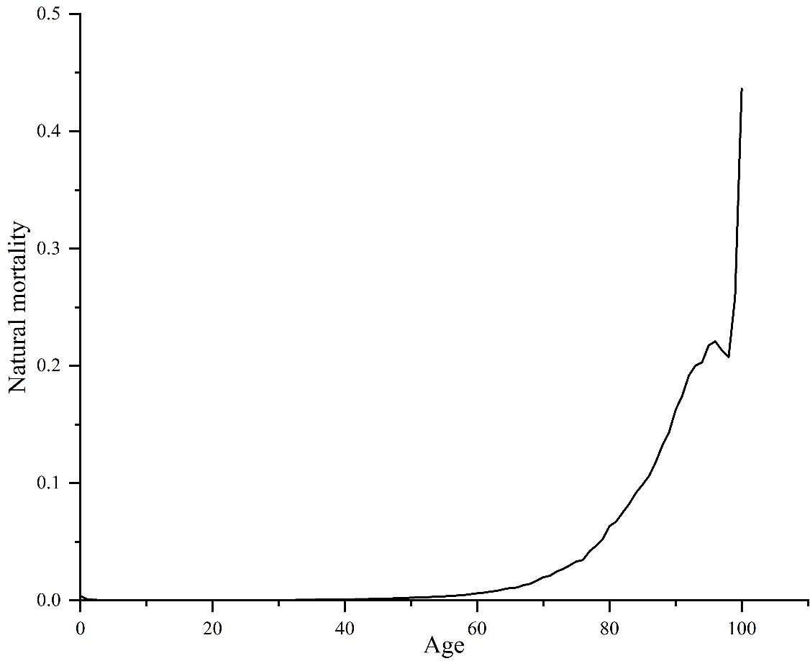

Appendix Figure 3. Natural mortality for different ages in China
* The natural mortality was obtained from the sixth national census.¹⁸

Appendix Formula. The calculation formula of eight settings per capita GDP
$$The per capita GDP for rural settings$$
$$=total GDP in rural areas/total rural population$$
$$=\frac{total GDP}{\left(1+\text{urban to rural ratio of per capita disposable income}\right)\left(\text{the total population}\left(1-\text{urbanization rate}\right)\right)}$$
$$=\frac{\text{overall per capita national GDP}}{\left(\left(1+\text{urban to rural ratio of per capita disposable income}\right)\left(1-\text{urbanization rate}\right)\right)}$$
$$The per capita GDP for urban China$$
$$=\frac{\text{overall per capita national GDP}}{\left(1+\left(\frac{1}{\text{urban to rural ratio of per capita disposable income}}\right)\right)*\text{urbanization rate}}$$

Appendix Table 6. Parameters for the calculation of eight settings per capita GDP
Regions | Total GDP, CNY | Total population | Urbanization rate | Disposable income, urban, CNY | Disposable income, rural, CNY | One time GDP, urban, $ | Three times GDP, urban, $
Western China | 3.E+13 | 382852295 | 52.86% | 40582.60 | 15608.20 | 13435.74 | 5794.45
Central China | 3.E+13 | 364694362 | 59.71% | 40706.80 | 17857.50 | 12462.75 | 8102.47
Eastern China | 6.E+13 | 563717119 | 68.82% | 56378.30 | 23556.10 | 16566.96 | 15278.23
Northeastern China | 6.E+12 | 98514948 | 63.89% | 38224.60 | 18280.40 | 9123.93 | 7720.23
*The parameters were obtained from 2022 China Statistics Yearbook.¹
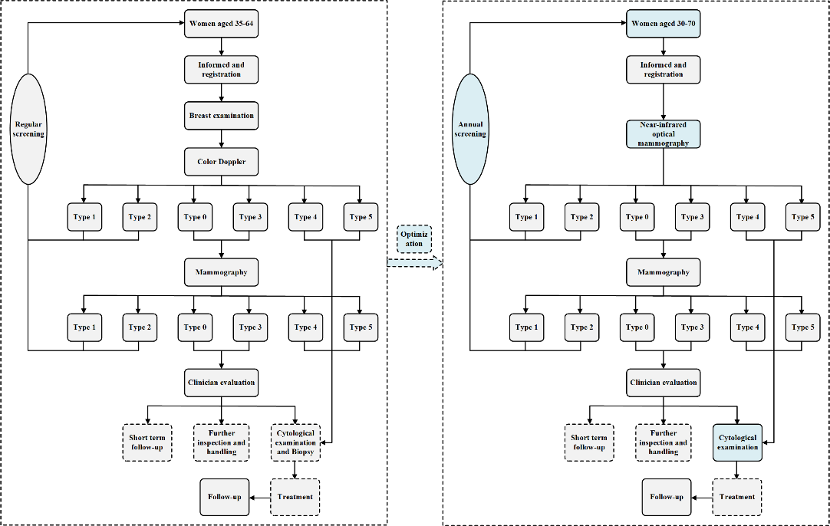

Appendix Figure 4. Breast cancer screening management system¹⁹

Appendix Table 7. Consolidated Health Economic Evaluation Reporting Standards (CHEERS) checklist
Section | Item No | Recommendation | Reported on page No/line No
Title and Abstract
Title | 1 | Identify the study as an economic evaluation or use more specific terms such as “cost-effectiveness analysis”, and describe the interventions compared. | Page 1
Abstract | 2 | Provide a structured summary of objectives, perspective, setting, methods (including study design and inputs), results (including base case and uncertainty analyses), and conclusions. | Page 1
Introduction
Background and objectives | 3 | Provide an explicit statement of the broader context for the study. | Page 6-7
Background and objectives | 3 | Present the study question and its relevance for health policy or practice decisions. | Page 6-7
Methods
Target population and subgroups | 4 | Describe characteristics of the base case population and subgroups analyzed, including why they were chosen. | Page 8
Setting and location | 5 | State relevant aspects of the system(s) in which the decision(s) need(s) to be made. | Page 8
Study perspective | 6 | Describe the perspective of the study and relate this to the costs being evaluated. | Page 11
Comparators | 7 | Describe the interventions or strategies being compared and state why they were chosen. | Page 9
Time horizon | 8 | State the time horizon(s) over which costs and consequences are being evaluated and say why appropriate. | Page 8
Discount rate | 9 | Report the choice of discount rate(s) used for costs and outcomes and say why appropriate. | Page 13
Choice of health outcomes | 10 | Describe what outcomes were used as the measure(s) of benefit in the evaluation and their relevance for the type of analysis performed. | Page 14
Measurement of effectiveness | 11a | Single study-based estimates: Describe fully the design features of the single effectiveness study and why the single study was a sufficient source of clinical effectiveness data. | Page 12
 | 11b | Synthesis-based estimates: Describe fully the methods used for identification of included studies and synthesis of clinical effectiveness data. | None defined
Measurement and valuation of preference based outcomes | 12 | If applicable, describe the population and methods used to elicit preferences for outcomes. | Page 13
Estimating resources and costs | 13a | Single study-based economic evaluation: Describe approaches used to estimate resource use associated with the alternative interventions. Describe primary or secondary re- search methods for valuing each resource item in terms of its unit cost. Describe any adjustments made to approximate to opportunity costs. | None defined
 | 13b | Model-based economic evaluation: Describe approaches and data sources used to estimate resource use associated with model health states. Describe primary or secondary research methods for valuing each resource item in terms of its unit cost. Describe any adjustments made to approximate to opportunity costs. | Page 14
Currency, price date, and conversion | 14 | Report the dates of the estimated resource quantities and unit costs. Describe methods for adjusting estimated unit costs to the year of reported costs if necessary. Describe methods for converting costs into a common currency base and the ex- change rate. | Page 12
Choice of model | 15 | Describe and give reasons for the specific type of decision- analytical model used. Providing a figure to show model structure is strongly recommended. | Page 8-11
Choice of model | 15 |  | Figure 1-2
Assumptions | 16 | Describe all structural or other assumptions underpinning the decision-analytical model. | Page 8-9
Assumptions | 16 |  | Supplement Page 1
Analytical methods | 17 | Describe all analytical methods supporting the evaluation. This could include methods for dealing with skewed, missing, or censored data; extrapolation methods; methods for pooling data; approaches to validate or make adjustments (such as half cycle corrections) to a model; and methods for handling population heterogeneity and uncertainty. | Page 13
Results
Study parameters | 18 | Report the values, ranges, references, and, if used, probability distributions for all parameters. Report reasons or sources for distributions used to represent uncertainty where appropriate. Providing a table to show the input values is strongly recommended. | Page 11-13
Study parameters | 18 |  | Supplement Table 1-5
Incremental costs and outcomes | 19 | For each intervention, report mean values for the main categories of estimated costs and outcomes of interest, as well as mean differences between the comparator groups. If applicable, report incremental cost-effectiveness ratios. | Page 15-18
Incremental costs and outcomes | 19 |  | Table 1
Characterizing uncertainty | 20a | Single study-based economic evaluation: Describe the effects of sampling uncertainty for the estimated incremental cost and incremental effectiveness parameters, together with the impact of methodological assumptions (such as discount rate, study perspective). | Page 18
 | 20b | Model-based economic evaluation: Describe the effects on the results of uncertainty for all input parameters, and uncertainty related to the structure of the model and assumptions. | Page 18
Characterizing heterogeneity | 21 | If applicable, report differences in costs, outcomes, or cost- effectiveness that can be explained by variations between subgroups of patients with different baseline characteristics or other observed variability in effects that are not reducible by more information. | Page 11-12
Characterizing heterogeneity | 21 |  | Supplement Figure1＆Table 2-3
Discussion
Study findings, limitations, generalizability, and current knowledge | 22 | Summarize key study findings and describe how they support the conclusions reached. Discuss limitations and the generalizability of the findings and how the findings fit with current knowledge. | Page 22-23
Other
Source of funding | 23 | Describe how the study was funded and the role of the fun- der in the identification, design, conduct, and reporting of the analysis. Describe other non-monetary sources of support. | Page 14
Conflicts of interest | 24 | Describe any potential for conflict of interest of study contributors in accordance with journal policy. In the absence of a journal policy, we recommend authors comply with International Committee of Medical Journal Editors recommendations. | Page 24
For consistency, the CHEERS Statement checklist format is based on the format of the CONSORT
statement checklist
The ISPOR CHEERS Task Force Report provides examples and further discussion of the 24-item
CHEERS Checklist and the CHEERS Statement. It may be accessed via the Value in Health link or via the ISPOR
Health Economic Evaluation Publication Guidelines – CHEERS: Good Reporting Practices
webpage: http://www.ispor.org/TaskForces/EconomicPubGuidelines.asp
The citation for the CHEERS Task Force Report is:
Husereau D, Drummond M, Petrou S, et al. Consolidated health economic evaluation reporting standards
(CHEERS)—Explanation and elaboration: A report of the ISPOR health economic evaluations publication guidelines
good reporting practices task force. Value Health 2013;16:231-50.

References
1 He Jie WW. 2019 china cancer registry annual reportPeople's Medical Publishing House, 2021.
2 Sun L, Legood R, Sadique Z, Dos-Santos-Silva I, Yang L. Cost-effectiveness of risk-based breast cancer screening programme, china. Bull World Health Organ 2018; 96(8): 568-77.
3 Malek PV, Sun L, Gilardino R, Legood R. Telemammography for breast cancer screening: a cost-effective approach in argentina. Bmj Health Care Inform 2021; 28(1).
4 Nguyen CP, Adang E. Cost-effectiveness of breast cancer screening using mammography in vietnamese women. Plos One 2018; 13(3): e194996.
5 Li H, Huang Y, Huang R, Li JY. [standard treatment cost of female breast cancer at different tnm stages]. Zhonghua Zhong Liu Za Zhi 2013; 35(12): 946-50.
6 Liao XZ, Shi JF, Liu JS, et al. Medical and non-medical expenditure for breast cancer diagnosis and treatment in china: a multicenter cross-sectional study. Asia Pac J Clin Oncol 2018; 14(3): 167-78.
7 Trentham-Dietz A, Ergun MA, Alagoz O, et al. Comparative effectiveness of incorporating a hypothetical dcis prognostic marker into breast cancer screening. Breast Cancer Res Treat 2018; 168(1): 229-39.
8 Xy W. Moving towards a personalized approach to breast cancer screening: are we ready? [Thesis]:National University of Singapore;2019.
9 Hayman JA, Fairclough DL, Harris JR, Weeks JC. Patient preferences concerning the trade-off between the risks and benefits of routine radiation therapy after conservative surgery for early-stage breast cancer. J Clin Oncol 1997; 15(3): 1252-60.
10 Lloyd A, Nafees B, Narewska J, Dewilde S, Watkins J. Health state utilities for metastatic breast cancer. Br J Cancer 2006; 95(6): 683-90.
11 Lee JH, Glick HA, Hayman JA, Solin LJ. Decision-analytic model and cost-effectiveness evaluation of postmastectomy radiation therapy in high-risk premenopausal breast cancer patients. J Clin Oncol 2002; 20(11): 2713-25.
12 O'Malley MS, Fletcher SW. Us preventive services task force. Screening for breast cancer with breast self-examination. A critical review. Jama 1987; 257(16): 2196-203.
13 Malmartel A, Tron A, Caulliez S. Accuracy of clinical breast examination's abnormalities for breast cancer screening: cross-sectional study. Eur J Obstet Gynecol Reprod Biol 2019; 237: 1-6.
14 Omranipour R, Kazemian A, Alipour S, et al. Comparison of the accuracy of thermography and mammography in the detection of breast cancer. Breast Care (Basel) 2016; 11(4): 260-4.
15 Kriege M, Brekelmans CT, Obdeijn IM, et al. Factors affecting sensitivity and specificity of screening mammography and mri in women with an inherited risk for breast cancer. Breast Cancer Res Treat 2006; 100(1): 109-19.
16 Jalalian A, Mashohor S, Mahmud R, Karasfi B, Iqbal SM, Ramli AR. Computer-assisted diagnosis system for breast cancer in computed tomography laser mammography (ctlm). J Digit Imaging 2017; 30(6): 796-811.
17 Watanabe T, Yamaguchi T, Okuno T, et al. Utility of b-mode, color doppler and elastography in the diagnosis of breast cancer: results of the cd-confirm multicenter study of 1351 breast solid masses. Ultrasound Med Biol 2021; 47(11): 3111-21.
18 Population And Employment Statistics Department Of The National Bureau Of Statistics Of The State Council Population Census Office C. The sixth national census2010. http://www.stats.gov.cn/sj/pcsj/rkpc/6rp/indexch.htm (accessed 3-30, 2023).
19 China NBOS. Statistical bulletin on national economic and social development of the people's republic of china in 20222023. http://www.stats.gov.cn/xxgk/sjfb/zxfb2020/202302/t20230228_1919001.html (accessed 3-22, 2023).

