Assessment of outdoor thermal human comfort over Houche Al-Oumara, North Lebanon
Mahmoud Ahmed Hewehy ⁽¹⁾; Ismail Ibrahim Abbas ⁽²⁾; El-Sayed Mohamed Robaa⁽³⁾; Mohammed SalahEl-din Mostafa ⁽⁴⁾; Ali Adnan Shaar ⁽⁵⁾∗

1) Department of Basic Science, Faculty of Graduate Studies & Environmental Research, Ain Shams University; Cairo, Egypt. 2) Department of Chemistry, Faculty of Science, Lebanese University; Beirut, Lebanon.3) Department of Astronomy, Space Science & Meteorology, Faculty of Science, Cairo University; Cairo, Egypt. 4) Department of Pediatric Studies, Faculty of Graduate Studies & Childhood, Ain Shams University; Cairo, Egypt. 5) Post Graduate, Department of Basic Science, Faculty of Graduate Studies & Environmental Research, Ain Shams University; Egypt.

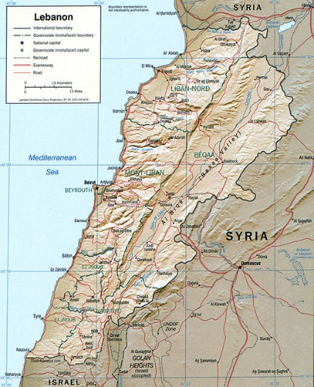 | 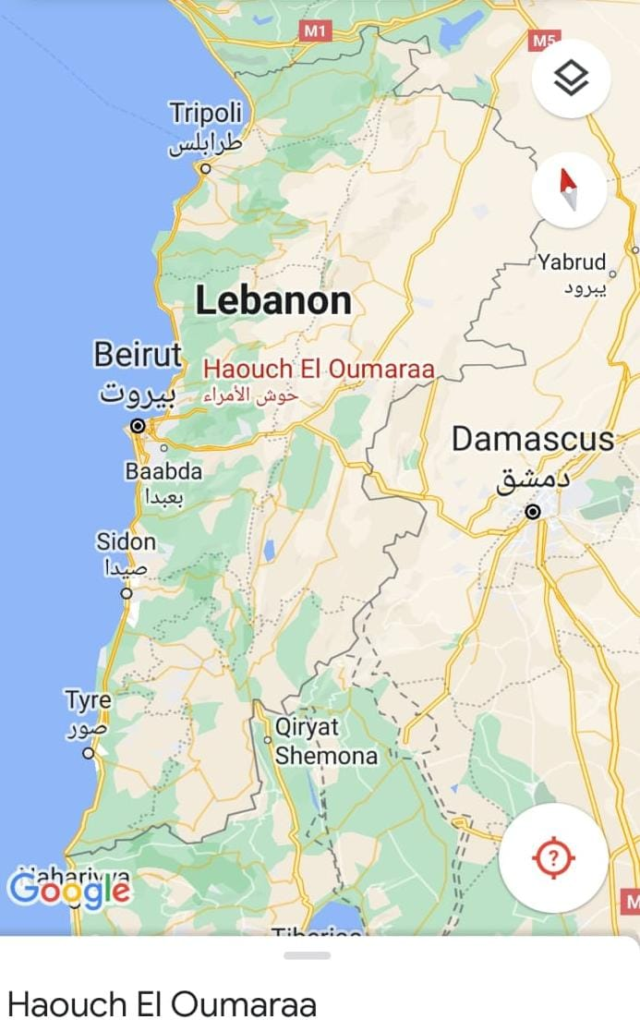
Figure 1SI. Map of Houche Al-Oumara and its position in Lebanon (www.worldatlas.com)

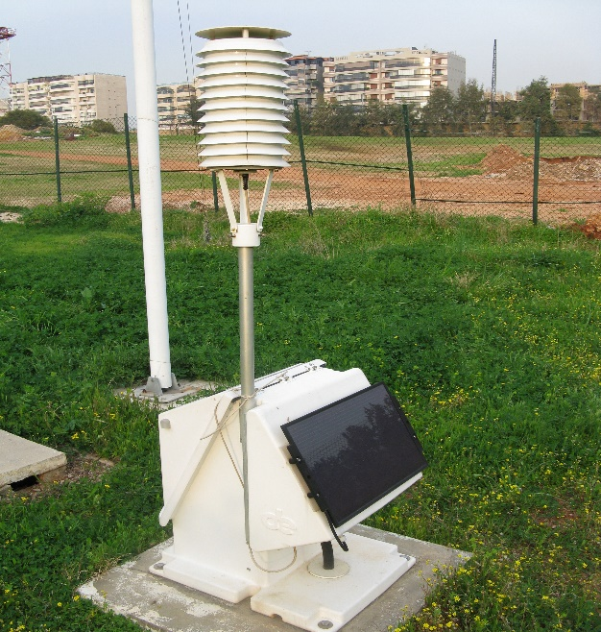 | 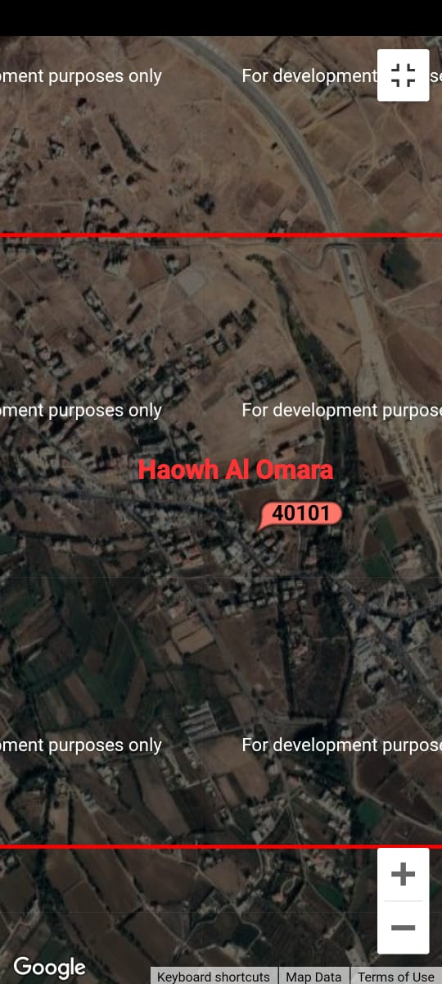

Figure 2SI. Meteorological Station at Houche Al-Oumara (WMO identifier: 40101).

Figure 3SI. Population of Haouch El Oumara from the years 1975 to 2021(city-facts.com).

Table 1 SI. Meteorological synoptic stations operated by the official Met. Office (LMD)
Station | Coordinates | WMO Id | Elevation (m)
Beirut  (BRHIA) | 33° 49' 15"N and 35° 29' 15"E | 40100 | 15
Haouch El Oumara | 33° 49' 0"N and 35° 51' 0"E | 40101 | 920

Table 2 SI. Average Rainfall over Houche El Oumara
Year | Average rain fall | Anomalies
1994 | 530.1 | 343.7
1995 | 501 | 372.8
1996 | 1045.1 | -171.3
1997 | 1061 | -187.2
1998 | 778.9 | 94.9
1999 | 364 | 509.8
2000 | 945.7 | -71.9
2001 | 678.3 | 195.5
2002 | 1102.6 | -228.8
2003 | 1252.8 | -379.1
2004 | 933.3 | -59.5
2005 | 795.9 | 77.9
2006 | 707.7 | 166.1
2007 | 789.8 | 83.9
2008 | 380.6 | 493.2
2009 | 1341.8 | -468.1
2010 | 907.9 | -34.1
2011 | 1248 | -374.2
2012 | 1561.3 | -687.5
2013 | 1057.4 | -183.6
2014 | 595.8 | 277.9
2015 | 912.8 | -39.1
2016 | 848.6 | 25.2
2017 | 388.2 | 485.6
2018 | 324 | 549.8
2019 | 1717.6 | -843.8
2020 | 1191.4 | -317.6
2021 | 504.2 | 369.6

∗ Corresponding Author: Ali Adnan Shaar; Beirut-Lebanon. E-mail: ali.shaar@hotmail.com; Phone: +9613287819; Fax: +9611841636. Post Graduate; Faculty of Graduate Studies & Environmental Research, Ain Shams University; Head of Climate Section at the Directorate General of Civil Aviation (BRHIA).

