Supplementary information

High Storage and Energy Efficient Memory for Cryogenic Computing

Yi Han¹, Jingxuan Sun¹, Benjamin Richstein², Jin Hee Bae¹, Frederic Allibert³, Ionut Radu³, Detlev Grützmacher,¹ Joachim Knoch², Qing-Tai Zhao¹*
¹Institute of Semiconductor Nanoelectronics, Peter Grünberg Institute 9 (PGI 9) and JARA-Fundamentals of Future Information Technologies, Forschungszentrum Juelich, 52428, Germany.
²Institute of Semiconductor Electronics, RWTH Aachen University, 52056 Aachen, Germany.
³SOITEC, 38190 Bernin, France.

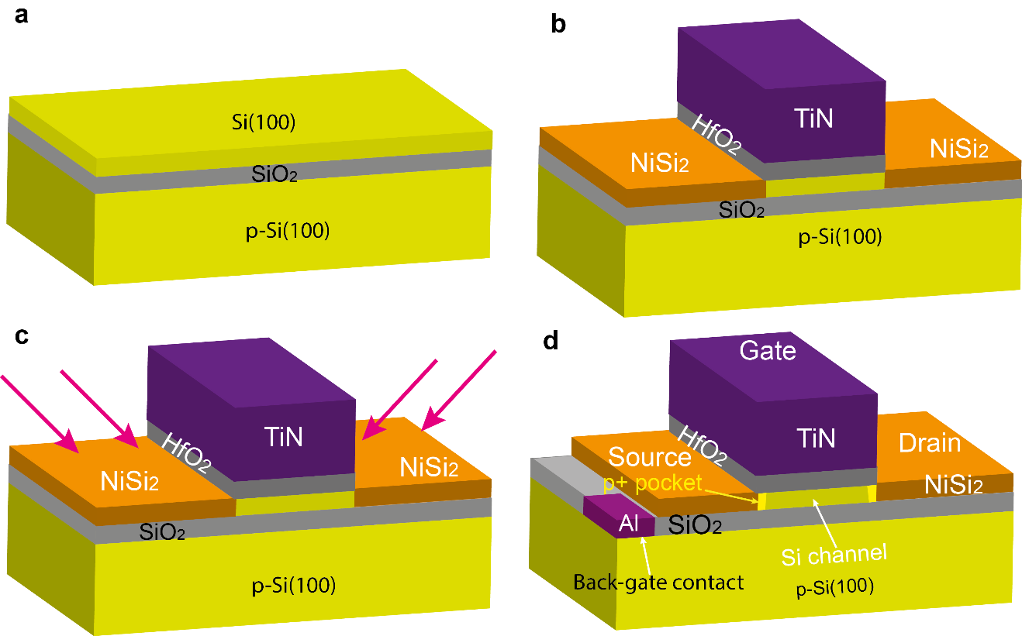
Figure S1. Device fabrication process. a. UTBB SOI wafer as the starting substrate. b. Device structure after gate formation and silicidation at source/drain. The source/drain is fully silicided into NiSi₂. c. Tilted B⁺ ion implantation into NiSi₂. d. After annealing highly doped pockets are formed at the NiSi₂/Si channel interfaces at both the source and drain. Aluminum (Al) back-contact is formed by etching through the BOX layer.
Figure S2. Device characterization at temperatures from 300 K to 5.5 K. a. I_{D}-V_{G} transfer characteristics for the fabricated device with a gate length of L_{g}=50 nm measured at temperatures of 300 K, 60 K, and 5.5 K, showing reduced subthreshold swing SS with reducing temperature. b. I_{D}-V_{DS} output characteristics measured at 5.5 K and overdrive voltages (V_{ov} = V_{G}- V_{TH}) from -0.1 V to -0.4 V. The dashed red curve presents the I_{D}-V_{DS} output characteristics measured at 300 K and V_{ov} = -0.1 V, as a reference. The comparison to the 300 K results indicates a large improvement of drain currents at 5.5 K due to the mobility improvement.

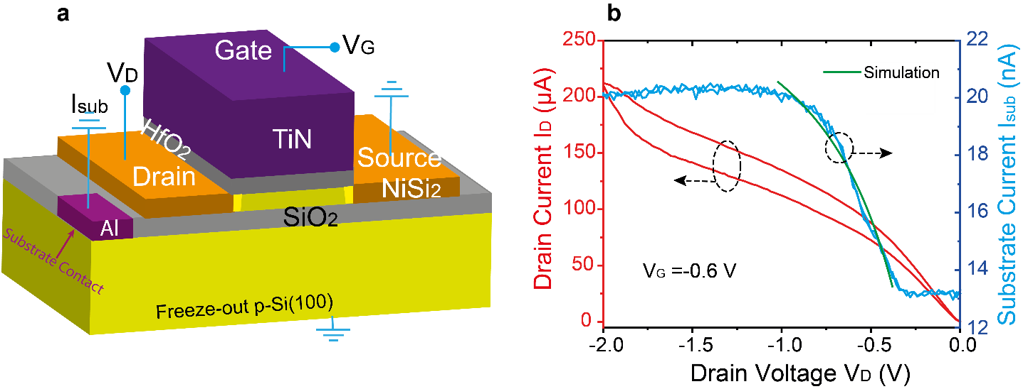
Figure S3. Measurement of the substrate current. a. Schematic showing the configuration of the device for the substrate current measurement using a substrate contact of aluminum (Al) through the BOX layer without applying any bias. b. the measured substrate currents I_{sub} and drain currents I_{D} as a function of the drain voltage V_{D}. The green curve is the fitting of the substrate current using the impact ionization theory. I_{sub} is caused by the holes, which is confirmed by the current polarity. These results confirm that the impact ionization induced holes dissolve to the substrate, leaving electrons staying in the region below the channel.

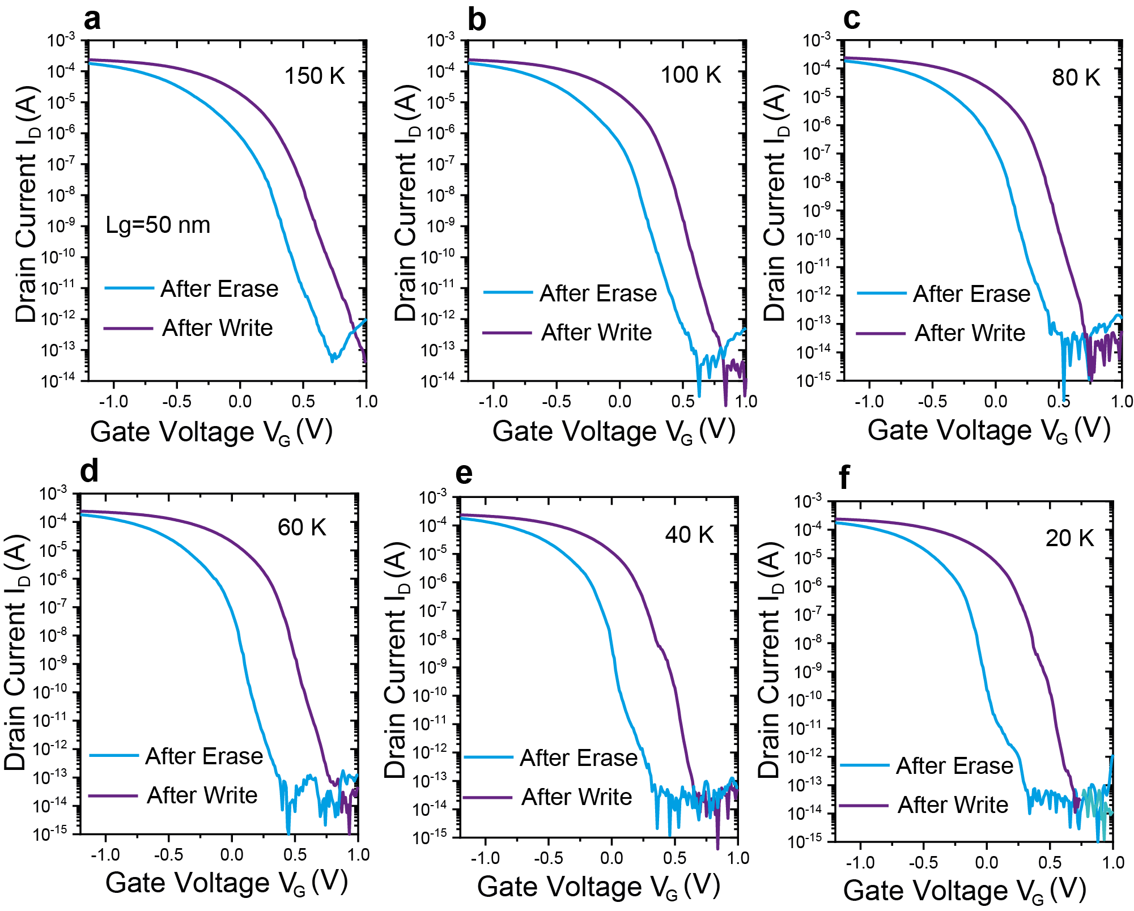
Figure S4. I_{D}-V_{G} transfer characteristics after writing and erase at the same conditions for the fabricated device with a gate length of L_{g}=50 nm measured at temperatures from 150 K to 20 K, showing the increasing memory window with cooling of the device.
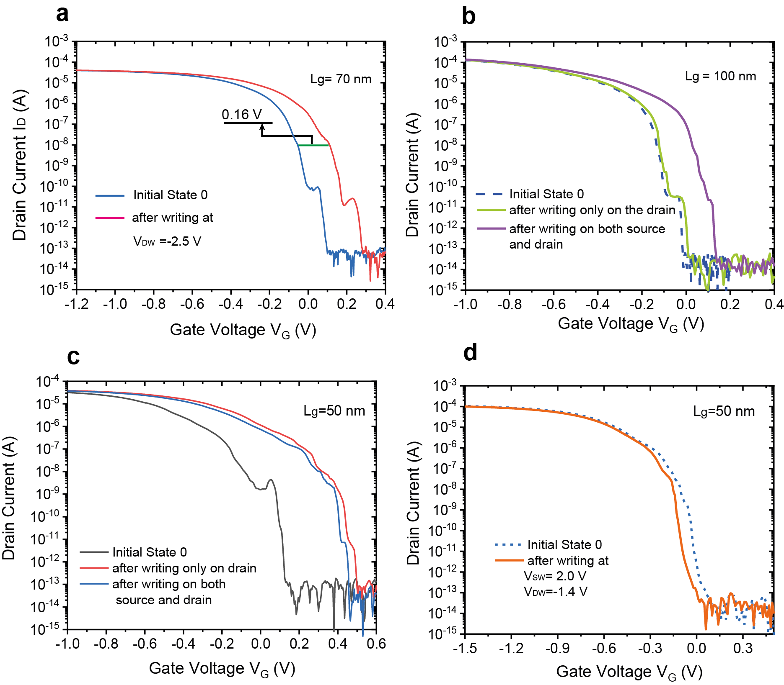
Figure S5. Characteristics for different gate length transistors under various writing conditions at 5.5 K. a. A 70 nm gate length transistor after writing at V_{DW}=-2.5 V, showing a memory window of 0.16 V. b. A gate length L_{g}=100 nm device after writing only on the drain at V_{DW}=-2.5 V, showing almost no writing. The writing simultaneously at both the source and drain with a writing voltage V_{DW}=V_{SW}=-2.5 V can realize state 1. c. For the short channel device with L_{g}=50 nm, the writing only on the drain with V_{DW}=-2.0 V shows similar writing window with the writing on both the source and drain simultaneously with V_{DW}=V_{SW}=-2.0 V. d. Applying a negative voltage on the drain V_{DW}=-1.4 V and a positive voltage on the source V_{SW}= 2.0 V cannot write state 1. Therefore, the source can be used as a selector for writing in short channel devices.

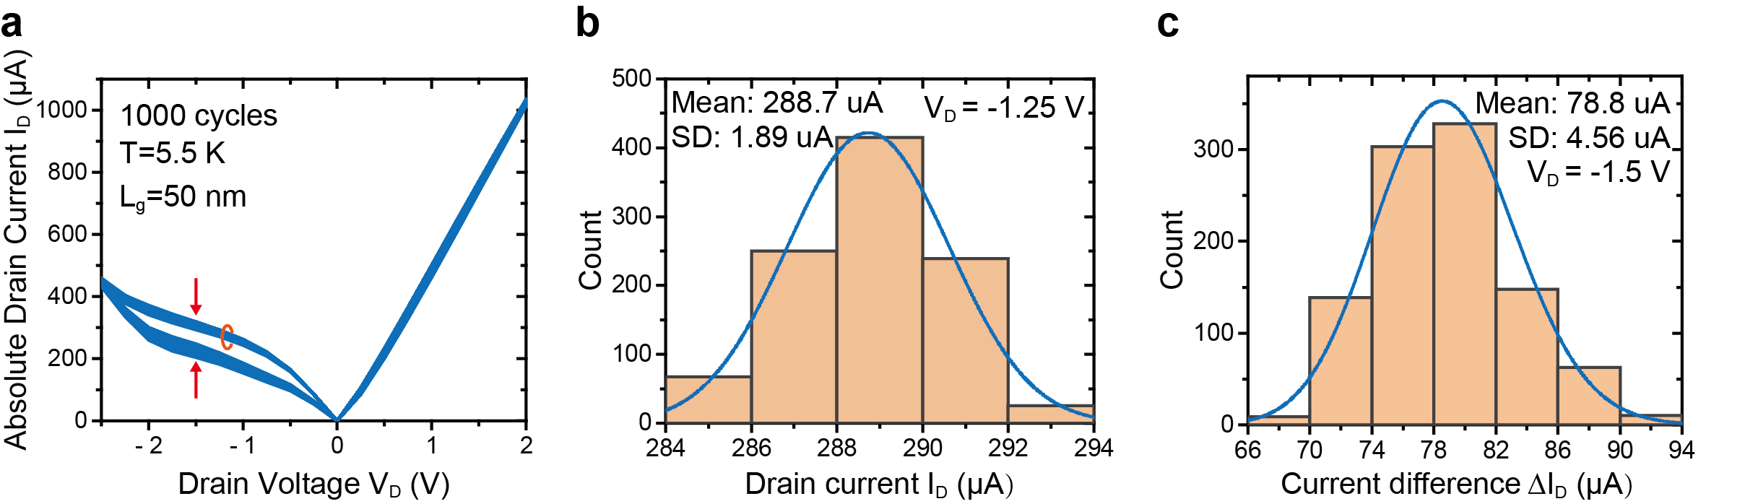
Figure S6. Endurance measurements. a. 1000 circles I_{D}-V_{D} characteristics measurements showing a very small variation of both the currents and current difference, indicating a good endurance. b. variation of the drain current measured at V_{D} = -1.25 V in the backward direction as marked by the red circle in (a), showing a small standard deviation of 1.89 µA. c. The current difference (∆I_{D}) between the backward and forward sweeping at a constant voltage V_{D} = -1.5 V as marked by red arrows in (a), showing a mean value of 78.8 µA and a small standard deviation of 4.56 µA.

Figure S7. the writing and erase speed demonstrated by measuring the reading current after 1s write/erase. The reading current I_{D} shows minimal changes for writing/erase times ranging from 1µs to 1s. The minimum writing time 1µs for the measurement is limited by the setup.

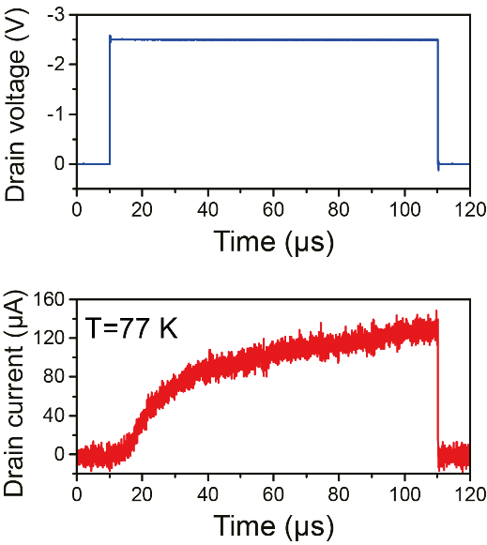
Figure S8. the response drain current to the input drain voltage pulse (top) showing neural sigmoid integration function at 77 K.
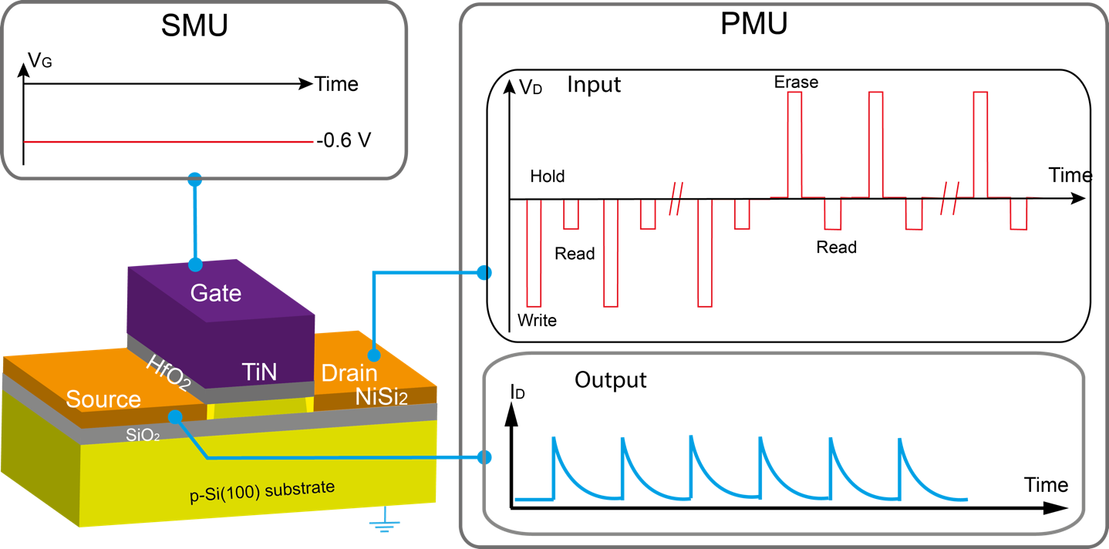
Figure S9. Artificial synapses characterization setup, including a digital oscilloscope, a high speed trans-impedance amplifier and an arbitrary waveform generator. The waveform for the input signals on gate and drain are schematically shown.

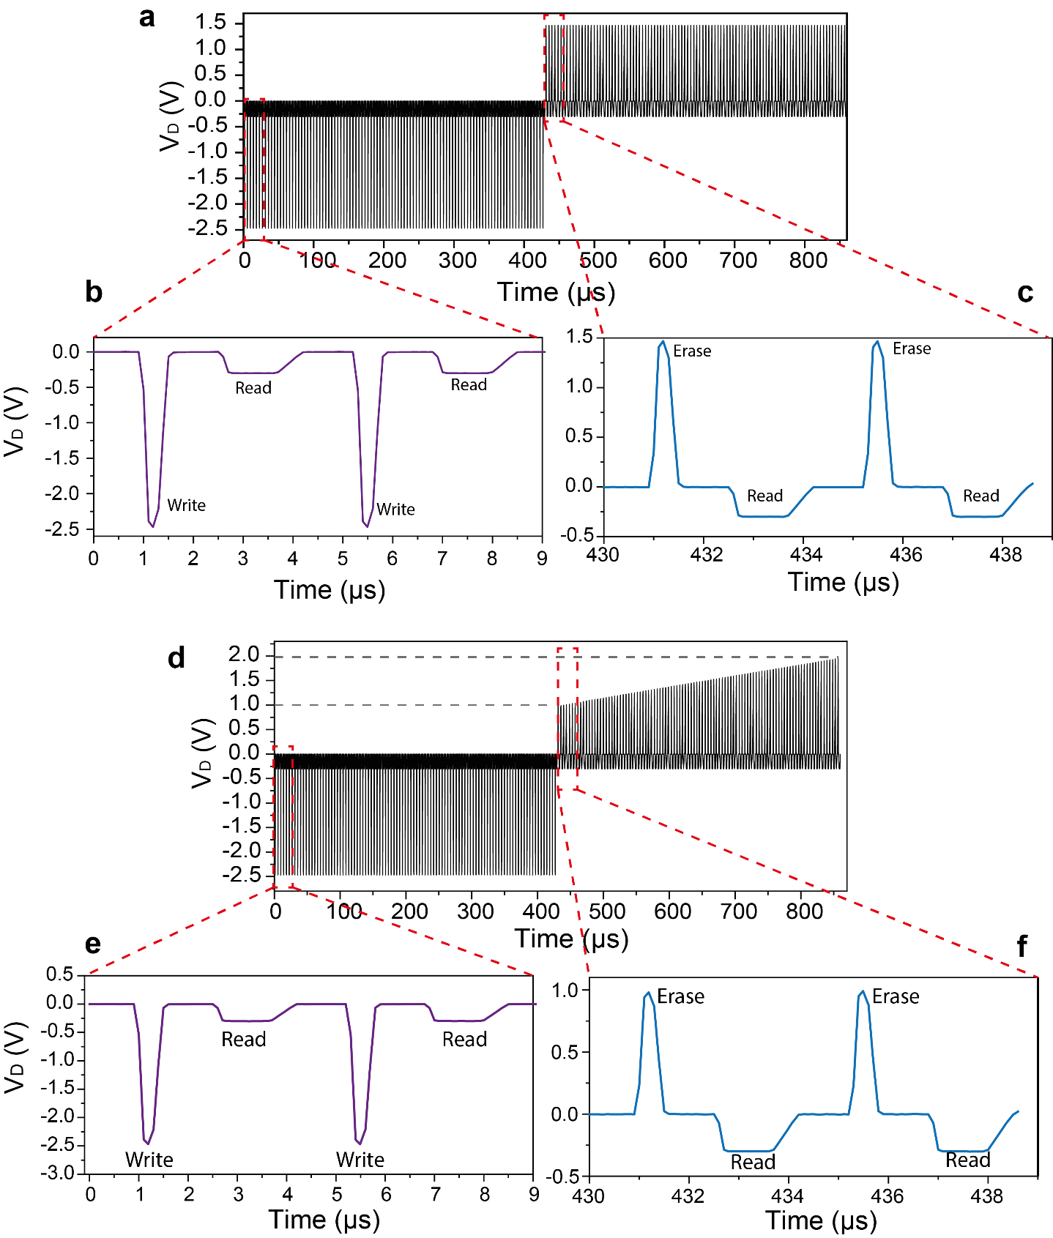
Figure S10. Voltage pulses applied on the drain for artificial synapse characterization with identical pulses for both potentiation and depression (a-c), and non-identical pulses for depression (d-f).
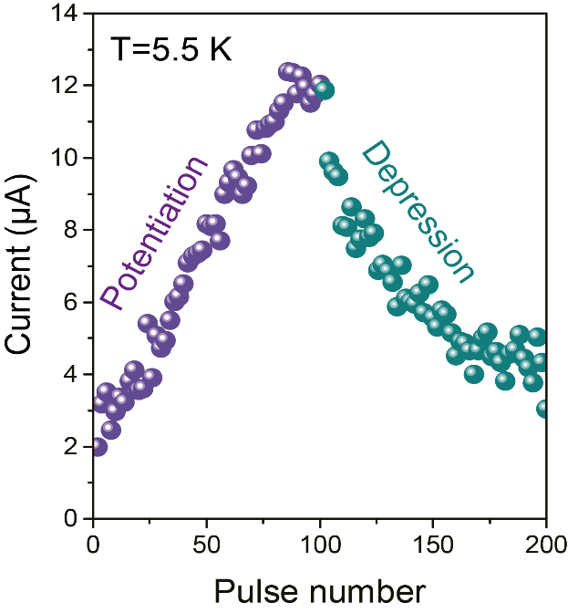
Figure S11. Long-term plasticity of the artificial synapse showing improved depression by using non-identical pulses as shown in Figure S10d-f at 5.5 K.

