Table 1. Cardiac function parameters of the left ventricle

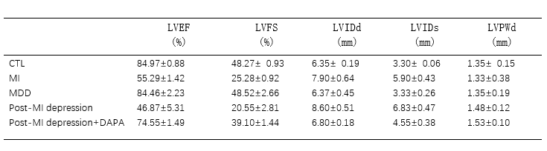
LVEF, left ventricular ejection fraction; LVFS, left ventricular systolic percentage; LVIDd, left ventricular end-diastolic internal diameter; LVIDs, left ventricular end-systolic inner diameters; LVPWd, left ventricular posterior wall diastole;

