Table 2. Parameters of hemodynamics, cardiac structure, and NT-proBNP

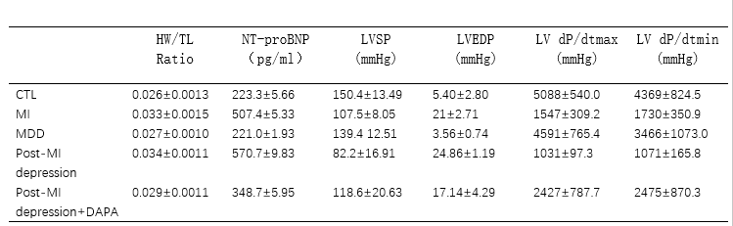
HW/TL, heart weight/tibial length; NT-proBNP, NT-proBNP concentration in serum; LVSP, LV systolic pressure; LVEDP, LV end-diastolic pressure; LV dp/dtmax, LV dp/dtmin, maximal rate of pressure rise and decline (dP/dtmax and dP/dtmin)

