Table 3. Parameters of Behavioral measurements，and 5-HT
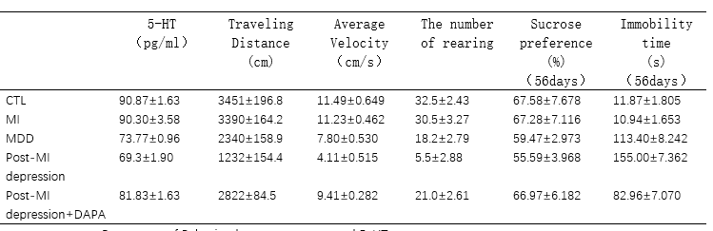
5-HT, 5-Hydroxytryptamine；Open field test (OFT):Traveling Distance、Average Velocity、The number of rearing；Sucrose preference test (SPT):Sucrose preference；Forced Swimming Test (FST):Immobility time.

