Supplemental Figures for: Lazzarro et al. Antiretroviral treatment is less effective at reducing gut microbiome-associated inflammation and T cell activation in people living with HIV in rural versus urban Zimbabwe

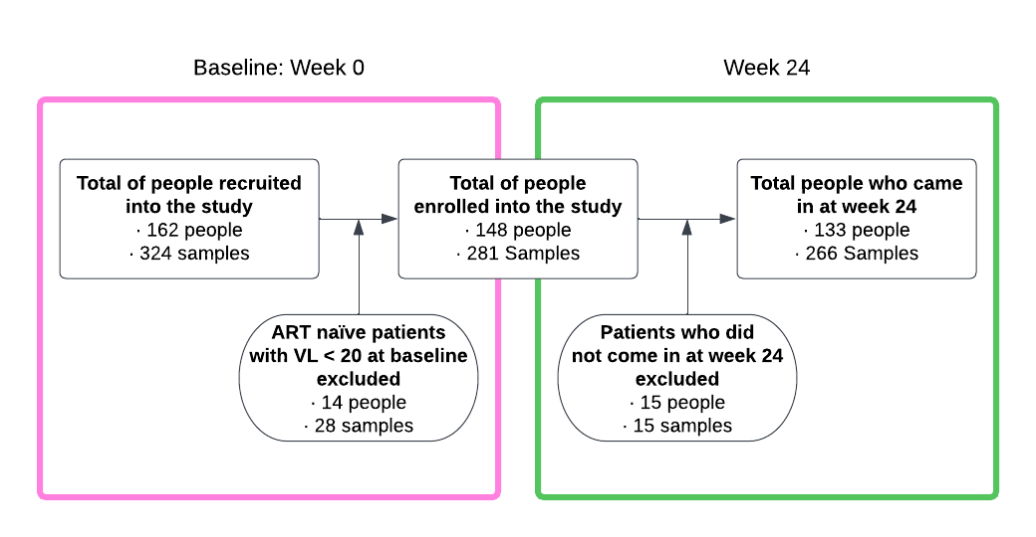
Figure S1: Number of study participants as impacted by exclusion due to inconsistent viral load with stated treatment status and subsequent loss of participation by week 24.

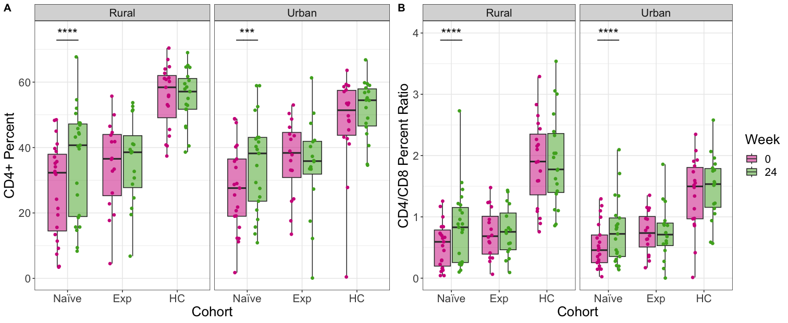

Figure S2: CD4+ T cell percent and CD4/CD8 percent ratios across all cohorts stratified by location and across time (Baseline= Week 0). Statistical significance was calculated using a paired Mann-Whitney U test. P-values are coded as ‘****’ between [0, 0.0001], ‘***’ (0.0001, 0.001], ‘**’ (0.001, 0.01], ‘*’ (0.01, 0.05], with square brackets indicating that the endpoints are included in the interval.

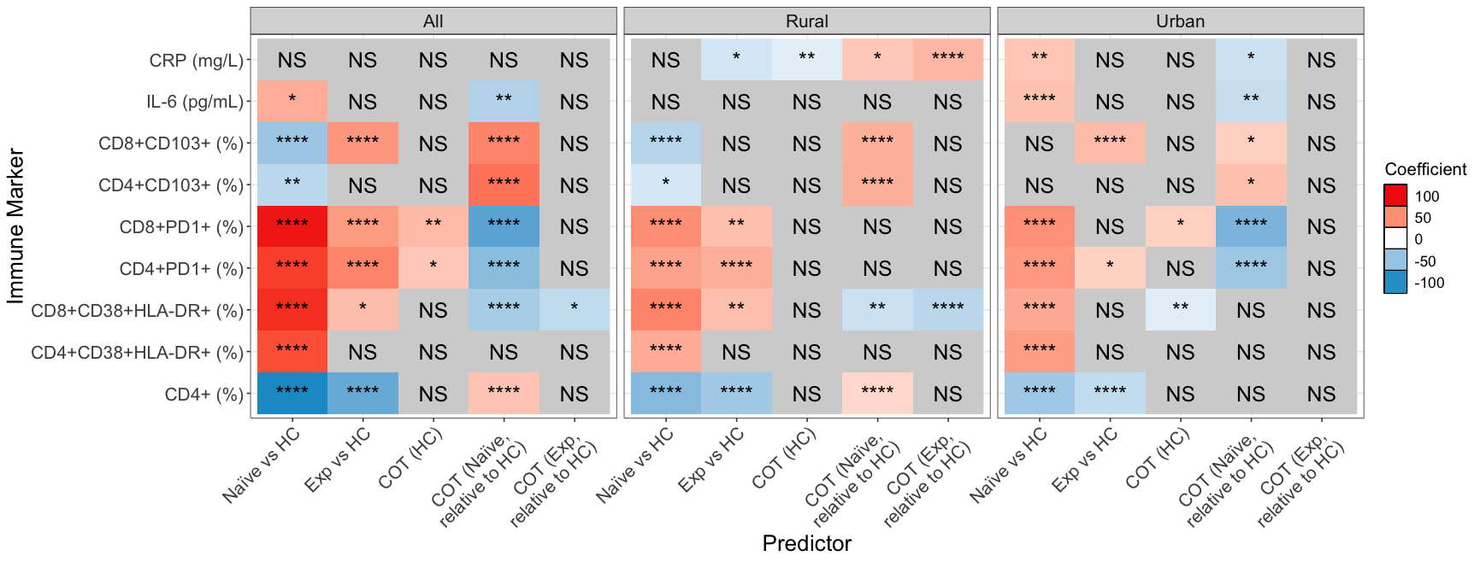

Figure S3: Fixed-effects ordinary least squares (OLS) linear modeling was used to evaluate the combined effects of differences in cohorts and time points overall (left panel) and stratified by rural (middle panel) and urban (right panel) location. From the left, columns representing predictors should be interpreted as follows: the effect of ART naïve PLWH relative to healthy controls; the effect of ART experienced PLWH relative to heathy controls; change over time (COT) in healthy controls; the interaction of ART naïve PLWH with time relative to healthy controls and time; and the interaction of ART experienced PLWH with time relative to healthy controls and time. Coefficient and color show directionality of the relationship – red is a positive effect and blue negative. P-values are coded as ‘****’ between [0, 0.0001], ‘***’ (0.0001, 0.001], ‘**’ (0.001, 0.01], ‘*’ (0.01, 0.05], with square brackets indicating that the endpoints are included in the interval.

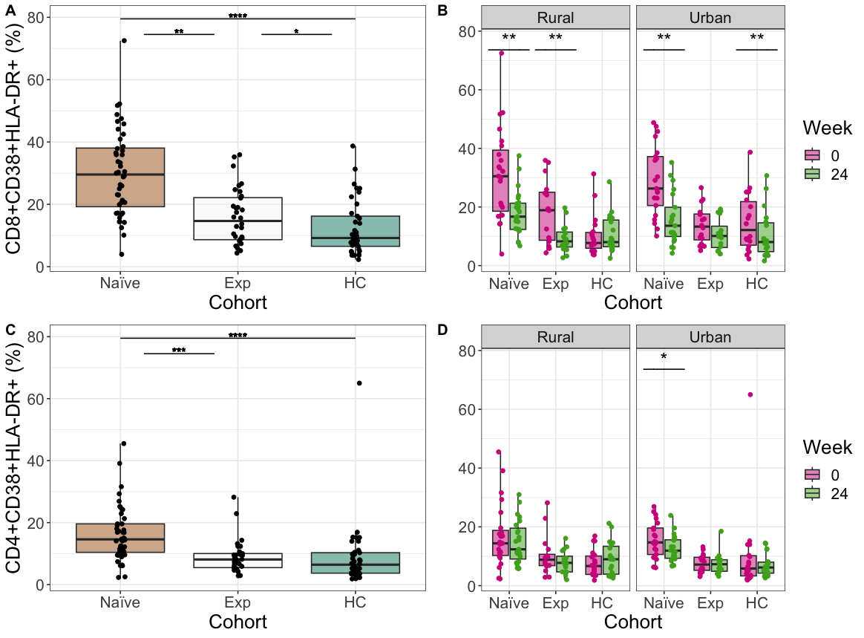

Figure S4: Detailed plots of CD8+CD38+HLA-DR+ (Panels A,B) and CD4+CD38+HLA-DR+ T (Panels C,D) cells underlying p-values reported in Figure 1A. Panels A,C: Inter-cohort comparisons using only baseline (Week 0) values. Statistical significance assessed using a Kruskal Wallis with a Dunn’s post-hoc test. Panels B,D: Intra-cohort longitudinal comparisons over time. Statistical significance assessed using a paired Mann-Whitney U test. P-values are coded as ‘****’ between [0, 0.0001], ‘***’ (0.0001, 0.001], ‘**’ (0.001, 0.01], ‘*’ (0.01, 0.05], with square brackets indicating that the endpoints are included in the interval.

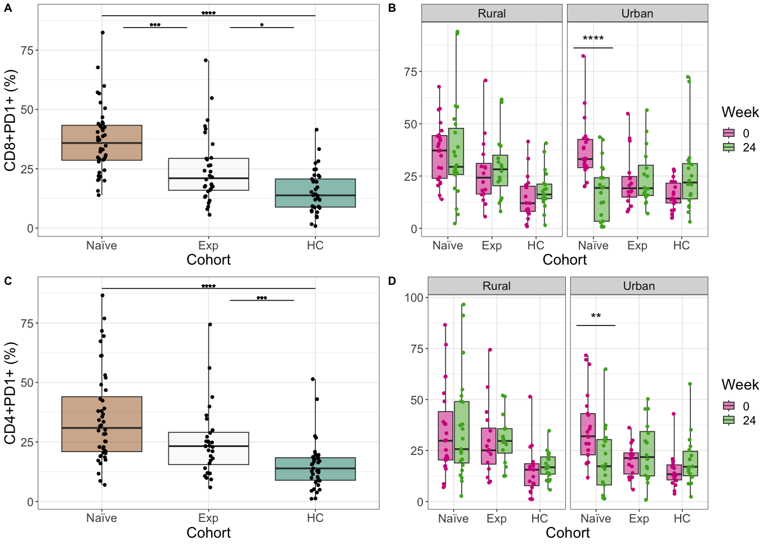
F

Figure S5: Detailed plots of CD8+PD1+ T cells (Panels A,B) and CD4+PD1+ T cells (Panels C, D) underlying p-values reported in Figure 1A. Panels A,C: Inter-cohort comparisons using only baseline (Week 0) values. Statistical significance assessed using a Kruskal Wallis test with a Dunn’s post-hoc test. Panels B,D: Intra-cohort longitudinal comparisons over time. Statistical significance assessed using a paired Mann-Whitney U test. P-values are coded as ‘****’ between [0, 0.0001], ‘***’ (0.0001, 0.001], ‘**’ (0.001, 0.01], ‘*’ (0.01, 0.05], with square brackets indicating that the endpoints are included in the interval.

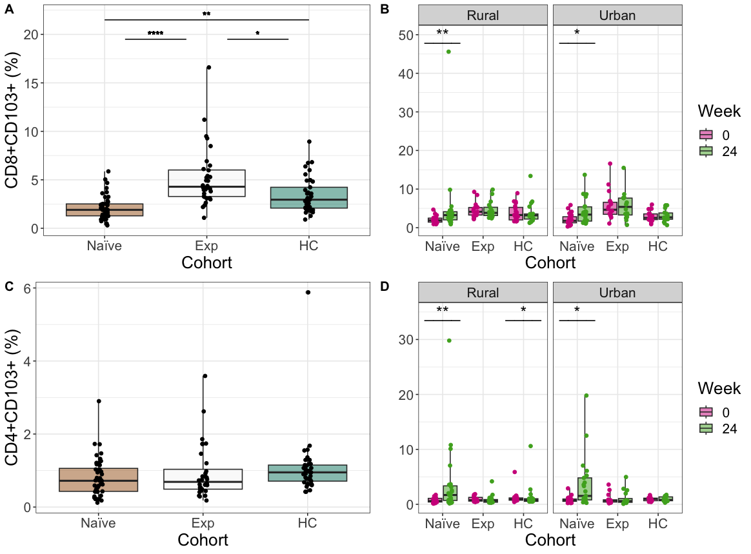

Figure S6: Detailed plots of CD8+CD103+ (Panels A,B) and CD8+CD103+ (Panels C,D) T cells underlying p-values reported in Figure 1A. Panels A,C: Inter-cohort comparisons using only baseline (Week 0) values. Statistical significance assessed using a Kruskal Wallis with a Dunn’s post-hoc test. Panels B,D: Intra-cohort longitudinal comparisons over time. Statistical significance assessed using a paired Mann-Whitney U test. P-values are coded as ‘****’ between [0, 0.0001], ‘***’ (0.0001, 0.001], ‘**’ (0.001, 0.01], ‘*’ (0.01, 0.05], with square brackets indicating that the endpoints are included in the interval.

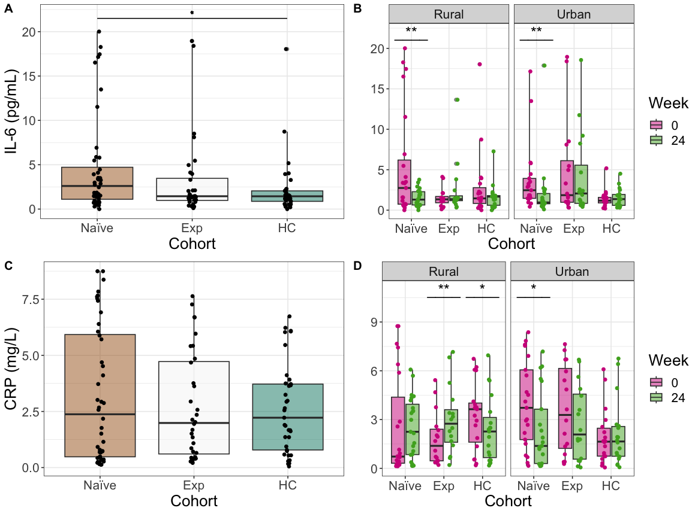

Figure S7: Detailed plots of IL-6 (Panels A,B) and CRP (Panels B,C) levels underlying p-values reported in Figure 1A. Panels A,C: Inter-cohort comparisons using only baseline (Week 0) values. Statistical significance assessed using a Kruskal Wallis with a Dunn’s post-hoc test. Panels B,D: Intra-cohort longitudinal comparisons over time. Statistical significance assessed using a paired P-values are coded as ‘****’ between [0, 0.0001], ‘***’ (0.0001, 0.001], ‘**’ (0.001, 0.01], ‘*’ (0.01, 0.05], with square brackets indicating that the endpoints are included in the interval.p-values < 0.0001 are labeled as ****, < 0.001 are ***, 0.01 are **, and < 0.05 are *.

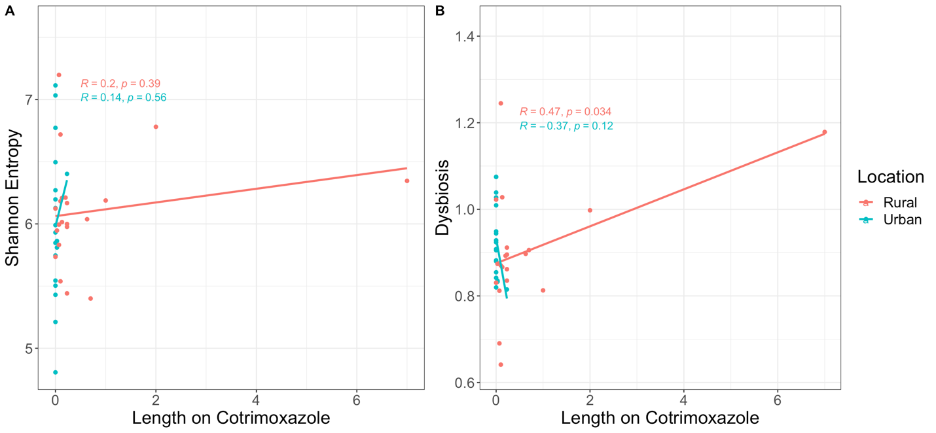

Figure S8: Correlation between the Length of time on Cotrimoxazole at Baseline (week 0) and alpha diversity (Shannon Entropy) and Dysbiosis (average weighted UniFrac distance of a given sample from each of the health control samples). Values shown for only the ART naïve cohort. A linear regression model was used with an interaction term for rural versus urban location.

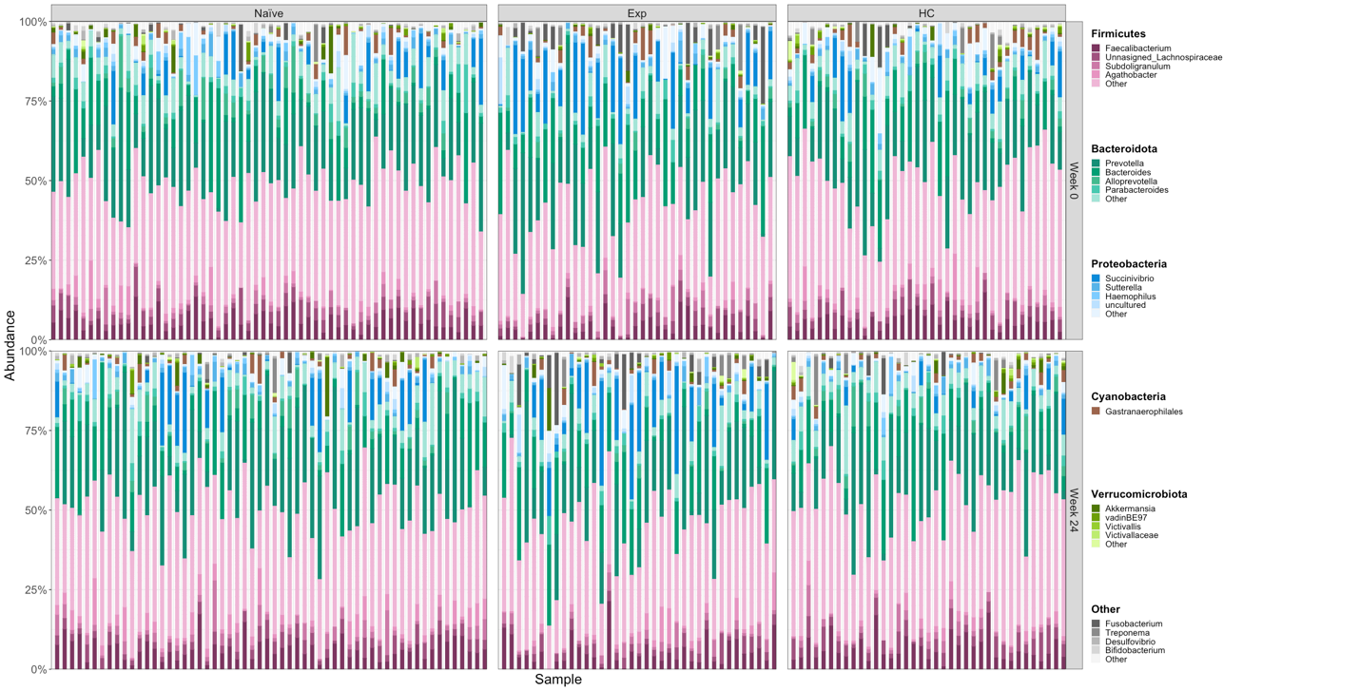

Figure S9: Taxa bar plots. Taxonomic assignments were made using a QIIME2 trained naïve-bayes classifier and the Silva (version 138) taxonomic database [47]. Each color represents a different bacterial genus, and genera within the same Phylum are depicted in different shades of the same color using microshades [101]. Samples are stratified by cohort and time.

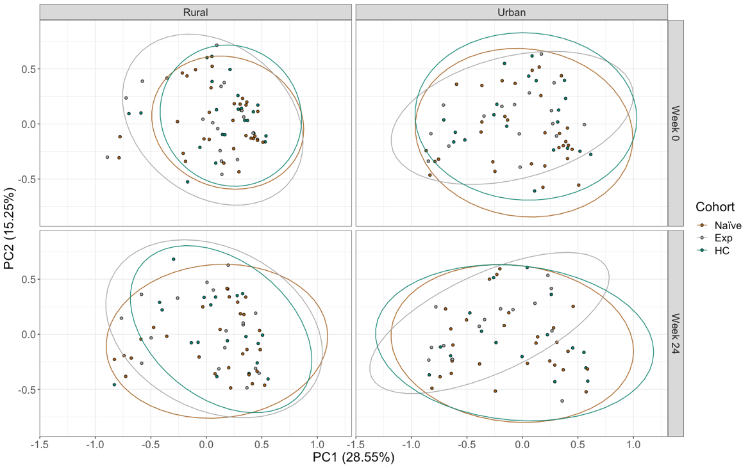

Figure S10: Weighted UniFrac Principal Coordinates Analysis (PCoA). The PCoA was conducted using data from all of the samples, but only a subset of samples are plotted in the different quadrants depending on whether they were from the rural or urban location (columns) or collected at week 0 or week 24 (rows). Points are colored by cohort. Naïve = HIV+ ART Naïve cohort, Exp = HIV+ ART Experienced cohort, HC= Healthy controls. The percent of variation explained by PC1 and PC2 are indicated on the x and y axes respectively.

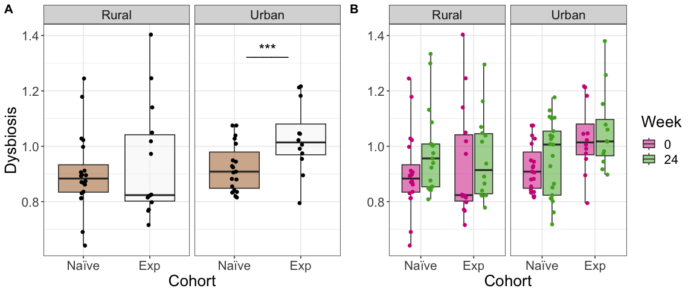

Figure S11: Detailed plots of microbiome dysbiosis levels. A dysbiosis value for each sample was calculated as the average weighted UniFrac distance of that sample from each of the health control samples. Panel A: Inter-cohort comparisons using only baseline (Week 0) values. Statistical significance assessed using a Mann Whitney U test. Panel B: Intra-cohort longitudinal comparisons over time. Statistical significance was assessed using a paired Mann-Whitney U test. P-values are coded as ‘****’ between [0, 0.0001], ‘***’ (0.0001, 0.001], ‘**’ (0.001, 0.01], ‘*’ (0.01, 0.05], with square brackets indicating that the endpoints are included in the interval.

Supplemental Tables

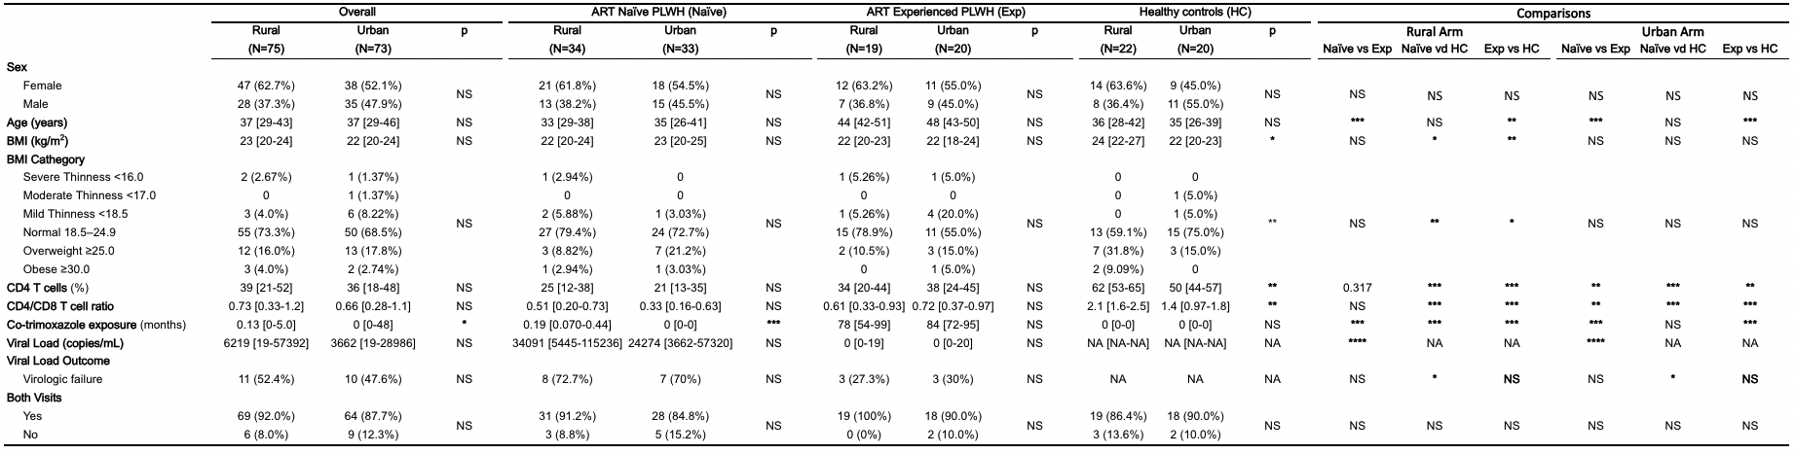

Table S1: Clinical and demographic characteristics of study population by cohort at baseline visit, stratified by the rural versus urban location. P-values were calculated using Mann Whitney U test. P-values are coded as ‘****’ between [0, 0.0001], ‘***’ (0.0001, 0.001], ‘**’ (0.001, 0.01], ‘*’ (0.01, 0.05], with square brackets indicating that the endpoints are included in the interval. NS means p-values were not significant. NA represents values not collected/ relevant to a particular cohort. Values are reported as the median with the interquartile range indicated in brackets. Virologic failure is defined as PLWH who are on ART but have uncontrolled viral replication(> 200 copies of HIV per milliliter of blood) [24, 25]. BMI categories were determined using World Health Organization (WHO) standards [26]

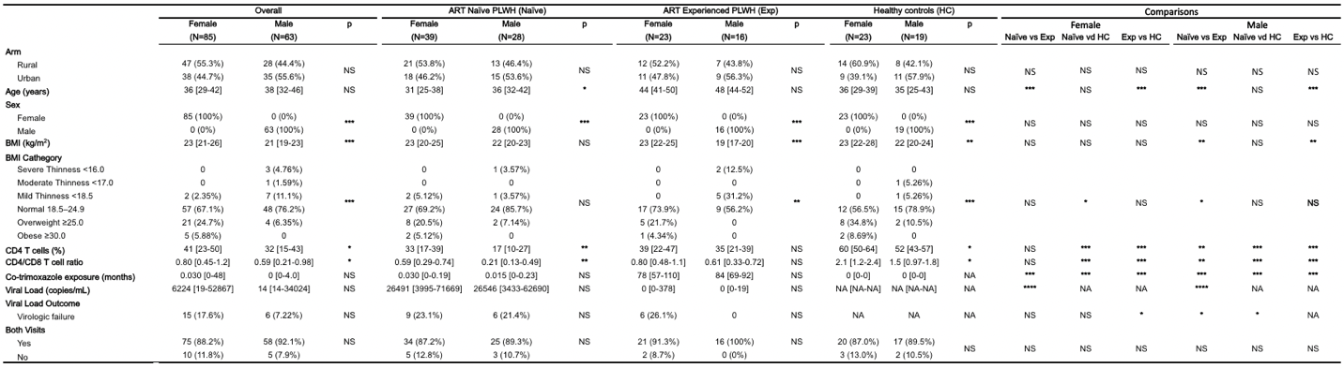

Table S2: Clinical and demographic characteristics of study population by cohort at baseline visit, stratified by sex. P-values were calculated using Mann Whitney U test. P-values are coded as ‘****’ between [0, 0.0001], ‘***’ (0.0001, 0.001], ‘**’ (0.001, 0.01], ‘*’ (0.01, 0.05], with square brackets indicating that the endpoints are included in the interval. NS means p-values were not significant. NA represents values not collected/ relevant to a particular cohort. Values are reported as the median with the interquartile range indicated in brackets. Virologic failure is defined as PLWH who are on ART but have uncontrolled viral replication(> 200 copies of HIV per milliliter of blood) [24, 25]. BMI categories were determined using World Health Organization (WHO) standards [26].

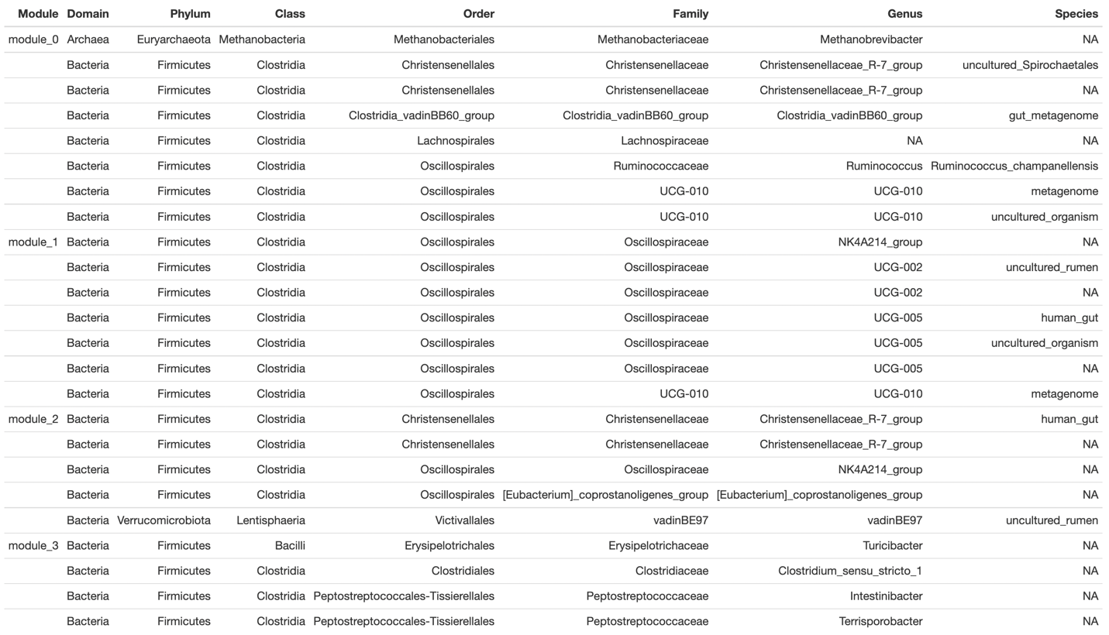

Table S3: Composition of largest modules found using SCNIC. Modules will have over four ASVs assigned to them.

