Mean | : | 0.643
95.00% Confidence Interval | : | 0.540 | to | 0.747
Standard Deviation | : | 0.042
t | : | -2,843.809
df | : | 2
p-value | : | 0.000
Bonferroni Adjusted p-value | : | 0.000
Dunn-Sidak Adjusted p-value | : | 0.000
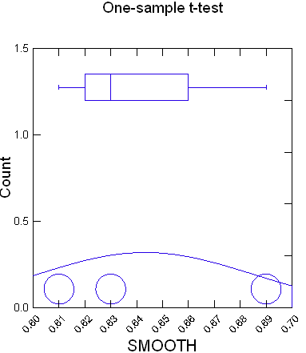

One-sample t-test of SOFT with 3 Cases
Ho: Mean = 0.550 vs Alternative = 'not equal'

Mean | : | 0.493
95.00% Confidence Interval | : | 0.357 | to | 0.630
Standard Deviation | : | 0.055
t | : | -1.782
df | : | 2
p-value | : | 0.217
Bonferroni Adjusted p-value | : | 0.217
Dunn-Sidak Adjusted p-value | : | 0.217

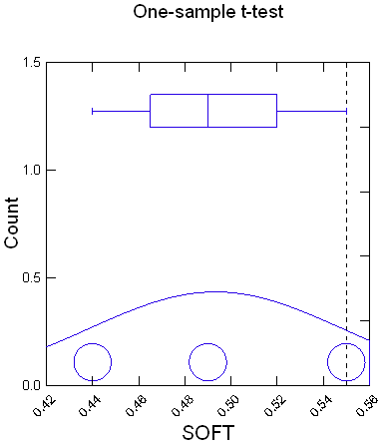

One-sample t-test of WARM with 3 Cases
Ho: Mean = 0.360 vs Alternative = 'not equal'

Mean | : | 0.403
95.00% Confidence Interval | : | 0.309 | to | 0.497
Standard Deviation | : | 0.038
t | : | 1.982
df | : | 2
p-value | : | 0.186
Bonferroni Adjusted p-value | : | 0.186
Dunn-Sidak Adjusted p-value | : | 0.186

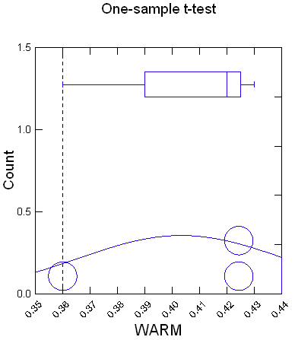
One-sample t-test of PSI with 3 Cases
Ho: Mean = 1.600 vs Alternative = 'not equal'

Mean | : | 1.540
95.00% Confidence Interval | : | 1.377 | to | 1.703
Standard Deviation | : | 0.066
t | : | -1.585
df | : | 2
p-value | : | 0.254
Bonferroni Adjusted p-value | : | 0.254
Dunn-Sidak Adjusted p-value | : | 0.254

