Supporting Information
Fig. S1 Sample sites for the field investigation of the leaf hole distribution of native plant leaves around invasive plants in different vegetation types, with a map of the Guangdong Province, China. The numbers on the map are the ID numbers of each sample site, and the geographical information and common plants of each sample site are listed in Supp. Table S1.
Fig. S2 Feeding preference of two insects (S. litura and S. frugiperda) toward invasive and native species. Invasive plants include S. trilobata, M. micrantha, and I. cairica. Native plants include S. calendulacea, I. batatas, and P. frutescens. The two photos on the top show the leaves of invasive plant and native plant before and after the feeding preference experiment with S. litura or S. frugiperda. The following photos show leaf herbivory by S. litura or S. frugiperda.
Fig. S1

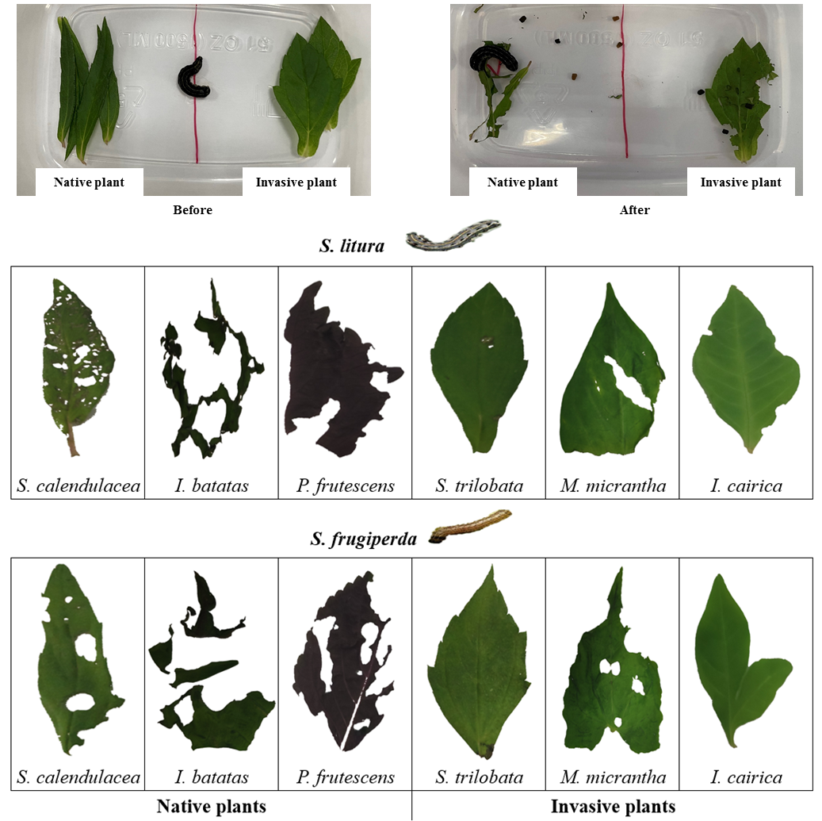

Fig. S2

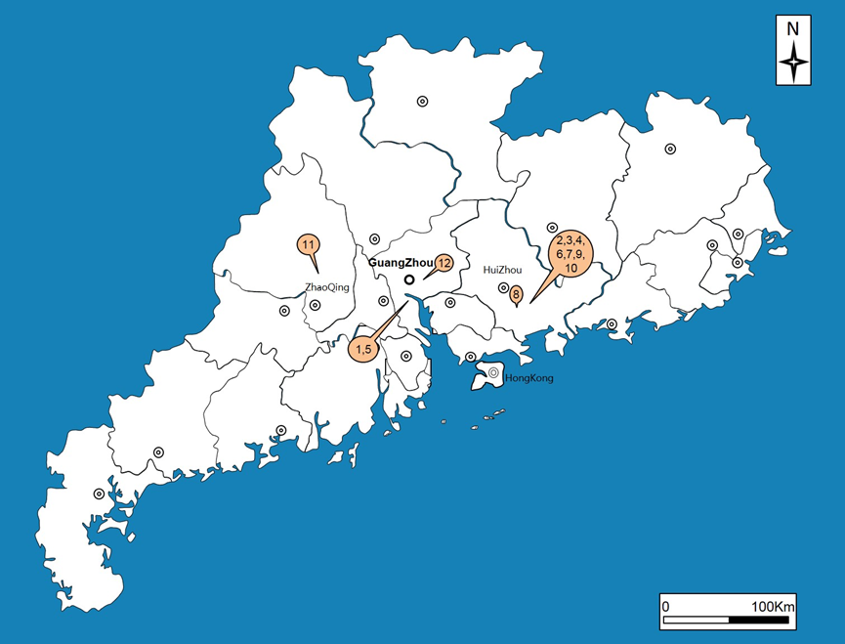

Table S1. Sites of the field investigation of the leaf holes on leaves fed on by native insects under the effects of invasive plants. PY (Panyu District of Guangzhou), GZ (Guangzhou City), HY (Huiyang District of Huizhou), HZ (Huizhou city), DH (Dinghu District of Zhaoqing), ZQ (Zhaoqing city), TH (Tianhe District of GZ), ID. refers to the number of each sample site on the map (Supp. Fig. S1)
Types | ID. | Site | Latitude and Longitude | Invasive Plants | Native Plants
Orchard | 1 | Bio-island, PY, GZ | N23°3′9.61″  E113°23′3.66″ | Bidens pilosa L.  Mikania micrantha Kunth,  Sphagneticola trilobata (L.) Pruski | Clausena lansium (Lour.) Skeels  Litchi chinensis Sonn.  Ipomoea nil (L.) Roth  Alocasia macrorrhiza (L.) Schott  Bauhinia purpurea L.  Polygonum hydropiper L.  Ipomoea batatas (L.) Lam.  Perilla frutescens (L.) Britt.
 | 2 | Huaguo village, HY, HZ | N22°52′22.52″  E114°21′21.36″ | M. micrantha  S. trilobata | L. chinensis  Maesa japonica (Thunb.) Moritzi  A. macrorrhizat
 | 3 | Shanding village, HY, HZ | N22°55′49.9″  E114°20′11.6″ | M. micrantha  B. pilosa | L. chinensis  M. japonica  A. macrorrhiza
 | 4 | Daguang village, HY, HZ | N22°93'77.82''  E114°30'39.93'' | M. micrantha | L. chinensis  Annona squamosa L.  Dimocarpus longan Lour.
Farmland | 5 | Biological island, PY, GZ | N23°3′9.61″  E113°23′3.66″ | B. pilosa  S. trilobata | Ricinus communis L.  P. frutescens  Hibiscus tiliaceus L.  B. purpurea
 | 6 | Xintang village, HY, HZ | N23°1′15″  E114°24′13″ | B. pilosa  M. micrantha | Raphanus sativus  Brassica juncea (L.) Czern.et Coss  Brassica oleracea var.capitata L.  Ipomoea aquatica Forsk  Boehmeria nivea (L.) Gaudich
 | 7 | Huaguo village, HY, HZ | N22°52′22.52″  E114°21′21.36″ | M. micrantha | R. sativus
Wasteland | 8 | Huizhou University, HY, HZ | N23°2′23.5″  E114°24′48.28″ | B. pilosa  S. trilobata | Hibiscus rosa-sinensis L.  Lagerstroemia speciosa (L.) Pers.  Cinnamomum camphora (L.) Presl  B. purpurea  Hibiscus tiliaceus L.
 | 9 | Xintang village, HR, HZ | N23°1′15″  E114°24′13″ | B. pilosa | B. nivea
 | 10 | Huaguo village, HY, HZ | N22°52′22.52″  E114°21′21.36″ | M. micrantha | B. nivea  Ficus religiosa L.
Forest | 11 | Dinghushan National Forest Park, DH, ZQ | N23°10′22.12″  E112°32′25.04″ | B. pilosa  S. trilobata  M. micrantha | B. nivea  Sterculia nobilis Smith  Caryota maxima Blume ex Martius  Mallotus paniculatus (Lam.) Muell. Arg.  Maesa perlarius (Lour.) Merr.
 | 12 | Huolushan Forest Park, TH, GZ | N23°11'14.57''  E113°23'14.14'' | M. micrantha  S. trilobata  B. pilosa | B. purpurea  Acacia mangium Willd.  Alchornea rewioides  Psychotria rubra (Lour.) Poir.

