Supplementary Material S2. Subgroup Analysis
1. Escape latency
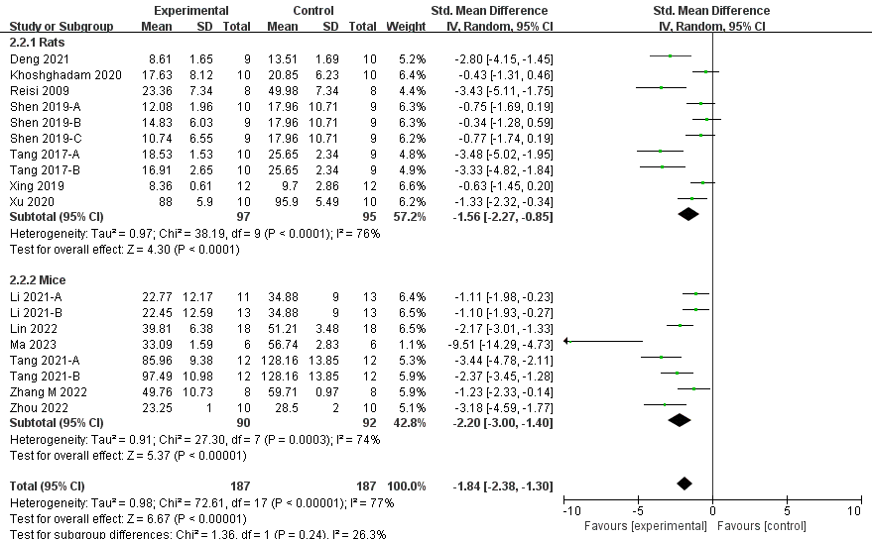
Figure 1. Animal species
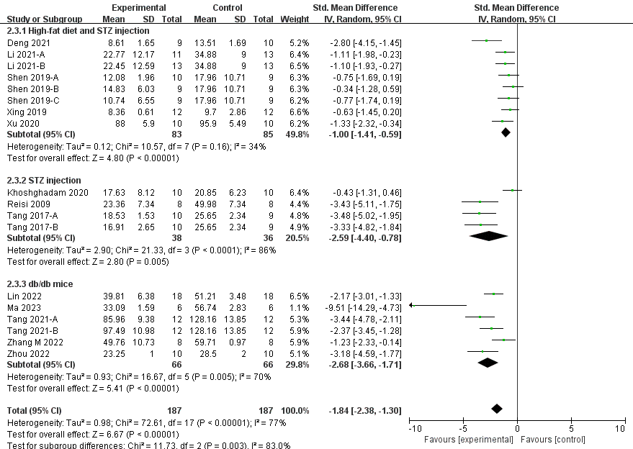
Figure 2. Modeling type
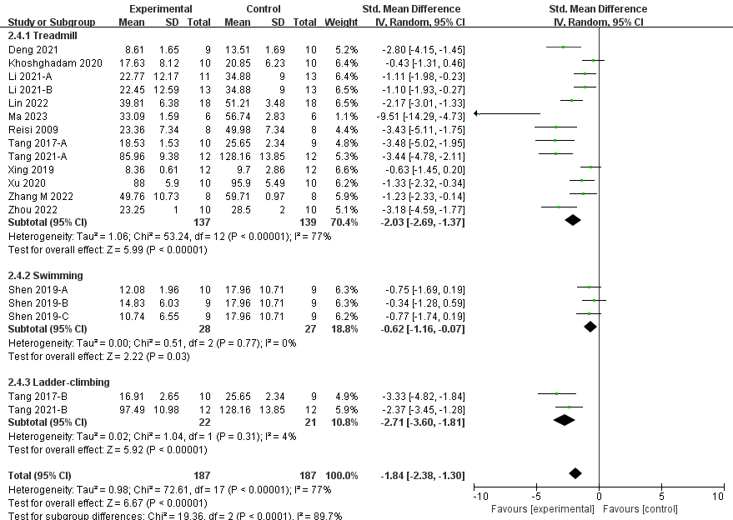
Figure 3. Exercise methods
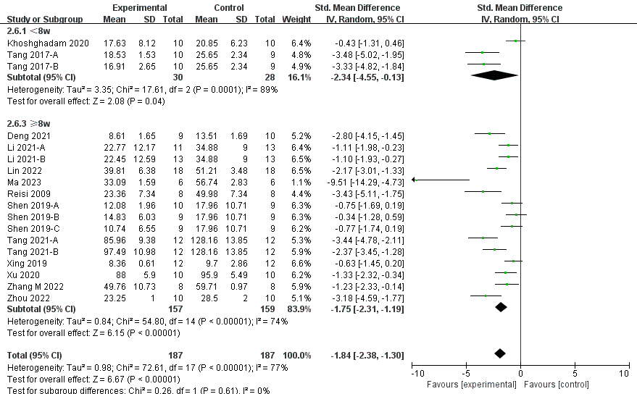
Figure 4. Exercise duration
2. The number of platform crossings
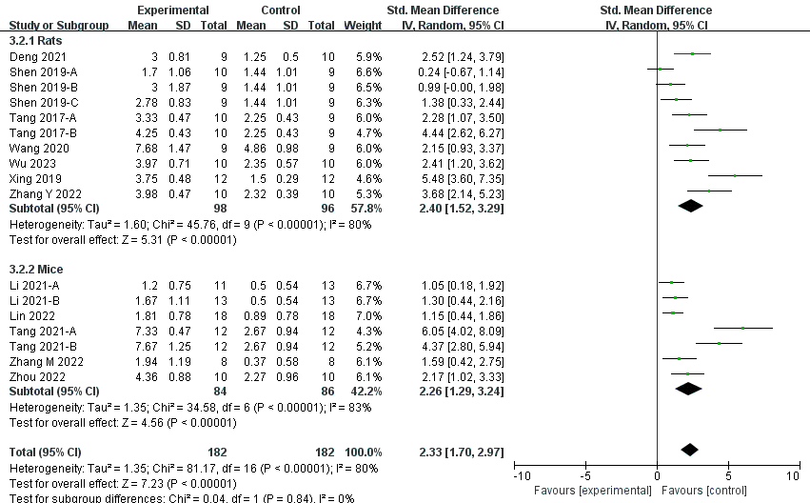
Figure 1. Animal species
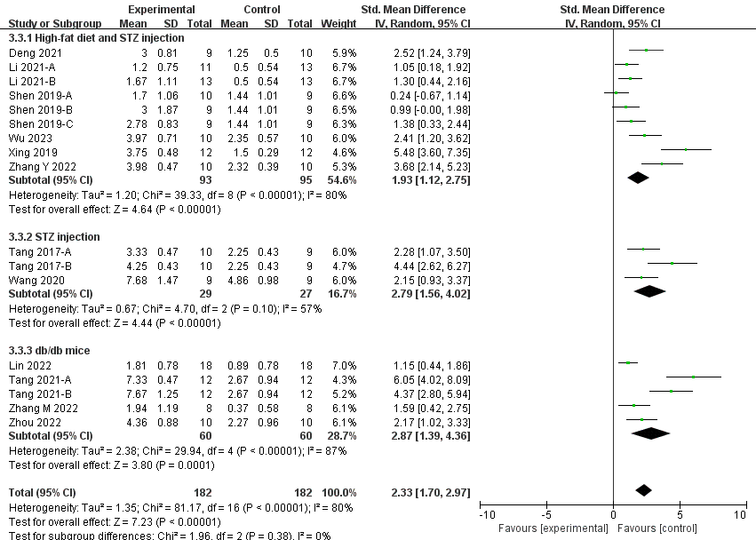
Figure 2. Modeling type
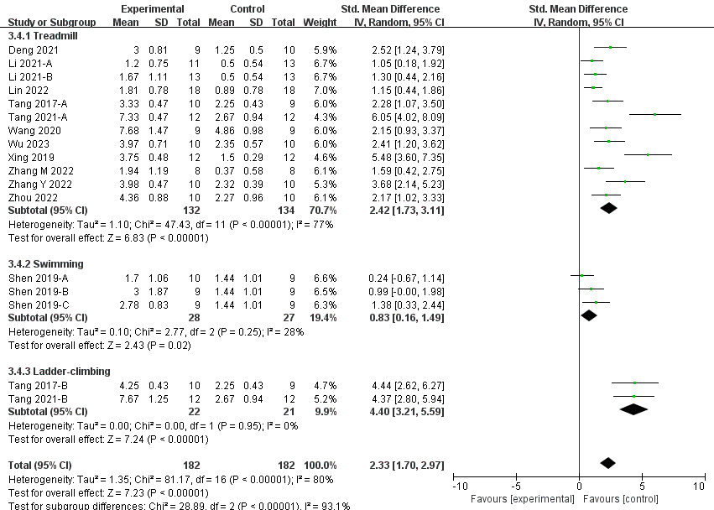
Figure 3. Exercise methods
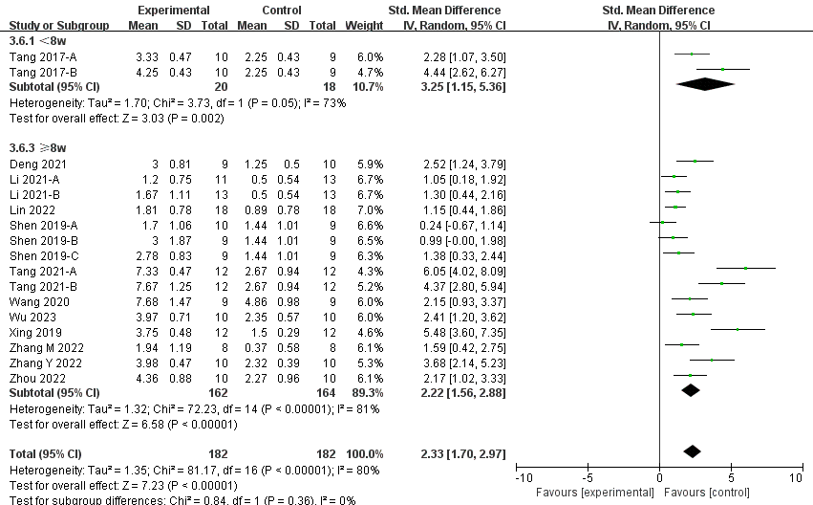
Figure 4. Exercise duration

