Supplementary Material S3
1. Sensitivity analysis
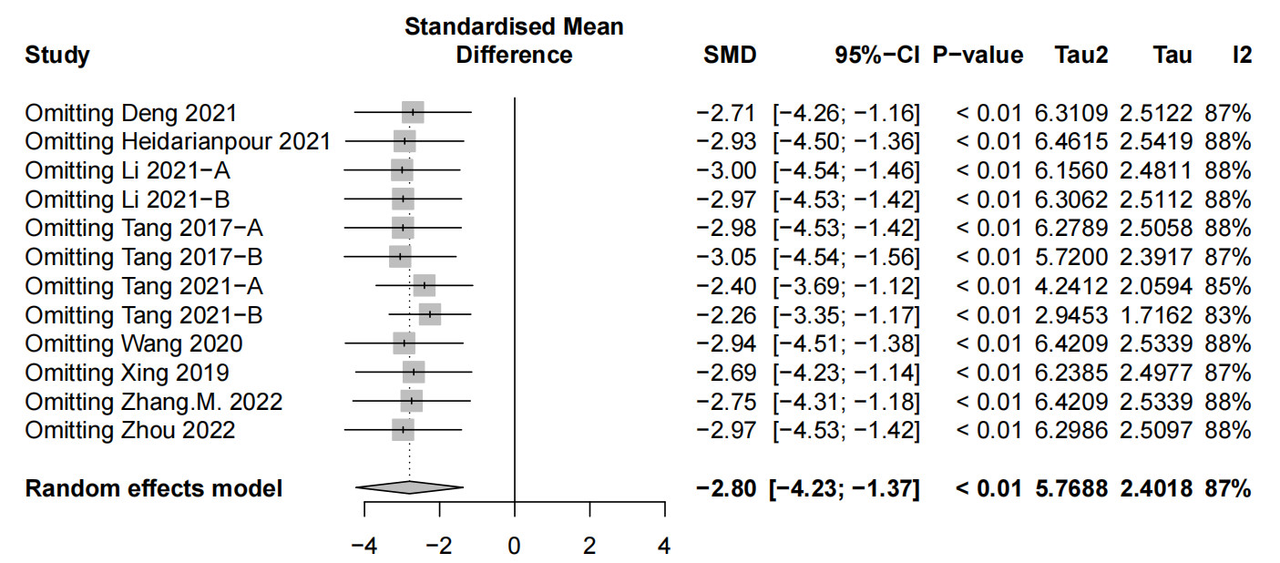
Figure 1. FBG
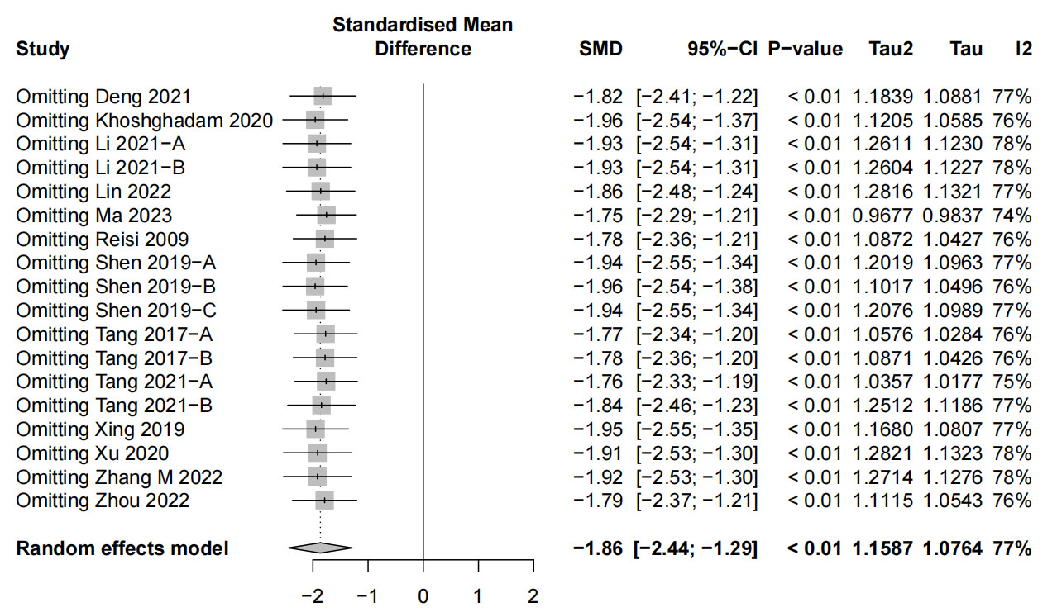
Figure 2. Escape latency
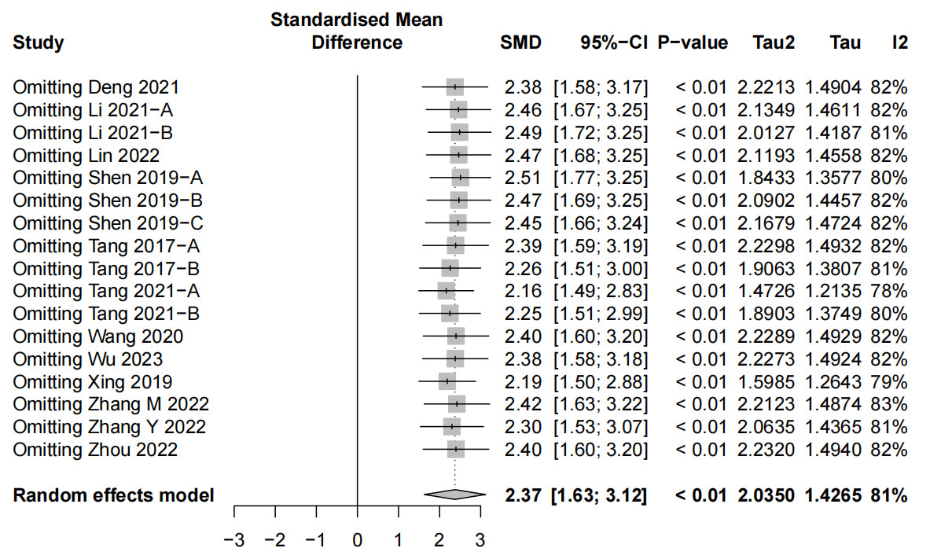
Figure 3. The number of platform crossings
2. Funnel plot
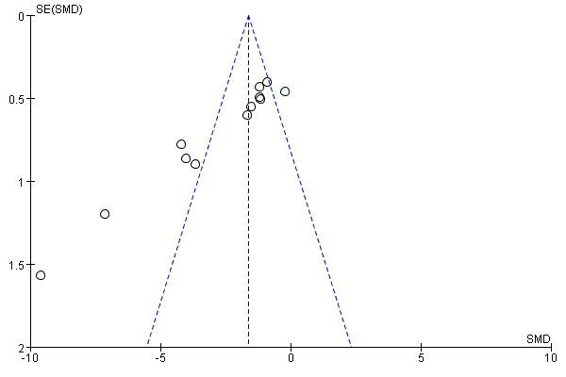
Figure 1. FBG
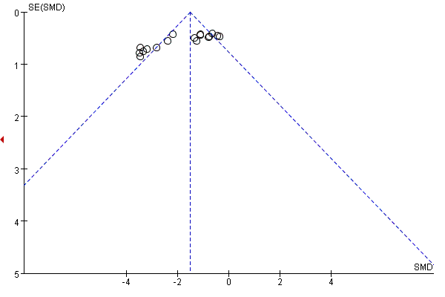
Figure 2. Escape latency
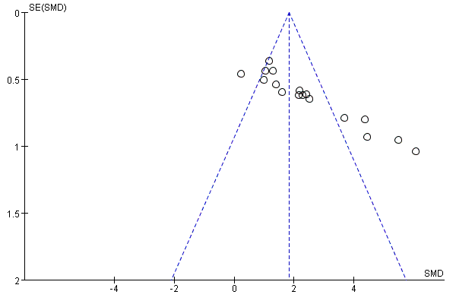
Figure 3. The number of platform crossings

