APPENDICES
Table A1: Determinants of household adoption of SAPs in Africa
Variable | I₁Z₀R₀A₀ | I₀Z₁R₀A₀ | I₀Z₀R₁A₀ | I₀Z₀R₀A₁ | I₁Z₁R₀A₀ | I₁Z₀R₁A₀ | I₁Z₀R₀A₁ | I₀Z₁R₁A₀ | I₀Z₁R₀A₁ | I₀Z₀R₁A₁ | I₁Z₁R₁A₀ | I₁Z₁R₀A₁ | I₁Z₀R₁A₁ | I₀Z₁R₁A₁ | I₁Z₁R₁A₁
Household level covariates
Gender | 0.57  (0.21)*** | 0.76  (0.19)*** | 0.28  (0.21) | 0.47  (0.23)** | 0.65  (0.25)** | 0.51  (0.28)* | 1.04  (0.28)*** | 0.95  (0.33)*** | 0.87  (0.33)*** | 0.07  (0.28) | 0.89  (0.30)*** | 1.24  (0.36)*** | 0.78  (0.36)** | -0.04  (0.42) | 0.48  (0.51)
Age | 0.00  (0.01) | 0.00  (0.00) | 0.00  (0.00) | 0.00  (0.01) | 0.01  (0.01) | 0.01  (0.01)** | 0.02  (0.01) | 0.01  (0.01) | 0.02  (0.01)*** | 0.01  (0.01) | 0.01  (0.01) | 0.00  (0.01) | 0.00  (0.01) | 0.00  (0.01) | 0.02  (0.01)**
Educational level | 0.06  (0.02)*** | 0.09  (0.02)*** | 0.07  (0.02)*** | 0.09  (0.03)*** | 0.09  (0.03)*** | 0.14  (0.03)*** | 0.18  (0.03)*** | 0.23  (0.03)*** | 0.18  (0.03)*** | 0.04  (0.03) | 0.05  (0.04) | 0.08  (0.04)** | 0.07  (0.04)* | 0.13  (0.04)*** | 0.08  (0.06)
Household size | 0.00  (0.02) | 0.00  (0.02) | 0.01  (0.02) | 0.04  (0.02)* | 0.04  (0.02)* | 0.03  (0.02) | 0.02  (0.02) | 0.05  (0.03)* | 0.03  (0.03) | 0.01  (0.03) | 0.01  (0.03) | -0.09  (0.04)** | 0.03  (0.03) | 0.05  (0.03) | 0.03  (0.04)
Off-farm income | 0.00  (0.00) | 0.00  (0.00) | 0.00  (0.00) | 0.00  (0.00) | 0.00  (0.00) | 0.00  (0.00) | 0.00  (0.00)*** | 0.00  (0.00)* | 0.00  (0.00)*** | 0.00  (0.00) | 0.00  (0.00) | 0.00  (0.00) | 0.00  (0.00)* | 0.00  (0.00)* | 0.00  (0.00)
Migrate | 0.08  (0.15) | 0.23  (0.14) | 0.33  (0.15)** | 0.45  (0.18)** | -0.03  (0.19) | 0.41  (0.21)** | -0.06  (0.23) | 0.04  (0.26) | -0.07  (0.27) | 0.09  (0.20) | 0.12  (0.23) | 0.39  (0.25) | -0.39  (0.27) | -0.41  (0.32) | 0.14  (0.40)
Plot level covariates
Farm size | 0.02  (0.01) | 0.02  (0.01)* | 0.01  (0.01) | 0.00  (0.01) | 0.01  (0.02) | 0.01  (0.02) | 0.00  (0.02) | -0.01  (0.02) | -0.03  (0.03) | -0.01  (0.02) | -0.01  (0.02) | 0.01  (0.02) | 0.03  (0.01)** | -0.01  (0.03) | 0.04  (0.02)***
Land title | 0.40  (0.21)* | 0.34  (0.20)* | 0.10  (0.21) | 0.02  (0.24) | 0.33  (0.27) | 0.03  (0.29) | 0.26  (0.30) | 1.00  (0.41)** | 1.42  (0.42)*** | -0.08  (0.30) | 0.73  (0.33)*** | 0.35  (0.33) | 0.47  (0.36) | 0.01  (0.49) | 0.14  (0.61)
Plot distance | -0.05  (0.03)* | -0.02  (0.02) | -0.01  (0.03) | 0.00  (0.03) | -0.01  (0.03) | -0.01  (0.03) | -0.03  (0.04) | 0.04  (0.05) | 0.12  (0.05)** | -0.03  (0.04) | 0.02  (0.04) | 0.03  (0.05) | -0.01  (0.05) | -0.03  (0.05) | -0.05  (0.06)
Location covariates
Labour price | 0.00  (0.00)** | 0.00  (0.00)** | 0.00  (0.00)** | 0.00  (0.00) | 0.00  (0.00)* | 0.00  (0.00)* | 0.00  (0.00)* | 0.00  (0.00)* | 0.00  (0.00) | 0.00  (0.00) | 0.00  (0.00) | 0.00  (0.00) | 0.00  (0.00)** | 0.00  (0.00)** | 0.00  (0.00)*
Fertilizer price | 0.02  (0.01)** | 0.01  (0.01)** | 0.01  (0.01)** | 0.02  (0.01)** | 0.02  (0.01)*** | 0.02  (0.01)** | 0.01  (0.01)** | 0.01  (0.01) | 0.01  (0.01) | 0.01  (0.01)* | 0.02  (0.01)*** | 0.02  (0.01)** | 0.01  (0.01) | 0.01  (0.01)* | 0.01  (0.01)
West¹ | 0.65  (0.17)*** | 0.03  (0.16) | -0.46  (0.17)*** | -0.75  (0.21)*** | -1.00  (0.22)*** | -0.85  (0.26)*** | -1.09  (0.25)*** | -1.79  (0.34)*** | -1.31  (0.29)*** | -0.10  (0.23) | -0.11  (0.27) | 0.56  (0.30* | -0.52  (0.33) | -0.46  (0.35) | -0.96  (0.43)**
South¹ | 0.44  (0.17)*** | 0.65  (0.16)*** | 0.44  (0.18)** | 1.23  (0.21)*** | 1.18  (0.22)*** | 1.50  (0.26)*** | 2.05  (0.22)*** | 1.51  (0.33)*** | 0.36  (0.35 | 0.32  (0.24) | 0.48  (0.28)*** | 0.61  (0.30) ** | 0.64  (0.35)* | 1.07  (0.38)*** | 0.81  (0.48)*
Institutional covariates
Contract farming | -1.84  (0.19)*** | -1.78  (0.18)*** | -1.92  (0.19)*** | -1.67  (0.21)*** | -1.66  (0.22)*** | -1.71  (0.23)*** | -1.57  (0.28)*** | -1.70  (0.30)*** | -2.22  (0.31)*** | -0.44  (0.29) | -1.41  (0.26)*** | -1.74  (0.29)*** | -1.51  (0.31)*** | -1.69  (0.37)*** | -1.49  (0.46)***
Credit | -1.19  (0.26)*** | -0.43**  (0.21) | -0.39  (0.21)* | -1.11  (0.26)*** | -0.52  (0.26)** | -0.10  (0.26) | -0.45  (0.28) | 0.04  (0.27) | -0.31  (0.31) | 0.22  (0.27) | -2.09  (0.53)*** | -0.62  (0.41) | -0.87  (0.43)** | -1.16  (0.50)** | 0.15  (0.45)
Market outlet | 0.02  (0.17) | 0.11  (0.16) | 0.06  (0.17) | 0.21  (0.20) | 0.25  (0.21) | 0.31  (0.22) | 0.10  (0.24) | -0.08  (0.31) | 0.27  (0.31) | -0.24  (0.27) | 0.09  (0.27) | 0.03  (0.28) | 0.23  (0.32) | 0.52  (0.32) | 0.77  (0.38)**
Instruments
Perception | -0.63  (0.22)*** | -0.92  (0.21)*** | -0.98  (0.24)*** | -1.23  (0.29)*** | -1.85  (0.31)*** | -1.32  (0.35)*** | -2.33  (0.32)*** | -1.77  (0.39)*** | -1.64  (0.42)*** | 0.06  (0.27) | -1.17  (0.38)*** | -0.75  (0.40)* | -0.66  (0.43) | -0.89  (0.53)* | -1.10  (0.54)**
Extension | -0.08  (0.16) | 0.12  (0.15) | 0.14  (0.15) | 0.38  (0.18)** | 0.69  (0.20)*** | -0.21  (0.04)*** | 0.65  (0.25)*** | 0.08  (0.28) | -0.22  (0.29 | -0.57  (0.22)** | 0.74  (0.24)*** | 0.00  (0.25) | 0.12  (0.29) | 0.56  (0.33)* | 0.08  (0.35)
FBO | -0.41  (0.19)** | -0.31  (0.18)* | -0.17  (0.03)*** | 0.33  (0.20) | 0.22  (0.02)*** | 0.09  (0.24) | -0.23  (0.25) | 0.32  (0.28) | 0.93  (0.32)*** | 0.23  (0.24) | -0.01  (0.27) | -0.65  (0.32)** | 0.03  (0.33) | 0.02  (0.33) | -0.34  (0.40)
Constant | -0.59  (0.42) | -0.41  (0.39) | -0.03  (0.41) | -1.39  (0.50)*** | -2.15  (0.52)*** | -2.69  (0.53)*** | -3.64  (0.62)*** | -4.26  (0.69)*** | -4.59  (0.74)*** | -1.83  (0.62)*** | -3.30  (0.60)*** | -2.65  (0.70)*** | -2.55  (0.79)*** | -2.22  (0.89)** | -4.21  (0.97)***
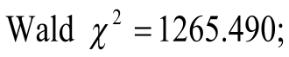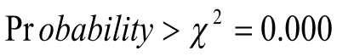
Notes:¹The reference for the various region of Africa is East Africa. The baseline is households that did not adopt any practice (I₀Z₀R₀A₀). Robust standard errors are in parentheses.
*** Denotes significance level at 1%.
** Denotes significance level at 5%.
* Denotes significance level at 10%.

Table A2: Test of Instrument Validity (Pooled sample)
Variables | Log (Farm income) |  | Log (SSF)
Variables | Coef. | Std. Err. | Coef. | Std. Err.
Household level covariates
Gender | 0.43 | 0.10*** | -0.14 | 0.06**
Age | 0.10 | 0.01*** | 0.00 | 0.00
Educational level | -0.01 | 0.01 | 0.01 | 0.01
Household size | 0.00 | 0.01 | -0.17 | 0.01***
Off-farm income | 0.23 | 0.01*** | 0.15 | 0.08**
Migrate | 0.32 | 0.07*** | 0.03 | 0.05
Plot level covariates
Farm size | 0.10 | 0.01*** | 0.51 | 0.01***
Land title | 0.11 | 0.01*** | 0.01 | 0.01
Plot distance | 0.04 | 0.10 | -0.14 | 0.06**
Location covariates
Labour price | 0.20 | 0.05*** | 0.00 | 0.00
Fertilizer price | 0.06 | 0.10 | 0.13 | 0.05**
West Africa² | -0.01 | 0.08 | -0.01 | 0.05
Southern Africa² | 0.09 | 0.01** | -0.05 | 0.05
Institutional level covariates
Contract farming | -0.25 | 0.08** | 0.08 | 0.05
Credit | -0.17 | 0.10 | 0.18 | 0.07***
Market outlet | -0.16 | 0.08* | -0.11 | 0.06**
Instruments
Perception | 0.08 | 0.22 | 0.05 | 0.15
Extension | -0.01 | 0.09 | -0.02 | 0.06
FBO | -0.01 | 0.11 | 0.07 | 0.12
Constant | 4.24 | 0.20*** | 5.89 | 0.13***
R-square | 0.0041 |  | 0.0542
F-statistics | 0.82 |  | 0.67
Notes:²The reference for the various region of Africa is East Africa.
*** Denotes significance level at 1%.
** Denotes significance level at 5%.
* Denotes significance level at 10%.
Table A3: Test of Instrument Validity (Eastern Africa)
Variables | Log (Farm income) |  | Log (SSF)
Variables | Coef. | Std. Err. | Coef. | Std. Err.
Household level covariates
Gender | -0.06 | 0.11 | -0.09 | 0.03**
Age | 0.00 | 0.00 | 0.00 | 0.00
Educational level | -0.01 | 0.11 | -0.01 | 0.31
Household size | -0.17 | 0.01*** | 0.10 | 0.01***
Off-farm income | 0.00 | 0.00 | 0.00 | 0.00
Migrate | 0.27 | 0.08*** | 0.19 | 0.09**
Plotlevel covariates
Farm size | 0.22 | 0.01*** | 0.20 | 0.19
Land title | 0.20 | 0.10* | -0.21 | 0.10**
Plot distance | -0.16 | 0.02*** | -0.26 | 0.14*
Location covariates
Labour price | 0.06 | 0.10 | 0.02 | 0.01*
Fertilizer price | 0.18 | 0.23 | 0.00 | 0.00
Ethiopia | 0.13 | 0.07* | -0.10 | 0.02**
Uganda | -0.19 | 0.03*** | 0.03 | 0.11
Tanzania | 0.06 | 0.10 | -0.01 | 0.12
Institutional level covariates
Contract farming | 0.28 | 0.11** | 0.07 | 0.03**
Credit | 0.05 | 0.08 | 0.13 | 0.07*
Market outlet | 0.22 | 0.08*** | 0.06 | 0.10
Instruments
Perception | 0.13 | 0.12 | -0.19 | 0.14
Extension | -0.07 | 0.11 | -0.08 | 0.10
FBO | 0.09 | 0.10 | 0.28 | 0.18
Constant | 5.66 | 0.22*** | 5.32 | 0.26***
R-square | 0.0415 |  | 0.0247
F-statistics | 1.2301 |  | 1.1121
Notes:³The reference for the country is Kenya.
*** Denotes significance level at 1%.
** Denotes significance level at 5%.
* Denotes significance level at 10%.
Table A4: Test of Instrument Validity (West Africa)
Variables | Log (Farm income) |  | Log (SSF)
Variables | Coef. | Std. Err. | Coef. | Std. Err.
Household level covariates
 | Coef. | Std. Err. | Coef. | Std. Err.
Gender | 0.07 | 0.17 | 0.18 | 0.15
Age | 0.01 | 0.00*** | 0.00 | 0.00
Educational level | 0.22 | 0.01*** | 0.02 | 0.01
Household size | 0.00 | 0.01 | -0.16 | 0.01***
Off-farm income | 0.31 | 0.00*** | 0.11 | 0.01***
Migrate | 0.03 | 0.10 | 0.09 | 0.09
Plot level covariates
Farm size | 0.19 | 0.01*** | 0.01 | 0.01
Land title | 0.13 | 0.04** | 0.08 | 0.12
Plot distance | 0.41 | 0.02*** | -0.02 | 0.02
Location covariates
Labour price | 0.01 | 0.00*** | 0.16 | 0.13
Fertilizer price | 0.30 | 0.01*** | 0.13 | 0.03***
Nigeria⁴ | -0.19 | 0.10* | -0.12 | 0.02***
Institutional level covariates
Contract farming | -0.16 | 0.13 | -0.27 | 0.11
Credit | -0.07 | 0.03** | 0.03 | 0.15
Market outlet | -0.07 | 0.11 | -0.11 | 0.06*
Instruments
Perception | -0.07 | 0.16 | 0.11 | 0.14
Extension | 0.05 | 0.11 | -0.07 | 0.10
FBO | 0.13 | 0.12 | 0.05 | 0.11
Constant | 4.20 | 0.34*** | 5.85 | 0.29***
R-square | 0.0272 |  | 0.0854
F-statistics | 1.33 |  | 1.05
Notes:⁴The reference for the country is Ghana.
*** Denotes significance level at 1%.
** Denotes significance level at 5%.
* Denotes significance level at 10%.

Table A5: Test of Instrument Validity (Southern Africa)
Variables | Log (Farm income) |  | Log (SSF)
Variables | Coef. | Std. Err. | Coef. | Std. Err.
Household level covariates
Gender | -0.12 | 0.10 | 0.19 | 0.11*
Age | 0.00 | 0.00 | 0.00 | 0.00
Educational level | 0.01 | 0.01 | 0.01 | 0.02
Household size | -0.15 | 0.01*** | 0.00 | 0.01
Off-farm income | 0.00 | 0.00 | 0.00 | 0.00
Migrate | 0.04 | 0.09 | -0.07 | 0.10
Plot level covariates
Farm size | 0.00 | 0.01 | -0.01 | 0.01
Land title | 0.01 | 0.01 | 0.01 | 0.02
Plot distance | -0.25 | 0.13* | 0.19 | 0.15
Location covariates
Labour price | 0.00 | 0.00 | 0.00 | 0.00
Fertilizer price | 0.00 | 0.00 | 0.00 | 0.00
Malawi⁵ | -0.74 | 0.12*** | -0.04 | 0.13
Zambia⁵ | -0.36 | 0.16** | 0.20 | 0.17
Institutional level covariates
Contract farming | -0.09 | 0.01*** | -0.15 | 0.05***
Credit | 0.34 | 0.09*** | -0.05 | 0.11
Market outlet | 0.18 | 0.14 | -0.16 | 0.03***
Instruments
Perception | -0.05 | 0.08 | -0.13 | 0.09
Extension | -0.02 | 0.11 | -0.19 | 0.12
FBO | 0.19 | 0.13 | -0.08 | 0.14
Constant | 6.48 | 0.23*** | 4.86 | 0.25***
R-square | 0.0675 |  | 0.0194
F-statistics | 1.4312 |  | 1.10
Notes:⁵The reference for the country is Mozambique.
*** Denotes significance level at 1%.
** Denotes significance level at 5%.
* Denotes significance level at 10%.
Table A6: Hausman tests of IIA assumption (Eastern Africa)
Omitted | chi2 | df | P>chi2
I₀Z₀R₀A₀ | 112.692 | 238 | 1.000
I₁Z₀R₀A₀ | 73.170 | 238 | 1.000
I₀Z₁R₀A₀ | 100.939 | 238 | 1.000
I₀Z₀R₁A₀ | 95.559 | 238 | 1.000
I₀Z₀R₀A₁ | 87.526 | 238 | 1.000
I₁Z₁R₀A₀ | 73.920 | 238 | 1.000
I₁Z₀R₁A₀ | 65.474 | 238 | 1.000
I₁Z₀R₀A₁ | 61.145 | 238 | 1.000
I₀Z₁R₁A₀ | 82.232 | 238 | 1.000
I₀Z₁R₀A₁ | 57.093 | 238 | 1.000
I₀Z₀R₁A₁ | 64.506 | 238 | 1.000
I₁Z₁R₁A₀ | 36.918 | 238 | 1.000
I₁Z₁R₀A₁ | -27.731 | 238 | 1.000
I₁Z₀R₁A₁ | 43.582 | 238 | 1.000
I₀Z₁R₁A₁ | 54.603 | 238 | 1.000
I₁Z₁R₁A₁ | 28.321 | 238 | 1.000
N | 1579
Note: H_{o} is Odds (Outcome-J Vs Outcome-K) are independent of other alternatives and a significant test is evidence against Ho
Table A7: Hausman tests of IIA assumption (Western Africa)
Omitted | chi2 | df | P>chi2
I₀Z₀R₀A₀ | 0.000 | 10 | 1.000
I₁Z₀R₀A₀ | 0.000 | 10 | 1.000
I₀Z₁R₀A₀ | 0.485 | 11 | 1.000
I₀Z₀R₁A₀ | 0.679 | 13 | 1.000
I₀Z₀R₀A₁ | 0.361 | 10 | 1.000
I₁Z₁R₀A₀ | 0.370 | 10 | 1.000
I₁Z₀R₁A₀ | 0.396 | 13 | 1.000
I₁Z₀R₀A₁ | 0.107 | 10 | 1.000
I₀Z₁R₁A₀ | 0.000 | 6 | 1.000
I₀Z₁R₀A₁ | 0.100 | 9 | 1.000
I₀Z₀R₁A₁ | 0.000 | 10 | 1.000
I₁Z₁R₁A₀ | 0.000 | 10 | 1.000
I₁Z₁R₀A₁ | 0.000 | 9 | 1.000
I₁Z₀R₁A₁ | 0.124 | 19 | 1.000
I₀Z₁R₁A₁ | 0.325 | 12 | 1.000
I₁Z₁R₁A₁ | 0.032 | 11 | 1.000
N | 1003
Note: H_{o} is Odds (Outcome-J Vs Outcome-K) are independent of other alternatives and a significant test is evidence against Ho

Table A8: Hausman tests of IIA assumption (Southern Africa)
Omitted | chi2 | df | P>chi2
I₀Z₀R₀A₀ | 0.000 | 3 | 1.000
I₁Z₀R₀A₀ | 0.000 | 3 | 1.000
I₀Z₁R₀A₀ | 1.562 | 17 | 1.000
I₀Z₀R₁A₀ | 0.005 | 5 | 1.000
I₀Z₀R₀A₁ | 0.437 | 6 | 0.999
I₁Z₁R₀A₀ | 0.020 | 3 | 1.000
I₁Z₀R₁A₀ | 0.001 | 8 | 1.000
I₁Z₀R₀A₁ | 0.004 | 3 | 1.000
I₀Z₁R₁A₀ | 0.151 | 3 | 1.000
I₀Z₁R₀A₁ | 0.196 | 8 | 1.000
I₀Z₀R₁A₁ | 0.000 | 3 | 1.000
I₁Z₁R₁A₀ | 0.123 | 2 | 1.000
I₁Z₁R₀A₁ | 0.000 | 3 | 1.000
I₁Z₀R₁A₁ | 1.480 | 23 | 1.000
I₀Z₁R₁A₁ | 0.036 | 8 | 1.000
I₁Z₁R₁A₁ | 0.074 | 26 | 1.000
N | 1227
Note: H_{o} is Odds (Outcome-J Vs Outcome-K) are independent of other alternatives and a significant test is evidence against Ho.

Table A9: AIPW estimates of effect adoption m relative to non-adoption l
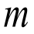 |  | East west 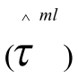 |  | West Africa |  | South Africa |  | Pooled sample
 |  | FI | SSF | FI | SSF | FI | SSF | FI | SSF
I₁Z₀R₀A₀ | I₀Z₀R₀A₀ | -0.46 (0.06)*** | -0.66 (0.54) | -0.30 (0.27)*** | -0.53 (0.02)*** | -0.27 (0.19) | -0.13 (0.22) | -0.06 (0.17) | -0.95 (1.15)
I₀Z₁R₀A₀ | I₀Z₀R₀A₀ | -0.51 (1.30) | -0.34 (0.17)** | -0.24 (0.13)** | -0.72 (1.13) | -0.33 (0.06)*** | -0.07 (0.15) | -0.31 (0.05)*** | -0.04 (0.10)
I₀Z₀R₁A₀ | I₀Z₀R₀A₀ | -0.63 (0.03)*** | -0.26 (0.24) | -0.01 (0.16) | -0.18 (0.07)*** | -0.19 (0.16) | -0.46 (0.07)*** | -0.24 (0.34) | -0.41 (0.01)***
I₀Z₀R₀A₁ | I₀Z₀R₀A₀ | -0.46 (0.76) | -0.66 (0.34)** | 0.30 (0.27)* | -0.53 (0.32)** | -0.27 (0.19)* | -0.13 (0.22) | -0.06 (0.17) | -0.95 (2.05)
I₁Z₁R₀A₀ | I₀Z₀R₀A₀ | -0.74 (1.17) | -0.85 (0.07)*** | -0.63 (0.03)*** | -0.45 (0.55) | -0.98 (0.01)*** | -0.93 (0.08)*** | -0.72 (0.01)*** | -0.59 (0.01)***
I₁Z₀R₁A₀ | I₀Z₀R₀A₀ | 0.17 (0.17) | -0.44 (0.40) | -0.13 (0.34) | -0.54 (0.04)*** | 0.98 (1.20) | -0.60 (0.30)** | -0.48 (0.06)*** | -0.51 (0.63)
I₁Z₀R₀A₁ | I₀Z₀R₀A₀ | 0.46 (0.24)* | 0.74 (0.29)*** | 0.38 (1.11) | 0.61 (0.87) | -0.58 (0.02)*** | -0.76 (0.08)*** | -0.41 (0.20)** | -0.78 (0.87)
I₀Z₁R₁A₀ | I₀Z₀R₀A₀ | -0.58 (0.08)*** | -0.27 (0.29) | -0.73 (1.16) | -0.08 (0.40) | -0.59 (0.24)*** | -0.67 (0.87) | -0.24 (0.24) | -0.46 (0.18)**
I₀Z₁R₀A₁ | I₀Z₀R₀A₀ | -0.79(0.40)** | -0.48 (0.27)** | -0.57 (0.39)* | -0.07 (0.47) | -0.11 (0.16) | 0.94 (0.05)*** | 0.06 (0.22) | -0.42 (0.22)**
I₀Z₀R₁A₁ | I₀Z₀R₀A₀ | -0.80 (0.02)*** | -0.11 (0.28) | -0.09 (0.23) | 0.18 (0.21) | -0.43 (0.28)* | 0.10 (0.23) | -0.12 (0.20) | -0.23 (0.54)
I₁Z₁R₁A₀ | I₀Z₀R₀A₀ | 0.35 (0.47) | 0.35 (0.41) | 0.51 (0.23)*** | 0.86 (0.03)*** | 0.35 (0.44) | 0.46 (0.34)* | -0.28 (0.20) | 0.86 (0.76)
I₁Z₁R₀A₁ | I₀Z₀R₀A₀ | 0.49 (0.25)* | 0.35 (0.27)* | 0.80 (0.23)*** | 0.86 (0.44)* | 0.52 (0.24)** | 0.98 (0.04)*** | 0.83 (0.02)*** | 0.93 (0.06)***
I₁Z₀R₁A₁ | I₀Z₀R₀A₀ | 0.58 (0.63) | 0.30 (0.31) | 0.61 (1.24) | 0.25 (0.11)** | -0.04 (0.19) | 0.81 (1.23) | 0.26 (0.21) | 0.21 (0.15)*
I₀Z₁R₁A₁ | I₀Z₀R₀A₀ | 0.59 (0.29)** | 0.81 (0.01)*** | 0.80 (0.36)*** | 0.06 (0.32) | -0.52 (0.22)** | 0.49 (0.22)** | 0.83 (0.08)*** | 0.93 (0.03)***
I₁Z₁R₁A₁ | I₀Z₀R₀A₀ | 0.79 (0.08)*** | 0.83 (0.09)*** | 0.67 (0.34)* | 0.87 (0.02)*** | 0.80 (0.05)*** | 0.17 (1.41) | 0.81 (0.07)*** | 0.37(0.21)
The figures in brackets represent standard deviations. *p<0.1; **p<0.5; ***p<0.001

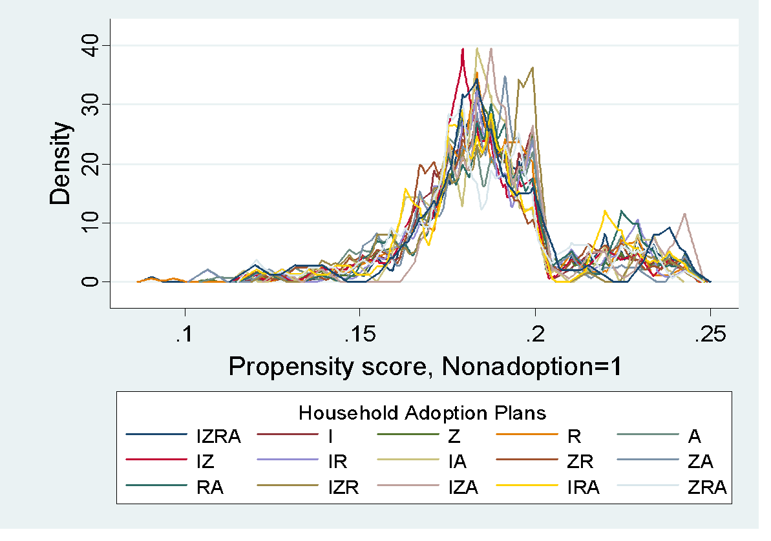
Figure A1: The estimated densities of the predicted probabilities of treatment level employed

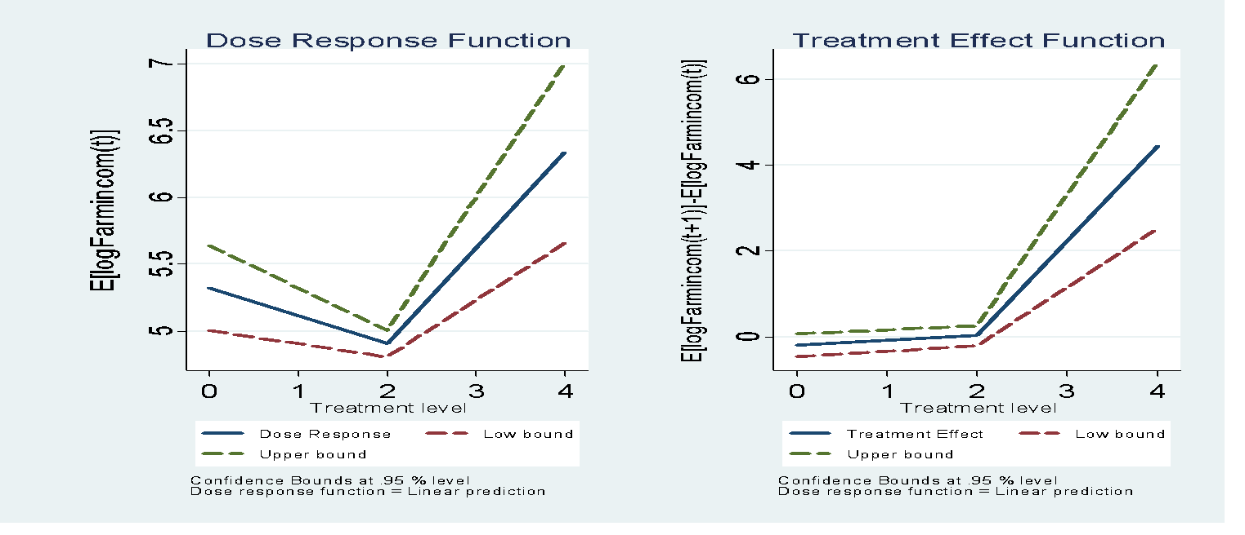
Fig. A2: Dose response (average treatment) and marginal treatment effect functions for farm income of households in East Africa
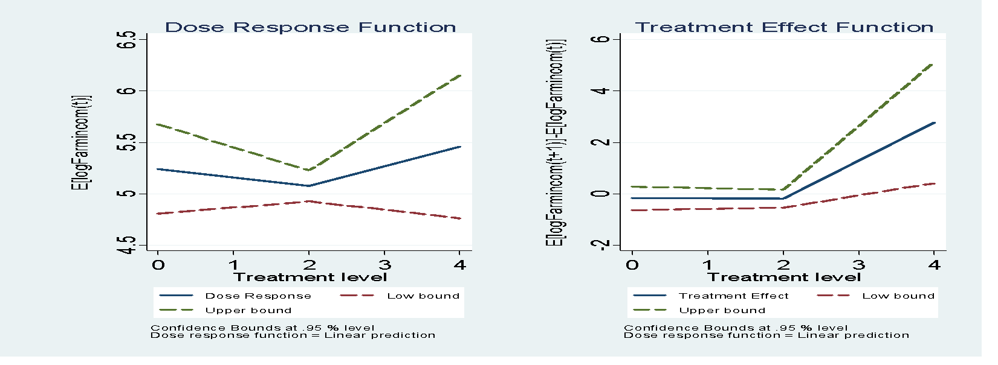
Fig. A3: Dose response (average treatment) and marginal treatment effect functions for farm income of households in West Africa
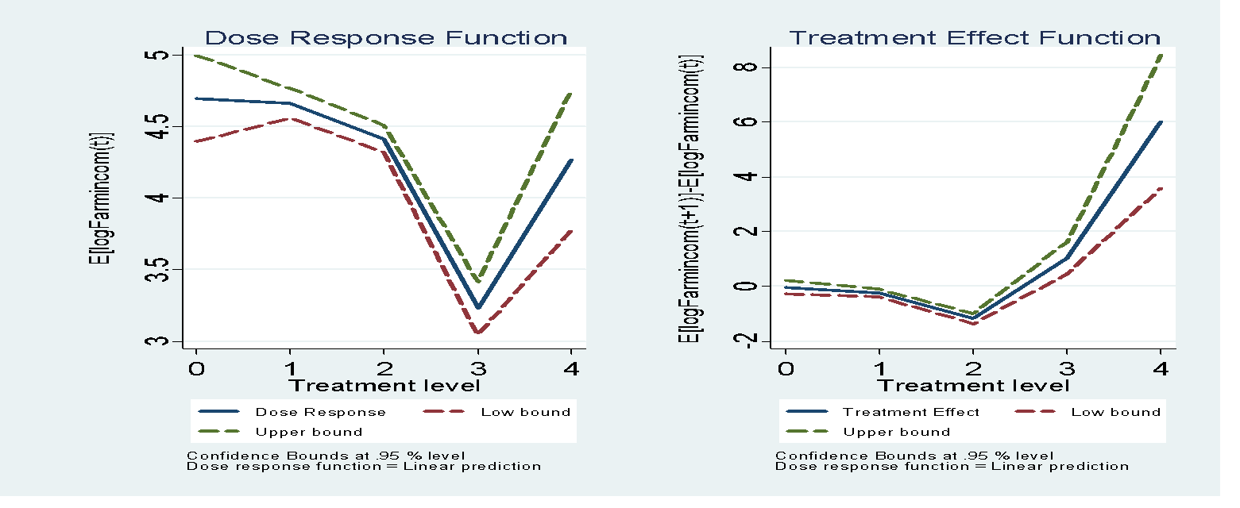
Fig A4: Dose response (average treatment) and marginal treatment effect functions for farm income of households in Southern Africa

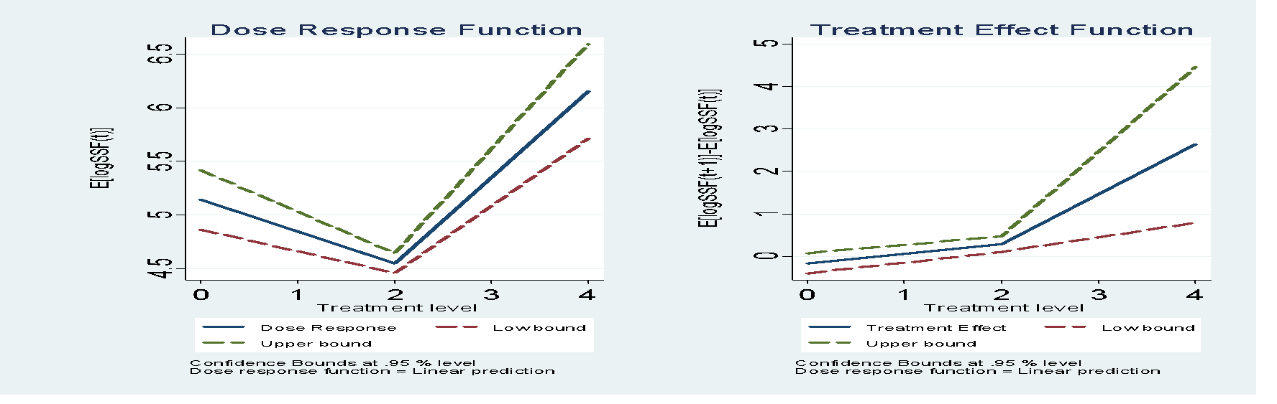
Fig. A5: Dose response (average treatment) and marginal treatment effect functions for food self-sufficiency of households in East Africa
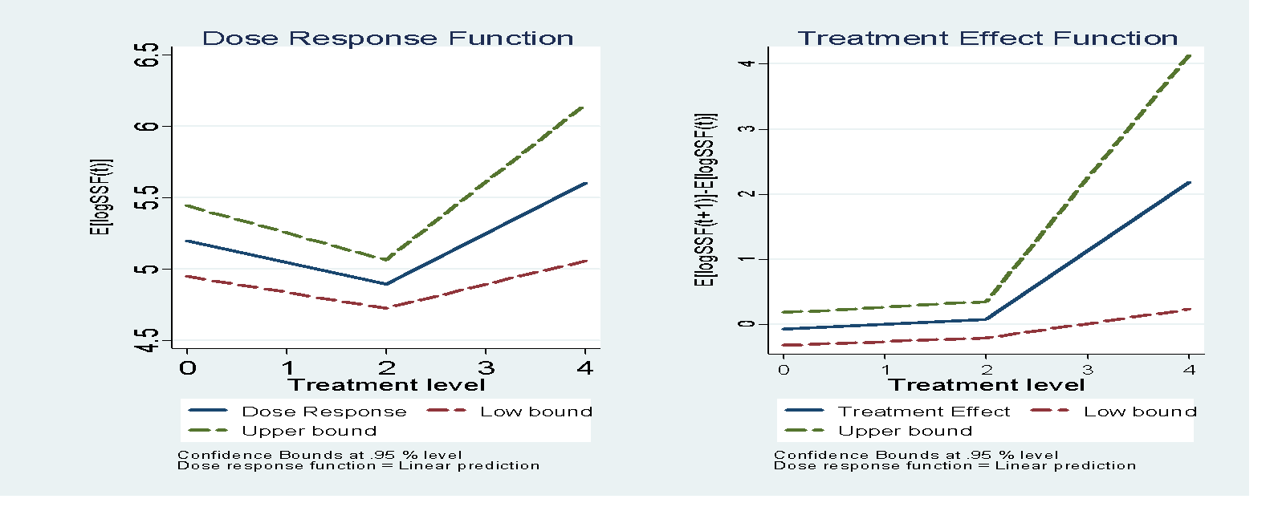
Fig. A6: Dose response (average treatment) and marginal treatment effect functions for food self-sufficiency of households in West Africa
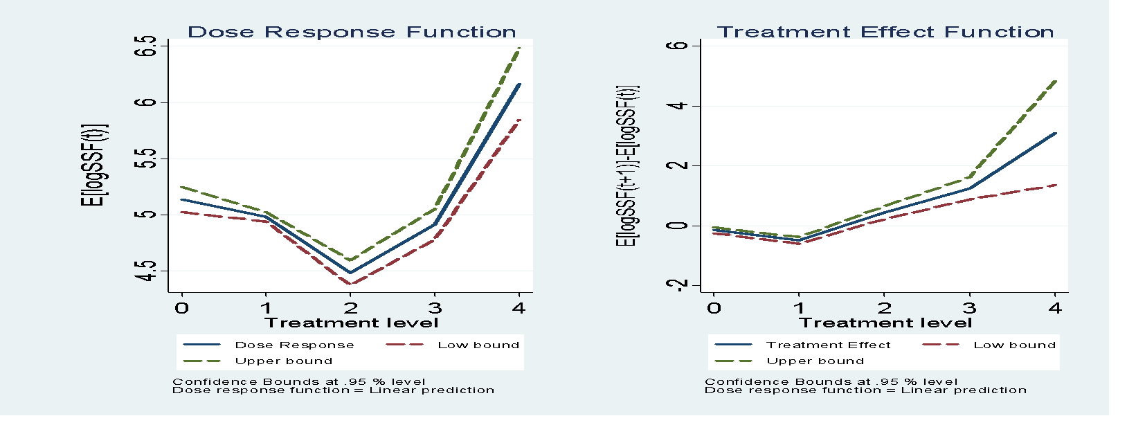
Fig. A7: Dose response (average treatment) and marginal treatment effect functions for food self-sufficiency of households in Southern Africa

