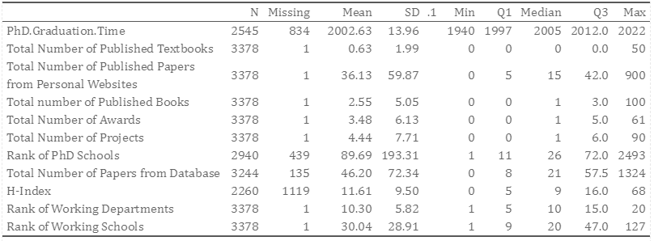
Table 1 Summary Statistics (Part 1)

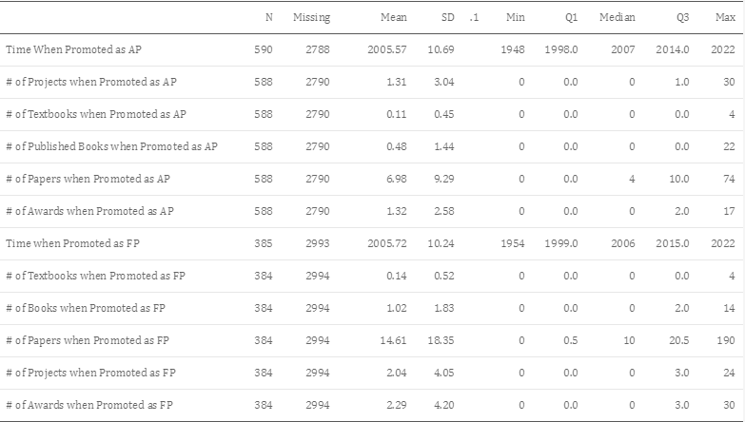
Table 2 Covariates when Promotion

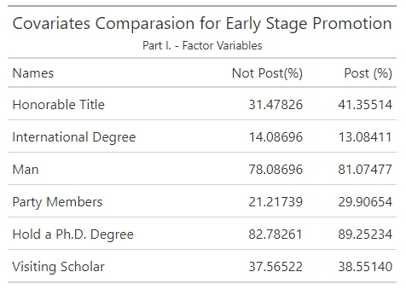
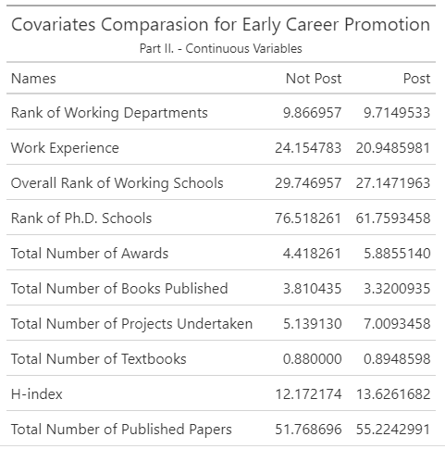
Table 4&5 Covariates Difference between Post and Not Post Group

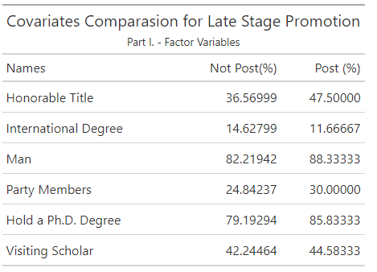

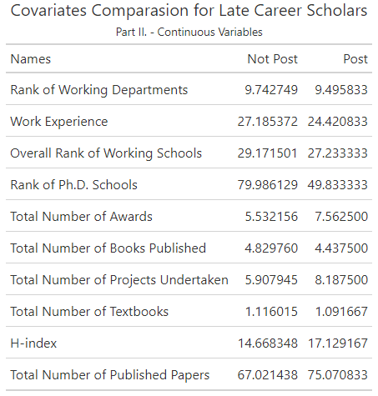
Table 6&7 Covariates Difference between Post and Not Post Group

could increase the chance by 5.923%. (Table 8, 9,10)
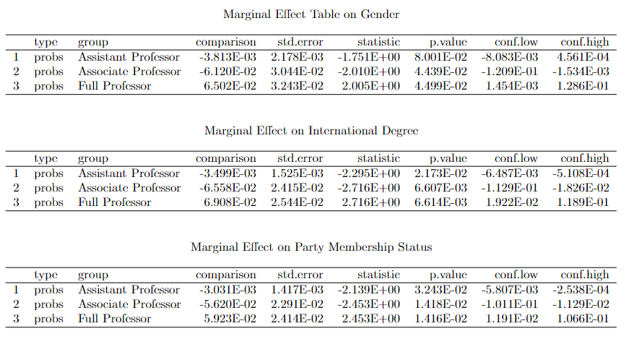
Table 8,9,10 Marginal Effect Table on Average

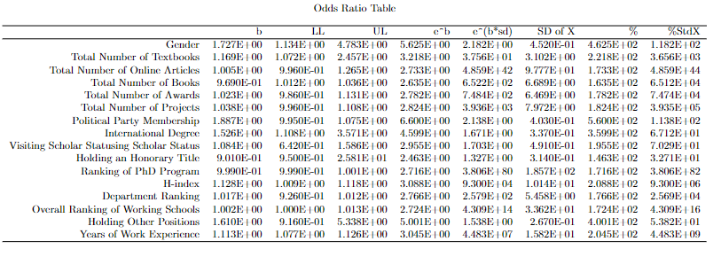
Table 11 Odds Ratio Table

