Supplementary information
Catalytic depolymerization of polyester textile wastes using 4d metal-doped ZnO and g-C₃N₄ nanocomposites
Murugan Anbarasu¹, Viswanathan Vinitha¹, Mani Preeyanghaa², Bernaurdshaw Neppolian³, Vajiravelu Sivamurugan¹*

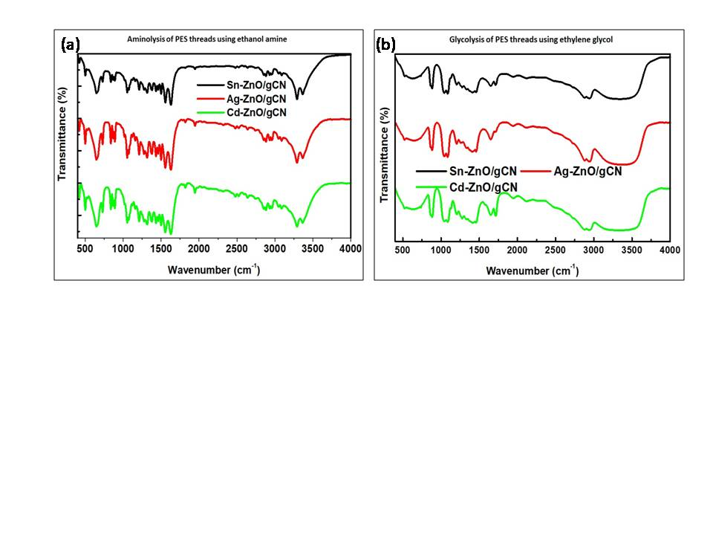
Fig. S1 FT-IR analysis of (a) BHETA and (b) BHET obtained from depolymerisation of PES textile catalysed by Sn-ZnO/g-CN, Ag-ZnO/g-CN, Cd-ZnO/g-CN
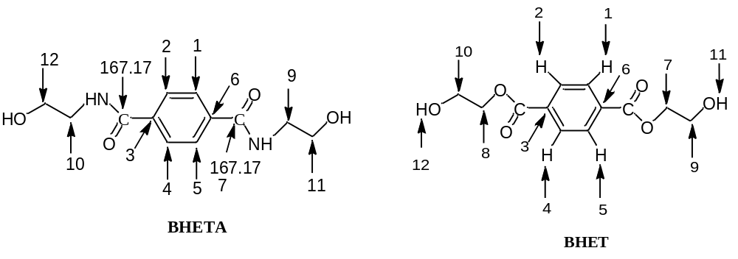
Chemical structure of BHETA and BHET

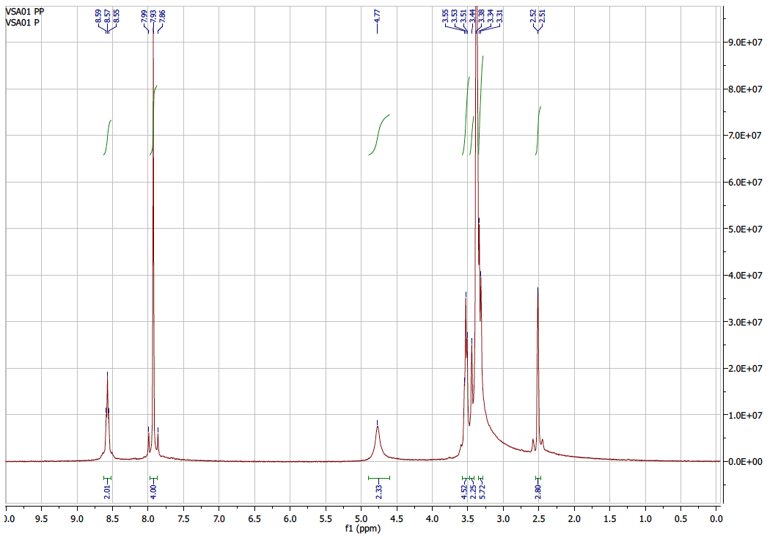
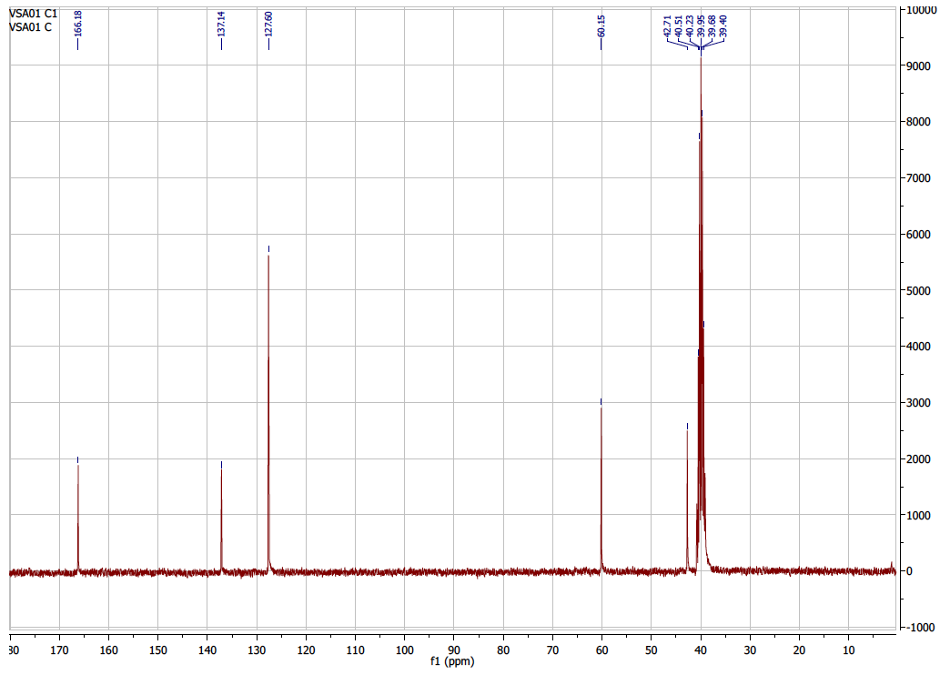
Fig. S2 NMR spectral analysis of BHETA (a) ¹H NMR (b) ¹³C NMR
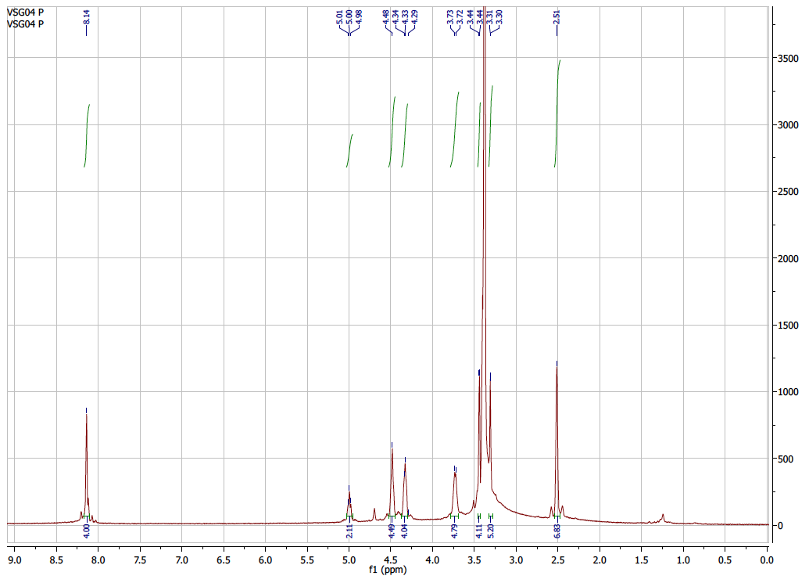
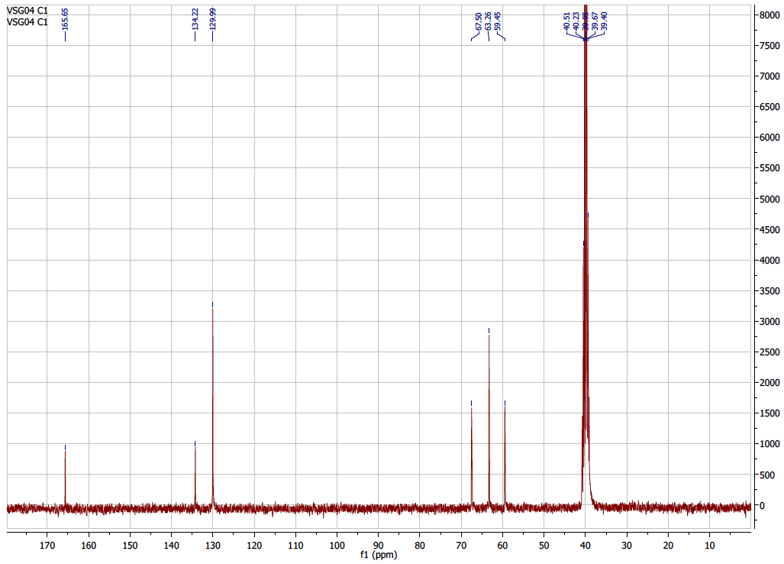
Fig. S3 NMR spectral analysis of BHET (a) ¹H NMR spectrum and (d) ¹³C NMR spectrum
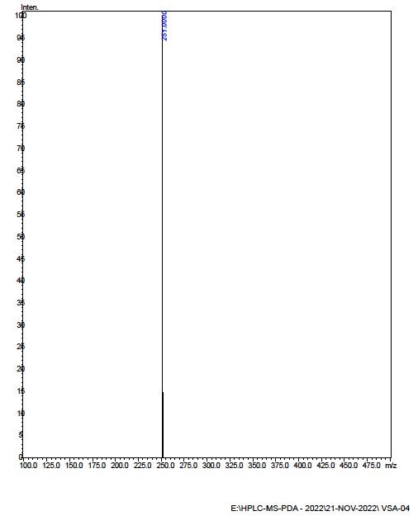
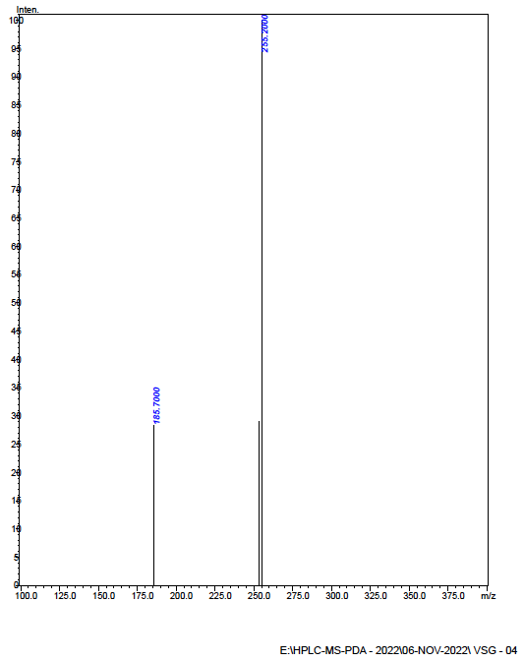
Fig. S4 Mass spectrum of analysis of (a) BHETA, and (b) BHET

