Figure S1: The Encapsulation efficiency (EE%) curve of thymoquinone-liposomal nanoparticles

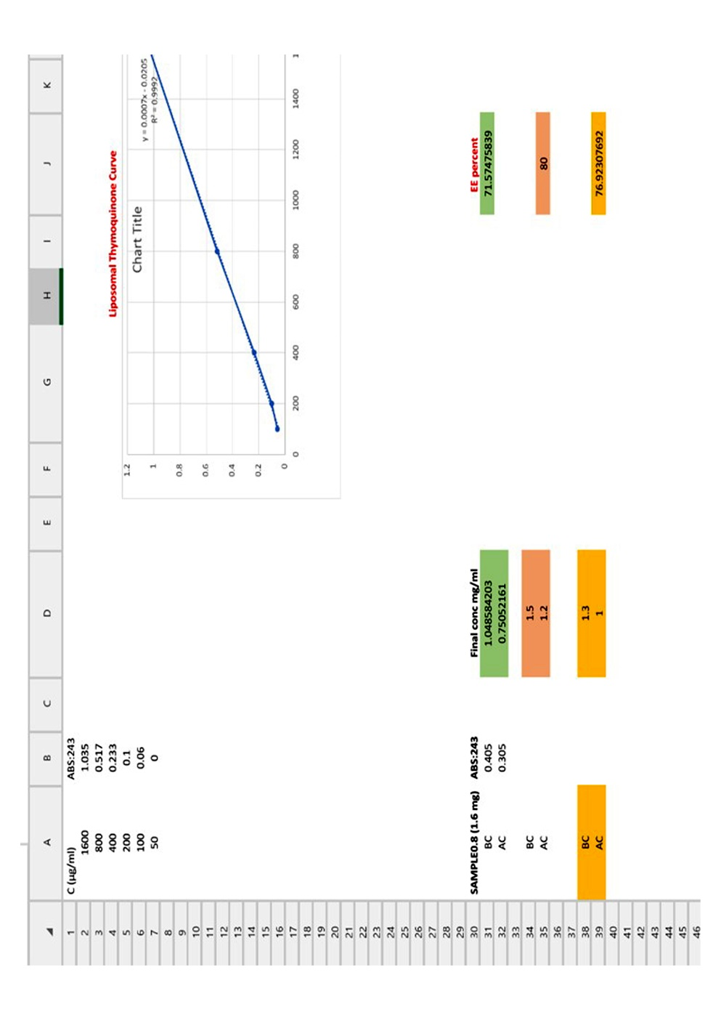
Figure S1: The Encapsulation efficiency (EE%) curve of thymoquinone-liposomal nanoparticles (TQ-Lip-

