Supplementary Figure
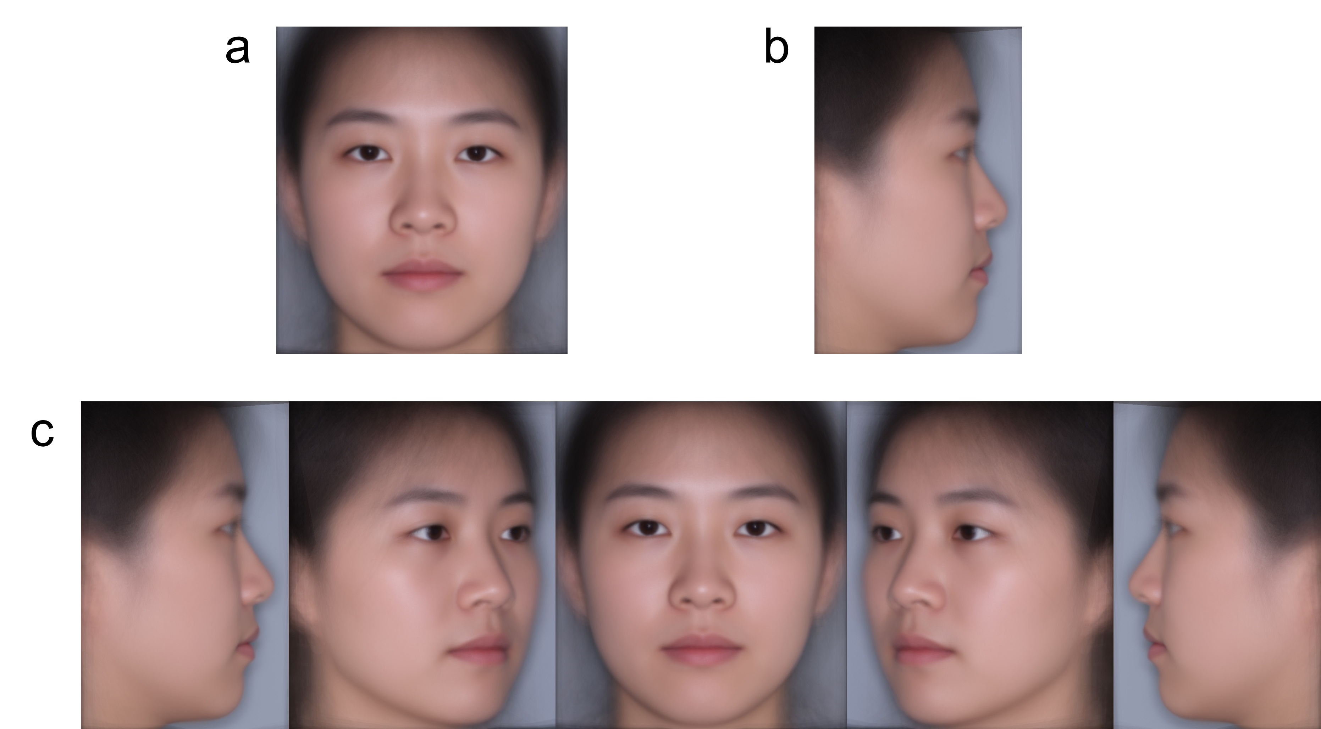Supplementary Figure 1: Reference Photos for Expert Ratings.
a: Frontal View Photo; b: 90-degree Profile View Photo; c: Overall Photos. The average faces, not actual patient photos, were used for reference photos.
Supplementary Figure 2: Illustration of Facial Soft Tissue Landmarks (in red) and Skeletal Landmarks (in green).
a: Frontal View Photo; b: 90-degree Lateral View Photo. The average faces, not actual patient photos, were used for reference photos.

