Supplementary material
An Eco-Friendly Antifouling Coating Based on Tannic Acid
Jine Wang, Rui Zhao, Pei Wang, Meihua Jin* Jiujun Xu*
Department of Materials Science and Engineering, Dalian Maritime University, Dalian 116026, P. R. China.
*Corresponding author.
E-mail addresses: jinewangxrc@163.com (J. Wang), zhaorui0004@163.com (R. Zhao), peterwp@dlmu.edu.cn (P. Wang), jinmh@dlmu.edu.cn (M. Jin), jjxu@dlmu.edu.cn.

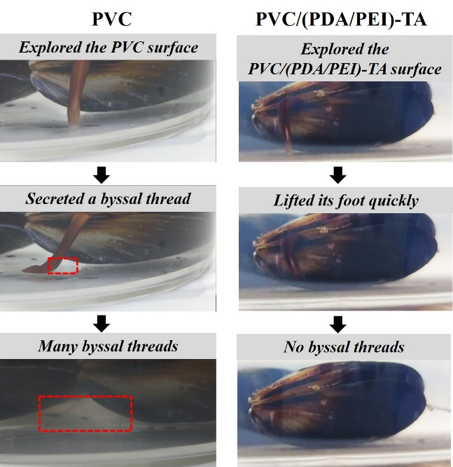
Fig. S1. Live observation of mussel surface exploration behavior and thread secretion on PVC and PVC/(PDA/PEI)-TA surfaces.

