Additional file 1. Illustration of defining the Certainty Index

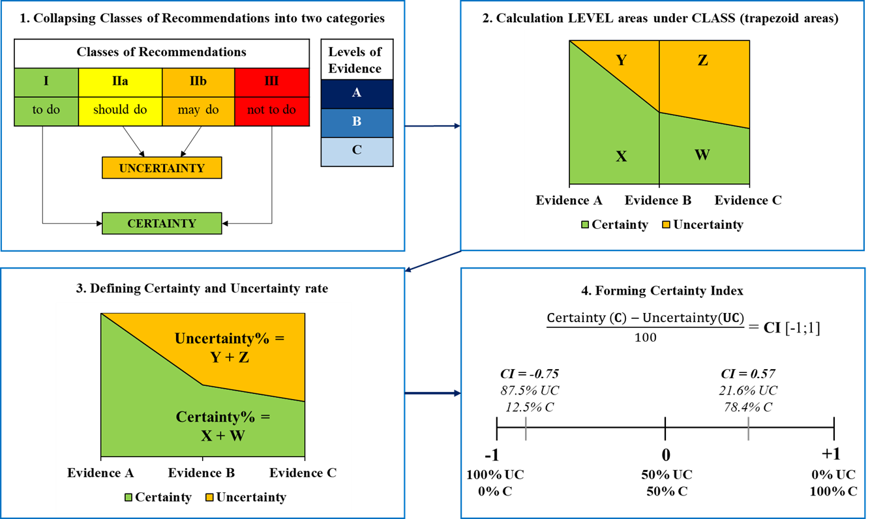
Notes. 1. Collapsing Classes of Recommendations into two categories: to define the Certainty and Uncertainty, we collapsed the Classes of Recommendations into two categories: Uncertainty (‘should + may do’) and Certainty (‘to do + not to do’). 2. Calculation LEVEL areas under CLASS: we calculated the areas using the trapezoid area formula: $= \left(a+b\right)\frac{h}{2}$ . 3. Defining Certainty and Uncertainty rate: based on the calculation in step 2, we expressed trapezoid areas in percentages. 4. Forming Certainty Index: based on the percentages in step 3, we formed an index of Certainty/Uncertainty which ranges from -1 to +1; a value of -1 implies 100% of Uncertainty, a value of +1 implies 100% Certainty and a value of 0 implies fifty-fifty Certainty and Uncertainty

Additional file 2. Illustration of the hypothetical optimal distribution based on the LEVEL (Levels of Evidence) and the CLASS (Classes of Recommendations)
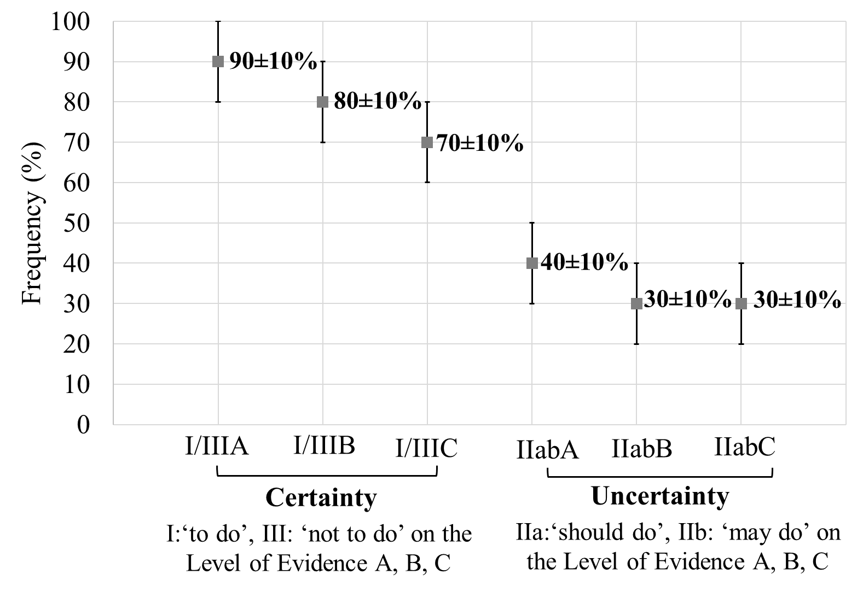
Notes. Estimation of the hypothetical optimal distribution using CLASS x LEVEL which specifies the following order of Certainty: I/IIIA, I/IIIB, I/IIIC (Certainty: ‘to do or not to do’ on the Level of Evidence A, B, C), IIabA, IIabB, IIabC (Uncertainty: ‘should or may do’ on the Level of Evidence A, B, C). We added an interval with 10 percentages to the point estimations.

Additional file 3. The observed distribution by the hypothetical optimal distribution of Certainty regarding both evidence and recommendations in GL-SCE

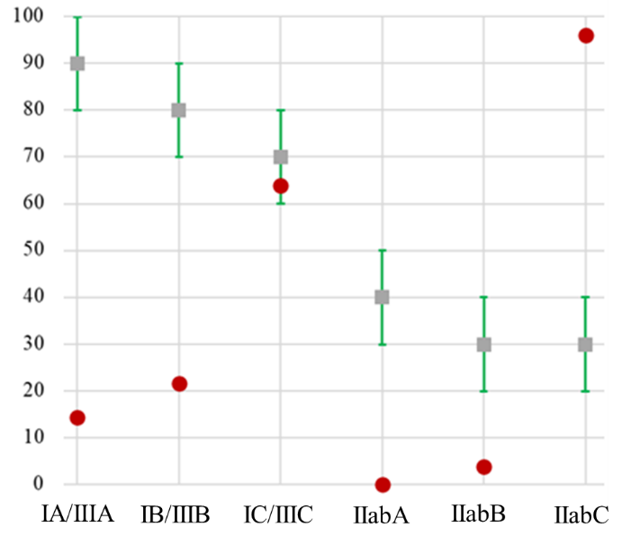
In sum, an informed decision can be made on what exercise treatments are recommended or not recommended even if these recommendations are based on consensus or opinion of the experts and/or small studies, as well as on retrospective studies, registries (Evidence C). We can experience a similar pattern in the recommendations for patients with specific cardiovascular diseases. At the same time, recommendations for individuals with cardiovascular risk factors and older adults are far behind from making informed decisions on exercise treatments.

Individuals with cardiovascular risk factors and older adults  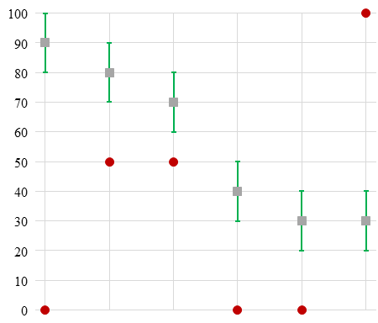 | Patients with cardiovascular disease  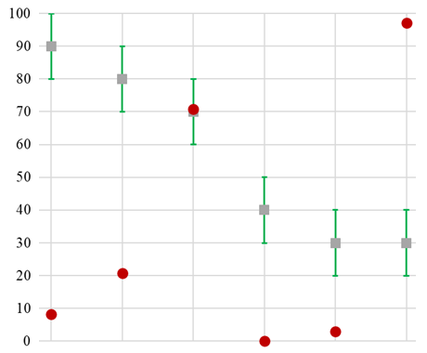

Future studies should focus on these ‘to do’ and ‘not to do’ Classes of Recommendations to provide a higher quality of evidence for exercise treatments (Data derived from multiple randomized clinical trials or meta-analyses – Evidence A, and data derived from a single randomized clinical trial or large non-randomized studies – Evidence B).

