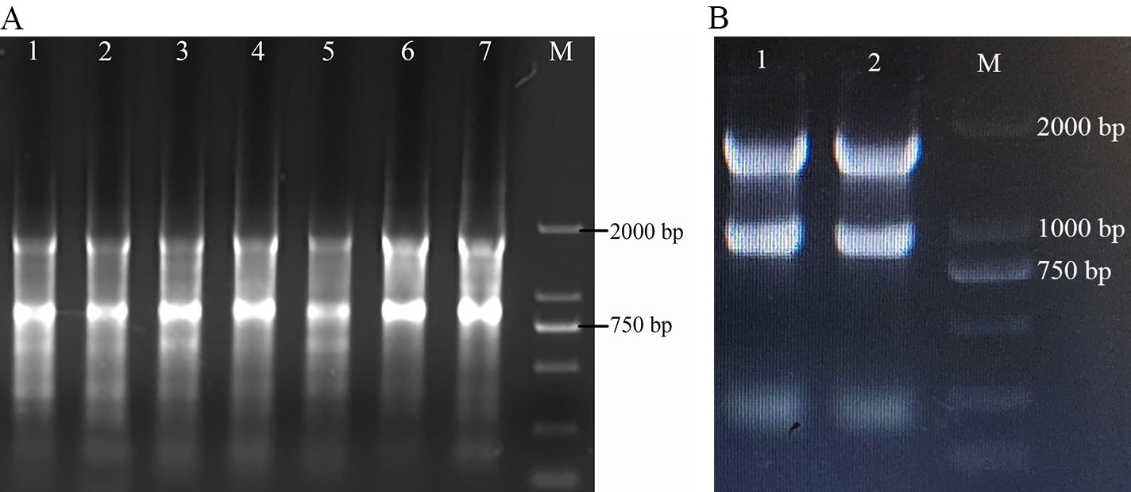
Supplementary Figure 1. Results of total RNA extraction from different tissues and BMECs of dairy cows.
A: 1 to 7 are the results of total RNA extraction from the small intestine, liver, kidney, uterus, heart, ovary and mammary gland of cows, respectively, and M is DL 2000 DNA Maker; B: 1 and 2 are the results of total RNA extraction from BMECs, and M is DL 2000 DNA Maker.

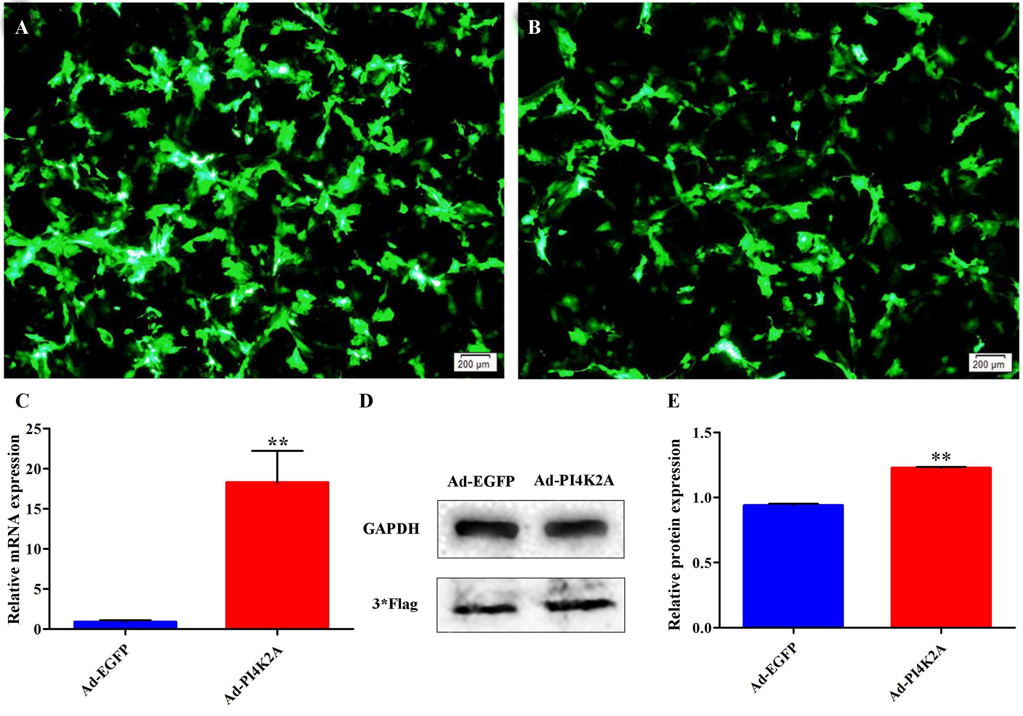
Supplementary Figure 2. Expression efficiency of PI4K2A gene after overexpression.
A and B: The fluorescence images of Ad-EGFP and Ad-PI4K2A infected BMECs 48 hours after infection, respectively; C: overexpression efficiency of PI4K2A detected by qRT-PCR after infection of BMECs with recombinant adenovirus; D: Western Blot to detect the expression of 3*flag tagged protein in the treated and control groups; E: protein bands of grayscale values. *: Significant difference (P < 0.05), **: Highly significant difference (P < 0.01), same below.

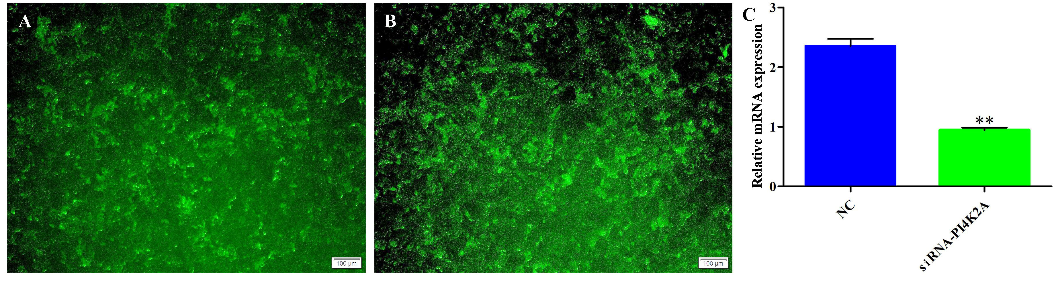
Supplementary Figure 3. Expression efficiency of PI4K2A gene after interference.
A and B: fluorescence plots in BMECs after infection with NC and siRNA-PI4K2A for 48 h, respectively; C: qRT-PCR detection of PI4K2A interference efficiency after infection of BMECs with recombinant lentivirus.

