Appendix 3:
Appendix 3 “Fig 3”: some excerpts from the dictionary of Lisan al-Arab, which explain the different synonymous for the meaning of the word (al-merratu –المِرَّةُ ), the singular (al-merratu), the dual (al-merratine- المِرَّتَيِّن) and the plural (meraru or amrarun مِرَرُ أو أمْرَارُ).
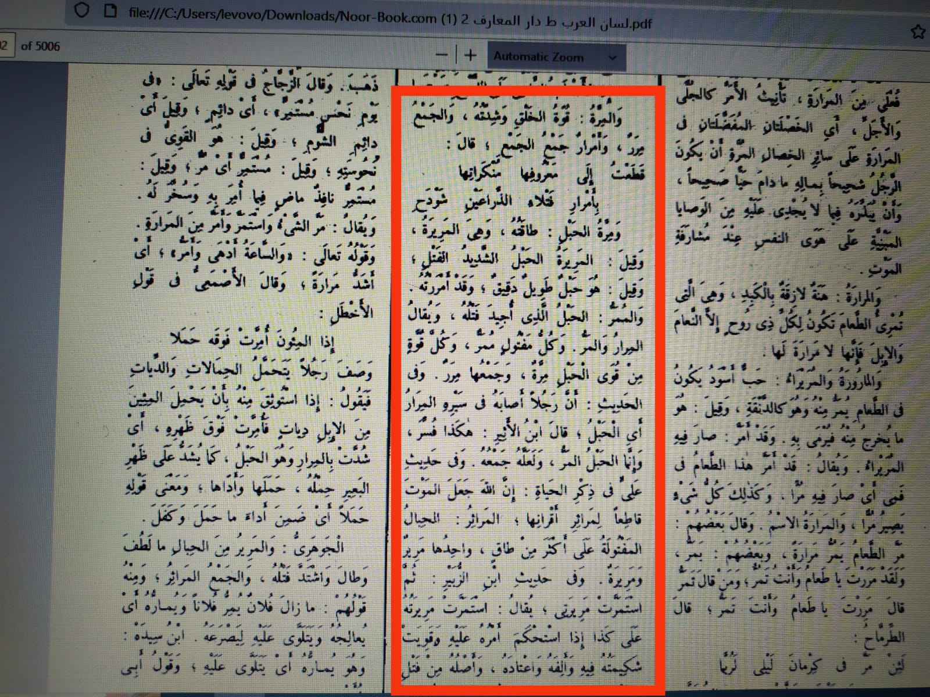

Page No 4176 - dictionary of Liasn al- Arab. This quote explains the meaning of the word (al-merratu) as:
- The strength and intensity of creation.
- Highly coiled strand (cord).
- The rope that has been coiled well.
- Fine long cord.
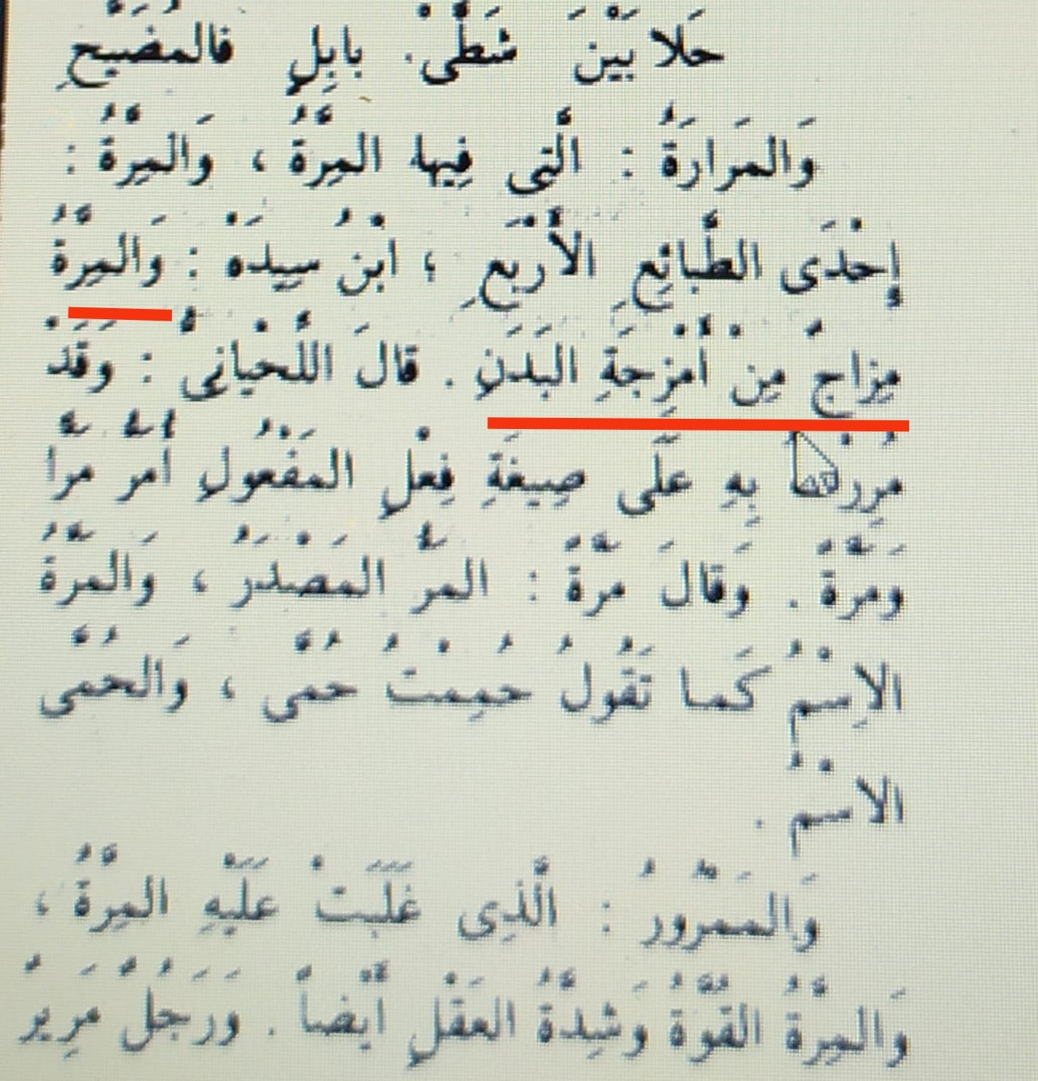

Page No 4176- dictionary of Liasn al- Arab.
This quote explains the meaning of the word (al-merratu) as a:
- Temperament of the body’s temperaments.
- The strength and intensity of the mind.

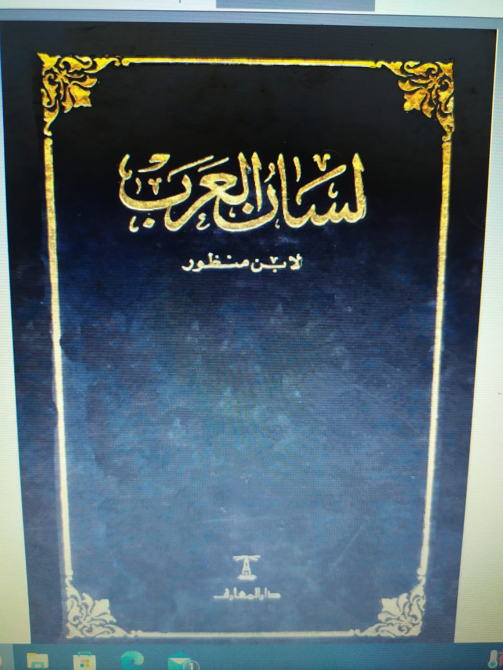
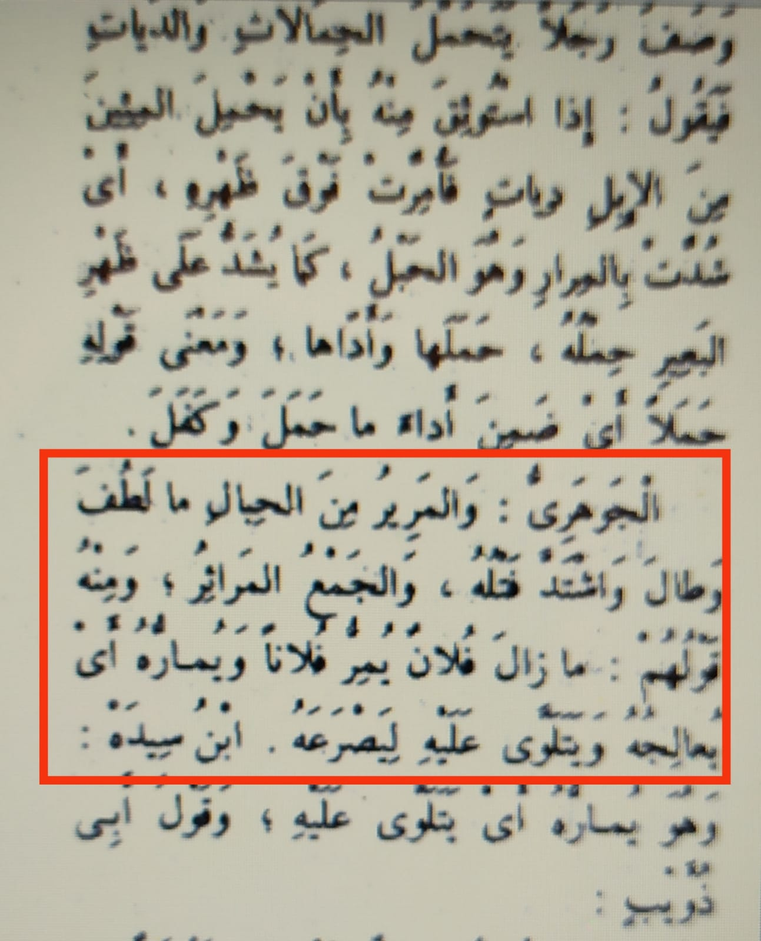

Page No 4176 - dictionary of Liasn al- Arab.
This quote explains the meaning of the word (al-merratu) as:
The ropes which are thin, fine, long and severely coiled.

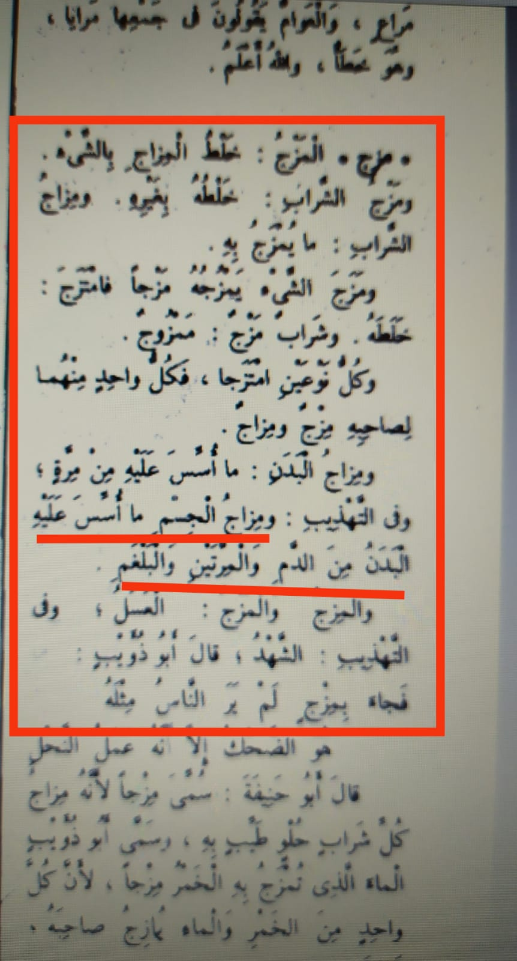
Page No 4191 - dictionary of Liasn al- Arab.
This quote explains the meaning of the definition of the “body temperament” as:
The temperament of the body is what the body is based on of the blood, “two powers” (Al-merrataine), and phlegm.

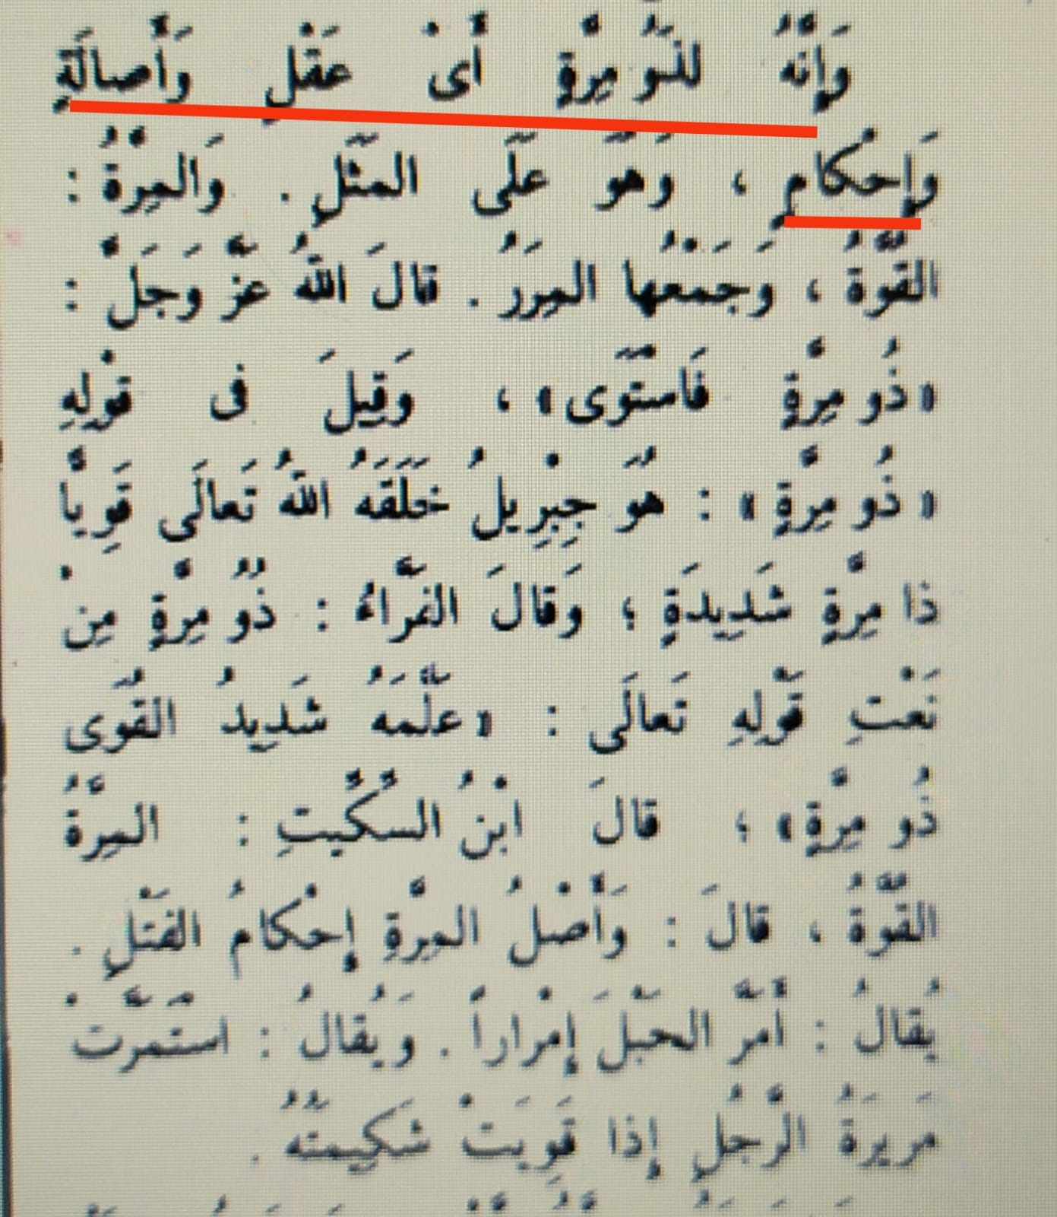

Page No 4177 - dictionary of Liasn al- Arab.
This quote explains the meaning of the word (al-merratu) as:
1-The man who has (al-merratu) is the man of sharp and precision reason.
2- The core of the (al-merratu) is the tightening of the coiled.

