Table S1: Description of meteorological stations within and in the vicinity of Narayani Basin
Index No. | Station Name | Location | Lat. | Lon. | Elevation  (masl) | Variable | Data Length
601 | Jomsom | Mustang | 28.78 | 83.72 | 2744 | P, T | 1980-2018
604 | Thakmarpha | Mustang | 28.75 | 83.70 | 2566 | P, T, RH | 1980-2018
605 | Baglung | Baglung | 28.27 | 83.60 | 984 | P, T | 1980-2018
606 | Tatopani | Myagdi | 28.48 | 83.65 | 1243 | P | 1980-2018
607 | Lete | Mustang | 28.63 | 83.60 | 2384 | P, T | 1980-2018
608 | Ranipauwa | Mustang | 28.82 | 83.88 | 3609 | P | 1980-2018
609 | Beni bazar | Myagdi | 28.35 | 83.57 | 835 | P, T | 1980-2017
610 | Ghami | Mustang | 29.05 | 83.88 | 3465 | P | 1980-2012
612 | Lomangthang | Mustang | 29.18 | 83.97 | 3705 | P, T | 1980-2005
613 | Karki neta | Parbat | 28.18 | 83.75 | 1720 | P | 1980-2018
614 | Kushma | Parbat | 28.22 | 83.70 | 891 | P, T | 1980-2018
615 | Bobang | Baglung | 28.40 | 83.10 | 2273 | P | 1980-2018
616 | Gurja khani | Myagdi | 28.60 | 83.22 | 2530 | P, T | 1980-2016
619 | Ghorepani | Myagdi | 28.40 | 83.73 | 2742 | P | 1993-2018
620 | Tribeni | Parbat | 28.03 | 83.65 | 700 | P | 1993-2018
621 | Darbang | Myagdi | 28.38 | 83.40 | 1160 | P | 1989-2018
622 | Rangkhani | Baglung | 28.15 | 83.57 | 1740 | P | 1989-2018
623 | Dhiee | Mustang | 29.10 | 84.00 | 3620 | P | 1992-2014
624 | Samar gaun | Mustang | 28.97 | 83.78 | 3570 | P | 1992-2018
625 | Sanda | Mustang | 28.90 | 83.68 | 3570 | P | 1992-2017
626 | Bega | Myagdi | 28.47 | 83.60 | 1770 | P | 1992-2018
627 | Kuhun | Myagdi | 28.38 | 83.48 | 1550 | P | 1992-2018
628 | Muna | Myagdi | 28.50 | 83.30 | 1970 | P | 1992-2018
629 | Baghara | Myagdi | 28.57 | 83.38 | 2330 | P | 1992-2018
630 | Sirkon | Parbat | 28.13 | 83.62 | 790 | P | 1992-2018
633 | Chhoser | Mustang | 29.18 | 83.98 | 3870 | P, T | 2005-2018
701 | Ridi bazar | Gulmi | 27.95 | 83.43 | 442 | P | 1980-2018
704 | Beluwa | Nawalparasi | 27.68 | 84.05 | 150 | P | 1980-2017
706 | Dumkauli | Nawalparasi | 27.68 | 84.22 | 154 | P, T, RH | 1980-2017
710 | Dumkibas | Nawalparasi | 27.58 | 83.87 | 164 | P | 1980-2017
715 | Khanchikot | Arghakhanchi | 27.93 | 83.15 | 1760 | P, T | 1980-2017
722 | Musikot | Gulmi | 28.17 | 83.27 | 1280 | P | 1980-2017
725 | Tamghas | Gulmi | 28.07 | 83.25 | 1530 | P, T | 1980-2017
726 | Garakot | Palpa | 27.87 | 83.80 | 500 | P | 1980-2017
801 | Jagat | Gorkha | 28.37 | 84.90 | 1334 | P | 1980-2018
802 | Khudi bazar | Lamjung | 28.28 | 84.37 | 823 | P, T | 1980-2017
804 | Pokhara airport | Kaski | 28.22 | 84.00 | 827 | P, T | 1980-2017
805 | Syangja | Syangia | 28.10 | 83.88 | 868 | P, T | 1980-2017
806 | Larke samdo | Gorkha | 28.67 | 84.62 | 3650 | P | 1980-2017
807 | Kunchha | Lamiung | 28.13 | 84.35 | 855 | P | 1980-2017
808 | Bandipur | Tanahun | 27.93 | 84.42 | 965 | P, T | 1980-2017
809 | Gorkha | Gorkha | 28.00 | 84.62 | 1097 | P, T, RH | 1980-2018
810 | Chapkot | Syangja | 27.88 | 83.82 | 460 | P, T | 1980-2017
811 | Malepatan | Kaski | 28.12 | 84.12 | 856 | P, T, RH | 1980-2017
813 | Bhadaure deurali | Kaski | 28.27 | 83.82 | 1600 | P | 1985-2017
814 | Lumle | Kaski | 28.30 | 83.80 | 1740 | P, T, RH | 1980-2018
815 | Khairini tar | Tanahun | 28.03 | 84.10 | 500 | P, T, RH | 1980-2017
816 | Chame | Manang | 28.55 | 84.23 | 2680 | P, T | 1980-2012
817 | Damauli | Tanahun | 27.97 | 84.28 | 358 | P, T | 1980-2017
818 | Lamachaur | Kaski | 28.27 | 83.97 | 1070 | P | 1980-2017
820 | Manang bhot | Manang | 28.67 | 84.02 | 3420 | P, T | 1980-2017
821 | Ghandruk | Kaski | 28.38 | 83.80 | 1960 | P | 1980-2017
823 | Gharedhunga | Lamjung | 28.20 | 84.62 | 1120 | P | 1980-2017
824 | Siklesh | Kaski | 28.37 | 84.10 | 1820 | P | 1980-2017
826 | Walling | Syangja | 27.98 | 83.77 | 750 | P | 1989-2017
827 | Rumjakot | Tanahun | 27.87 | 84.13 | 660 | P | 1989-2017
829 | Sallyan | Kaski | 28.27 | 83.75 | 1000 | P | 1992-2017
830 | Pamdur | Kaski | 28.27 | 83.78 | 1160 | P | 1992-2017
832 | Dandaswanra | Syangja | 28.08 | 83.92 | 1432 | P | 2000-2017
833 | Chhekampar | Gorkha | 28.48 | 85.00 | 3300 | P | 2000-2017
834 | Phu gaun | Manang | 28.77 | 84.28 | 4100 | P | 2002-2010
866 | Pokhara reg.office | Kaski | 28.22 | 83.98 | 827 | P, T | 2005-2014
902 | Rampur | Chitawan | 27.62 | 84.42 | 256 | P, T, RH | 1980-2018
903 | Jhawani | Chitawan | 27.58 | 84.53 | 270 | P | 1980-2017
904 | Chisapani gadhi | Makwanpur | 27.55 | 85.13 | 1706 | P | 1980-2018
906 | Hetaunda n.f.i. | Makwanpur | 27.42 | 85.05 | 474 | P, T | 1980-2017
919 | Makwanpur gadhi | Makwanpur | 27.42 | 85.17 | 1030 | P | 1980-2017
920 | Beluwa | Makwanpur | 27.55 | 84.82 | 274 | P | 1980-2016
925 | Rajaiya | Makwanpur | 27.43 | 84.98 | 332 | P | 1992-2014
927 | Bharatpur | Chitawan | 27.67 | 84.43 | 205 | P, T | 1980-2018
1002 | Aru ghat d.bazar | Dhading | 28.05 | 84.82 | 518 | P | 1980-2008
1004 | Nuwakot | Nuwakot | 27.92 | 85.17 | 1003 | P, T | 1980-2018
1005 | Dhading | Dhading | 27.87 | 84.93 | 1420 | P | 1980-2014
1007 | Kakani | Nuwakot | 27.80 | 85.25 | 2064 | P, T, RH | 1980-2018
1038 | Dhunibesi | Dhading | 27.72 | 85.18 | 1085 | P, T | 1980-2018
1054 | Thamachit | Rasuwa | 28.17 | 85.32 | 1847 | P | 1980-2018
1055 | Dhunche | Rasuwa | 28.10 | 85.30 | 1982 | P, T | 1980-2018
1057 | Pansayakhola | Nuwakot | 28.02 | 85.12 | 1240 | P | 1980-2018
1079 | Nagarjun | Kathmandu | 27.75 | 85.25 | 1690 | P | 1998-2017

Note: masl is “meters above mean sea level”; Index is “Station Identification Number of Department of Hydrology and Meteorology, Nepal”; Lat. Is “Latitude”; Lon. Is “Longitude”; S. is “Station”; P is “Precipitation”; T is “Temperature”; RH is “Relative Humidity”.

Table S2: Status of missing data for the period of 1980-2017 at the rainfall stations within and in the vicinity of the Narayani Basin
Index  No. | missing data (%) | Index  No. | missing data (%) | Index  No. | missing data (%) | Index  No. | missing data (%)
601 | 2.98 | 626 | 32.79 | 808 | 3.73 | 834 | 83.96
604 | 3.38 | 627 | 34.77 | 809 | 3.76 | 866 | 79.45
605 | 8.48 | 628 | 32.79 | 810 | 0.66 | 902 | 4.17
606 | 3.26 | 629 | 33.69 | 811 | 5.84 | 903 | 3.52
607 | 1.53 | 630 | 35.43 | 813 | 13.61 | 904 | 0.31
608 | 11.97 | 633 | 67.45 | 814 | 0.24 | 906 | 3.08
609 | 8.75 | 701 | 0.33 | 815 | 3.49 | 919 | 3.73
610 | 23.29 | 704 | 0.22 | 816 | 19.22 | 920 | 5.68
612 | 40.33 | 706 | 0.00 | 817 | 4.36 | 925 | 51.85
613 | 0.66 | 710 | 5.53 | 818 | 4.16 | 927 | 56.73
614 | 3.29 | 715 | 1.54 | 820 | 7.28 | 1002 | 29.71
615 | 5.56 | 722 | 0.98 | 821 | 7.03 | 1004 | 10.10
616 | 8.67 | 725 | 0.71 | 823 | 4.30 | 1005 | 15.19
619 | 36.97 | 726 | 0.89 | 824 | 0.44 | 1007 | 0.54
620 | 37.99 | 801 | 3.65 | 826 | 29.05 | 1038 | 0.32
621 | 24.10 | 802 | 3.68 | 827 | 29.05 | 1054 | 3.40
622 | 24.66 | 804 | 0.00 | 829 | 33.82 | 1055 | 15.07
623 | 60.34 | 805 | 0.09 | 830 | 33.15 | 1057 | 4.03
624 | 40.05 | 806 | 6.52 | 832 | 53.49 | 1079 | 48.49
625 | 36.46 | 807 | 0.45 | 833 | 62.70
Note: stations with bold were discarded for further quality assessment

Table S3: Details of missing temperature data for the study period 1980-2017 in Narayani basin
S. No. | Station  Index  No. | Number of missing data  (Tmax) | % of missing data (Tmax) | Number of missing data  (Tmin) | % of missing data  (Tmin)
1 | 601 | 840 | 6.05 | 671 | 4.83
2 | 604 | 842 | 6.07 | 723 | 5.21
3 | 605 | 1287 | 9.27 | 1521 | 10.96
4 | 607 | 6965 | 50.18 | 6975 | 50.25
5 | 609 | 5589 | 40.27 | 5678 | 40.91
6 | 612 | 8968 | 64.61 | 8579 | 61.81
7 | 614 | 3718 | 26.79 | 4603 | 33.16
8 | 616 | 8826 | 63.59 | 10445 | 75.25
9 | 633 | 9317 | 67.13 | 9298 | 66.99
10 | 706 | 72 | 0.52 | 87 | 0.63
11 | 715 | 1900 | 13.69 | 1847 | 13.31
12 | 725 | 2365 | 17.04 | 2223 | 16.02
13 | 802 | 441 | 3.18 | 1514 | 10.91
14 | 804 | 9 | 0.06 | 15 | 0.11
15 | 805 | 229 | 1.65 | 550 | 3.96
16 | 808 | 10635 | 76.62 | 10628 | 76.57
17 | 809 | 915 | 6.59 | 1616 | 11.64
18 | 810 | 170 | 1.22 | 1180 | 8.50
19 | 811 | 828 | 5.97 | 1282 | 9.24
20 | 814 | 33 | 0.24 | 18 | 0.13
21 | 815 | 186 | 1.34 | 113 | 0.81
22 | 816 | 2798 | 20.16 | 2901 | 20.90
23 | 817 | 9316 | 67.12 | 9323 | 67.17
24 | 866 | 11516 | 82.97 | 11517 | 82.98
25 | 902 | 0 | 0.00 | 213 | 1.53
26 | 906 | 62 | 0.45 | 33 | 0.24
27 | 927 | 10596 | 76.34 | 10598 | 76.35
28 | 1004 | 3303 | 23.8 | 2593 | 18.68
29 | 1007 | 720 | 5.18 | 482 | 3.473
30 | 1038 | 253 | 1.8 | 140 | 1.01
31 | 1055 | 5789 | 41.7 | 5841 | 42.08

Table S4: Annual and seasonal trends of observed evapotranspiration in Narayani River Basin
Station Index | Annual | Pre-monsoon | Monsoon | Post-monsoon | Winter
Station_276831 | -6.778 | -1.638 | -3.827 | -1.064 | -0.682
Station_276834 | -5.389 | -0.376 | -4.092 | -0.881 | -0.318
Station_276838 | -4.333 | -0.300 | -4.597 | -0.304 | -0.250
Station_276841 | -6.029 | -1.441 | -5.250 | -0.456 | -0.575
Station_276844 | -7.591 | -1.892 | -4.975 | -0.914 | -1.037
Station_276847 | -6.420 | -2.222 | -4.250 | -0.895 | -0.982
Station_276850 | -4.408 | -1.762 | -3.510 | -0.558 | -0.486
Station_279831 | -4.654 | -1.245 | -3.707 | -0.617 | -0.433
Station_279834 | -4.644 | -1.538 | -3.971 | -0.492 | -0.427
Station_279838 | -4.380 | -0.628 | -4.291 | -0.414 | -0.467
Station_279841 | -3.779 | -0.725 | -3.357 | -0.440 | -0.767
Station_279844 | -3.367 | -0.824 | -2.592 | -0.471 | -1.050
Station_279847 | -1.375 | -0.171 | -1.468 | -0.321 | -0.900
Station_279850 | 1.800 | 1.991 | -0.414 | 0.119 | 0.109
Station_283831 | -2.590 | -0.913 | -2.650 | -0.118 | 0.100
Station_283834 | -1.100 | -0.338 | -2.131 | 0.250 | 0.231
Station_283838 | 1.878 | 0.867 | -0.620 | 0.430 | 0.600
Station_283841 | 1.000 | 1.296 | -1.295 | 0.067 | 0.375
Station_283844 | 0.082 | 1.390 | -1.256 | -0.167 | -0.089
Station_283847 | 0.670 | 1.563 | -0.989 | -0.167 | 0.005
Station_283850 | 2.200 | 2.165 | -0.444 | 0.250 | 0.706
Station_286831 | 4.180 | 2.186 | -1.256 | 0.775 | 2.014
Station_286834 | 4.592 | 2.688 | -0.880 | 1.100 | 1.925
Station_286838 | 6.042 | 2.888 | 0.022 | 1.078 | 1.831
Station_286841 | 2.742 | 1.500 | -0.655 | 0.668 | 0.967
Station_286844 | -0.318 | 0.517 | -2.125 | 0.418 | 0.492
Station_286847 | 0.233 | 0.807 | -1.577 | 0.357 | 0.444
Station_286850 | 2.085 | 1.446 | -0.443 | 0.491 | 0.846
Station_289831 | 5.848 | 2.857 | 0.080 | 1.123 | 1.269
Station_289834 | 2.622 | 1.500 | -0.992 | 0.910 | 0.746
Station_289838 | 3.473 | 1.325 | -0.304 | 0.782 | 0.700
Station_289841 | 3.550 | 1.638 | -0.042 | 0.642 | 0.936
Station_289844 | 1.046 | 0.614 | -1.130 | 0.330 | 0.507
Station_289847 | 0.285 | 0.626 | -1.620 | 0.300 | 0.481
Station_289850 | 1.372 | 1.000 | -1.222 | 0.356 | 0.755

Figure S1: Land use map of Narayani River Basin
Figure S2: Terrain map of Narayani River basin

Spatial Annual Distribution of Hydroclimatic Extremes in Narayani River Basin

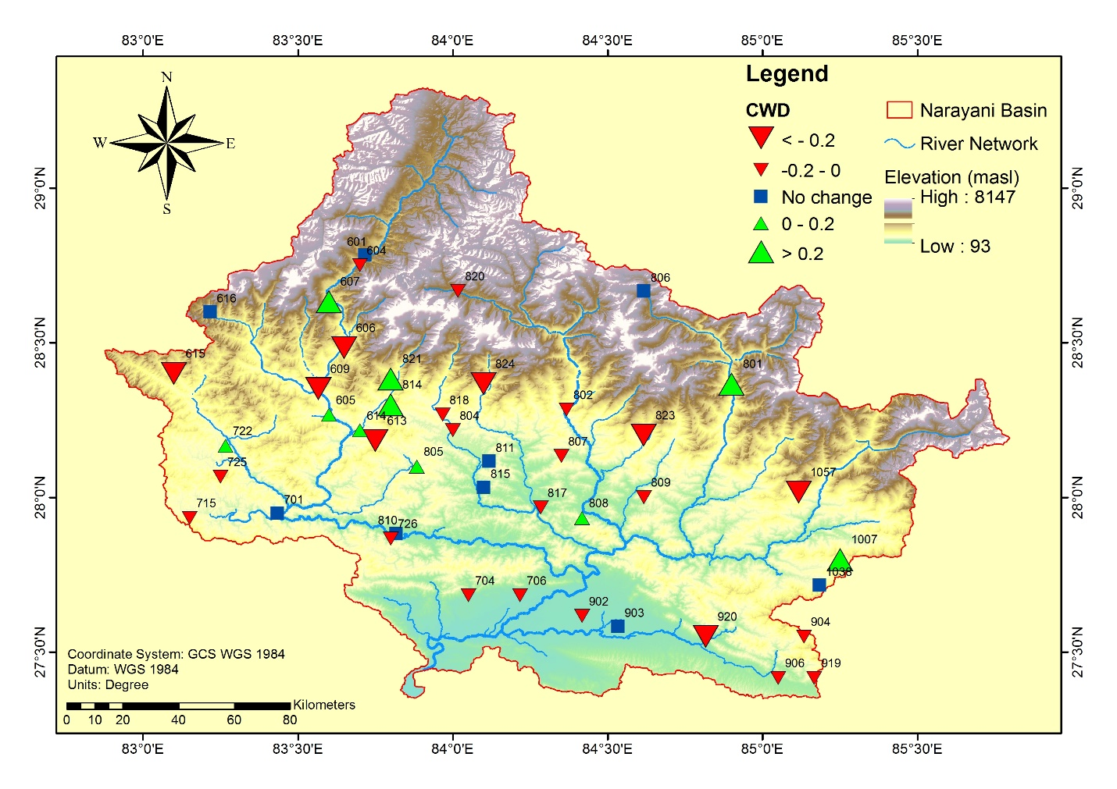
Figure S3: Spatial distribution of CWD in Narayani River Basin
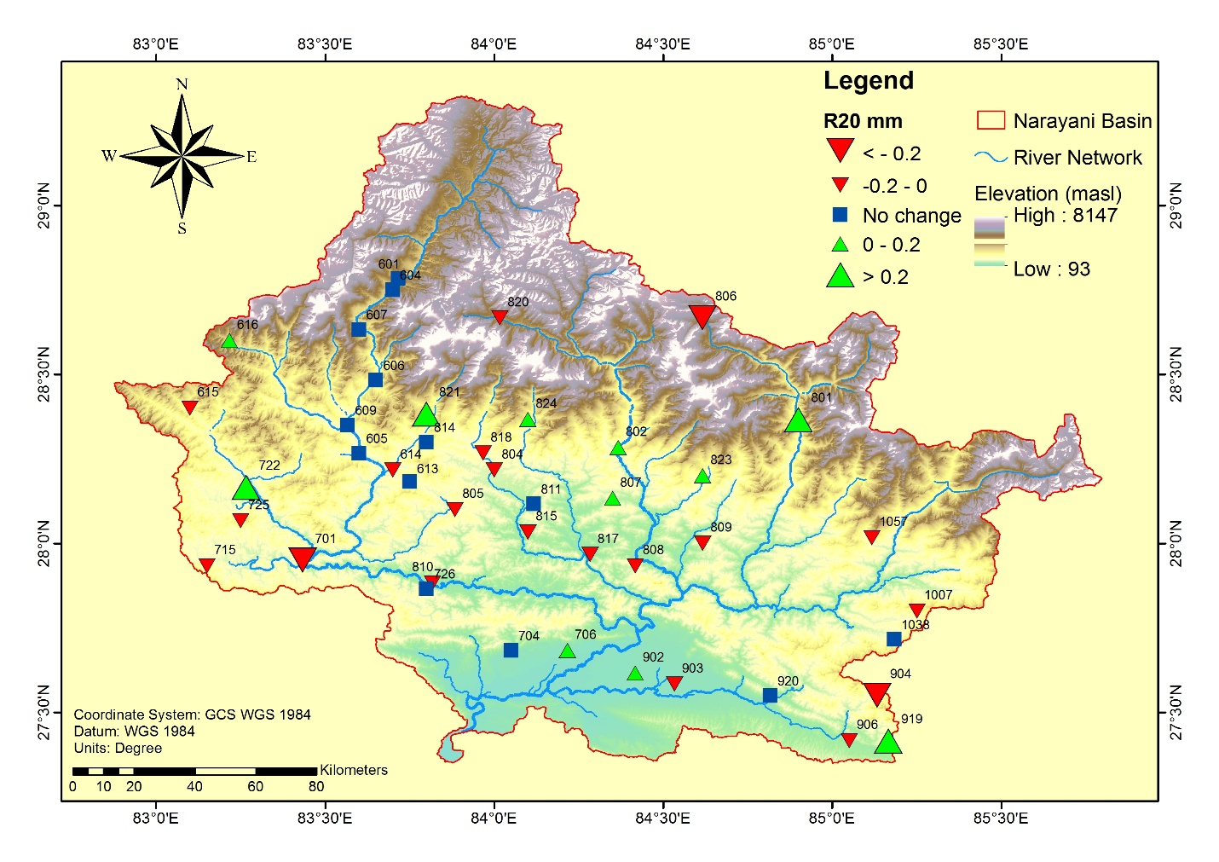
Figure S4: Spatial distribution of R20mm in Narayani River Basin
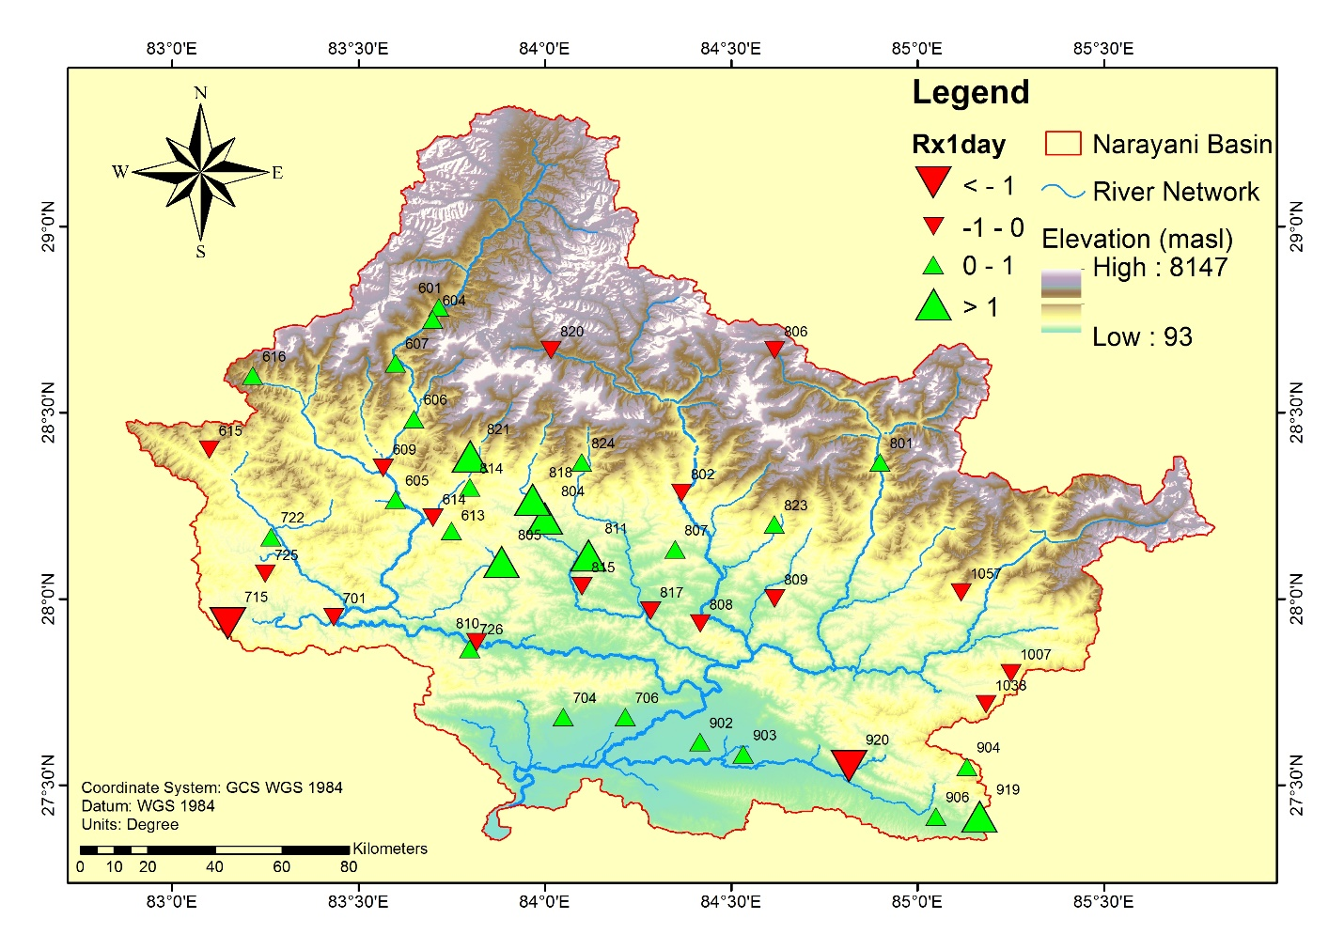
Figure S5: Spatial distribution of RX1day in Narayani River Basin

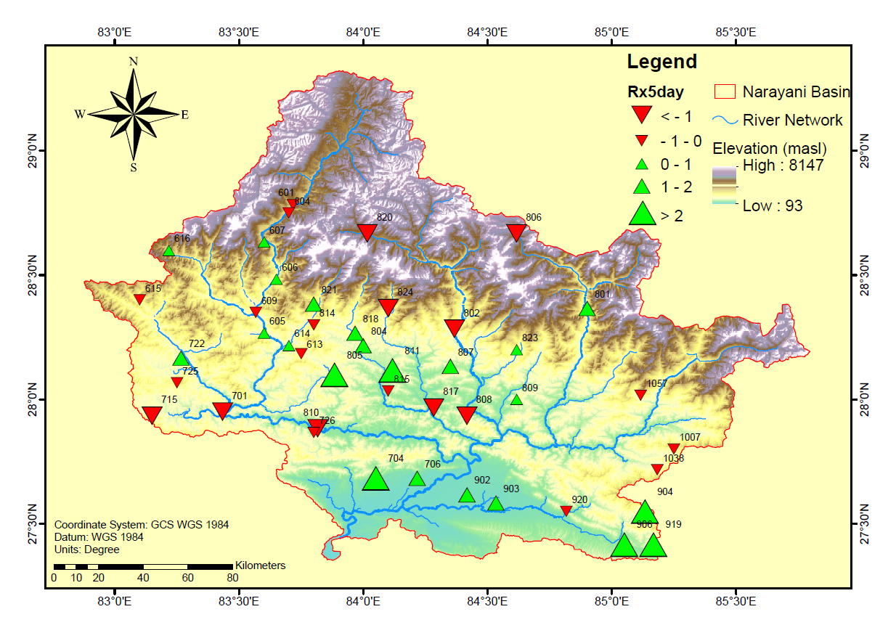
Figure S6: Spatial distribution of RX5day in Narayani River Basin

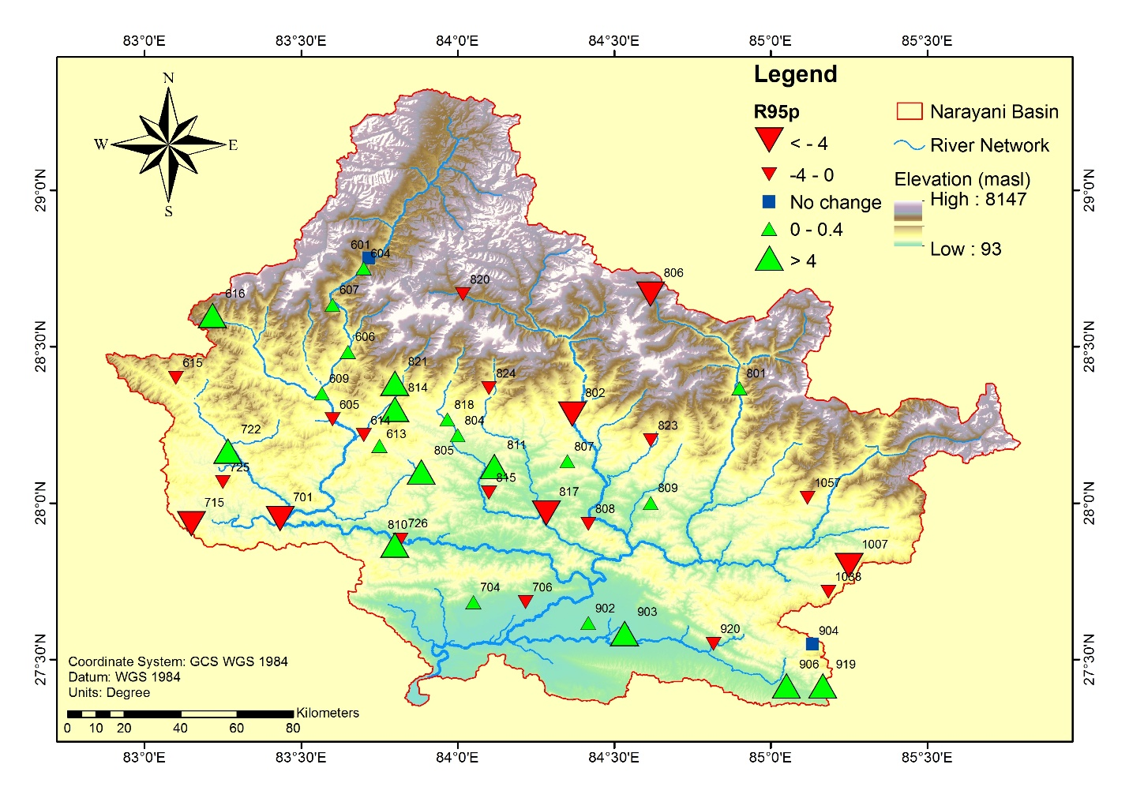
Figure S7: Spatial distribution of R95p in Narayani River Basin
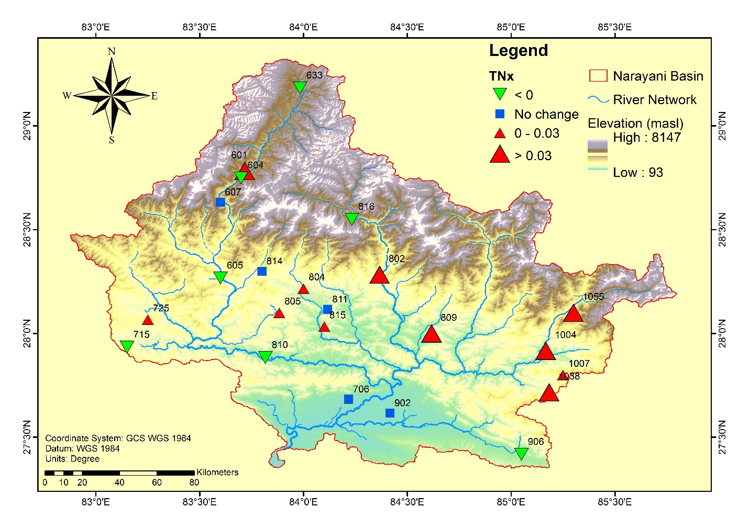
Figure S8: Spatial distribution of TNx in Narayani River Basin
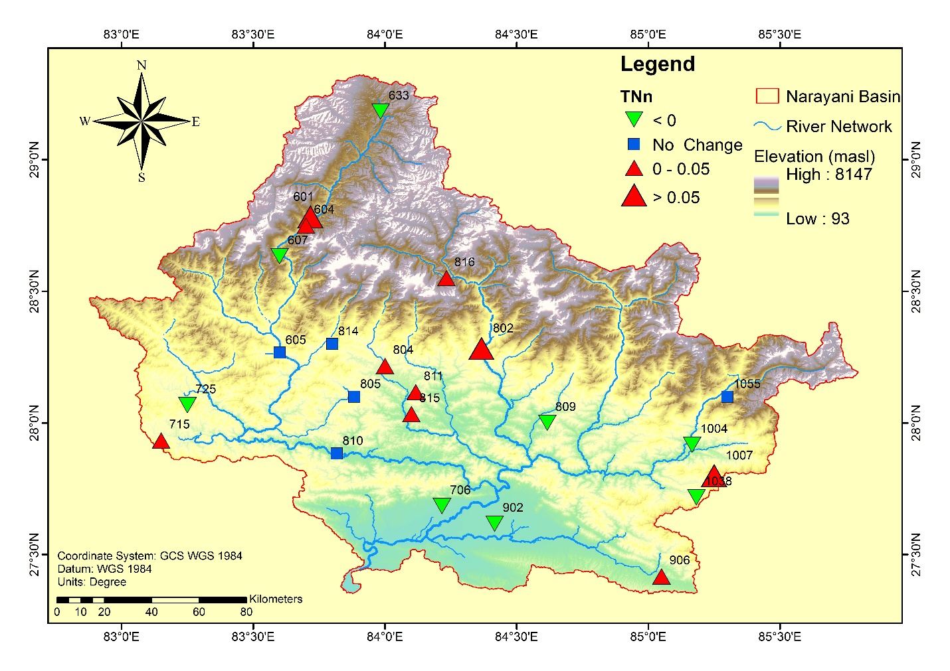
Figure S9: Spatial distribution of TNn in Narayani River Basin
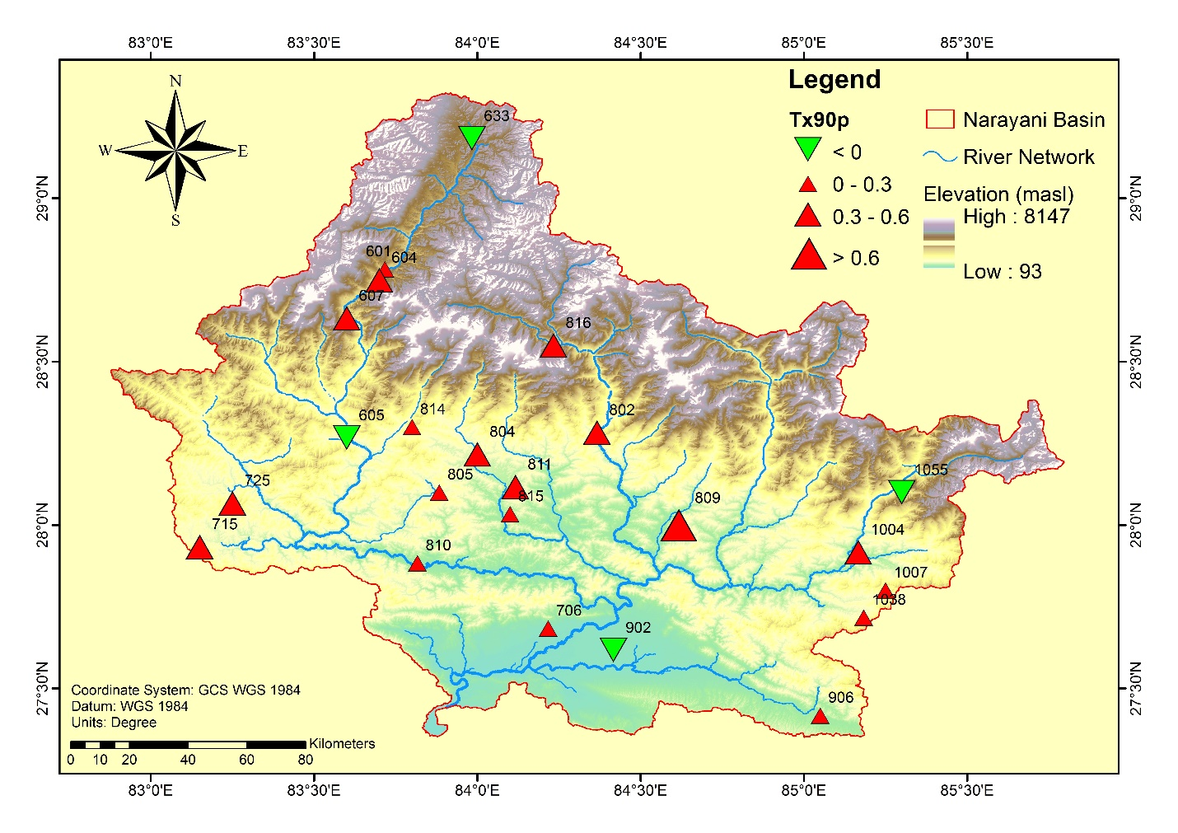
Figure S10: Spatial distribution of TX90p in Narayani River Basin
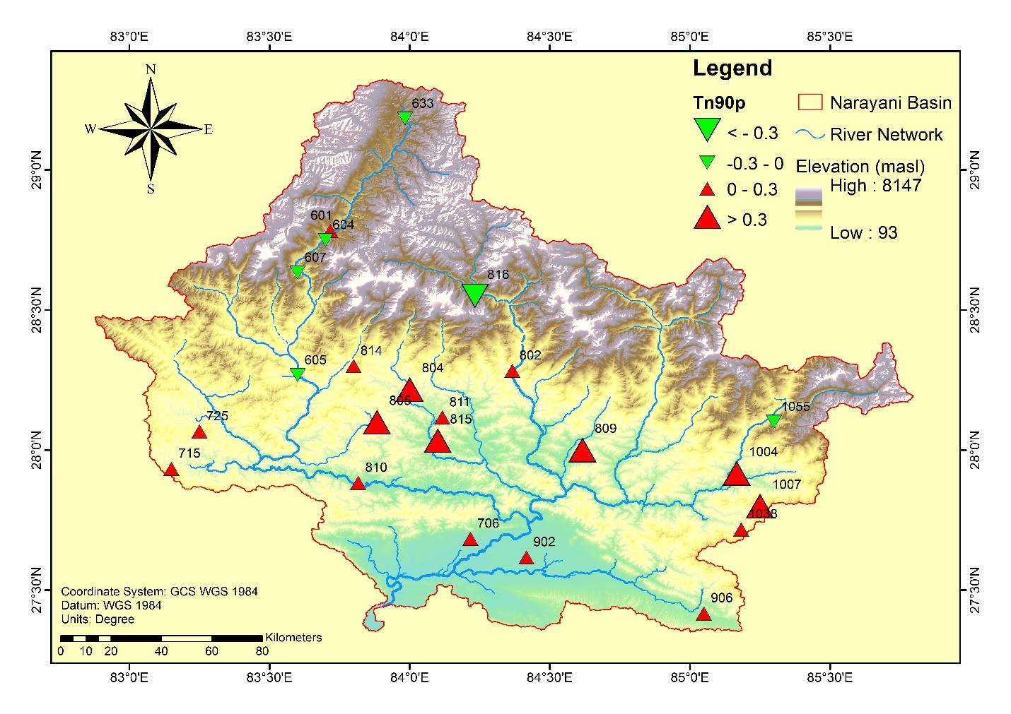
Figure S11: Spatial distribution of TN90p in Narayani River Basin
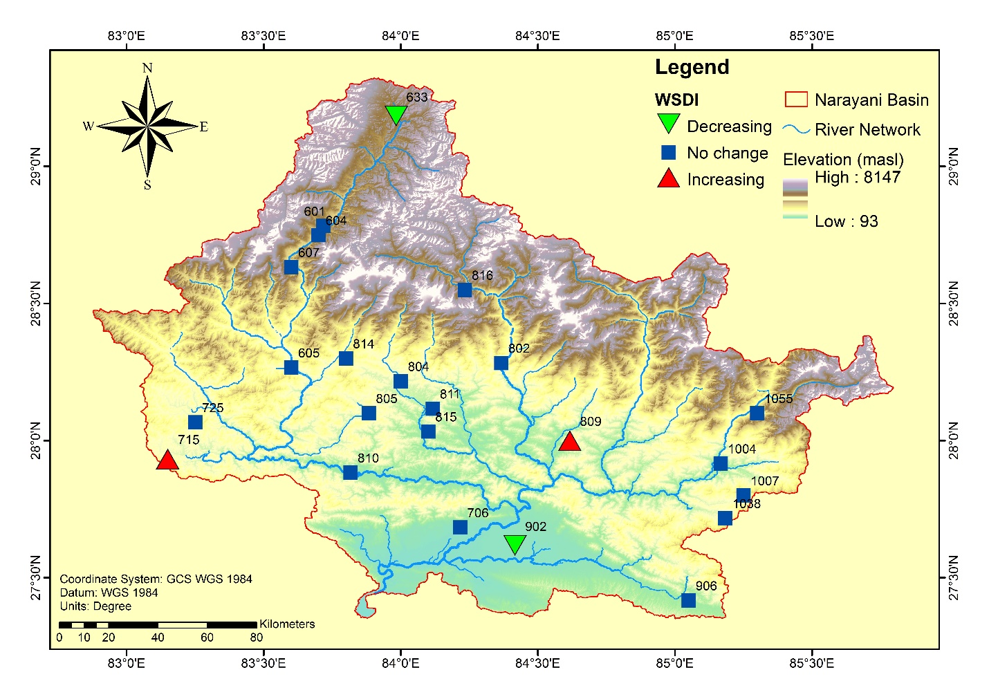
Figure S12: Spatial distribution of WSDI in Narayani River Basin

Text S1: Additional details on the data quality assessment
The data quality of 79 rainfall stations were assessed by analyzing annual rainfall charts, distribution of missing data, trends from hyetographs and single mass curves (SMCs), monthly rainfall charts, and comparative analysis of filled and raw annual as well as seasonal rainfall data. The graphs of SMC and hyetograph were used to track missing data and employ a suitable data correction method. If a significant amount of data was found to be unavailable or available, data trend was difficult to depict, then such stations were discarded in exploratory analysis. The World Meteorological Organization (WMO) estimates a climatic unit to be 30 years. Therefore, two assumptions were made: a) Any station having data less than 30 years may not be able to truly reflect the climatic properties of that region, b) Estimation of more than 10% of data in the period dilutes the data quality and, therefore, must be avoided. In this study, stations with more than 10% missing data were monitored for mass curves and hyetographs, and those showing questionable errors were rejected from the study. This goes with the second assumption as it rules out the possibility of filling in more than 10% of missing data in the period. In addition, the first criterion is also fulfilled at the initially available data period was that of 37 years, 10% of which accounts for 33 years which is greater than 30 years. Hence climatic properties are preserved.
Similarly, Daily maximum temperature (T_{max}) and daily minimum temperature (T_{min}) for the stations with missing data <10% for the entire study period and for those with missing data >10% for a reasonable study period were plotted, which was useful in observing the pattern of temperature in the station. It helped in quality assessment, indicating some absurd peaks or depressions and the nature of missing data periods. Likewise, raw data from the stations were carefully observed and analyzed for the annual and seasonal averages for T_{max} and T_{min}. This indicator was used for the quality assessment of the temperature data as a significant peak or depression may indicate the poor quality of data resulting due to shifting of the station, defective instruments, missing values, etc. Some of the absurd data were removed and treated as missing values, and a literature review was also done to confirm the values. The stations with consistent data with no sudden peak or fall are retained in this stage. Some stations showing major variations were subjected to manual data reading for those years to consider their selection for the study.

Text S2: Normal Weighted Ratio method
In Normal Weighted Ratio (NWR) method is used for estimating the missing meteorological data at the base station using the weights obtained from the neighboring stations as:

$$P_{missing}=\frac{\sum_{i=1}^{n}{P_{i}}⋅W_{i}}{\sum_{i=1}^{n}{W_{i}}}$$
Where, P_{missing} refers to the missing precipitation/temperature data to be estimated, P_{i} refers to the data of the neighboring reference station i and W_{i} is the weight associated with the reference station i.
$$W_{i}=\frac{P_{T}}{P_{i}}$$
Where, P_{T} represents the sum of data of nearby stations
However, in case of temperature, the proportion in W_{i} is replaced by the average differences.

Text S3: Modified Mann Kendall Trend Test
Climatic variables are known to be susceptible to autocorrelation which can lead to detect spurious trends in the data using the Mann Kendall (MK) trend test. Thus, Hamed and Rao’s approach modified the variance term in MK by considering the autocorrelation in the data which enhances the reliability and robustness of the trend. This makes the spurious trends that could have appeared from autocorrelation less likely. The following equations formulate the rank correlation test for two sets of observations X = x₁, x₂, …. x_{n} and Y = y₁, y₂, … y_{n}. The statistic S is computed as in equation (1).

$S=\sum_{i < j}{a_{ij}b_{ij}}$ (1)
where
$a_{ij}=sgn\left(x_{j}-x_{i}\right)=\left\{\begin{aligned}1{ x}_{i}<x_{j} \\ 0 x_{i}=x_{j} \\ -1 x_{i}>x_{j}\end{aligned}\right.$ (2)
And b_{ij} is computed similarly for the observations in Y. The statistic S tends towards normality for the large n assuming the null hypothesis where X and Y are randomly ordered and independent for the daily meteorological parameters, with mean and variance provided by

$E\left(S\right)=0$ (3)
$var\left(S\right)=n\left(n-1\right)\left(2n+5\right)/18$ (4)

The test can be applied to trend test by substituting the values in Y with the sequence of time series X, i.e., 1, 2, … n and the statistic S reduces to equation (5) with the same variance and mean as that in equation (3). The asymptotic normality of statistic S is demonstrated by Kendall (1955).
$S=\sum_{i < j}{a_{ij} }=\sum_{i < j}{sgn\left(x_{j}-x_{i}\right)}$ (5)
The significance level of the trend is evaluated using the standard test static Z = S/ [var(S)]^{0.5} with the standard normal variate. In the MMK approach for autocorrelated case, if the variable X is distributed normally with mean (μ) and variance (σ²), then (x_{j}-x_{i}) should also be normally distributed with mean of zero and variance of 2σ² which is symmetric about origin. Hence, we have
$$E\left(S\right)=E\left[\sum_{i < j}{a_{ij} }\right]=E\left[\sum_{i < j}{sgn\left(x_{j}-x_{i}\right)}\right]=\sum_{i < j}{E\left[sgn\left(x_{j}-x_{i}\right)\right]}$$
$=P\left(x_{j}-x_{i}>0\right)-P\left(x_{j}-x_{i}<0\right)=0$ (6)
$var\left(S\right)=E\left(S^{2}\right)=E{\left[\sum_{i < j}{a_{ij} }\right]}^{2}=E\left[\sum_{i < j, k<l}{a_{ij}a_{kl}}\right]$ (7)

The sum in equation (7) for a time series with n observation includes n²(n-1)²/4 terms and the sum reduces to equation (8).
$var\left(S\right)=\left({n \atop 2}\right)E\left(a_{ij}^{2}\right)+6\left({n \atop 2}\right)E\left(a_{ij}a_{ik}\right)+6\left({n \atop 2}\right)E\left(a_{ij}a_{kl}\right)$ (8)
The first, second and third expectations in equation (8) account for terms with identical suffixes, one common suffix and distinct suffixes respectively. Hamed and Rao (1998) have shown in their research that,
$E\left(a_{ij}a_{ik}\right)= P(a_{ij}a_{ik} = 1) - P(a_{ij}a_{ik} = -1) = \frac{2}{π}sin^{-1}($ρ) (9)
In equation (9), ρ denotes the correlation between the two binormal variates Y and Z where
$Y=x_{j}-x_{i},Z=x_{l}-x_{k}$. Since, $Y,z\sim N\left(0,2σ^{2}\right)$,$E\left(a_{ij}^{2}\right) = 1$, $E\left(a_{ij}a_{ik}\right)=1/9$ and $E\left(a_{ij}a_{kl} = 0\right)$,
$var\left(s\right)=\left({n \atop 2}\right).1+6\left({n \atop 2}\right).1/9+6\left({n \atop 2}\right).0=n\left(n-1\right)\left(2n+5\right)/18$ (10)
Which is the same expression in equation (4) given by Kendall (1955) in MK test. The standardized statistic Z is indicated by,
$Z=\left\{\begin{aligned}\frac{S-1}{\sqrt{V\left(s\right)}} S>0 \\ 0 S= 0 \\ \frac{S+1}{\sqrt{V\left(s\right)}} S<0\end{aligned}\right.$ (11)
It follows normal distribution, and the significance of the trend can be evaluated by comparing the desired significance level with the value of Z.
When the tied rank exists, var(s) becomes,
$V*(S) = [n\left(n-1\right)\left(2n+5\right)/18-\sum_{j=1}^{m}{t_{j}\left(t_{j}-1\right)\left(2t_{j}+5\right)/18}$ (12)
Where, m denotes the number of groups with ties and t_{j} denotes the total number of tied observations.
The magnitude of the trends can be obtained from the non-parametric estimator of the slope given by (Sen, 1968).
$$β=Median\left[\frac{x_{i}-x_{j}}{i-j}\right] for all j<i$$

