Supplementary Information
Supplementary Tables
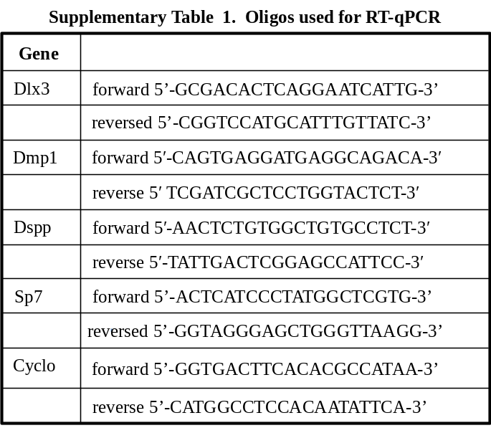

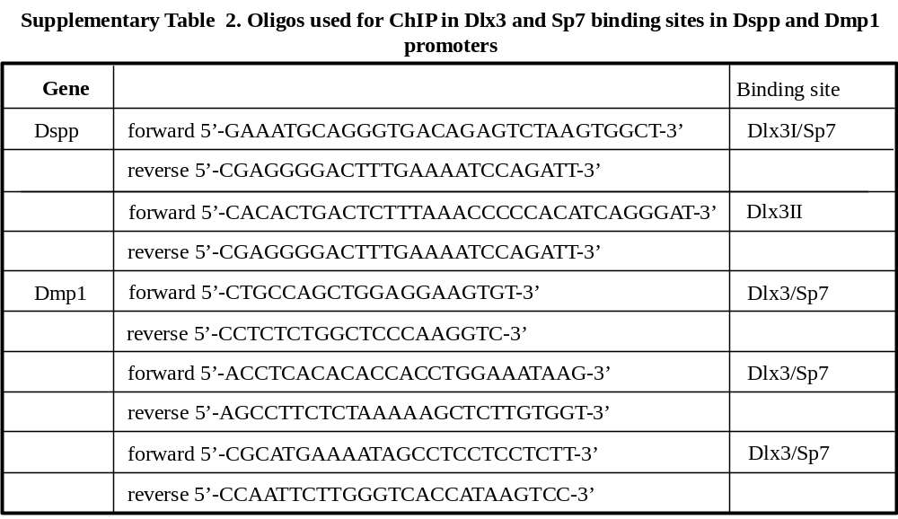

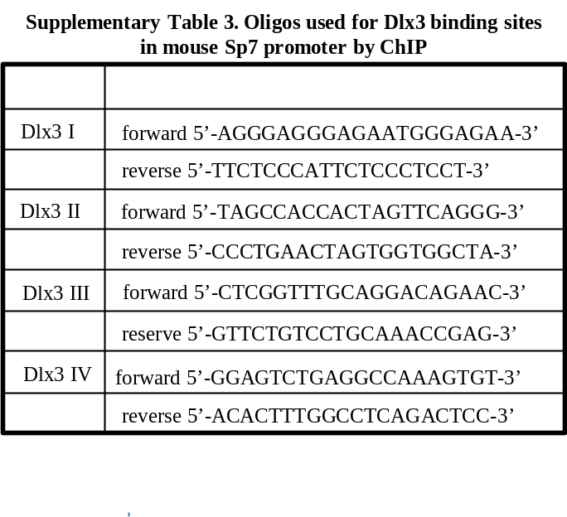

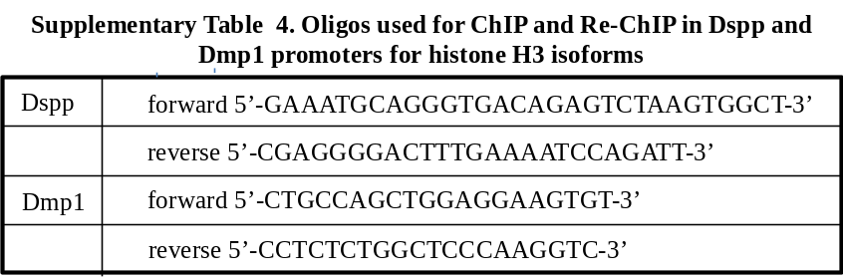

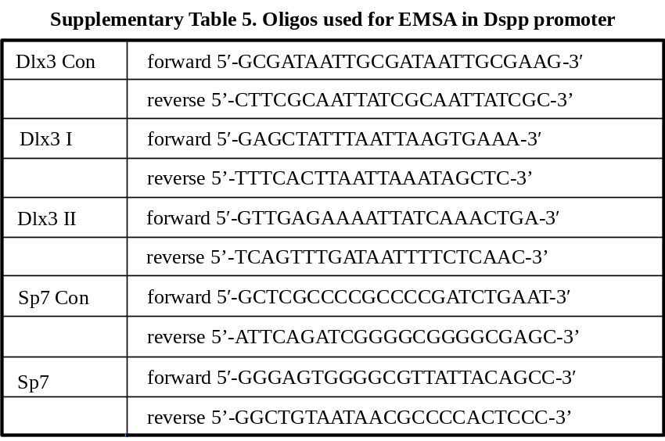

Supplementary Materials and Methods
Southern blot assay and genotyping
Southern blot assay was shown in Fig. S1b. In brief, genomic DNAs from tails of the wild type, Bmpfx/fx, and Bmp2 cKO mice were isolated by a Genomic DNA Purification Kit (Promega, Madison, WI, USA). The genomic DNAs were digested with BstE II (B) restriction enzyme and run on 0.8% agarose gels. The gels were then transferred to nitrocellulose membranes and hybridized to the radio-labeled probes using Primer-a-Gene Labeling System according to Manufacture’s protocol (Promega). The hybridization membranes were exposed to X-ray film (Kodak BioMax film, Sigma-Aldrich) at -80°C for 2 days. For PCR analyses of genotypes shown in Fig. S1c, d, the fragments from wild type and Bmp2 floxed alleles were amplified by PCR using primers A and B. Primers C and D were used to detect the wild type, and Cre-dependent deletion of the floxed region was identified by primers A and E. Primers F and G were used to detect Cre gene in the mice. The primers were shown as follows: A, 5'-AGCATGAACCCTCATGTGTTGC-3'; B, 5’-CTCGTATCCATCTCATCCT CATTCG-3’; C, 5'-AGGGTTTCAGGTCAGTTTCCG-3'; D, 5'-TCCGAAGGTAAGTGTGC TTGG-3'; E, 5'-GATGATGAGGTTCTTGGCGG -3'; Cre sense, 5'-CCGGGCTGCCACGACCAAGT-3' and Cre antisense, 5'-GCGCGAGTTGATAGCTGGCTGGT-3'.

Antibodies
The antibodies were used for this study as follows: goat-anti-β-Actin (Santa Cruz Biotechnology Inc., Santa Cruz, CA, USA, sc-1616, 1:1,000); rabbit anti-Dlx3 (Abcam, Cambridge, MA, USA, ab64953, 1:500); rabbit-anti-Dmp1(Alpha Diagnostic International, San Antonio, TX, USA; 1:400); rabbit anti-mouse Dsp (Alpha Diagnostic International, 1:400); goat anti-Sp7 (Santa Cruz Biotechnology Inc., sc-22538, 1:400); rabbit anti-GCN5 (Santa Cruz Biotechnology Inc., sc-20698, 1:300); rabbit anti-histone H3 (Abcam, ab1791, 1:600); mouse anti-Akt (Santa Cruz Biotechnology Inc., sc-5298, 1:400); rabbit anti-pAkt^{1/2/3} (Santa Cruz Biotechnology Inc., sc-7985, 1:400); rabbit anti-pErk^{42/44} (Cell Signaling, Boston, MA, USA, 9101, 1:500); rabbit anti-Erk42/44 (Cell Signaling, 9102, 1:500); mouse anti-p38 (Santa Cruz Biotechnology Inc., sc-7972, 1:400); mouse anti-p-p38 (Santa Cruz Biotechnology Inc., sc7973, 1:500); mouse anti-Flag (Thermo Fisher Scientific, Waltham, MA, USA, MA191878, 1:500); mouse anti-Myc (Thermo Fisher Scientific, MA121316, 1:500); rabbit anti-acetyl-lysine (Abcam, ab21623, 1:400); rabbit anti-acetyl-histone H3K9ac (Lys9) (Millipore, Burlington, MA, USA, 07-352, 1:400); rabbit anti-histone H3K18ac (Lys18) (Abcam, ab1191, 1:500); rabbit anti-histone H3K23ac (Active motif, Carlsbad, CA, USA, 13131, 1:500); rabbit anti-histone H3K27ac (Lys27) (Abcam, ab4729, 1:500); mouse anti-HDAC1 (Abcam, ab46985, 1:500); rabbit anti-HDAC6 (Active motif, 40971, 1:400); rabbit anti-HDAC11 (Abcam, ab18973, 1:500); rabbit anti-Sirt (Abcam, ab86671, 1:500); rabbit anti-pol II (Santa Cruz Biotechnology Inc., sc-9-001, 1:200); mouse anti-pTyr (Santa Cruz Biotechnology Inc., sc-7020, 1:500); mouse anti-pThr (Santa Cruz Biotechnology Inc., sc-5267, 1:500).

RNA in situ hybridization
For in situ hybridization, tissues were prepared in RNase-free diethylpyrocarbonate (DEPC) water in all solutions. The tissues were fixed and decalcified in 15% EDTA buffer for 4-6 weeks at 4°C. Serial tissue sections were mounted on saline-treated slides. For the in situ hybridization assay, the amplified PCR product of the mouse Bmp2 gene (nt 1657-2040, NM_007553) was inserted into the Topo-pCRII vector (Topo-TA cloning kit, Invitrogen). [a-³⁵S]-labeled UTP sense and antisense Bmp2 gene probes were created after linearization with restriction enzymes. In situ hybridization was carried out with minor modified procedures described previously ¹.

RNA interference
For knockdown endogenous Sp7 or Dlx3 gene expression, small interfering RNA (siRNA) specific to mouse Dlx3 (sc-38654) or Sp7 (sc-45909), negative control siRNA (sc-37007) (Santa Cruz Biotechnology Inc.) was transfected into iMDP3 cells, respectively, at 100 nM with Lipofectamine ^{2000TM}. The cell lysate was harvested at 24h and 48h transfections. Protein expression of Dlx3, Sp7, Dmp1, and Dsp were analyzed by Western blotting. For the knockdown of GCN5, iMDP3 cells were transfected with GCN5-shRNA (sc-37947-SH) or scramble-shRNA (sc-108060, Santa Cruz Biotechnology Inc.). After 72h, the cells were lysed and immunoblotted by using indicated antibodies.

A computer-aided analysis of the Dspp gene regulatory region
Potential transcription factor binding sites in the DSPP gene from the regulatory region to the first intron (-2.5 kb to +3.2 kb) were predicted by the Transcription Element Search System (TESS) (http://www.cbil.upenn.edu/cgi-bin/tess/tess). Furthermore, the conserved motifs of the promoter and the first intron of DSPP genes among humans, rats, and mice were analyzed by Vista plots (http://genome. lbl.gov/vista/index.shtml).

References:
- Chen S, Gluhak-Heinrich J, Wang YH, Wu YM, Chuang HH, Chen L, Yuan GH, Dong J, Gay I, MacDougall M. 2009. Runx2, osx, and dspp in tooth development. Journal of dental research. 88(10):904-909.

Supplementary Figures

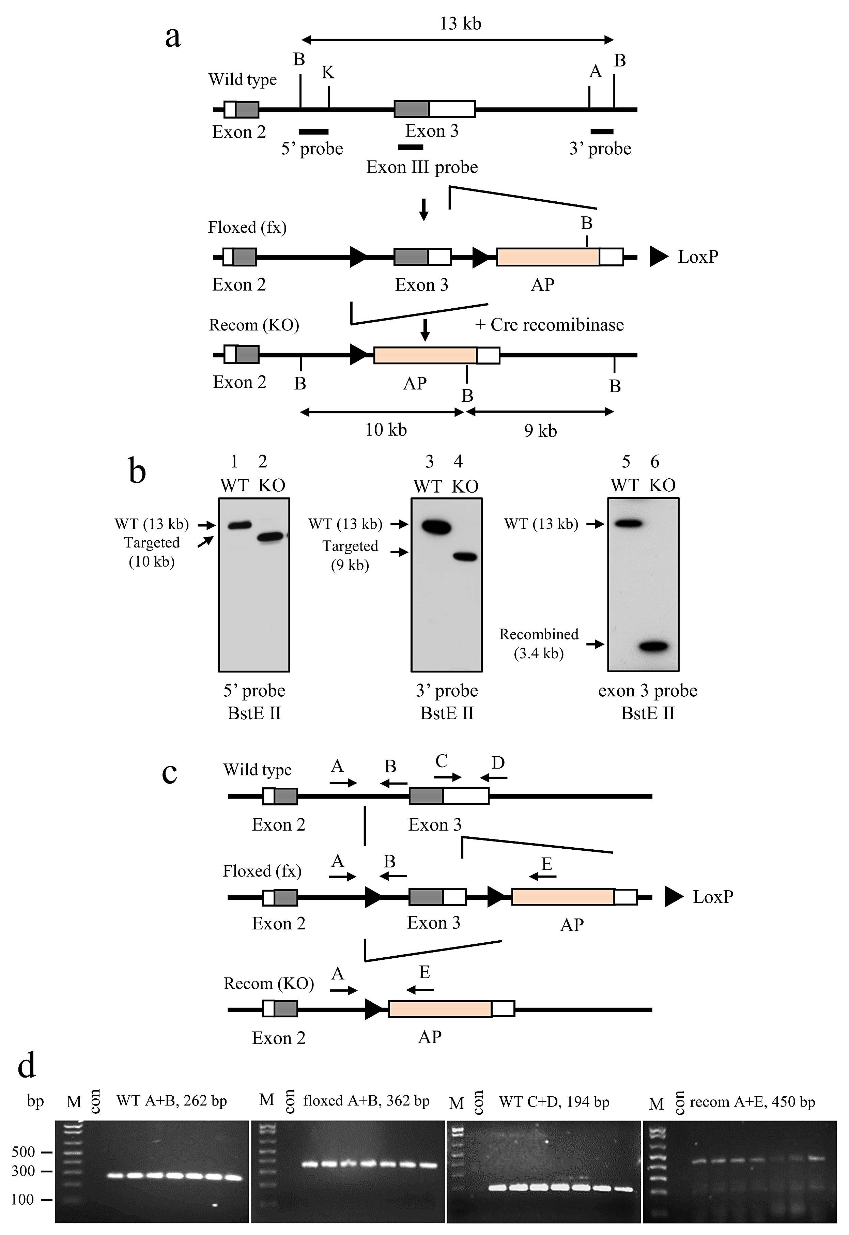

Figure S1 Generation of conditional Bmp2 knock-out mice. (a) Schematic representation of different alleles of Bmp2 locus. LoxP sites (triangles) were inserted into introns 2 and 3 of the Bmp2 gene. The human alkaline phosphatase (AP) gene (pink box) was inserted into the 3’ untranslated region. White boxes show the untranslated regions of exons 2 and 3 of the Bmp2 gene and coding regions in exons 2 and 3 indicate gray boxes. B, BstEII; K, Kpnl; A, AccIII. (b) Correctly targeted fragments from wild-type and Bmp cKO mice were confirmed by Southern blot analysis of BstEII-digested genomic DNAs. 5’ (Left, lanes 1, 2), 3’ (Center, lanes 3, 4), and exon 3 probe (Right, lanes 5, 6) indicate in A and this panel. WT, wild type; KO, Bmp2 cKO. (c) Schematic representation of the structure of each allele and positions of primers (A-E). (d) Genotyping and PCR strategy. Tail genomic DNA isolated from wild-type, Bmp2fx/fx and Bmp2 cKO mice was amplified by PCR using Bmp2-specific primers shown in the Materials and methods. M, 1 kb plus DNA ladder. A+B primers measure the 5’ loxP site and WT alleles. C+D primers show wild-type alleles. A+E primers show Cre-mediated recombination.
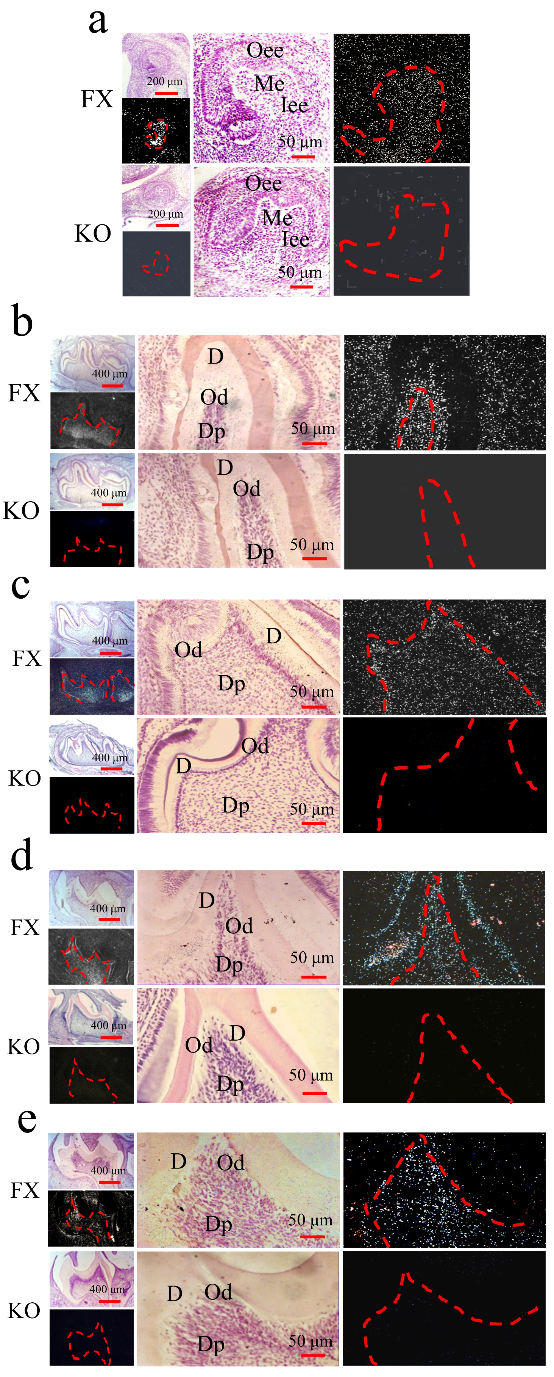

Figure S2 BMP2 expression in odontoblasts during odontogenesis. In situ hybridization of mouse tooth development at E15 (a), E18 (b), PN3 (c), PN10 (d), and PN14 (e) with Exon 3 antisense Bmp2 probe. Bmp2 expression was seen in odontoblast and dental pulp mesenchymal cells in Bmp2^{fx/fx} mice whereas Bmp2 was not detected in odontoblasts and dental pulp mesenchymal cells in Bmp2^{ko/ko} mice. D, Dentin; Dp, Dental pulp; Fx, floxed; Iee, Inner enamel epithelium; Ko, knock out; Me, Mesenchyme; Od, Odontoblasts; Oee, Outer enamel epithelium.
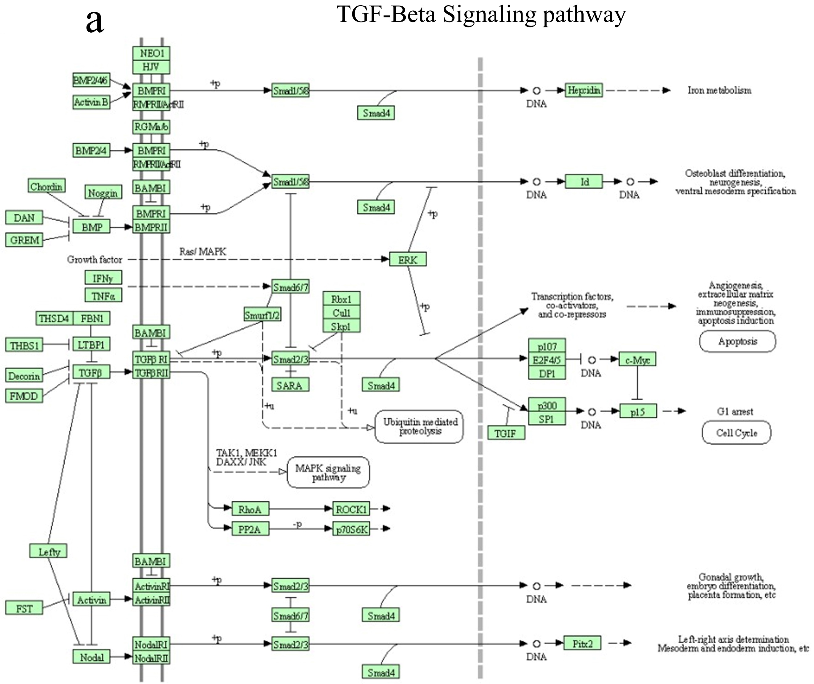

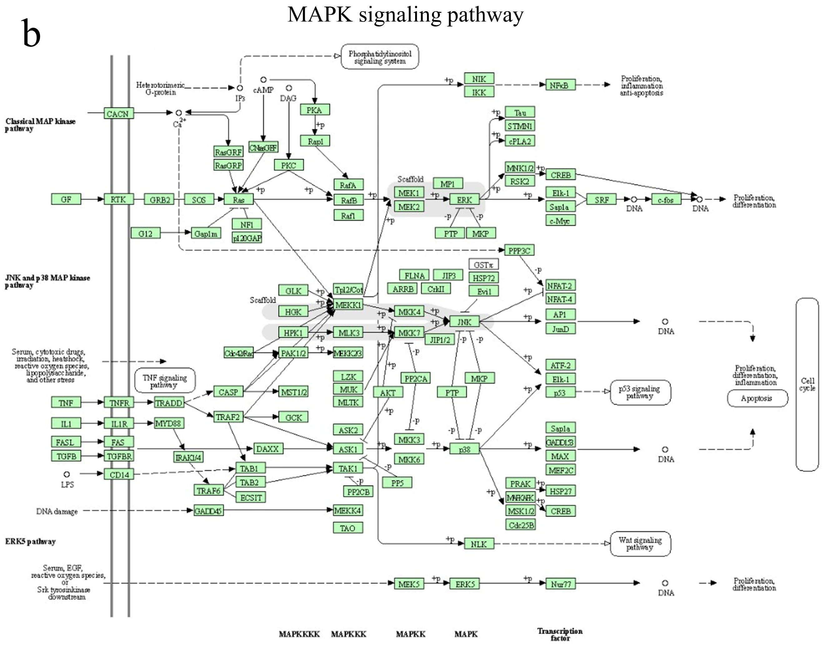

Figure S3 RNA-seq gene expression and signal pathways. (a) Analysis of KEGG and GO related to TGF-β signal pathway. (b) The non-canonical BMP signaling pathway. KEGG and GO analyses of MAPK signaling pathway related to Bmp2. (c) The non-canonical BMP signaling pathway. KEGG and GO analyses of PI3K-AKT signaling pathway related to Bmp2.
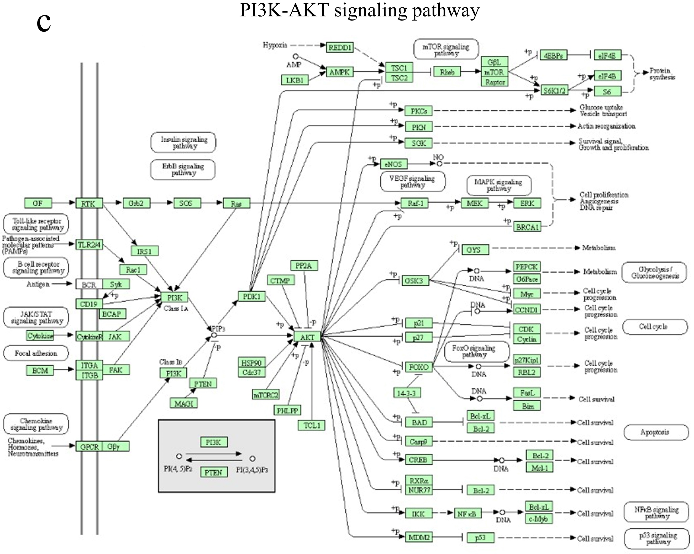

Figure S4 Dlx3 and Sp7 regulation of Dmp1 and Dspp expression. (a, b) RNA interference of Dlx3 and Sp7 gene expressions. The cells were transfected with 100 nm of Dlx3 siRNA or Sp7 siRNA, scramble siRNA as a control for 24h and 48h. After transfection, expression of Dlx3, Sp7, Dsp, Dmp1, and β-actin was analyzed by Western blotting. Up panels were quantified data assessed by ImageJ software. Bars represent the mean ± S.E. from three separate experiments. t-test, *p <0.05; **p <0.01. (c) Scheme represents 4 Dlx3 binding sites in the mouse Sp7 gene promoter. +1 represents the translational start site. (d) The cells were transiently transfected with pcDNA-Dlx3 or pcDNA 3.1 for 48h. ChIP assay was performed and Dlx3 specifically binds to the Dlx3 binding elements in the mouse Sp7 gene promoter by ChIP assay using oligonucleotides shown in Table S3.
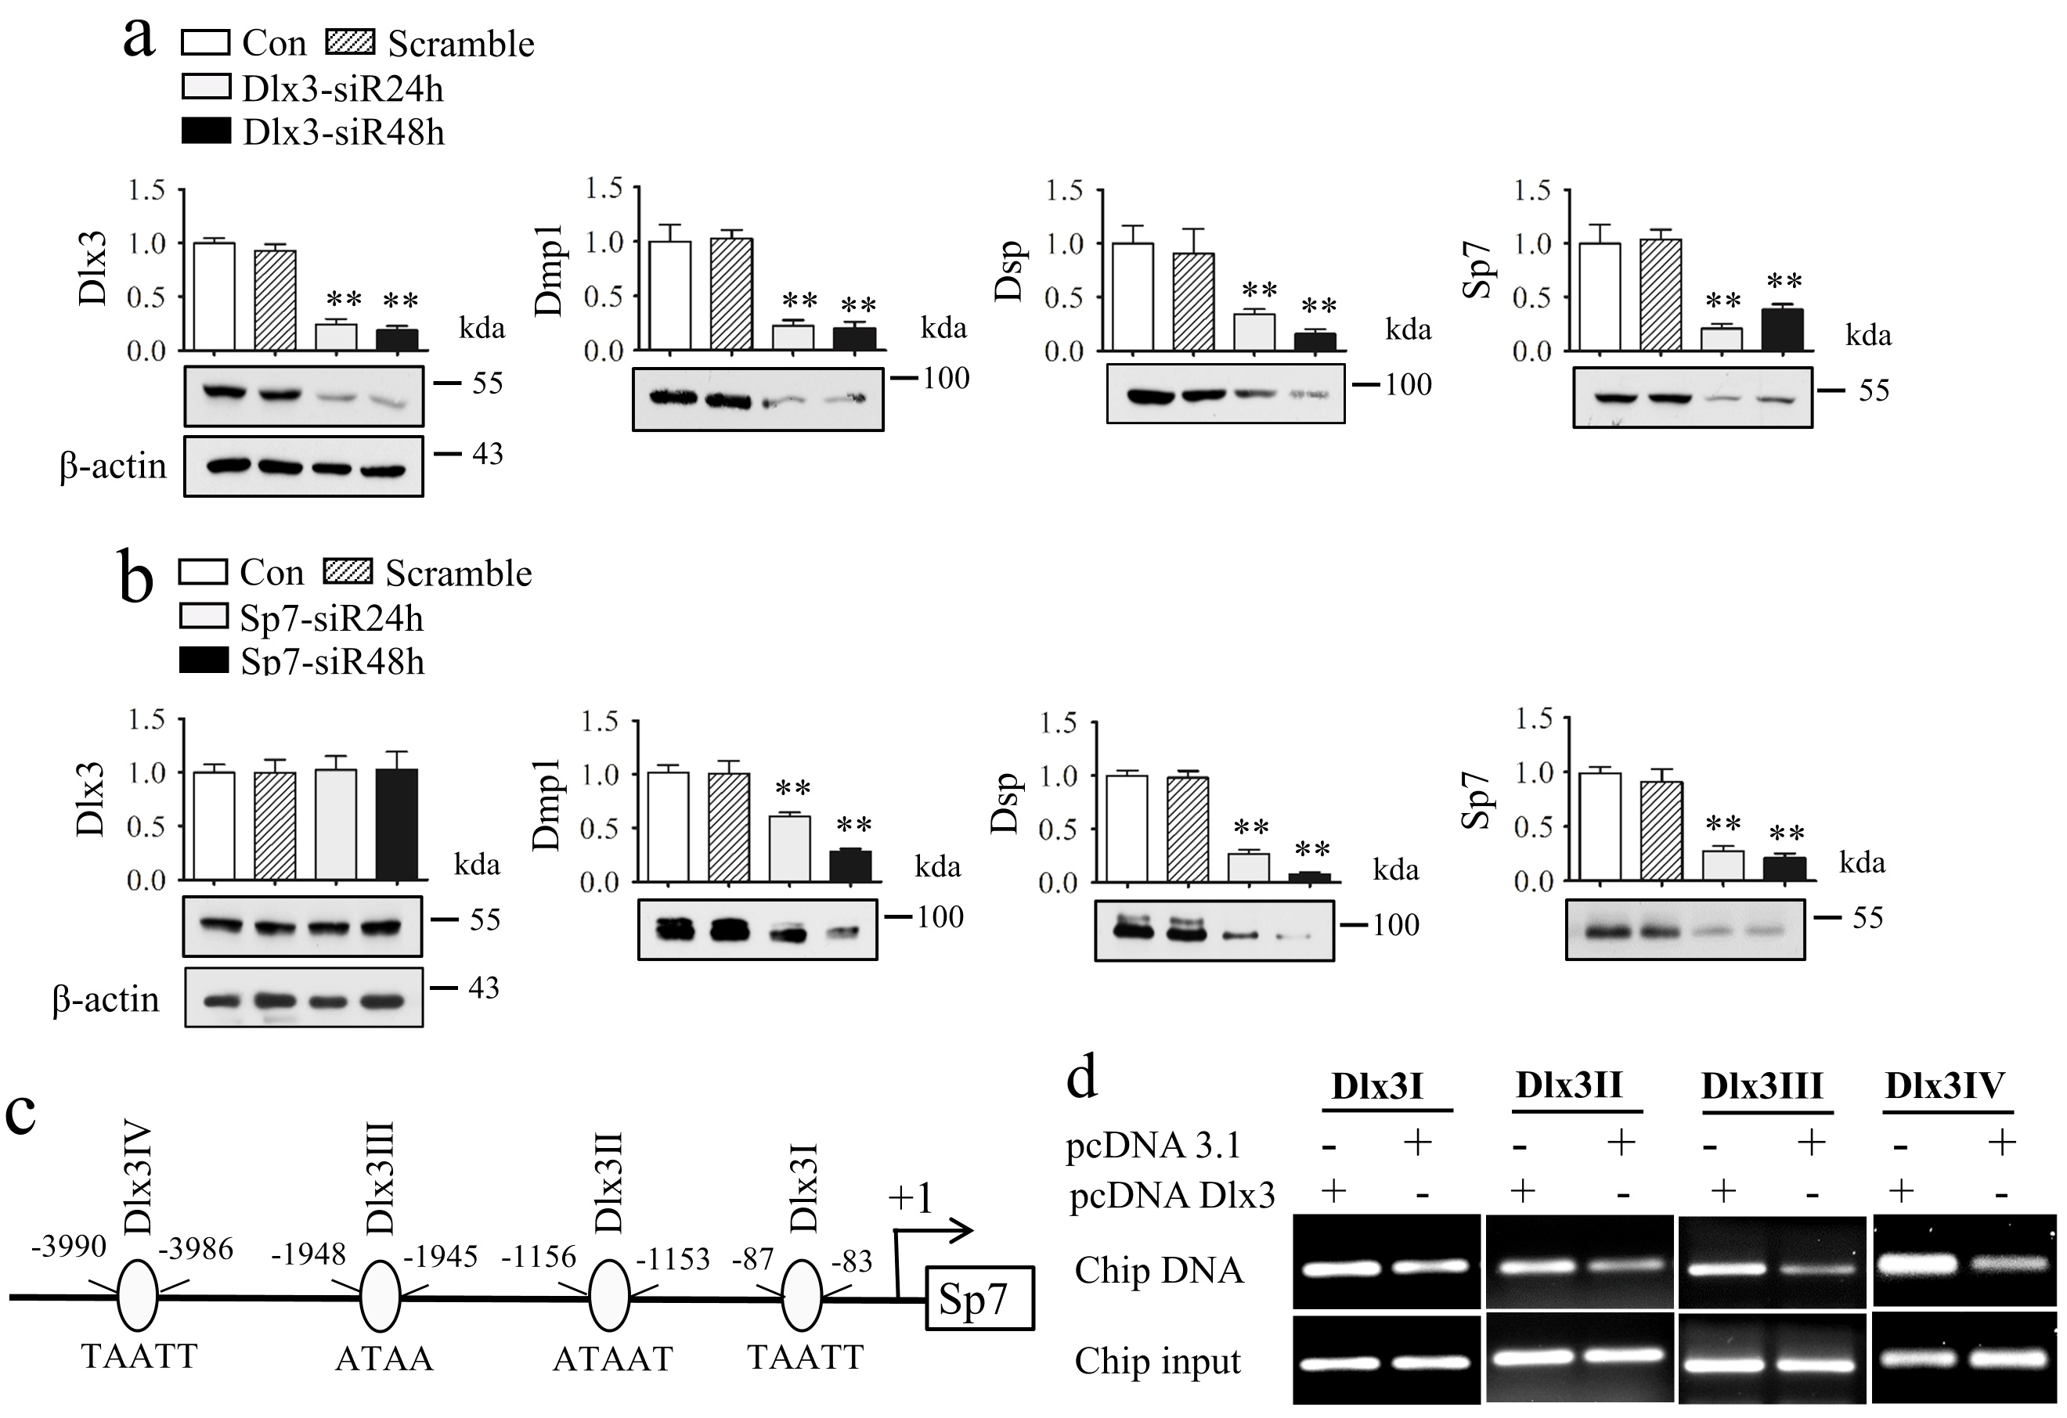

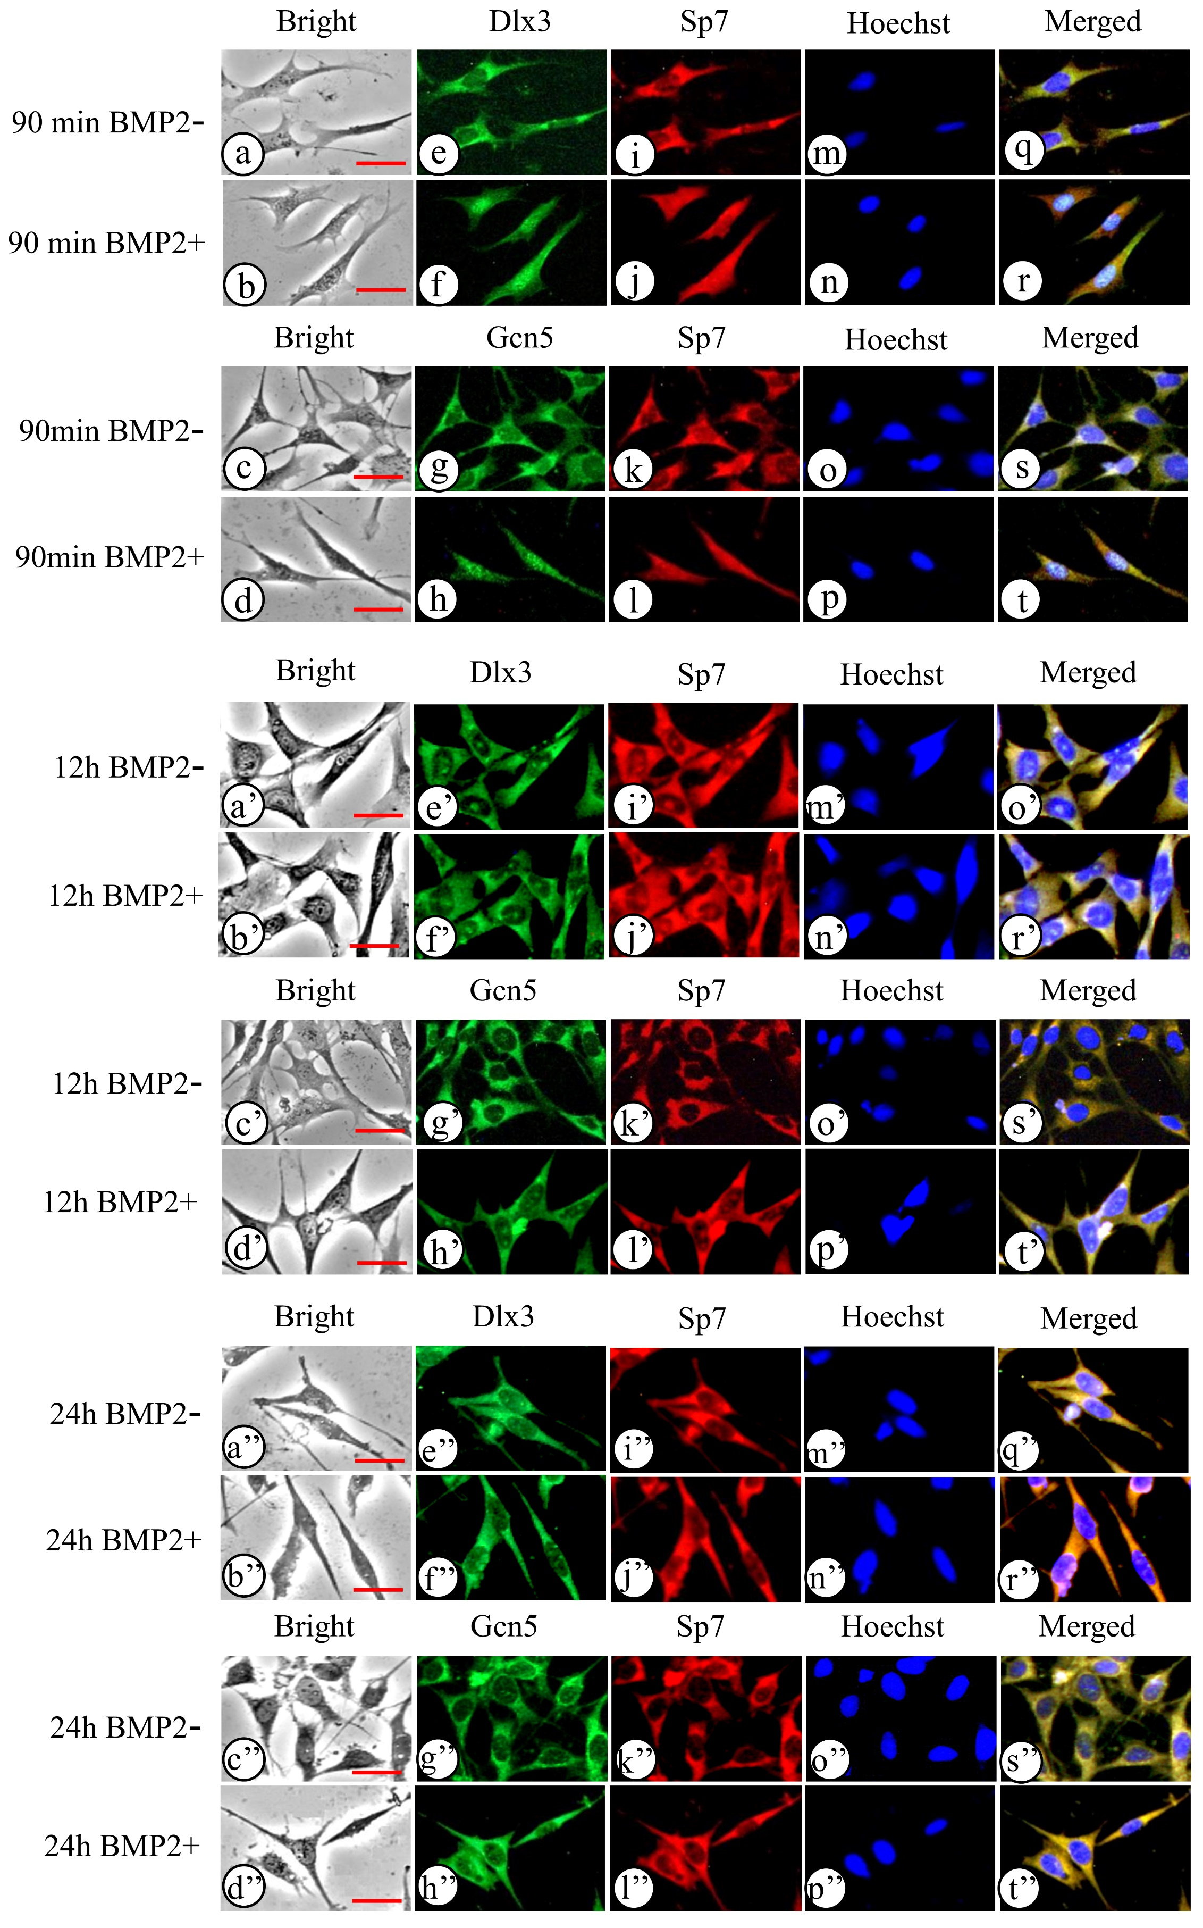

Figure S5 BMP2 induces translocation of Dlx3, Sp7, and GCN5 proteins. The iMDP3 cells were treated with or without 100 ng/ml of recombinant BMP2 for 1.5h, 12h, and 24h. Localization of Dlx3, Sp7, and GCN5 expressions was observed by fluorescent images. The expression of Dlx3 (green, e, f, e’, f’, e’’, f’’) and Sp7 (red, i, j, i’, j’, i’’, j’’) as well as GCN5 (green, g, h, g’, h’, g’’, h’’) and Sp7 (red, k, l, k’, l’, k’’, l’’) was observed in the cells. Expression of Sp7 was overlapped with Dlx3 (q, r, q’, r’, q’’, r’’) and GCN5 (s, t, s’, t’, s’’, t’’) respectively in the cells. a-d, a’-d’, and a’’-d’’ show bright images. Cells were stained with Hoechst for nuclei (m, n, o, p, m’, n’, o’, p’, m’’, n’’, o’’, p’’). The images were merged (q, r, s, t, q’, r’, s’, t’, q’’, r’’, s’’, t’’). At 90 min BMP2 treatment, Dlx3, GCN5, and Sp7 proteins mostly appeared in the nucleus compared to the control groups. After 12h and 24h of BMP2 induction, expression of Dlx3, Sp7, and GCN5 proteins was mainly redistributed in the cytoplasm. Bars, 10 μm.
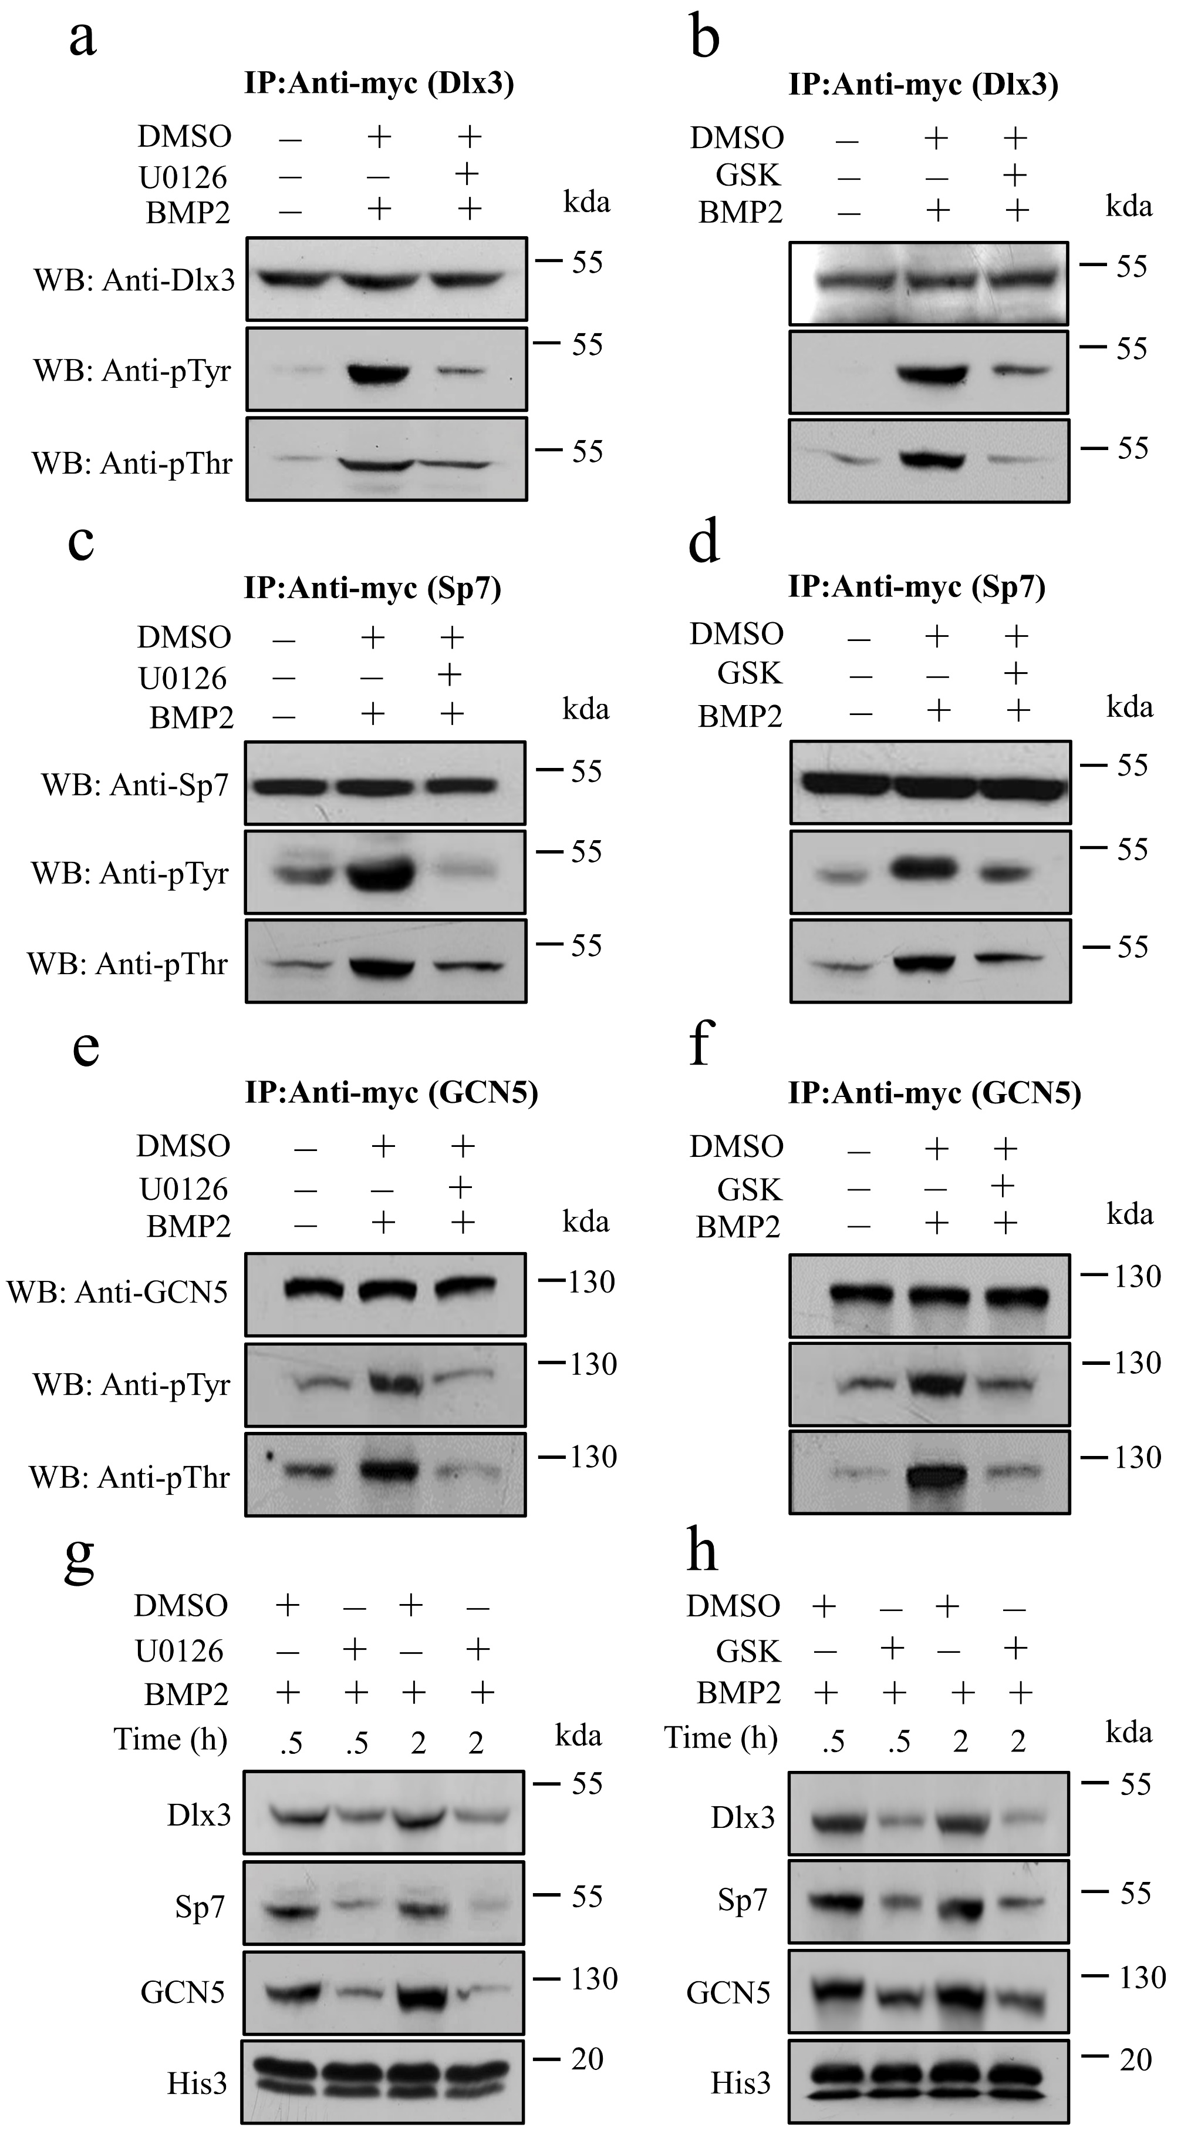

Figure S6 Blockage of BMP2-mediated Dlx3, GCN5, and Sp7 phosphorylation at Tyr and Thr residues via Akt and Erk^{42/44} kinases by Akt and Erk inhibitors. Cells were treated or untreated with 10 μM of U0126 and GSK630693 (GSK), respectively, for 2h and followed by adding recombinant BMP2 protein for 30 min. The cells were lysed and Dlx3, Sp7, and GCN5 proteins were immunoprecipitated. Phosphorylation of Dlx3 (a, b), Sp7 (c, d), and GCN5 (e, f) proteins at Tyr and Thr residues were detected by Western blotting using anti-pTyr or anti-pThr antibody. (g, h) Cells were treated or untreated with 10 μM of U0126 or GSK, respectively for 2 h and followed by adding BMP2. After 0.5h and 2h BMP2 induction, nuclear extracts were isolated and expression of Dlx3, Sp7, and GCN5 proteins in the nuclei was detected by Western blotting using anti-Dlx3, anti-Sp7, or anti-GCN5 antibody, respectively.
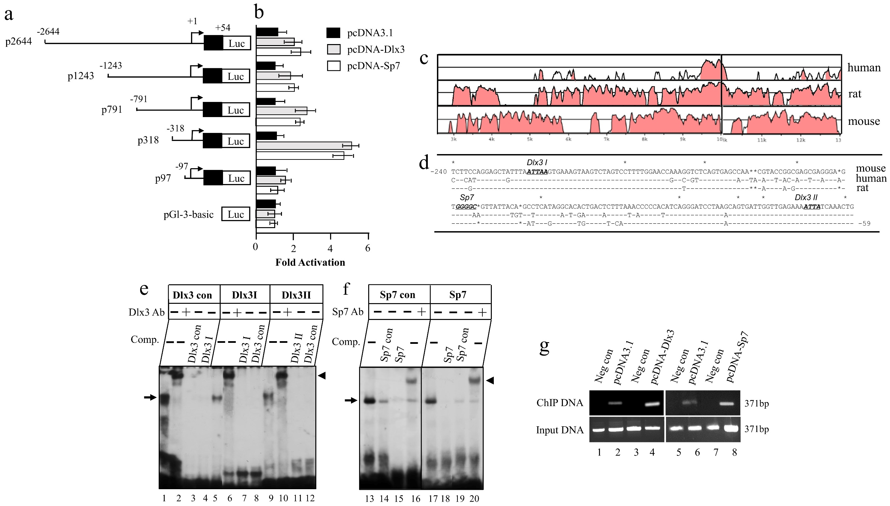

Figure S7 Dlx3 and Sp7 regulate Dspp gene transcription. (a) Schematic representation of the constructs used in Luc assay. (b) Chimeric constructs were transfected into iMDP3 cells with pcDNA-Dlx3 or pcDNA-Sp7, pcDNA3.1 as control. After 48h transfection, Luc activity was determined. The value obtained from the control group was taken as 1-fold and fold increases were calculated by dividing the individual value by the control group value and mean ± S.E. from three independent experiments in triplicate was plotted. (c) Identify Dlx3 and Sp7 binding sites in the Dspp promoter. Conserved non-coding sequence islands were compared to regulatory regions of the mouse, rat, and human DSPP genes. Pink regions are peaks of conserved nucleotide sequences with a minimum of 70% homologies. (d) Homogeneity of DSPP promoters in mice, humans, and rats. The putative Dlx3 and Sp7 binding sites are underlined. (e, f) P32-labeled probes of the Dlx3I, Dlx3II, and Dlx3 consensus oligos (e) and Sp7 and Sp7 consensus oligos (f) were incubated with cell nuclear extracts in the presence or absence of 100-fold molar excesses of the unlabeled DNA competitors and the labeled probes were incubated with the nuclear extracts alone or together with anti-Dlx3 or anti-Sp7 antibody. The arrows represent protein-DNA complexes, and the arrowheads indicate antibody-protein-DNA complexes. Lanes 1, 5, and 9 show probes of Dlx3 con, Dlx3I, and Dlx3II plus nuclear proteins; lanes 2, 6, and 10, are probes of Dlx3 con, Dlx3I and Dlx3II with nuclear protein plus anti-Dlx3 antibody; lanes 3-4, 7-8, and 11-12 indicate that probes of Dlx3 con, Dlx3I, and Dlx3II with 100-fold molar excesses of cold oligos of the Dlx3 con, Dlx3I, and Dlx3II, respectively. Lanes 13,17, show probes of Sp7 con and Sp7 plus nuclear proteins; lanes 14-15, 18-19 indicate that probes of Sp7 con and Sp7 with 100-fold molar excesses of cold oligos of the Sp7 con and Sp7, respectively; lanes 16, 20 are probes of Sp7 con and Sp7 with nuclear protein plus anti-Sp7 antibody. Con, consensus. G. Overexpression of the Dlx3 or Sp7 gene increased binding to their sites in the mouse Dspp promoter in vivo by ChIP assay. Neg, negative.

