Supplementary materials

Methods

Participants

The age of toddlers in the Down syndrome [TwDS] group (x = 24.1 months, SD = 4.7, min = 16, max = 32) was significantly higher than that of their counterparts in the other group (x = 20.6, SD = 6.3, min = 10, max = 37) as verified by a Welch two-sample t-test (t_{(53.742)} = 2.4229, p = 0.018). A two-way between-subjects ANOVA conducted to test the effect of group (Down syndrome/typical development) and the assessed parent (mother/father) on parental age revealed a significant effect of the former (F_{(1, 116)} = 9.462, p = 0.003) but not of the latter (F_{(1, 116)} = 2.444, p = 0.121), and no interaction between them (F_{(1, 116)} = 0.346 p = 0.557). Participating families’ socioeconomic level was calculated according to income, with no differences across groups.

Procedure

Families of children with Down syndrome were reached by means of population-related organisations providing therapeutic and educational services to children with Down syndrome and their families. Interested parents signed informed consent forms and provided personal contact information so that they could be reached by a research assistant. toddlers with typical development were recruited through social media and day-care institutions.
Examiners consisted of graduate students and professionals with previous training in developmental evaluation. As a reward for participation, a report was delivered to the families containing results of the developmental evaluation.
Instructions for participating parents were as follows: “I invite you to enjoy some free play time with (child's name). There is nothing specific you need to do, just do what you always do (or play as you always play with the child). Pretend I am not here.” [Invite them to take the toys out of the box.]

Statistical Analyses

Hypothesis testing
Shapiro-Wilk normality tests were applied to assess the distribution of the variables, returning normal distributions in all cases except for the TADI Cognitive dimension in the typical development group and the ABAS-II communication subscale in the Down syndrome group, which evidenced a quasi-normal distribution (Table 5).

 | Group
TADI dimensions | DS | TD
Motor | 0.97138 ; 0.577 | 0.96113 ; 0.331
Cognitive | 0.9553 ; 0.233 | 0.92001 ; 0.046
Language | 0.95522 ; 0.232 | 0.95078 ; 0.177
Socioemotional | 0.96703 ; 0.461 | 0.91153 ; 0.067
ABAS-II subscales
Communication | 0.91201 ; 0.048 | 0.9716 ; 0.5838
Community Use | 0.94563 ; 0.129 | 0.93998 ; 0.090
Functional academic | 0.93882 ; 0.051 | 0.9254 ; 0.063
Home Living | 0.93882 ; 0.084 | 0.94053 ; 0.093
Health & Safety | 0.94083 ; 0.095 | 0.97374 ; 0.645
Leisure | 0.93781 ; 0.074 | 0.9563 ; 0.082
Self-Care | 0.94861 ; 0.091 | 0.97473 ; 0.534
Self-direction | 0.94856 ; 0.154 | 0.96227 ; 0.353
Social | 0.95625 ; 0.247 | 0.95375 ; 0.212
Motor | 0.93502 ; 0.066 | 0.93056 ; 0.054

Table 5. Shapiro-Wilk normality test assessed variables (W ; p-value)

Results

Validation of the ESA scale on a sample consisting of toddlers with Down syndrome

One-way between-subjects ANOVA fitted for the DS group with the judges as factor and total ESA scores as the dependent variable. As illustrated in Figure 4, the ratings of one particular judge (names have been deleted in order to protect their identity) significantly differed in the DS group model (F_{(8,51)} = 0.823, p = 0.441, η²_{G} = 0.122). Videos rated by the outlying judge were thus reassessed by three of the remaining eight judges, and a new ANOVA revealed no significant effect of the judge factor this time (F_{(8,51)} = 0.758, p = 0.641) (Figure 5).

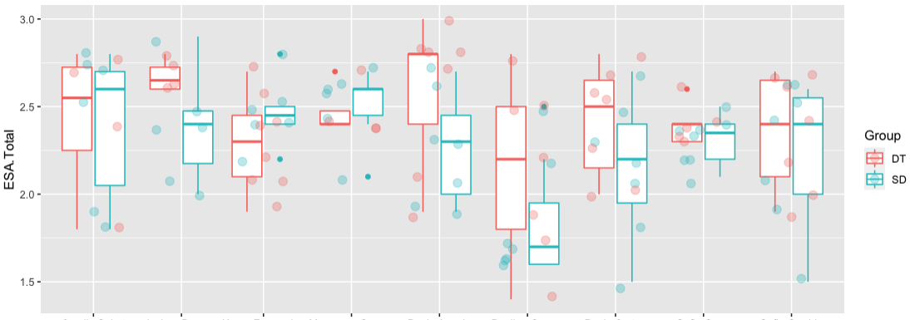
Figure 4. Total ESA score per judge (x axis) and group (Down syndrome [SD, in sky-blue] or typical development [DT, in red]) before re-ratings

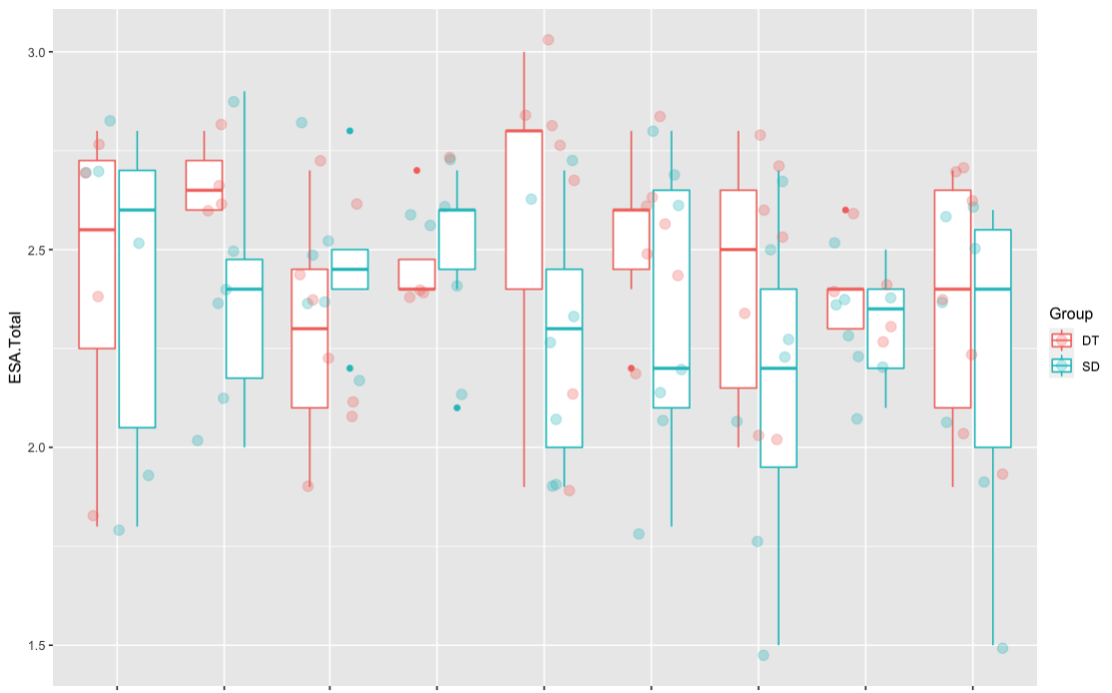

Figure 5. Total ESA score per judge (x axis) and group (Down syndrome [SD, in sky-blue] or typical development [DT, in red]) after re-ratings

Hypotheses 1 and 3a

Our first hypothesis stated that PCIs involving TswDS would exhibit similar levels of sensitivity yet higher levels of directivity, compared to their counterparts. This would be reflected by significant differences in the ESA F1—Empathetic Response —across groups. In a similar fashion, our hypothesis 3a predicted that maternal scores would be significantly higher than those corresponding to fathers.
To this end, two-way between-subjects ANOVAs were conducted to test the effects of group (DS/TD) and parent (mother/father) on the ESA total scores as well as each of its three Factors. In the case of the ESA total scores, a significant effect of toddler group was found (F_{(1,116)} = 6.116, p = 0.014) but not of the assessed parent (F_{(1, 116)} = 2.219, p = 0.138) nor the interaction between them (F_{(1,116)} = 0.41 p = 0.838). Results for F1 Empathetic Response also revealed a significant effect of toddler group (F_{(1,116)} = 9.937, p = 0.002) but not of the assessed parent (F_{(1, 116)} = 0.726, p = 0. 395), as well as no significant interaction effect between them (F_{(1,116)} = 0. 207 p = 0. 649).
A two-way between-subjects ANOVA was also conducted in order to test the effects of group (DS/TD) and parent (mother/father) on ESA Factor 2 Playful Interaction scores. Results revealed no significant effects of toddler group (F_{(1,116)} = 3.149, p = 0.078) or assessed parent (F_{(1, 116)} = 1.537, p = 0.217), as well as no significant interaction effect between them (F_{(1,116)} = 0.809, p = 0.370). Finally, an equivalent ANOVA was fitted for the ESA Factor 3 Emotional Expression with similar results: no significant effects of toddler group (F_{(1,116)} = 0.046, p = 0.83) or assessed parent (F_{(1, 116)} = 1.956, p = 0.164), as well as no significant interaction effect between them (F_{(1,116)} = 0.046, p = 0.83).

Hypotheses 2 and 3b

Our second hypothesis anticipated regression models confirming the predictive power of the ESA scale’s first factor— the one measuring directivity over adaptive development. Such predictive power was expected to be overall higher than that of factors 2 and 3. Furthermore— according to our third hypothesis, mother-child interactions were expected to better predict AB than father-child equivalents. The present section thus tests the predictive power of the ESA factor 1, first on the toddlers’ development (TADI dimensions) and then on their adaptive development (ABAS-II subscales). Finally, the same analyses are then repeated for ESA factors 2 and 3.

TADI dimensions. A multiple linear regression was calculated to predict the ABAS cognitive dimension based on the child’s group (TD/DS) and participating fathers’ Empathetic Response. A significant regression equation was found explaining 36.9% of the variance (F_{(2,57)} = 18.27, p < 0.001, R²_{Adjusted} = 0.369). Toddler’s predicted cognitive development was thus found to be equal to 5.765 + 4.563 (Group:TD) + 4.870 (fathers’ Empathetic Response) raw points (see Table 1 in the manuscript).
A different scenario was found when fitting an equivalent model, this time including maternal— instead of paternal — Empathetic Response. A significant regression equation was found (F_{(3,56)} = 13.43, p < 0.001, R²_{Adjusted} = 0.387). In this model, the Group and Empathetic Response predictors did not reach statistical significance (p = 0.96 and p = 0.533 respectively). Instead, a significant interaction effect between them was found (p = 0.012). In other words, while paternal Empathetic Response significantly and consistently predicted cognitive development— regardless of the group, maternal Empathetic Response only did so when it came to toddlers with typical development. This double interaction pattern is illustrated in Figure 2A, and applies to the models corresponding to the TADI Socioemotional and Motor dimensions.
The sole TADI dimension that exhibited an overall pattern different from the previously mentioned was Language (see Figure 2B). Significant regression equations were found for the mothers’ (F_{(3,56)} = 18.03, p < 0.001, adjusted R² = 0.464) and fathers’ (F_{(3,56)} = 16.55, p < 0.001, adjusted R² = 0.442) models. In this case, the aforementioned double interaction was not found, as a significant simple interaction effect between Group and Empathetic Response was evidenced in both maternal (p = 0.003) and paternal (p = 0.043) models.

ABAS-II subscales. Models corresponding to the ten subscales will hereby be grouped by composite. In the Conceptual Composite, the Communication and Functional Academic subscales exhibited the same double interaction pattern already illustrated in Figure 2A. Further details concerning these models can be found in the next section in Figure 7 and Table 7. In the case of the Self-Direction subscale, a new overall pattern was observed (see Figure 2C and Table 1 in the manuscript): while paternal Empathetic Response significantly predicted cognitive development across groups (p = 0.021), maternal Empathetic Response did not predict toddlers’ self-direction capacities at a significant level, regardless of the examined group (p = 0.362).
The Practical Composite returned two new patterns. Regarding the Community Use subscale, significant regression equations were found for the maternal (F_{(3,56)} = 11.54, p < 0.001, R²_{adjusted} = 0. 263) and paternal models (F_{(3,56)} = 13.27, p < 0.001, R²_{adjusted} = 0294), with both mothers’ (p = 0.019) and fathers’ (p = 0.005) Empathetic Response significantly predicting the subscale raw scores, regardless of the assessed group (Figure 2D and Table 1 in the manuscript). In terms of the Health & Safety subscale, significant regression equations were once again found for the mothers’ (F_{(3,56)} = 8.14, p < 0.001, R²_{adjusted} = 0. 266) and fathers’ (F_{(3,56)} = 9.437, p < 0.001, R²_{adjusted} = 0.222) models. This time a second, new type of double interaction pattern was evidenced. On the one hand, paternal Empathetic Response failed to significantly predict toddlers’ adaptive development across groups (p = 0.121). On the other hand, a significant interaction effect was found between the group and maternal Empathetic Response factors (p = 0.018), factors that failed to reach statistical significance independently. It should also be noted that, in this case, Health & Safety scores of TswDS decrease as maternal sensitivity rises (Figure 2E and Table 1 in the manuscript). Models corresponding to the Home Living and Self-Care subscales exhibited equivalent patterns to those of the Community Use and Health & Safety subscales respectively. For further details concerning all models in this paragraph, see Figure 8 and Table 8 in the next section.
In the Social Composite, the Social subscale models revealed the same double-interaction pattern that was first introduced (Figure 2A). Models corresponding to the Leisure subscale in turn presented a virtually similar pattern to those of the Community Use subscale and illustrated in Figure 2D, with maternal Empathetic Response significantly predicting adaptive leisure (p = 0.021) and paternal Empathetic Response also doing so albeit at a quasi-significant level (p = 0.051), regardless of the assessed group. Finally, the supplementary Motor subscale models displayed the same double-interaction pattern that already corresponded to the Communication, Functional Academic and Social subscales illustrated in Figure 2A. For further details concerning all models in this paragraph, see Figure 9 and Table 9 in the next section.
Results concerning the second ESA factor (Playful Interaction) systematically exhibited one out of two of the aforementioned patterns. In all but two of the assessed TADI dimensions and ABAS-II subscales, paternal— but not maternal — Playful Interaction proved significant across groups (Figure 2C). As an exception to this trend, in the case of the TADI dimension Language and ABAS-II subscale Communication both parents’ Playful Interaction significantly predicted (adaptive) development regardless of the assessed group (Figure 2D). All pertinent models can be found in detail in Figures 10 and 11, and Tables 10-13 in the next section.
In terms of the third ESA factor, on the exception of paternal sensitivity in the Communication ABAS-II subscale, no significant effects of Emotional Expression were found whatsoever (see Tables 14-16 in the next section).

Comprehensive list of linear models

The following section is structured as follows: ESA Factor 1 Empathetic response (Figures 6-9 and Tables 6- 9), ESA Factor 2 Playful Interaction (Figures 10 and 11, Tables 10-13) and ESA Factor 3 Emotional Expression (Tables 14-16).

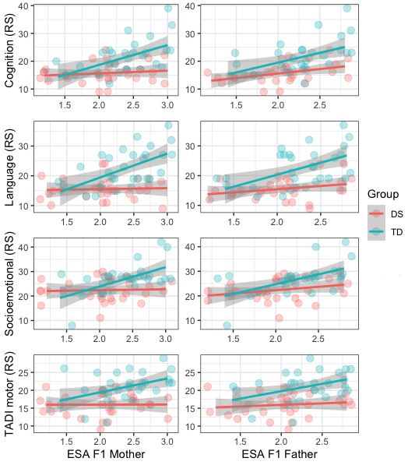

Figure 6. TADI Dimensions (raw score). Scatterplots displaying TADI Cognition, Language, Socioemotional and Motor dimensions’ raw scores (y axis) by group (Down syndrome [red] or typical development [sky-blue]). Each dot corresponds to a participating toddler and lines represent fitted linear regression models. In the left-hand side plot the x axis represents participating mothers’ ESA Factor 1 Empathetic Response scores, while in the right-hand side plot such an axis corresponds to their paternal counterparts.

 | TADI scales (RS)
 | Cognition |  |  |  | Language |  |  |  | Socioemotional |  |  |  | Motor
 | Mother |  | Father |  | Mother |  | Father |  | Mother |  | Father |  | Mother |  |  | Father
Predictors | Estimates | p | Estimates | p | Estimates | p | Estimates | p | Estimates | p | Estimates | p | Estimates | p |  | Estimates | p
(Intercept) | 13.71  (7.15 –  20.27) | <0.001 | 5.76  (-0.10 –  11.63) | 0.054 | 14.83  (8.14 –  21.51) | <0.001 | 11.17  (3.32 –  19.02) | 0.006 | 21.60  (14.51 –  28.68) | <0.001 | 12.16  (5.76 –  18.57) | <0.001 | 15.90  (10.74 –  21.06) | <0.001 |  | 11.32  (6.71 –  15.93) | <0.001
Group [TD] | -9.35  (-20.40 –  1.71) | 0.096 | 4.56  (2.17 –  6.96) | <0.001 | -11.41  (-22.68 –  -0.15) | 0.047 | -6.96  (-19.58 –  5.67) | 0.274 | -13.36  (-25.31 –  -1.41) | 0.029 | 3.33  (0.71 –  5.95) | 0.014 | -4.25  (-12.94 –  4.45) | 0.332 |  | 4.38  (2.50 –  6.27) | <0.001
ESA M F1 | 0.96  (-2.11 –  4.03) | 0.534 |  |  | 0.34  (-2.78 –  3.46) | 0.828 |  |  | 0.39  (-2.93 –  3.70) | 0.815 |  |  | 0.03  (-2.38 –  2.45) | 0.978
Group [TD] *  ESA M F1 | 6.19  (1.40 –  10.99) | 0.012 |  |  | 7.68  (2.79 –  12.56) | 0.003 |  |  | 7.45  (2.27 –  12.63) | 0.006 |  |  | 3.84  (0.07 –  7.61) | 0.046
ESA F F1 |  |  | 4.87  (2.11 –  7.63) | 0.001 |  |  | 2.14  (-1.62 –  5.90) | 0.260 |  |  | 5.02  (2.00 –  8.03) | 0.002 |  |  |  | 2.28  (0.11 –  4.45) | 0.040
Group [TD] *  ESA F F1 |  |  |  |  |  |  | 5.91  (0.20 –  11.63) | 0.043
Observations | 60 |  | 60 |  | 60 |  | 60 |  | 60 |  | 60 |  | 60 |  | 60
R² / R²adjusted | 0.418 / 0.387 |  | 0.391 / 0.369 |  | 0.491 / 0.464 |  | 0.470 / 0.442 |  | 0.340 / 0.304 |  | 0.293 / 0.268 |  | 0.399 / 0.366 |  | 0.370 / 0.348

Table 6. TADI Dimensions (raw score). Multiple linear regression models predicting the four TADI dimensions. Two models are displayed for each dimension, corresponding to the mothers’ (left) and fathers’ (right) sensitivity as measured by the ESA Factor 1 (Empathetic Response). Statistically significant p-values are displayed in bold font

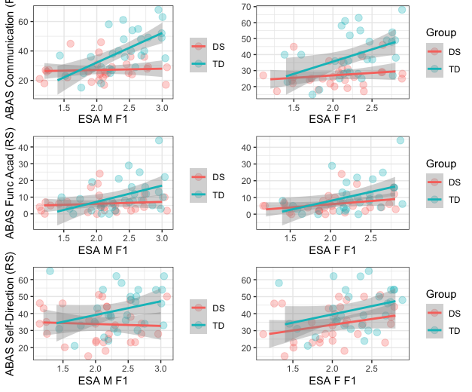
Figure 7. ABAS Conceptual Composite (RS). For interpretation, see Figure 6.

 | ABAS Conceptual Composite (RS)
 | Communication |  |  |  | Functional academic |  |  |  | Self-Direction
 | Mother |  | Father |  | Mother |  | Father |  | Mother |  | Father
Predictors | Estimates | p | Estimates | p | Estimates | p | Estimates | p | Estimates | p | Estimates | p
(Intercept) | 25.31  (11.56 –  39.05) | 0.001 | 10.01  (-3.84 –  23.87) | 0.153 | 3.66  (-7.51 –  14.82) | 0.514 | -7.84  (-17.68  – 2.00) | 0.116 | 28.29  (14.96 – 41.62) | <0.001 | 17.32  (2.95 – 31.69) | 0.019
Group [TD] | -33.40  (-56.56 –  -10.23) | 0.006 | 10.66  (5.00 – 16.33) | <0.001 | -15.91  (-34.72 –  2.91) | 0.096 | 3.18  (-0.84 –  7.21) | 0.119 | 7.64  (1.45 – 13.83) | 0.017 | 6.61  (0.73 – 12.48) | 0.028
ESA M F1 Empathetic  Response | 0.88  (-5.54 –  7.31) | 0.785 |  |  | 1.18  (-4.04 – 6.40) | 0.653 |  |  | 2.63  (-3.48 – 8.73) | 0.393
Group [TD] * ESA M F1  Empathetic Response | 19.23  (9.19 –  29.27) | <0.001 |  |  | 8.53  (0.38 – 16.69) | 0.041
ESA F F1 Empathetic  Response |  |  | 8.39  (1.87 – 14.91) | 0.013 |  |  | 6.83  (2.20 – 11.47) | 0.005 |  |  | 8.05  (1.28 – 14.81) | 0.021
Observations | 60 |  | 60 |  | 60 |  | 60 |  | 60 |  | 60
R² / R² adjusted | 0.496 / 0.469 |  | 0.328 / 0.304 |  | 0.220 / 0.178 |  | 0.205 / 0.177 |  | 0.135 / 0.105 |  | 0.203 / 0.175

Table 7. ABAS Conceptual Composite (RS). For interpretation see Table 6.

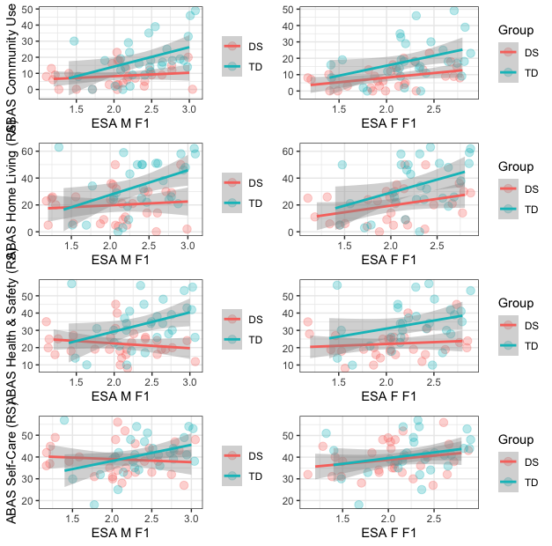
Figure 8. ABAS Practical Composite (RS). For interpretation, see Figure 6.

 | ABAS Practical Composite (RS)
 | Community Use |  |  |  | Home Living |  |  |  | Health & Safety |  |  |  | Self-Care
 | Mother |  | Father |  | Mother |  | Father |  | Mother |  | Father |  | Mother |  | Father
Predictors | Estimates | p | Estimates | p | Estimates | p | Estimates | p | Estimates | p | Estimates | p | Estimates | p | Estimates | p
(Intercept) | -4.44  (-15.67 –  6.79) | 0.432 | -8.90  (-21.25 –  3.46) | 0.155 | 0.96  (-17.82 –  19.74) | 0.919 | -8.78  (-29.22 –  11.65) | 0.393 | 28.01  (12.44 –  43.58) | 0.001 | 11.58  (-2.54 –  25.70) | 0.106 | 41.84  (30.08 –  53.61) | <0.001 | 29.79  (19.34 –  40.24) | <0.001
Group [TD] | 8.45  (3.24 –  13.67) | 0.002 | 8.41  (3.36 –  13.46) | 0.002 | 11.66  (2.93 –  20.38) | 0.010 | 11.24  (2.89 –  19.60) | 0.009 | -20.84  (-47.08 –  5.40) | 0.117 | 10.08  (4.31 –  15.85) | 0.001 | -18.51  (-38.34 –  1.33) | 0.067 | 1.02  (-3.25 –  5.29) | 0.635
ESA M F1 Empathetic  Response | 6.19  (1.05 –  11.34) | 0.019 |  |  | 9.15  (0.55 –  17.75) | 0.037 |  |  | -2.79  (-10.06 –  4.49) | 0.447 |  |  | -1.40  (-6.90 –  4.10) | 0.611
ESA F F1 Empathetic  Response |  |  | 8.48  (2.66 –  14.29) | 0.005 |  |  | 14.08  (4.46 –  23.70) | 0.005 |  |  | 5.22  (-1.43 –  11.87) | 0.121 |  |  | 4.48  (-0.44 –  9.40) | 0.073
Group [TD] * ESA M F1  Empathetic Response |  |  |  |  |  |  |  |  | 13.87  (2.49 –  25.24) | 0.018 |  |  | 8.82  (0.23 –  17.42) | 0.044
Observations | 60 |  | 60 |  | 60 |  | 60 |  | 60 |  | 60 |  | 60 |  | 60
R² / R² adjusted | 0.288 / 0.263 |  | 0.318 / 0.294 |  | 0.225 / 0.198 |  | 0.273 / 0.248 |  | 0.304 / 0.266 |  | 0.249 / 0.222 |  | 0.101 / 0.053 |  | 0.070 / 0.038

Table 8. ABAS Practical Composite (RS). For interpretation see Table 6.

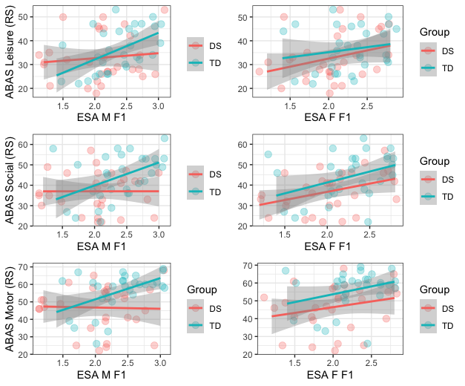
Figure 9. ABAS Social Composite and Motor (RS). For interpretation, see Figure 6.

 | ABAS Social Composite + Motor (RS)
 | Social |  |  |  | Leisure |  |  |  | Motor
 | Mother |  | Father |  | Mother |  | Father |  | Mother |  | Father
Predictors | Estimates | p | Estimates | p | Estimates | p | Estimates | p | Estimates | p | Estimates | p
(Intercept) | 37.00  (22.17 –  51.83) | <0.001 | 18.30  (5.53 –  31.06) | 0.006 | 20.73  (10.02 –  31.45) | <0.001 | 21.15  (8.95 –  33.35) | 0.001 | 48.18  (31.16 –  65.21) | <0.001 | 31.51  (16.37 –  46.64) | <0.001
Group [TD] | -19.72  (-44.71 –  5.28) | 0.120 | 5.02  (-0.20 –  10.24) | 0.059 | 1.77  (-3.21 –  6.75) | 0.480 | 2.24  (-2.75  –  7.23) | 0.372 | -21.03  (-49.72 –  7.66) | 0.148 | 7.65  (1.46 –  13.83) | 0.016
ESA Mother F1 | 0.02  (-6.92 –  6.95) | 0.996 |  |  | 5.82  (0.91 –  10.73) | 0.021 |  |  | -0.72  (-8.67 –  7.24) | 0.858
Group [TD] *  ESA Mother F1 | 11.28  (0.45 –  22.12) | 0.042 |  |  |  |  |  |  | 12.87  (0.43 –  25.30) | 0.043
ESA Father F1 |  |  | 9.18  (3.17 –  15.19) | 0.003 |  |  | 5.71  (-0.03 –  11.45) | 0.051 |  |  | 7.45  (0.32 –  14.57) | 0.041
Observations | 60 |  | 60 |  | 60 |  | 60 |  | 60 |  | 60
R² / R²adjusted | 0.211 / 0.169 |  | 0.233 / 0.206 |  | 0.121 / 0.090 |  | 0.097 / 0.065 |  | 0.228 / 0.186 |  | 0.199 / 0.171

Table 9. ABAS Social Composite + Motor (RS). For interpretation see Table 6.

ESA Factor 2. Playful Interaction

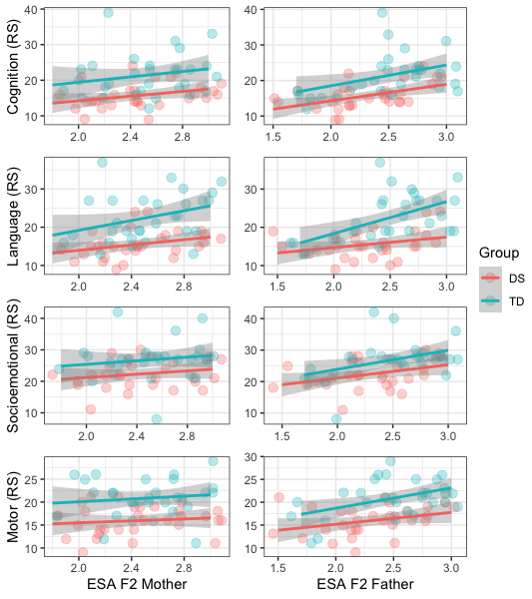

Figure 10. TADI Dimensions (raw score). For interpretation, see Figure 6.

 | Cognitive (RS) |  |  |  | Language (RS) |  |  |  | Socioemotional (RS) |  |  |  | Motor (RS)
 | Mother |  | Father |  | Mother |  | Father |  | Mother |  | Father |  | Mother |  | Father
Predictors | Estimates | p | Estimates | p | Estimates | p | Estimates | p | Estimates | p | Estimates | p | Estimates | p | Estimates | p
(Intercept) | 7.07  (2.1 –  16.2) | 0.128 | 3.48  (-3.36 –  10.32) | 0.313 | 3.62  (-5.66 –  12.91) | 0.438 | 2.28  (-4.75 –  9.31) | 0.519 | 15.64  (5.58 –  25.71) | 0.003 | 10.42  (2.87 –  17.97) | 0.008 | 12.84  (5.90 –  19.78) | <0.001 | 7.69  (2.54 –  12.85) | 0.004
Group [TD] | 5.46  (2.97  – 7.94) | <0.001 | 4.70  (2.34 – 7.05) | <0.001 | 6.64  (4.13 – 9.16) | <0.001 | 5.88  (3.46 – 8.30) | <0.001 | 4.30  (1.57 – 7.03) | 0.003 | 3.51  (0.91 – 6.12) | 0.009 | 4.82  (2.94 – 6.71) | <0.001 | 4.24  (2.47 –  6.02) | <0.001
ESA M F2 Playful  Interaction | 3.52  (0.15 –  7.19) | 0.060 |  |  | 4.86  (1.14 – 8.57) | 0.011 |  |  | 2.75  (-1.27 –  6.78) | 0.176 |  |  | 1.27  (-1.50 –  4.05) | 0.362
ESA F F2 Playful  Interaction |  |  | 5.30  (2.42 – 8.18) | 0.001 |  |  | 5.75  (2.79 – 8.71) | <0.001 |  |  | 5.19  (2.01 – 8.37) | 0.002 |  |  | 3.59  (1.42 –  5.76) | 0.002
Observations | 60 |  | 60 |  | 60 |  | 60 |  | 60 |  | 60 |  | 60 |  | 60
R² / R²adjusted | 0.302 / 0.278 |  | 0.400 / 0.379 |  | 0.397 / 0.376 |  | 0.466 / 0.447 |  | 0.182 / 0.154 |  | 0.289 / 0.264 |  | 0.331 / 0.308 |  | 0.431 / 0.411

Table 10. TADI dimensions (RS). Multiple linear regression models predicting the TADI dimensions. Two models are displayed for each dimension, corresponding to the mothers’ (left) and fathers’ (right) sensitivity as measured by the ESA Factor 2 (Playful Interaction). Statistically significant p-values are displayed in bold font
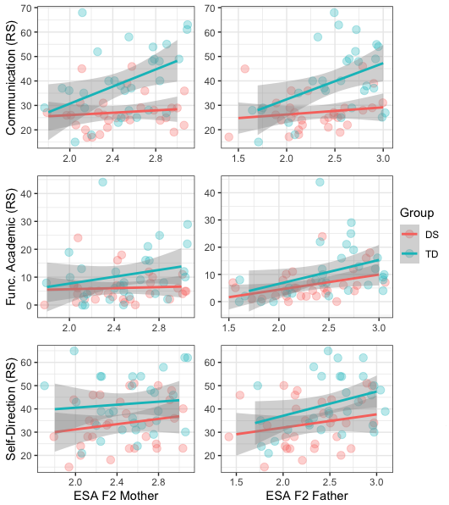

Figure 11. ABAS Conceptual Composite. For interpretation, see Figure 6.
 | ABAS Conceptual Composite (RS)
 | Communication |  |  |  | Functional academic |  |  |  | Self-Direction
 | Mother |  | Father |  | Mother |  | Father |  | Mother |  | Father
Predictors | Estimates | p | Estimates | p | Estimates | p | Estimates | p | Estimates | p | Estimates | p
(Intercept) | 3.71  (-16.73 –  24.15) | 0.718 | 5.66  (-10.52 –  21.84) | 0.487 | -2.20  (-17.49 –  13.08) | 0.774 | -10.66  (-22.22 –  0.89) | 0.070 | 22.68  (0.86 – 44.51) | 0.042 | 14.80  (-2.15 –  31.74) | 0.086
Group [TD] | 11.99  (6.45 –  17.53) | <0.001 | 10.86  (5.29 –  16.43) | <0.001 | 4.53  (0.39 – 8.67) | 0.033 | 3.40  (-0.58 – 7.38) | 0.092 | 8.16  (2.25 – 14.08) | 0.008 | 6.93  (1.09 – 12.76) | 0.021
ESA M F2 Playful  Interaction | 9.55  (1.37 –  17.73) | 0.023 |  |  | 3.38  (-2.73 –  9.50) | 0.273 |  |  | 4.50  (-4.23 –  13.24) | 0.306
ESA F F2 Playful  Interaction |  |  | 9.31  (2.50 –  16.12) | 0.008 |  |  | 7.27  (2.40 – 12.13) | 0.004 |  |  | 8.21  (1.07 – 15.35) | 0.025
Observations | 60 |  | 60 |  | 60 |  | 60 |  | 60 |  | 60
R² / R²adjusted | 0.315 / 0.291 |  | 0.337 / 0.314 |  | 0.102 / 0.071 |  | 0.207 / 0.180 |  | 0.140 / 0.110 |  | 0.199 / 0.170

Table 11. ABAS Conceptual composite. For interpretation see Table 6.

 | ABAS Practical Composite (RS)
 | Community Use |  |  | Home Living |  |  |  |  |  |  | Health & Safety |  |  |  |  |  | Self-Care
 | Mother |  | Father |  | Mother |  |  | Father |  |  | Mother |  |  | Father |  |  | Mother |  |  | Father
Predictors | Estimates | p | Estimates | p | Estimates | p |  | Estimates | p |  | Estimates | p |  | Estimates | p |  | Estimates | p |  | Estimates | p
(Intercept) | -0.17  (-19.39 –  19.05) | 0.986 | -11.93  (-26.48 –  2.63) | 0.106 | 10.10  (-21.82 –  42.03) | 0.529 |  | -13.80  (-37.88 –  10.27) | 0.256 |  | 22.76  (1.68 –  43.84) | 0.035 |  | 0.46  (-15.42 –  16.34) | 0.954 |  | 33.32  (17.68 –  48.96) | <0.001 |  | 26.22  (14.07 –  38.37) | <0.001
Group [TD] | 10.12  (4.91 –  15.33) | <0.001 | 8.72  (3.71 –  13.73) | 0.001 | 14.19  (5.54 –  22.85) | 0.002 |  | 11.75  (3.46 –  20.04) | 0.006 |  | 11.28  (5.57 –  16.99) | <0.001 |  | 9.54  (4.07 –  15.01) | 0.001 |  | 1.90  (-2.34 –  6.13) | 0.374 |  | 1.02  (-3.16 –  5.21) | 0.626
ESA M F2 Playful  Interaction | 3.49  (-4.20 –  11.19) | 0.367 |  |  | 4.01  (-8.77 –  16.78) | 0.533 |  |  |  |  | -0.22  (-8.65 –  8.22) | 0.959 |  |  |  |  | 2.29  (-3.97 –  8.54) | 0.467
ESA F F2 Playful  Interaction |  |  | 8.81  (2.68 –  14.94) | 0.006 |  |  |  | 14.63  (4.49 –  24.76) | 0.005 |  |  |  |  | 9.44  (2.75 –  16.13) | 0.006 |  |  |  |  | 5.51  (0.39 –  10.63) | 0.035
Observations | 60 |  | 60 | 60 |  |  | 60 |  |  | 60 |  |  | 60 |  |  | 60 |  |  | 60
R² / R²adjusted | 0.227 / 0.200 |  | 0.315 / 0.291 | 0.170 / 0.140 |  |  | 0.271 / 0.245 |  |  | 0.216 / 0.189 |  |  | 0.312 / 0.288 |  |  | 0.025 / -0.009 |  |  | 0.090 / 0.058

Table 12. ABAS Practical composite. For interpretation see Table 6.

 | ABAS Social Composite + Motor (RS)
 | Social |  |  |  | Leisure |  |  |  | Motor
 | Mother |  | Father |  | Mother |  | Father |  | Mother |  | Father
Predictors | Estimates | p | Estimates | p | Estimates | p | Estimates | p | Estimates | p | Estimates | p
(Intercept) | 18.10  (-1.37 –  37.58) | 0.068 | 10.90  (-3.64 –  25.44) | 0.139 | 25.26  (6.93 –  43.59) | 0.008 | 18.79  (4.46 –  33.13) | 0.011 | 35.36  (12.61 –  58.11) | 0.003 | 12.03  (-3.82 –  27.88) | 0.134
Group [TD] | 6.64  (1.36 –  11.92) | 0.015 | 5.02  (0.02 –  10.03) | 0.049 | 3.35  (-1.62 –  8.32) | 0.182 | 2.42  (-2.52 –  7.36) | 0.330 | 9.06  (2.89 –  15.22) | 0.005 | 6.58  (1.12 –  12.04) | 0.019
ESA M F2 Playful  Interaction | 7.72  (-0.08 –  15.51) | 0.052 |  |  | 3.07  (-4.26 –  10.41) | 0.405 |  |  | 4.62  (-4.48 –  13.72) | 0.313
ESA F F2 Playful  Interaction |  |  | 11.33  (5.21 –  17.45) | <0.001 |  |  | 6.07  (0.04 –  12.11) | 0.049 |  |  | 15.03  (8.35 –  21.71) | <0.001
Observations | 60 |  | 60 |  | 60 |  | 60 |  | 60 |  | 60
R² / R²adjusted | 0.165 / 0.135 |  | 0.280 / 0.255 |  | 0.046 / 0.013 |  | 0.098 / 0.067 |  | 0.153 / 0.123 |  | 0.364 / 0.342

Table 13. ABAS Social composite and motor subscale. For interpretation see Table 6.

ESA Factor 3. Emotional Expression

 | ABAS Conceptual Composite (RS)
 | Communication |  |  |  | Functional academic |  |  |  | Self-Direction
 | Mother |  | Father |  | Mother |  | Father |  | Mother |  | Father
Predictors | Estimates | p | Estimates | p | Estimates | p | Estimates | p | Estimates | p | Estimates | p
(Intercept) | 26.71  (4.16 – 49.25) | 0.021 | 3.85  (-17.47 – 25.17) | 0.719 | 9.94  (-6.30 – 26.19) | 0.225 | -1.62  (-17.54 – 14.29) | 0.839 | 34.83  (11.62 – 58.04) | 0.004 | 33.32  (10.44 – 56.20) | 0.005
Group [TD] | 12.57  (6.79 – 18.35) | <0.001 | 12.57  (7.03 – 18.11) | <0.001 | 4.69  (0.53 – 8.86) | 0.028 | 4.73  (0.60 – 8.87) | 0.026 | 8.42  (2.47 – 14.37) | 0.006 | 8.43  (2.49 – 14.38) | 0.006
ESA M F3 Emotional  Expression | 0.16  (-8.39 – 8.71) | 0.969 |  |  | -1.48  (-7.64 – 4.68) | 0.632 |  |  | -0.42  (-9.22 – 8.38) | 0.924
ESA F F3 Emotional  Expression |  |  | 9.34  (0.93 – 17.74) | 0.030 |  |  | 3.10  (-3.18 – 9.37) | 0.327 |  |  | 0.17  (-8.86 – 9.19) | 0.971
Observations | 60 |  | 60 |  | 60 |  | 60 |  | 60 |  | 60
R² / R²adjusted | 0.250 / 0.224 |  | 0.310 / 0.286 |  | 0.087 / 0.055 |  | 0.099 / 0.067 |  | 0.124 / 0.093 |  | 0.124 / 0.093

Table 14. ABAS conceptual composite. For interpretation see Table 6.

 | ABAS Practical Composite (RS)
 | Community Use |  |  |  | Home Living |  |  |  | Health & Safety |  |  |  | Self-Care
 | Mother |  | Father |  | Mother |  | Father |  | Mother |  | Father |  | Mother |  | Father
Predictors | Estimates | p | Estimates | p | Estimates | p | Estimates | p | Estimates | p | Estimates | p | Estimates | p | Estimates | p
(Intercept) | 12.11  (-8.27 –  32.49) | 0.239 | 6.86  (-13.25 –  26.97) | 0.497 | 17.53  (-16.23 –  51.28) | 0.303 | 21.56  (-11.73 –  54.84) | 0.200 | 35.74  (13.83 –  57.65) | 0.002 | 19.27  (-2.61 –  41.15) | 0.083 | 47.13  (30.72 –  63.54) | <0.001 | 42.65  (26.36 –  58.94) | <0.001
Group [TD] | 10.30  (5.07 –  15.52) | <0.001 | 10.33  (5.11 –  15.56) | <0.001 | 14.46  (5.80 –  23.11) | 0.001 | 14.43  (5.78 –  23.08) | 0.001 | 11.13  (5.51 –  16.75) | <0.001 | 11.27  (5.58 –  16.95) | <0.001 | 1.95  (-2.26 –  6.16) | 0.358 | 2.03  (-2.20 –  6.27) | 0.340
ESA M F3 Emotional  Expression | -1.43  (-9.16  –  6.30) | 0.712 |  |  | 0.93  (-11.87 –  13.73) | 0.885 |  |  | -5.21  (-13.52 –  3.10) | 0.215 |  |  | -3.16  (-9.39 –  3.06) | 0.313
ESA F F3 Emotional  Expression |  |  | 0.62  (-7.31 –  8.55) | 0.877 |  |  | -0.65  (-13.77 –  12.47) | 0.921 |  |  | 1.19  (-7.44 –  9.82) | 0.784 |  |  | -1.49  (-7.91 –  4.93) | 0.644
Observations | 60 |  | 60 |  | 60 |  | 60 |  | 60 |  | 60 |  | 60 |  | 60
R² / R²adjusted | 0.218 / 0.190 |  | 0.216 / 0.188 |  | 0.164 / 0.135 |  | 0.164 / 0.135 |  | 0.237 / 0.210 |  | 0.217 / 0.190 |  | 0.033 / -0.000 |  | 0.020 / -0.015

Table 15. ABAS Practical composite. For interpretation see Table 6.
 | ABAS Social Composite + Motor (RS)
 | Social |  |  |  | Leisure |  |  |  | Motor
 | Mother |  | Father |  | Mother |  | Father |  | Mother |  | Father
Predictors | Estimates | p | Estimates | p | Estimates | p | Estimates | p | Estimates | p | Estimates | p
(Intercept) | 27.51  (6.45 –  48.57) | 0.011 | 27.80  (7.03 –  48.57) | 0.010 | 26.78  (7.41 – 46.15) | 0.008 | 31.57  (12.41 – 50.72) | 0.002 | 58.83  (34.87 – 82.80) | <0.001 | 41.98  (18.17 – 65.79) | 0.001
Group [TD] | 7.20  (1.80 –  12.60) | 0.010 | 7.10  (1.70 –  12.50) | 0.011 | 3.60  (-1.37 – 8.56) | 0.153 | 3.53  (-1.44 – 8.51) | 0.161 | 9.21  (3.06 – 15.35) | 0.004 | 9.33  (3.15 – 15.52) | 0.004
ESA M F3 Emotional  Expression | 3.67  (-4.31 –  11.66) | 0.361 |  |  | 2.32  (-5.02 – 9.67) | 0.529 |  |  | -4.68  (-13.77 – 4.41) | 0.307
ESA F F3 Emotional  Expression |  |  | 3.70  (-4.49 –  11.89) | 0.369 |  |  | 0.50  (-7.06 – 8.05) | 0.896 |  |  | 1.89  (-7.49 – 11.28) | 0.688
Observations | 60 |  | 60 |  | 60 |  | 60 |  | 60 |  | 60
R² / R²adjusted | 0.120 / 0.089 |  | 0.120 / 0.089 |  | 0.041 / 0.007 |  | 0.035 / 0.001 |  | 0.153 / 0.124 |  | 0.140 / 0.110

Table 16. ABAS Social composite and Motor subscales. For interpretation see Table 6.

