Supplemental Table 1. Summary of major algorithms used for signal detection
Algorithm | Equation | Standard
ROR | $$ROR=\frac{\left(\frac{a}{c}\right)}{\left(\frac{b}{d}\right)}=\frac{ad}{bc}$$  $$95\%CI=e^{ln⁡(ROR)±1.96{\left(\frac{1}{a}+\frac{1}{b}+\frac{1}{c}+\frac{1}{d}\right)}^{0.5}}$$ | 95%CI＞1；N≥2；
PRR | $$PRR=\frac{a/(a+b)}{c/(c+d)}$$  $$95\%CI=e^{ln⁡(ROR)±1.96{\left(\frac{1}{a}+\frac{1}{b}+\frac{1}{c}+\frac{1}{d}\right)}^{0.5}}$$ | 95%CI＞1；N≥2；
MGPS | $$EBGM=\frac{a(a+b+c+d)}{(a+c)(b+d)}$$  $$90\%EBGM=e^{ln⁡(EBGM)−1.64{\left(\frac{1}{a}+\frac{1}{b}+\frac{1}{c}+\frac{1}{d}\right)}^{0.5}}$$ | 90%EBGM＞1
CI:confidence interval; EBGM:empirical Bayesian geometric mean

Supplemental Table 2. 2×2 Contingency table for disproportionality analysis.
 | Target Adverse Event | All other Adverse Event | Total
Target drug | a | b | a+b
All other drugs | c | d | c+d
Total | a+c | b+d | a+b+c+d
a is the number of reports containing both the target drug and the target adverse event; b is the number of reports containing the target drug with other adverse events; c is the number of reports containing the target adverse event with other drugs; d is the number of reports containing other drugs and other adverse events.

Supplemental table 3. Treatment outcomes of S1PR modulators
 | Fingolimod | Siponimod | Ozanimod | Ponesimod
Death | 1,142 | 126 | 46 | 0
Disability | 1,276 | 57 | 69 | 1
Hospitalization | 11,168 | 881 | 404 | 12
Life-threatening | 1,195 | 55 | 38 | 1
Deficiency | 916 | 0 | 1 | 0
Permanent defect | 26 | 3 | 0 | 0
Other | 33,105 | 1,942 | 1,024 | 49

Supplemental table 4. Usage of S1PR modulators in different indications
Indications | P
Relapsing multiple sclerosis patient group VS Other groups | 0.8644 ＞ 0.05
Non-immune disease VS Immune system disease | 0.1975 ＞ 0.05
COVID-19 patients VS Non COVID-19 patients | 0.9605 ＞ 0.05

Supplemental table 5. Differences in demographic and clinical characteristics between the two groups
Name | levels | Other Risks (N=1433) | Severe Risks (N=272) | p
SEX | female | 414 (28.9%) | 84 (30.9%) | 0.555
 | male | 1019 (71.1%) | 188 (69.1%)
WT | Mean ± SD | 73.5 ± 22.7 | 71.1 ± 21.6 | 0.102
AGE | Mean ± SD | 44.4 ± 13.4 | 46.2 ± 12.3 | 0.034
Vitamin | no | 1151 (80.3%) | 209 (76.8%) | 0.219
 | yes | 282 (19.7%) | 63 (23.2%)
Antidepressant | no | 1235 (86.2%) | 236 (86.8%) | 0.873
 | yes | 198 (13.8%) | 36 (13.2%)
Corticosteroids | no | 1252 (87.4%) | 236 (86.8%) | 0.861
 | yes | 181 (12.6%) | 36 (13.2%)
Benzodiazepine | no | 1249 (87.2%) | 246 (90.4%) | 0.159
 | yes | 184 (12.8%) | 26 (9.6%)
Muscle Relaxants | no | 1241 (86.6%) | 239 (87.9%) | 0.640
 | yes | 192 (13.4%) | 33 (12.1%)
Antiepileptic Drug | no | 1265 (88.3%) | 248 (91.2%) | 0.200
 | yes | 168 (11.7%) | 24 (8.8%)
PPI | no | 1275 (89%) | 239 (87.9%) | 0.670
 | yes | 158 (11%) | 33 (12.1%)
Antipyretic Analgesic | no | 1284 (89.6%) | 244 (89.7%) | 1.000
 | yes | 149 (10.4%) | 28 (10.3%)
PCBs | no | 1311 (91.5%) | 259 (95.2%) | 0.049
 | yes | 122 (8.5%) | 13 (4.8%)
Urinary Syste Drugs | no | 1342 (93.6%) | 251 (92.3%) | 0.482
 | yes | 91 (6.4%) | 21 (7.7%)
Thyroid Preparations | no | 1346 (93.9%) | 244 (89.7%) | 0.016
 | yes | 87 (6.1%) | 28 (10.3%)
Monocloning Antibody | no | 1371 (95.7%) | 246 (90.4%) | <0.001
 | yes | 62 (4.3%) | 26 (9.6%)
Propionic Acid Derivative | no | 1346 (93.9%) | 260 (95.6%) | 0.352
 | yes | 87 (6.1%) | 12 (4.4%)
Acylanilides | no | 1346 (93.9%) | 258 (94.9%) | 0.651
 | yes | 87 (6.1%) | 14 (5.1%)
SSRIs | no | 1357 (94.7%) | 252 (92.6%) | 0.230
 | yes | 76 (5.3%) | 20 (7.4%)
HMG CoA Reductase Inhibitors | no | 1353 (94.4%) | 258 (94.9%) | 0.886
 | yes | 80 (5.6%) | 14 (5.1%)
Antihistamine | no | 1368 (95.5%) | 261 (96%) | 0.841
 | yes | 65 (4.5%) | 11 (4%)
CCB | no | 1353 (94.4%) | 257 (94.5%) | 1.000
 | yes | 80 (5.6%) | 15 (5.5%)
Interferons | no | 1362 (95%) | 266 (97.8%) | 0.065
 | yes | 71 (5%) | 6 (2.2%)
Medications For Treating Constipation | no | 1382 (96.4%) | 258 (94.9%) | 0.280
 | yes | 51 (3.6%) | 14 (5.1%)
Surgical And Medical Procedures | no | 896 (62.5%) | 166 (61%) | 0.690
 | yes | 537 (37.5%) | 106 (39%)
Nervous System Disorders | no | 113 (7.9%) | 27 (9.9%) | 0.316
 | yes | 1320 (92.1%) | 245 (90.1%)
Psychiatric Disorders | no | 1191 (83.1%) | 235 (86.4%) | 0.210
 | yes | 242 (16.9%) | 37 (13.6%)
Gastrointestinal Disorders | no | 1286 (89.7%) | 251 (92.3%) | 0.239
 | yes | 147 (10.3%) | 21 (7.7%)
General Disorders And Administration Site Conditions | no | 1269 (88.6%) | 248 (91.2%) | 0.246
 | yes | 164 (11.4%) | 24 (8.8%)
Vascular Disorders | no | 1316 (91.8%) | 249 (91.5%) | 0.968
 | yes | 117 (8.2%) | 23 (8.5%)
Metabolism And Nutrition Disorders | no | 1320 (92.1%) | 254 (93.4%) | 0.551
 | yes | 113 (7.9%) | 18 (6.6%)
Musculoskeletal And Connective Tissue Disorders | no | 1335 (93.2%) | 258 (94.9%) | 0.369
 | yes | 98 (6.8%) | 14 (5.1%)
Infections And Infestations | no | 1368 (95.5%) | 264 (97.1%) | 0.304
 | yes | 65 (4.5%) | 8 (2.9%)
Renal And Urinary Disorders | no | 1374 (95.9%) | 255 (93.8%) | 0.161
 | yes | 59 (4.1%) | 17 (6.2%)
Investigations | no | 1388 (96.9%) | 265 (97.4%) | 0.760
 | yes | 45 (3.1%) | 7 (2.6%)
Respiratory Thoracic And Mediastinal Disorders | no | 1398 (97.6%) | 268 (98.5%) | 0.446
 | yes | 35 (2.4%) | 4 (1.5%)
Endocrine Disorders | no | 1390 (97%) | 257 (94.5%) | 0.056
 | yes | 43 (3%) | 15 (5.5%)
Injury Poisoning And Procedural Complications | no | 1414 (98.7%) | 271 (99.6%) | 0.299
 | yes | 19 (1.3%) | 1 (0.4%)
Skin And Subcutaneous Tissue Disorders | no | 1409 (98.3%) | 271 (99.6%) | 0.171
 | yes | 24 (1.7%) | 1 (0.4%)
Neoplasms Benign Malignant And Unspecified | no | 1430 (99.8%) | 270 (99.3%) | 0.390
 | yes | 3 (0.2%) | 2 (0.7%)
Cardiac Disorders | no | 1422 (99.2%) | 270 (99.3%) | 1.000
 | yes | 11 (0.8%) | 2 (0.7%)
Immune System Disorders | no | 1415 (98.7%) | 268 (98.5%) | 1.000
 | yes | 18 (1.3%) | 4 (1.5%)
Blood And Lymphatic System Disorders | no | 1415 (98.7%) | 270 (99.3%) | 0.671
 | yes | 18 (1.3%) | 2 (0.7%)
Eye Disorders | no | 1416 (98.8%) | 271 (99.6%) | 0.375
 | yes | 17 (1.2%) | 1 (0.4%)
Hepatobiliary Disorders | no | 1423 (99.3%) | 270 (99.3%) | 1.000
 | yes | 10 (0.7%) | 2 (0.7%)
Reproductive System And Breast Disorders | no | 1419 (99%) | 271 (99.6%) | 0.527
 | yes | 14 (1%) | 1 (0.4%)
Ear And Labyrinth Disorders | no | 1423 (99.3%) | 270 (99.3%) | 1.000
 | yes | 10 (0.7%) | 2 (0.7%)
Pregnancy Puerperium And Perinatal Conditions | no | 1430 (99.8%) | 272 (100%) | 1.000
 | yes | 3 (0.2%) | 0 (0%)
Social Circumstances | no | 1429 (99.7%) | 272 (100%) | 0.850
 | yes | 4 (0.3%) | 0 (0%)
Congenital Familial And Genetic Disorders | no | 1431 (99.9%) | 272 (100%) | 1.000
 | yes | 2 (0.1%) | 0 (0%)

Supplemental Table 6. Baseline characteristics of the patients within the training and internal validation sets.
Name | desc | Other risks (N=1433) | Severe risk (N=272) | id | OR (univariable) | OR (final)
SEX | female | 414 (28.9%) | 84 (30.9%) | SEX female
 | male | 1019 (71.1%) | 188 (69.1%) | SEX male | 0.91(0.69-1.20, p=0.508)
WT | Mean ± SD | 73.5 ± 22.7 | 71.1 ± 21.6 | WT | 1.00(0.99-1.00, p=0.102) | 0.99(0.99-1.00, p=0.024)
AGE | Mean ± SD | 44.4 ± 13.4 | 46.2 ± 12.3 | AGE | 1.01(1.00-1.02, p=0.034) | 1.02(1.01-1.03, p=0.004)
Vitamin | no | 1151 (80.3%) | 209 (76.8%) | Vitamin no
 | yes | 282 (19.7%) | 63 (23.2%) | Vitamin yes | 1.23(0.90-1.68, p=0.191) | 1.36(0.98-1.89, p=0.070)
Antidepressant | no | 1235 (86.2%) | 236 (86.8%) | Antidepressant no
 | yes | 198 (13.8%) | 36 (13.2%) | Antidepressant yes | 0.95(0.65-1.39, p=0.798)
Corticosteroids | no | 1252 (87.4%) | 236 (86.8%) | Corticosteroids no
 | yes | 181 (12.6%) | 36 (13.2%) | Corticosteroids yes | 1.06(0.72-1.55, p=0.784)
Benzodiazepine | no | 1249 (87.2%) | 246 (90.4%) | Benzodiazepie no
 | yes | 184 (12.8%) | 26 (9.6%) | Benzodiazepie yes | 0.72(0.47-1.11, p=0.133) | 0.59(0.37-0.94, p=0.027)
Muscle relaxants | no | 1241 (86.6%) | 239 (87.9%) | Muscle relaxants no
 | yes | 192 (13.4%) | 33 (12.1%) | Muscle relaxants yes | 0.89(0.60-1.32, p=0.572)
Antiepileptic drugs | no | 1265 (88.3%) | 248 (91.2%) | Antiepileptic drugs no
 | yes | 168 (11.7%) | 24 (8.8%) | Antiepileptic drugs yes | 0.73(0.47-1.14, p=0.167)
PPI | no | 1275 (89%) | 239 (87.9%) | PPI no
 | yes | 158 (11%) | 33 (12.1%) | PPI yes | 1.11(0.75-1.66, p=0.596)
Antipyretic analgesic | no | 1284 (89.6%) | 244 (89.7%) | Antipyretic analgesic no
 | yes | 149 (10.4%) | 28 (10.3%) | Antipyretic analgesic yes | 0.99(0.65-1.51, p=0.959)
PCBs | no | 1311 (91.5%) | 259 (95.2%) | PCBs no
 | yes | 122 (8.5%) | 13 (4.8%) | PCBs yes | 0.54(0.30-0.97, p=0.039) | 0.43(0.23-0.79, p=0.006)
Urinary syste drugs | no | 1342 (93.6%) | 251 (92.3%) | Urinary syste drugs no
 | yes | 91 (6.4%) | 21 (7.7%) | Urinary syste drugs yes | 1.23(0.75-2.02, p=0.404)
Thyroid preparations | no | 1346 (93.9%) | 244 (89.7%) | Thyroid preparations no
 | yes | 87 (6.1%) | 28 (10.3%) | Thyroid preparations yes | 1.78(1.14-2.78, p=0.012) | 1.80(1.13-2.85, p=0.013)
Monocloning antibody | no | 1371 (95.7%) | 246 (90.4%) | Monocloning antibody no
 | yes | 62 (4.3%) | 26 (9.6%) | Monocloning antibody yes | 2.34(1.45-3.77, p<0.001) | 2.76(1.68-4.52, p<0.001)
Propionic acid derivative | no | 1346 (93.9%) | 260 (95.6%) | Propionic acid derivative no
 | yes | 87 (6.1%) | 12 (4.4%) | Propionic acid derivative yes | 0.71(0.38-1.32, p=0.285)
Acylanilides | no | 1346 (93.9%) | 258 (94.9%) | Acylanilides no
 | yes | 87 (6.1%) | 14 (5.1%) | Acylanilides yes | 0.84 (0.47-1.50, p=0.554)
SSRIs | no | 1357 (94.7%) | 252 (92.6%) | SSRIs no
 | yes | 76 (5.3%) | 20 (7.4%) | SSRIs yes | 1.42(0.85-2.36, p=0.181)
HMG CoA reductase inhibitors | no | 1353 (94.4%) | 258 (94.9%) | HMG CoA reductase inhibitors no
 | yes | 80 (5.6%) | 14 (5.1%) | HMG CoA reductase inhibitors yes | 0.92(0.51-1.64, p=0.773)
Antihistamine | no | 1368 (95.5%) | 261 (96%) | Antihistamine no
 | yes | 65 (4.5%) | 11 (4%) | Antihistamine yes | 0.89(0.46-1.70, p=0.719)
CCB | no | 1353 (94.4%) | 257 (94.5%) | CCB no
 | yes | 80 (5.6%) | 15 (5.5%) | CCB yes | 0.99(0.56-1.74, p=0.964)
Interferons | no | 1362 (95%) | 266 (97.8%) | Interferons no
 | yes | 71 (5%) | 6 (2.2%) | Interferons yes | 0.43(0.19-1.01, p=0.051) | 0.44(0.18-1.03, p=0.059)
Medications for treating constipation | no | 1382 (96.4%) | 258 (94.9%) | Medications for treating constipation no
 | yes | 51 (3.6%) | 14 (5.1%) | Medications for treating constipation yes | 1.47(0.80-2.70, p=0.212)
Surgical and medical procedures | no | 896 (62.5%) | 166 (61%) | Surgical and medical procedures no
 | yes | 537 (37.5%) | 106 (39%) | Surgical and medical procedures yes | 1.07(0.82-1.39, p=0.641)
Nervous system disorders | no | 113 (7.9%) | 27 (9.9%) | Nervous system disorders no
 | yes | 1320 (92.1%) | 245 (90.1%) | Nervous system disorders yes | 0.78(0.50-1.21, p=0.262)
Psychiatric disorders | no | 1191 (83.1%) | 235 (86.4%) | Psychiatric disorders no
 | yes | 242 (16.9%) | 37 (13.6%) | Psychiatric disorders yes | 0.77(0.53-1.13, p=0.180)
Gastrointestinal disorders | no | 1286 (89.7%) | 251 (92.3%) | Gastrointestinal disorders no
 | yes | 147 (10.3%) | 21 (7.7%) | Gastrointestinal disorders yes | 0.73(0.45-1.18, p=0.200) | 0.70(0.43-1.16, p=0.166)
General disorders and administration site conditions | no | 1269 (88.6%) | 248 (91.2%) | General disorders and administration site conditions no
 | yes | 164 (11.4%) | 24 (8.8%) | General disorders and administration site conditions yes | 0.75(0.48-1.17, p=0.207)
Vascular disorders | no | 1316 (91.8%) | 249 (91.5%) | Vascular disorders no
 | yes | 117 (8.2%) | 23 (8.5%) | Vascular disorders yes | 1.04(0.65-1.66, p=0.873)
Metabolism and nutrition disorders | no | 1320 (92.1%) | 254 (93.4%) | Metabolism and nutrition disorders no
 | yes | 113 (7.9%) | 18 (6.6%) | Metabolism and nutrition disorders yes | 0.83(0.49-1.39, p=0.472)
Musculoskeletal and connective tissue disorders | no | 1335 (93.2%) | 258 (94.9%) | Musculoskeletal and connective tissue disorders no
 | yes | 98 (6.8%) | 14 (5.1%) | Musculoskeletal and connective tissue disorders yes | 0.74(0.42-1.31, p=0.303)
Infections and infestations | no | 1368 (95.5%) | 264 (97.1%) | Infections and infestations no
 | yes | 65 (4.5%) | 8 (2.9%) | Infections and infestations yes | 0.64(0.30-1.34, p=0.237)
Renal and urinary disorders | no | 1374 (95.9%) | 255 (93.8%) | Renal and urinary disorders no
 | yes | 59 (4.1%) | 17 (6.2%) | Renal and urinary disorders yes | 1.55(0.89-2.71, p=0.121) | 1.72(0.96-3.07, p=0.067)
Investigations | no | 1388 (96.9%) | 265 (97.4%) | Investigations no
 | yes | 45 (3.1%) | 7 (2.6%) | Investigations yes | 0.81(0.36-1.83, p=0.619)
Respiratory thoracic and mediastinal disorders | no | 1398 (97.6%) | 268 (98.5%) | Respiratory thoracic and mediastinal disorders no
 | yes | 35 (2.4%) | 4 (1.5%) | Respiratory thoracic and mediastinal disorders yes | 0.60(0.21-1.69, p=0.331)
Endocrine disorders | no | 1390 (97%) | 257 (94.5%) | Endocrine disorders no
 | yes | 43 (3%) | 15 (5.5%) | Endocrine disorders yes | 1.89(1.03-3.45, p=0.039)
Injury poisoning and procedural complications | no | 1414 (98.7%) | 271 (99.6%) | Injury poisoning and procedural complications no
 | yes | 19 (1.3%) | 1 (0.4%) | Injury poisoning and procedural complications yes | 0.27(0.04-2.06, p=0.209)
Skin and subcutaneous tissue disorders | no | 1409 (98.3%) | 271 (99.6%) | Skin and subcutaneous tissue disorders no
 | yes | 24 (1.7%) | 1 (0.4%) | Skin and subcutaneous tissue disorders yes | 0.22(0.03-1.61, p=0.135) | 0.20(0.03-1.52, p=0.120)
Neoplasms benign malignant and unspecified | no | 1430 (99.8%) | 270 (99.3%) | Neoplasms benign malignant and unspecified no
 | yes | 3 (0.2%) | 2 (0.7%) | Neoplasms benign malignant and unspecified yes | 3.53(0.59-21.23, p=0.168)
Cardiac disorders | no | 1422 (99.2%) | 270 (99.3%) | Cardiac disorders no
 | yes | 11 (0.8%) | 2 (0.7%) | Cardiac disorders yes | 0.96(0.21-4.34, p=0.955)
Immune system disorders | no | 1415 (98.7%) | 268 (98.5%) | Immune system disorders no
 | yes | 18 (1.3%) | 4 (1.5%) | Immune system disoders yes | 1.17(0.39-3.49, p=0.774)
Blood and lymphatic system disorders | no | 1415 (98.7%) | 270 (99.3%) | Blood and lymphatic system disorders no
 | yes | 18 (1.3%) | 2 (0.7%) | Blood and lymphatic system disorders yes | 0.58(0.13-2.52, p=0.470)
Eye disorders | no | 1416 (98.8%) | 271 (99.6%) | Eye disorders no
 | yes | 17 (1.2%) | 1 (0.4%) | Eye disorders yes | 0.31(0.04-2.32, p=0.253)
Hepatobiliary disorders | no | 1423 (99.3%) | 270 (99.3%) | Hepatobiliary  disorders no
 | yes | 10 (0.7%) | 2 (0.7%) | Hepatobiliary  disorders yes | 1.05(0.23-4.84, p=0.946)
Reproductive  system and breast disorders | no | 1419 (99%) | 271 (99.6%) | Reproductive system and breast disorders no
 | yes | 14 (1%) | 1 (0.4%) | Reproductive system and breast disorders yes | 0.37(0.05-2.86, p=0.343)
Ear and labyrinth disorders | no | 1423 (99.3%) | 270 (99.3%) | Ear and labyrinth disorders no
 | yes | 10 (0.7%) | 2 (0.7%) | Ear and labyrinth disorders yes | 1.05(0.23-4.84, p=0.946)
Pregnancy puerperium and perinatal conditions | no | 1430 (99.8%) | 272 (100%) | Pregnancy puerperium and perinatal conditions no
 | yes | 3 (0.2%) | 0 (0%) | Pregnancy puerperium and perinatal conditions yes | 0.00 (p=0.969)
Social circumstances | no | 1429 (99.7%) | 272 (100%) | Social circumstances no
 | yes | 4 (0.3%) | 0 (0%) | Social circumstances yes | 0.00 (p=0.977)
Congenital familial and genetic disorders | no | 1431 (99.9%) | 272 (100%) | Congenital familial and genetic disorders no
 | yes | 2 (0.1%) | 0 (0%) | Congenital familial and genetic disorders yes | 0.00 (p=0.975)

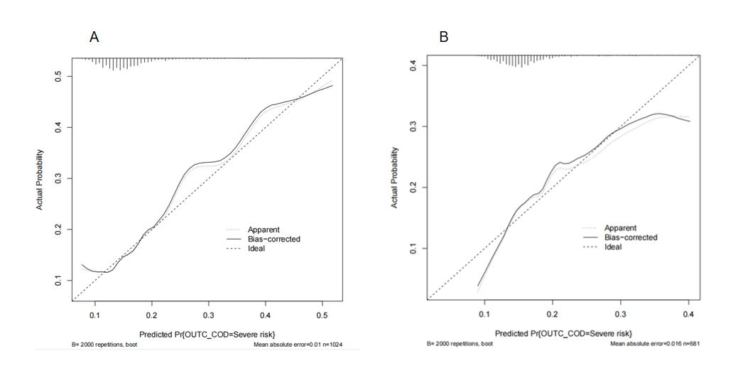
Supplemental Figure 1. The calibration curve of the column chart to predict the risk of death. (A) The calibration curve of the training set, (B) the calibration curve of the validation set.

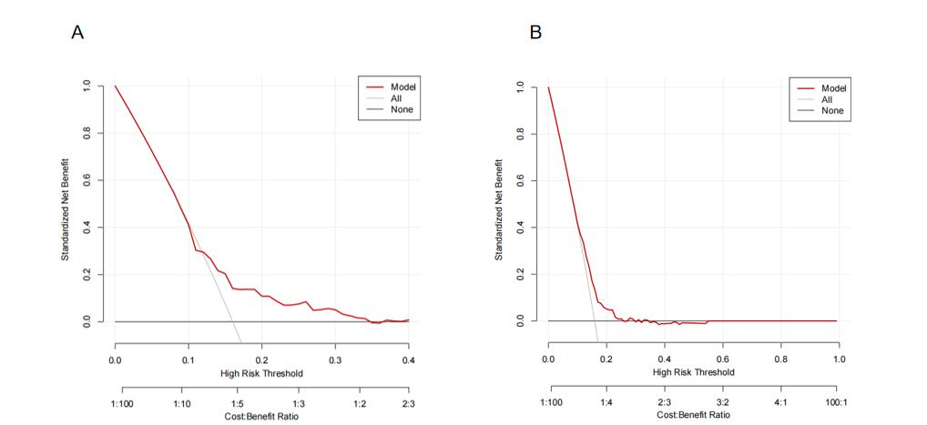
Supplemental Figure 2. The decision curve of the column chart to predict the risk of death. (A) The decision curve of the training set, (B) the decision curve of the validation set.

