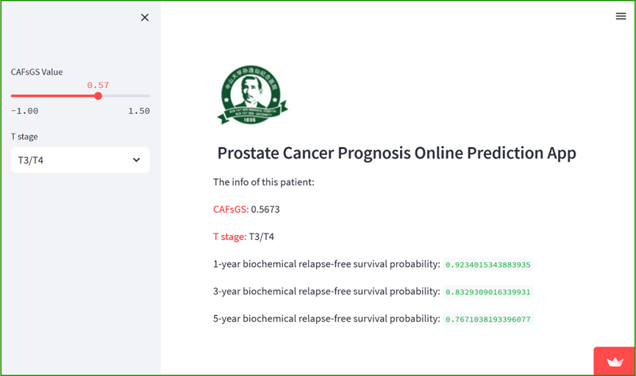
Figure S1. Online prognostic prediction app for predicting BRFS of PCa. This online tool can assist clinical doctors in better applying the nomogram model constructed by this study.

