Supplementary Information
Optical modulation of hole doping via atomically thin fluorine-functionalized graphene endowed transparent and flexible UV-photodetector

Po-Hsuan Hsiao¹, Kuan-Han Lin¹, Tsung-Yen Wu¹, Thi Dieu Hien Nguyen ², Ming-Fa Lin^{2,3}, and Chia-Yun Chen^{1,3*}

¹Department of Materials Science and Engineering, National Cheng Kung University, Tainan 70101, Taiwan
²Department of Physics, National Cheng Kung University, Tainan 70101, Taiwan
³Hierarchical Green-Energy Materials (Hi-GEM) Research Center, National Cheng Kung University, Tainan 70101, Taiwan
*Email: timcychen@mail.ncku.edu.tw

S1 Morphological observations of UV-absorptive CQD layers
S1-1 Cross-sectional SEM images of heterostructures
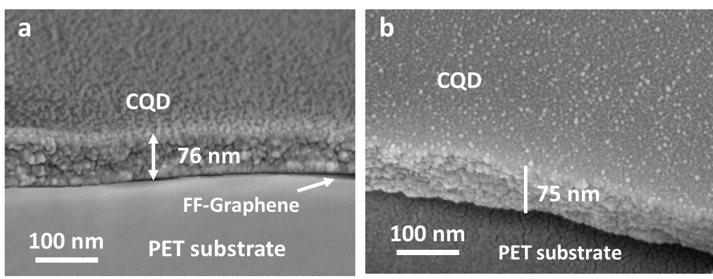
Figure S1. The cross-sectional SEM image of (a) CQD/FF-Gra/PET and (b) CQD/PET.

The CQD-based coupled heterostructures, including CQD/FF-Gra/PET and CQD/PET have been finely elaborated with large-area uniformity. Evidently, surfaces morphologies of these CQD-based configurations were characterized by cross-sectional SEM images, where the CQD layers were controlled with a fixed thickness of 75±1 nm. Both of as-prepared CQD/FF-Gra/PET and CQD/PET coupled heterostructures exhibited the uniform and finely stacked contact behaviors on monolayer FF-Gra or directly onto PET substrates, as evidenced in Figure S1(a) and S1(b), respectively.

S1-2 Size distribution of synthetic monodispersed CQDs
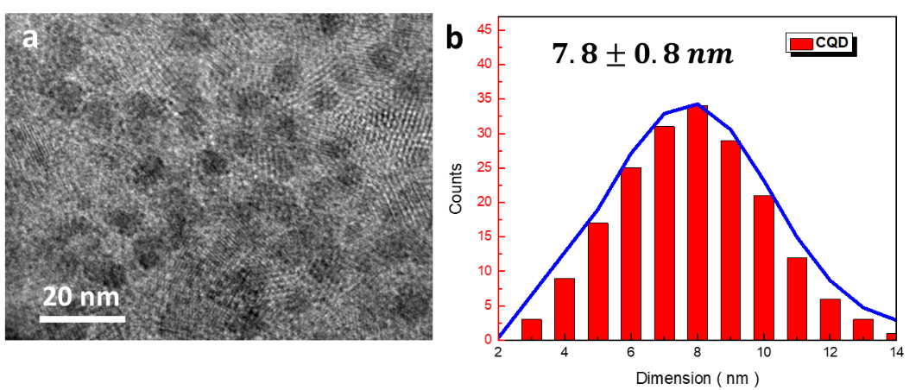
Figure S2. (a) TEM image of densely accumulated monodispersed CQD structures, and the corresponding (b) size distribution analysis. The results show the high uniformity of monodispersed CQDs with average size of 7.8±0.8 nm.

S1-3 HRTEM and EELS analysis of coupled heterostructures
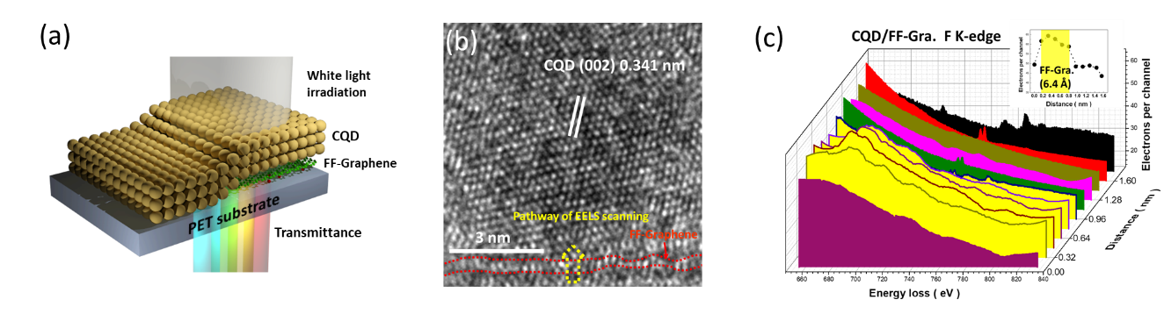
Figure S3. (a) Scheme diagram of CQD/FF-Gra/PET coupled heterostructures transparent flexible photodetector. (b) The cross-sectional HRTEM of CQD/FF-Gra coupled heterostructures, and the corresponding (c) EELS line scanning at the F K-edge.

Figure S3(a) showed a schematic illustration representing CQD/FF-Gra/PET coupled heterostructures, where the monolayer FF-Gra was evenly sandwiched between top monodispersed CQD and PET substrates. To readily investigate the associated heterointerfaces via the atomically thin FF surfaces coupled with CQDs, cross-sectional high-resolution TEM (HRTEM) image combined with electron energy loss spectroscopy (EELS) were performed, as demonstrated in Figures S3(b) and S3(c), respectively. The samples for EELS analysis were prepared by in-situ coating of platinum layer using an FEI gas injection system to protect the sample surfaces from damage during FIB milling. A cross-sectional specimen approximately 50 nm in thickness was obtained. In HRTEM features, one could clearly observe the well crystallographic lattice fringes of 0.341 nm appearing in CQD microstructures, which was in good agreement with the (002) crystal phase of graphite.¹ In addition, the actual thickness of monolayer FF-Gra in direct contact with CQDs was determined to be 0.64 nm, this which stayed close to the theoretical results of monolayer graphene (0.61-0.64 nm).² Apart from that, the spatial elemental composition of F signals appearing on the edge of monolayer FF-Gra facing to CQD architectures were identified with line scan of quantitative EELS characterizations, as displayed in Figure S18(b), with the resultant F K-edge spectra as a function of spatial location across the FF-Gra/CQD interfaces were vailed, showing the features of surficial functionalization rather than direct doping.³ It should be pointed out that the thickness of the FF-Gra in this EELS micrograph was consistent with quantitative EELS visualization in line scan form, which were estimated to be approximately 0.63 nm, as evidenced in the inset figure of Figure S3(c).

S2 Carrier density under various light-illumination conditions
S2-1 Mott Schottky results
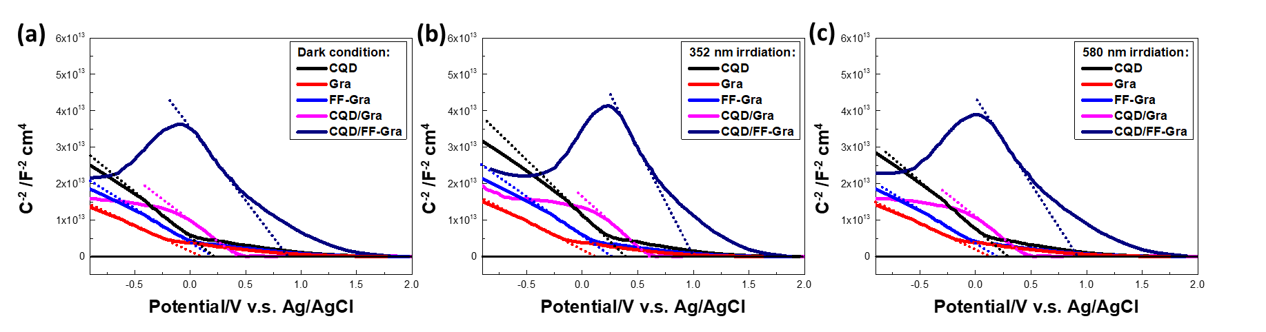
Figure S4. Mott-Schottky plots of CQD/FF-Gra/PET devices under (a) dark condition, (b) 352-nm light irradiations and (c)580-nm light irradiations.

Charge carrier concentration and flat band potentials of CQD, Gra, FF-Gra, CQD/Gra and CQD/FF-Gra were calculated using the Mott-Schottky relation, given by Eq. (S1),⁴
$\frac{1}{C^{2}}=\frac{2}{∈_{0}∈_{r}A^{2}eN_{d}}(V-V_{bi})$ (S1)
In Eq. (1), N_{d}, the charge carrier concentration, was calculated from the slope of the Mott-Schottky equation. C, the differential capacitance, was space-charge capacitance per unit area; ε₀ and ε_{r} the dielectric constants of vacuum and sample, A the electrode area, the electron charge, and V and V_{bi} were the applied potential and the built-in potential, respectively. According to Mott-Schottky plot, all the samples and their heterostructures investigated belonged to p type due to negative slope of C⁻²-V curves.⁴ As shown in Figure S4(a), the charge carrier concentration at dark condition of CQD, Gra, FF-Gra, CQD/Gra and CQD/FF-Gra were estimated to be 2.82x10¹⁵ cm⁻³, 9.32x10¹² cm⁻³, 3.18x10¹³ cm⁻³, 3.72x10¹⁴ cm⁻³ and 7.55x10¹⁵ cm⁻³, respectively. Under UV exposure (352 nm as light source), the carrier density was increased by an order of magnitude in dark condition in cases of CQD (4.51x10¹⁶ cm⁻³), Gra (1.02x10¹³ cm⁻³), FF-Gra (9.80x10¹³ cm⁻³) and CQD/Gra (5.41x10¹⁵ cm⁻³). It could be noted that the charge carrier concentration of CQD/FF-Gra (2.01x10¹⁸ cm⁻³) under 352-nm light irradiation was three orders of magnitude higher than that in dark condition. Similarly, with visible-light irradiation (580 nm as light source) the carrier density ignorable change in CQD (6.51x10¹⁵ cm⁻³), Gra (9.91x10¹² cm⁻³), FF-Gra (4.70x10¹³ cm⁻³) and CQD/Gra (6.10x10¹⁴ cm⁻³) cases.

S2-2 Hall-effect measurements
Hall effect measurements were conducted in a vacuum chamber from which we found the concentration and mobility of charge carriers in CQD, Gra, FF-Gra, CQD/Gra and CQD/FF-Gra at dark condition, 352 nm irradiation and 580 nm irradiation, as shown in Table S1-S3, respectively. Overall, the results in terms of carrier concentration corresponded to the findings from Mott-Schottky measured results.

Table S1 Hall effect measurement of CQD, Gra, FF-Gra, CQD/Gra and CQD/FF-Gra under dark condition.
Sample | Carrier concentration (cm⁻³) | Mobility (${cm}^{2}/Vs$)
CQD | 2.8X10¹⁵ | 23.7
Gra | 9.28X10¹² | 51300
FF-Gra | 3.1X10¹³ | 6320
CQD/Gra | 3.59X10¹⁴ | 353
CQD/FF-Gra | 7.62X10¹⁵ | 798

Table S2 Hall effect measurement of CQD, Gra, FF-Gra, CQD/Gra and CQD/FF-Gra under 352-nm light irradiation.
Sample | Carrier concentration (cm⁻³) | Mobility (${cm}^{2}/Vs$)
CQD | 4.50X10¹⁶ | 20.6
Gra | 1.14X10¹³ | 51300
FF-Grab | 9.82X10¹³ | 6201
CQD/Gra | 5.41X10¹⁵ | 321
CQD/FF-Gra | 2.06X10¹⁸ | 31988

Table S2 Hall effect measurement of CQD, Gra, FF-Gra, CQD/Gra and CQD/FF-Gra under 580-nm light irradiation.
Sample | Carrier concentration (cm⁻³) | Mobility (${cm}^{2}/Vs$)
CQD | 6.52X10¹⁵ | 22.8
Gra | 9.88X10¹² | 51300.0
FF-Gra | 4.68X10¹³ | 6230.0
CQD/Gra | 6.04X10¹⁴ | 326.0
CQD/FF-Gra | 4.94X10¹⁶ | 615.0

S3 Investigations of band diagrams
S3-1 Cyclic voltammetry measurement of monodispersed CQD layers

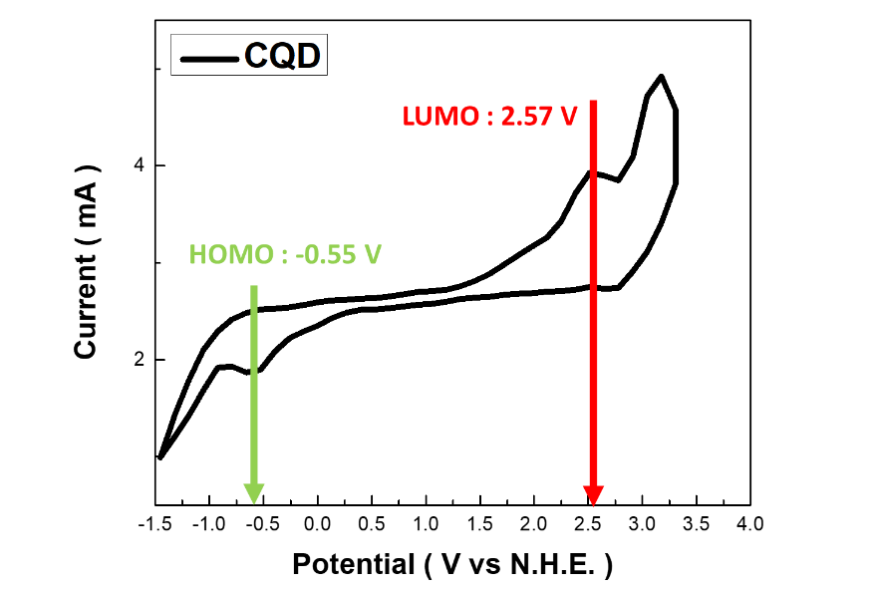
Figure S5. CV measurement of monodispersed CQD layers.

Cyclic voltammetry measurements were utilized to directly determine the LUMO and HOMO energy levels of the CQD, and hence to find the bandgap energy. Applying potentials above the LUMO to form an accumulation layer, or below the HOMO to form inversion layers, can lead to abrupt emergence of cathodic and anodic currents, respectively. Electrode for electrochemical analysis was prepared by drop-casting CQD suspensions (5 μl) and nafion (0.5 μl, 5% w) onto a glassy carbon electrode (diameter of 3 mm) and dried naturally at room temperature. Figure S5 showed the behavior of the glassy carbon electrode in the absence and presence of CQD layer. The oxidation and reduction peaks related to electron and hole injections into the conduction and valence bands were consequently utilized to determine the E_{HOMO} and E_{LUMO} using the following three equations:⁵
$E_{HOMO}=-e(E_{Ox. vs NHE}+4.75)(eV)$ (S2)
$E_{LUMO}=-e(E_{Red. vs NHE}+4.75)(eV)$ (S3)
The SLGQDs/glassy carbon electrode shows a reduction peak at −0.55 V and an oxidation peak at +2.57 V versus N.H.E.. The values for E_{LUMO} and E_{HOMO} calculated from these peaks are E_{LUMO} = −2.23 eV and E_{HOMO} = −5.35 eV versus vacuum, respectively. The band-gap energy determined from the cyclic voltammetry was 3.12 eV.

S3-2 AFM and KPFM analyses of various coupled heterostructures
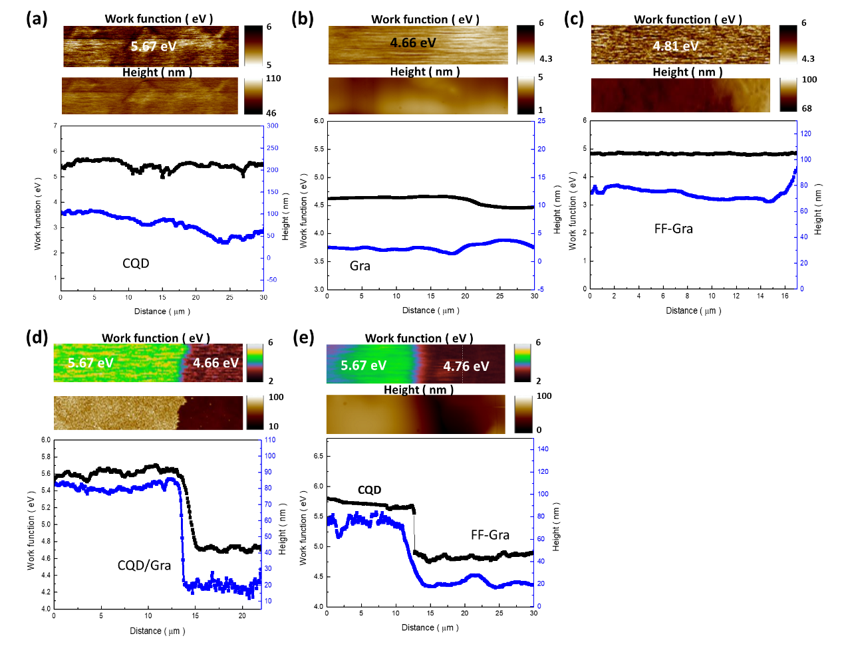
Figure S6. Topographic AFM images and KPFM mappings of (a) CQD, (b) Gra, (c) FF-Gra, (d) CQD/Gra and (e) CQD/FF-Gra.

In order to analyze the band diagrams of CQD and FF-Gra, KPFM mapping of corresponding samples were characterized, as shown in Figure S3. In the case of CQDs, the average height and work function were 76.81±8.6 nm and 5.67 eV, respectively. In addition, the work function of FF-Gra raised from 4.66 eV (bare Gra) to 4.81 eV due to fluorine functionalization. In the case of CQD/Gra coupled heterostructures, the topographic image could be divided into CQD part (figure left) and Gra part (figure right).

S4 Spectral detectivity, NPDR and NEP of CQD-based coupled heterostructures
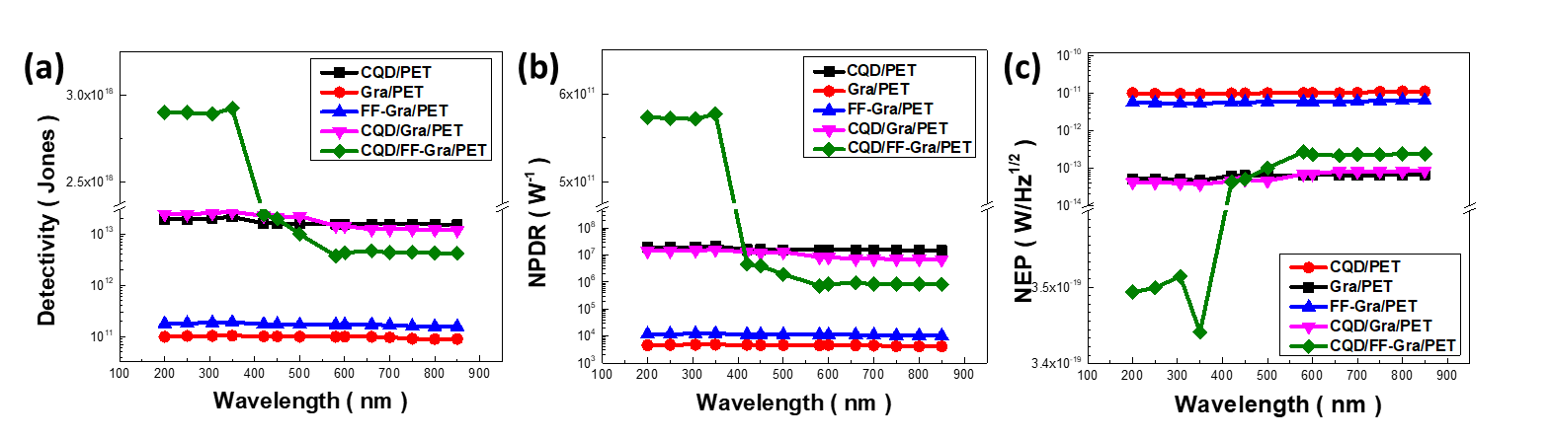
Figure S7. (a) Spectral detectivity as a function of irradiated wavelength: CQD/PET, Gra/PET, FF-Gra/PET, CQD/Gra/PET and CQD/FF-Gra/PET devices, respectively. Plot of (b) normalized photocurrent to dark current ratio (NPDR) and (c) noise equivalent power (NEP) as a function of irradiated wavelength for various photodetectors, resepctively.

With respect to the on-off switching results, the sensitivity of an optical device mainly relies on critical parameter of detectivity (D) could be calculated and which defined as the inverse of the NEP. Herein, we have recorded the detectivity, NPDR and NEP CQD-based coupled heterostructures, as shown in Figure S4. To evaluate the photodetection performance of CQD/PET, Gra/PET, FF-Gra/PET, CQD/Gra/PET and CQD/FF-Gra/PET were determined as a function of light intensity. The maximum calculated D values were 2.14X10¹³ Jones, 1.05X10¹¹ Jones, 1.0X10¹¹ Jones, 2.7X10¹³ Jones and 2.92X10¹⁸ Jones, respectively. The on-off ratio of on-chip photodetector could be expressed by NPDR. The NPDR of devices with value of 2.14X10⁷, 4.8X10³, 1.24X10⁴, 1.59X10⁷and 5.73X10¹¹ W⁻¹, respectively. Similarly, the corresponding NEP of devices with value of 4.66X10⁻¹⁴, 9.5X10⁻¹², 5.26X10⁻¹², 3.7X10⁻¹⁴ and 2.42X10⁻¹⁹ W/Hz^{1/2}, respectively.

S5 Optical characteristics of CQD-based coupled heterostructures
S5-1 Optical transmittance and absorption measurement

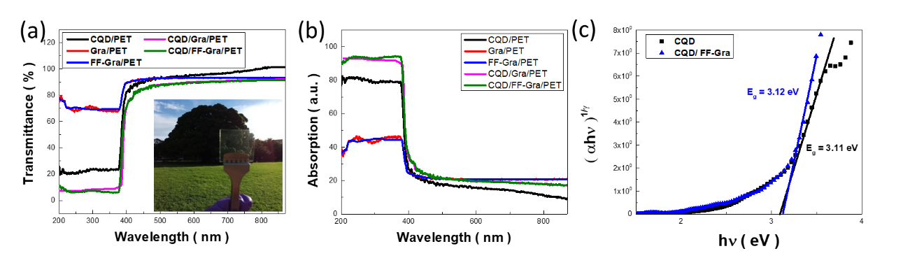
Figure S8. The optical (a) transmittance and (b) absorption of CQD/PET, Gra/PET, FF-Gra/PET, CQD/Gra/PET and CQD/FF-Gra/PET. Inset: The photograph of highly transparent CQD/FF-Gra/PET flexible photodetector with area of 1.5 x 1.5 cm². (c) Tauc’s plot of CQD and CQD/FF-Gra were calculated by absorption data.

The results indicated the pronounce light-absorption range within 200-400 nm from coupled CQD/FF-Gra coupled heterostructures, whereas the light transmittance maintained above 86%-88% under spectral range from 400-850 nm. The band gap of CQD and CQD/FF-Gra were calculated using Tauc’s plot, which were estimated to be 3.11 and 3.12 eV, respectively.

S5-2 Finite-Difference Time-Domain (FDTD) simulation of CQD/FF-Gra

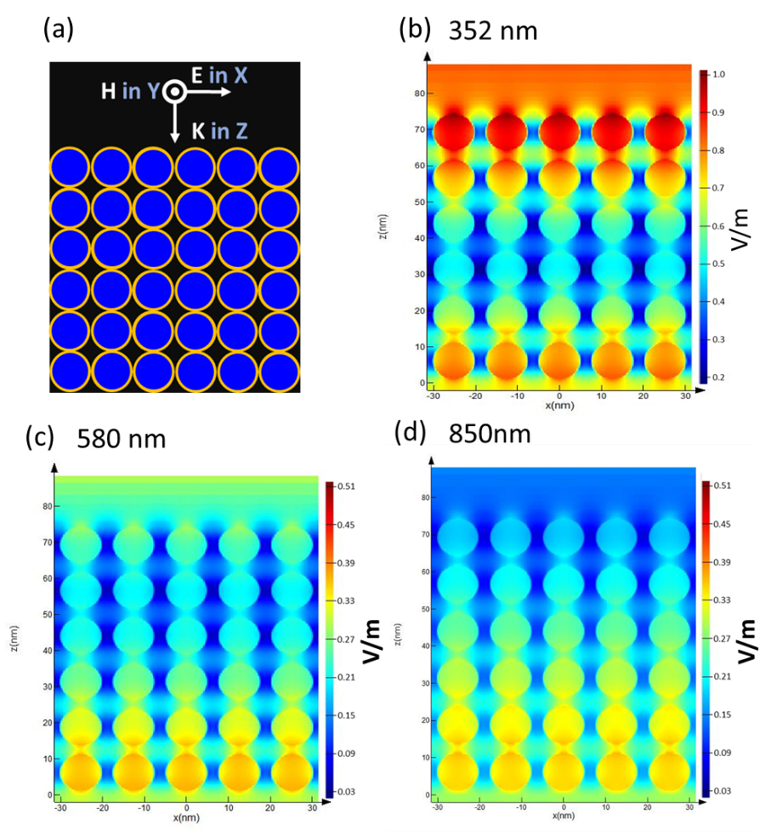

Figure S9. (a) The side-view of the CQD/FF-Gra for the setting of FDTD calculation. The electron-field distribution of FDTD simulation of CQD/FF-Gra under (b) 352 nm, (c) 580 nm and (d) 850 nm plane wave irradiation.

Finite-difference time-domain (FDTD) simulation was conducted in order to unveil the spatial distribution of light-trapping effect of CQD/FF-Gra coupled system, as shown in Figure S9. Examinations of total-field scattered-filed (TFSF) source was adapted and the irradiated lights were configurated perpendicularly to the specimens, as presented in Figure S9(a). Under 352-nm light irradiations, the normalized local intensity electric field reached the maximum at CQD top surfaces, according to the side-view configuration shown in Figure S9(b). Under relatively large incident wavelengths of both 580 nm and 850 nm, the excited E_{max} values dramatically reduced to 0.35 and 0.33, indicating the trivial light-detector interaction and in turn low light absorptance, as shown in Figure S9(c) and S9(d), respectively.

S6 Chemical-shift and oxidation-state characterizations
S6-1 XPS C 1s spectrums
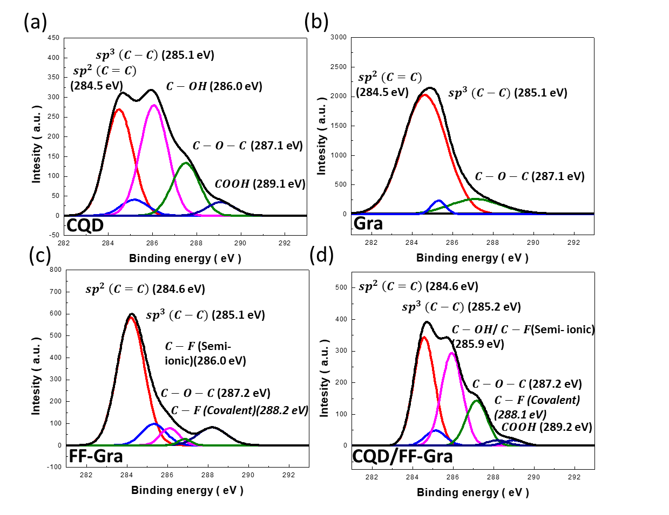
Figure S10. XPS characterizations of C1s spectra: (a) CQD, (b) Gra, (c) FF-Gra and (d) CQD/FF-Gra coupled heterostructures.

The correlated C 1s spectrum of sole CQD was deconvoluted into five components, corresponding to sp² carbonic bond (C=C, 284.5 eV), sp³ carbonic bond (C-C, 285.1 eV), C-OH bond (286.0 eV), C-O-C bond (287.1 eV) and COOH bond (289.1 eV), indicating the sp² hybridized and covalently bonded to oxygen in the form of epoxy, hydroxyl, carboxyl and carbonyl groups at CQD edges,⁶ as shown in Figure S10(a). It could be seen from Figure S10(b) that bare Gra mainly consisted of sp² carbonic bond, sp³ carbonic bond and C-O-C bond, which were in a great agreement to previous work. By contrast, two characteristic signals, semi-ionic C-F bond (286.0 eV) and covalent C-F bond (288.2 eV),⁷ could be found in FF-Gra, as displayed in Figure S10(c). By coupling CQDs with FF-Gra, the spectral blue shift, including sp³ carbonic bond (285.2 eV) and COOH groups (289.2 eV) was envisioned in the case of CQD/FF-Gra, as shown in Figure S10(d). On the other hand, we also found that the slightly red shift of binding energies in both semi-ionic C-F bond and covalent C-F bond toward 285.9 eV and 288.1 eV,⁸ respectively, indicating the presence of electron transfer from CQDs to FF-Gra.

S6-2 XPS F 1s spectrums
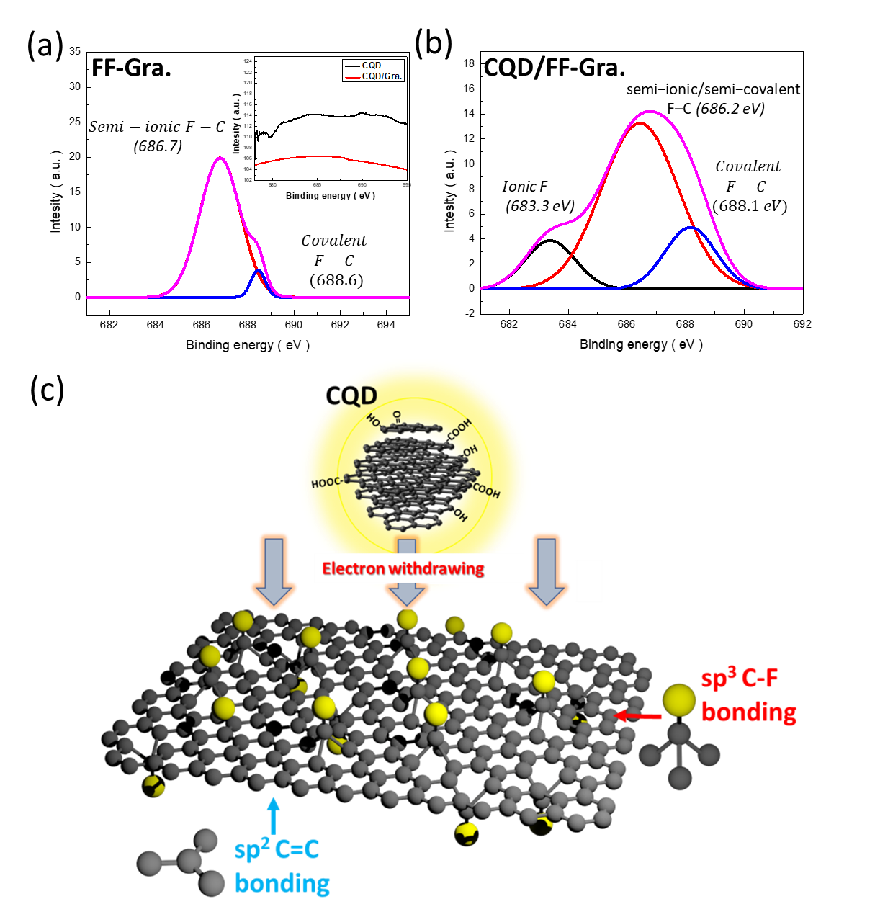
Figure S11. The XPS F 1s spectrums of (a) FF-Gra and (b)CQD/FF-Gra. (c) The scheme diagram of electron withdrawing in CQD/FF-Gra interfaces.

The correlated F 1s spectrum of bare FF-Gra was deconvoluted into two symmetric peaks, including semi-ionic F-C bond (688.6 eV) and covalent F-C bond (688.6 eV), indicating the successful fluorine functionalization, as shown in Figure S11(a).⁸⁻¹⁰ By contrast, an additional ionic F-C bond located at 683.3 eV could be found in CQD/FF-Gra coupled heterostructures, as displayed in Figure S11(b). Such newly formed ionic F-C bond was promoted by the bridge of carbonyl group in CQD surfaces that was mediated at CQD/FF-Gra interfaces. Besides, we also found that the slightly red shift of binding energies in both semi-ionic F-C bond and covalent F-C bond toward 686.2 eV and 688.1 eV, respectively, indicating the presence of electron transfer from CQDs to FF-Gra. The above results clearly evidenced the direct evidence that support the electron withdrawing effect, as shown in Figure S11(c).

S7 DFT calculation
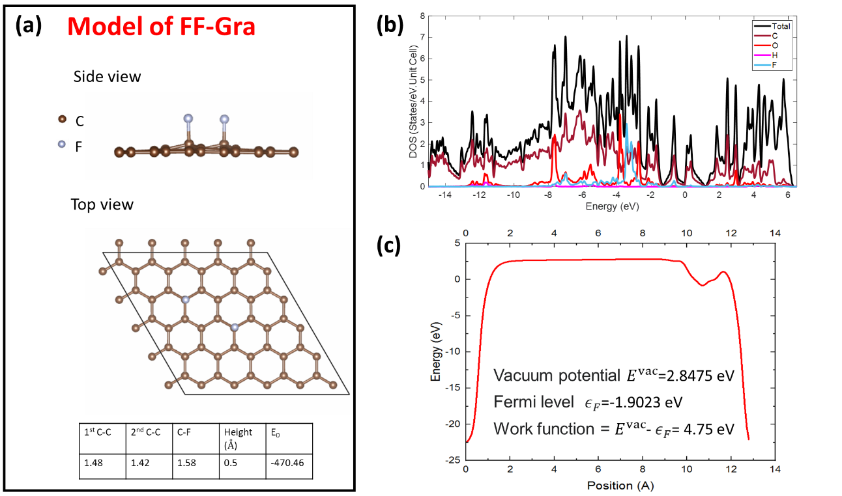
Figure S12. (a) 5 × 5 FF-Gra supercell with two F atom. (b) DOS diagrams for FF-Gra. (c) Energy versus position diagram of FF-Gra.

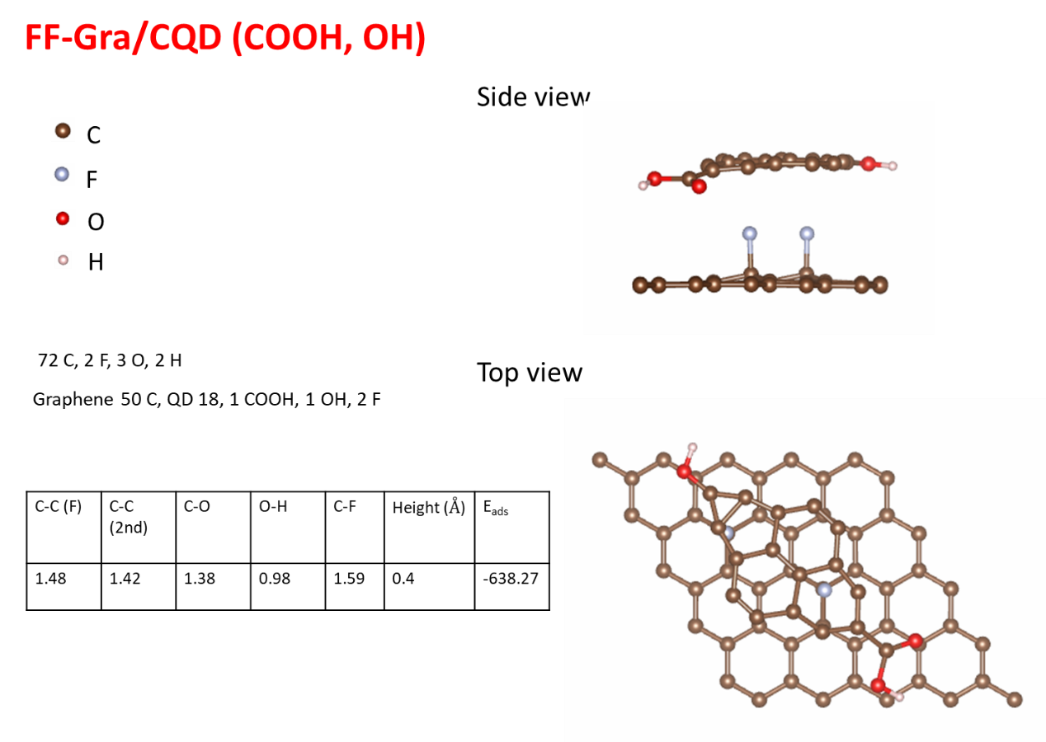
Figure S13. (a) Model of 5 × 5 FF-Gra supercell with CQD attachment.

The first-principle density functional theory (DFT) studies were performed on FF-Gra and CQD/FF-Gra to study the structural properties and electronic properties of the layers of isomers, as shown in Figure S9 and S10. To investigate the effect of F atom adsorbates on the electronic properties of monolayer FF-Gra configuration, F atoms was placed on top of the 5 × 5 FF-Gra supercell [Figure S12(a)]. The bond length of graphene was 0.142~0.148 nm and the C-F bond length was 0.158~0.159 nm in this calculated system. The associated adsorption energy was evaluated with the formula,¹¹
$E_{bond}=(E_{Gra}+E_{0}-E_{total})$ (S4)
where E_{bond} the binding energy of the adsorbed atom to a monolayer graphene sheet. E_{Gra} the total energy of one sheet of the graphene and E₀ the total energy as an isolated atom of the adatom. In the FF-Gra case, the E₀ of FF-Gra showed a negative value of -470.5 meV, indicating that electron transferred from the graphene to the F atom. Furthermore, the calculated vacuum potential and the fermi level could be obtained from the DOS diagram and energy distribution diagram, as shown in Figure S9(b)-(c). The work function, φ, of any material could be defined as the energy required to remove an electron from the highest filled level in the Fermi distribution of a solid to vacuum (i.e., stationary at a point in a field-free zone just outside the solid) at absolute zero: φ = E_{vacuum} − E_{Fermi}. φ was a fundamental electronic property of any material and provides understanding of the relative position of the Fermi surface levels. Herein, the calculated work function of FF-Gra could be defined as 4.75 eV, which was close to the experimental value (4.81 eV) that was determined by CV measurements.
In the case of CQD/FF-Gra, the monolayer FF-Gra sheet with adsorption of CQD edge (single layer CQD with C-OH and COOH function groups) was examined and placed on top of the 5 × 5 FF-Gra supercell, as shown in Figure S13. The height between FF-Gra and CQD was 0.4 Å in this coupled system according to experimental observation. The adsorption energy (E_{ads}) of CQD/FF-Gra were negative value of -638.27 meV, indicating that CQD and FF-Gra were in an relatively pronounced adsorbed state due to electron withdrawing effect bridged in between FF-Gra surfaces (electron acceptor) and defect-bound CQDs (electron donor).

S8 Device characteristics: On-off switch photodetection
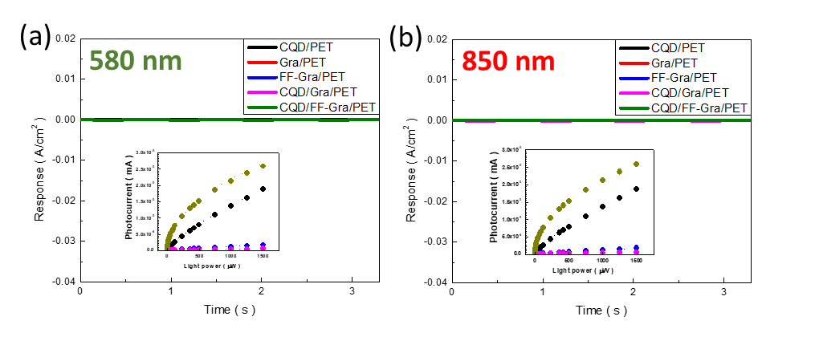
Figure S14. On-off switching photoresponses under illuminated wavelength of (a) 580 nm and (b) 850 nm and their repetitive on/off cycles were recorded.

With respect to the obtained material and interface properties, in order to investigate the photoresponse of the devices, the devices were illuminated with switching light of different wavelengths and its repetitive on/off cycles was recorded. Figures S14(a) and S14(b) showed the repetitive on/off cycles, at 1 V bias, under 580 nm and 850 nm, respectively. Each transient plot exhibited extremely stable and reproducible on-off cycles that indicated the excellent electrical stability of the devices. The photocurrent value of CQD/PET, Gra/PET, FF-Gra/PET, CQD/Gra/PET and CQD/FF-Gra/PET devices the obtained values (580 nm/850 nm) were 36.7/35.4 nA/cm², 5.1/4.6 nA/cm², 6.2/5.67 nA/cm², 57.3/4.7 nA/cm² and 44.3/5.0 nA/cm², respectively.

S9 Crystallographic and functional-feature analysis of various carbon-based coupled heterostructures
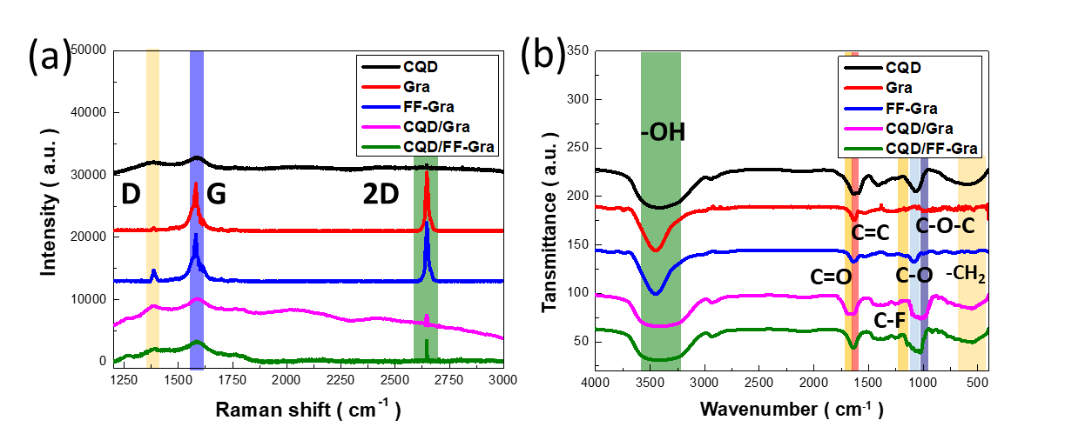
Figure S15. The structural analyses of CQD, Gra, FF-Gra, CQD/Gra and CQD/FF-Gra photodetector devices were performed by (a) Raman and (b) FTIR spectroscopy.

Explorations of structural properties were performed with Raman spectroscopy, where the characteristic features of low-dimensional carbon structures including first-order G peak (1580 cm ⁻¹), a second-order 2D Raman peak (2700 cm⁻¹), and a defect-induced D peak (1370 cm⁻¹) were examined, as shown in Figure S15(a).¹² The correlated G and D bands were originated from the double degenerate (E_{2g}) vibration mode of in-plane sp² C=C bond and breathing mode of defective sp³ carbon ring, respectively, while 2D band represented the second overtone of D peak, arising from the inelastic scattering event involving two phonons of opposite wave vectors.¹³ Notably, the red shift of G peak (1.6 cm⁻¹) was found from CQD structures compared with that of monolayer Gra, which could be attributed to the increase of atomic bond length in graphite core of CQDs.¹⁴ Besides,, the G peaks of CQD/Gra and CQD/FF-Gra exhibited the clear red shift of 1.6 and 1.37 cm⁻¹, respectively, in comparison with monolayer Gra.. This indicated that the electrons from surface functional group of CQD was captured by the surficial fluorine functionalization existed on FF-Gra.¹⁵ Meanwhile, the intensity ratio of D and G peaks in terms of I_{D}/I_{G} was evaluated to investigate the degree of defects in correlated graphite lattices of carbon nanostructures.^{16,17} The calculated I_{D}/I_{G} ratios for CQD, Gra, FF-Gra, CQD/Gra and CQD/FF-Gra samples were 0.68, 0.06, 0.17, 0.69 and 0.64, respectively. The involvement of oxygen-containing groups on CQD surfaces caused the strong suppression of correlated value of I_{D}/I_{G}. In line with these findings, the I_{D}/I_{G} response of CQD/FF-Gra was comparably lower than bare CQDs, indicating the surficial defects of CQDs were partially compensated with C-F bonding of FF-Gra, as indicated in XPS results.
Fourier transfer infrared (FTIR) spectroscopy was used to investigate the bonding states and correlated functional groups of carbon-based structures. FTIR spectra of bare CQD, Gra, FF-Gra, CQD/Gra and CQD/FF-Gra were presented in Figure S15(b). In the case of CQDs, an obvious absorption peak centered at 1641 cm⁻¹ was envisioned, which was caused by C=C stretching.¹⁷ A weak absorption peak at 852 cm⁻¹ from the surface state of CQDs was assigned to the origin of CH₂ rocking.¹⁸ The broad peak centered at 3392 cm⁻¹ was assigned to O-H bonding.¹⁸ The absorptions at 994, 1076, 1635 cm⁻¹ were attributed to C-O-C, C-O and C=O bonding, respectively.^{18,19} In addition, similar characteristics also appeared in monolayer Gra and FF-Gra, including bonding modes of C=C, C=O, C-O and O-H. It should be noted that the absorption peak at 1225-1260 cm⁻¹ corresponded to C-F bonding that could be evidently observed in FF-Gra.²⁰

S10 Photoconductive gain

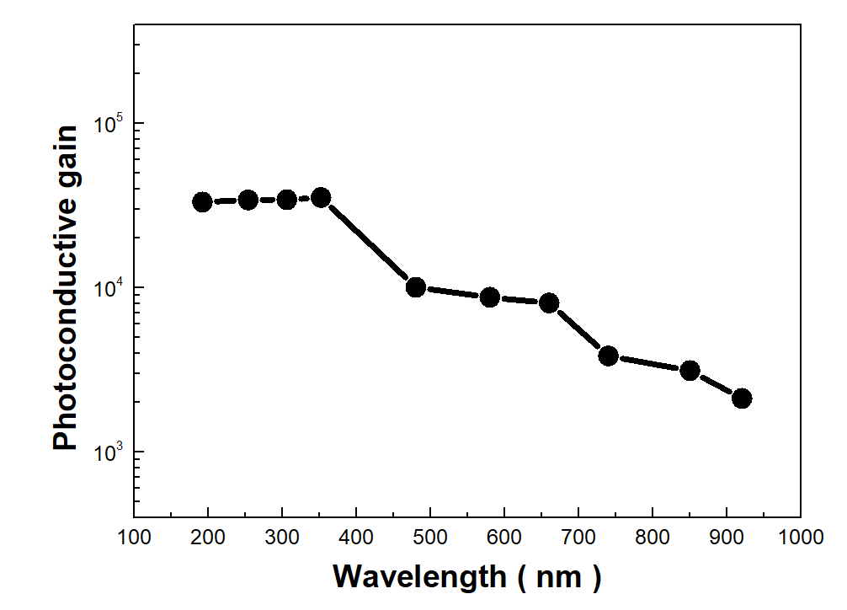
Figure S16. Photoconductive gain of CQD/FF-Gra/PET coupled heterostructures.

The ohmic contact in photoconductor favours charge carriers’ circulation for several cycles before recombination, hence every single absorbed photon could result in more than one electron detected, i.e., EQE larger than unity was possible.¹⁸ The gain mechanism in such structures can be explained by a trap-assisted model and the corresponding photoconductive gain (G) can be expressed by²¹
$G=\frac{τ}{t} (t=\frac{L^{2}}{μ_{h}∙V})$ (S5)
where τ was the photocarrier lifetime, t was the carrier transit time, L was the channel length, μ_{h} was the mobility of hole and V was the applied voltage between the channels. In the case of CQD/FF-Gra, we have reported the maximum photoconductive gain of 3.5x10⁴ at 352 nm illumination. This indicated that the high EQE over 100% were exhibited in CQD/FF-Gra coupled heterostructures.

S11 Mott Schottky plot and band structures of CQD/FF-Gra/PET
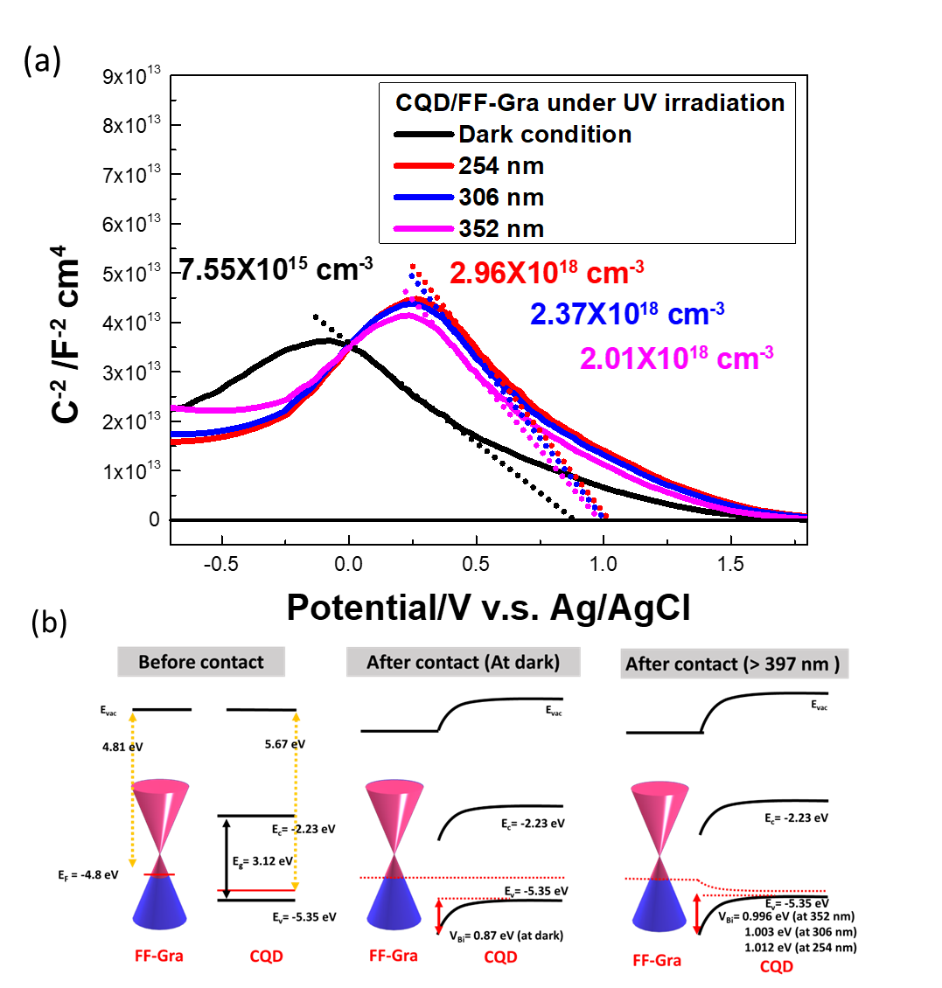
Figure S17. (a) Plots of the inverse square capacitance (1/ C²) versus applied Potential/V for the CQD/FF-Gra photodetectors obtained under different light illuminations (254, 306 and 352 nm) , respectively, at 300 K and 5 kHz. The linear fitting was carried out by assuming the Schottky–Mott model. (b) Energy-level diagrams of the CQD/FF-Gra before contact, in the dark and under the illumination of UV lights at the bias of 0 V.

We have carried out capacitance (C)–voltage (V) measurements for CQD/FF-Gra photodetectors in the dark or under 254, 306, 352 nm UV illumination. The results were shown in Figure S17(a). By linearly fitting a C⁻²-V curve, we could work out the built-in potential (V_{bi}) of the CQD/FF-Gra Schottky junction, and estimated the corresponding carrier concentrations.²² It was found that V_{bi} was 0.91 eV when CQD/FF-Gra was under the dark condition. By using $V_{bi}$ and the work function of FF-Gra (4.76 eV), we obtained that the work function of CQD was (5.67 eV) for CQD/FF-Gra coupled heterostructures. These results were the same as those directly measured with a KPFM (Figure S2). The work function of FF-Gra (4.76 eV) was slightly different form the intrinsic value of fluorographene (4.81 eV), indicating that the strong electronegativity of C-F bonding on FF-Gra extracted the electron on surface groups of CQD. In addition, the corresponding photogenerated hole concentration of CQD changed from 7.55x10¹⁵ cm⁻³ to 2.96x10¹⁸ cm⁻³ (2.37x10¹⁸ cm⁻³ and 2.01x10¹⁸ cm⁻³) under 254 nm (306 nm and 352 nm) of light illuminations, respectively. Accordingly, the correlated diagrams of the CQD/FF-Gra before contact, in the dark and under the illumination of UV lights were presented in Figure S17(b).

S12 Statistic deconvolution of PL Intensity and calculation of Mass Action Models
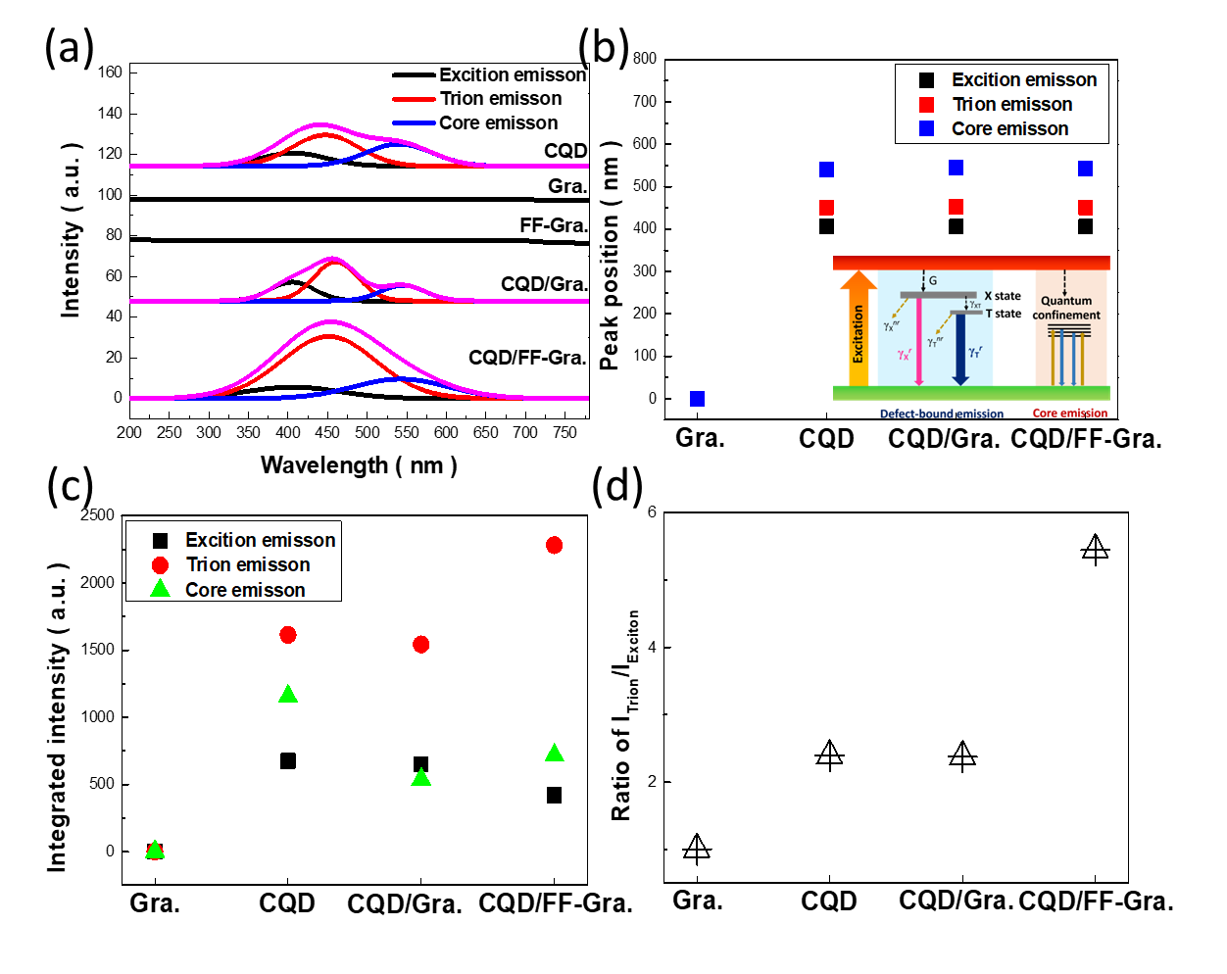
Figure S18. (a) PL spectra of CQD, Gra, FF-Gra, CQD/Gra and CQD/FF-Gra coupled heterostructures. (b) The correlated PL peak positions and (c) integrated intensities of exciton, trion and core emissions of Gra, CQD, CQD/Gra and CQD/FF-Gra coupled heterostructures. (d) Intensity ratio of trion emission/exciton emission of Gra, CQD, CQD/Gra and CQD/FF-Gra coupled heterostructures.

The prominent PL characteristics of low-dimensional materials showed the strong correlation with carrier interaction. Both of PL emissions of excitons and positive trions (charged exciton), a bound state of two holes and one electron excited from 365-nm lights could be observed in CQD-based heterostructures, as presented in Figure S18(a). In addition, PL spectra acquired from Gra and FF-Gra were also compared. In CQD/FF-Gra, the correlated PL spectrum could be decomposed into three components: defect-bound exciton emission, defect-bound trion emission and core emission (resulting from direct electron−hole recombination at crystalline core of CQDs). It should be noted that exciton emission could be ascribed to carbon defects such as carbon vacancies or irregular carbon rings at the surface state of CQDs, whereas the long-wavelength emissions stemmed from the radiative recombination of defect-bound trion state in the vicinity of CQD surfaces.²³ In addition, the energy difference between exciton emission and trion emission was referred to as the trion binding energy (ΔE = E_{X} − E_{T}), which was about 268 meV and fairly close to the defect-bound trion binding energy of SWCNTs (262 meV).²⁴ The relative spectral positions of three characteristic PL peaks remained the same from all samples, as shown in Figure S18(b). Nevertheless, the pronounced increase of trion emission could be envisioned when coupling CQD with FF-Gra in comparison with bare CQDs, and CQD/Gra coupled features, as indicated in Figure S18(c). It could be speculated that the involved FF-Gra indeed caused the effect on the enhancement of defect-bound trion emission of CQDs due to electron withdrawing effect and subsequent hole doping toward defect-bound states of CQD surfaces.
The intensity ratio of defect-bound trion (I_{trion}) and defect-bound exciton (I_{exciton}) was further carried out, as shown in Figure S18(d). To interpret the underlying spectral dynamics, a three-level model of the topological defect state was illustrated in the inset figure of Figure S18(d), in which X represented the defect-bound exciton state ,T stood for the defect-bound trion state, G referred to the generation rate of defect-bound excitons, γ_{X}^{r} and γ_{X}^{nr} were assigned to radiative decay rate and nonradiative decay rate of excitons, respectively; and γ_{XT} represented the trion formation rate. In addition, trions could also decay via radiative (γ_{T}^{r}) and nonradiative (γ_{T}^{nr}) processes. It was supposed that the trions were formed from excitons. In Figure S18(a), we identified the spectral positions of 410 nm (defect-bound exciton emission) and 450 nm (trion emission) of various CQD-based nanostructures.^{25,26} The rate equations for the population of exciton (N_{X}) and trion (N_{T}) are expressed,
$\frac{{dN}_{x}}{dt}=G_{X}-(γ_{X}^{r}+γ_{X}^{nr}+γ_{XT})$ $N_{x}$ (S6)
$\frac{{dN}_{T}}{dt}$= $γ_{XT}N_{X}-(γ_{T}^{r}+γ_{T}^{nr})$ $N_{T}$ (S7)

where N_{X} and N_{T} could be derived from the steady-state solutions,
$N_{X}=\frac{G_{X}}{γ_{X}^{r}+γ_{X}^{nr}+γ_{XT}}$ (S8)
$N_{T}=\frac{γ_{XT}}{γ_{T}^{r}+γ_{T}^{nr}}\frac{G_{X}}{γ_{X}^{r}+γ_{X}^{nr}+γ_{XT}}$ (S9)

Correlations of PL peak intensity with carrier population of excitons ${(I}_{x}∝$ $γ_{X}^{r} N_{X}$) and trions ${(I}_{T}∝γ_{T}^{r} N_{T}$) were presented,
$\frac{I_{T}}{I_{X}}\sim \frac{r_{T}^{r}N_{T}}{r_{X}^{r}N_{X}}=\frac{γ_{T}^{r}γ_{XT}}{γ_{X}^{r}(γ_{T}^{r}+γ_{T}^{nr})}$ (S10)
Now we took further steps to unveil the carrier dynamics when carrier doping on CQDs was involved. By assuming that the changes of γ_{X}^{r}, γ_{T}^{r} and γ_{X}^{r}+ γ_{T}^{nr} with doping could be neglected, and then the adsorption rate followed the Langmuir’s law, the rate of trion formation depending on doping concentrations could be described as γ_{XT}(δ), as shown below,²⁷
$γ_{XT}\left(δ\right)=γ_{XT}\left(0\right)(1-s∙\frac{1}{αδ+1})$ (S11)
where s (~95%) the ability of charge transfer, and $α$ the adsorption probability. The populations of excitons and trions could be derived from the steady-state functions as below:
$N_{X}(n)=\frac{G_{X}}{γ_{X}^{r}+γ_{XT}\left(n\right)}$ (S12)
where n could be expressed as $\frac{δ}{δ_{0}}$ and δ₀ was estimated to be 5mg L⁻¹ in our experiment.²⁸
$N_{T}=\frac{γ_{XT}\left(n\right)}{γ_{T}^{r}}\frac{G_{X}}{γ_{X}^{r}+γ_{XT}\left(n\right)}$ (S13)
Accordingly, PL intensity was proportional to populations of exciton (trion), expressed as
$I_{X}(n)=\frac{AG_{X}Γ_{X}}{γ_{X}^{r}+γ_{XT}\left(n\right)}$ (S14)
$I_{T}(n)=\frac{γ_{XT}\left(n\right)}{γ_{T}^{r}}\frac{{AG}_{X}Γ_{T}}{γ_{X}^{r}+γ_{XT}\left(n\right)}$ (S15)
where parameter A the collection efficiency of luminescence, Γ_{X} and Γ_{T} the radiative rates of exciton and trion. Here, the rate of radiative decay was considered independent to the carrier density for simplicity. Thus, the values, γ_{X}^{r} =2.85 ps⁻¹, γ_{T}^{r}=1.64 ps⁻¹ were estimated based on the data reported in S5. The fitting parameter of ${{AG}_{X}Γ_{T}}/{AG_{X}Γ_{X}}$ to the experimental data was 1.35x10⁻⁴. For simple condition that γ_{XT >>} γ_{i}^{r} (i = ex,tr), the PL intensity could be approximately expressed as,
$I_{X}(n)≈\frac{AG_{X}Γ_{X}}{γ_{XT}\left(n\right)}$ (S16)
$I_{T}(n)≈\frac{{AG}_{X}Γ_{T}}{γ_{T}^{r}}$ (S17)
The mass action law associated with the trion formation was used to calculate the charge density in CQDs. Under the law of mass action, the following function could be obtained,²⁹
$\frac{N_{X}n_{h}}{N_{T}}=(\frac{16πm_{X}m_{e}}{h^{2}m_{T}})k_{B}Texp(-\frac{E_{b}}{k_{B}T})$ (S18)
where k_{B} the Boltzman constant, T the temperature, E_{b} the binding energy of trions near the band gap, m₀ the mass of a free electron, m_{e} (0.35 m₀) and m_{h} (0.45 m₀) the effective mass of electron and hole, respectively. The effective mass of an exciton and a trion can be calculated as m_{x}= m_{e}+ m_{h}= 0.8 m₀, m_{T}= m_{e}+ 2m_{h}= 1.25 m₀. By using these parameters, the weight of trion PL intensity could be expressed as,
$\frac{I_{T}}{I_{total}}=\frac{\frac{Γ_{T}}{Γ_{X}}\frac{N_{T}}{N_{X}}}{1+\frac{Γ_{T}}{Γ_{X}}\frac{N_{T}}{N_{X}}}≈\frac{4×{10}^{-17}n_{h}}{1+4×{10}^{-17}n_{h}}$ (S19)
$\frac{I_{X}}{I_{total}}≈\frac{1}{1+4×{10}^{-17}n_{h}}$ (S20)
The reduction of the exciton weight ($\frac{I_{T}}{I_{total}}$) from 0.7 to 0.85, after the coupling of CQDs with FF-Gra as heterostructures. Accordingly, the estimated charge density of CQD was 10¹⁴ cm⁻², and the correlated result of CQD/FF-Gra was increased to 4.4x10¹⁵ cm⁻².

S13 Photoluminescence lifetime
Photoluminescence quantum yield (PLQY) examinations of CQD, CQD/Gra and CQD/FF-Gra samples were extracted from PL results, as shown in Table S1, and the correlated radiative decay rates were given by the following equation:³⁰
$Kr(Radiative decay rate)=\frac{PLQY}{Lifetime}$ (S21)
Accordingly, the radiative decay rates of trion and exciton, in the case of CQD/FF-Gra, were obtained to be 1.64 ps⁻¹ and 2.85 ps⁻¹, respectively.

Table S4 Calculated PLQY of CQD, CQD/Gra and CQD/FF-Gra.
Sample | PLQY_{total} | PLQY_{Exciton} | PLQY_{trion}
CQD | 0.33 | 0.064 | 0.155
CQD/Gra | 0.30 | 0.071 | 0.17
CQD/FF-Gra | 0.4 | 0.049 | 0.267

S15 Practical mechanical stability of the flexible transparent photodetectors
S15-1 Testing configuration and LBIC mapping after the bending test
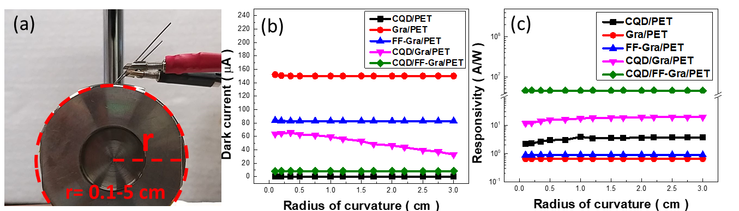
Figure S19. (a) Photograph of home-made measured system. The spectral (b) dark current and (c) responsivity of CQD/PET, Gra/PET, FF-Gra/PET, CQD/Gra/PET and CQD/FF-Gra/PET devices as a function of curvature radius after 120 times bending.

To investigate the mechanical stability of the flexible transparent photodetectors, repeated bending test were performed as functions of the curvature radius (r) (r = 5-0.1 cm), as shown in Figure S19(a). The resulting dark currents of Gra/PET, FF-Gra and CQD/FF-Gra/PET were almost invariant under all the bending deformations at r = 0.1 cm of bending condition, and displayed the ultra-low decreasing of 0.79 %, 1.23 % and 0.09 %, respectively, as shown in Figure S19(b). Nevertheless, both CQD/PET and CQD/Gra/PET exhibited unstable performances and displayed the great variation of dark currents by 38% and 48.2 % after the 120 cycles bending test at r = 0.1 cm condition, respectively. In addition, the responsivity results of Gra/PET, FF-Gra/PET and CQD/FF-Gra/PET were almost invariant under the bending deformations, with low variation of 0.43 %, 0.89 % and 1.5 %, respectively.

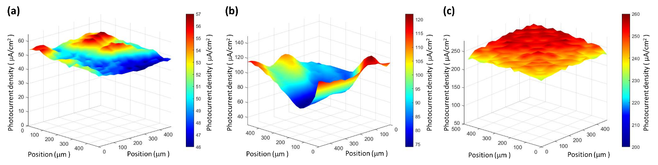
Figure S20. Laser beam induced current (LBIC) measurement of (a) CQD/PET, (b) CQD/Gra/PET and (c) CQD/FF-Gra/PET after the bending test (120 cycles) at r = 0.5 cm.

The bending tests were done at a bending frequency of 1 Hz under an area of 400 μm x 400 μm. In the case of CQD/FF-Gra/PET, the mapping results displayed the homogeneous distribution of photocurrent after the bending test with a small standard deviation of 1.82 %. By contrast, CQD/PET and CQD/Gra/PET showed the relatively uneven results after undergoing bending test, with large standard deviation of 11.43 % and 27.72 %, respectively.

S15-2 PL mapping after the bending test
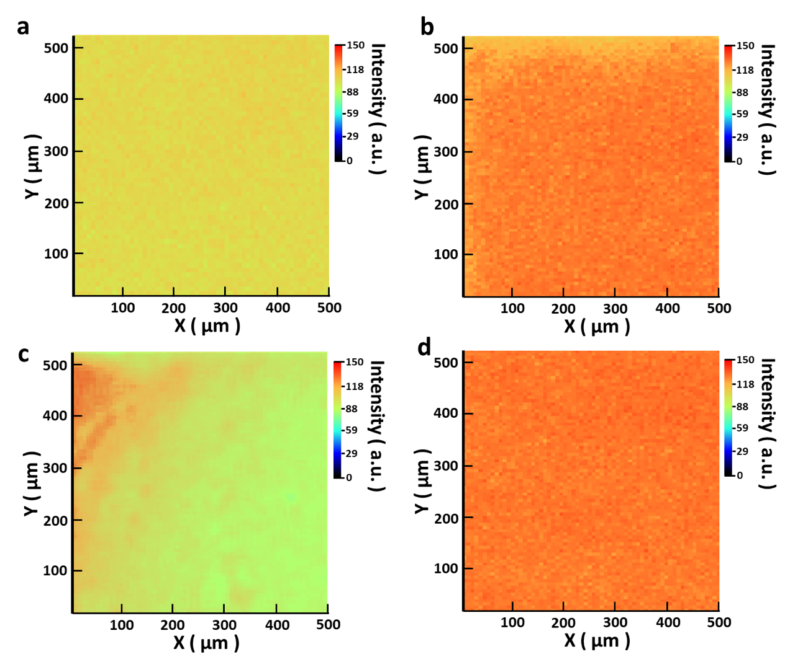
Figure S21. Spatial photoluminescence mapping of (a)CQD/Gra/PET, (b)CQD/FF-Gra/PET before and (c)(d) after bending test.

To further investigate the mechanical stabilities of the CQD/Gra/PET and CQD/FF-Gra/PET, the PL mapping could spatically display the existence of nano-crack or nano-defect in the tested samples with an area of 500 μm x 500 μm, before and after bending test at r = 0.5 cm. Clearly, the spatial PL mapping results of CQD/FF-Gra were almost consistent before and after bending test.

S15-3 Cycling reliability
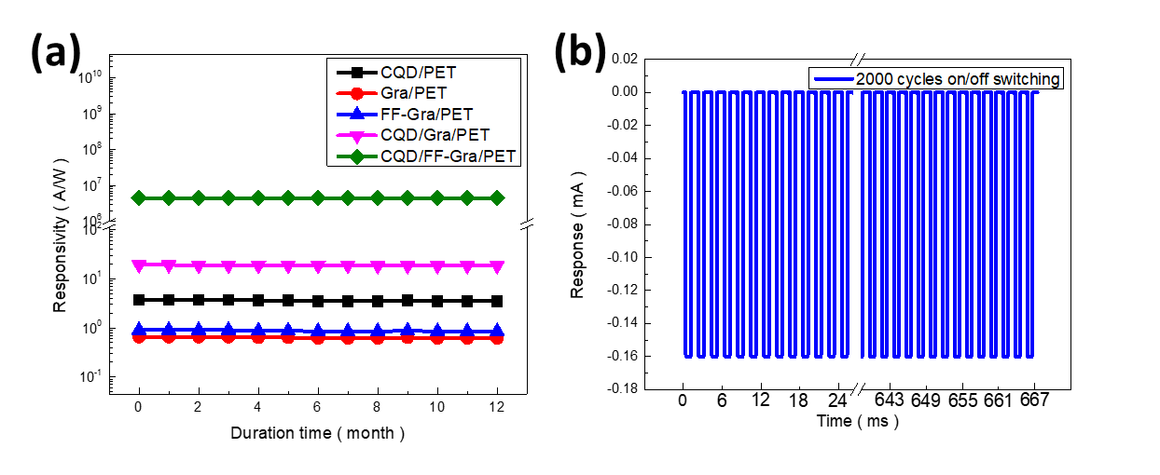
Figure S22. (a)Long-term duration test of CQD/PET, Gra/PET, FF-Gra/PET, CQD/Gra/PET and CQD/FF-Gra/PET devices, respectively. (b)On/off cycling test of CQD/FF-Gra/PET.

Figure S22(a) presented the long-term duration test (0-12 months) of CQD/PET, Gra/PET, FF-Gra/PET, CQD/Gra/PET and CQD/FF-Gra/PET devices, respectively, where the correlated reduction of responsivities by 12.3%, 0.88 %, 0.93%, 6.5 % and 0.72 % after 12-month duration, respectively, could be observed. Specifically, CQD/FF-Gra/PET further displayed extremely low reduction of photoresponse around 0.4 % after undergoing 2000-cycle switching cycles, as shown in Figure S22(b).

S15 Comparison of recent transparent flexible photodetector devices
Table S5 Summary of comparative photodetection performances for recent transparent flexible photodetector devices
Sample | R (A/W) | D (Jones) | Bias (V) | Reference
n-SnO₂-p-ZnO:Ag | 8.67 A/W | 2.33 × 10¹³ Jones | 5 V | ³¹
a-IGZO MSM | 5 mA/W | 5.1 × 10¹² Jones | -0.5 V | ³²
ITO/SWCNT/ITO | 1.02 × 10⁴ A/W | 1.73 × 10¹⁶ Jones | 10 V | ³³
β-Ga₂O₃/γ-In₂O₃/α-Al₂O₃ | 94.3 A/W | 3.09 × 10¹² Jones | -5 V | ³⁴
ITO/TAPC: C₆₀/Al | 2.91 × 10³ A/W | 1.28 × 10¹⁴ Jones | -14 V | ³⁵
Graphite QDs/graphene | 2.3 × 10⁶ A/W | 5.5 × 10¹³ Jones | 1 V | ³⁶
AgNW@ZnO NRs | 6.5 × 10⁻⁶ A/W | 1.15 × 10¹⁰ Jones | 5 V | ³⁷
n-ZnO/n-V2O5 | 18.9 A/W | 10¹² Jones | -4 V | ³⁸
WS2-QDs/RGO | 5.22 × 10⁻³A/W | 1.6 × 10⁶ Jones | 12 V | ³⁹
β-Ga2O3:Si MESFET | 74.0 A/W | 2.2 × 10¹⁴ Jones | 5 V | ⁴⁰
CQD/FF-Gra | 4.7X10⁶ A/W | 2.9X10¹⁸ Jones | 1 V | This work

Reference
- Guo, X., Wang, C.-F., Yu, Z.-Y., Chen, L. & Chen, S. Facile access to versatile fluorescent carbon dots toward light-emitting diodes. Chem. Commun. 48, 2692-2694 (2012).
- Chronopoulos, D. D., Bakandritsos, A., Pykal, M., Zbořil, R. & Otyepka, M. Chemistry, properties, and applications of fluorographene. Appl. Mater. Today 9, 60-70 (2017).
- Hayashi, T. et al. NanoTeflons: structure and EELS characterization of fluorinated carbon nanotubes and nanofibers. Nano Lett. 2, 491-496 (2002).
- Darowicki, K., Krakowiak, S. & Ślepski, P. Selection of measurement frequency in Mott–Schottky analysis of passive layer on nickel. Electrochim. Acta 51, 2204-2208 (2006).
- Cardona, C. M., Li, W., Kaifer, A. E., Stockdale, D. & Bazan, G. C. Electrochemical Considerations for Determining Absolute Frontier Orbital Energy Levels of Conjugated Polymers for Solar Cell Applications. J. Phys. Chem. C 115 (18), 8996-9004 (2011).
- Hsiao, P.-H., Lai, Y.-C. & Chen, C.-Y. Dual-sized carbon quantum dots enabling outstanding silicon-based photodetectors. Appl. Surf. Sci. 542, 148705 (2021).
- Lee, J. H. et al. Property Control of Graphene by Employing “Semi‐Ionic” Liquid Fluorination. Adv. Funct. Mater. 23, 3329-3334 (2013).
- Liu, H., Li, Y., Xiang, M., Zeng, H. & Shao, X. Single-layered MoS2 directly grown on rutile TiO2 (110) for enhanced interfacial charge transfer. ACS Nano 13, 6083-6089 (2019).
- Wu, Q., He, J., Wang, F., Yang, X. & Zhu, J. Comparative study on effects of covalent-covalent, covalent-ionic and ionic-ionic bonding of carbon fibers with polyether amine/GO on the interfacial adhesion of epoxy composites. Appl. Surf. Sci. 532, 147359 (2020).
- MURRAY, R., WC, S. & RK, P. INTERMOLECULAR INTERACTIONS OF THE CF BOND: THE CRYSTALLOGRAPHIC ENVIRONMENT OF FLUORINATED CARBOXYLIC ACIDS AND RELATED STRUCTURES. J. Chem. Soc., P. RK 2, (2), 263-271 (1983).
- Pham, T. L. M., Phung, T. K. & Thang, H. V. DFT insights into the adsorption mechanism of five-membered aromatic heterocycles containing N, O, or S on Fe (1 1 0) surface. Appl. Surf. Sci. 583, 152524 (2022).
- Ding, X., Ding, G., Xie, X., Huang, F. & Jiang, M. Direct growth of few layer graphene on hexagonal boron nitride by chemical vapor deposition. Carbon 49, 2522-2525 (2011).
- Lalwani, G., Xing, W. & Sitharaman, B. Enzymatic degradation of oxidized and reduced graphene nanoribbons by lignin peroxidase. J. Mater. Chem. B 2, 6354-6362 (2014).
- Cheng, W. & Ren, S.-F. Calculations on the size effects of Raman intensities of silicon quantum dots. Phys. Rev. B 65, 205305 (2002).
- Lin, L. et al. Electron transport across plasmonic molecular nanogaps interrogated with surface-enhanced Raman scattering. ACS Nano 12, 6492-6503 (2018).
- Guizani, C., Haddad, K., Limousy, L. & Jeguirim, M. New insights on the structural evolution of biomass char upon pyrolysis as revealed by the Raman spectroscopy and elemental analysis. Carbon 119, 519-521 (2017).
- Hu, K. M. et al. Tension‐Induced Raman Enhancement of Graphene Membranes in the Stretched State. Small 15, 1804337 (2019).
- Tang, L. et al. Deep ultraviolet photoluminescence of water-soluble self-passivated graphene quantum dots. ACS Nano 6, 5102-5110 (2012).
- Novak, T. G. et al. Fast P3HT exciton dissociation and absorption enhancement of organic solar cells by PEG‐functionalized graphene quantum dots. Small 12, 994-999 (2016).
- Jeon, K.-J. et al. Fluorographene: a wide bandgap semiconductor with ultraviolet luminescence. ACS Nano 5, 1042-1046 (2011).
- Dan, Y., Zhao, X., Chen, K. & Mesli, A. A photoconductor intrinsically has no gain. ACS Photonics 5, 4111-4116 (2018).
- Kaspar, T. C. et al. Built‐In Potential in Fe2O3‐Cr2O3 Superlattices for Improved Photoexcited Carrier Separation. Adv. Mater. 28, 1616-1622 (2016).
- Mouri, S., Miyauchi, Y., Iwamura, M. & Matsuda, K. Temperature dependence of photoluminescence spectra in hole-doped single-walled carbon nanotubes: Implications of trion localization. Phys. Rev. B 87, 045408 (2013).
- Brozena, A. H., Leeds, J. D., Zhang, Y., Fourkas, J. T. & Wang, Y. Controlled defects in semiconducting carbon nanotubes promote efficient generation and luminescence of trions. ACS Nano 8, 4239-4247 (2014).
- Hao, Y. et al. Emission from trions in carbon quantum dots. J. Phys. Chem. C 119, 2956-2962 (2015).
- Koyama, T., Shimizu, S., Miyata, Y., Shinohara, H. & Nakamura, A. Ultrafast formation and decay dynamics of trions in p-doped single-walled carbon nanotubes. Phys. Rev. B 87, 165430 (2013).
- Li, Z. et al. Light-triggered interfacial charge transfer and enhanced photodetection in CdSe/ZnS quantum dots/MoS 2 mixed-dimensional phototransistors. Opto-Electron. Adv. 4, 210017-210011-210017-210011 (2021).
- Li, Z. et al. Graphene quantum dots doping of MoS2 monolayers. Adv. Mater. 27, 5235-5240 (2015).
- Gaur, A. P. et al. Manipulation of exciton and trion quasiparticles in monolayer WS2 via charge transfer. Appl. Phys. Lett. 115 (2019).
- Mallick, A., Haldar, B. & Chattopadhyay, N. Spectroscopic investigation on the interaction of ICT probe 3-acetyl-4-oxo-6, 7-dihydro-12H indolo-[2, 3-a] quinolizine with serum albumins. J. Phys. Chem. B 109, 14683-14690 (2005).
- Long, Z. et al. Cross‐bar SnO₂‐NiO nanofiber‐array‐based transparent photodetectors with high detectivity. Adv. Electron. Mater. 6, 1901048 (2020).
- Huang, C.-Y., Peng, T.-Y. & Hsieh, W.-T. Realization of a self-powered InGaZnO MSM UV photodetector using localized surface fluorine plasma treatment. ACS Appl. Electron. Mater. 2, 2976-2983 (2020).
- Zhou, Y. et al. A full transparent high-performance flexible phototransistor with an ultra-short channel length. J. Mater. Chem. C 9, 1604-1613 (2021).
- Li, K.-H. et al. Single-crystalline all-oxide α–γ–β heterostructures for deep-ultraviolet photodetection. ACS Appl. Mater. Interfaces 12, 53932-53941 (2020).
- Guo, D. et al. Visible-blind ultraviolet narrowband photomultiplication-type organic photodetector with an ultrahigh external quantum efficiency of over 1000000%. Mater. Horizons 8, 2293-2302 (2021).
- Tetsuka, H., Nagoya, A. & Tamura, S.-i. Graphene/nitrogen-functionalized graphene quantum dot hybrid broadband photodetectors with a buffer layer of boron nitride nanosheets. Nanoscale 8, 19677-19683 (2016).
- Zhang, L. et al. Large-area flexible and transparent UV photodetector based on cross-linked Ag NW@ ZnO NRs with high performance. J. Mater. Sci. Technol. 110, 65-72 (2022).
- Kumar, N., Nguyen, T. T., Patel, M., Kim, S. & Kim, J. Transparent and all oxide-based highly responsive nn heterojunction broadband photodetector. J. Alloys Compd. 898, 162788 (2022).
- Abid, Sehrawat, P., Julien, C. & Islam, S. WS₂ quantum dots on e-textile as a wearable UV photodetector: how well reduced graphene oxide can serve as a carrier transport medium? ACS Appl. Mater. Interfaces 12, 39730-39744 (2020).
- Liu, Z. et al. Enhancement-mode normally-off β-Ga₂O₃: Si metal-semiconductor field-effect deep-ultraviolet phototransistor. Semicond. Sci. Technol. 37, 015001 (2021).

