Supplementary material

Fig. S1. Effect of cyanide concentration on growth of isolated bacterial strain Pseudomonas BSPS_PHE2 (Temperature=27°C, pH=7, Time=38hr) (Error bars indicate the standard deviation of triplicate samples).

Fig. S2. Phenol and cyanide removal efficiency of nZVI particles synthesized by different plant extracts (Dose of nZVI=2g/L, pH=10, Temperature=27°C, Phenol concentration=100mg/L, Cyanide concentration=50mg/L) (Error bars indicate the standard deviation of triplicate samples)

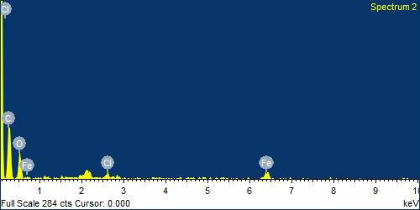
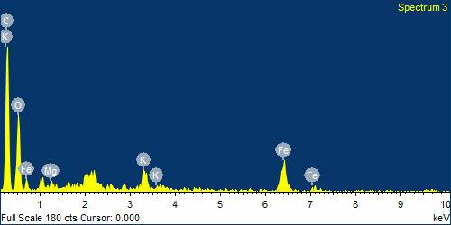
A
B

Fig. S3. EDS analysis GL-nZVI before treatment with cyanide (A) and after treatment with cyanide (B) (Dose of nZVI=2g/L, pH=10, Temperature=25°C, Time =28 hr, Cyanide concentration=100 mg/L)

Fig. S4. X-ray powder diffraction pattern of nZVI (A) before cyanide treatment and (B) after cyanide treatment.

Fig. S5. Correlation between actual and predicted values of percent cyanide removal

Fig. S6. Determination of point of zero charge (pH_{PZC}) of GL-nZVI

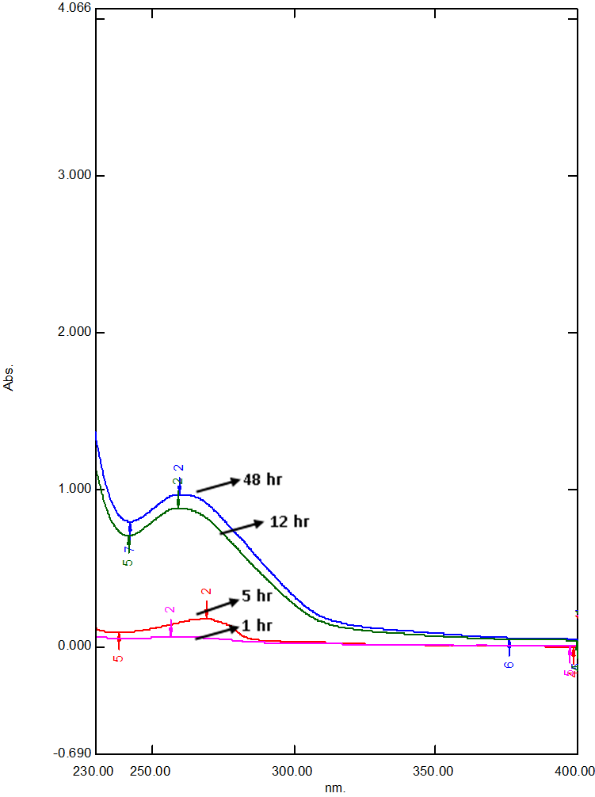
Wavelength (nm)
Absorbance

Fig. S7. UV- spectrophotometric analysis of cis, cis muconic acid production during phenol biodegradation by Pseudomonas BSPS_PHE2

