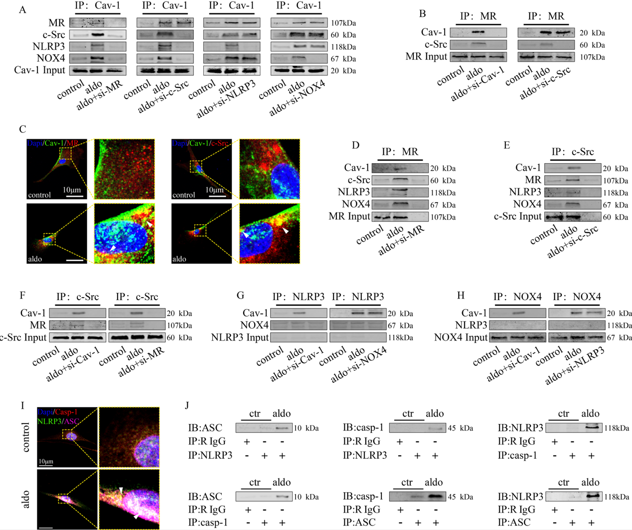
Supplemental Figure 1
Aldo induces the interaction between MR, c-Src, NLRP3 and NOX4 in HSCs and promotes NLRP3 inflammasome assembly.
(A) Co-immunoprecipitation was used to detect the interaction between Cav-1 and MR, NLRP3, NOX4, c-Src proteins in primary rat HSCs after Aldo stimulation. (B) Co-immunoprecipitation was used to detect the interaction between MR and Cav-1, c-Src proteins in primary rat HSCs after Aldo stimulation. (C) The co-localization of Cav-1, MR and c-Src in primary rat HSCs was determined by IF after Aldo stimulation. (D-H) Co-immunoprecipitation was used to detect the interaction among Cav-1, MR, NLRP3, NOX4 and c-Src proteins after Aldo stimulation. (I) The co-localization of NLRP3, ASC and caspase-1 in primary rat HSCs was determined by immunofluorescence after Aldo stimulation. (J) Co-immunoprecipitation was used to detect the interaction among NLRP3, ASC and caspase-1 proteins after Aldo stimulation.

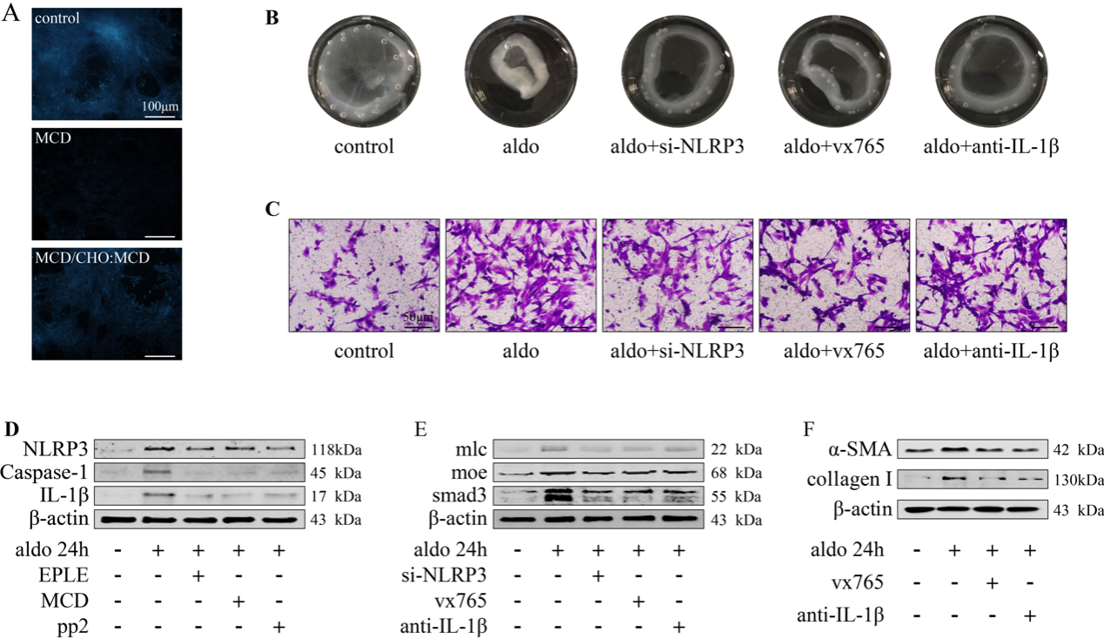
Supplemental Figure 2
Aldo induction of NLRP3 inflammasome associated inflammation is dependent on the intact caveolae structure.
(A) Ultraviolet light was used to detect cholesterol depletion and reloading in primary rat HSCs by MCD or MCDC. (B) Gel contract assay of primary rat HSCs. (C) Cell migration experiment of primary rat HSCs (scale bar: 50 μm). (D-F) Immunoblot for relative protein expression in primary rat HSCs.

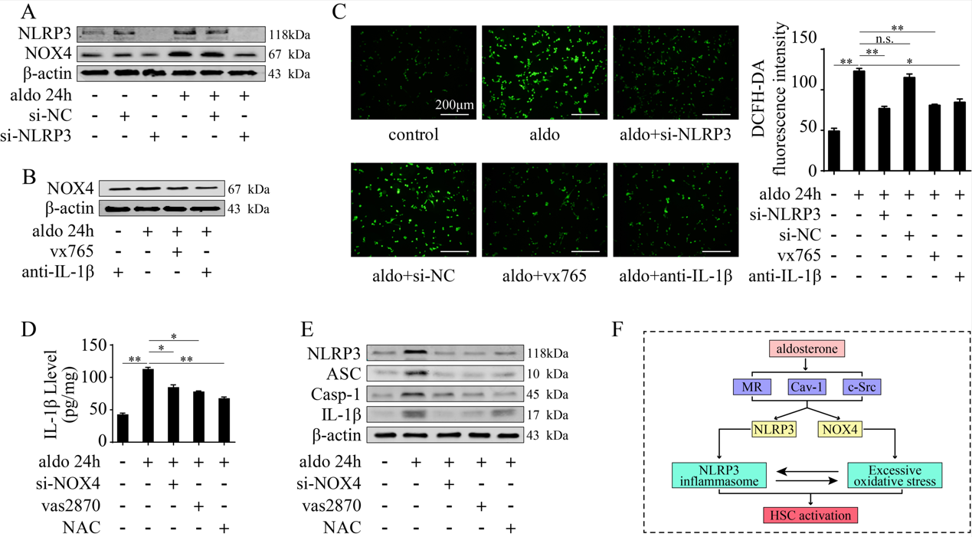
Supplemental Figure 3
The NLRP3 inflammasome and NOX4 functions in the HSCs induced by Aldo have interactive effects.
(A,B) Immunoblot for NLRP3 and NOX4 expression in primary rat HSCs. (C) DCFH-DA was used to detect ROS levels in primary rat HSCs. (D) Testing of serum IL-1β in primary rat HSCs. (E) Immunoblot for NLRP3, Caspase-1, ASC and IL-1β expression in primary rat HSCs. (F) Schematic diagram of Aldo induces NLRP3 inflammasome and NOX4 proteins in HSCs in a caveolae-dependent manner to play their functions and their interactive regulatory roles. Data in C is reported as the mean ± SD with an indicated significance (*p <0.05, **p <0.01, ***p <0.001, n.s.: not significant; One-way ANOVA).

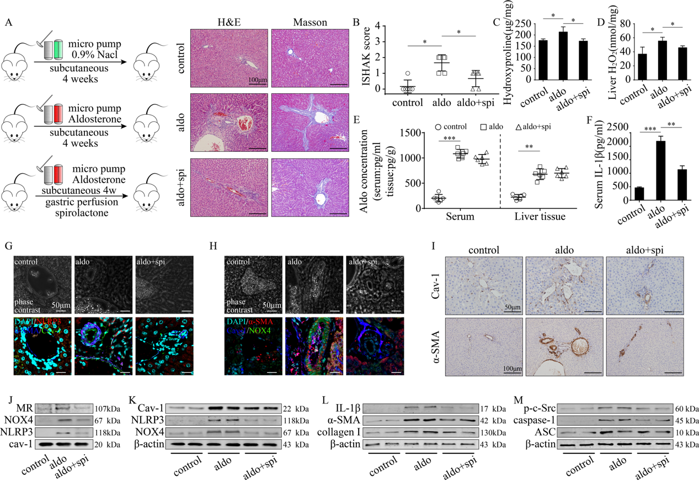
Supplemental Figure 4
Aldo-continuous pumping induces HSCs activation and liver fibrosis via MR dependent pathway in rats
(A) Rat liver sections from each group were stained with H&E and Masson (scale bars, 100 μm). (B) ISHAK score of rat liver fibrosis. (C) Liver hydroxyproline levels were detected in each group. (D) Liver hydrogen peroxide testing of each group. (E) Serum and liver Aldo were detected in each group. (F) Testing of serum IL-1β in each group. (G,H) Representative images of α-SMA/Cav-1/NLRP3 and α-SMA/Cav-1/NOX4 IF of each group (scale bars, 50μm). (I) Cav-1 and α-SMA in each group were detected by IHC. (J) Immunoblot for relative protein expression in caveolae of primary rat HSCs. (K-M) Immunoblot for relative protein expression in primary rat HSCs. Data in B-F are reported as the mean ± SD with an indicated significance (*p <0.05, **p <0.01, ***p <0.001, n.s.: not significant; One-way ANOVA).

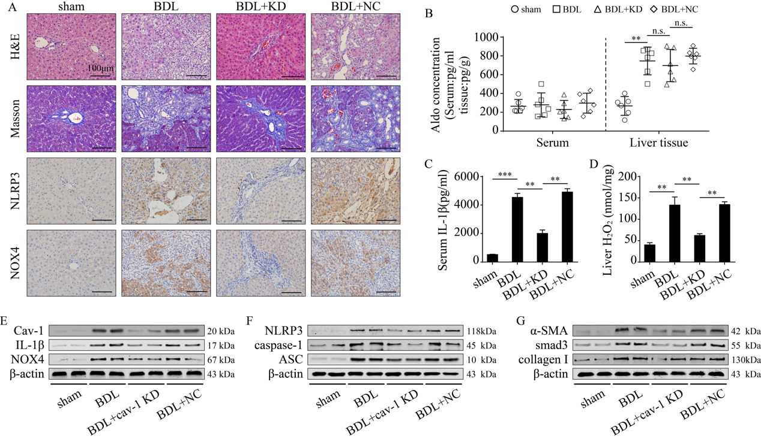
Supplemental Figure 5
Knockdown of Cav-1 in HSCs suppresses BDL-induced liver fibrosis in rats
(A) Rat liver sections from each group were stained with H&E and Masson, protein NLRP3 and NOX4 in each group were detected by IHC(scale bars, 100μm). (B) Serum and liver Aldo were detected in each group. (C) Testing of serum IL-1β in each group. (D) Liver hydrogen peroxide testing of each group. (E-F) Immunoblot for relative protein expression in primary rat HSCs. Data in B-D are reported as the mean ± SD with an indicated significance (*p <0.05, **p <0.01, ***p <0.001, n.s.: not significant; One-way ANOVA).

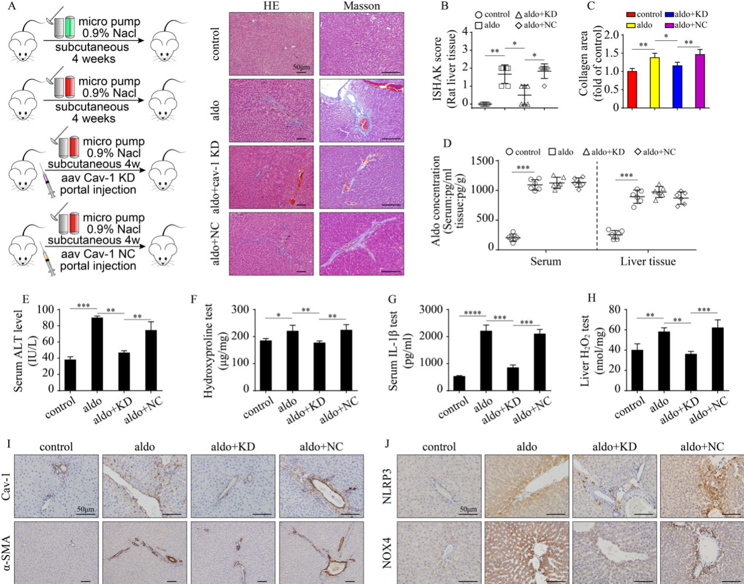
Supplemental Figure 6
Knockdown of Cav-1 in HSCs suppresses Aldo-induced liver fibrosis in rats
(A) Rat liver sections from each group were stained with H&E and Masson; scale bars, 100μm. (B) ISHAK score of rat liver fibrosis. (C) Collagen area of Masson staining. (D) Serum and liver Aldo were detected in each group. (E) Testing of serum ALT in each group. (F) Liver hydroxyproline levels were detected in each group. (G) Testing of serum IL-1β in each group. (H) Liver hydrogen peroxide testing of each group. (I,J) Immunoblot for relative protein expression in primary rat HSCs. Data in B-H are reported as the mean ± SD with an indicated significance (*p <0.05, **p <0.01, ***p <0.001, n.s.: not significant; One-way ANOVA).

