Temporal and spatial transcriptomic analysis of neutrophils and monocyte/macrophages in intracerebral hemorrhage

Supplemental data
Supplemental Figure S1. Cell populations in peripheral blood and hematoma of ICH patients. Single-cell transcriptomic analysis (tSNE plots) of peripheral blood (P-PB) (A) and hematoma (P- Hematoma) (B).

Supplemental Figure S2. Annotation of cell clusters according to surface markers in peripheral blood. Single-cell transcriptomic analysis (SingleR) of peripheral blood (P-PB) in ICH patients.

Supplemental Figure S3. Annotation of cell clusters according to surface markers in hematoma. Single-cell transcriptomic analysis (SingleR) of hematoma (P- Hematoma) in ICH patients.

Supplemental Figure S4. Gene co-expression networks at the geographical level. (A) Monocyte/macrophages in peripheral blood between ICH patients and healthy individuals. (B) Monocyte/macrophages between peripheral blood and hematoma in ICH patients. (C) Neutrophils in peripheral blood between ICH patients and healthy individuals. (D) Neutrophils between peripheral blood and hematoma in ICH patients. P-PB, peripheral blood of ICH patients; P-Hematoma, hematoma of ICH patients; H-PB, peripheral blood of healthy individual.

Supplemental Figure S5. Gene co-expression network at the temporal level. (A) Monocyte/macrophages in peripheral blood between ICH patients and healthy individuals. (B) Monocyte/macrophages between peripheral blood and hematoma in ICH patients. (C) Neutrophils in peripheral blood between ICH patients and healthy individuals. (D) Neutrophils between peripheral blood and hematoma in ICH patients. P-PB, peripheral blood of ICH patients; P-Hematoma, hematoma of ICH patients; H-PB, peripheral blood of healthy individual.

Figure S1

Figure S2

Figure S3

Figure S4
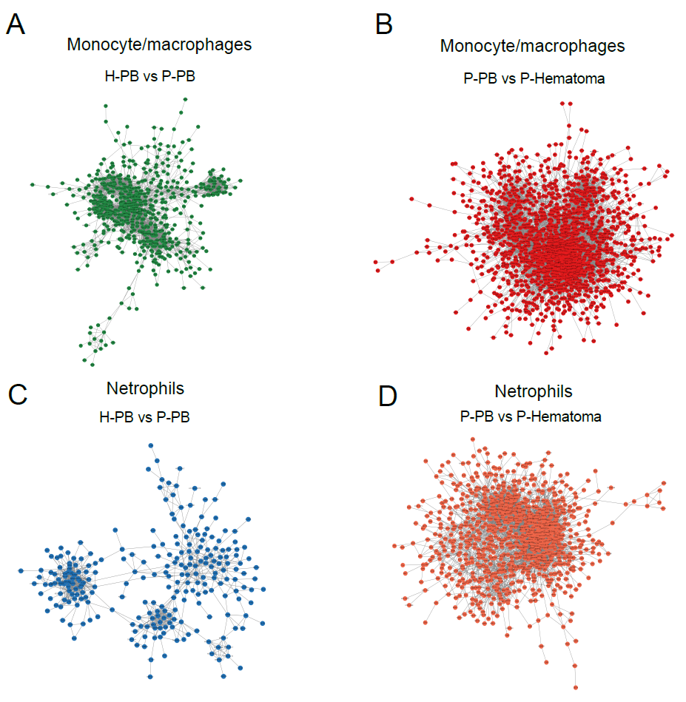

Figure S5

