Measuring employees’ perceptions of sustainability transitions at work – A novel survey method with findings from Finland
Discover Sustainability
Fanni Moilanen¹², Arho Toikka²
¹Finnish Institute of Occupational Health, ²University of Helsinki
fanni.moilanen@ttl.fi

Appendix A Polychoric factor loadings of the measurements

1. Workplace sustainability
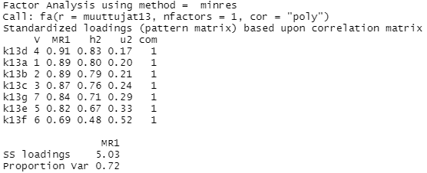
2. Employer’s sustainable actions
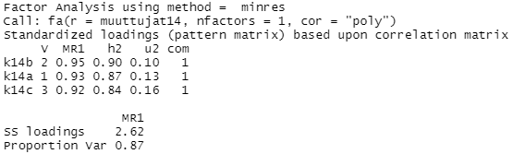

3. Work organization’s sustainability actions
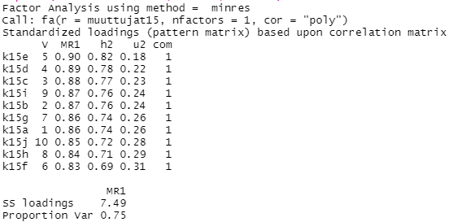
4. Sustainability skills training
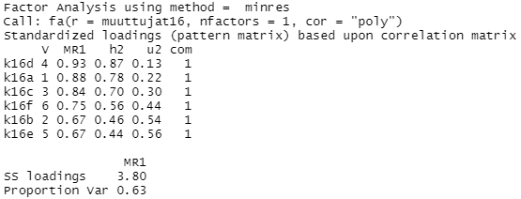
5. Sustainable work environment
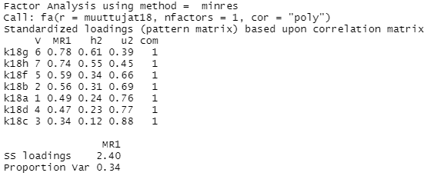

6. Own sustainable actions
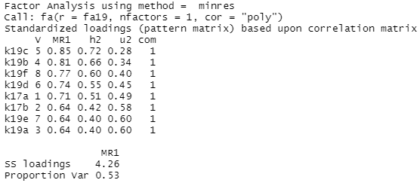
7. Awareness of new occupational safety and health risks
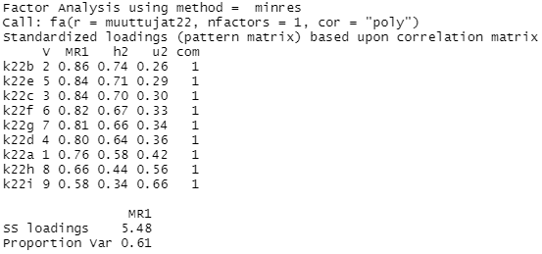
8. Preparedness to hot working conditions
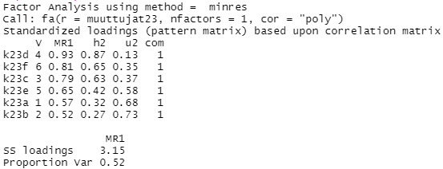

9. Climate change related worries and opportunities
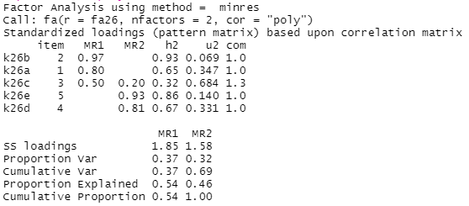
10. Sustainability values
