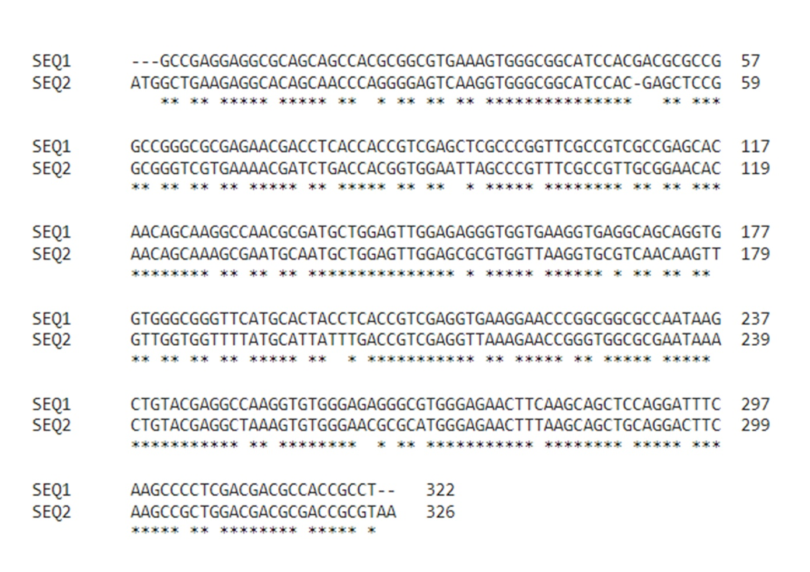

Figure S1. Multiple sequence alignment of OC II protein coding region before and after codon optimization. SEQ1 refers to the coding sequence before codon optimization and SEQ2 refers to the codon-optimized sequence. * Describes the similarity between two sequences after optimization.

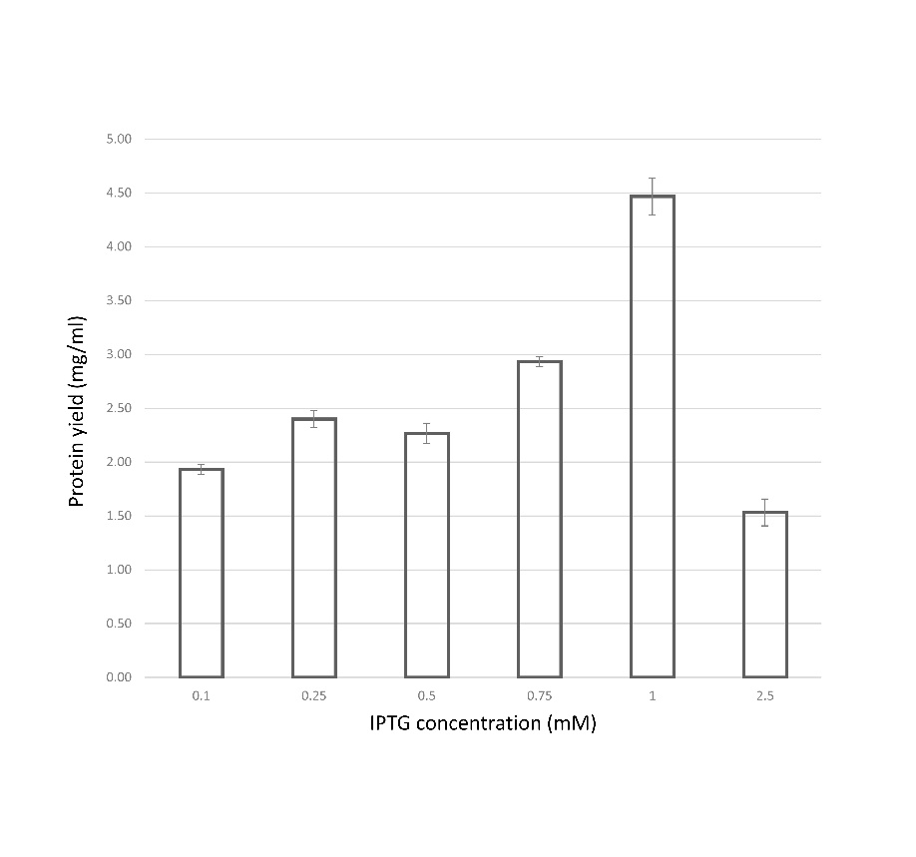
Figure S2. Expression standardization of OC II protein through different IPTG concentrations. 0.1, 0.25, 0.5, 0.75, 1 and 2.5 mM IPTG concentrations were used and respective protein yields were depicted. Increasing IPTG concentration resembled OC II protein expression. 1mM IPTG concentration exhibited a higher yield of purified protein than other concentrations.

