KNN

May 1, 2023

[1]:
## plt as Jlotting the graph
## numpy for array implementation ## pandas for reading csv file
## seaborn as heatmap
## rcParams for provides a way to customize default settings and behavior of␣
𝗌Matplotlib plots using a dictionary of key-value pairs.

[5]:
import numpy as np
import matplotlib.pyplot as plt import pandas as pd
from matplotlib import rcParams
from matplotlib.cm import rainbow
%matplotlib inline
import warnings
warnings.filterwarnings('ignore')

[28]:
from sklearn.neighbors import KNeighborsClassifier
[29]:
df = pd.read_excel('C:/Users/hp/Desktop/KNN.xlsx')
[30]:
df
[30]: age sex cp trestbps chol fbs restecg thalach exang oldpeak \ 0 37 1 0 140 200 0 1 175 0 1.0
1 32 0 1 130 204 0 0 172 0 1.4
2 56 1 1 120 236 0 1 178 0 0.8
3 57 0 0 120 354 0 1 163 1 0.6
4 57 1 0 140 192 0 1 148 0 0.4
.. … … .. … … … … … … …
299 45 1 3 110 264 0 1 132 0 1.2
300 68 1 0 144 193 1 1 141 0 3.4
301 57 1 0 130 131 0 1 115 1 1.2
302 57 0 1 130 236 0 0 174 0 0.0
303 57 0 1 130 236 0 0 174 0 0.0

slope ca thal target 0 1 0 2 1
1 2 0 2 1

[31]:
[32]:

[33]:
[34]:
df.describe()
2 2 0 2 1
3 2 0 2 1
4 1 0 1 1
.. … .. … …
299 1 0 3 0
300 1 2 3 0
301 1 1 3 0
302 1 1 2 0
303 1 1 2 0
[304 rows x 14 columns]
## df.info prints data type of each column
df.info()

<class 'pandas.core.frame.DataFrame'> RangeIndex: 304 entries, 0 to 303 Data columns (total 14 columns):
# Column Non-Null Count Dtype

- age 304 non-null int64
- sex 304 non-null int64
- cp 304 non-null int64
- trestbps 304 non-null int64
- chol 304 non-null int64
- fbs 304 non-null int64
- restecg 304 non-null int64
- thalach 304 non-null int64
- exang 304 non-null int64
- oldpeak 304 non-null float64
- slope 304 non-null int64
- ca 304 non-null int64
- thal 304 non-null int64
- target 304 non-null int64 dtypes: float64(1), int64(13)
memory usage: 33.4 KB
## df.describe mean count standardization of each column in the dataset

[34]: age sex cp trestbps chol fbs \ count 304.000000 304.000000 304.000000 304.000000 304.000000 304.000000
mean 54.243421 0.674342 0.944079 131.838816 246.720395 0.138158
std 9.104814 0.469393 1.024533 17.709901 51.856403 0.345635
min 29.000000 0.000000 0.000000 94.000000 126.000000 0.000000
25% 47.750000 0.000000 0.000000 120.000000 211.000000 0.000000

[35]:
50% 55.000000 1.000000 1.000000 130.000000 240.500000 0.000000
75% 61.000000 1.000000 2.000000 140.000000 275.000000 0.000000
max 77.000000 1.000000 3.000000 200.000000 564.000000 1.000000

restecg thalach exang oldpeak slope ca \ count 304.000000 304.000000 304.000000 304.000000 304.000000 304.000000
mean 0.536184 149.740132 0.328947 1.034868 1.404605 0.730263
std 0.531521 22.786024 0.470605 1.156201 0.605894 1.021035
min 0.000000 71.000000 0.000000 0.000000 0.000000 0.000000
25% 0.000000 133.000000 0.000000 0.000000 1.000000 0.000000
50% 1.000000 153.000000 0.000000 0.800000 1.000000 0.000000
75% 1.000000 166.250000 1.000000 1.600000 2.000000 1.000000
max 2.000000 202.000000 1.000000 6.200000 2.000000 4.000000

thal target count 304.000000 304.000000
mean 2.315789 0.539474
std 0.607120 0.499261
min 0.000000 0.000000
25% 2.000000 0.000000
50% 2.000000 1.000000
75% 3.000000 1.000000
max 3.000000 1.000000
## checking correlation of all the features (if it comes +ve then the factors␣
𝗌have +ve corelation with the mode if it comes -ve then the factors have -ve␣
𝗌correlation with the model)

[36]:
import seaborn as sns
#obtain the correlation of each feature in dataset
corrmat = df.corr() top_corr_features = corrmat.index plt.figure(figsize=(20,20))
#plot heat map sns.heatmap(df[top_corr_features].corr(),annot=True,cmap='RdYlGn') plt.show()

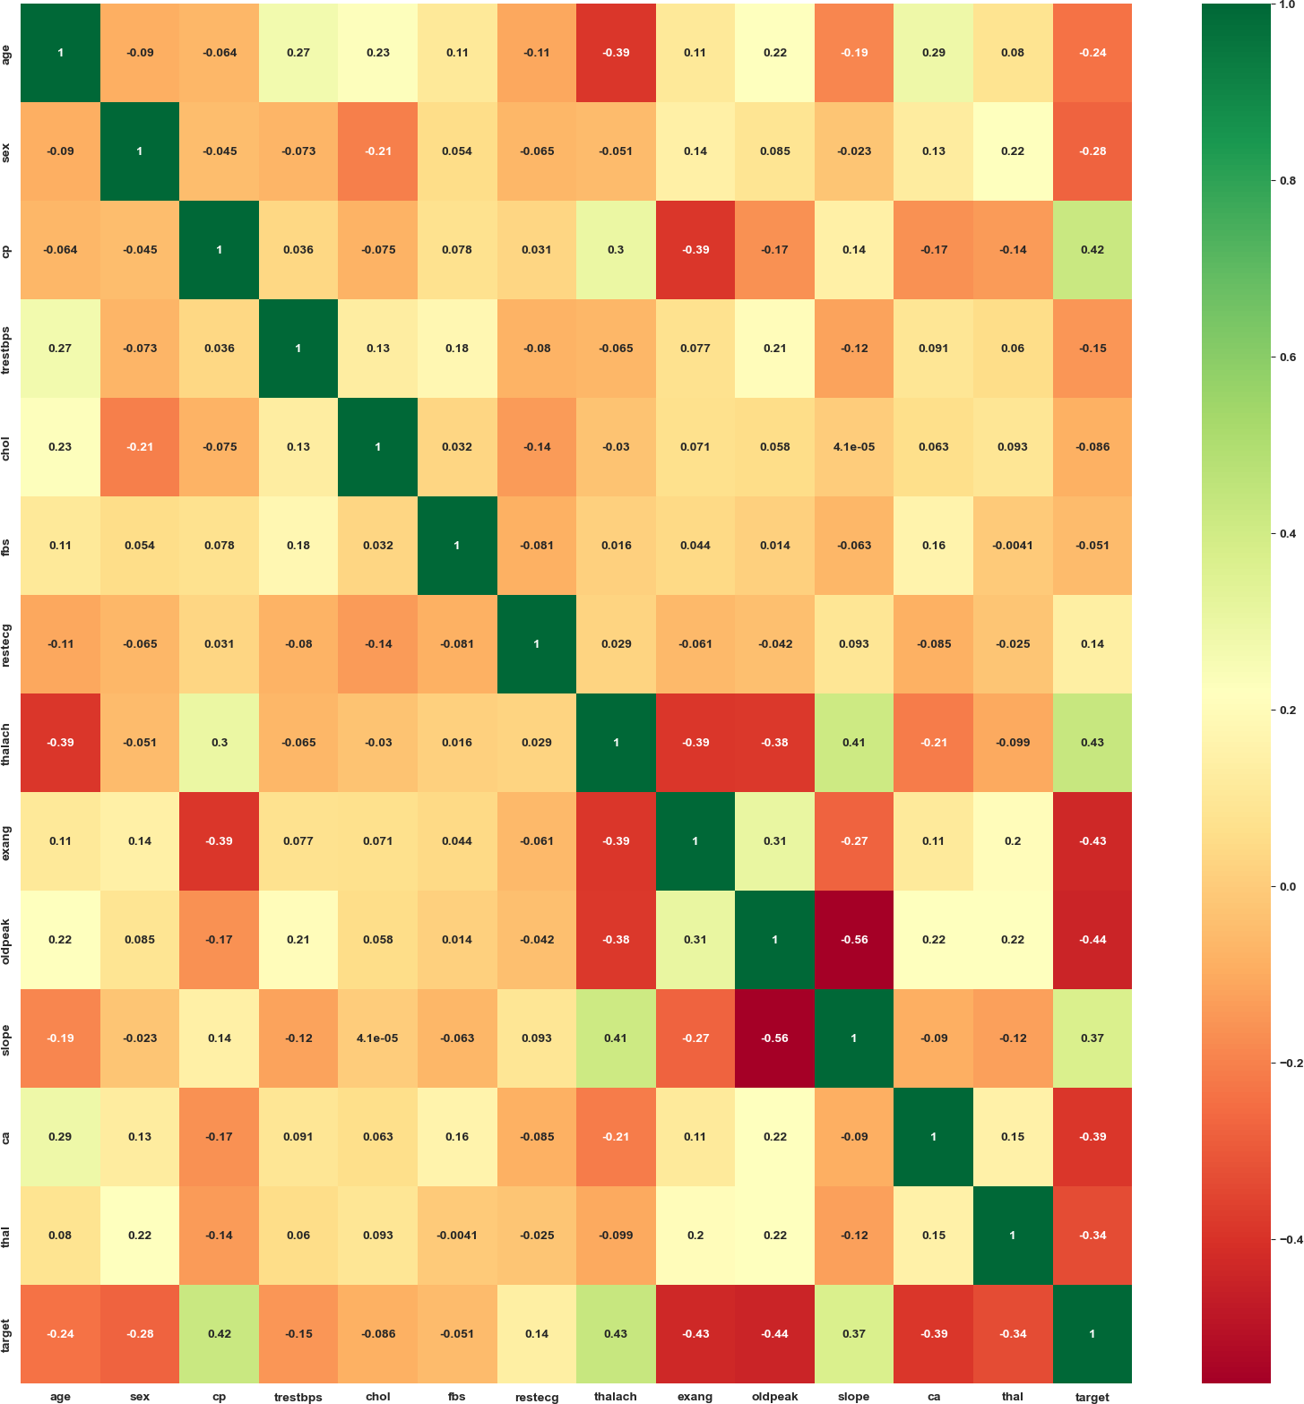

[37]:
## it will create histogram of all the columns in df
[38]:
df.hist(figsize=(14,14)) plt.show()

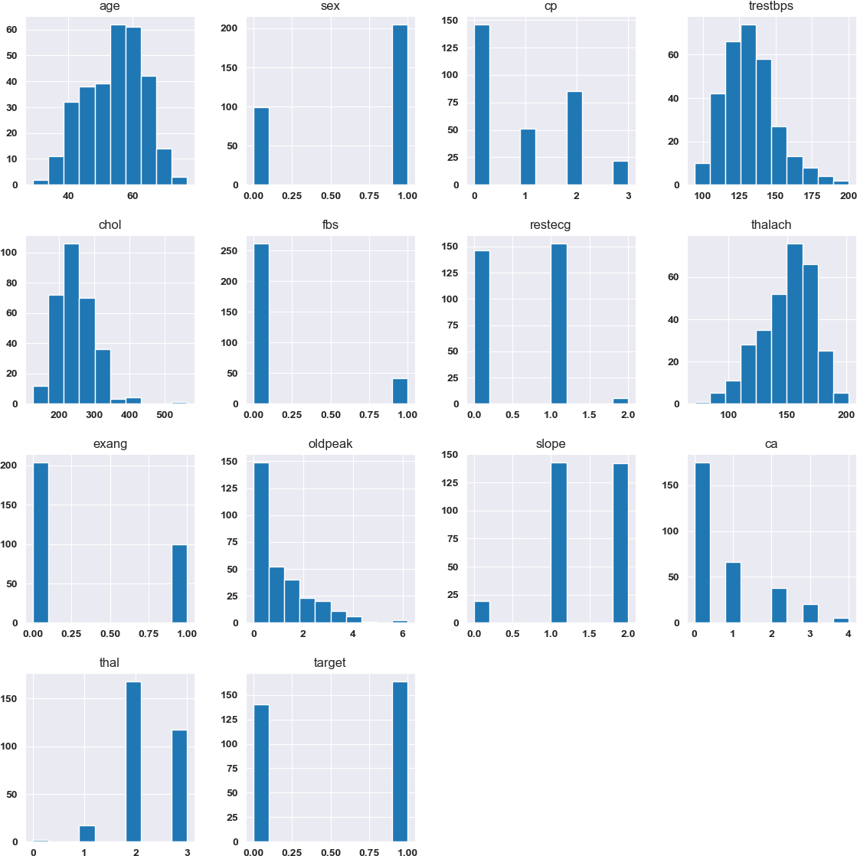

[39]:
## countplot whether the dataset is balanced or not
[40]:
sns.set_style('darkgrid') sns.countplot(x='target',data=df,palette='RdBu_r') plt.show()

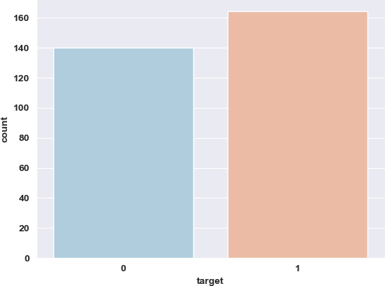

[41]:
##In data processing, the categorical values are converted to dummy variables␣
𝗌and scale all the values before training the machine leraning models.

[42]:
dataset = pd.get_dummies(df,columns = ['sex' , 'cp', 'fbs', 'restecg', 'exang',␣
𝗌'slope', 'ca', 'thal'])

[43]:
from sklearn.model_selection import train_test_split from sklearn.preprocessing import StandardScaler standardScaler = StandardScaler()
columns_to_scale = ['age', 'trestbps', 'chol', 'thalach', 'oldpeak'] dataset[columns_to_scale] = standardScaler.
𝗌fit_transform(dataset[columns_to_scale])

[44]:
dataset.head()
[44]: age trestbps chol thalach oldpeak target sex_0 sex_1 \ 0 -1.897002 0.461586 -0.902443 1.110396 -0.030207 1 0 1
1 -2.447068 -0.104001 -0.825179 0.978520 0.316324 1 1 0
2 0.193247 -0.669588 -0.207073 1.242273 -0.203473 1 0 1
3 0.303260 -0.669588 2.072193 0.582889 -0.376739 1 1 0
4 0.303260 0.461586 -1.056969 -0.076494 -0.550004 1 0 1

[45]:
cp_0 cp_1 … slope_2 ca_0 ca_1 ca_2 ca_3 ca_4 thal_0 thal_1 \ 0 1 0 … 0 1 0 0 0 0 0 0
1 0 1 … 1 1 0 0 0 0 0 0
2 0 1 … 1 1 0 0 0 0 0 0
3 1 0 … 1 1 0 0 0 0 0 0
4 1 0 … 0 1 0 0 0 0 0 1

thal_2 thal_3 0 1 0
1 1 0
2 1 0
3 1 0
4 0 0
[5 rows x 31 columns]
y=dataset['target'] x=dataset.drop(['target'],axis=1)
X_train, X_test, y_train, y_test = train_test_split(x, y, test_size = 0.33,␣
𝗌random_state = 0)

[46]:
knn_scores = []
for k in range(1, 21):
knn_classifier = KNeighborsClassifier(n_neighbors = k) knn_classifier.fit(X_train, y_train) knn_scores.append(knn_classifier.score(X_test, y_test))

[47]:
plt.plot([k for k in range(1,21)],knn_scores,color='blue')
for i in range(1,21):
plt.text(i, knn_scores[i-1], (i, knn_scores[i-1])) plt.xticks([i for i in range(1, 21)])
plt.xlabel('Number of Neighbors (K)',color='Red',weight='bold',fontsize='12') plt.ylabel('Scores',color='Red',weight='bold',fontsize='12')
plt.title('K Neighbors Classifier scores for different K␣
𝗌values',color='Red',weight='bold',fontsize='24')
plt.show() plt.rcParams["font.weight"]= "bold"
plt.rcParams["axes.labelweight"] = "bold"

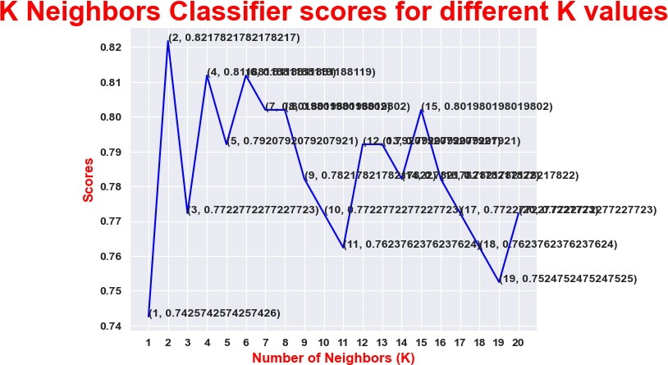

[48]:
from sklearn.model_selection import cross_val_score knn_classifier = KNeighborsClassifier(n_neighbors = 12) score=cross_val_score(knn_classifier,x,y,cv=10)

[49]:
score.mean()
[49]: 0.841720430107527 [ ]:

