Supplemental Figure 1. Calculation of the inter-electrode distance, D
Supplemental Figure 2. Optimized electrode montage for subject S3 and S13
Supplemental Table 1. Distance between conventional tDCS electrodes and optimized tDCS electrodes
Supplemental Table 2. Electric field intensity at target region in conventional and optimized tDCS

Supplemental Figure 1. Calculation of the inter-electrode distance, D
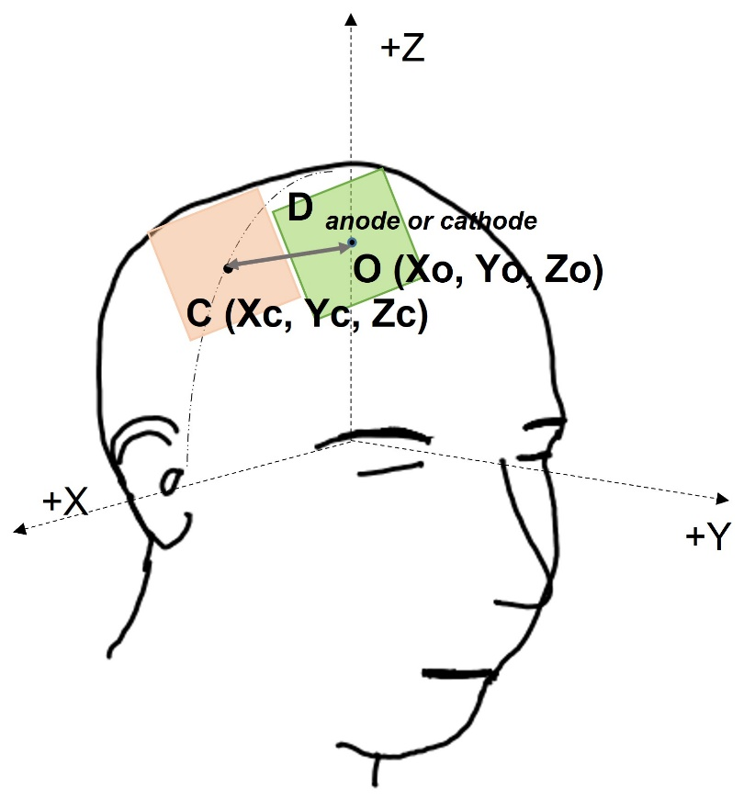
The orange electrode is the conventional tDCS electrode, and the green electrode is the optimized tDCS electrode. The inter-electrode distance, D was calculated using the following formula
D= $\sqrt{({X{c-Xo)}^{2}+{(Yc-Yo)}^{2}+(Zc-Zo)}^{2}}$,
where Xo, Yo, and Zo are NIfTI coordinate values for the center of the optimized tDCS electrode, and Xc, Yc, and Zc are NIfTI coordinate values for the center of the conventional tDCS electrode. D_{anode} represents the Euclidian distance from the center of the conventional tDCS anode to the center of the optimized tDCS anode. D_{cathode} represents the Euclidian distance from the center of the conventional tDCS cathode to the center of the optimized tDCS cathode. The sum of D_{anode} and D_{cathode} is defined as the distance D, which represents the discrepancy of electrode positions between conventional tDCS and optimized tDCS.

Supplemental Figure 2. Optimized electrode montage for subject S3 and S13
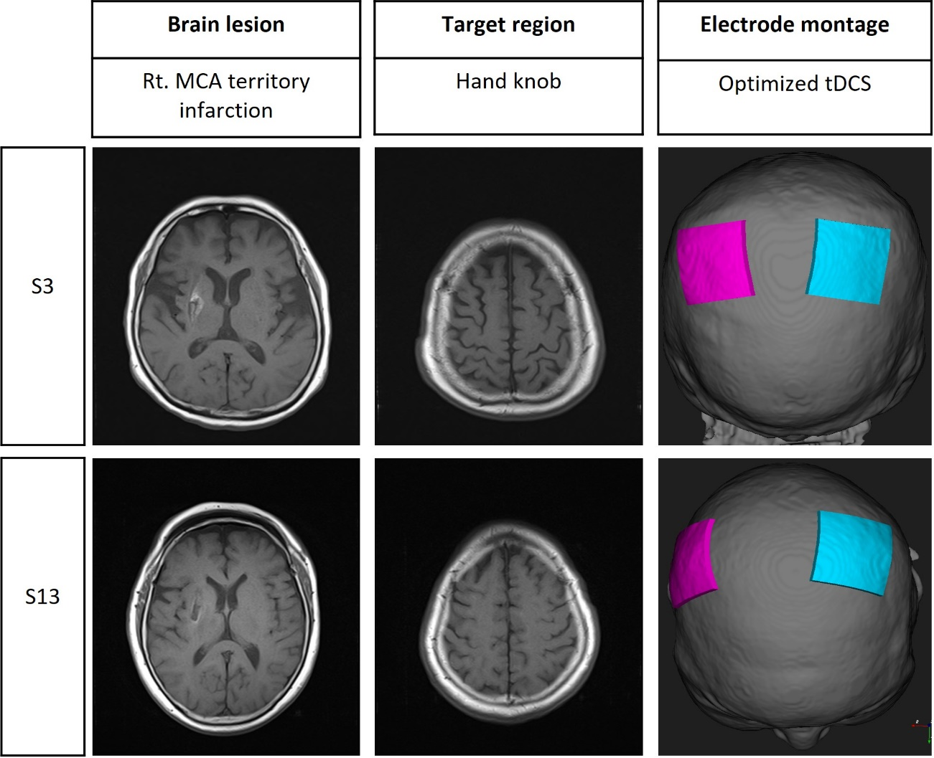
Left column shows MRI image of scar remaining after right middle cerebral artery territory infarction. Middle column shows MRI image corresponding to the hand knob area, which is the target of tDCS. Right column shows the montage pairs of optimized tDCS. The pink electrode represents the anode and the cyan electrode represents the cathode.

Supplemental Table 1. Distance between conventional tDCS electrodes and optimized tDCS electrodes
Patient | D_{cathode} (mm) | D_{anode} (mm) | D (mm)
S1 | 34.76 | 32.19 | 66.95
S2 | 46.40 | 26.98 | 73.38
S3 | 44.44 | 36.37 | 80.81
S4 | 38.24 | 23.13 | 61.37
S5 | 37.24 | 20.16 | 57.39
S6 | 41.45 | 16.66 | 58.10
S7 | 27.89 | 16.12 | 44.02
S8 | 32.60 | 31.21 | 63.80
S9 | 32.12 | 27.76 | 59.89
S10 | 44.69 | 18.46 | 63.15
S11 | 37.88 | 41.72 | 79.60
S12 | 28.87 | 29.42 | 58.29
S13 | 41.67 | 30.99 | 72.66
S14 | 42.07 | 23.28 | 65.35
S15 | 31.41 | 19.99 | 51.40
S16 | 30.57 | 29.67 | 60.23
S17 | 29.56 | 7.28 | 36.84
S18 | 42.43 | 17.77 | 60.20
S19 | 40.05 | 17.10 | 57.15
S20 | 27.96 | 26.04 | 54.01
S21 | 38.63 | 15.48 | 54.12
median  [IQR] | 37.87  [31.19-41.76] | 23.28  [17.60-29.99] | 60.21  [57.14-66.94]

D_{anode} represents the Euclidian distance from the center of conventional tDCS anode to the center of optimized tDCS anode. D_{cathode} represents the Euclidian distance from the center of conventional tDCS cathode to the center of optimized tDCS cathode. D is the sum of D_{cathode} and D_{anode}. IQR, interquartile range.
Supplemental Table 2. Electric field intensity at target region in conventional and optimized tDCS
Patient | Conventional EF (V/m) | Optimized EF (V/m) | Improvement (%)
S1 | 0.27 | 0.41 | 52
S2 | 0.32 | 0.37 | 16
S3 | 0.24 | 0.26 | 8
S4 | 0.38 | 0.45 | 18
S5 | 0.29 | 0.36 | 24
S6 | 0.3 | 0.36 | 20
S7 | 0.67 | 0.77 | 15
S8 | 0.21 | 0.27 | 29
S9 | 0.32 | 0.40 | 25
S10 | 0.24 | 0.29 | 21
S11 | 0.12 | 0.18 | 50
S12 | 0.29 | 0.33 | 14
S13 | 0.31 | 0.40 | 29
S14 | 0.34 | 0.41 | 21
S15 | 0.35 | 0.37 | 6
S16 | 0.33 | 0.42 | 27
S17 | 0.45 | 0.51 | 13
S18 | 0.29 | 0.32 | 10
S19 | 0.22 | 0.24 | 9
S20 | 0.29 | 0.29 | 0
S21 | 0.30 | 0.34 | 13
median [IQR] | 0.30  [0.26-0.33] | 0.36  [0.29-0.41] | P value <0.001

Improvement (%) was calculated as ((electric field during optimized tDCS minus electric field during conventional tDCS)/electric field during conventional tDCS) x 100%. P value was derived from Wilcoxon signed rank test. IQR, interquartile range, EF, electric field intensities.

