Supplementary Material
Hemodynamic Profile of decompensated cirrhotic Patients with Sepsis and Septic Shock: A retrospective cohort study with propensity score matching.

¹Jee Young You, MD (YouJ2@ccf.org)
²Ryota Sato, MD (st051035@gmail.com)
^{1,3}Abhijit Duggal, MD, MPH, MSc, FACP (duggala2@ccf.org)
¹Sanchit Chawla, MD (chawlas@ccf.org)
¹Aanchal Kapoor, MD (Kapoora@ccf.org)
⁴Xiaofeng Wang, Ph.D. (wangx6@ccf.org)
⁵Patrick Collier, MD, Ph.D., FASE (colliep@ccf.org )
^{3,6, 7} Georg, Auzinger AFICM FRCP EDIC (auzingg2@ccf.org)
^{1,3}Siddharth Dugar, MD FCCM FASE (dugars@ccf.org)

Corresponding Author: Siddharth Dugar, MD
Tel: +1(216)337-4495, Email: dugars@ccf.org, Address: 9500 Euclid Avenue, Cleveland, OH, USA 44195

Table of Content | Page No.
Supplementary Text T1 | 3
Supplementary Text T2 | 4
Supplementary Table S1 | 5-6
Supplementary Table S2 | 7
Supplementary Table S3 | 8
Supplementary Table S4 | 9
Supplementary Table S5 | 10
Supplementary Table S6 | 11
Supplementary Table S7 | 12
Supplementary Figure E1 | 13
Supplementary Figure E2 | 13
Supplementary Figure E3 | 14
Supplementary Figure E4 | 14
Supplementary Figure E5 | 15
Supplementary Figure E6 | 16

Supplementary Text T1

Materials and methods:

Sepsis 3.0 definition for identification of patient with sepsis and septic shock on admission to ICU.

- Had a clinically suspected or confirmed infection by treating physician
- qSOFA score of ≥ 2
- Septic shock as above requiring an infusion of any dose of vasopressor and serum lactate 2mmol/L.

References
- Singer M, Deutschman CS, Seymour CW, Shankar-Hari M, Annane D, Bauer M, Bellomo R, Bernard GR, Chiche JD, Coopersmith CM, Hotchkiss RS, Levy MM, Marshall JC, Martin GS, Opal SM, Rubenfeld GD, van der Poll T, Vincent JL, Angus DC. The Third International Consensus Definitions for Sepsis and Septic Shock (Sepsis-3). JAMA 2016; 315: 801-810.

Supplementary Text T2

Echocardiographic measurements of Ea, Ees, and V-A coupling

Arterial Elastance (Ea), the slope of the end-systolic pressure-stroke volume relationship represents the pressure (mmHg) necessary to create stroke volume (SV) per unit (ml). It is used as a load independent surrogate of arterial afterload. Ventricular arterial coupling (Ea/Ees), a ratio between arterial elastance (Ea) and LV end-systolic elastance (Ees) represents cardiac contractility independent from afterload(1, 2). Ea was calculated as follows: 0.9 x [systolic blood pressure (SBP)] / SV. Ees was calculated by a simplified approach as follows: 0.9 x SBP / [LV end-systolic volume (LVESV)](3). These parameters to calculate Ea and Ees were obtained from electronic health records at the time of performance of echocardiogram and echocardiogram. We calculated ventricular arterial coupling as Ea/Ees. Systemic vascular resistance (SVR) was calculated as follows: [mean arterial pressure (MAP) – central venous pressure (CVP)] x 80 / [cardiac output (CO)], where CVP was estimated based on ASE recommendations(4).

Reference

1. Pinsky MR, Guarracino F. How to assess ventriculoarterial coupling in sepsis. Curr Opin Crit Care 2020;26:313-318.
2. Kwon HM, Moon YJ, Jung KW, Park YS, Kim KS, Jun IG, Song JG, et al. Appraisal of Cardiac Ejection Fraction With Liver Disease Severity: Implication in Post–Liver Transplantation Mortality. Hepatology 2020;71:1364-1380.
3. Antonini-Canterin F, Poli S, Vriz O, Pavan D, Bello VD, Nicolosi GL. The Ventricular-Arterial Coupling: From Basic Pathophysiology to Clinical Application in the Echocardiography Laboratory. J Cardiovasc Echogr 2013;23:91-95.
4. Rudski LG, Lai WW, Afilalo J, Hua L, Handschumacher MD, Chandrasekaran K, Solomon SD, et al. Guidelines for the Echocardiographic Assessment of the Right Heart in Adults: A Report from the American Society of Echocardiography. Journal of the American Society of Echocardiography 2010;23:685-713.

Supplementary Table S1: Patient characteristics and echocardiographic parameters before the propensity score matched case control.
Characteristics | N | Cirrhosis (+)  (N = 422) | Cirrhosis (-)  (N = 2,729) | P-Value
 | Patient Characteristics
Age (Years) | 3,151 | 58 (51 – 66) | 65 (54 – 74) | < 0.001
Sex (Female) (n, %) | 3,151 | 186 (44.2%) | 1,310 (48.0%) | 0.157
Apache III Score | 3,143 | 103 (87 – 124) | 84 (66-106) | < 0.001
Body Mass Index (kg/m²) |  | 29.7 (25.0 – 35.5) | 28.1 (23.4 – 34.0) | < 0.001
Chronic dialysis (n, %) | 3,151 | 58 (13.8%) | 361 (13.2%) | 0.758
COPD (n, %) | 3,151 | 100 (23.8%) | 691 (25.2%) | 0.507
Diabetes (n, %) | 3,151 | 120 (28.5%) | 863 (31.6%) | 0.214
Immunosuppression (n, %) | 3,151 | 63 (15.0%) | 759 (27.8%) | < 0.001
Malignancy (n, %) | 3,151 | 36 (8.6%) | 659 (24.2%) | < 0.001
Heart Failure (n, %) | 3,151 | 61 (14%) | 618 (23%) | < 0.001
SBP (mmHg) | 2,824 | 103 (92 – 119) | 106 (96 – 120) | 0.031
MAP (mmHg) | 2,824 | 86 (79 -98) | 91 (81 – 101) | 0.004
DBP (mmHg) | 2,824 | 55 (50 - 62) | 58 (53 – 65) | < 0.001
WBC (k/ µl) | 3,038 | 15 (7- 22) | 14 (7 - 21) | 0.029
Max 24 hr Lactate (mmol/L) | 3,074 | 3.8 (2.3 - 6.8) | 2.5 (1.5 - 4.6) | <0.001
Fluid balance on the day of echo (ml) | 3,109 | 3,000 (664 – 5,928) | 2,478 (485 – 5,408) | 0.064
Septic Shock | 1892 | 328 (77.5 %) | 1565 (57.3%) | <0.001
Maximum 24 hr NEE (µg/kg/min) | 1892 | 0.38 (0.16 – 0.79) | 0.33 (0.16 – 0.68) | 0.028
Epinephrine (n, %) |  | 65 (15.4 %) | 233 (8.5 %) | < 0.001
Other Inotropes# (n, %) |  | 16 (3.8 %) | 160 (5.7%) | 0.084
Cirrhosis Characteristics on ICU admission
Cause of Cirrhosis  Alcohol  Viral  Nash  Biliary  Others | 422 | 149 (35.3%)  88 (20.8%)  78 (18.5%)  24 (5.6%)  83 (19.7%)
Cirrhosis Complication  Hepatic Encephalopathy  Ascites  Esophageal Varices  Portal Hypertension | 422 | 344 (81.5%)  379 (89.9%)  283 (67.1%)  394 (93.3%)
MELD (IQR) | 408 | 26.9 (20 – 34.6)
MELD Na (IQR) | 408 | 29.9 (22.57 – 36.61)
Platelet Count (k/ µl) | 418 | 77 (44-126)
PT (sec) | 415 | 18.6 (14.5 – 24.9)
INR | 418 | 1.7 (1.4 – 2.38)
Albumin (g/dL) | 409 | 2.4 (1.9 – 2.9)
Bilirubin (mg/dL) | 412 | 4.00 (1.8 – 10.65)
 | Echocardiographic Parameters
LVEF (%) | 3,151 | 63.6 (55.8 – 69.2) | 56.7 (49.9 – 63.4) | < 0.001
E velocity (m/sec) | 2,491 | 0.95 (0.76 – 1.18) | 0.85 (0.66 – 1.05) | < 0.001
e’ lateral (m/sec) | 2,631 | 0.11 (0.09 – 0.13) | 0.09 (0.07 – 0.12) | < 0.001
e’ septal (m/sec) | 2,617 | 0.08 (0.07 – 0.10) | 0.07 (0.06 – 0.09) | < 0.001
E/A | 2,011 | 1.19 (0.87 – 1.52) | 1.00 (0.77 – 1.35) | < 0.001
E/e’ average | 2,089 | 9.80 (7.86 – 12.72) | 10.07 (7.63 – 13.13) | 0.263
CVP (mmHg) | 2,359 | 8 (3 – 8) | 8 (3-8) | 0.098
LA volume index (ml/m²) | 1,845 | 32.7 (25.3 – 42.3) | 29.7 (22.7 – 39.7) | 0.005
LVEDV (ml) | 2,270 | 96.5 (75.0 – 120.4) | 90.0 (67.8 – 114.9) | 0.003
LVESV (ml) | 2,267 | 33.6 (24.5 – 46.6) | 36.5 (25.6 – 53.2) | 0.010
TAPSE (cm) | 2,115 | 2.20 (1.80 – 2.62) | 1.90 (1.50 – 2.30) | < 0.001
RV TDI S’(cm/sec) | 2,722 | 14.0 (11.0 – 18.0) | 12.0 (9.5 – 15.0) | < 0.001
RVSP (mmHg) | 2,286 | 37.7 (30.2 – 45.5) | 39.2 (30.7 – 48.4) | 0.029
Ea | 2583 | 1.35 (1.02 – 1.77) | 1.90 (1.51 – 2.50) | < 0.001
Ees | 2093 | 2.83 (1.68 – 3.68) | 2.58 (1.68 – 3.68) | 0.030
Ea/Ees | 2026 | 0.48 (0.34 – 0.68) | 0.72 (0.48 – 1.18) | < 0.001
SV (ml) | 2693 | 72 (55 - 89) | 48 (37 – 76)) | < 0.001
LV Cardiac Output (L/min) | 2684 | 6.11 (4.71-7.65) | 4.54 (3.57 – 5.84) | < 0.001
 | Outcomes
In-hospital mortality (n, %) | 3,151 | 208 (49.4%) | 735 (26.9%) | < 0.001
ICU mortality (n, %) | 3,151 | 167 (39.7%) | 547 (20.1%) | < 0.001
30 days Hosp free days | 3,151 | 0.0 (0.0 – 12.0) | 8.0 (0.0 – 18.2) | < 0.001

Definition of abbreviations: COPD: chronic obstructive pulmonary disease, NEE = norepinephrine equivalent dose, SBP = systolic blood pressure, MAP = mean arterial pressure, DBP = diastolic blood pressure, LVEF = left ventricle ejection fraction, E/e’ = ratio between mitral E wave and tissue Doppler e’ wave, CVP = central venous pressure, LA = left atrium, LVEDV = left ventricle end-diastolic volume; LVESV = left ventricle end-systolic volume; LVEDD = left ventricle end-diastolic diameter; LVESV = left ventricle end-systolic diameter, TAPSE = tricuspid annular plane systolic excursion, RV TDI S’ = tricuspid annular peak systolic velocity, RVSP = right ventricle systolic pressure
# includes dopamine, dobutamine and milrinone

Supplementary Table S2: Proportion of patient with impaired diastolic dysfunction parameters in patients with sepsis (cirrhosis vs. non-cirrhosis) in unmatched cohort.

Diastolic Parameters | N | Cirrhotic  (N =422) | Non-Cirrhotic  (N = 2729) | P-Value
MV Lateral e’ < 0.10 | 1395 (53.0 %) | 38.2 % | 55.5 % | P < 0.0001
MV Septal e’ < 0.07 | 1011 (38.7 %) | 30.7 % | 40.0 % | P = 0.0026
Average E/e’ > 14 | 436 (20.1 %) | 18.2 % | 21.3 % | P = 0.2429
LAVI > 34 | 710 (38.5 %) | 45.9 % | 37.2 % | P = 0.0075
TR Jet > 2.8 m/sec | 1573(63.2 %) | 47.1 % | 66.5 % | P < 0.0001
At least 3 of above 5 criteria meet | 271 (15.3 %) | 9.6 % | 16.4 % | P = 0.0058

Supplementary Table S3: Sensitivity analysis in patients with sepsis (cirrhosis vs. non-cirrhosis) after the propensity score matched case control.

Characteristics | Cirrhosis (+)  (N = 96) | Cirrhosis (-)  (N = 95) | P-Value
Blood pressures on the day of echo
SBP (mmHg) | 107 (95 – 121) | 113 (100 – 126) | 0.068
MAP (mmHg) | 73 (66 - 80) | 81 (70 – 88) | 0.006
DBP (mmHg) | 56 (52 - 63) | 60 (55 – 70) | 0.001
Echocardiographic parameters
LVEF (%) | 62 (56 – 68) | 55 (40 – 60) | < 0.001
SV (ml) | 79 (66 – 87) | 46 (36 – 59) | < 0.001
LV Cardiac Output (L/min) | 6.54 (5.36 – 8.36) | 4.29 (3.42 – 5.28) | < 0.001
Ea | 1.24 (1.00 – 1.58) | 2.25 (1.59 – 3.05) | < 0.001
Ees | 2.55 (1.85 – 3.39) | 2.02 (1.13 – 1.85) | 0.070
Ea/Ees | 1.05 (0.59 – 1.99) | 0.5 (0.37 – 0.66) | < 0.001
SVR | 814 (619 – 1,067) | 1,401 (1,043 – 1,758) | < 0.001
E/A | 1.18 (0.78 – 1.48) | 1.13 (0.80 – 1.51) | > 0.900
E/e’ average | 9.7 (7.6 – 11.5) | 10.1 (8.0 – 14.1) | 0.120
LA volume index | 34 (27 – 42) | 29 (22 – 37) | 0.029
LVEDV (ml) | 107 (83 – 130) | 101 (78 – 131) | 0.600
LVESV (ml) | 36 (29 – 51) | 46 (32 – 80) | 0.016
TAPSE (cm) | 2.27 (1.80 – 2.79) | 1.83 (1.48 – 2.07) | 0.002
Tricuspid annular S’ (cm/sec) | 15.0 (11.0 – 18.8) | 12.0 (9.1 – 14.0) | < 0.001
RVSP (mmHg) | 40 (30 – 45) | 41 (32 – 50) | 0.071
Outcomes
In-hospital mortality (n, %) | 17 (17.7%) | 26 (27.4%) | 0.130
ICU-mortality (n, %) | 13 (13.5%) | 18 (18.9%) | 0.300
30 Day Hosp free days | 13 (0 – 18) | 7 (0 - 17) | 0.058

Supplementary Table S4: Sensitivity analysis in patients with septic shock (cirrhosis vs. non-cirrhosis) after the propensity score matched case control.
Characteristics | Cirrhosis (+)  (N = 318) | Cirrhosis (-)  (N = 319) | P-Value
Blood pressures on the day of echo
SBP (mmHg) | 102 (92 – 117) | 106 (94 – 120) | 0.059
MAP (mmHg) | 70 (64 – 78) | 73 (66 – 82) | 0.014
DBP (mmHg) | 54 (50 – 62) | 56 (51 – 64) | 0.020
Echocardiographic parameters
LVEF (%) | 64 (56 – 70) | 59 (49 – 65) | < 0.001
SV (ml) | 69 (54 – 89) | 49 (38 – 62) | < 0.001
LV Cardiac Output (L/min) | 6.00 (4.46 – 7.34) | 4.50 (3.59 – 6.01) | < 0.001
Ea | 1.43 (1.02 – 1.82) | 1.99 (1.57 – 2.62) | < 0.001
Ees | 2.87 (1.94 – 3.91) | 2.54 (1.58 – 3.73) | 0.010
Ea/Ees | 0.47 (0.33 – 0.70) | 0.77 (0.49 – 1.19) | < 0.001
SVR | 863 (650 – 1,211) | 1,146 (876 – 1,448) | < 0.001
E/A | 1.21 (0.90 – 1.55) | 1.11 (0.82 – 1.54) | 0.100
E/e’ average | 9.9 (7.9 – 12.8) | 10.6 (7.5 – 12.9) | 0.800
LA volume index | 31 (24 – 42) | 29 (21 – 39) | 0.031
LVEDV (ml) | 94 (74 – 118) | 97 (73 – 123) | 0.700
LVESV (ml) | 33 (24 – 46) | 38 (27 – 62) | 0.002
TAPSE (cm) | 2.15 (1.80 – 2.60) | 1.70 (1.38 – 2.10) | < 0.001
Tricuspid annular S’ (cm/sec) | 14.0 (11.0 – 17.2) | 12.0 (9.0 – 15.0) | < 0.001
RVSP (mmHg) | 38 (30 – 46) | 39 (31 – 49) | 0.140
Outcomes
In-hospital mortality (n, %) | 184 (58%) | 134 (42%) | < 0.001
ICU-mortality (n, %) | 147 (46%) | 111 (35%) | 0.004
30 Day Hosp free days | 0 (0 – 5) | 0 (0 –11) | 0.006

Table S5: Sensitivity analysis in patients with LV systolic function assessed by Simpson Method after the propensity score matched case control.

Echocardiographic parameters | Cirrhosis (+)  (N = 332) | Cirrhosis (-)  (N = 316) | P-Value
LVEF (%) | 65 (59 - 70) | 58 (45 - 65) | <0.001
SV (ml) | 73 (56 - 89) | 50 (38 - 64) | <0.001
LV Cardiac Output (L/min) | 6.05 (4.69 - 7.70) | 4.50 (3.53 - 6.00) | <0.001
Ea | 1.30 (1.01 - 1.72) | 2.01 (1.47 - 2.66) | <0.001
Ees | 2.83 (1.91 - 3.83) | 2.45 (1.48 - 3.65) | 0.002
Ea/Ees | 0.48 (0.34 - 0.68) | 0.86 (0.50 - 1.40) | <0.001
SVR | 846 (637 - 1 -172) | 1198 (876 - 1 -535) | <0.001
E/A | 1.19 (0.87 - 1.56) | 1.17 (0.83 - 1.57) | 0.6
E/e’ average | 9.8 (7.9 - 12.6) | 10.6 (8.2 - 13.3) | 0.086
LA volume index | 32 (25 - 42) | 29 (23 - 41) | 0.048
LVEDV (ml) | 97 (77 - 120) | 97 (74 - 125) | >0.9
LVESV (ml) | 35 (25 - 47) | 41 (28 - 64) | <0.001
TAPSE (cm) | 2.21 (1.80 - 2.65) | 1.76 (1.30 - 2.20) | <0.001
Tricuspid annular S’ (cm/sec) | 14.0 (11.0 - 17.6) | 12.0 (9.0 - 14.0) | <0.001
RVSP (mmHg) | 38 (30 - 45) | 41 (32 - 49) | 0.011

Table S6: Sensitivity analysis in patients with sepsis and septic shock with no inotropic agent used after the propensity score matched case control.

Echocardiographic parameters | Cirrhosis (+)  (N = 318) | Cirrhosis (-)  (N = 295) | P-Value
LVEF (%) | 63 (55 - 69) | 56 (50 - 64) | <0.001
SV (ml) | 73 (56 - 89) | 48 (38 - 61) | <0.001
LV Cardiac Output (L/min) | 6.11 (4.81 - 7.61) | 4.49 (3.59 - 5.90) | <0.001
Ea | 1.34 (1.01 - 1.73) | 2.03 (1.57 - 2.68) | <0.001
Ees | 2.77 (1.91 - 3.68) | 2.58 (1.57 - 3.71) | 0.064
Ea/Ees | 0.48 (0.35 - 0.68) | 0.83 (0.49 - 1.21) | <0.001
SVR | 847 (643 - 1 -175) | 1205 (928 - 1 -554) | <0.001
E/A | 1.20 (0.87 - 1.48) | 1.09 (0.80 - 1.52) | 0.11
E/e’ average | 9.8 (7.9 - 12.8) | 10.3 (7.6 - 13.1) | 0.3
LA volume index | 33 (26 - 42) | 28 (21 - 37) | <0.001
LVEDV (ml) | 98 (78 - 119) | 96 (73 - 118) | 0.3
LVESV (ml) | 35 (25 - 47) | 39 (27 - 61) | 0.008
TAPSE (cm) | 2.20 (1.80 - 2.62) | 1.77 (1.40 - 2.10) | <0.001
Tricuspid annular S’ (cm/sec) | 14.6 (11.0 - 18.0) | 12.0 (9.0 - 15.0) | <0.001
RVSP (mmHg) | 38 (30 - 45) | 40 (31 - 49) | 0.05

Table S7: Distribution of LVEF(%) in patients with sepsis and septic shock based on source of infection and presence of bacteremia.

 | LVEF (%) – All patients |  |  |  | LVEF (%) - Propensity matched Patients
Source of Infection | Percentage | Non-Cirrhosis | Cirrhosis | P value | Percentage | Non-Cirrhosis | Cirrhosis | P value
Bacteremia +ve | 45.54% | 56 (47 - 62) | 64 (57 - 69) | <0.001 | 39.13% | 57 (41 - 65) | 64 (57 - 68) | <0.001
Bacteremia -ve | 54.46% | 57 (50 - 64) | 64 (55 - 70) | <0.001 | 60.87% | 55 (48 - 63) | 64 (55 - 70) | <0.001
Pulmonary | 33.07% | 56 (48 - 63) | 62 (55 - 68) | <0.001 | 31.88% | 57 (45 - 63) | 62 (55 - 68) | <0.001
Urological | 15.93% | 57 (50 - 62) | 64 (55 - 67) | 0.001 | 12.56% | 53 (40 - 60) | 64 (55 - 67) | <0.001
Abdominal | 12.88% | 56 (50 - 64) | 64 (59 - 70) | <0.001 | 20.17% | 56 (50 - 63) | 64 (59 - 70) | <0.001
Skin/Soft tissue | 7.55% | 55 (45 - 63) | 64 (56 - 68) | 0.005 | 6.88% | 59 (49 - 64) | 64 (56 - 68) | 0.063
Other | 30.31% | 57 (50 - 64) | 64 (57 - 69) | <0.001 | 28.50% | 56 (48 - 65) | 64 (57 - 69) | <0.001

Supplementary Figure E1 : Association of LVEF(%) to Unadjusted In-hospital Mortality

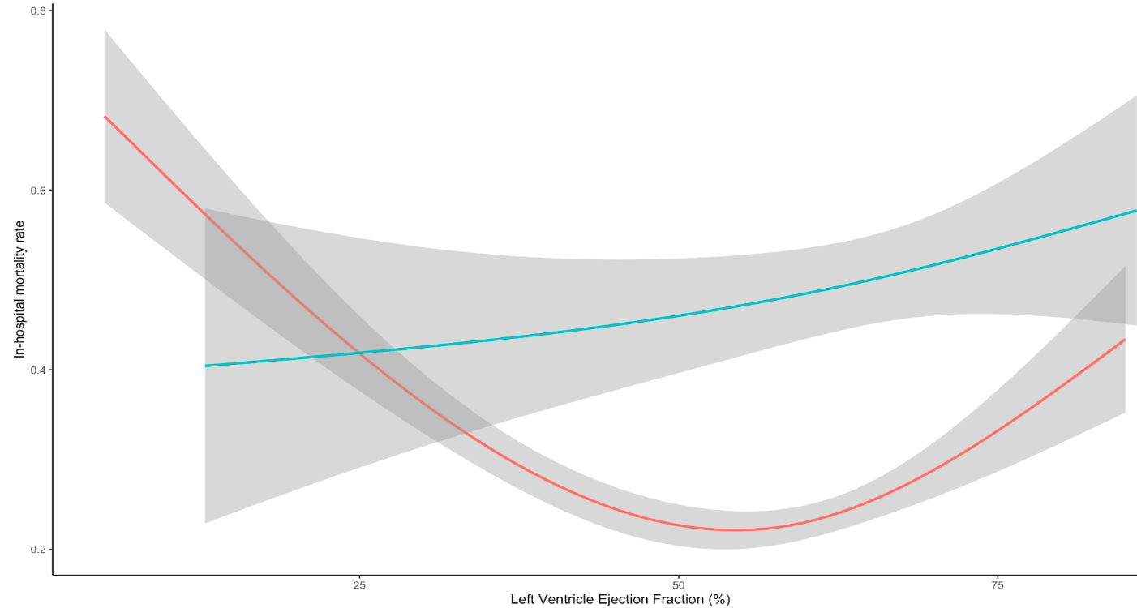

Blue: Cirrhotic Patients with sepsis and septic shock
Red: Non-Cirrhotic Patients with sepsis and septic shock

Supplementary Figure E2

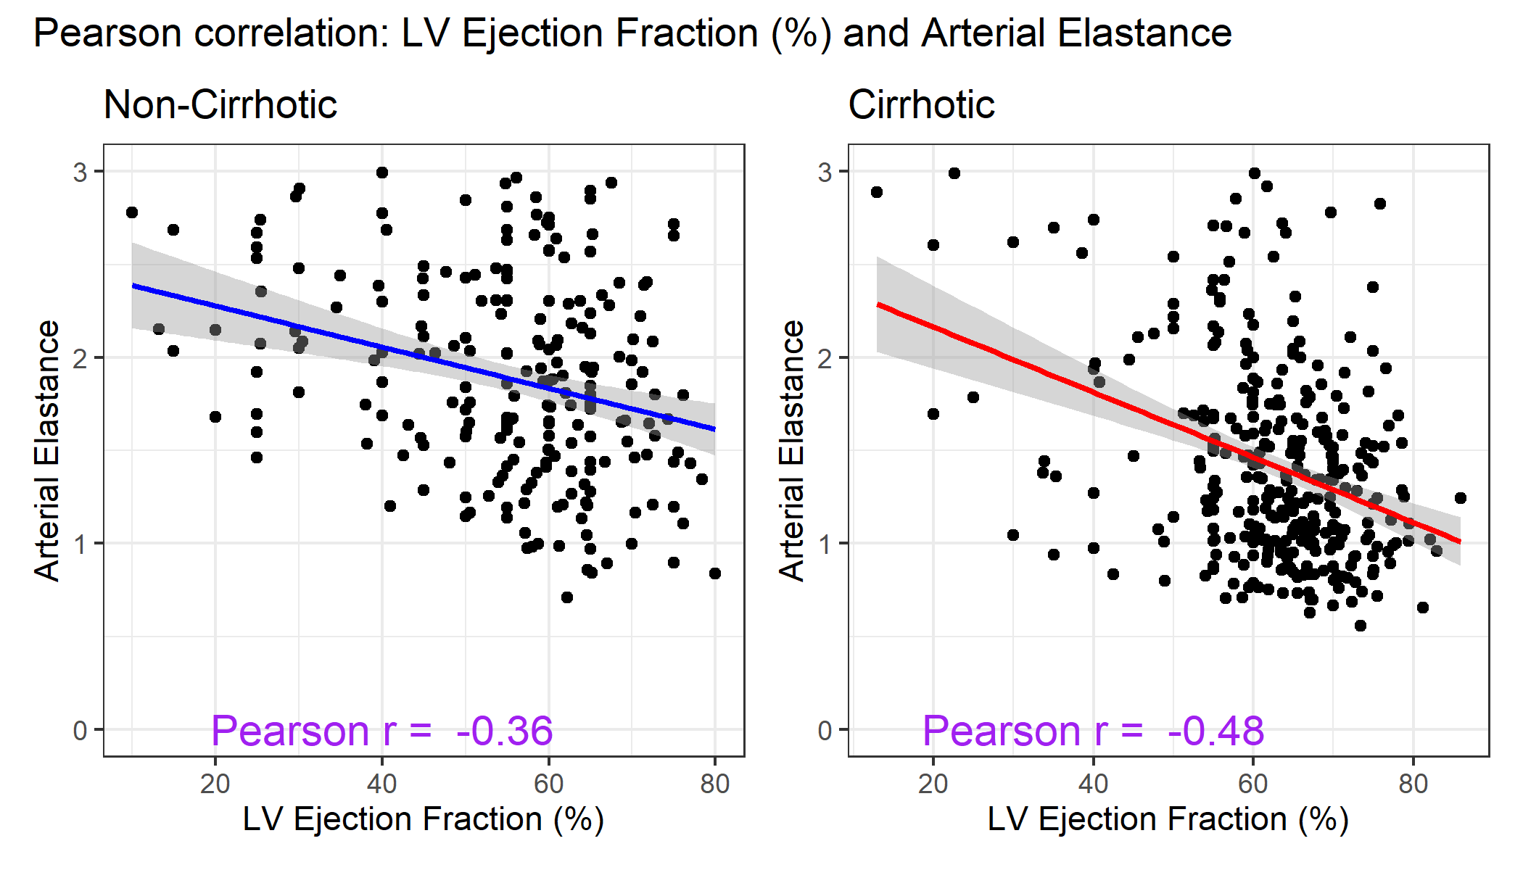

Supplementary Figure E3

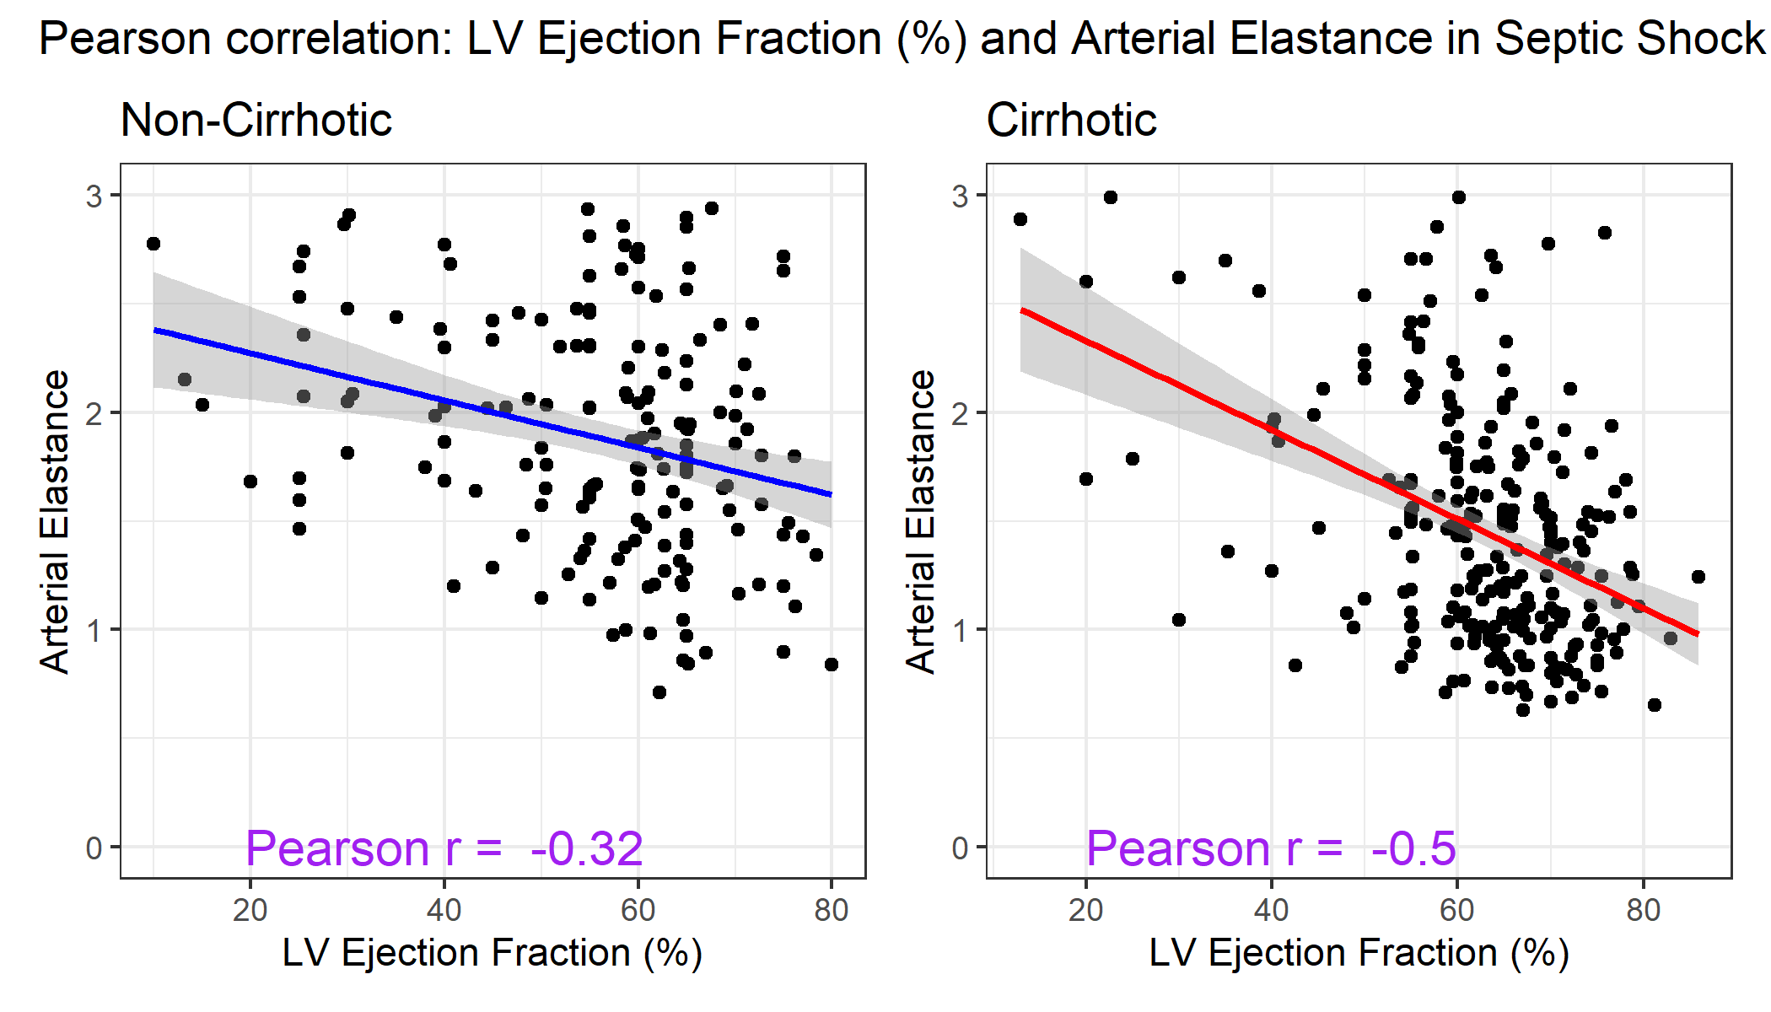

Supplementary Figure E4

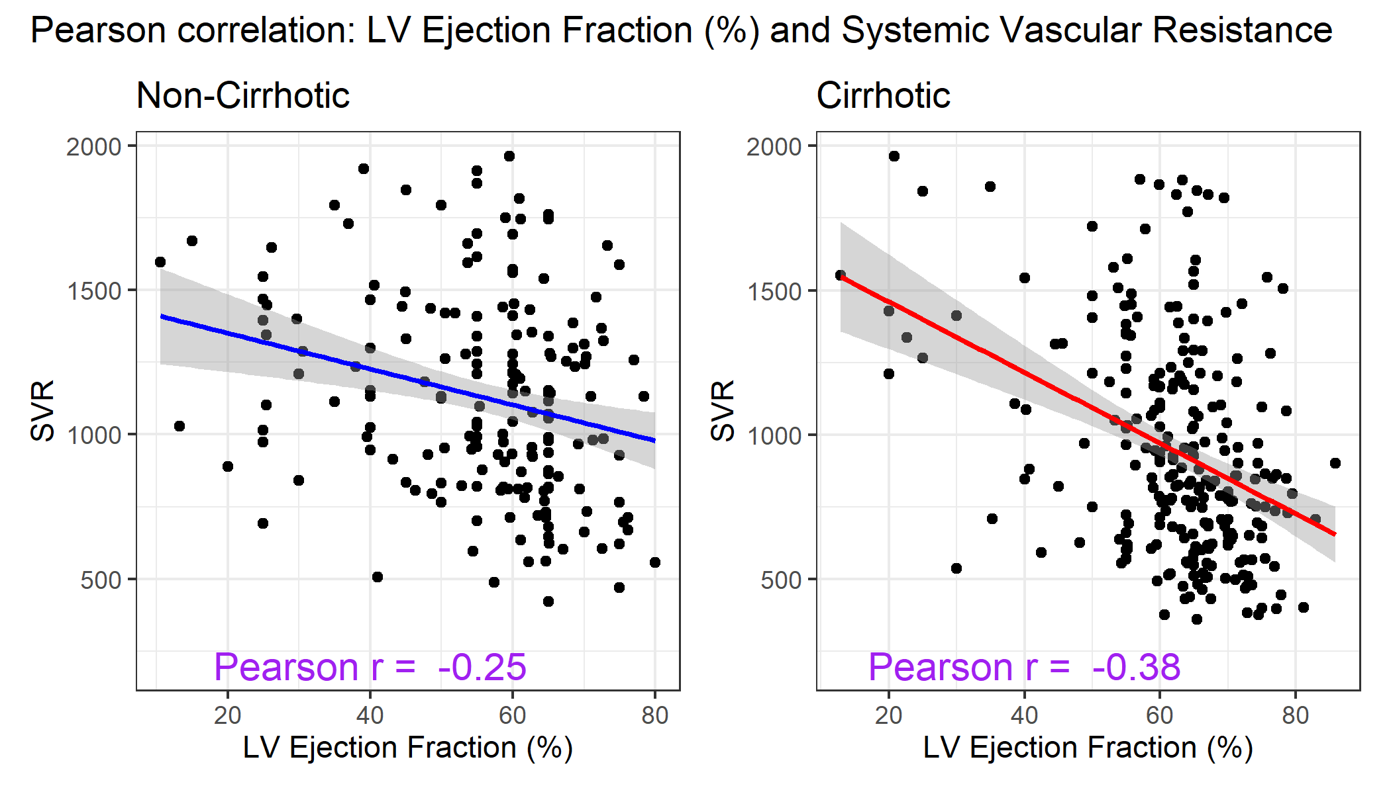

Supplementary Figure E5

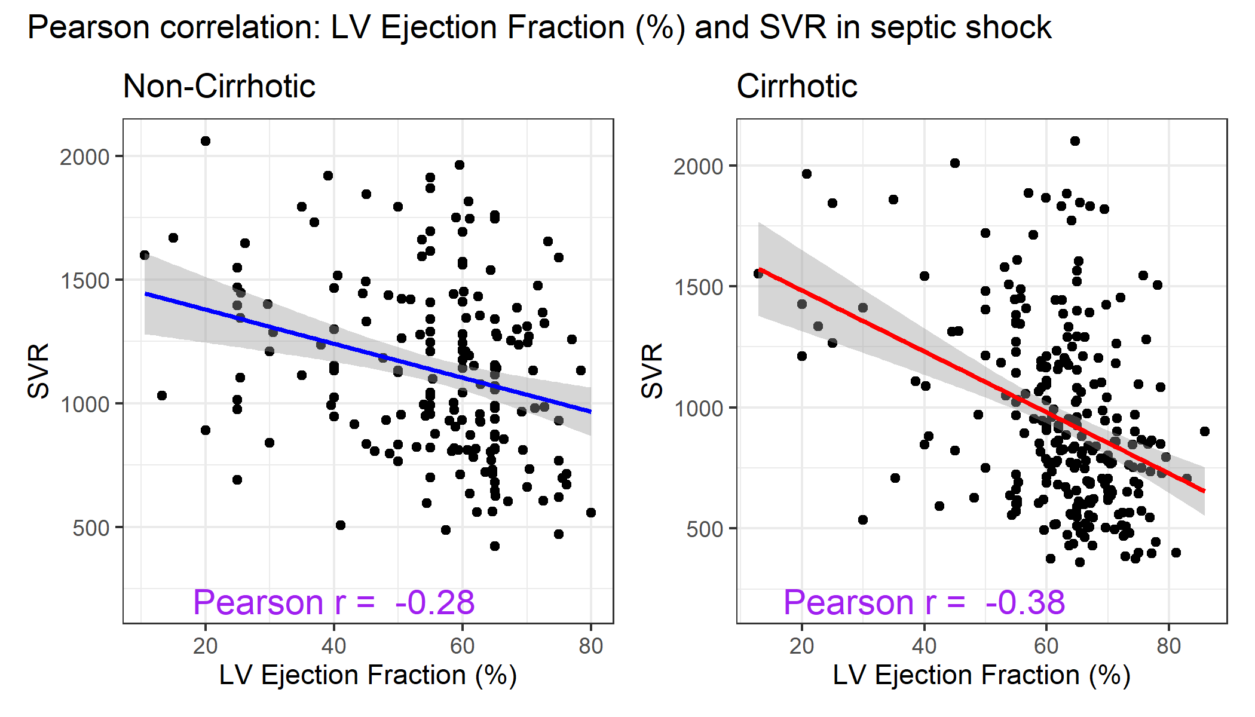

Supplementary Figure E6

Pearson Correlation: MELD Score and LVEF (%) and MELD Score

