Electronic Supplementary Material:

Fine-Scale hydrodynamic modelling of Lake Ontario: Observed Changes in the circulation patterns

Bogdan Hlevca*¹, Todd Howell¹, Mohammad Madani² and Nadine Benoit¹
1 Ministry of the Environment, Conservation and Parks
2 DHI Canada

* Correspondent author: bogdan.hlevca@ontario.ca
Current address: 125 Resources Rd, Toronto, Ontario Canada

The following five parts, listed below, provide supportive information cited in the manuscript.
- Part I. Additional Field Observations - Meteorological
- Part II. Calibration and Validation Data
- Part III. Additional Spectral Analysis
- Part IV. Model Validation
- Part V. Bottom Slope analysis
- Part VI. Tables

Part I. Additional Field Observations
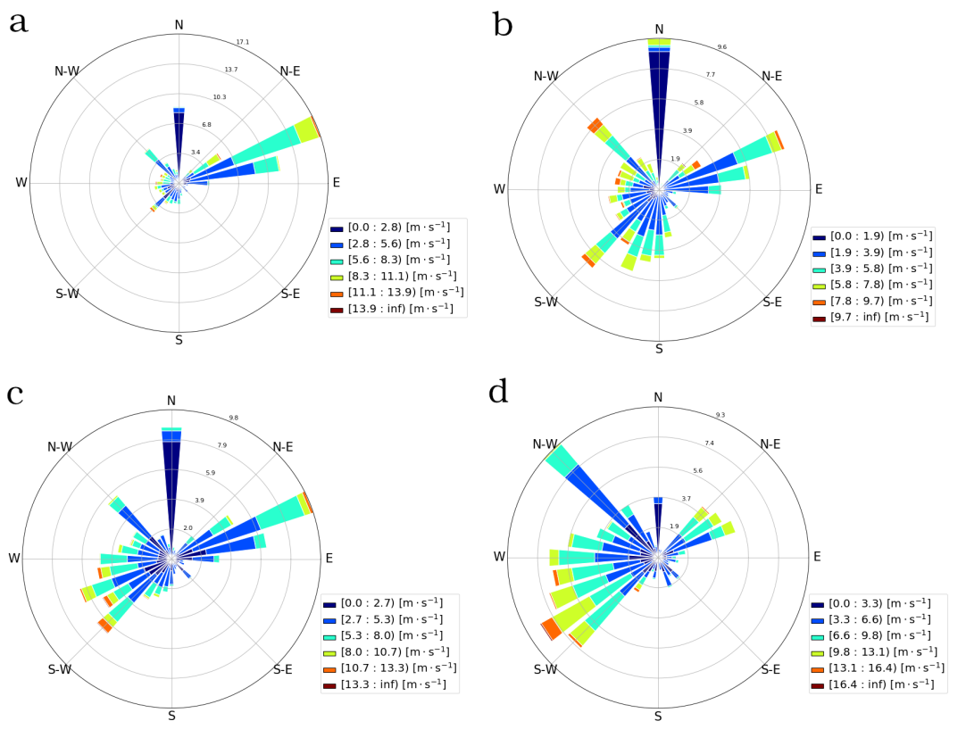
Fig S1. Wind distribution at Toronto Island Environment and Climate Change Canada station. Wind speed and direction for year 2013: a) Spring, b) Summer, c) Fall, d) Winter.
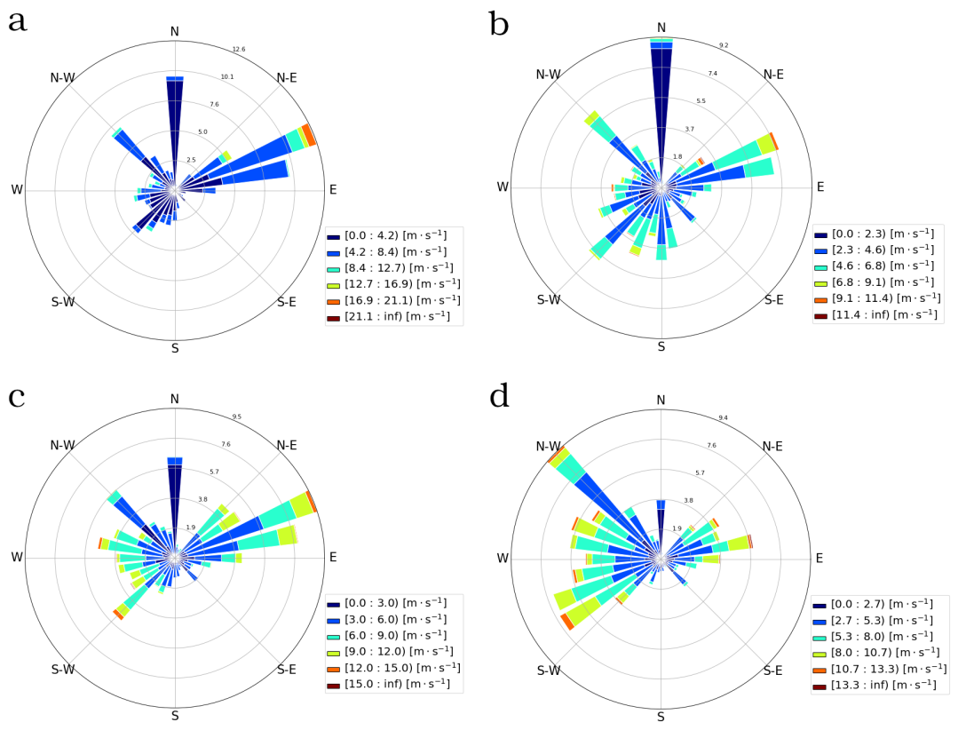
Fig S2. Wind distribution at Toronto Island Environment and Climate Change Canada station. Wind speed and direction for year 2018: a) Spring, b) Summer, c) Fall. d) Winter.
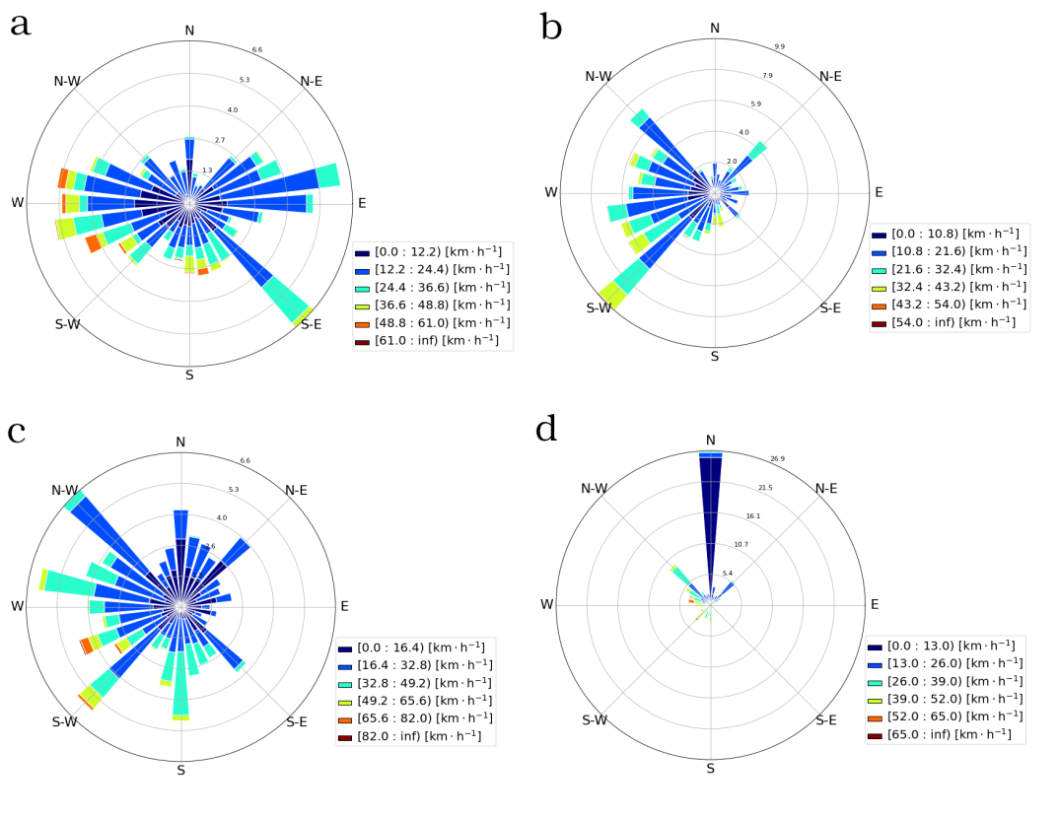
Fig S3. Wind distribution at Point Petre Environment and Climate Change Canada station. Wind speed and direction for year 2013: a) Spring, b) Summer, c) Fall, d) Winter.

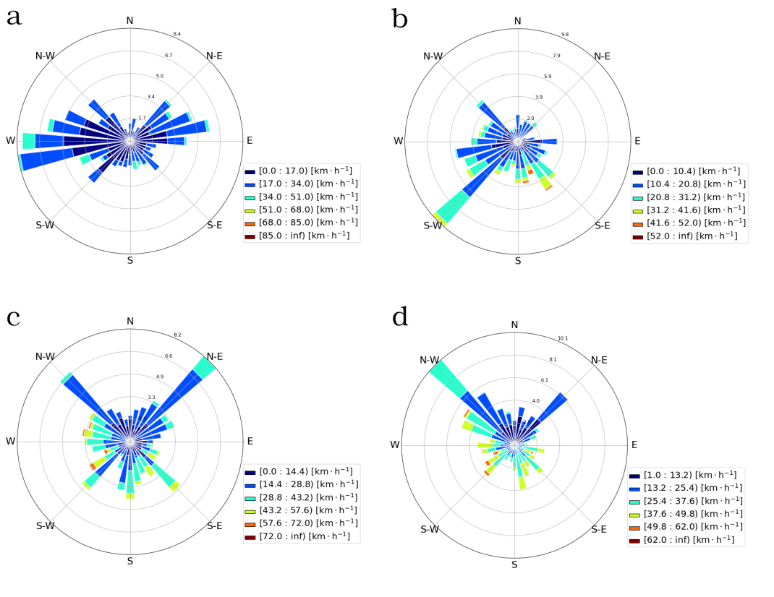
Fig S4. Wind distribution at Point Petre Environment and Climate Change Canada station. Wind speed and direction for year 2018: a) Spring, b) Summer, c) Fall. d) Winter.
Lake Ontario is traditionally known for its predominantly westerly winds. However, our data analysis has shown changes in wind patterns especially at the eastern end. We suspect that more frequent storms from north and east have created a more diversified wind pattern during the warmer periods of spring, summer, and fall. These wind patterns are influencing the current patterns and frequency of upwelling and downwelling events. At the western end (Point Petre station) the wind patterns are almost the opposite. The winter season experienced predominant northern winds, and mostly the traditionally reported westerly winds for the rest of the seasons.

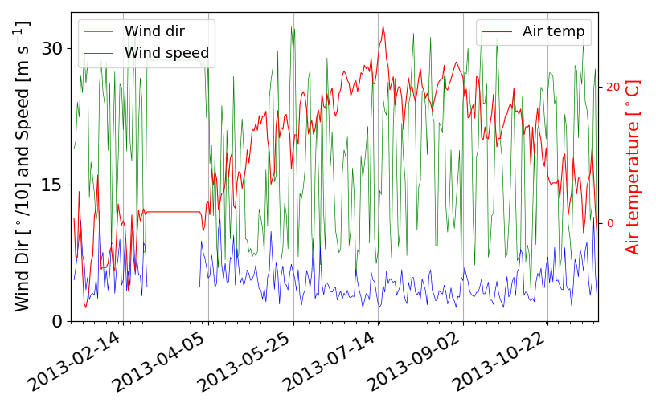
Fig S5. Wind speed and direction, and air temperature at Toronto Island Environment and Climate Change Canada station during the year 2013
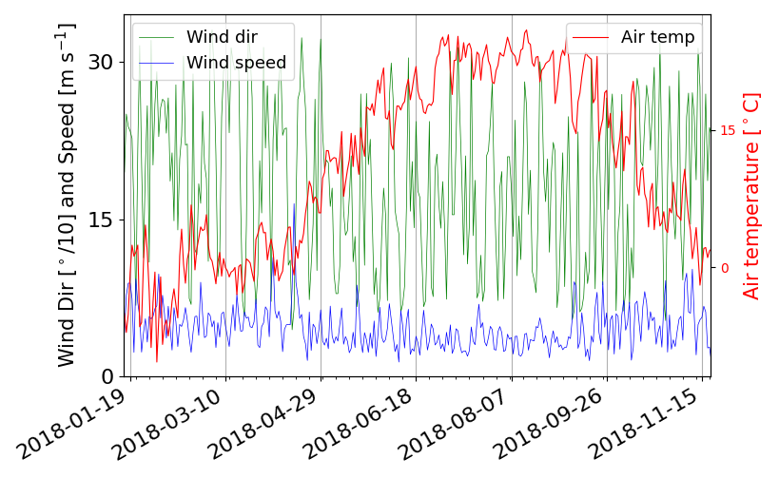
Fig S6. Wind speed and direction, and air temperature at Toronto Island Environment and Climate Change Canada station during the year 2018
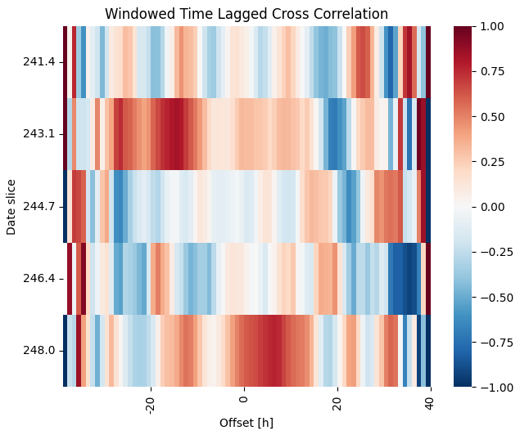
Fig S7. Windowed cross correlation between velocity time series at station E2_N20 and station E1 N17.

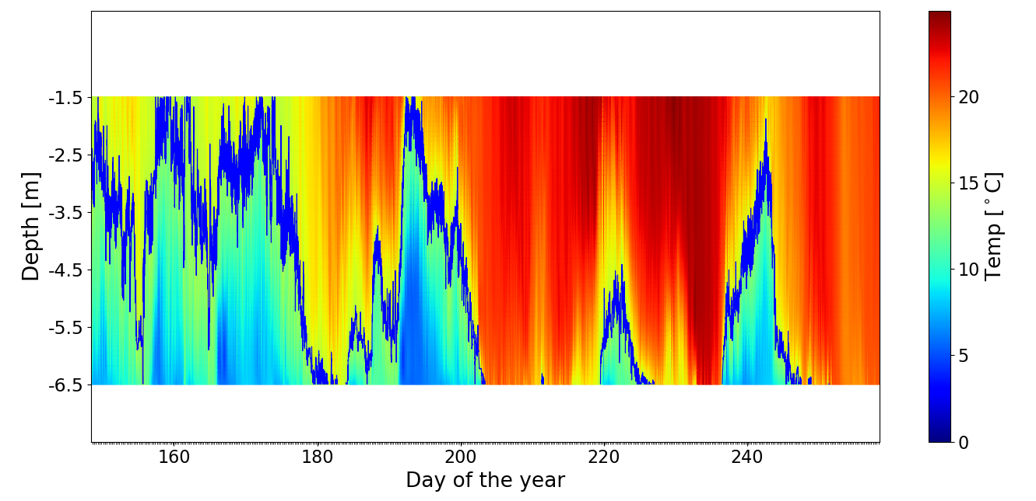
Fig S8. Temperature profile at a shallow site (W2 N14)

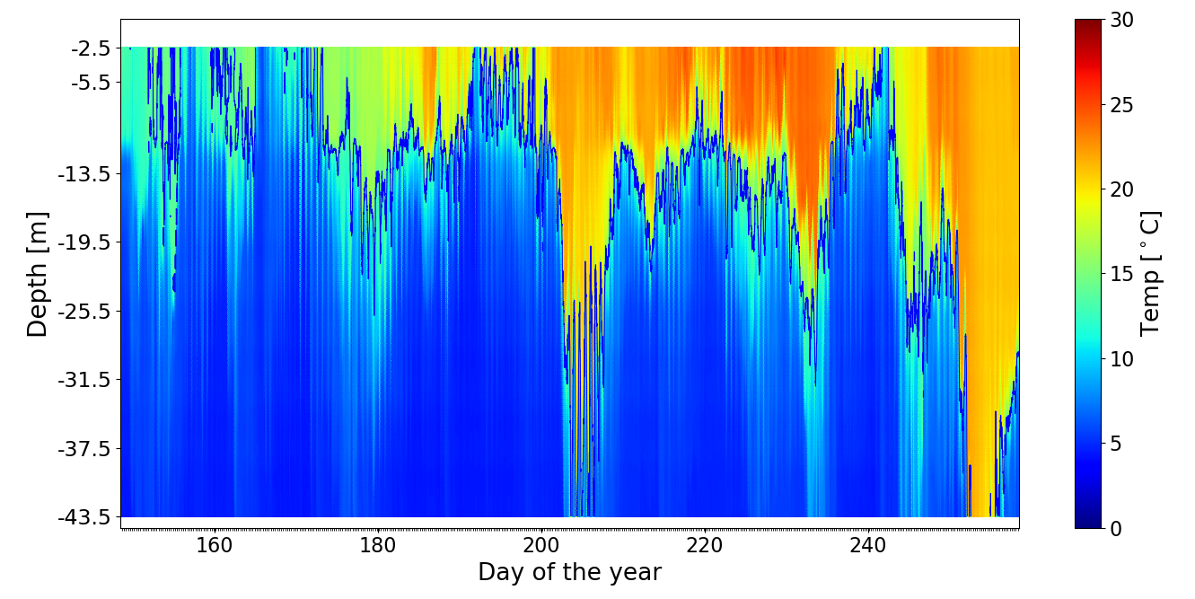
Fig S9. Temperature profile at a deep site (E2 N25)

Part II. Calibration and Validation Data

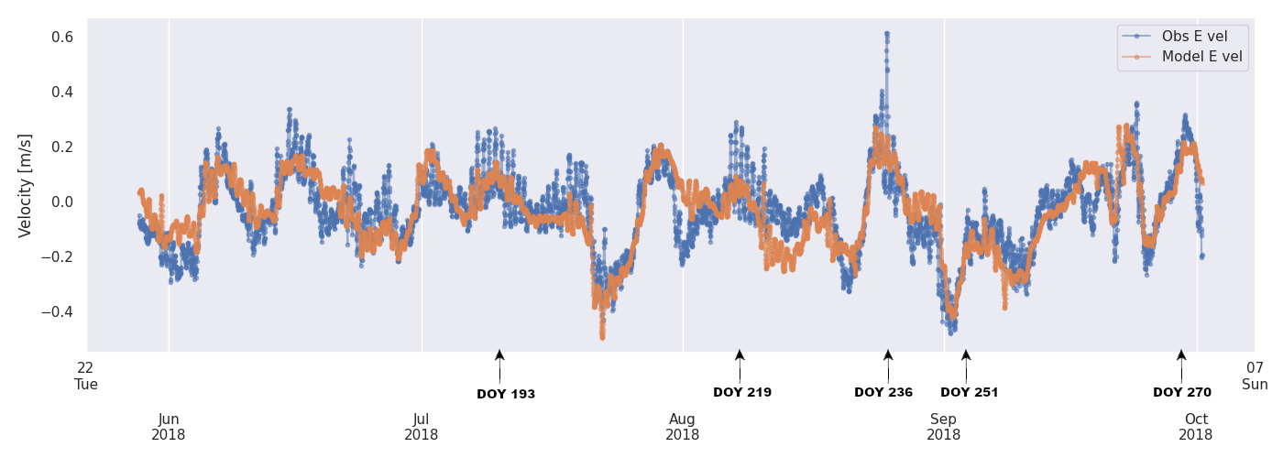
Fig S10. Observed and Modeled E Velocity at Station E2_N20 at a depth of 6 m.
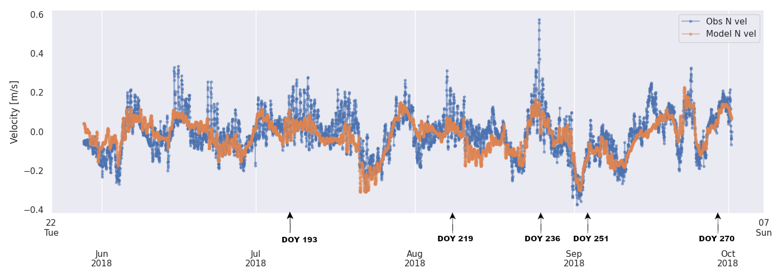
Fig S11 Observed and Modeled N Velocity at Station E2_N20 at a depth of 6 m.
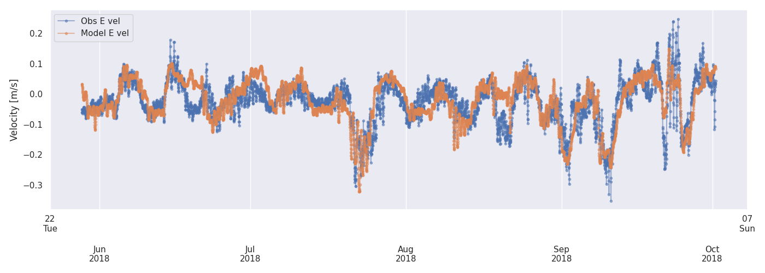
Fig S12 Observed and Modeled E Velocity at Station E2_N20 at a depth of 24 m.
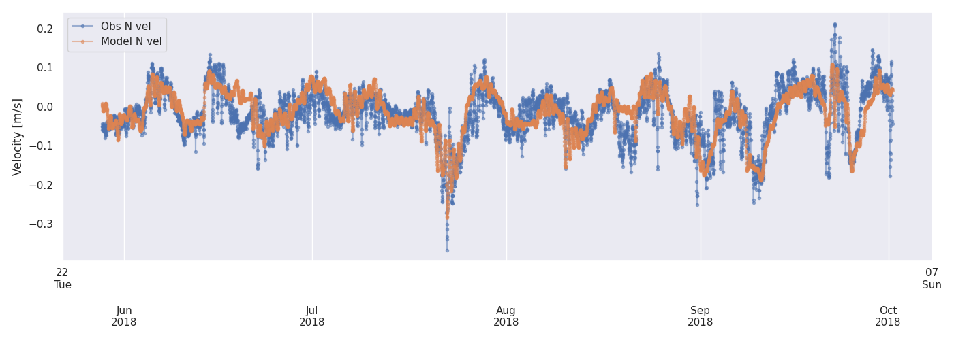
Fig S13. Observed and Modeled E Velocity at Station E2_N20 at a depth of 28 m.

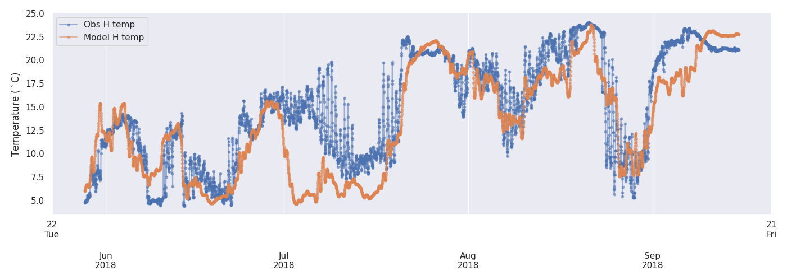
Fig S14 Observed and Modeled temperature at Station E2_N20 at a depth of 9 m

Part III. Additional Spectral Analysis
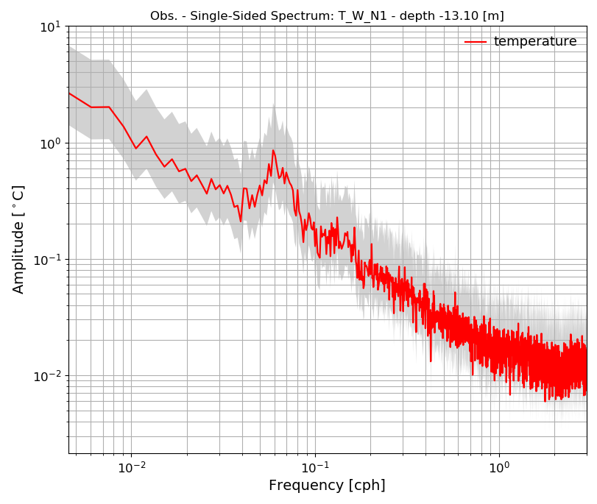
Fig S15. Single-sided amplitude spectrum of the observed temperature. The grey shade represents the 95% confidence intervals.
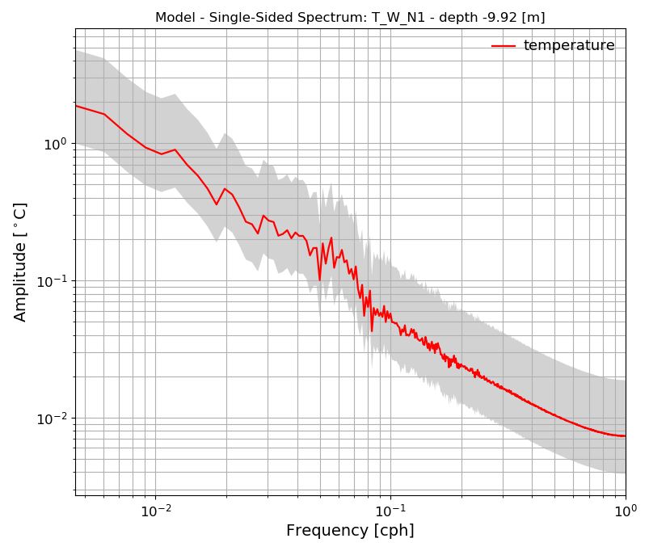
Fig S16. Single-sided amplitude spectrum of the modelled temperature. The gray shade represent the 95% confidence intervals.

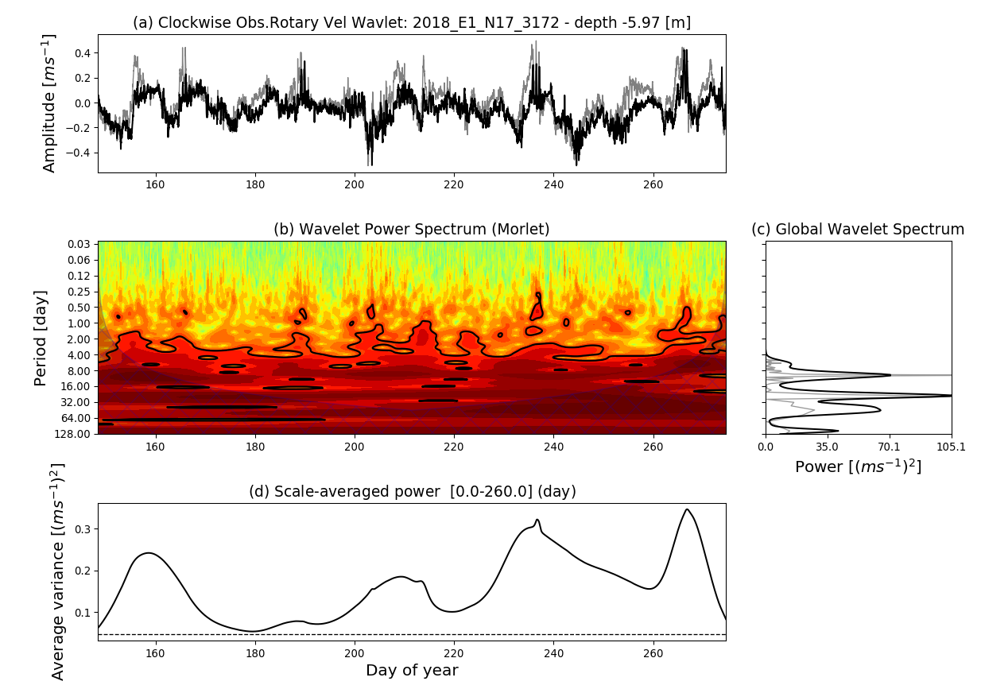
Fig S17. Clockwise Rotary Wavelet Analysis (a) Time series of the velocity of the currents at 6 m depth at Station E1 N17. In black is the original signal in grey the reconstructed signal with the inverse wavelet transform; (b) Wavelet Power Spectrum using the Morlet mother wavelet. The solid curve outlines the 95% confidence level. The shaded area represents the 'cone of influence' region where edge effects due to finite nature of the time series become essential; (c) the global wavelet spectrum (black) and Fourier power spectrum (grey); (d) scale-averaged wavelet power over the 1-2-year band, and the dashed line indicates passing the 95% confidence level.
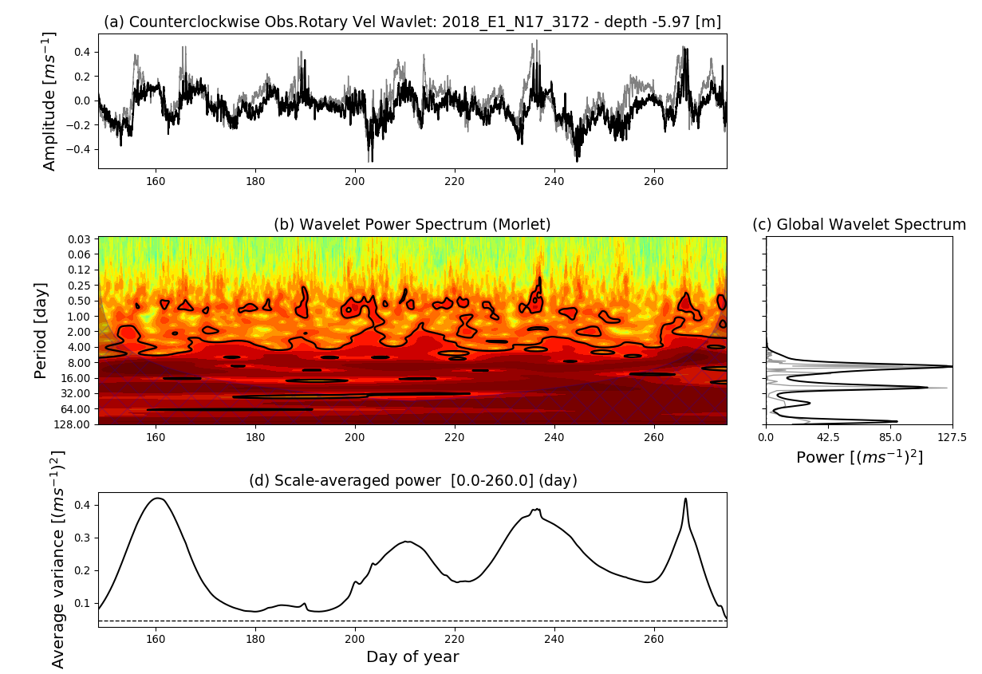
Fig S18. Counterclockwise Rotary Wavelet Analysis. (a) Time series of the velocity of the currents at 6 m depth at Station E1 N17. In black is the original signal in grey the reconstructed signal with the inverse wavelet transform; (b) Wavelet Power Spectrum using the Morlet mother wavelet. The solid curve outlines the 95% confidence level. The shaded area represents the 'cone of influence' region where edge effects due to finite nature of the time series become essential; (c) the global wavelet spectrum (black) and Fourier power spectrum (grey); (d) scale-averaged wavelet power over the 1-2-year band, and the dashed line indicates passing the 95% confidence level.

Part IV. Model Validation

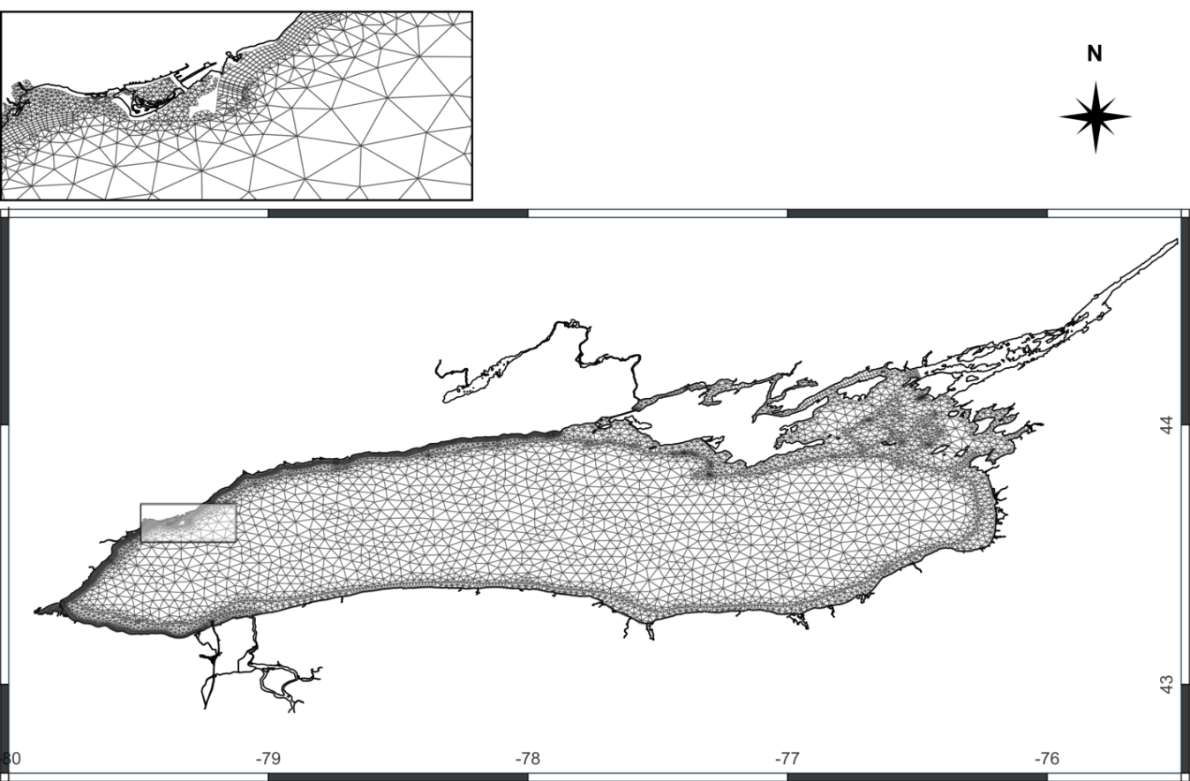

Fig S19. Mike 3 flexible mesh for the entire Lake Ontario. The smallest resolution in the quads section of the mesh is 50 m.

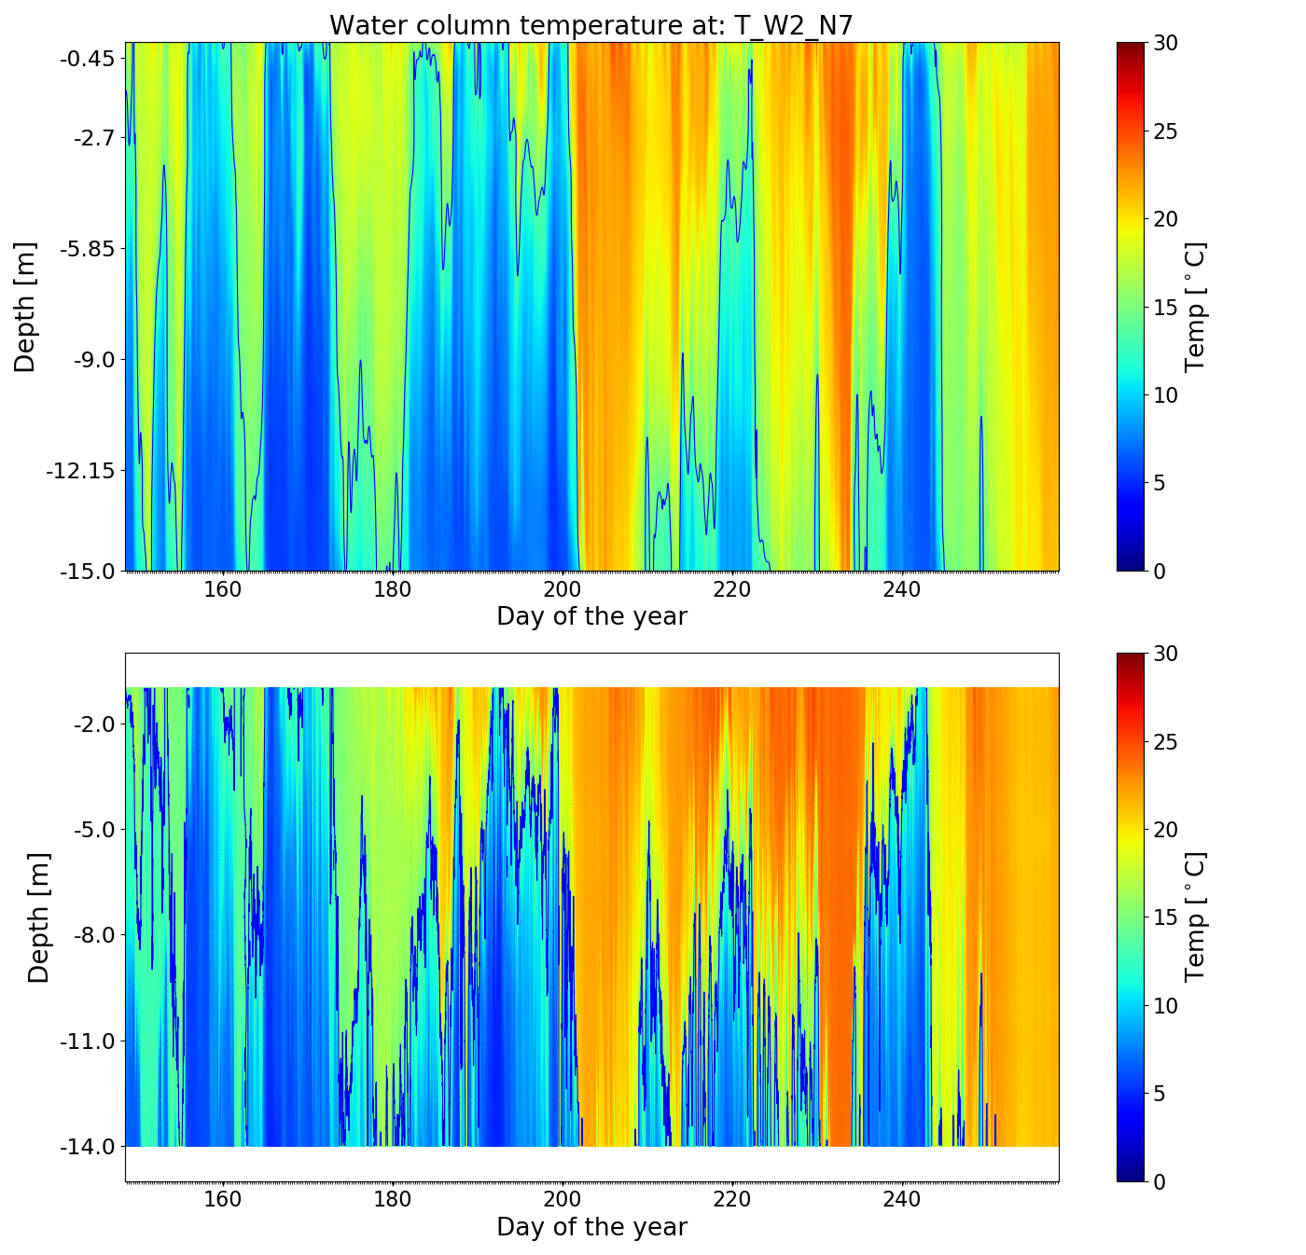
Fig S20. Modeled temperatures and observations in 2018. The upper plot in each subfigure is the model result and the bottom plot is the observed data. Station W2_N7. a) model result; b) observational data

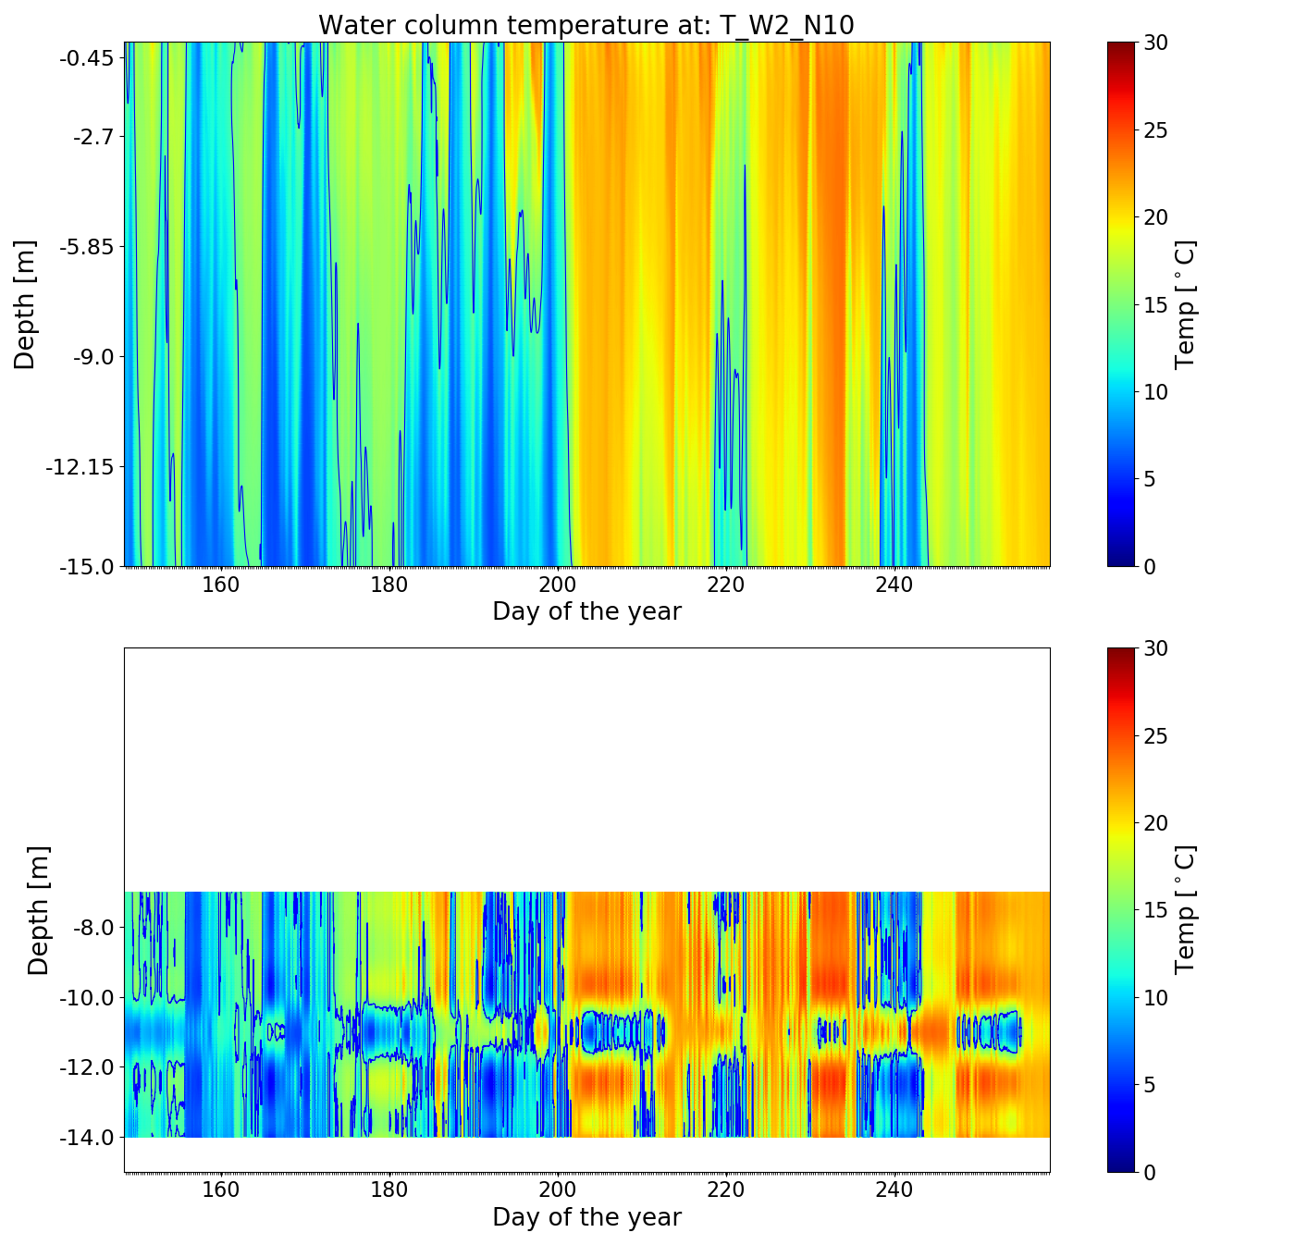
Fig S21. Modeled temperatures and observations in 2018. The upper plot in each subfigure is the model result and the bottom plot is the observed data. Station W2_N10. Observed data incomplete due to gaps in the observations in the top layer and some malfunctioning temperature loggers. a) model result; b) observational data
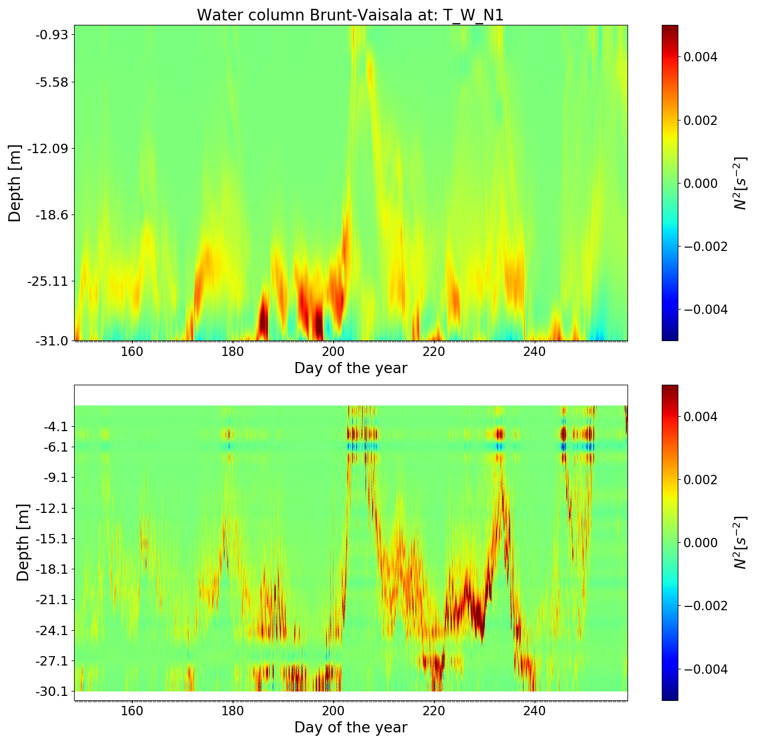

Fig S22. Brunt–Väisälä frequency in the water column at Station W_N1. a) calculated from the model result; b) calculated from the observational data. The value of N² follows closely the position of the thermocline. The water column is stable (N²>0) during the stratified season and starts crossing into the unstable zone after DOY 250

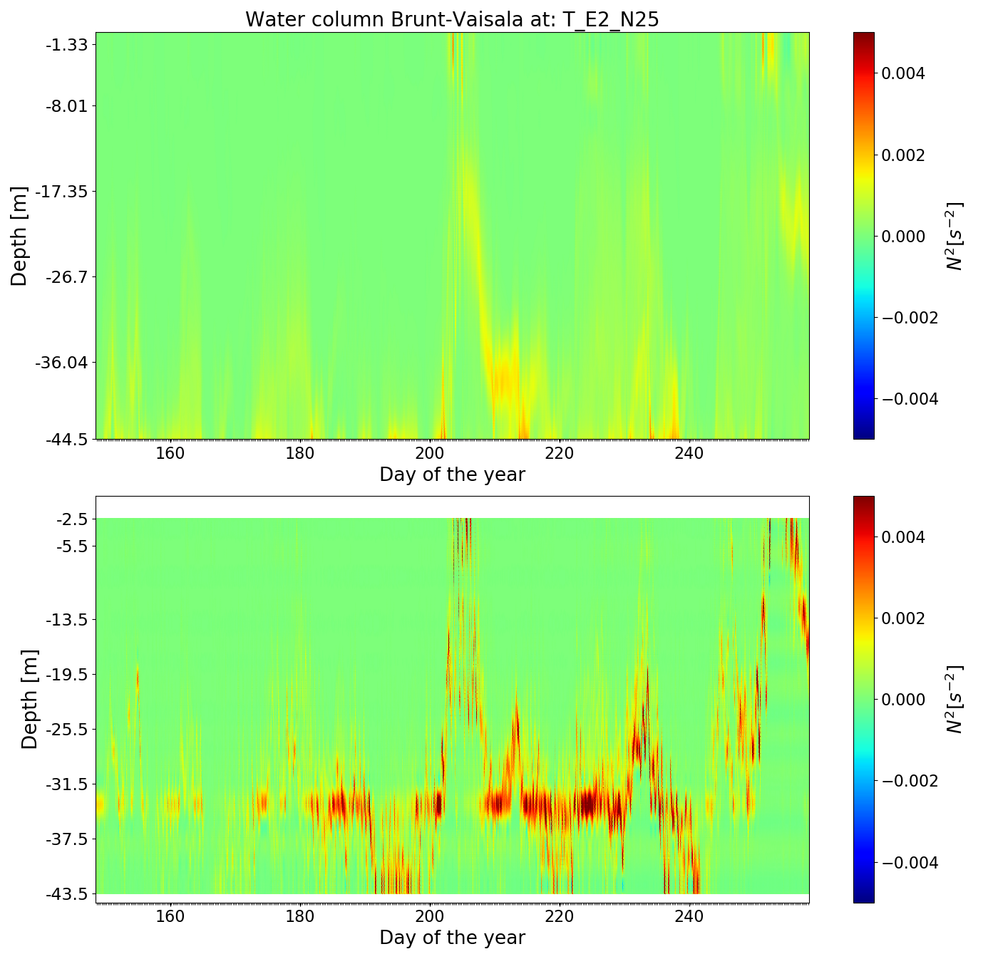
Fig S23. Brunt–Väisälä frequency in the water column at Station E_N25. a) N² estimated from observed data. b) N² estimated from modelled data. The value of N follows closely the position of the thermocline.
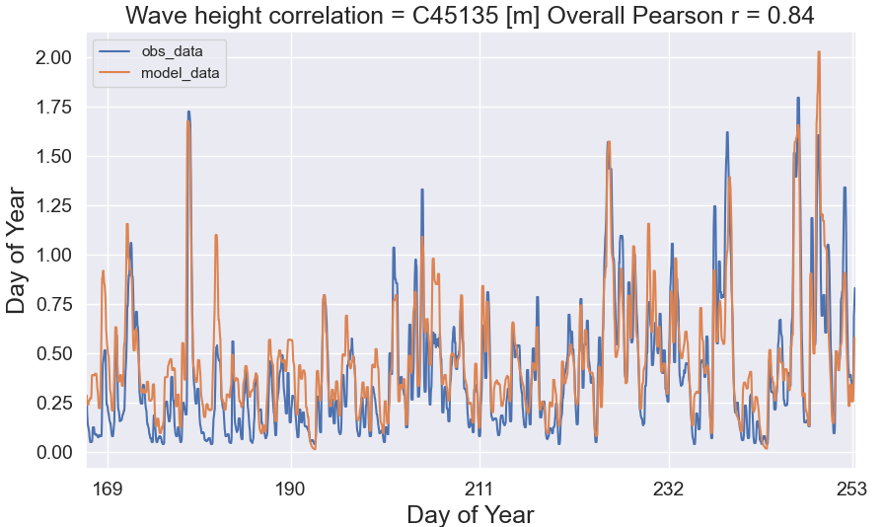
Fig S24. Calibration plot of the Spectral Waves module at the ECCC Station
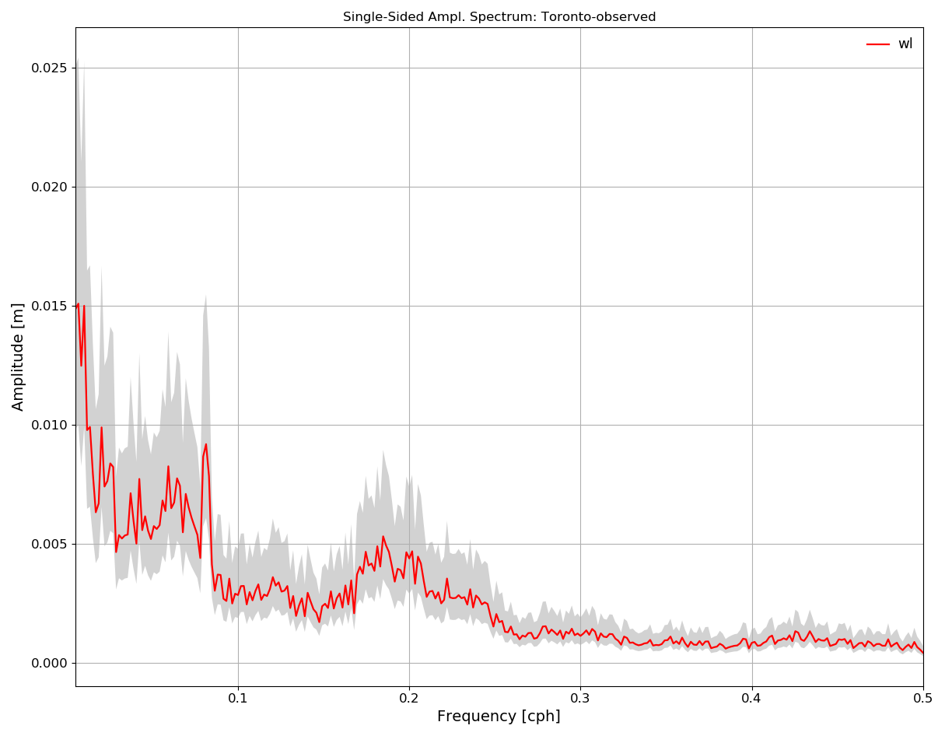
Fig S25. Spectral analysis of observed water levels in Toronto Harbour
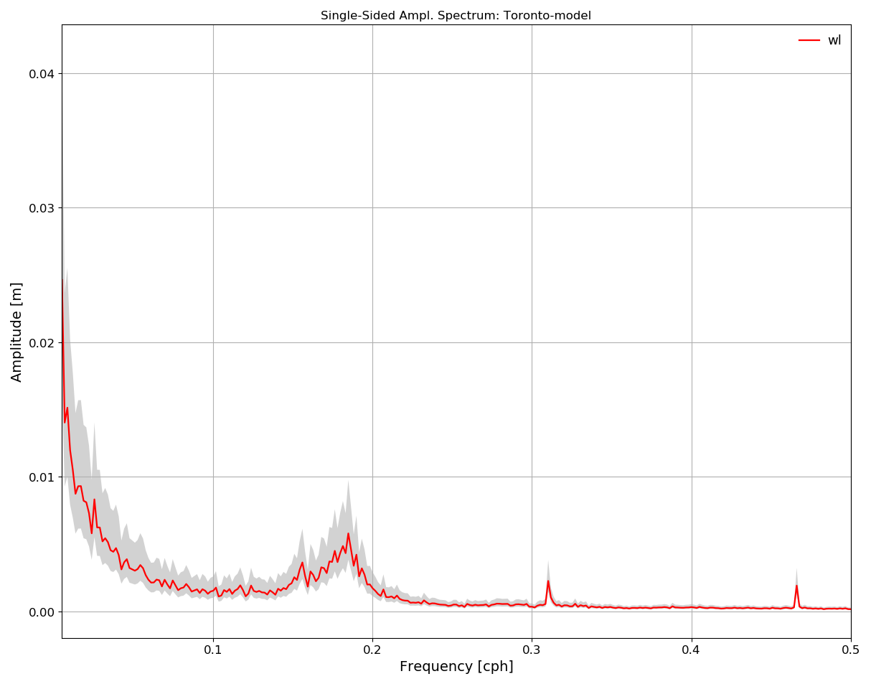
Fig S16. Spectral analysis of modelled water levels at the Toronto Harbour

Part V. Bottom slope analysis

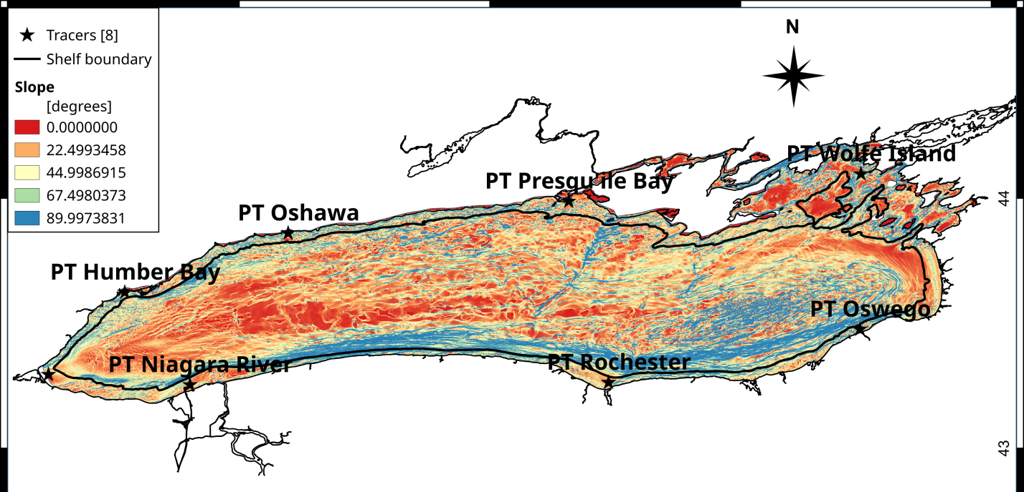
Fig S27. Bottom slope map. The colours represent the slope values in degrees, from flat (red) to vertical (blue)

Part VI. Tables

Table S1. 2013 and 2018 in Lake Ontario, details of instrument deployments at study sites
Station | Lat (N) | Lon. (W) | Depths [m] | Instrument | Period [day] | Sampling int
Oak_N36 | 43.430632 | 79.639372 | 30 | ADCP | 94-313 | 20 min
W_N1 | 43.530306 | 79.539778 | 30 | ADCP | 94-313 | 20 min
W_N2 | 43.548575 | 79.560293 | 9 | ADCP | 94-313 | 20 min
W_N4 | 43.571020 | 79.512102 | 20 | ADCP | 94-313 | 20 min
W2_N7 | 43.613463 | 79.473715 | 15 | ADCP | 94-313 | 20 min
W2_N10 | 43.624380 | 79.437217 | 9 | ADCP | 94-313 | 20 min
E1_N17 | 43.635768 | 79.276699 | 19 | ADCP | 94-313 | 20 min
E2_N21 | 43.580434 | 79.152514 | 9 | ADCP | 94-313 | 20 min
E2_N26 | 43.948595 | 78.031583 | 19 | ADCP | 94-313 | 20 min
Oak_N35 | 43.429715 | 79.641011 | 29 | Tidbit/Pres log | 94-313 | 10 min
T_W_N1 | 43.524575 | 79.538767 | 1,2,3,4,7,8,9,11,12,13,14,16,17,18,19,21,22,23,24,26,27,28 | Tidbit/Pres log | 94-313 | 10 min
T_W_N2 | 43.550047 | 79.557071 | 1,2,3,4,7,8 | Tidbit/Pres log | 94-313 | 10 min
T_W2_N7 | 43.617741 | 79.465576 | 1,2,3,4,7,8,9,11,12,13 | Tidbit/Pres log | 94-313 | 10 min
T_W2_N10 | 43.625880 | 79.439911 | 1,2,3,4,7,8 | Tidbit/Pres log | 94-313 | 10 min
T_W2_N14 | 43.630685 | 79.372637 | 1,2,3,4 | Tidbit/Pres log | 94-313 | 10 min
T_E1_N17 | 43.640556 | 79.271750 | 1,2,3,4,7,8,9,11,12,13,14,16,17,18 | Tidbit/Pres log | 94-313 | 10 min
T_E2_N20 | 43.730684 | 79.130833 | 1,2,3,4,7,8,9,11,12,13,14,16,17,18,19,21,22,23,24,26,27,28 | Tidbit/Pres log | 94-313 | 10 min
T_E2_N21 | 43.750806 | 79.148917 | 1,2,3,4,7,8 | Tidbit/Pres log | 94-313 | 10 min
T_E2_N25 | 43.598102 | 79.398886 | 1,2,4,8,12,14,18,22,24,28,32,34, 38, 42 | Tidbit/Pres log | 94-313 | 10 min
T_Oak_N36 | 43.433111 | 79.639083 | 1,2,3,4,7,8,9,11,12,13,14,16,17,18,19,21,22,23,24,26,27,28 | Tidbit/Pres log | 94-313 | 10 min

Table S2. Calibration and validation results
Quantity | Calibration / Validation | File name
Velocity | Calibration | Velocity_Calibration.csv
Velocity | Validation | Velocity_Validation.csv
Temperature | Calibration | Temp_Calibration.csv
Temperature | Validation | Temp_Validation.csv
Waves | Calibration | Wave_Calibration.csv
Waves | Validation | Wave_Validation.csv
Water levels | Calibration | WL_Calibration.csv
Water levels | Validation | WL_Validation.csv

