Extended data figures
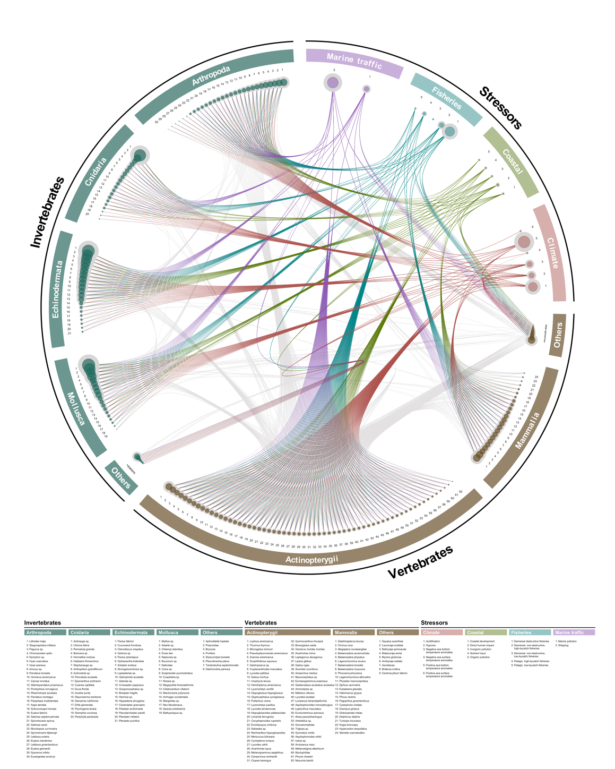
Extended Data Figure 1 | Multiplex network of cumulative effects. Multiplex network presenting the metaweb of interactions between the 193 taxa considered (grey connections), the presence of an effect of individual stressors on each taxa (colored connections), the overall cumulative effect on each taxon (taxa point size) and the mean effect of stressors (stressor point size).

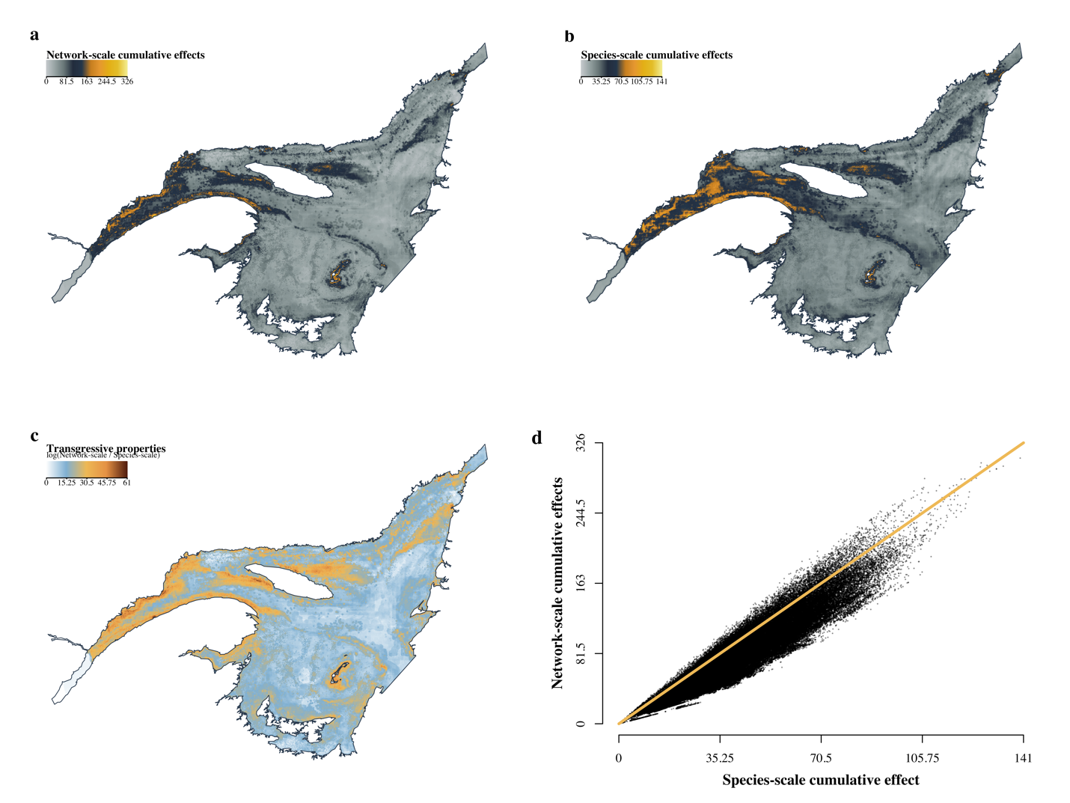
Extended Data Figure 2 | Comparison between the network-scale and species-scale cumulative effects assessment. a) Network-scale relative cumulative effects assessment of 18 stressors on 193 taxa in the St. Lawrence System explicitly considering the underlying structure of the ecological community. b) Species-scale relative cumulative effects assessment of 18 stressors on 193 taxa in the St. Lawrence System ignoring the underlying structure of the ecological community, i.e. the environmental impact assessment status quo or individual approach to cumulative effects assessment. c) Spatial distribution of transgressive properties arising from species interactions, measured as the sum of the log ratio of individual species network-scale assessment over species-scale assessment in each 1 $km^{2}$ grid cell. d) Scatterplot of the network cumulative effects score as a function of the individual cumulative effect score for each 1 $km^{2}$ grid cell. The orange line is the 1:1 identity line.

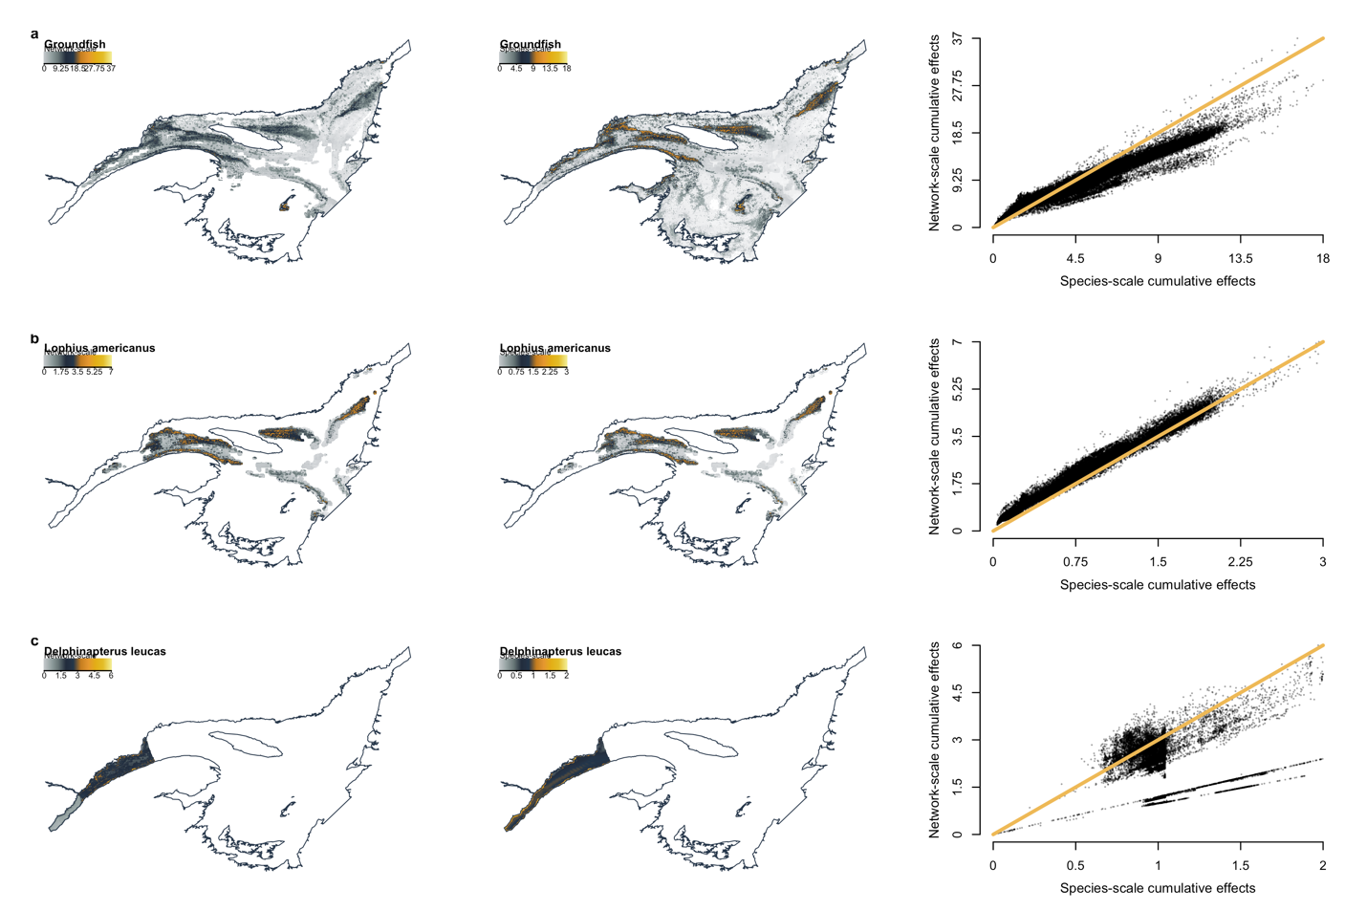
Extended Data Figure 3 | Comparison of the network-scale and species-scale cumulative effects assessments for selected species. a) groundfish species (i.e. Atlantic halibut Hippoglossus hippoglossus; American plaice Hippoglossoides platessoides; witch flounder Glyptocephalus cynoglossus; Atlantic cod Gadus morhua; redfish Sebastes spp.; Greenland halibut Reinhardtius hippoglossoides), b) monkfish (Lophius americanus) and c) beluga whales (Delphinapterus leucas).

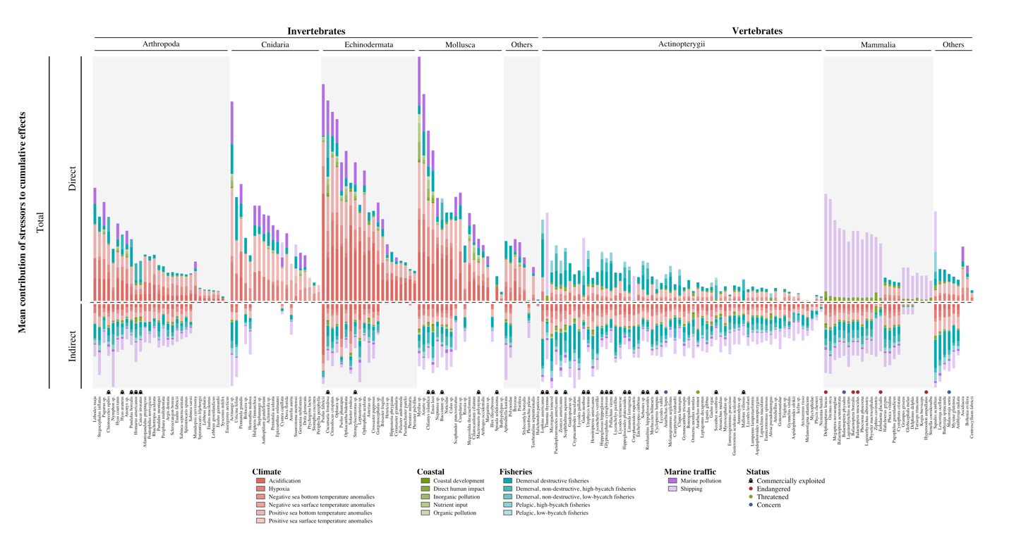
Extended Data Figure 4 | Contribution of stressors to cumulative effects of species. Mean contribution of 18 stressors to the regional cumulative effects assessment ($C/km^{2}$) of 193 taxa in the St. Lawrence System classified into 8 taxonomic groups. Taxonomic groups for invertebrates and vertebrates are divided at the phyla and classes level, respectively. The contribution can be divided as the direct and indirect contributions of each stressor to the cumulative effects on each taxa. Direct effects are those attributable to the effect of a stressor on a focal species, while indirect effects are the mean effects of stressors spreading through all 3-species interactions a taxa is involved in. The total contribution to cumulative effect is the sum of the direct and indirect contributions. Commercially exploited taxa and endangered, threatened and species of concern under the Canadian species at risk act are identified on the figure next to taxa names.

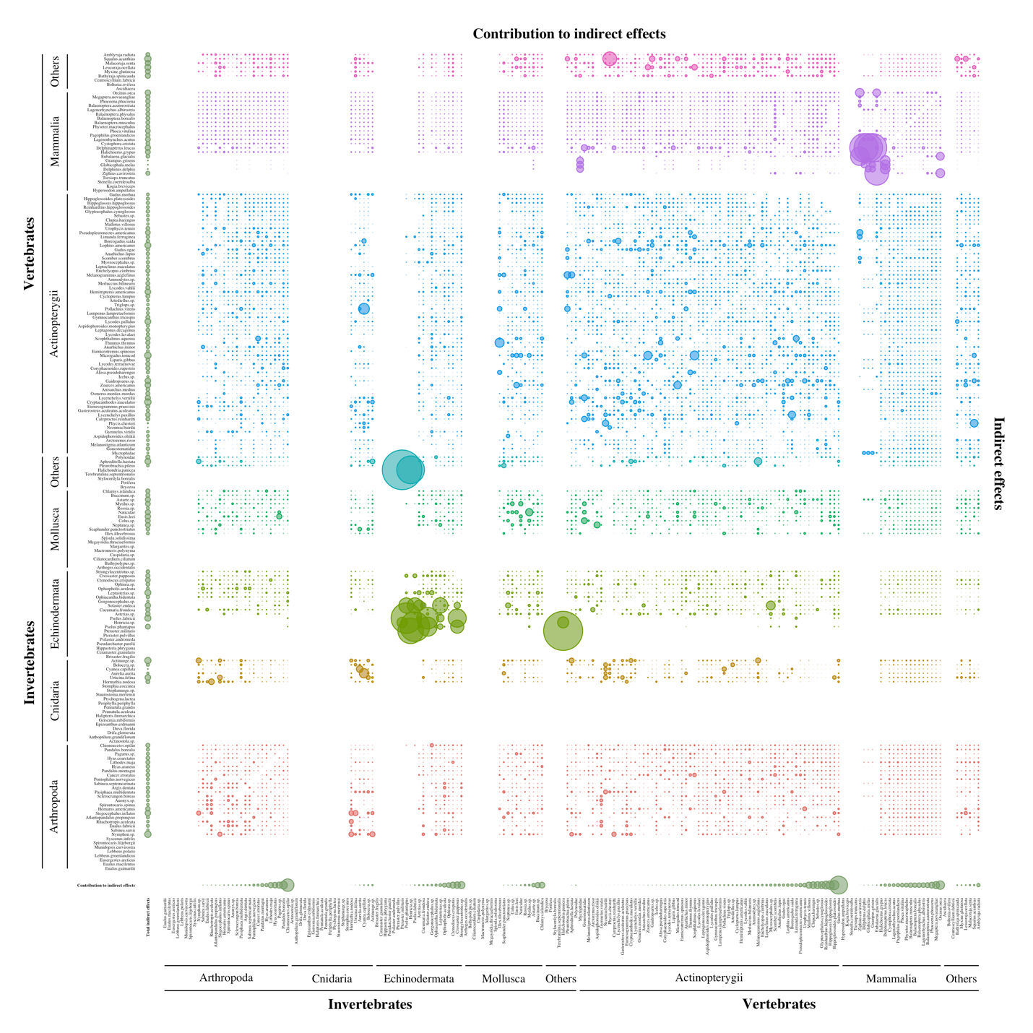
Extended Data Figure 5 | Contribution of species to indirect effects. Mean contribution of species to the indirect propagation of regional cumulative effects ($C_{i}/km^{2}$) of 18 stressors through ecological interactions among 193 taxa in the St. Lawrence System classified into 8 taxonomic groups. Taxonomic groups for invertebrates and vertebrates are divided at the phyla and classes level, respectively.

Extended Data Table 1 | Stressors data. List of stressors used to perform the cumulative effects assessment³².
Groups | Drivers | Spatial  resolution | Temporal  resolution | Years | Units | Source
Climate | Acidification | Lat/Lon | August-September | 2018 | Ω Aragonite | Starr and Chassé 2019
Climate | Bottom-water  temperature | ~2 km² | Monthly | Climatology: 1980-2010; Current: 2013-2017 | negative anomalies | Galbraith et al. 2018
Climate | Bottom-water  temperature | ~2 km² | Monthly | Climatology: 1980-2010; Current: 2013-2017 | positive anomalies | Galbraith et al. 2018
Climate | Hypoxia | Lat/Lon | August-September | 2013-2017 | ml L⁻¹ | Blais et al. 2019
Climate | Surface-water  temperature | ~2 km² | Monthly | Climatology: 1980-2010; Current: 2013-2017 | negative anomalies | Galbraith et al. 2018
Climate | Surface-water  temperature | ~2 km² | Monthly | Climatology: 1980-2010; Current: 2013-2017 | positive anomalies | Galbraith et al. 2018
Coastal | Coastal  development | 15 arc-second | Annual | 2015-2016 | nanoWatts cm⁻² sr⁻¹ | Earth observation group 2019
Coastal | Direct human  impact | Variable: <1 to >40000 km² | Annual | 2016 | population count | Statistics Canada 2017
Coastal | Inorganic  pollution | Modeled 1 km² | Annual | 2000-2001 | - | Halpern et al. 2015
Coastal | Nutrient import | Modeled 1 km² | Annual | 2007-2010 | t fertilizer | Halpern et al. 2015
Coastal | Organic  pollution | Modeled 1 km² | Annual | 2007-2010 | t pesticide | Halpern et al. 2015
Fisheries | Demersal, destructive | Lat/Lon | Event based | 2010-2015 | kg | DFO 2016
Fisheries | Demersal, non-destructive, high-bycatch | Lat/Lon | Event based | 2010-2015 | kg | DFO 2016
Fisheries | Demersal, non-destructive, low-bycatch | Lat/Lon | Event based | 2010-2015 | kg | DFO 2016
Fisheries | Pelagic, high-bycatch | Lat/Lon | Event based | 2010-2015 | kg | DFO 2016
Fisheries | Pelagic, low-bycatch | Lat/Lon | Event based | 2010-2015 | kg | DFO 2016
Marine traffic | Marine  pollution | Modeled 1 km² | Event based \ annual | 2003-2011 \ 2011 | n lanes + t port volume | Halpern et al. 2015
Marine traffic | Shipping | 0.1 degree | Event based | 2003-2011 | n lanes | Halpern et al. 2015

Extended Data Table 2 | Biotic data. List of biotic data used to obtain species list and occurrences. Except for IUCN data, monitoring programs are all conducted or managed by the Government of Canada’s Department of Fisheries and Oceans (DFO).
Programs | Description | Sampling | Period | Taxa | Occurrences Absences | Years | Source
Multidisciplinary Research Survey | Scientific survey | Random stratified | August-September | 293 | 44497  434851 | 2011-2015 | Bourdages et al. 2018
Fisheries  Logbooks | Fisheries landings | Fisheries-specific | Fishing  season | 48 | 271236  0 | 2010-2015 | DFO 2016
At-Sea Observers | Fishing observers | Fisheries-specific | Fishing  season | 200 | 93230  0 | 2010-2015 | -
Sentinel Fisheries | Scientific fisheries | Fisheries or random stratified | Fishing  season or July | 99 | 15990  0 | 2011-2015 | -
Marine Mammals | IUCN Species Red List of Threatened Species | - | - | 30 | 24 | - | IUCN 2020
Total | - | - | - | 391 | 424953 434851

Extended Data Table 3 | Abiotic data. List of abiotic descriptors used to extrapolate and map taxa distribution in the St. Lawrence System.
Environmental  descriptors | Units | Spatial  resolution | Source
Depth | m | 10 x 10 km | Dutil et al. 2011
Latitude | m | - | -
Longitude | m | - | -
Surface
pH | - | 5 arcmin | Assis et al. 2018
Dissolved oxygen | mol.m⁻³ | 5 arcmin | Assis et al. 2018
Primary productivity | g.m⁻³.day⁻¹ | 5 arcmin | Assis et al. 2018
Salinity | - | 2.5 x 2.5 km | Dutil et al. 2012
Temperature | ºC | ~2 km² | Galbraith et al. 2018
Bottom
Aragonite | Ω Aragonite | Modeled 1 km² | Starr and Chassé 2019
Oxygen saturation | % | Modeled 1 km² | Blais et al. 2019
Primary productivity | g.m⁻³.day⁻¹ | 5 arcmin | Assis et al. 2018
Salinity | - | 10 x 10 km | Dutil et al. 2011
Temperature | ºC | ~2 km² | Galbraith et al. 2018

Extended Data Table 4 | R packages. List of R packages used listed in alphabetical order. All analyses were carried out with the R programming language version 4.2.3 ⁹³.
Name | Version | Repository | Source
btb | 0.2.0 | CRAN | Dos Santos et al. (2022)
eDrivers | 0.0.1 | GitHub | Beauchesne (2020a)
fasterize | 1.0.4 | CRAN | Ross (2022)
magrittr | 2.0.3 | CRAN | Bache and Wickham (2022)
motifcensus | 0.1.0.9000 | GitHub | Cazelles and Beauchesne (2023)
randomForest | 4.6.14 | CRAN | Liaw and Wiener (2002)
raster | 3.6-20 | CRAN | Hijmans (2023)
rcea | 1.0.0 | GitHub | Beauchesne and Cazelles (2023)
rfishbase | 3.0.3 | CRAN | Boettiger et al. (2012)
rglobi | 0.2.28 | CRAN | Poelen et al. (2022)
rmarkdown | 2.21 | CRAN | Xie et al. (2018), Xie et al. (2020), Allaire et al. (2023)
sf | 1.0-12 | CRAN | Pebesma (2018), Pebesma and Bivand (2023)
sp | 1.6-0 | CRAN | Pebesma and Bivand (2005), Bivand et al. (2013)
stars | 0.6-0 | CRAN | Pebesma (2022)
taxize | 0.9.100 | CRAN | Chamberlain and Szocs (2013), Chamberlain et al. (2020)
tidyverse | 2.0.0 | CRAN | Wickham (2019)
worrms | 0.4.2 | CRAN | Chamberlain (2020)

