Supplementary results

NFE2L2-siRNA is effectively transfected in AGS cells
By electroporating FITC-conjugated siRNA control, the capacity of cellular transfection of AGS cells using flow cytometry was evaluated, and cells without electroporation were examined as control groups. The control group cells rarely showed any fluorescence, whereas the AGS electroporated cells with FITC- attached siRNA control clearly showed fluorescence (Fig. 8). Using flow cytometry, the initial NRF2- siRNA transfection efficiency was determined to be 66% efficient. Compared to the control group, the electroporated cells displayed the highest fluorescence intensity of AGS cells. fluorescence intensity of AGS cells.
Transfection
Control
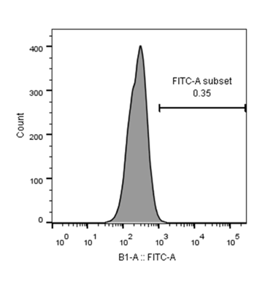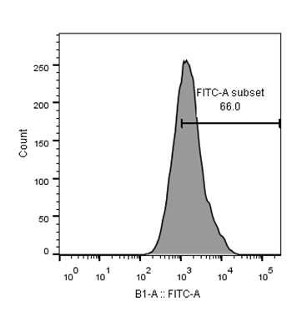

Figure 8
Using flow cytometry, the efficiency of the electroporation-mediated transfection of FITC-conjugated siRNA control was evaluated in AGS cancer cells in comparison to control groups.

NFE2L2-siRNA transfection significantly downregulated NRF2 mRNA expression in AGS cells
To investigate the effect of NRF2 suppression in GC, we transfected the AGS cells with NRF2 siRNA. Non-transfected cells and negative control cells transfected with non-target siRNA (scrambled siRNA) were also employed as controls. The qRT-PCR analysis demonstrated that the level of NRF2 mRNA expression in the transfected group was significantly lower compared to the control group (Fig. 9).

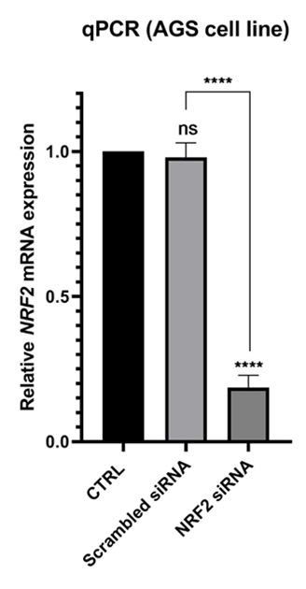

Figure 9
NRF2 siRNA significantly downregulated NRF2 expression in the AGS cell line. (****p value<0.0001)

