Extended data
Extended Data Table 1. Criteria for scoring the intensity of sexual selection in birds. All species were scored from literature by applying this classification system to textual descriptions of mating systems and breeding behaviour, including territoriality and offspring provisioning roles. By our definition, monogamy involves both sexes maintaining the same breeding partner for the duration of a reproductive event or season, and thus includes both sequential and perennial (lifelong) monogamy. Where available, we used quantitative estimates of polygamy, EPP and OSR to refine our scores. The quantitative thresholds used for scores 0–3 were based on previous studies (Verner & Willson 1966; Møller 1986; Owens & Hartley 1998). Scores for all species are presented in Supplementary Dataset 1 along with literature sources and estimates of data certainty (see Extended Data Table 2).

Score | Criteria
0 | Strict monogamy, including extreme low rates (<0.1%) of individual polygamy and <5% extra-pair paternity (EPP).
1 | Frequent monogamy, including relatively low rates (0.1–5%) of individual polygamy and <25% EPP. Species with occasional or anecdotal records of polygamy were assigned this score.
2 | Regular polygamy, including cases with multiple records of polygamy. Where empirical data are available, this score was applied to species with 5–20% of individuals polygamous. This score was also applied to species with 25–50% EPP, or highly skew in operational sex ratio (OSR).
3 | Frequent polygamy with >20% of individuals polygamous or very high rates of EPP (>50% of offspring) or extremely skewed OSR.
4 | Extreme polygamy characterized by communal display (lekking) behaviour or permanent display posts used by solitary individuals. This score was not assigned according to levels of polygamy, EPP or OSR.

Extended Data Table 2. Scoring system for assigning data certainty to estimates of sexual selection in birds. Bird species vary from well-known to almost entirely unknown in life, creating potential biases in knowledge. To account for this, we applied a classification system to quantify the availability of information relevant to the scoring procedure for estimating levels of sexual selection in each species. This classification system is adapted from Tobias et al. (2016).

Score | Criteria
1 | No direct or indirect evidence, including a lack of clear information preventing inference from closely related species. This score is mainly restricted to extremely rare species with no close relative, or poorly known species occurring in taxonomic groups with no clear pattern in mating systems.
2 | Low levels of certainty due to conflicting evidence. This includes cases where inference from closely related species is complicated by high levels of variation in mating systems or where published evidence about mating systems is conflicting.
3 | Moderate levels of certainty based on inference and reasonable circumstantial evidence. This includes reliable field observations suggestive of particular mating systems, as well as inference from closely related species.
4 | High levels of certainty based on direct evidence published in primary and secondary literature.

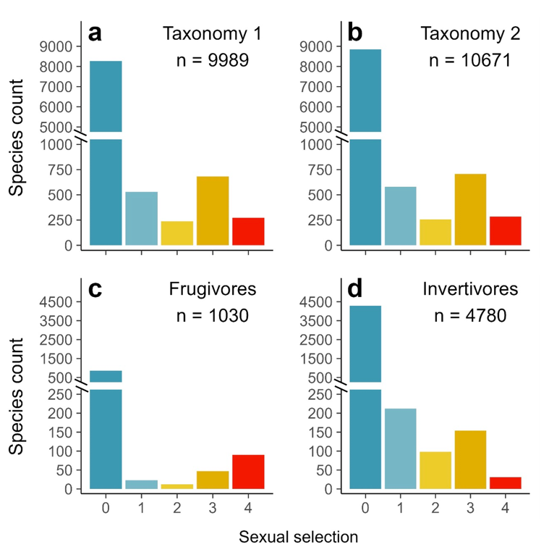
Extended Data Fig. 1. Species richness of birds assigned to different levels of sexual selection. Plots show number of species in categories 0–4 according to the species limits in BirdTree (Jetz et al. 2012) (a) or a more recent taxonomic update (Clements et al. 2021) (b), as well as within the two largest dietary guilds: invertivory (c) and frugivory (d). The strength of sexual selection increases from 0 (strict monogamy) to 4 (extreme polygamy) according to our scoring system (Extended Data Table 1).

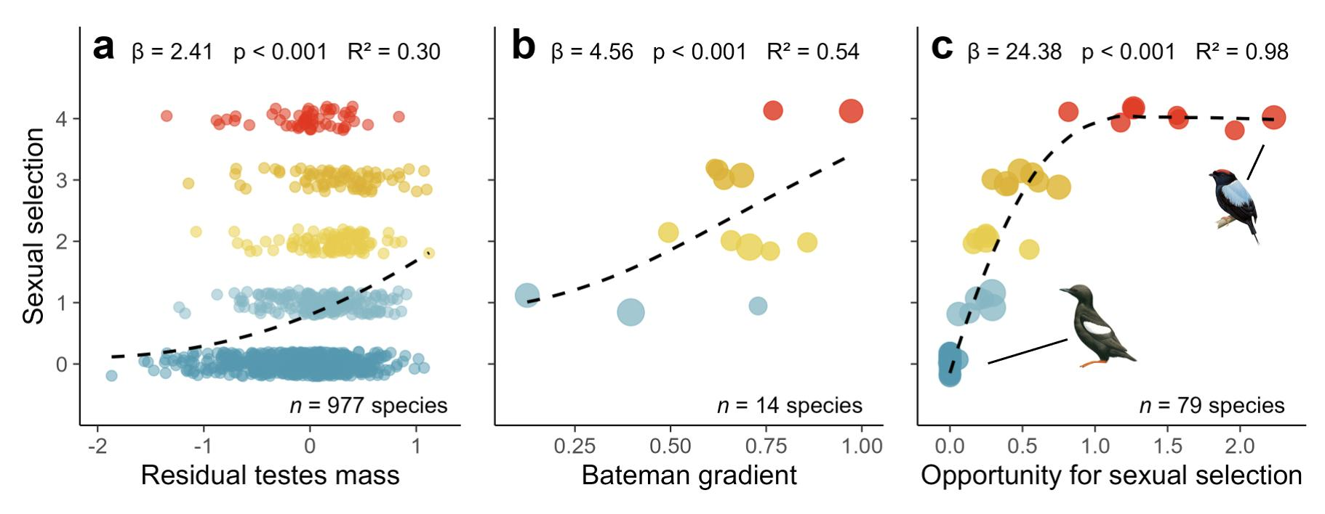
Extended Data Fig. 2. Comparison of scores with alternative metrics of sexual selection. Panels show results of Bayesian phylogenetic models assessing the relationship between our sexual selection scores and three independent measures of sexual selection: (a) residual testes mass, (b) Bateman gradients (β_{ss}), (c) the opportunity for sexual selection (I_{s}) (see Methods). Dashed lines show the relationship for subsets of species with available data, using predictions from models accounting for phylogeny using a sample of 50 phylogenetic trees extracted from www.birdtree.org (Jetz et al. 2012), grafted to the Prum et al. (2015) genomic backbone. Effect sizes, p-values, and explained variance (R²) were calculated from fixed effects only, and therefore represent the specific variation explained by each predictor separate from phylogenetic effects.. In b and c, point size is scaled by the number of individuals used to calculate sex-specific metrics. To compare sex-specific metrics with bidirectional scores, we selected the largest β_{ss} or I_{s} from each species, treating males and female metrics equally. We estimated I_{s} of 51 genetically monogamous species (with 0% extra-pair paternity) as zero. Excluding these species from I_{s} models produced similar results (Table S1). Illustrations of Black Guillemot and Lance-tailed Manakin are shown as exemplars of extremely low and extremely high I_{s}, respectively; images shared with permission of Birds of the World, Cornell University.
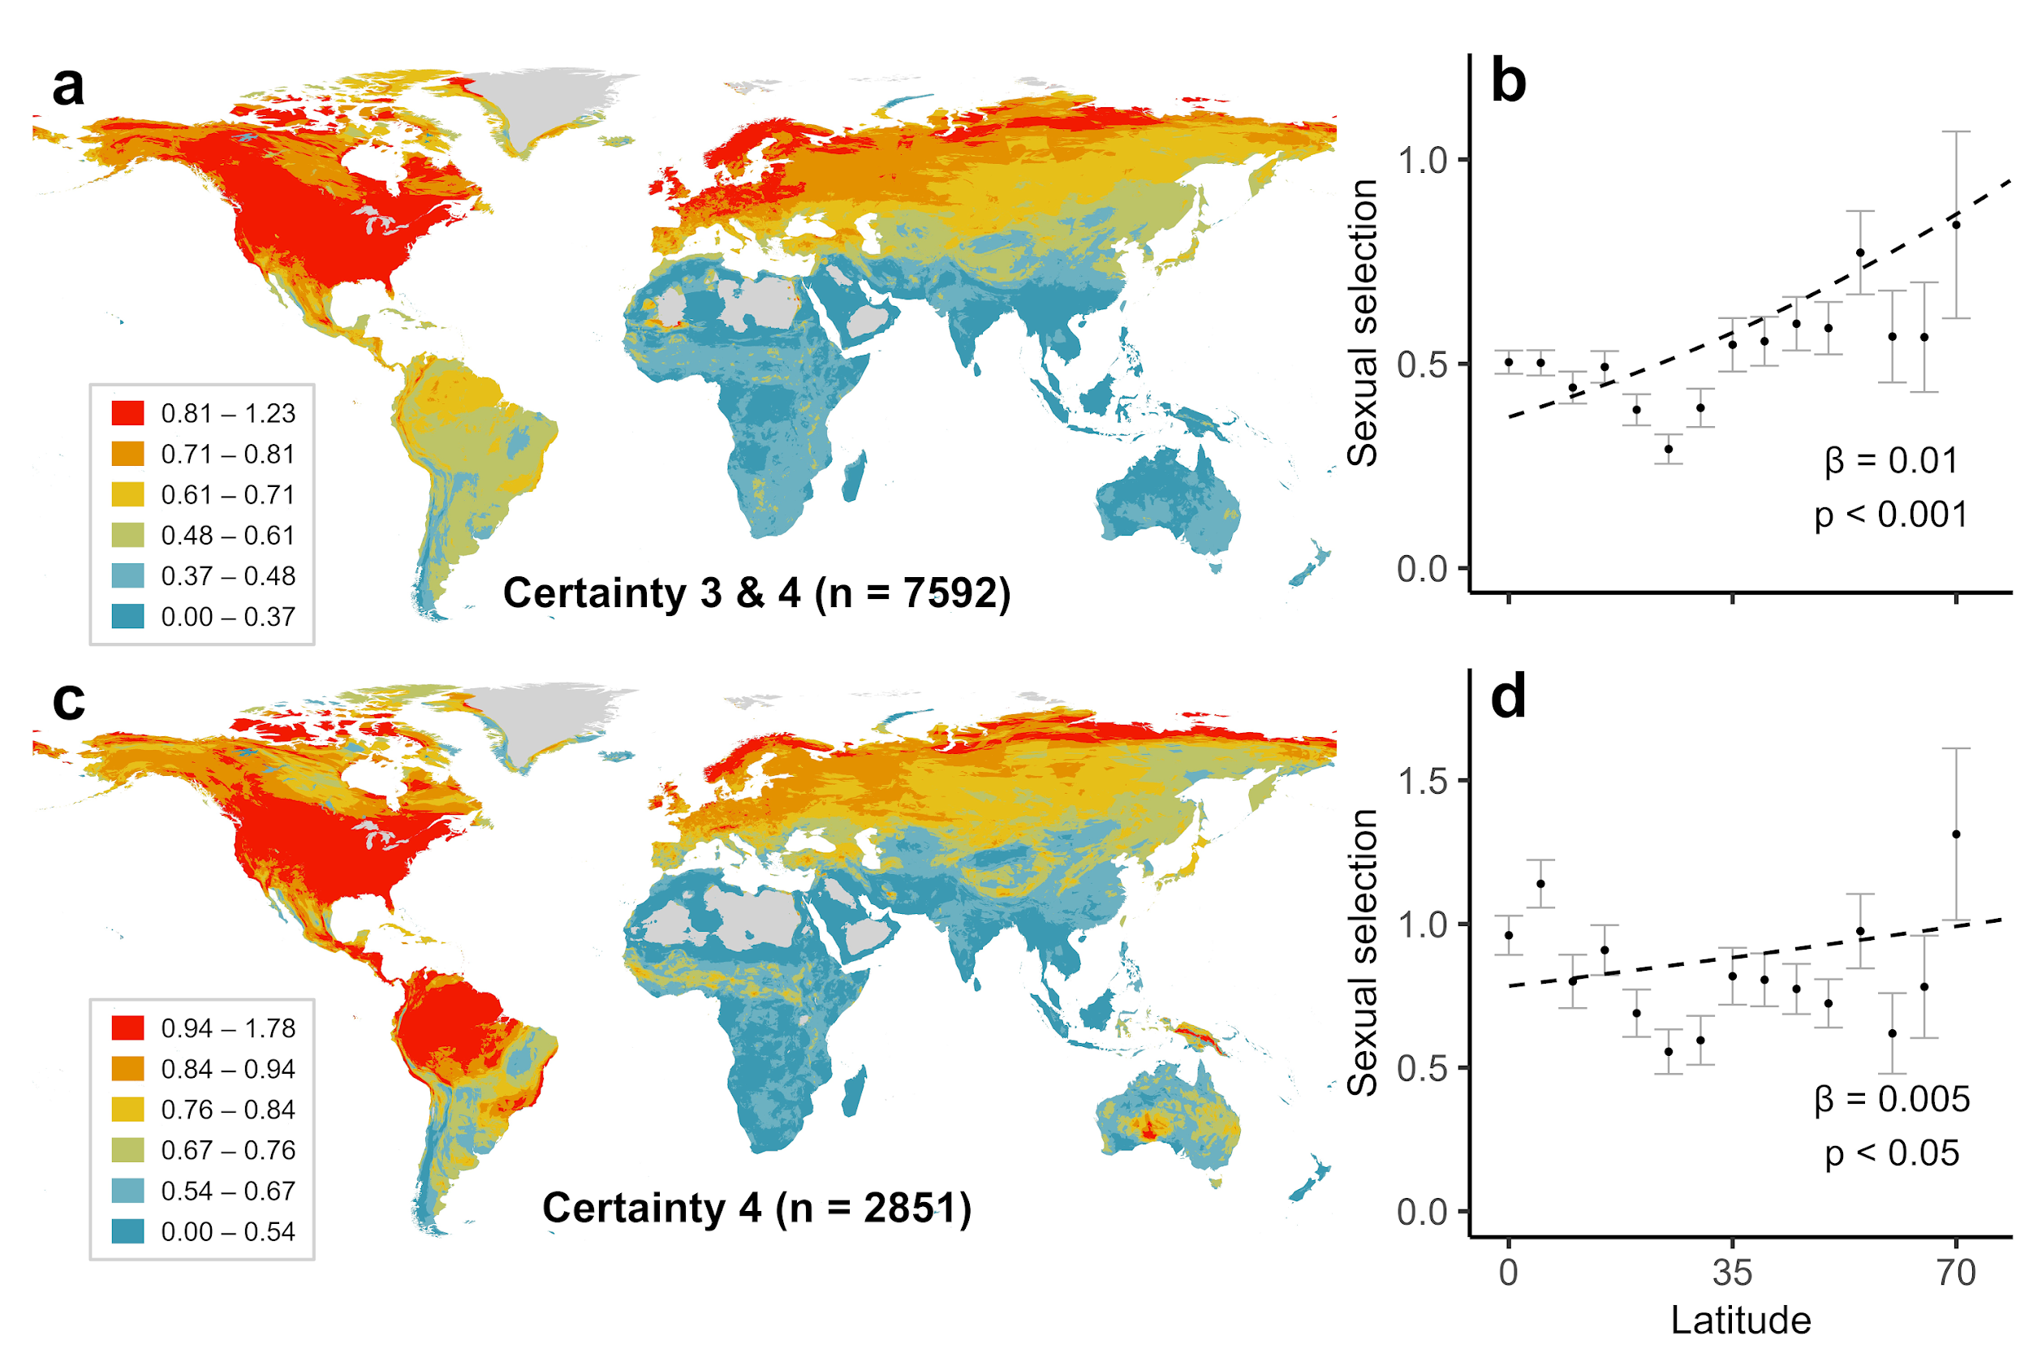
Extended Data Fig. 3. Effects of data quality on the distribution of sexual selection. a, Upper panels show average sexual selection for species with moderate to high data certainty (scored 3–4; n = 7592) mapped globally (a) and plotted against latitude (b). Lower panels show average sexual selection for species with high certainty data only (scored 4; n = 2851), again mapped globally (c) and plotted against latitude (d). In a and c, averages for each cell are calculated from all species with geographical range maps overlapping each 5-km grid cell; cells with <10 species were excluded. In b and d, sexual selection scores are averaged across five-degree latitudinal bins, with each species assigned to a single bin according to its latitudinal centroid; and latitudinal bins above 70 degrees were excluded from all scatterplots. Points represent means and range bars denote one standard error; dashed lines were generated from species-level Bayesian regression models predicting sexual selection strength.
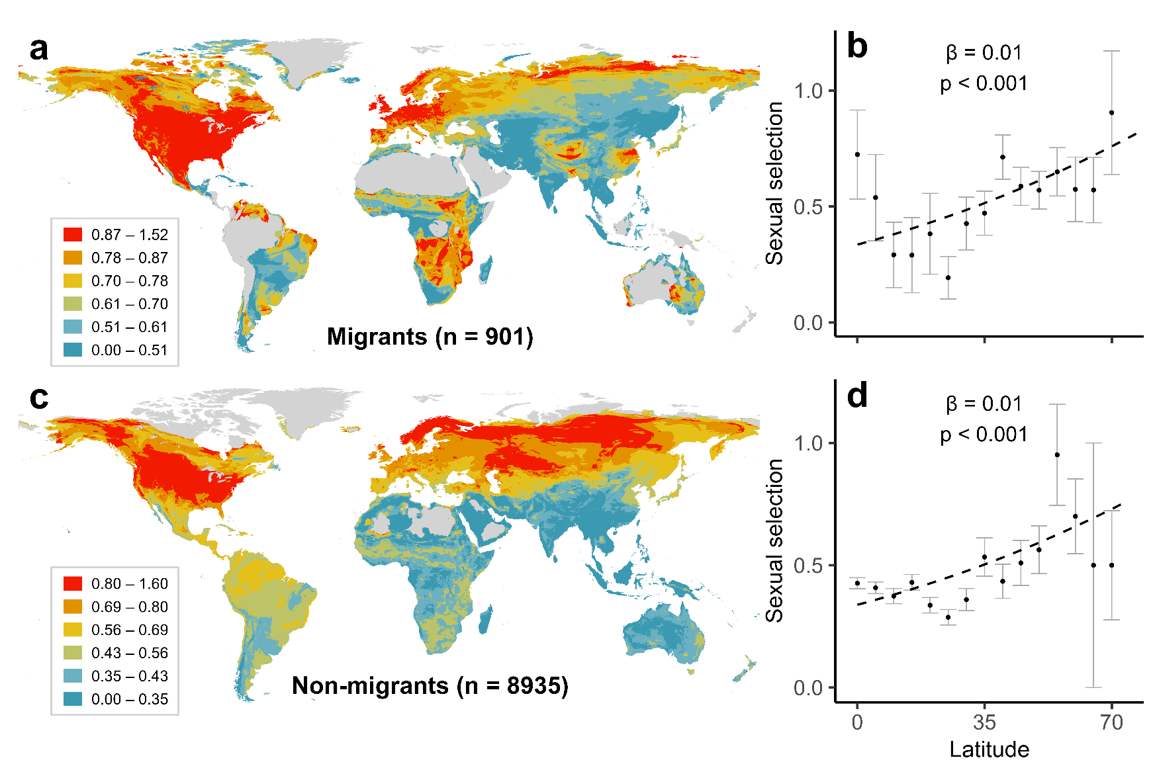
Extended Data Fig. 4. Global distribution of sexual selection partitioned by migration tendency. Upper panels show strength of sexual selection in long-distance migrants mapped globally (a) and plotted against latitude (b). Lower panels show strength of sexual selection in short-distance and resident species mapped globally (c) and plotted against latitude (d). Sexual selection was scored in five categories ranging from monogamy (0) to extreme polygamy (4; see Methods). In a and c, averages for each cell are calculated from all species with geographical range maps overlapping each 5-km grid cell; In scatterplots, variables were averaged within five-degree latitudinal bins based on the centroid latitude of their geographical ranges; points represent means; bars denote one standard error; dashed lines were generated from species-level Bayesian regression models predicting sexual selection strength. Additional species-level models on a high certainty subset (scored 3–4) showed similar patterns and are reported in Table S2. To reduce noise, cells with <10 species were excluded from all maps, and latitudinal bins above 70 degrees were excluded from all scatterplots.
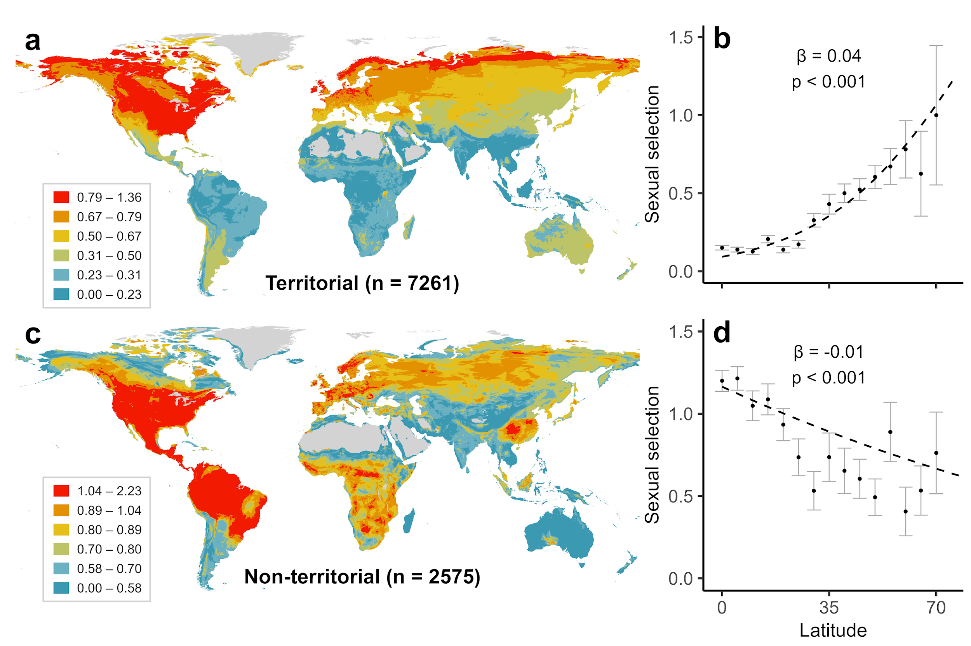
Extended Data Fig. 5. Global distribution of sexual selection partitioned by territorial behaviour. Upper panels show strength of sexual selection in seasonal and year-round territorial species mapped globally (a) and plotted against latitude (b). Lower panels show strength of sexual selection in non-territorial species mapped globally (c) and plotted against latitude (d). Sexual selection was scored in five categories ranging from monogamy (0) to extreme polygamy (4; see Methods). In a and c, averages for each cell are calculated from all species with geographical range maps overlapping each 5-km grid cell. In scatterplots, variables were averaged within five degree latitudinal bins based on the centroid latitude of their geographical ranges; points represent means; bars denote one standard error; dashed lines were generated from species-level bayesian regression models predicting sexual selection strength. Additional species-level models on a high certainty subset (scored 3–4) showed similar patterns and are reported in Table S2. To reduce noise, cells with <10 species were excluded from all maps, and latitudinal bins above 70 degrees were excluded from all scatterplots.
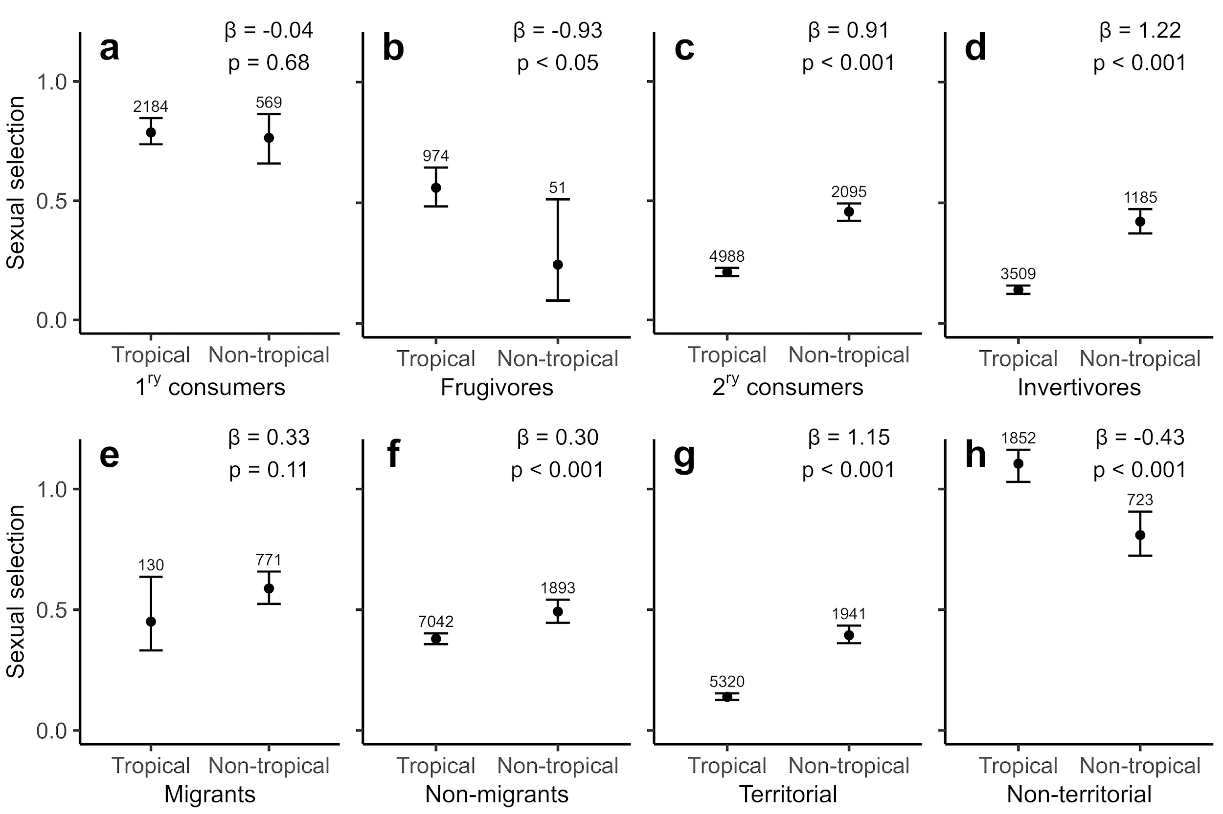
Extended Data Fig. 6. Variation in sexual selection for tropical and non-tropical species. Models predicting the difference in sexual selection strength between tropical and non-tropical species, partitioned by ecological trait. Black points show estimated sexual selection for each group, extracted from species-level bayesian regression models; whiskers show 95% confidence intervals from model predictions. Additional species-level models on a high certainty subset (scored 3–4) showed similar patterns (Table S3; Supplementary Information). Numbers above whiskers are sample sizes (number of species).
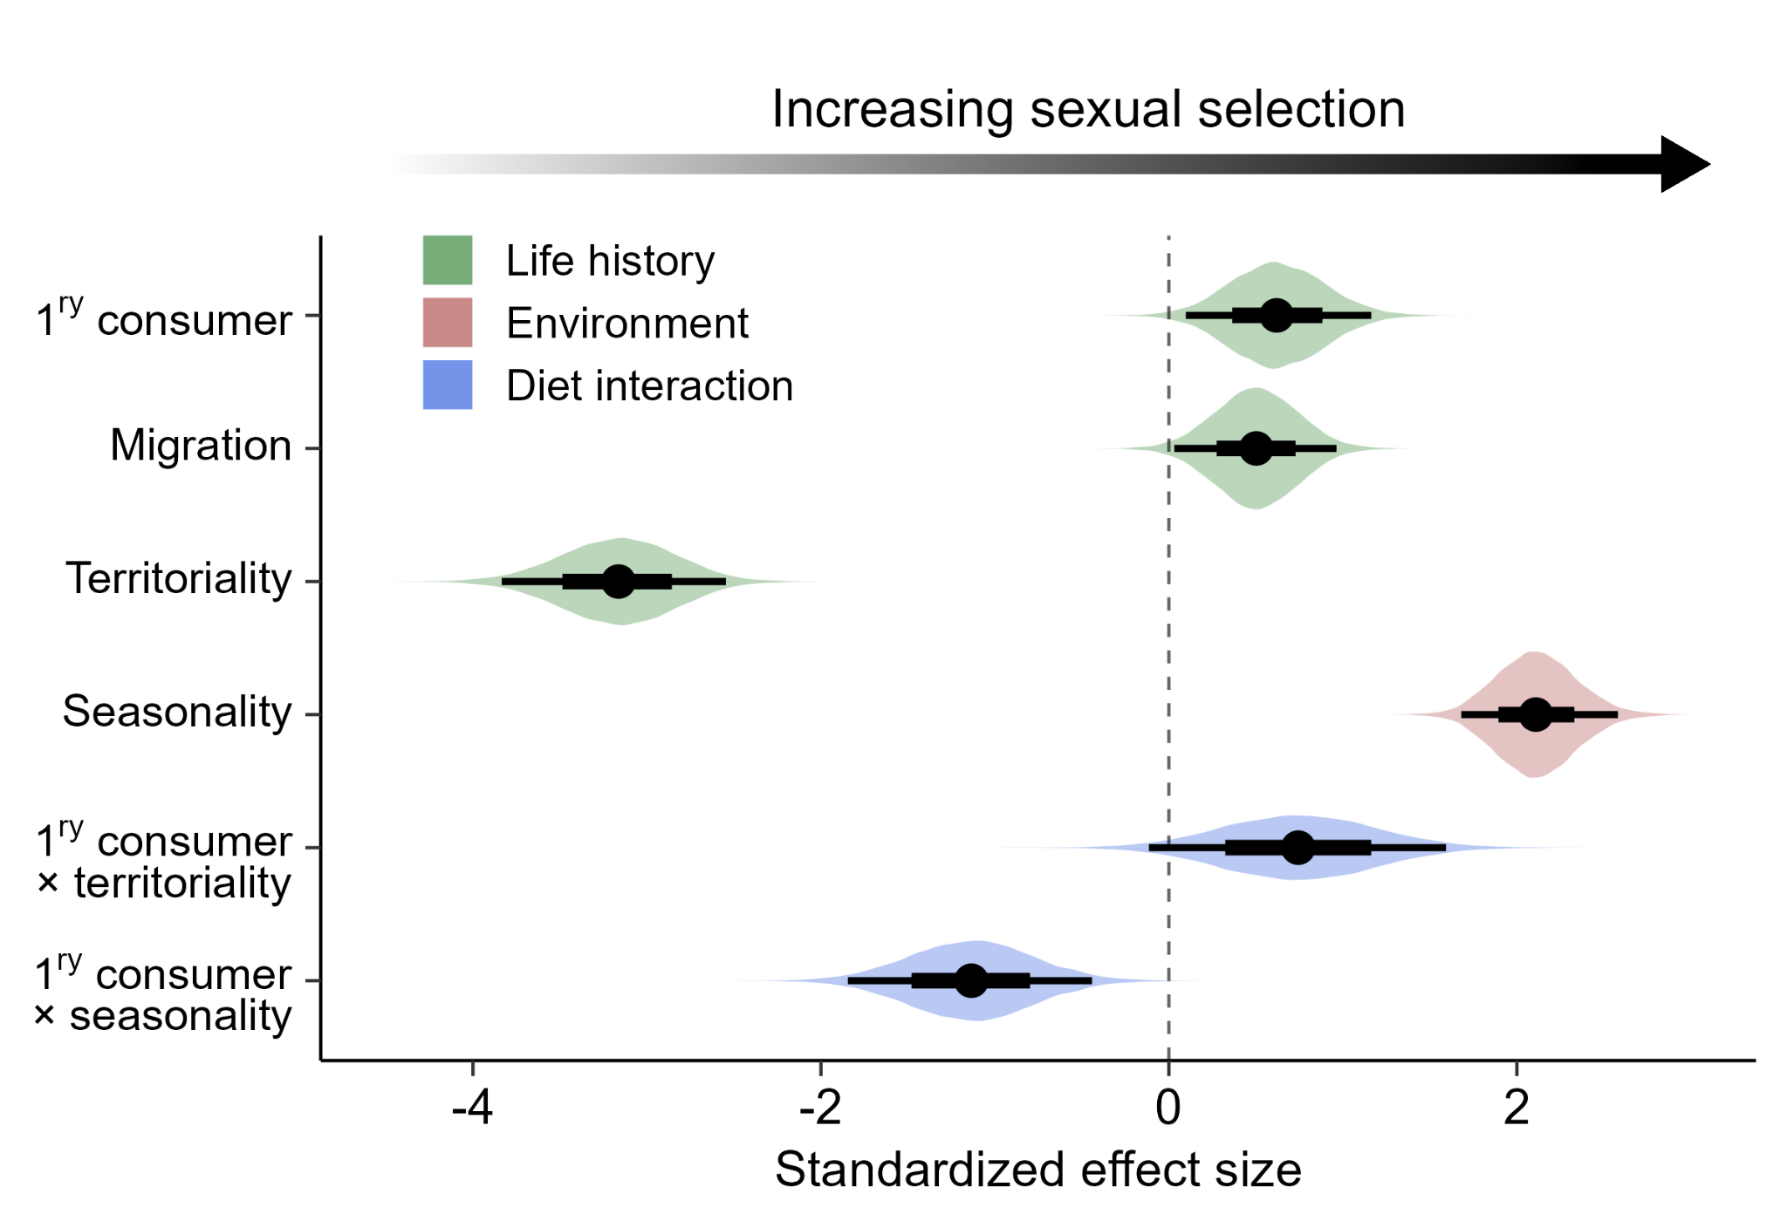
Extended Data Fig. 7 Evolutionary drivers of avian sexual selection. Results shown are from Bayesian phylogenetic models testing drivers of sexual selection in species scored with moderate and high data certainty scores (scored 3–4; n = 7592 species). Predictors include three life history variables (green), one climatic variable (pink), and two key interactions between diet and the dominant effects (territoriality and seasonality; blue). The reference groups for the three categorical predictors are as follows: secondary consumer; no migration; and no territoriality, respectively (see Methods for definitions). Models were run on a sample of 50 phylogenetic trees extracted from www.birdtree.org (Jetz et al. 2012), grafted to the Prum et al. (2015) genomic backbone. Dots show mean effect size estimates from 12,500 posterior draws. For each effect, broad bases of whiskers show 66% confidence intervals; narrow tips of whiskers show 95% confidence intervals. Coloured distributions indicate the spread of effect size estimates, generated from a sample of 1000 posterior draws. Full statistical results are presented in Supplementary Table S5.
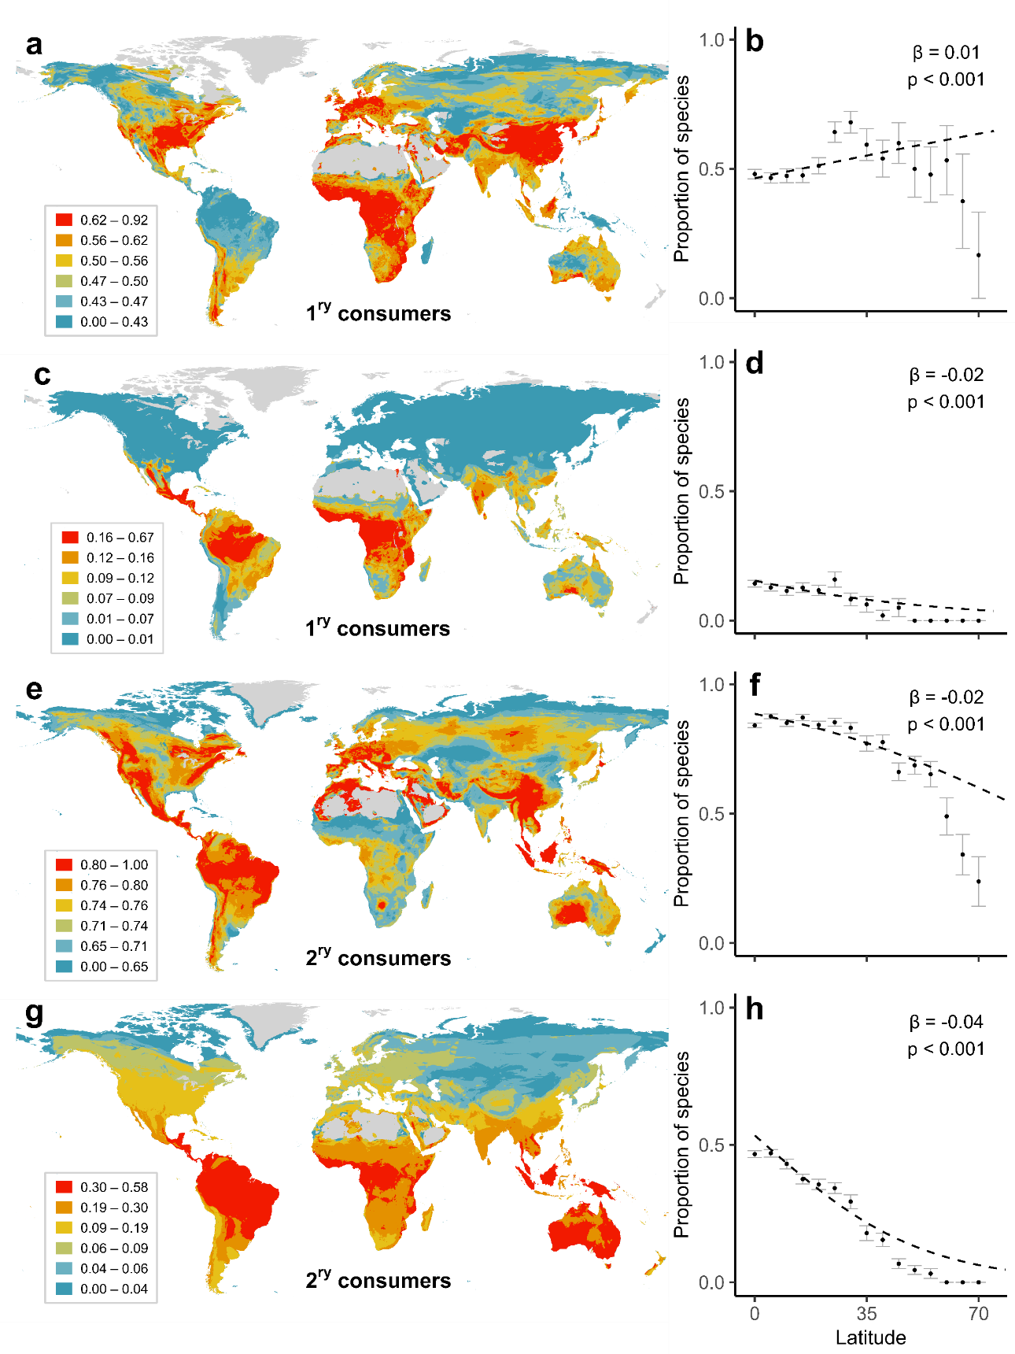
Extended Data Fig. 8. Biogeography of avian territoriality. Proportion of territorial primary consumers (n = 1379 species) mapped globally (a), and plotted against latitude (b), compared with those holding year-round territories only (c, d; n = 333 species). Proportion of territorial secondary consumers (n = 5882 species) mapped globally (e) and plotted against latitude (f), compared with those holding year-round territories only (g, h; n = 2640 species). Territoriality data (see Methods) were converted into binary scores for mapping purposes, as follows: in a, b, e and f (0 = none; 1 = seasonal/year-round); in c, d, g and h (0 = none/seasonal; 1 = year-round). In a, c, e and g averages for each 5-km grid cell are calculated from all species with geographical range maps overlapping each cell. In b, d, f and h, scores were averaged in 5-degree bins based on the centroid latitude of ranges; latitudinal bins above 70 degrees were excluded from all scatterplots. Points represent means; bars denote one standard error; dashed lines were generated from species-level Bayesian regression models. In a, c, e and g, cells with <10 species were excluded from maps.

