Table 1. Summary of the sequencing results of HAV transcript-added RNA extracts from raspberries.
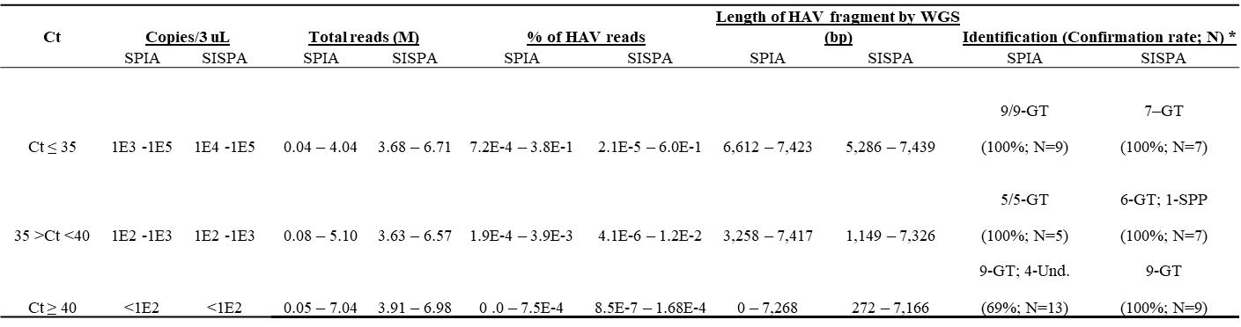

*GT: genotype; SPP: species; Und.: Undetectable. N: sample number; Confirmation rate: Percentage of RT-qPCR-positive samples confirmed by WGS.

Table 2. Summary of the sequencing results of norovirus transcript-added RNA extracts from raspberries.
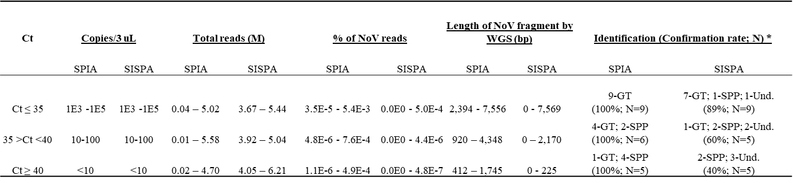
*GT: genotype; SPP: species; Und.: Undetectable. N: sample number; Confirmation rate: Percentage of RT-qPCR-positive samples confirmed by WGS.

Table 3. Summary of the sequencing results of HAV-spiked strawberry samples.
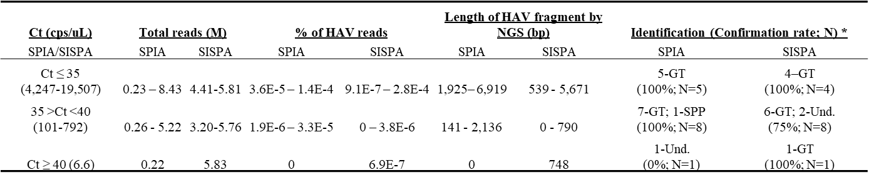
*GT: genotype; SPP: species; Und.: Undetectable. N: sample number; Confirmation rate: Percentage of RT-qPCR-positive samples confirmed by WGS.

Table 4. Summary of the sequencing results of HuNoV-spiked strawberry samples.
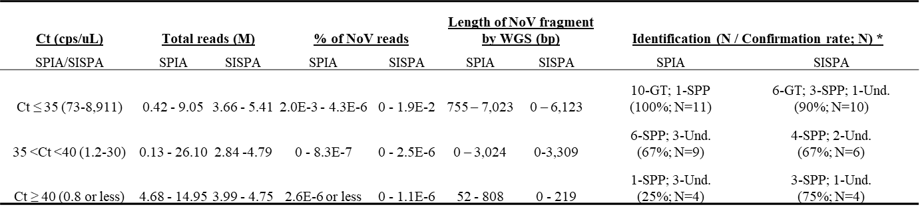

*GT: genotype; SPP: species; Und.: Undetectable. N: sample number; Confirmation rate: Percentage of RT-qPCR-positive samples confirmed by WGS.

Table 5. RT-qPCR and Sequencing results of a blackberry sample naturally contaminated with norovirus.
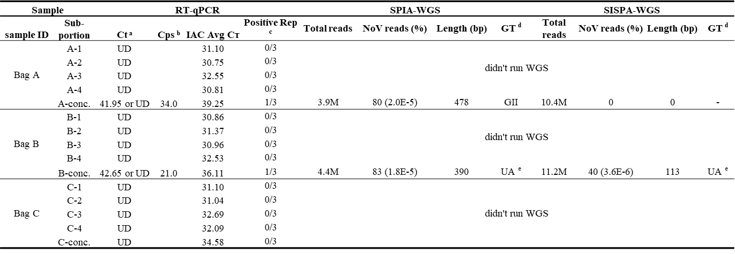
ª Ct UD: undetermined
^{b} Cps: total copy number of norovirus recovered from 50g blackberries, calculated based on the ratio of total volume of berry extract and the volume of extract used for RNA isolation.
^{c} Positive Rep: positive replicates of RT-qPCR assay
^{d} GT: genotype
^{e} UA: unassigned

